1. **Add>**Thread>Thread Group> To create a user

2. **HTTP Request** > To pass the ip

3. **Http Header Manager** > Authorization

4. **View Result Tree** > To check the result

5. **Assertions** (Response) > Check the response through response code or error message

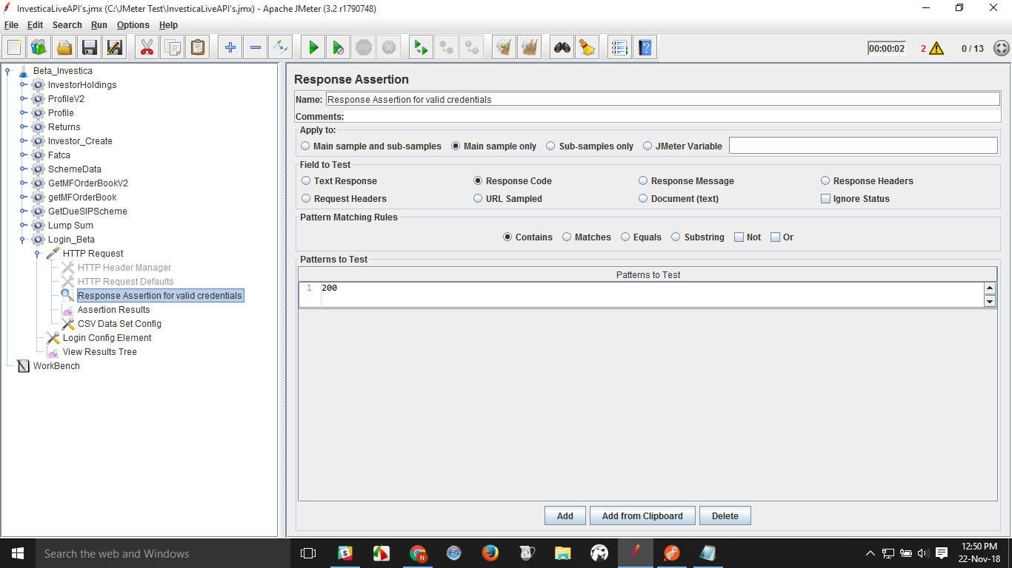

**6.Assertion Result**

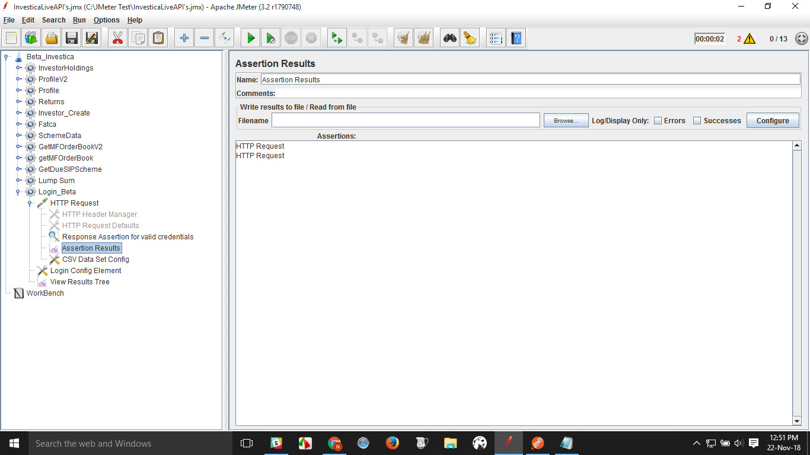

-------------------------------------------------------------------------------------------------------------------------------------------

**CSV data set config >** To Handle the dynamic values

* Add thread>http request>Add ip>Define parameters (i.e. username,password)
* Add CSV data set config> create a csv file>copy file path>paste in filename field+add file name.csv>Define variable name
* view results in tree

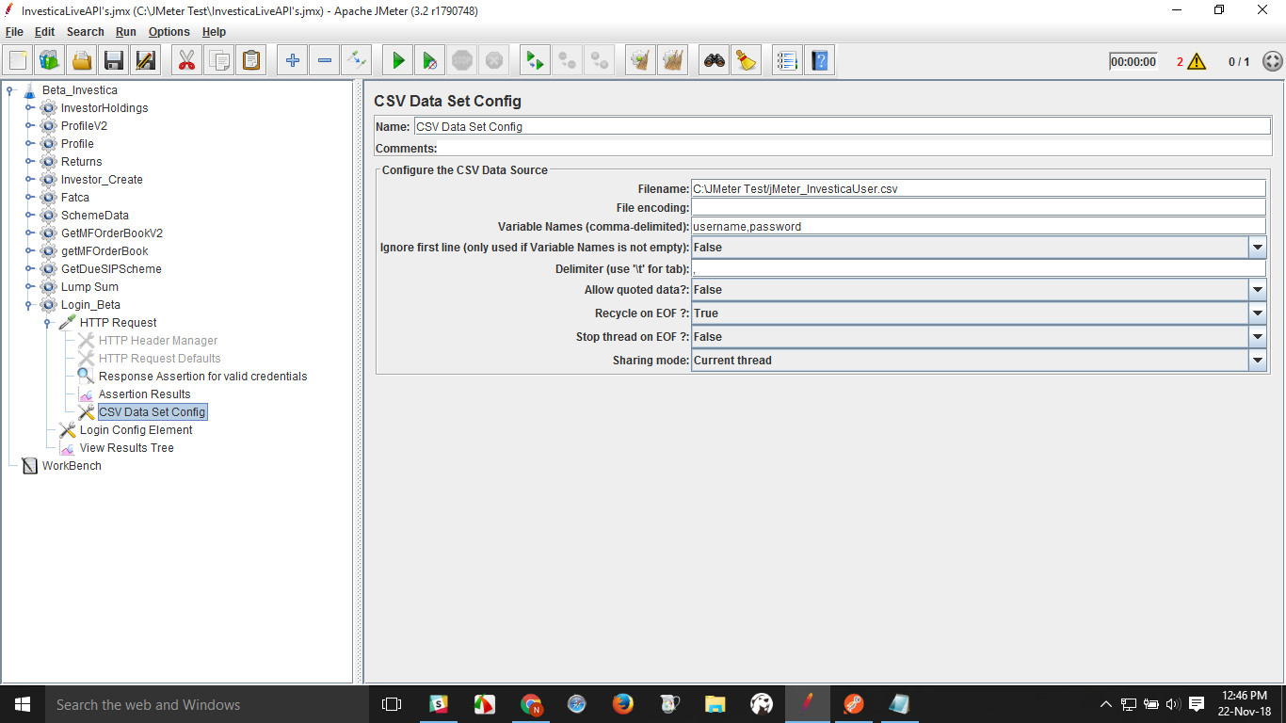

--------------------------------------------------------------------------------------------------------------------------------------------

7. **Login config element** > We can check only one login at a time

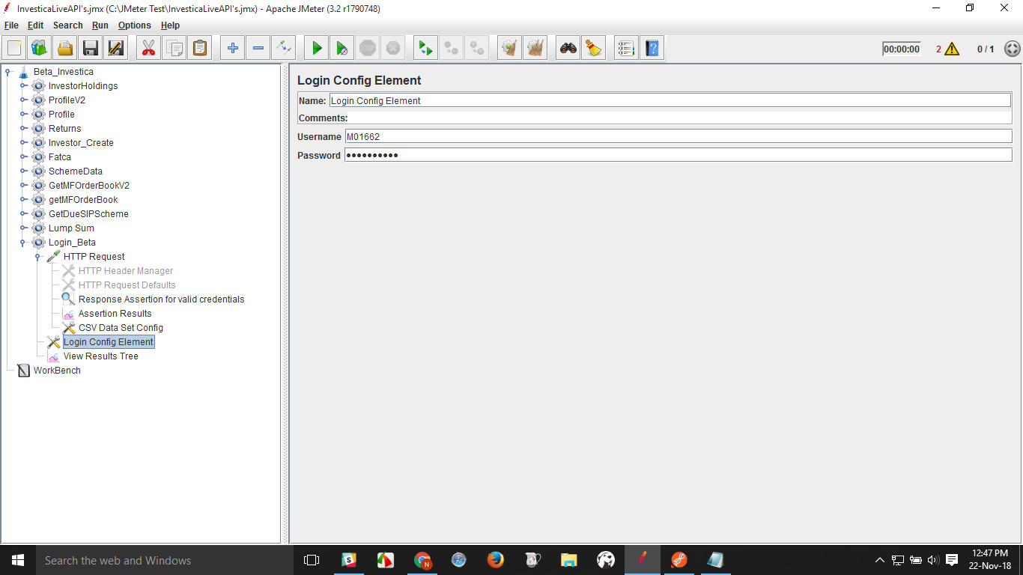

--------------------------------------------------------------------------------------------------------------------------------------------

**Bearer Token Handling**

**1.Add Http Request>Add Login parameters in http request**

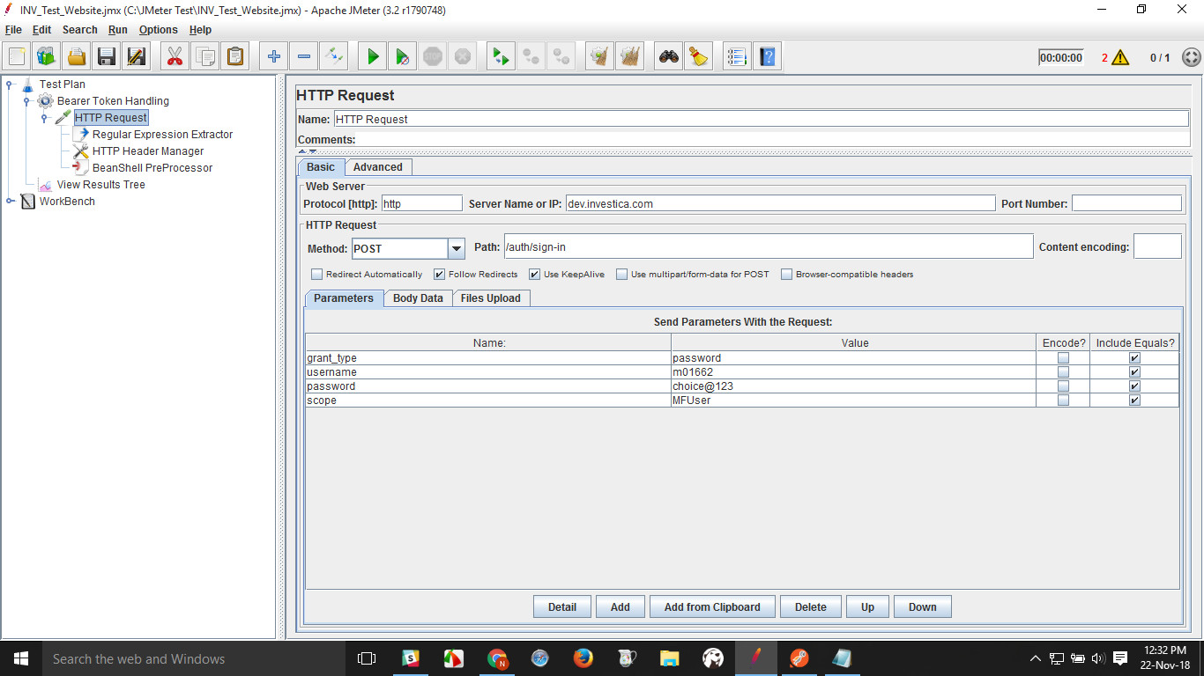

**2.Add Regular expression Extractor**

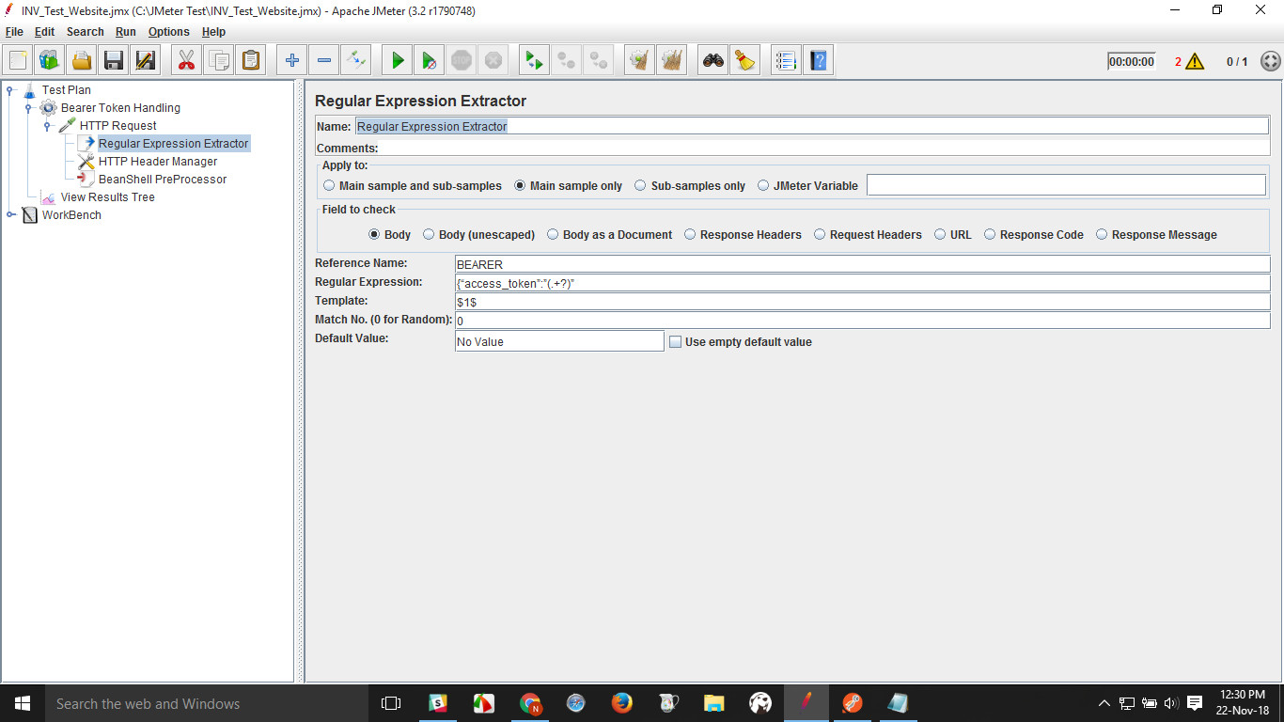

3.**Add HTTP Header Manager**

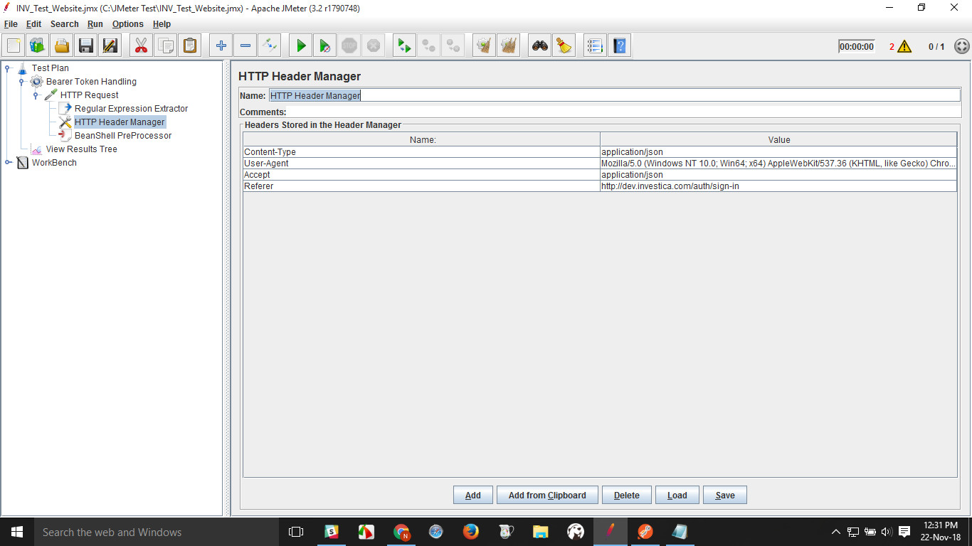

**4.Add Bean Shell preprocessor**

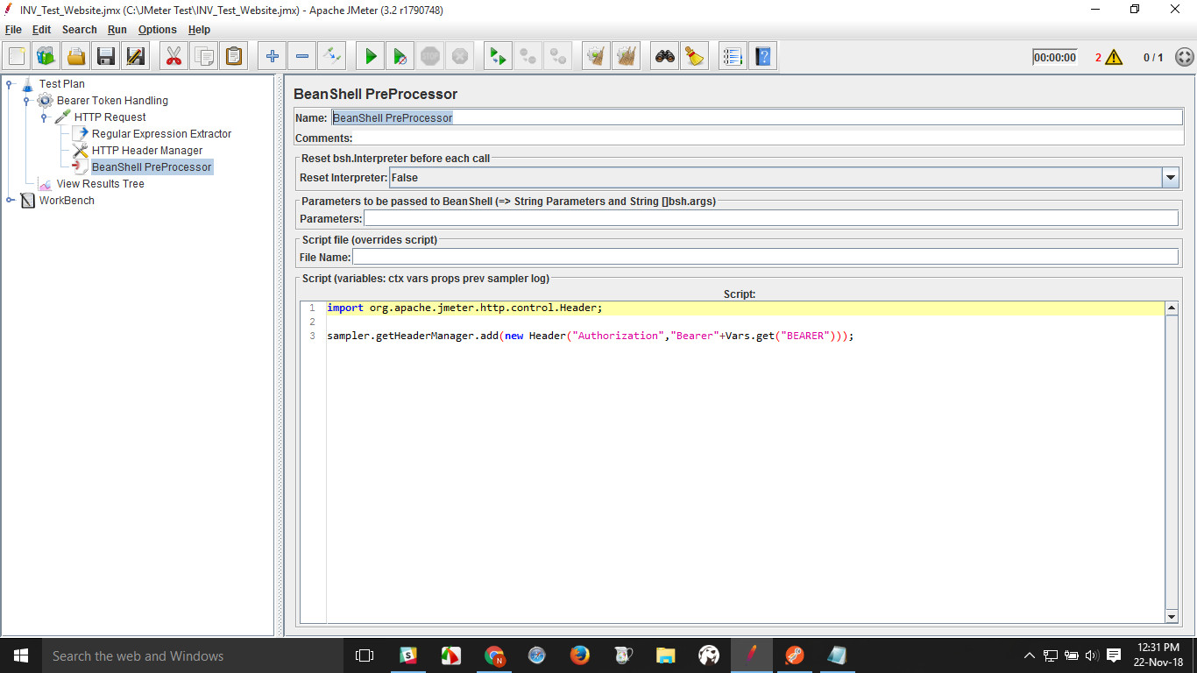

* 5.**View Result in Tree**

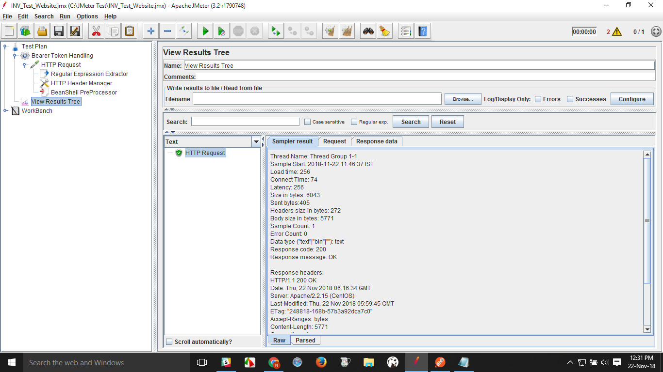

**Database Testing using “JDBC Connection configuration”**

**1.setup database in your system :**

**2.Download** [**Microsoft JDBC Driver for SQL Server**](https://msdn.microsoft.com/en-us/sqlserver/aa937724.aspx)**, and the open source** [**jTDS JDBC Driver for SQL Server**](http://jtds.sourceforge.net/)**.**

**3.Download the jTDS JDBC Driver**

**4.Setting up parameters in "JDBC Connection Configuration" :**

**JDBC Driver Class: It’s different for every Database vendor**

* **Mysql uses com.mysql.jdbc.Driver**
* **Oracle uses oracle.jdbc.driver.OracleDriver**
* **Microsoft uses com.microsoft.sqlserver.jdbc.SQLServerDriver**

1.**Add Thread group** :

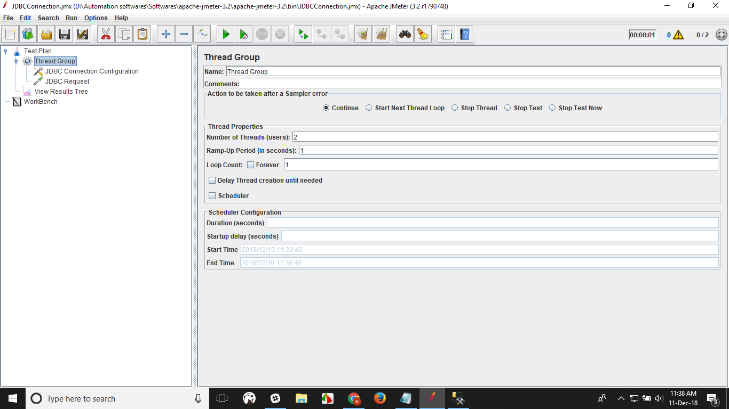

2.**jdbc connection configuration** : we will define the database URL, JDBC driver class, the MySQL username and password, etc.

***jdbc:sqlserver://[serverName[\instanceName][:portNumber]][;property=value[;property=value]]***

.

* **Variable Name:** This value will be used in our JDBC Sampler. In case there is more than one SQL connection, JDBC request will use the right DB Connection by using this value.
* **Connection Pool Configuration:** Leave it as it is. These values are good enough for a performance test. In case it’s needed, increasing or decreasing the values is a possibilities.

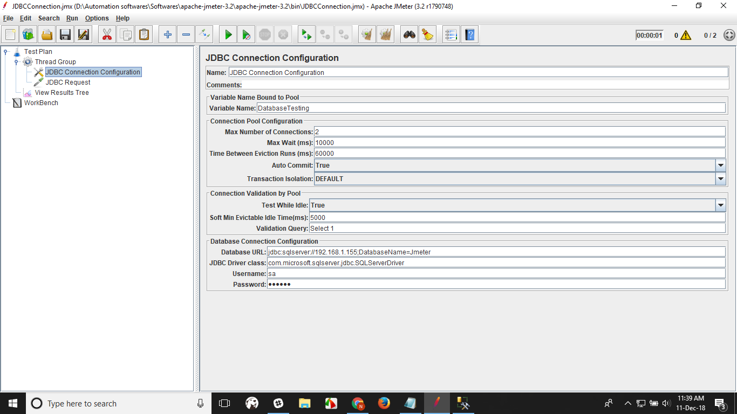

3.**jdbc request** : we define the query (Select * from abc)

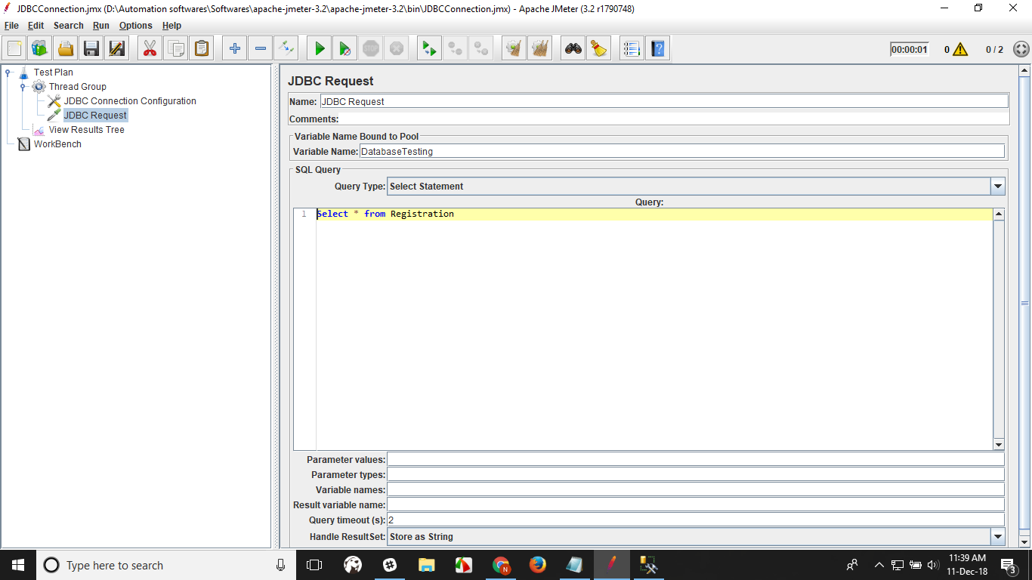

4.**Listener** : To check result

