Survey™ Project v. 2.4
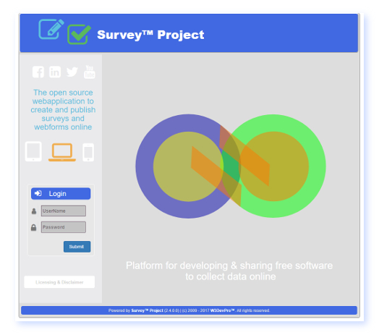
- New Features & Fixes -

Survey™ Project - Documentation
Author: W3DevPro™
Version: 1.0
Date: 2017-04-24
Table Of Contents
I. Introduction & Overview 3
II. New Features 4
1. Installation Settings 4
2. Graphical Reporting Charts added and updated 6
3. Option to present a resultsreport after submitting survey 7
4. New Answer Type: (Google) Address Field 9
5. Paging Options 10
6. New CSS features 11
7. Token Security Labels added 13
8. Answer Editor Page presentation 13
9. Asp.net User on voterreport 14
10. RequiredMarker Title and ordering 14
III. Bugfixes 15
IV. Technical Changes 15
1- Automated creation of Install version 15
2. SurveyBoxControl Usercontrol 16
3. SurveyBox DNN module adjustments 16
4. HTML5 settings/ directives 16
5. SurveyMobile.css Redo 16
Additional Information & Sources 18

I. Introduction & Overview
The new release - version 2.4 - of the Survey™ Project webapplication contains new features, (bug)fixes and technical updates.
The purpose of this document is to describe these features, fixes and technical upgrades in more detail to end-users, administrators and developers.
In case of major additions to the webapplication the integrated helpfiles and webscreen helptips provide more information on the use and working of the particular features.
II. New Features
1. System Settings
a. General Description
- A new webpage and menuoption [Surveys/ Settings/ System Settings] to manage and secure several of the SP webapplication settings that are stored in the web.config file:
* database connections
* globalization culture (language settings)
* mailserver settings
* miscellanious settings
- Option to secure (encrypt/ decrypt) different parts of the web.cong file.
- Helpfile webpage is added including description of the editable parts of the web.config file.
b. Application
- These features are only accessible to Administrators due to the critical nature of several of the settings to the correct working of the SP webapplication;
- After the initial installation it is no longer necessary to access the web.config text file directly (e.g. though FTP) or outside of SP to make relevant changes to these settings;
- By default the web.config file is not encrypted after the initial installation of SP. To encrypt one of the editable entries as presented on the System Settings page the submit button has to be clicked. Next the associated entry in the web.config file will no longer be (humanly) readable (encrypted) and changes (if any) will be saved as well.
- To decrypt an entry click the associated Decrypt button. Information on the System Settings webpage will always be readable even if the entry is encrypted in the web.config file.
- Encryption/ decryption will raise the level of security of the webapplication. In particular on 3d party hosting platforms or to avoid unvoluntary disclosure of technical details it may be usefull to encrypt the relevant sections of the web.config file.
- The helpfile can be accessed by clicking the help button on the System Settings webpage or through the menu: Help/ Help files/ .... --> II. Survey Management / 2.0 Installation Settings
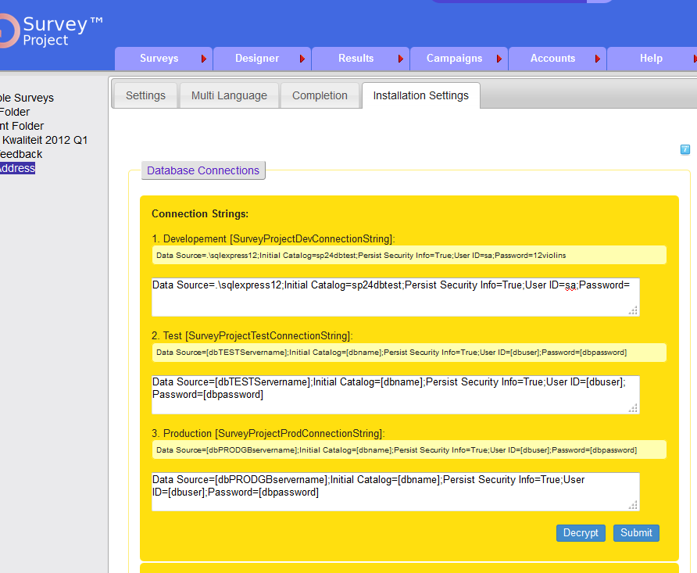Web.config Installation Settings
2. Graphical Reporting Charts added and updated
a. General Description
- Graphical reporting charts have been added and updated:
* Column chart (updated)
* Html chart (unchanged)
* Bubble chart (new)
* Bar chart (new)
* Pie chart (updated)
- 2D and 3D option per chart type are available
Technical changes
- former webcharting objects are removed and replaced by the MS Chart control
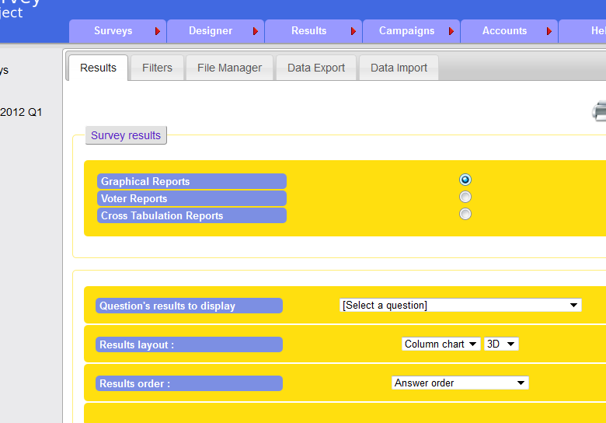New Graphical Charting options
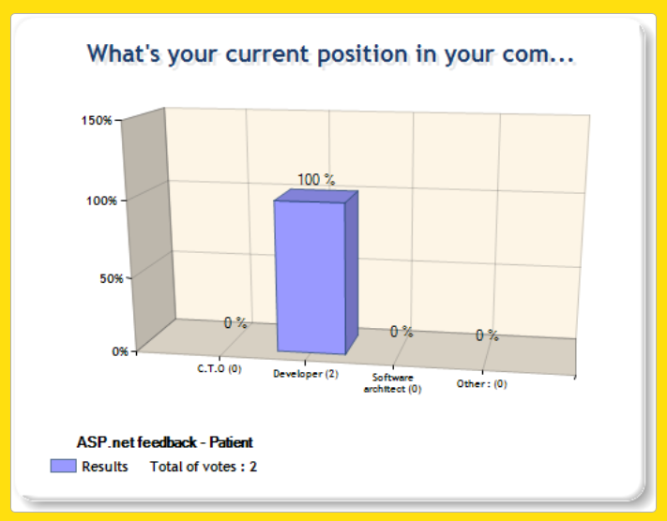New Column Chart 3D
- web.config: MS Charts lines added
b. Application
New and modernized graphical reporting charts are now available including a 2D/3D option per charttype. Menu Results/ Reports/ .. Graphical Reports ... Question Results to Display (select) ... Results Layout (select) ....
The former charting object was no longer supported. The use of the MS Chart control and charting libary is much more flexible and offers more (prestentation) features.
More information on MS Charts:
https://msdn.microsoft.com/en-us/library/dd456632(VS.100).aspx
3. Option to present a "Results Report" after submitting a survey
a. General Description
- Option to show a survey results report to the individual respondent after submitting the survey.
- Option can be set through menu Survey/ Settings/ Completion --> Settings/ Redirection URL...
- Help Tip added to Redirection URL field
- Description added to Helpfile Completion Actions
Technical changes
- new webpage added: [webroot]/ resultsreport.aspx
- based on the voterreport: surveyid, voterid (session);
- url set through Completion Settings;
- surveyprivacy.aspx: completion page tooltip added
- helppage on Completion: resultsreport redirection url
- xml helpfile en-us: entry added
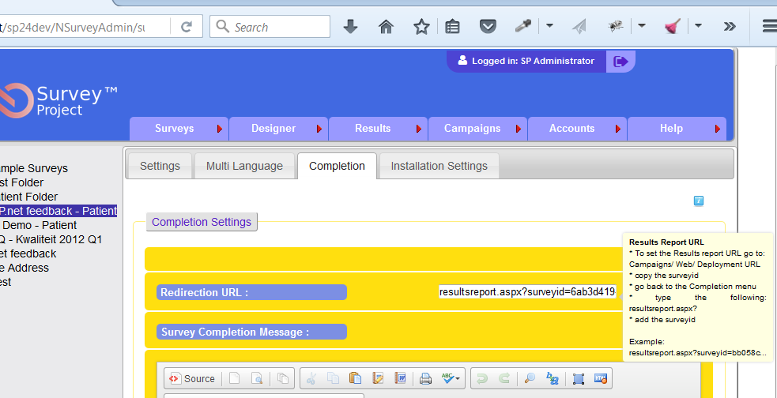Completion Settings: Results Report
b. Application
The results report will show an overview of all questions and answers submitted by the respondent. The report can be printed by clicking the reports print button.
The report is a copy of the existing voterreport which is available at menu Results/ Reports/ .. Voter Reports.. Details...
To activate the option to present the resultsreport after submitting the survey the resultsreport url of the survey has to be added to the Redirection URL field at the Completion settings.
Go to menu Survey/ Settings/ Completion/.. and enter the url of the resultsreport into the Redirection URL field according to the instructions (see: tooltip + helpfiles).
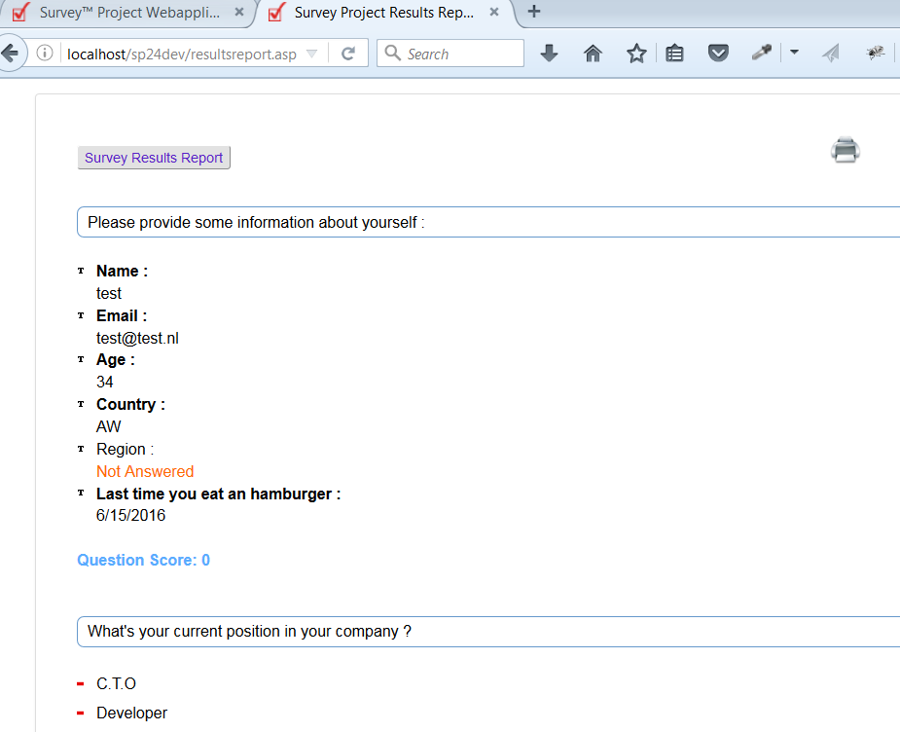Results Report Example
4. New Answer Type: (Google) Address Field
a. General Description
- A new (field) Address answertype has been added to the list of (default) answertypes to select from when creating questions and adding answers
- A helpfile has been added to the Helpfile menu explaining the working of the Address Answer Type
- An XML file has been added to set/ edit the Google Maps Keys
Technical changes
- AnswerFieldAddressItem.cs added to Votations.NSurvey.WebControls.UI Libary
- database changes: table Vts_tbanswertype
- XmlData\Address folder added and Address.xml
- helpfile added Help/Field_Address.aspx
b. Application
- The new Address Answer Type can be selected from the list of available (default) answertypes when adding answers to a question;
- it can be used on the surveyform to search/ enter and complete addresses/ locations though Google Maps;
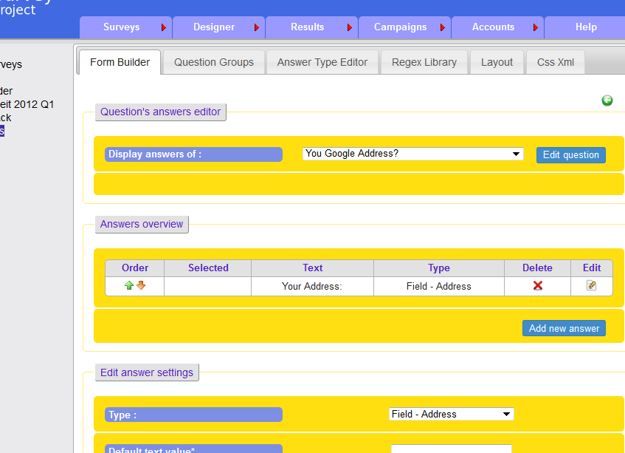Answer Editor (Google) Field Address Type
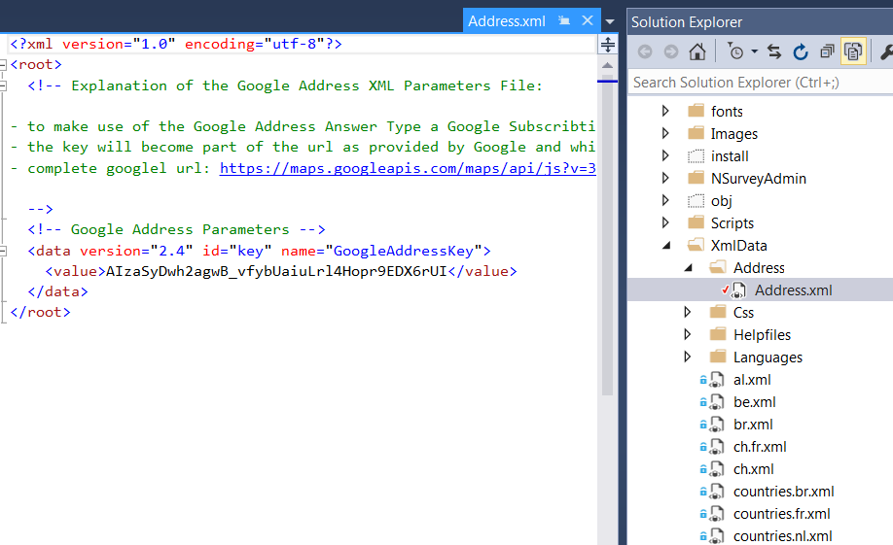Google Addres Field - Address.xml file
- the selected address will also be presented on the surveyform as a marker on a map;
Installation
- to make use of the Google Address Answer Type a Google Subscription is needed in order to get a key;
- the key must be copied to the Address.xml file at the XmlData\Address directory;
- the key will become part of the url as provided by Google and which is programmed into SP;
- the complete Google url: https://maps.googleapis.com/maps/api/js?v=3.exp&libraries=places&sensor=false&key=[YOURKEY]&language=en
Google Maps Keys
For Information & Links go to:
https://developers.google.com/maps/documentation/javascript/get-api-key
The working of the Google Maps features is determined by the Google Company. Limitations may apply.
More information can be found at:
https://developers.google.com/maps/documentation/javascript/usage
5. Paging Options Added
a. General Description
- Paging options are added to:
* surveylist page (overview of surveys)
* mailing status page
* mailing error log page
* results/ voter reports overview (existing paging adjusted)
Technical changes
a- surveylist.aspx page, default pagesize set:
<asp:GridView ID="gridSurveys" Width="100%" runat="server" AutoGenerateColumns="False" AllowSorting="True"
ShowHeaderWhenEmpty="true" OnSorting="gvSurveys_Sorting" AlternatingRowStyle-BackColor="#FFF6BB" ShowFooter="True" AllowPaging="True" OnPageIndexChanging="gridSurveys_PageIndexChanging" PageSize="10" FooterStyle-BackColor="#FFDF12" FooterStyle-BorderStyle="None" FooterStyle-BorderColor="#E2E2E2">
b- mailingstatus.aspx, default page size set:
<asp:datagrid id="PendingEmailsDataGrid" runat="server" PageSize="2" AllowPaging="True" AutoGenerateColumns="False" Width="100%" >
<asp:datagrid id="AnsweredEmailsDatagrid" runat="server" border="0" AllowPaging="False" Pagesize="3" AutoGenerateColumns="False" Width="100%">
c- mailinglog.aspx
<asp:datagrid id="MailingLogDataGrid" runat="server" Width="100%" AutoGenerateColumns="False" AllowCustomPaging="True" PageSize="1">
d. databasechanges: adjusted stored procedures
b. Application
a. Surveylist
- In case of > [*] surveys the paging option will appear on the surveylist table to page to the next set of surveys;
- the number(*) of surveys per page to be shown can be set by editing the surveylist.aspx page (see technical changes)
b. Mailing Status page
- In case of > [*] pending or validated mailmessags in the overview lists the next/previous page links are activated;
- the number(*) of messages page to be shown can be set by editing the mailingstatus.aspx page (see technical changes)
c. Mailing Errorlog Page
- In case of > [*] mailing errorlog messages in the overview lists the next/previous page links are activated;
- the number(*) of messages page to be shown can be set by editing the mailinglog.aspx page (see technical changes)
d. Results/Reports/ Voter Report Overview
- the number(*) of voterreports per page to be shown can be set by editing the Fieldreporting.aspx page
6. New Design/ CSS features
a. General Description
I- Css Xml Layout Options
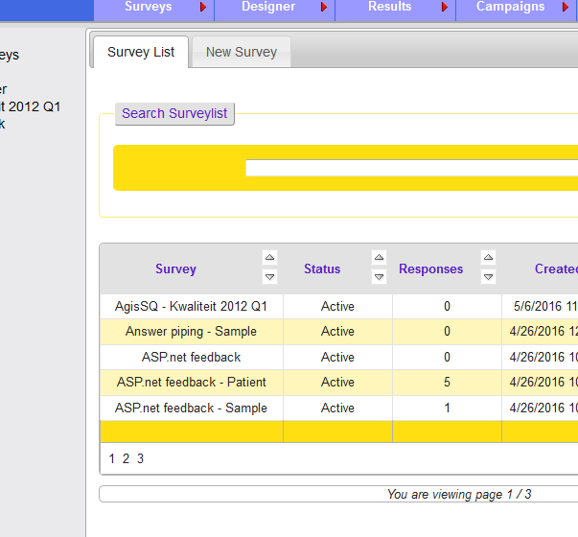SurveyList Paging Option

As part of the different features to determine the look and feel of the surveyform as it is presented to respondents a list of CSS/ XML entries has been created.

Through this list the "CSS Selectors" column can be edited. The CSS Selector or CSS Class names refer to the selectors and classes as defined in the CSS files (*.css) used with a particular survey (default or custom). CSS files can be found in the NSurveyAdmin/CSS directories.

If a CSS Selectors is added (multiple selectors per item are possible) it's CSS rules will be applied to the part of the surveyform/page that can be recognised by the ID that is mentioned in the ObjectID column.

Different parts of the survey webpage and surveycontrol have been given an ID that can be used in client-side scripting (e.g. Javascript or Jquery) or to apply specific CSS rules to a page element or object. The Name Column briefly describes the particular element and its feature/ function.

When rendered on the webpage an ID is proceeded by "SurveyControl_". ID's can be found in the browsers HTML code of the webpage (click F12 button).

Radiobuttion Labeltext Alignment

One special entry in the list called 'GlobalRadioButtonTextAlign' is used to determine the left or right position of the radiobutton labeltext. Instead of referring to a CSS class or selector the entry is picked at runtime to present the label left or right of the radiobutton.

Options to set the alignment are: 'Left' or 'Right' (case sensitive).
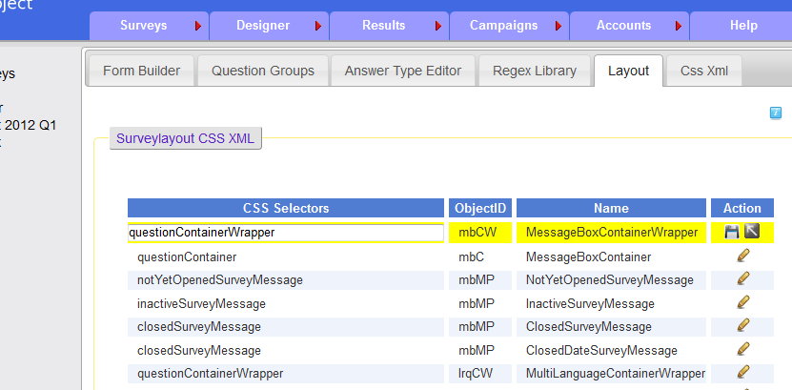SurveyLayout CSS XML editor
II - Selection Answertype CSS
A special option is available to determine the CSS class used on Selection Answertypes - Radiobutton. Besides making use of the CSS/XML list its possibe to set the CSS on the DIV tag surrounding individual Selection Answertype Radiobutton through the Answer Editing form.
b. Application
When a Selection Answertype Radiobutton is chosen from the Type DropDownList the Radiobutton CSS option is shown to enter a CSS Class/ selector as defined in the CSS files.
If the "Radiobutton CSS" textbox is left empty but the Alias textbox is filled with the name of any existing CSS class the particular CSS class/ selector will be applied to the Answer DIV.
7. Token Security Labels added
Minor adjustment: two labels/ headers added to the webpage to clarify the page structure.
8. Answer Editor Page presentation
Layout adjustments: depending on the answertype selected from the DropdownList the appropriate anwersettings will show on the page.
Former situation: all rows were shown including (empty) rows not containing setting options.
9. Asp.net User on voterreport
Adjusted to "SP username": a registered user of the SP webapplication (username/ password). The use of 'ASP.NET user' is confusing and incorrect.
Technical change
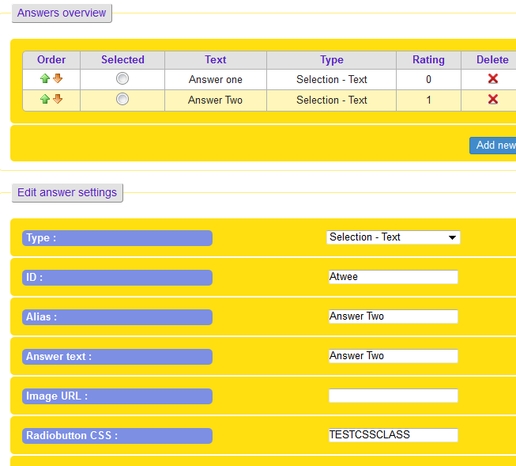RadioButton CSS
* XML language files
<data version="1.4" id="432" name="VoterUserNameLabel">
<value>SP Username :</value>
</data>
10. RequiredMarker Title and ordering
On the Surveyform:
- 'Title' attribute added (xml language file and code) to Required Marker
- Order of text/ helptext split -> new order: number, text, mandatory sign, helptext
11. Date/Time changes to UTC format
a. General Description
Throughout the SP webapplication several of the the date/time fields have been changed to the Univeral Time Code (UTC) format and/ or will be saved as such in the SP Database.
Technical Changes
- datetime.now converted to UtcNow in :
* surveybox startdate/ enddate
* DAL/ survey.cs - new survey
* pipemanager.cs
* cookiewebsecurityaddin.cs
* Answerfieldcalendaritem
* Answerproperties.cs
* Asyncmailing
* AsyncMailingReminder
* Exportdata
* Fieldreporting
* Surveyoptioncontrol
* Wapmaster.cs
b. Application
Independend of where the SP webapplication, webserver and database are installed or running (machine/ location/ timezone) time and dates will be registered in UTC format to maintain uniformity in registration.
12. 'Create Answer Type' - Cancel button
Minor change:
- Cancel button added to TypeOptionControl.ascx page - Create New AnswerType
- on Cancel return to TypeEditor.aspx - Answer Type Editor
13. Multilanguage Mode - Get from QueryString
- explanation added to the Helpfiles
- helptext on ML menupage updated
14. Question and Answer Piping Helpfile
- helpfile added explaining how to make use of the answer piping features
15. New Design of SP admin tool Frontpage
- a new design has been applied to the frontpage and loginscreen of the SP admin tool
- traditional graphics have been removed for faster loading and performance reasons
- another small step towards a fully 'responsive' design
16. Updated XML Languagefiles
- Default language files have been updated: en, en-US
- Additional human translated updates: nl, nl-NL
- Additional machine + human translated updates: de, de-DE, fr, fr-FR
Note: The machine translated updates have been created through the following translation sites:
http://www.worldlingo.com/microsoft/document_translator.html
https://www.freetranslation.com/en/translate-english-dutch
The impact (e.g. Layout/design) of these translations of the SP admin tool and surveys has not been fully tested.
III. Bugfixes
1. Security Setting Entries missing
- Issue: missing entries in table vts_tbsecuritysettings
- Solution: two entries missing from table: filter, token (re)added to mssql scripts (2x)
2. Codeplex issue 10103 - XML language files not containing all elements
- ongoing open issue, but several new entries added to code and xml files
3. - Github issue ... - XML question import error
- Issue: error on importing XML file containing SP question (exported from SP)
- Solution: code asking for surveyid (is null) removed
4. Completion Redirection URL removed
- Issue: if a Redirection Url was set and saved it would be removed again after making changes to the Settings/ Notification options;
- Solution: this was caused by an incomplete Stored Procedure and some missing code which is now corrected;
5. LastLogin date not set in DB
- Issue: the LastLogin field in the Vts_tbUser table is never filled
- Solution: on loging into the SP tool the LastLogin Date must be set
Technical Changes
- LoginBox.ascx.cs: ValidateCredentialsButton_Click: added authUser.Users[0].LastLogin = DateTime.UtcNow;
- adjusted stored procedures: vts_spUserUpdate
- adjusted SQLServerDAL/ User.cs: public void UpdateUser(NSurveyUserData updatedUser)
6. CSV DataExport – Email column never filled – Gitbhub Issue #35
- Issue: Stored procedure vts_spVoterExportCSVData incomplete: email missing
- Solution: if available (depending on use of security addin) email taken from table vts_tbvoteremail (emailid) and vts_tbemail (email address)
- Note: Username if filled correctly (if available – depending on survey security)
7. Default Text not shown on Multilanguage Survey - Github Issue #E
- Issue: on a ML survey the defaulttext was not shown for the initial language when it was selected at the start of the survey;
- Cause: invalid code in the Stored procedures: vts_spQuestionGetAnswers
- Solution: on isnull result set to defaulttext instead of null
Note: same error in : vts_spAnswerGetDetails] : no impact, left unchanged
8. DefaultText on Field-Slider Answertype can never be used
- Issue: if the defaulttext field is used on a Field-Slider Answertype answer, the slider will not show on the surveyform;
- Cause: on Field-Slider – Default Text value should not be set ;
- Solution: hide DefaultText field on AnswerEdit screen;
- Technical change: AnswerOptionsControl.ascx.cs - SetUIState(int typeMode, bool resetValues)
9. Default CSS file not removed when adding new Layout CSS file
- Issue: when a new CSS layout file is added and saved to a survey through the Designer/Layout menu on opening the survey the default CSS file is not removed;
- Cause: link to default CSS file hard coded in head of surveymobile.ascx fle
- Solution: ID added to link and runat server to handle in codebehind file
- Technical changes: defaultCSS object set to invible in case of custom CSS file
IV. Technical Changes
1. Automated creation of Install version
a. General Description
Several changes have been made to enable creating a "ready to use" install package automatically of the SP webapplication when the solution is build/compiled with [release] settings in Visual Studio:
Technical changes
* MS Buildscripts are added to create install files on release compile to the [install] directory
* web.config transform files added (debug, release)
* the [deployment] directory is used for the web.config transform
* surveyproject.sp file is added to read the correct SP version on build;
* surveywap.cproj.file changes: MS build additions
b. Application
These changes are meant to be used by webdevelopers/ programmers:
- To create a new install package of the SP source code files open the SP solution (including 8 projects) in Visual Studio and set the "solution configuration" to [release];
- Next (re)build the entire solution to create a zip file containing the necessary install files for SP;
- The zip file [SurveyProject_02.04.00_Install.zip] is saved to the [Install] directory;
- All code and technical files have been removed from the install version;
- The install package can be used to implement SP for production purposes on any webserver
2. SurveyBoxControl Usercontrol
a. General Description
- A new usercontrol [surveyboxcontrol.ascx) has been added in the NsurveyAdmin/UserControls directory
b. Application
- The Usercontrol could be used as an option to integrate the SP frontend into 3d party webapplications
- Features are copied from the surveymobile.aspx files and technically adjusted to the (.ascx) Usercontrol format
- More information on the Integration of the SurveyBox Webcontrol into (3d Party) Webapplications - (2014/09/13) can be downloaded at:
http://download-codeplex.sec.s-msft.com/Download?ProjectName=survey&DownloadId=908946
3. SurveyBox DNN module adjustments
a. General Description
- Technical adjustments are made to enable the integration of the SP survey frontend into the DNN CMS throught the Surveybox DNN module:
* if statements are added to differentiate between DNN and SP directories (desktopmodules or scripts)
webcontrol proj: freetextbox , fieldslider
* in the web.config file the application name is added:
<add key="SiteName" value="Survey Project" />
b. Application
The technical changes have no effect on the working of SP but are necessary to make the SurveyBox DNN module work correctly with a DotNetNuke (DNN) CMS installation.
4. HTML5 settings/ directives
a. General Description
- Html5 based settings and directives have (in part) been applied to the surveymobile.aspx page (survey presentation page).
b. Application
- Part of gradual modifications and adjustment to make SP backend (admin tool) and frontend (survey form) compatible with latest web technologies and multiple devices (PC/ Laptop, Mobile, Tablet etc).
5. CSS restructuring & changes
- Cleanout, restructering and commenting of the main CSS files
- Minified surveymobile.css version added for production purposes and faster loading (minified through: https://devilo.us )
Current document flow:
- surveymobile.aspx
--> link: surveymobile.css --> now: runat server to set to invisible in case of custom CSS
--> link: content/bootstrap.min.css;
--> link: content/ bootstrap-theme.min.css
--> link: surveymobile.css -> imports: content/font-awesome.min.css -> links to font files: ../ font/......
Bootstrap including
- js.file at bottom of page
- html5 shim and respond.js in header
Bootstrap Information
https://www.w3schools.com/bootstrap/bootstrap_get_started.asp
http://getbootstrap.com/getting-started/
Local file:
<!-- jQuery local version 3.2.0 (necessary for Bootstrap's JavaScript plugins) -->
<script type="text/javascript" src="<%= Page.ResolveUrl("~")%>Scripts/bootstrap.min.js"></script>
Local file:
<script src="Scripts/Javascript/HTML5shiv/html5shiv.js"></script>
<script src="Scripts/respond.min.js"></script>
6. Javascript & Jquery Upgrades and cleanout
a. General Description
- Upgrade of all relevant script files and cleanout of old/ redundant files.
- Moved from Jquery v. 1.11.0 to new 3.*
- Moved from Jquery UI 1.10.4 to new 1.12.1
- Upgrades through Nuget Package Manager (see below)
b. Application
-
Note: load from codebehind file because of page loadorder jquery
Error: https://community.c9.io/t/being-flagged-as-not-defined-in-js-file-when-using-jquery/4231
7. Nuget Packages integration
a. General Description
- Upgrade of all (Nuget) Packages and improved integration into the SP solution
b. Application
- Usefull for development purposes
- Upgrading to the latest version of a package through Nuget Package manager in Visual Studio
- Upgraded/ new files added automatically to the SP solution by the Package Manager
Background information
https://docs.microsoft.com/en-us/nuget/consume-packages/overview-and-workflow
https://docs.microsoft.com/en-us/nuget/tools/package-manager-console
8. Default.aspx.cs file added
- Original default.aspx page referred to login.aspx.cs only for code of the disclaimer text (literal)
- .cs file added and code moved from login.aspx.cs to default.aspx.cs
- login.aspx and .cs files removed from project
- the disclaimer text and (literal) code have moved to the Wap.Master pages
9. Logout files adjusted
- Redundant code removed from logout.aspx and .cs files
10. MultilanguagesEdit files removed
- ascx and cs files removed
- redundant and replaced by multilanguages.aspx
11. SQL files saved as UTF-8
- all SQL files have been saved as UTF-8 instead of the default UTF-16 of MSSqlserver
- reason to switch: compatibily with the Github Repository (now able to keep track of version changes)
12. SessionState and machinekey added to Web.config
- option to set the timeout period on the application session
More information on SessionState: https://msdn.microsoft.com/en-us/library/h6bb9cz9(v=vs.71).aspx
13. KeepSessionAlive.aspx webpage
a. General Description
KeepSessionAlive.aspx webpage added to the application. The new page is also part of the surveymobile.aspx webpage (webform) through an (invisible) Iframe.
The page will automatically refresh every 10 minutes and call the webserver/ webapplication from the users browser.
b. Application
- Used For Application Pool Idle timeout preventage and keep Session variables active
- Content of the KSA webpage: lists active Session Variables
Options:
o Open KeepSessionAlive.aspx url in webbrowser with internetconnection;
o Page is added through Iframe to surveymobile.aspx webpage, as long as survey is opened in webbrowser the page will refresh;
The Refresh rate (default 10 min.) can be changed in the KeepSessionAlive.aspx webpage.
14. Legacy URL Web Deployment removed
a. General Description
- Menu Campaigns/Web – Survey Hyperlinks options adjustment
- ControlCode.aspx webpage adjustments
* Legacy Url options removed
* Friendly Url LI visible/ invisible
* Delete button added
Technical changes
- New stored procedure added to DB and DB scriptfiles: vts_spSurveyDeleteFriendlyName
Note: the old survey.aspx webform was no longer supported, it has been removed from the solution including the nsurveyform.css file.
15. Survey Layout adjustments
a. General Description
- Menu Survey Layout:
* Confirmation and Error messages added
* Buttons made visible/invisible on selecting CSS file
b. Application
- Page more userfriendly and more comprehensible
Additional Information & Sources
More information on SP features can be found at:
http://www.surveyproject.org
http://survey.codeplex.com
http://www.youtube.com/thesurveyproject

