Table of Contents
MeghaConnect – Software Requirements Specification (SRS) 1
Table of Contents 1
1. System Overview 1
1.1 Purpose 1
1.2 Scope 1
1.3 System Goals 1
1.4 Constraints 1
2. User Roles 1
2.1 Role Matrix 1
2.2 Role Permission Matrix 1
3. Visitor Registration & Flow 1
3.1 Visitor Categories 1
3.2 Functional Requirements 1
3.3 KYC Verification Flow 1
3.4 Non-Functional Requirements 1
4. Appointment Workflow – Type A & B 1
4.1 Appointment Type Definitions 1
4.2 Appointment Submission Requirements 1
4.3 Multi-Step Application Form 1
5. Approval Hierarchy 1
5.1 Standard Workflow (A4 Individual) 1
5.2 Walk-in Workflow (B2) 1
5.3 Batch Workflow (B1 Public Durbar) 1
5.4 Approval Delegation 1
6. Scheduling Engine Logic 1
6.1 Calendar Slots 1
6.2 Capacity Limits 1
6.3 Scheduling Rules 1
6.4 Conflict Detection 1
7. Calendar Hyperlink System 1
7.1 Overview 1
7.2 ICS Fields Mapped 1
7.3 Calendar View Modes 1
8. Direction Color-Coding System 1
8.1 Direction Types 1
8.2 Direction Workflow 1
8.3 Direction Requirements 1
9. Audit Trail 1
9.1 Audit Coverage 1
9.2 Audit Log Schema 1
9.3 Non-Functional Requirements 1
10. Offline Mode (HCM) 1
10.1 Scope 1
10.2 Cached Data 1
10.3 Offline Capabilities 1
10.4 Sync Protocol 1
10.5 Technology 1
11. AI Summary Engine 1
11.1 Overview 1
11.2 Input Sources 1
11.3 Process Flow 1
11.4 Requirements 1
12. QR Pass + Face Verification 1
12.1 Overview 1
12.2 QR Pass Contents 1
12.3 Entry Process 1
12.4 Requirements 1
13. Heatmap Analytics 1
13.1 Overview 1
13.2 Data Sources 1
13.3 Visualisation Layers 1
13.4 Filters 1
13.5 Analytics Cards 1
14. DB Schema Mapping 1
14.1 Core Tables 1
14.2 Extended Tables (V3) 1
15. Status Lifecycle Mapping 1
15.1 Appointment Status 1
15.2 Scheme Application Status 1
15.3 Grievance Status 1
15.4 Visitor Pass Status 1
15.5 Direction Status 1
16. Mermaid Flow Diagrams 1
16.1 Visitor Registration Flow 1
16.2 Appointment Submission Flow 1
16.3 Scheme Application Workflow 1
16.4 Approval Hierarchy Flow 1
16.5 Scheduling Engine Flow 1
16.6 Direction Color-Coding Flow 1
16.7 QR Pass + Face Verification Flow 1
16.8 Grievance Management Flow 1
16.9 Heatmap Analytics Flow 1
16.10 Audit Trail Flow 1
17. ER Diagram 1
18. System Architecture Diagram 1
18.1 Component Responsibilities 1
19. Deployment Architecture 1
19.1 Infrastructure Overview 1
19.2 Environment Tiers 1
19.3 Docker Compose (DEV) 1
19.4 Security Requirements 1
19.5 High Availability 1
19.6 Disaster Recovery 1

MeghaConnect – Software Requirements Specification (SRS)
Document Title: MeghaConnect – Meghalaya Entry & Governance System
Version: 1.0
Status: Draft for Government Approval
Prepared by: CM Office, Government of Meghalaya
Classification: Official Use Only
Date: March 2026

Table of Contents
- System Overview
- User Roles
- Visitor Registration & Flow
- Appointment Workflow – Type A & B
- Approval Hierarchy
- Scheduling Engine Logic
- Calendar Hyperlink System
- Direction Color-Coding System
- Audit Trail
- Offline Mode (HCM)
- AI Summary Engine
- QR Pass + Face Verification
- Heatmap Analytics
- DB Schema Mapping
- Status Lifecycle Mapping
- Mermaid Flow Diagrams
- ER Diagram
- System Architecture Diagram
- Deployment Architecture

1. System Overview

1.1 Purpose
MeghaConnect is a Government-grade, full-stack digital governance platform designed for the Chief Minister’s Office (CMO) of Meghalaya. It digitises and streamlines the complete lifecycle of citizen interactions with the CM’s office—covering visitor registration, appointment scheduling, scheme applications, grievance management, and real-time analytics.

1.2 Scope
Layer | Technology
Web Frontend | Angular 17 + PrimeNG + PrimeFlex
Mobile App | Flutter 3 (Material 3)
Backend API | Spring Boot 3 (Java 17) + JWT
Database | PostgreSQL 15
File Storage | MinIO / NFS (object store)
Deployment | Docker Compose / Kubernetes

1.3 System Goals
- Digitise entry & exit of visitors at the CM’s office (Shillong & Tura circuits).
- Streamline appointment scheduling with a calendar engine supporting Type A (individual) and Type B (batch) events.
- Manage CM scheme applications (CMSDF, CMSG, CM Care, CM Connect, CM Elevate, Focus+).
- Provide a Grievance Management portal accessible to citizens and managed by the CMO.
- Enable real-time heatmap analytics for district-level scheme distribution tracking.
- Provide offline capability for the HCM mobile app during field visits.
- Enforce a complete audit trail for every action in the system.

1.4 Constraints
- Jurisdiction: Government of Meghalaya, India
- Data Localisation: All data stored within the State Data Centre (SDC), Shillong
- Supported Browsers: Chrome 120+, Edge 120+, Firefox 115+ (web)
- Mobile OS: Android 10+, iOS 14+ (Flutter app)

2. User Roles

2.1 Role Matrix
Role | Code | Description | Access Level
Hon. Chief Minister | HCM | Ultimate decision-maker. Approves/rejects/snoozes appointments and scheme applications. | Full (read + approve/reject)
System Administrator | ADMIN | Manages users, configuration, and full system access. | Full
OSD to CM | SAIDUL_OSD | Manages CM’s daily schedule, approves scheme recommendations. | Full (excluding admin config)
Joint Secretary | APPROVER_JT_SECY | Second-level approver in appointment/scheme workflow. | Approve/Forward/Reject
CMO Officer | CMO_OFFICER | First-line CMO review: validates documents, adds remarks. | Review + Remark
Data Entry Operator | DATA_ENTRY_OPERATOR | Registers walk-in visitors, processes paper applications. | Create + View
Public Visitor | PUBLIC | Citizens/applicants self-registering via OTP. | Own records only

2.2 Role Permission Matrix
Feature | HCM | ADMIN | OSD | JT_SECY | CMO | DEO | PUBLIC
Visitor Dashboard | ✓ | ✓ | ✓ | ✓ | ✓ | ✓ | ✓ (own)
Calendar / Schedule | ✓ | ✓ | ✓ | ✓ | ✓ | – | –
View All Appointments | ✓ | ✓ | ✓ | ✓ | ✓ | ✓ | –
Create Appointment | ✓ | ✓ | ✓ | – | – | ✓ | ✓
Walk-in Counter | – | ✓ | ✓ | – | – | ✓ | –
Scheme Applications (view) | ✓ | ✓ | ✓ | ✓ | ✓ | – | –
Scheme Application (create) | – | ✓ | ✓ | – | – | – | ✓
Grievance Management | ✓ | ✓ | ✓ | ✓ | ✓ | ✓ | ✓ (own)
HCM Direction | ✓ | – | – | – | – | – | –
Heatmap Analytics | ✓ | ✓ | ✓ | ✓ | ✓ | – | –
Audit Trail | – | ✓ | – | – | – | – | –
User Management | ✓ | ✓ | ✓ | – | – | – | –

3. Visitor Registration & Flow

3.1 Visitor Categories
Category | Identification | Registration Channel
Citizen (General) | EPIC / Mobile OTP | Public portal (web/mobile)
Govt. Official | Emp. ID / Aadhaar | Staff-assisted DEO counter
Walk-in | Captured at counter | DEO walk-in counter
Pre-scheduled | QR Pass | Appointment link

3.2 Functional Requirements
ID | Requirement
VR-001 | Citizen registers using mobile number (OTP-based login)
VR-002 | Aadhaar-based KYC (UIDAI API) or EPIC-based verification (EC API)
VR-003 | Live photo capture with face verification (embedding match)
VR-004 | System checks for duplicate registration (by phone/EPIC/Aadhaar)
VR-005 | Visitor profile created/updated; profile accessible to CMO staff
VR-006 | QR Pass generated upon appointment confirmation
VR-007 | Public users see a visitor dashboard showing own records

3.3 KYC Verification Flow
Visitor → Enter Mobile → OTP → Profile Form
→ EPIC Number → EC API Lookup → Match/No-Match
→ If no EPIC: Aadhaar → UIDAI API Lookup
→ Live Photo Capture → Face Embedding Store
→ Registration Complete → Visitor Portal Access

3.4 Non-Functional Requirements
- OTP delivery within 30 seconds (SMS gateway)
- Face verification response within 3 seconds
- KYC API timeout: 10 seconds with graceful fallback
- Photo stored as file (not BLOB); path stored in DB

4. Appointment Workflow – Type A & B

4.1 Appointment Type Definitions
Type | Code | Description | Mode | Cap
Cabinet / Union Minister / Media / Flight | A1 | High-priority blocked time | Individual | Unlimited
Event / Programme | A2 | Scheduled public or official events | Individual | As per event
File Clearing / Birthday | A3 | Administrative / personal blocks | Individual | Unlimited
Individual Appointment | A4 | One-on-one citizen/official meeting | Individual | 10/day (Shillong), 20/day (Tura)
Public Durbar | B1 | Batch public meeting (≤15 per session) | Batch | 15/batch
Public Walk-in | B2 | Open walk-in counter session | Batch | As configured

4.2 Appointment Submission Requirements
ID | Requirement
AP-001 | Applicant must be a registered visitor (or registered by DEO)
AP-002 | Agenda type selected: Scheme, Governance, Trade, Political, Grievance
AP-003 | Requested location: Shillong / Tura / Delhi / Others
AP-004 | Supporting documents uploaded (plans, hospital reports, bank details)
AP-005 | MLA/MDC endorsement letter required for scheme applications
AP-006 | System checks prior meeting count (last 6 months)
AP-007 | System checks prior scheme receipts (CMSDF 2-year block)
AP-008 | Application ID generated: format MC-YYYY-NNNNN

4.3 Multi-Step Application Form
Step | Fields
1. Personal Info | Full name, mobile, EPIC, designation, district, constituency, booth
2. Agenda | Agenda type, location, agenda brief, last meeting date
3. Scheme Details | Scheme type, project name, category, beneficiary type/count, cost, justification
4. Documents | EPIC scan, photo, plan/estimate, MLA letter, medical certificate, bank details
5. Review & Submit | Summary preview before submission

5. Approval Hierarchy

5.1 Standard Workflow (A4 Individual)
Submitted (PUBLIC/DEO)
↓
DEO_PROCESSED (Data Entry Operator)
↓
CMO_REVIEW (CMO Officer – verify docs, add remarks)
↓
APPROVER_REVIEW (Joint Secretary – approve/reject/forward)
↓
HCM_PENDING (OSD presents to HCM)
↓
HCM_ACCEPTED → SCHEDULED
HCM_SNOOZED → Back to waiting list
HCM_REJECTED → Closed with remarks

5.2 Walk-in Workflow (B2)
Walk-in Registered (DEO) → CMO_REVIEW → HCM_PENDING → HCM Decision

5.3 Batch Workflow (B1 Public Durbar)
Batch Created (OSD/Admin)
↓
Applicants Assigned to Batch (DEO/System)
↓
CMO_REVIEW (bulk review)
↓
SCHEDULED (all batch members)
↓
COMPLETED (post-meeting)

5.4 Approval Delegation
- Jt. Secretary may delegate review authority to CMO Officer via approval_delegation_log.
- Delegation is time-bound (start/end date) and scoped to specific appointment types.

6. Scheduling Engine Logic

6.1 Calendar Slots
Rule | Definition
Working hours | 08:00 – 20:00
Minimum slot | 15 minutes
Buffer between slots | 5 minutes (configurable)
A1 blocks | Cannot be overridden
Travel time | Added as non-schedulable buffer (Shillong↔Tura: 3h, Delhi: varies)

6.2 Capacity Limits
Location | A4 per day | B1 per session | B1 sessions/day
Shillong | 10 | 15 | 2
Tura | 20 | 15 | 2
Delhi | 5 | – | –

6.3 Scheduling Rules
ID | Rule
SCH-001 | No two A4 events can overlap
SCH-002 | A1 events have absolute priority; other slots auto-shift or reject
SCH-003 | Travel time blocks are automatically inserted between Shillong and Tura events
SCH-004 | Waiting list activates when daily cap reached
SCH-005 | Drag-and-drop reschedule available for OSD/Admin; HCM can drag-upgrade
SCH-006 | B1 batches show attendee count; excess goes to next available batch
SCH-007 | HCM schedule exported to .ics / Google Calendar via hyperlink

6.4 Conflict Detection
On save:
1. Load all events for date + location
2. Check if (new_start < existing_end AND new_end > existing_start)
3. If conflict: return 409 with conflicting event ID
4. If A1 conflict: reject outright
5. Else: offer nearest available slot

7. Calendar Hyperlink System

7.1 Overview
Each scheduled appointment generates a calendar entry that can be: - Added to Google Calendar via a googlecalendar.com/event/add deep-link - Exported as an ICS file for Outlook / Apple Calendar - Embedded in the CMO Command Dashboard as an interactive day/week/month view

7.2 ICS Fields Mapped
ICS Field | MeghaConnect Source
SUMMARY | Appointment agenda brief (first 80 chars)
DTSTART | schedule_events.start_time
DTEND | schedule_events.end_time
LOCATION | appointments.location
DESCRIPTION | Applicant name, district, scheme type, AI summary
UID | MC-{appointment_id}@meghaconnect.gov.in

7.3 Calendar View Modes
Mode | Description
Day View | Hourly slots 08:00–20:00; colour-coded by event type
Week View | 5-day grid; travel blocks shown
Month View | Summary counts per day; click to expand

8. Direction Color-Coding System

8.1 Direction Types
Colour | Code | Meaning | Action Required
🟢 Green | GREEN | Follow-up mandatory – CM directed specific action | Assigned department must report completion by deadline
🟡 Yellow | YELLOW | Forward to concerned office – Referred for further processing | CMO to route to department; track acknowledgement
🔵 Blue | BLUE | Noted / Forward to ignore – Acknowledged, no action needed | Filed; no follow-up required

8.2 Direction Workflow
HCM Reviews Appointment
↓
Issues Direction (Green / Yellow / Blue)
↓
Direction text + deadline recorded
↓
Green: Assigned Department notified (SMS/WhatsApp)
→ Department submits completion report
→ CMO Officer marks isCompleted=true
Yellow: CMO routes to department
→ Department acknowledges
Blue: Filed; periodic report only

8.3 Direction Requirements
ID | Requirement
DIR-001 | Direction linked to appointment OR scheme application
DIR-002 | Green directions have mandatory deadline
DIR-003 | System sends reminders 3 days before deadline
DIR-004 | Pending Green directions surfaced in CMO dashboard
DIR-005 | Completed directions archived in audit log

9. Audit Trail

9.1 Audit Coverage
Every state-changing action in MeghaConnect is recorded in audit_logs:
Entity Type | Audited Actions
Appointment | CREATED, STATUS_CHANGE, DIRECTION_ISSUED, RESCHEDULED, CANCELLED
SchemeApplication | CREATED, STATUS_CHANGE, HCM_APPROVED, HCM_REJECTED
Grievance | CREATED, STATUS_CHANGE, FORWARDED, RESOLVED
Direction | CREATED, COMPLETED, DEADLINE_EXTENDED
User | LOGIN, LOGOUT, FAILED_LOGIN, PASSWORD_CHANGE, ROLE_CHANGE
VisitorPass | GENERATED, SCANNED_ENTRY, SCANNED_EXIT
Document | UPLOADED, DELETED
Schedule | EVENT_ADDED, EVENT_MOVED, EVENT_DELETED

9.2 Audit Log Schema
audit_logs (
audit_id BIGINT PK,
user_id BIGINT FK → users,
action_type VARCHAR(50), -- e.g. STATUS_CHANGE
entity_type VARCHAR(50), -- e.g. Appointment
entity_id BIGINT,
description TEXT, -- human-readable detail
old_value JSONB, -- previous state snapshot
new_value JSONB, -- new state snapshot
ip_address INET,
created_at TIMESTAMP WITH TIME ZONE
)

9.3 Non-Functional Requirements
- Audit records are immutable (no UPDATE/DELETE on audit_logs)
- Stored for minimum 7 years (GoM record retention policy)
- Exportable as PDF or CSV from the Audit Trail screen
- Searchable by user, entity, action, date range

10. Offline Mode (HCM)

10.1 Scope
The HCM mobile app supports offline operation for field visits (Tura, remote districts) where network connectivity is unreliable.

10.2 Cached Data
Data | Cache Strategy | Sync
Today’s schedule | Pre-fetched on login + daily refresh | Push when online
Pending appointment list | Pre-fetched; last 50 records | Pull-on-connect
Visitor profiles | Fetched on appointment view | Read-only offline
Directions issued offline | Stored in local SQLite | Push queue on reconnect

10.3 Offline Capabilities
Feature | Offline Available
View today’s schedule | ✓
View appointment details | ✓ (pre-fetched)
Issue direction (Green/Yellow/Blue) | ✓ (queued)
Approve/reject appointment | ✓ (queued)
Submit grievance | ✗ (requires connectivity)
Upload documents | ✗ (requires connectivity)
Heatmap analytics | ✗ (requires connectivity)

10.4 Sync Protocol
Device goes online
↓
Sync client reads local SQLite queue
↓
For each pending action:
POST /api/sync/batch with action payload
↓
Server validates + applies in order
↓
Server returns updated state
↓
Device local cache refreshed
↓
Conflict: server-wins policy; notification shown

10.5 Technology
- Flutter: shared_preferences for auth state; sqflite for offline queue
- Conflict Resolution: Timestamp-based; server state takes precedence
- Security: Offline data encrypted with device keystore (AES-256)

11. AI Summary Engine

11.1 Overview
The AI Summary Engine generates a concise, structured summary from uploaded documents (scheme estimates, hospital reports, MLA letters) to assist CMO Officers and HCM in rapid decision-making.

11.2 Input Sources
Document Type | AI Output
CMSDF/CMSG Estimate | Project summary, total cost, beneficiary count
Hospital Certificate | Diagnosis, recommended procedure, estimated cost
MLA/MDC Letter | Endorsement confirmation, constituency
Village Council Resolution | Community need, resolution date, signatories
Bank Statement | Account number (masked), bank name, balance range

11.3 Process Flow
Document Uploaded (PDF/JPEG/PNG)
↓
File stored in object store
↓
AI Microservice (async) picks up file reference
↓
OCR extraction (Tesseract / Google Vision API)
↓
LLM summarisation (configurable: local Llama3 / OpenAI GPT-4o)
↓
Summary stored in scheme_applications.ai_summary (TEXT)
↓
Summary displayed in CMO Review panel

11.4 Requirements
ID | Requirement
AI-001 | Summary generated within 30 seconds of upload
AI-002 | Summary language: English (with Garo/Khasi transliteration option)
AI-003 | Summary capped at 200 words
AI-004 | HCM/CMO can edit/override the AI summary
AI-005 | AI model provider configurable (no vendor lock-in)
AI-006 | PII in documents must not be logged in AI service

12. QR Pass + Face Verification

12.1 Overview
Upon appointment confirmation, each visitor receives a digitally-signed QR Pass. At the CM Office gate, security personnel scan the QR code and the system performs live face verification.

12.2 QR Pass Contents
Field | Value
Visitor ID | persons.visitor_id
Appointment ID | MC-YYYY-NNNNN
Date & Time | Scheduled slot
Location | Shillong / Tura
Validity | 2 hours before and after appointment
Signature | HMAC-SHA256 (server secret)

12.3 Entry Process
Visitor arrives at gate
↓
Security scans QR code (mobile / fixed scanner)
↓
System validates:
1. QR signature (tampering check)
2. Appointment status = SCHEDULED
3. Date/time within validity window
↓
Live photo captured (gate camera / mobile)
↓
Face embedding compared to stored embedding
(cosine similarity > 0.85 threshold)
↓
PASS: visitor_passes.entry_time recorded → Green light
FAIL: Alert to security personnel → Manual verification
↓
Exit: visitor_passes.exit_time recorded

12.4 Requirements
ID | Requirement
QR-001 | QR pass delivered via SMS and in-app
QR-002 | QR pass printable (A5 size)
QR-003 | Face verification response < 2 seconds
QR-004 | Gate system works offline (last 1 hour of pre-fetched passes)
QR-005 | Failed verifications alerted to CMO Officer via push notification
QR-006 | Each QR pass single-use (marked used on entry)

13. Heatmap Analytics

13.1 Overview
The Heatmap Analytics module visualises district-level and constituency-level scheme application density on an interactive Meghalaya map.

13.2 Data Sources
Metric | Source Table
Applications per district | scheme_applications + persons.district
Approved per district | scheme_applications WHERE status='HCM_ACCEPTED'
Pending per district | scheme_applications WHERE status IN ('SUBMITTED','CMO_REVIEW',...)
Pre-computed cache | constituency_heatmap_cache (refreshed nightly)

13.3 Visualisation Layers
Layer | Colour Scale | Description
Application Density | Red (high) → Green (low) | Total applications per district
Approval Rate | Gradient blue | % approved vs applied
Pending Heat | Orange circles | Count of pending applications

13.4 Filters
- Scheme type (CMSDF, CMSG, CM Care, etc.)
- Date range
- Status (All / Pending / Approved / Rejected)
- District (drill-down to constituency level)

13.5 Analytics Cards
Each district marker popup shows: - Total applied, total approved, total pending - Top scheme type for that district - Link to filtered appointment list

14. DB Schema Mapping

14.1 Core Tables
Table | Purpose | Key Columns
roles | Role definitions | role_id, role_name
users | Staff accounts | user_id, role_id, login_id, password_hash
persons | Visitors/citizens | visitor_id, mobile_number, epic_number, aadhaar_number, face_embedding
visitor_associates | Additional visitors in appointment | associate_id, primary_visitor_id
appointments | Core appointment record | appointment_id, visitor_id, type_id, status, batch_id
appointment_types | A1–A4, B1–B2 definitions | type_id, type_code, is_batch
appointment_batches | B1/B2 batch containers | batch_id, start_datetime, end_datetime
appointment_approvals | Per-approver decisions | approval_id, appointment_id, approver_id, decision
schedule_events | Calendar events | event_id, appointment_id, event_date, start_time, end_time
calendar_events | Exported calendar entries | event_id, appointment_id, title, short_notes
directions | HCM directives | direction_id, color_code, direction_text, followup_deadline
schemes | Scheme master | scheme_id, scheme_code, scheme_name
scheme_applications | Citizen scheme requests | application_id, visitor_id, scheme_id, status, estimated_cost
scheme_documents | Uploaded supporting documents | document_id, application_id, file_path
grievances | Citizen grievances | grievance_id, visitor_id, category, status
visitor_passes | QR entry passes | pass_id, appointment_id, qr_code_value, entry_time
heatmap_data | Pre-computed analytics | heatmap_id, district, scheme_id, total_applied
audit_logs | Immutable action log | audit_id, user_id, action_type, entity_id
public_registrations | Citizen self-reg flow | registration_id, mobile_number, kyc_type
kyc_verification_log | API call logs (EPIC/Aadhaar) | log_id, person_id, api_provider, status

14.2 Extended Tables (V3)
Table | Purpose
document_uploads | Files for appointments/schemes/persons
bank_account_details | Disbursement account (encrypted)
appointment_day_limits | Configurable daily caps per location/type
prior_scheme_history | Previous scheme receipts (duplicate check)
notification_log | SMS/WhatsApp/Push sent to visitors
meeting_timer_log | Actual vs scheduled meeting duration
face_recognition_sources | Reference embeddings for gate verification
external_scheme_records | Excel-imported legacy scheme data
approval_delegation_log | Authority delegation records
constituency_heatmap_cache | Pre-aggregated heatmap data
npp_interaction_log | OSD popup decisions for NPP contacts
appointment_rejection_history | Rejection reason tracking

15. Status Lifecycle Mapping

15.1 Appointment Status
SUBMITTED
└─► DEO_PROCESSED
└─► CMO_REVIEW
└─► APPROVER_REVIEW
└─► HCM_PENDING
├─► HCM_ACCEPTED → SCHEDULED → COMPLETED
├─► HCM_SNOOZED → (back to HCM_PENDING after X days)
└─► HCM_REJECTED → CANCELLED

15.2 Scheme Application Status
SUBMITTED
└─► CMO_REVIEW
└─► HCM_PENDING
├─► HCM_APPROVED (with optional cost modification)
└─► HCM_REJECTED

15.3 Grievance Status
SUBMITTED
└─► ACKNOWLEDGED
└─► UNDER_REVIEW
├─► FORWARDED → (department action) → RESOLVED
└─► RESOLVED
└─► CLOSED

15.4 Visitor Pass Status
GENERATED → VALID → USED (entry scanned) → EXPIRED
→ REVOKED (admin action)

15.5 Direction Status
ISSUED (Green/Yellow/Blue)
└─► (Green only) PENDING_FOLLOWUP
└─► COMPLETED (department reports back)
└─► ARCHIVED

16. Mermaid Flow Diagrams

16.1 Visitor Registration Flow

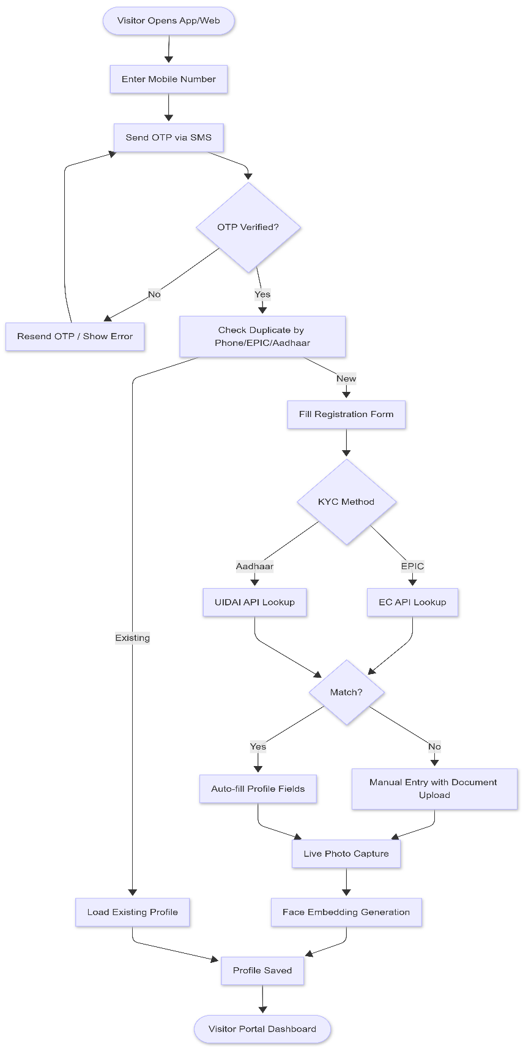

16.2 Appointment Submission Flow

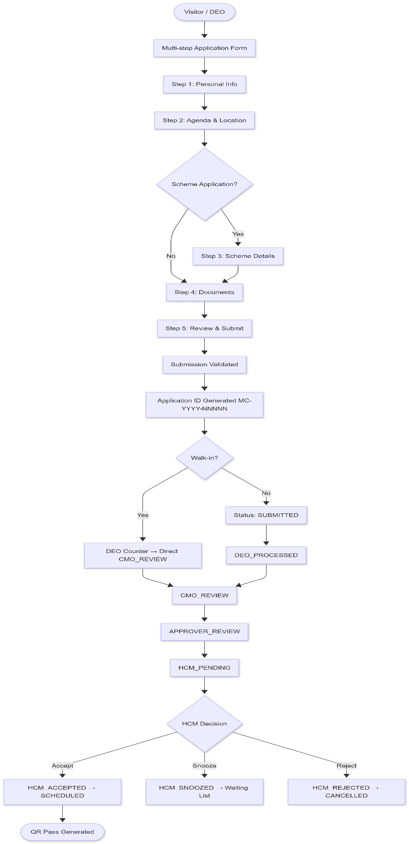

16.3 Scheme Application Workflow

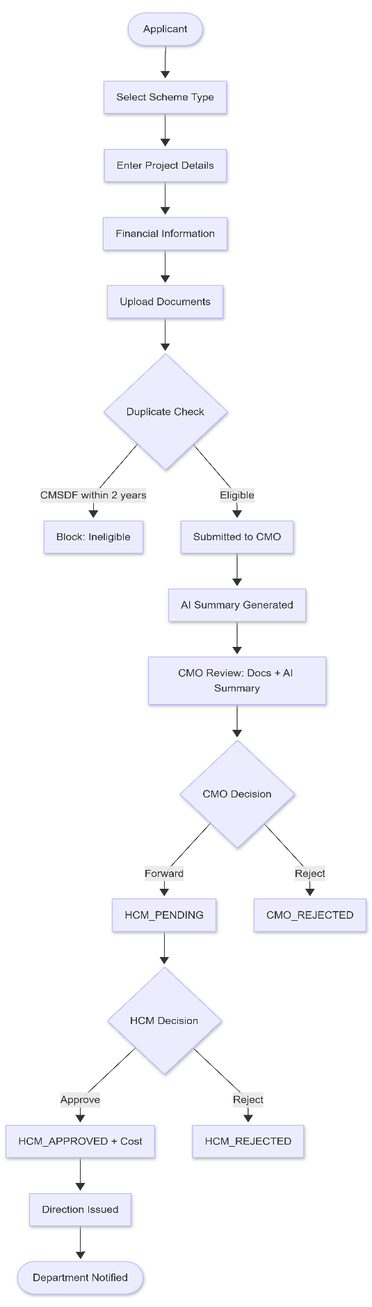

16.4 Approval Hierarchy Flow

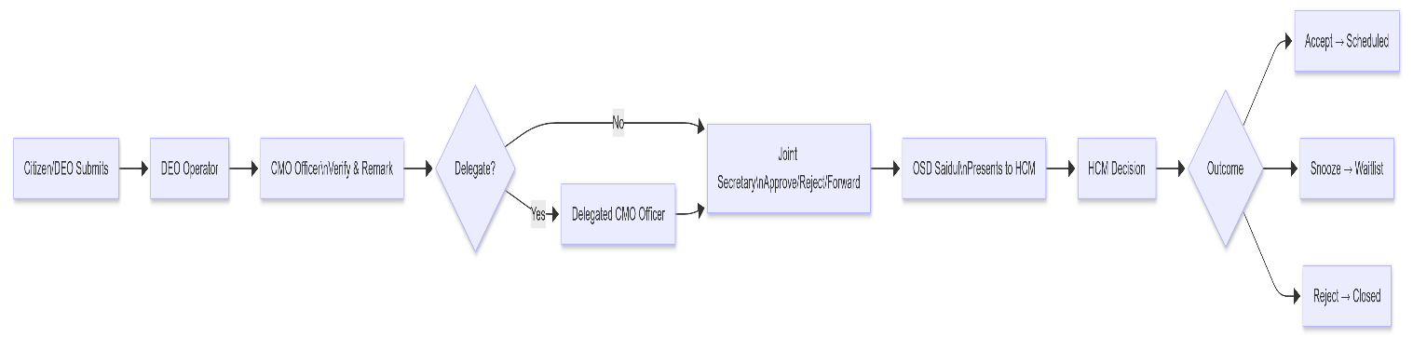

16.5 Scheduling Engine Flow

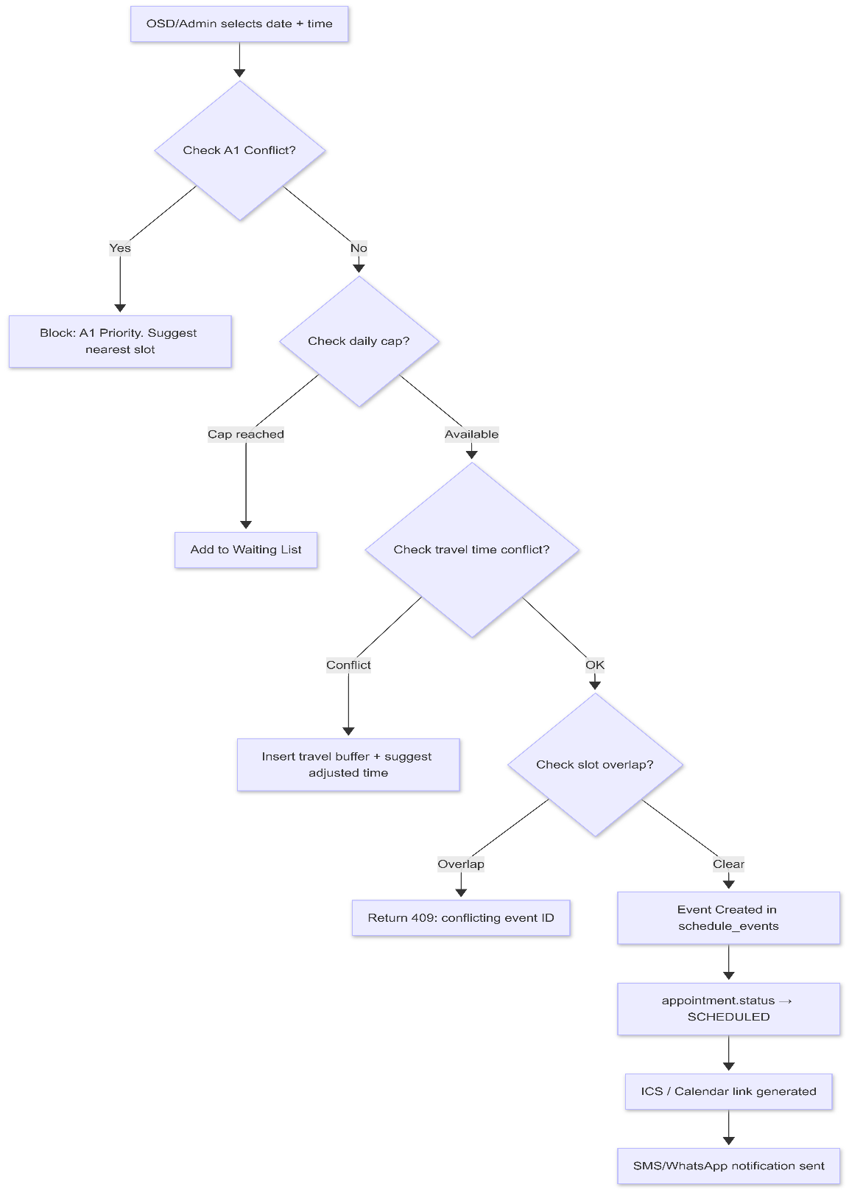

16.6 Direction Color-Coding Flow

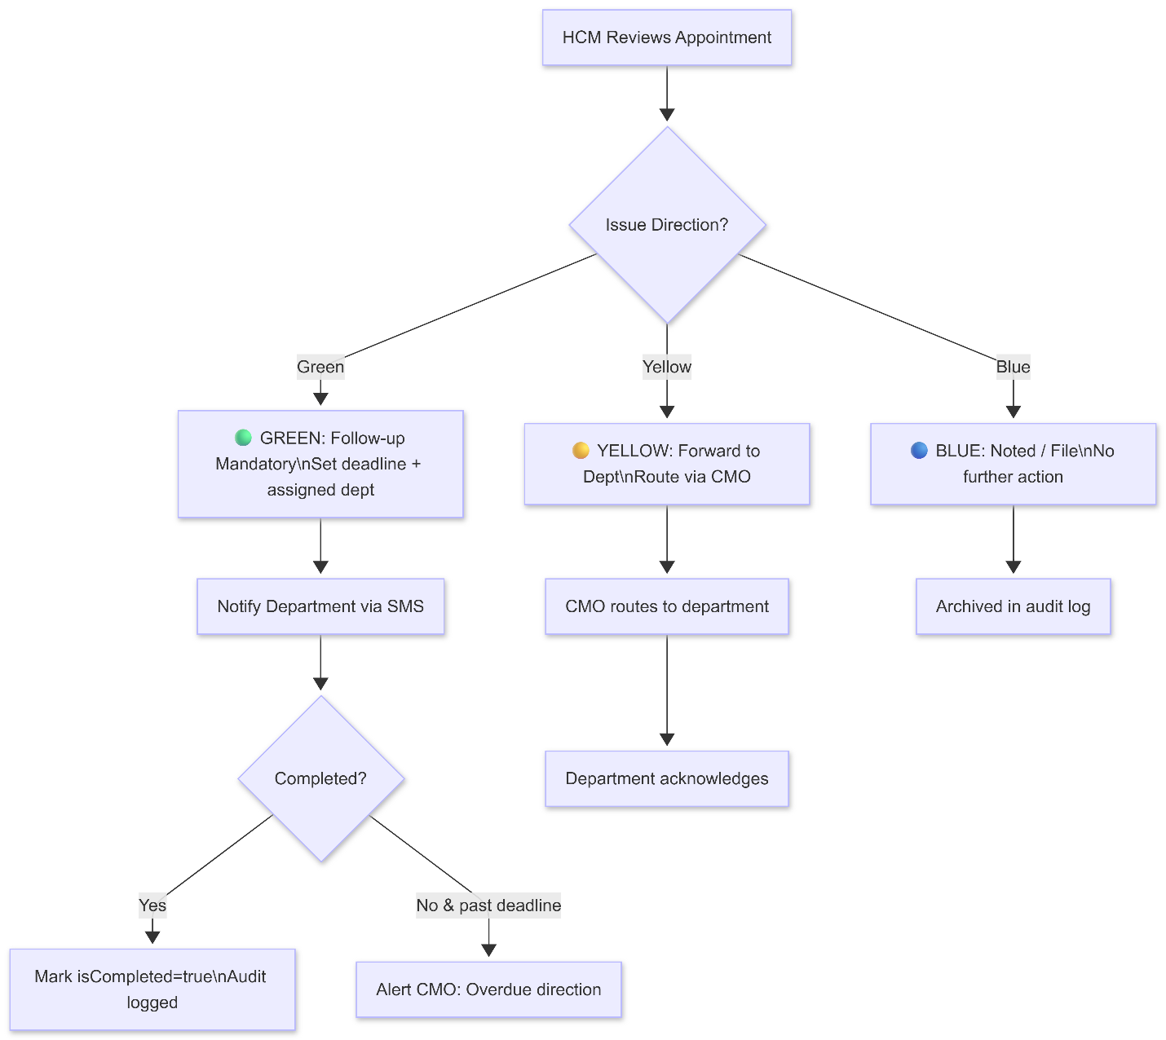

16.7 QR Pass + Face Verification Flow

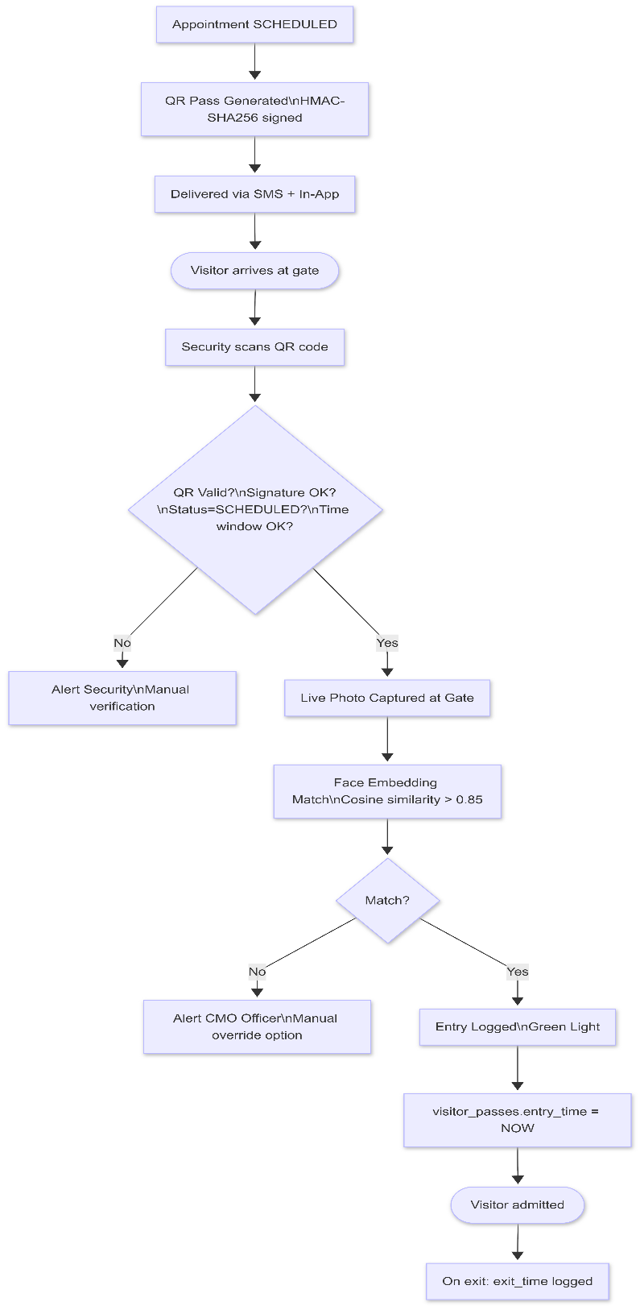

16.8 Grievance Management Flow

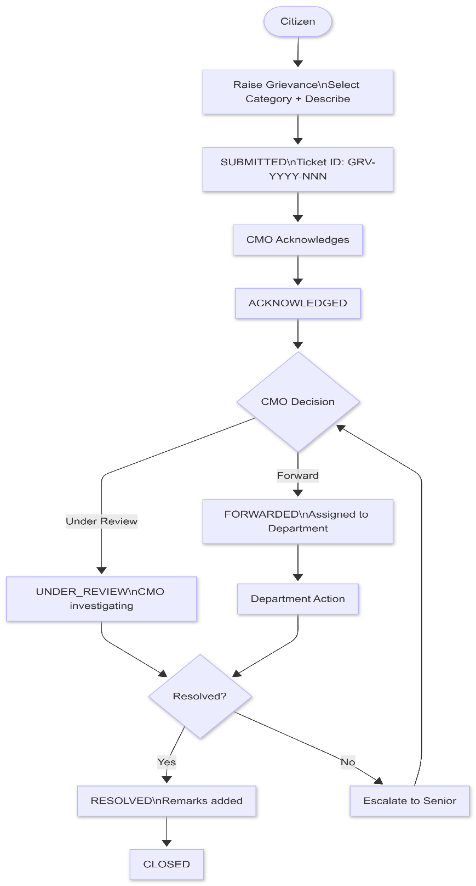

16.9 Heatmap Analytics Flow
flowchart TD
A[Nightly Batch Job] --> B[Query scheme_applications\nGROUP BY district, constituency, scheme_id]
B --> C[Compute: total_applied, total_approved, total_pending]
C --> D[Update constituency_heatmap_cache]
D --> E[Web Frontend requests heatmap]
E --> F[GET /api/heatmap?scheme=CMSDF&district=ALL]
F --> G[Return JSON: district → heat score]
G --> H[Leaflet.js renders choropleth]
H --> I[User applies filters\nScheme / Date / Status]
I --> J[Re-fetch filtered data]

16.10 Audit Trail Flow
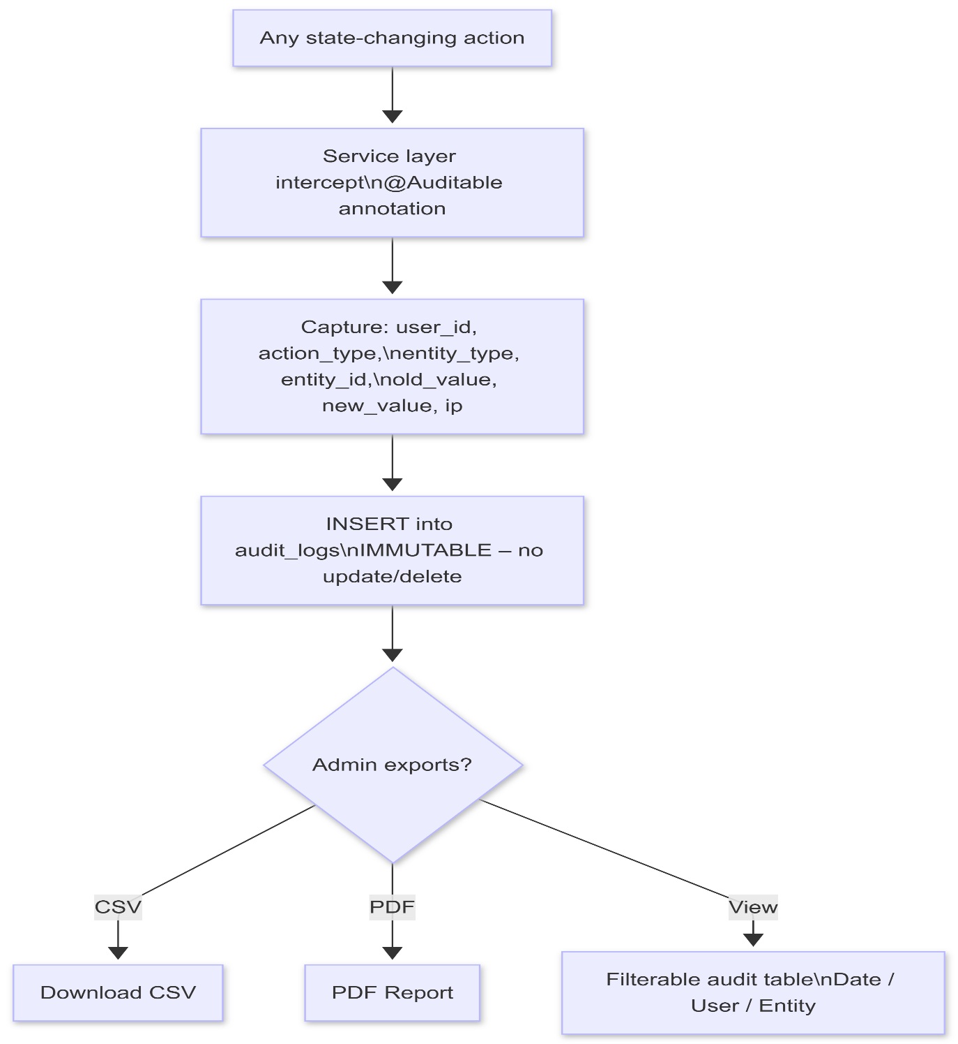

17. ER Diagram

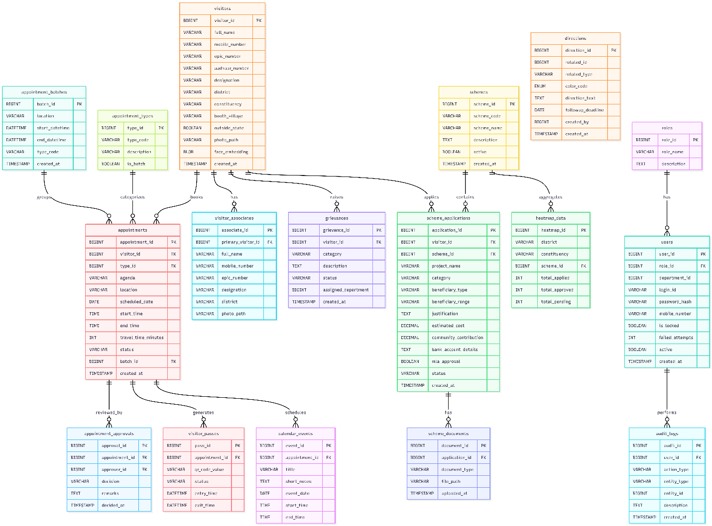

18. System Architecture Diagram
graph TB
subgraph CLIENT["Client Layer"]
WEB["Angular 17 Web App\nPrimeNG + PrimeFlex\nChrome / Edge"]
MOB["Flutter Mobile App\nMaterial 3\nAndroid / iOS"]
end
subgraph GATEWAY["API Gateway Layer"]
GW["NGINX Reverse Proxy\nRate Limiting\nSSL Termination"]
AUTH["JWT Auth Filter\nSpring Security"]
end
subgraph APP["Application Layer (Spring Boot 3)"]
APPTCTRL["Appointment\nController"]
SCHEMECTRL["Scheme\nController"]
GRIEV["Grievance\nController"]
SCHED["Scheduling\nController"]
ADMIN["Admin /\nUser Controller"]
VISREG["Visitor\nRegistration"]
AUDIT["Audit\nInterceptor"]
AI["AI Summary\nMicroservice\n(Async)"]
NOTIF["Notification\nService"]
QR["QR / Face\nVerification"]
end
subgraph DATA["Data Layer"]
PG["PostgreSQL 15\nPrimary DB\n(SDC Shillong)"]
PGR["PostgreSQL\nReplica (Read)"]
REDIS["Redis Cache\nSession / Rate limit"]
FILES["MinIO / NFS\nObject Store\nDocuments / Photos"]
end
subgraph EXTERNAL["External Services"]
SMS["SMS Gateway\n(NIC / Airtel)"]
WA["WhatsApp\nBusiness API"]
EC["Election Commission\nEPIC Verification API"]
UIDAI["UIDAI\nAadhaar API"]
GCAL["Google Calendar\nICS Export"]
end
WEB --> GW
MOB --> GW
GW --> AUTH
AUTH --> APPTCTRL
AUTH --> SCHEMECTRL
AUTH --> GRIEV
AUTH --> SCHED
AUTH --> ADMIN
AUTH --> VISREG
APPTCTRL --> AUDIT
SCHEMECTRL --> AI
VISREG --> EC
VISREG --> UIDAI
VISREG --> QR
SCHED --> GCAL
NOTIF --> SMS
NOTIF --> WA
APPTCTRL --> PG
SCHEMECTRL --> PG
GRIEV --> PG
SCHED --> PG
ADMIN --> PG
VISREG --> PG
AUDIT --> PG
AI --> FILES
QR --> FILES
VISREG --> FILES
PG --> PGR
AUTH --> REDIS

18.1 Component Responsibilities
Component | Responsibility
Angular Web | Staff-facing SPA; full CMO dashboard; scheduling calendar
Flutter Mobile | HCM + DEO mobile app; offline mode; face capture
NGINX | Reverse proxy; SSL (HTTPS 443); rate limiting (100 req/min)
Spring Boot API | REST endpoints; business logic; JWT validation
PostgreSQL | Primary RDBMS; all transactional data
Redis | JWT token blacklist; session cache; API rate-limit counter
MinIO / NFS | Document / photo file storage (not BLOBs in DB)
AI Microservice | Async OCR + LLM summarisation; independent scaling
Notification Service | SMS/WhatsApp/Push delivery; retry queue

