Supplementary Materials

1. Supplement 1: 4D PICTURE Collaborators
The scientific members of the 4D PICTURE consortium who are not authors on this manuscript. Names and affiliations are as follows:
Gaby Sroczynski$​^{1,2}$, Uwe Siebert$​^{1,2,3,4}$, Roberto Pazo-Cid$​^{5,6,7}$, Lára R. Hallsson$​^{1,2}$, Michel W. Wouters$​^{8}$, Iñaki Alvarez Busto$​^{5,6,7}$, Lennart Koch$​^{1,2}$, Mette Byg Josefsen$​^{9}$, Yassin Engelberts$​^{10}$, Yufeng Liu$​^{11}$, Claudia Cruz Oliveira$​^{10}$, Elfi M. Verheul$​^{10}$, Barbara Perić$​^{12}$, Anne Stiggelbout$​^{8}$, Ida Korfage$​^{10}$, Kasper Frank$​^{9}$, Tamara Wit$​^{8}$, Amara Callistus Nwosu$​^{13,14}$, Ellen Kapiteijn$​^{15}$, Frank Doornkamp$​^{16}$, Judith Rietjens$​^{10,17}$, Suzan Verberne$​^{18}$, Carlos Romero-Piqueras$​^{19}$
¹ Institute of Public Health, Medical Decision Making and Health Technology Assessment
² Department of Public Health, Health Services Research and Health Technology Assessment, UMIT TIROL – University for Health Sciences and Technology, Hall in Tirol, Austria
³ Center for Health Decision Science and Departments of Epidemiology and Health Policy & Management, Harvard T.H. Chan School of Public Health
⁴ Institute for Technology Assessment, Department of Radiology, Massachusetts General Hospital, Harvard Medical School, Boston, MA, USA
⁵ Department of Medical Oncology, Miguel Servet University Hospital, Facultad de Medicina. Universidad de Zaragoza, Instituto Investigación Sanitaria Aragón, Zaragoza, Spain
⁶ Medical Oncology, Instituto de Investigación Sanitaria de Aragón (IIS-A)
⁷ Hospital Universitario Miguel Servet, Zaragoza, Spain
⁸ Medical Decision Making, Department of Biomedical Data Sciences, Leiden University Medical Center, Leiden, the Netherlands
⁹ Center for Shared Decision Making Vejle/Lillebaelt University Hospital of Southern Denmark
¹⁰ Department of Public Health, Erasmus MC, University Medical Center Rotterdam, Rotterdam, the Netherlands
¹¹ Department of Linguistics and English Language, Lancaster University, Lancaster, United Kingdom
¹² Institute of Oncology Ljubljana, Medical faculty Ljubljana, University of Ljubljana, Ljubljana, Slovenia
¹³ International Observatory on End of Life Care, Lancaster University, Lancaster, United Kingdom
¹⁴ Marie Curie North West, Liverpool, United Kingdom
¹⁵ Department of Medical Oncology, Leiden University Medical Center, Leiden, the Netherlands
¹⁶ Medical Statistics, Department of Biomedical Data Sciences, Leiden University Medical Center, Leiden, the Netherlands
¹⁷ Department of Design, Organisation and Strategy, Faculty of Industrial Design Engineering, Delft University of Technology, Delft, the Netherlands
¹⁸ Leiden Institute of Advanced Computer Science, Leiden University, Leiden, the Netherlands
¹⁹ Fractal Strategy, Zaragoza, Spain

2. Supplement 2: Variance of the Cox model prediction
In the article, we assume the Cox model variance is estimated using the delta method. We use the derivation from the book by Andersen, Borgan, Gill and Keiding. Using this method, the variance of a Cox model prediction for the new patient is:
$$V_{Cox}\left({\hat{S}}_{new}\left(t\right)\right)=V(\hat{S}\left(t\left|x_{new})\right|β\right)+{\left.\frac{∂S}{∂β}\right|}_{β=\hat{β}}^{⊤}V\left(\hat{β}\right){\left.\frac{∂S}{∂β}\right|}_{β=\hat{β}}$$
where $V(\hat{S}\left(t\left|x_{\text{new}})\right|β\right)$ is the variance of the survival function for a patient with covariates $x_{new}$, ignoring uncertainty in $\hat{β}$. The second term of the sum concerns the variance due to coefficient estimation and how this variance impacts the survival function by looking at the gradient of the survival function. The first term of the variance is given by:
V(Stxnew)β=S2t|xnewexp2β⊤xnewj:tj≤t​dji∈Rj​expβ⊤xi2
which is the Aalen formula for the variance of the baseline survival function based on the risk-weighted number at risk, multiplied by the risk score of our new patient.
The uncertainty in ${\hat{S}}_{\text{new}}\left(t\right)$ caused by the estimation of the coefficients depends on the variance of the coefficients and the gradient of the survival function with respect to the coefficients. The variance of the estimated coefficients $V\left(\hat{β}\right)$ is asymptotically equal to the inverse Fisher information matrix $I{\left(\hat{β}\right)}^{−1}$. Finally, we can estimate the gradient of the survival function with respect to the coefficient by:
$${\left.\frac{∂\hat{S}\left(t|x_{\text{new}}\right)}{∂β}\right|}_{β=\hat{β}}=exp\left(β^{⊤}x_{\text{new}}\right)w$$
where $w=\left(w_{1},…,w_{p}\right)$ is a vector of partial derivatives, with $w_{q}$ the partial derivative of the survival function in the direction of $β_{q}$ for $q∈\{1,…,p\}$ with:
wq=j:tj≤t​1i∈Rj​expβ⊤xixq−xnew,q
where ${\overline{x}}_{q}$ is the risk-weighted mean of $x_{j,q}$’s (xq=i∈Rj​xi,qexpβ⊤xii∈Rj​expβ⊤xi), which are the $q$-th covariate for individuals $j$. Together, we have that the effective sample size for a Cox model prediction of a patient with covariate values $x_{\text{new}}$ at time $t$ is:
N*t,xnew=Snewt1−Snewtexp2β⊤xnewSnew2tj:tj≤t​dji∈Rj​expβ⊤xi2+w⊤Iβ−1w.

3. Supplement 3: Efficiency Breslow vs Nelson-Aalen
To understand why the effective sample size $N_{*}$ can exceed the development sample size $N$, we compare the variance of the hazard increments in a non-parametric setting versus the Cox proportional hazards setting.
In the absence of covariates, the Nelson-Aalen estimator for the cumulative hazard is Ht=tj≤t​djnj. The variance of a single hazard increment at event time $t_{j}$ is given by:
$$Var\left(Δ{\hat{H}}_{NA}\left(t_{j}\right)\right)=\frac{d_{j}}{n_{j}^{2}}$$
where $d_{j}$ is the number of events and $n_{j}$ is the number of individuals in the risk set $R_{j}$.
In the Cox model, the predicted hazard increment for a new patient with covariate profile $x_{new}$ is $Δ{\hat{H}}_{new}\left(t_{j}\right)=Δ{\hat{H}}_{0}\left(t_{j}\right)e^{{\hat{β}}^{⊤}x_{new}}$. Considering only the variance component stemming from the baseline hazard (treating $β$ as fixed), the variance is:
VarΔH0tjeβ⊤xnew∣β=eβ⊤xnew2dji∈Rj​eβ⊤xi2
The Cox model provides a more precise estimate (lower variance) than the Nelson-Aalen estimator at time $t_{j}$ when:
eβ⊤xnew2dji∈Rj​eβ⊤xi2<djnj2
Taking the square root and rearranging, this simplifies to:
eβ⊤xnew<i∈Rj​eβ⊤xinj
This inequality demonstrates that the Cox model yields a lower prediction variance whenever the new patient’s risk score $e^{β^{⊤}x_{new}}$ is lower than the arithmetic mean of the risk scores currently in the risk set $R_{j}$.
The informational efficiency of the Cox model stems from the proportional hazards assumption, which allows the model to utilize the entire longitudinal history of the cohort to estimate $β$. While the Nelson-Aalen estimator treats all individuals at risk as identical units, the Cox model utilizes their prognostic heterogeneity. For patients with a risk profile below the cohort average, this structural weighting reduces the stochastic noise of the baseline hazard estimation, leading to a variance lower than that of a standard binomial experiment and, consequently, an $N_{*}>N$.

4. Supplement 4: Distribution of predictors
The first predictor was the adhere variable, a dichotomous indicator for adherence of the tumor to nearby organs (positive in 135 of 929 patients). The second predictor was rx, a three-level categorical variable of the three treatment arms from the randomized clinical trial. The third predictor was age as a continuous variable. The mean age was 60 years with a standard deviation of 12 years. The age distribution was left-skewed. Finally, the fourth predictor, nodes, was a heavily right-skewed variable (median 4 nodes, range of 0 to 33).
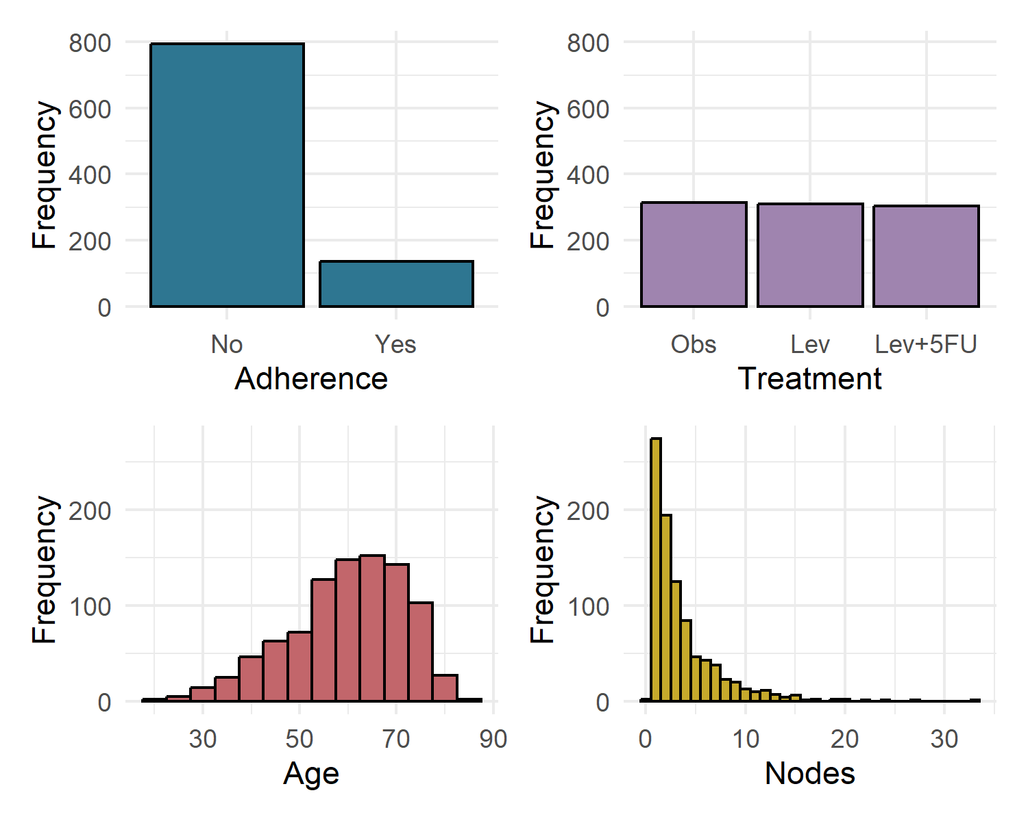
Distribution of 4 prognostic factors in the colon dataset.

5. Supplement 5: Cox model has narrower 95% CI than Kaplan-Meier
The effective sample size of a prediction from a univariate Cox model based only on treatment is higher than that of a Kaplan-Meier curve for the same treatment group, especially early on in follow-up. This suggests that the Cox model prediction is more certain about the prediction and this should reflect in a smaller 95% confidence interval. Indeed, when comparing the Cox model prediction for a patient receiving ‘Lev+5FU’ treatment from univariate Cox model based only on treatment to the Kaplan-Meier curve for this treatment group in Figure 1, we see that the 95% confidence interval of the Cox model prediction is narrower than that of the Kaplan-Meier curve, especially early on in follow-up. This is consistent with the higher effective sample size of the Cox model prediction compared to the Kaplan-Meier curve for this patient and treatment group.
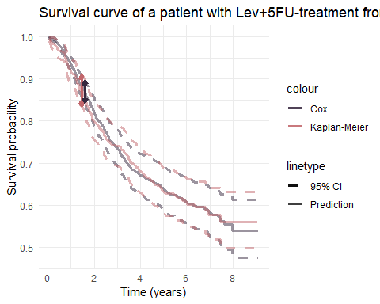
Figure 1: 95% Confidence Interval comparison.

6. Supplement 6: Effective sample size of mean patient is $N$ in linear regression
To support a claim made in the article, we quickly show in an example with the GUSTO data that a patient with the mean value of all predictors in the model has an effective sample size equal to the development sample size in a linear regression model. We fit a linear regression model for the day30 outcome based on age and height, two continuous predictors. We find that the effective sample size for a patient with mean age and mean height is 1214, equal to the development sample size of 1214 patients in this subset of the GUSTO data. We follow code from Thomassen 2024:
[1] "Development sample size: 1214"
[1] "Effective sample size of a patient with mean height and age: 1214"

7. Supplement 7: Effective sample size for linear regression is bounded by number of patients in same category, but not for logistic regression
Effective sample size in linear regression models based on one continuous and one categorical variable are bounded by the number of patients in the same category. Below is an example in the GUSTO data for a linear regression model for height based on age and sex. There are 317 women in this subset of the data. First, we find that for a female patient with the population mean age, her effective sample size is 300, lower than the number of women in the data. However, if we calculate the effective sample size for a woman with the mean age of women, then the effective sample size is 317, equal to the total number of women in the data.
[1] "Number of female patients: 317"
[1] "Effective sample size of a woman with population mean age from linear regression: 300"
[1] "Effective sample size of a woman with female mean age from linear regression: 317"
In logistic regression effective sample size can be higher then the total number of patients in your categorical subgroup, such as sex. To illustrate, we fit a logistic regression model for the day30 outcome based on age and sex, again based on 1214 patients, 317 of which are women. Below is the same model based on age and gender, but now using a glm with logit link function. In a logistic regression model, the effective sample size can be higher than the amount of women in the data. The effective sample size for the prediction for a woman with the population mean age (406) is higher than that for a woman with the mean age among women (345). This contrasts with the linear regression model where effective sample size was the highest for the woman with the mean age among women.
[1] "Number of women in data: 317"
[1] "Effective sample size of a woman with population mean age from logistic regression without interaction: 406"
[1] "Effective sample size of a woman with female mean age from logistic regression without interaction: 345"
Next we include an interaction term between age and sex to the logistic regression model. Effective sample size is much lower for both predictions, with the effective sample size for a women with the population mean age dropping from 406 to 194 and for a women with the female mean age dropping from 345 to 235. Note that the effective sample size for a woman with the mean age in her subgroup of women, is now higher than for a woman with the mean age in the overall development population.
[1] "Number of patients with your gender: 317"
[1] "Effective sample size of a woman with population mean age from logistic regression with interaction: 194"
[1] "Effective sample size of a woman with female mean age from logistic regression with interaction: 235"

8. Supplement 8: Multivariable Cox effective sample size at 5 years with separate baseline hazards for treatment
Similar to figure 3 in the main text, but now with the model stratified by treatment instead of estimating a hazard ratio for treatment effect. At this 5-year survival prediction there is very little difference between the stratified and the non-stratified model, with the stratified model having slightly lower effective sample sizes, but not by much.

9. Supplement 9: Heuristic explanation of higher than total sample size
The baseline hazard for the Cox model at time $t_{i}$ with $δ_{i}$ events is estimated as dji∈Rj​expβ⊤xi, where the denominator is the risk-weighted number at risk. This risk-weighted number at risk is the implicit sample size used for the baseline hazard estimation and based on $β$, which is estimated based on all events including those in the future.
Near $t=0$ in Figure 4, a single death in 10,000 patients leads to a risk-weighted number at risk in the data of $5,000⋅2+5,000⋅1=15,000$. At such early follow-up time, the hazard of a patient is expβ⊤xnewi∈Rj​expβ⊤xi, the product of their hazard ratio and the baseline hazard. For a woman, the risk of being this first death is $1/15,000$, giving us an effective sample size of 15,000, exactly what was found in the simulation. For a man, the risk of being this first death is $2/15,000=1/7,500$, again matching the effective sample size of 7,500 in the simulation.
We can investigate this heuristic explanation in the simulation example as well:
Our assumption/hypothesis is that the effective sample size at the beginning is this $\frac{HR_{new}}{Totalrisk}$ value. We cannot estimate variance before any events, so we analyse this hypothesis at the first event time. As we simulate with a HR of 2, we expect the total risk to be equal to $5000⋅1+5000⋅2=15000$, the effective sample size for a female patient with HR of 1 should have an effective sample size of 15,000 (the denominator) and a male patient with HR of 2 should have an effective sample size of 7,500 (the denominator divided by HR).
The Cox model imperfectly estimates the hazard ratio, estimating it as: 1.98197. The expected effective sample size for women after one event, with this new assumed HR becomes 14910 (rounded to integer), and 7523 for men. However, we find that our effective sample size is estimated as 14907 for women and 7523 for men. The discrepancy for women may be caused by the variance from coefficient estimation, event if that is very small at this early time. If we assume the coefficient is perfectly estimated and only consider the variance caused by baseline hazard estimation, we find effective sample sizes of 14910 for women. This matches our hypothesis exactly. For men, it appears the impact of the coefficient estimation is too small to be a factor in the effective sample size at this early time.

10. Supplement 10: Heuristic explaination of asymmetry / variance attributable to coefficient
The asymmetry in predictions for equally exceptional patients based on a continuous variable can be explained in the same way. We find that the contribution of the coefficient uncertainty to the total variance for women drops off substantially from $t=7.5$ (Figure 4D). At the time of the first event $t_{1}$, the gradient (Equation 5, 6) for women ($x_{w}$, equation 8) and men ($x_{m}$, equation 9) is:
∂St1|x1=1∂β=expβ⊤x1i∈R1​expβ⊤xii∈R1​xi,qexpβ⊤xii∈R1​expβ⊤xi−x1,q=1150001000015000−0=2450000 8
∂St1|x1=0∂β=expβ⊤x1i∈R1​expβ⊤xii∈R1​xi,qexpβ⊤xii∈R1​expβ⊤xi−x1,q=2150001000015000−1=−2450000 9
and because we multiply them (equation 3), sign cancels out. Therefore, the uncertainty from coefficient estimation is the same for both men and women since the variance of the coefficient is constant. Compare this to the gradient when there are twice as many women as men remaining in the risk set $\left(S_{women}\left(t_{*}\right)=2S_{men}\left(t_{*}\right)\right)$. At time $t_{*}$, the gradient changes $\left(\frac{∂\hat{S}\left(t_{*}|x_{new}\right)}{∂β}−\frac{∂\hat{S}\left(t_{*−1}|x_{new}\right)}{∂β}\right)$ by $\frac{1}{10000}$ for women and $\frac{−2}{10000}$ for men. With twice as many women alive as men, the distance from men to the population mean is now twice as high as for women and the gradient for men also changes at twice the rate as that for women.
We need to investigate this at a time where we have quite a lot of knowledge of the ratio of the two groups in the data. At some point in time, the ratio between the two survival probabilities will be exactly 2. We will evaluate at this time $t$. We can find this by calculating:
$$\frac{S\left(t|Woman\right)}{S\left(t|Man\right)}=2$$
$$log\left(S\left(t|Woman\right)\right)−log\left(S\left(t|Man\right)\right)=log\left(2\right)$$
$$−H\left(t|Woman\right)+H\left(t|Man\right)=log\left(2\right)$$
$$−10t+HR⋅10t=log\left(2\right)$$
$$t=\frac{10}{\left(HR−1\right)}log\left(2\right)$$
[1] "With our HR of 1.98197, this time becomes: 7.0587 time units."
First, we look at the first event time and assume no one left the risk set. At the time of the first event, we assume that the number at risk in both groups is still $5000$. This means that $w_{men}$ is: $w_{men}=\frac{1}{5000+2⋅5000}\left\{\frac{2⋅5000}{5000+2⋅5000}−1\right\}=−\frac{1}{45000}$ and $w_{women}=\frac{2}{5000+2⋅5000}\left\{\frac{2⋅5000}{5000+2⋅5000}−0\right\}=\frac{2}{45000}$.
The gradient is $exp\left(β^{⊤}X_{new}\right)w$, which is $−\frac{2}{45000}$ for men and $\frac{2}{45000}$ for women. This is as expected, since men and women are both equally distant from the population mean in the risk set. Then the coefficient variance is (for one variable) the squared gradient times the variance of the coefficient, the last of which is constant.
At $t=6.913$, we can calculate the increment of the gradient by hand, which should be $2⋅w_{men}=2⋅\frac{1}{2500+2⋅1250}\left\{\frac{2⋅1250}{2500+2⋅1250}−1\right\}=−2⋅\frac{1}{10000}$ for men and $w_{women}=\frac{1}{2500+2⋅1250}\left\{\frac{2⋅1250}{2500+2⋅1250}−0\right\}=\frac{1}{10000}$ for women. We see that the increment of the gradient is now twice as high for men.

11. Supplement 11: Logistic regression has higher variance than Cox regression
We can show that the variance of a logistic regression prediction is higher than that of a Cox regression prediction for the same patient in a simulation with no censoring. We simulate data on 10,000 patients with a time-to-event outcome based on a single continuous predictor $X∼N\left(0,1\right)$ with a hazard ratio of 2 and an exponential baseline hazard with scale 10. We fit a Cox and make survival predictions at time $t$ and fit a logistic regression model on the outcome at time $t$ and predict at time $t$. We make these predictions with the Cox at time $t=0.01$ and $t=2$ and fit logistic regression models on the observed outcomes at these times.
The prediction at $t=0.01$ for both models is nearly identical (0.00003% difference), with any difference being explained by finite sample behaviour, rather than bias. The variance of the Cox model prediction is only 66% of the logistic regression model variance. This also results in a much larger effective sample size for the Cox model prediction compared to the LR: 12684 vs 8722. The width of the confidence interval from the Cox model is only 75.7% that of the logistic regression model. When comparing it to the Cox model fit on the data restricted to $t=0.01$, we see that the variance of the Cox model prediction is only over 99% of the logistic regression model variance, showing that most of the increased efficiency of the Cox model comes from the estimation of the coefficients based on data throughout the follow-up. Effective sample size is also the same for the restricted Cox model compared to logistic regression.
At $t=2$ the predictions are again nearly identical (0.006% difference). The variance of the Cox model prediction is much lower, at 79% of the logistic regression variance. This is also reflected in the effective sample size, as the Cox model still has higher effective sample size at 10561 compared to 8489 for the LR model. The width of the confidence interval from the Cox model is only 88.7% that of the logistic regression model. When restricting the Cox model to data up to $t=2$, we see that the variance of the Cox model prediction is 97% of the logistic regression model variance. The effective sample size of the Cox model prediction has now similarly increased to 200 above the logistic regression model estimate. This indicates the increased efficiency over a logistic regression model due to knowing the survival times in addition to the status at time $t=2$.

12. Supplement 12: Average hazard ratio in the data is above 1
The explanations in section 4 are based on simulations where all hazard ratios are above 1, resulting in a risk-weighted number at risk that is higher than the development sample size. One could suggest changing the reference category and reduce the risk-weighted number at risk. If men were the reference category and women the alternative with a hazard ratio of $0.5$, then the risk-weighted number at risk would be 7,500. The risk for men would be 1/7,500 and the risk for women $\frac{0.5}{7500}=\frac{1}{15000}$, providing the same heuristic effective sample size as before.
After normalizing variables by centering and rescaling, the mean hazard ratio in the development data will be above 1. For a $N\left(0,1\right)$ variable with a HR of 2, the mean linear predictor in the data is 0, but the mean HR is not equal to 1, since $E\left[\text{exp}\left(Xβ\right)\right]≠\text{exp}\left(E\left[Xβ\right]\right))$. As an example, for $X∼N\left(0,1\right)$ and a HR of 2, $E\left[\text{exp}\left(X \text{ln}2\right)\right]=\text{exp}\left(\frac{\text{ln}2^{2}}{2}\right)≈1.2715$. This transformation increases the risk-weighted number at risk to naturally be larger than the development population, which contributes to the larger effective sample sizes of Cox model predictions for patients with the population mean risk.
We can investigate this in practice:
[1] -0.0007861614
[1] 1.270255
So we observe that the mean linear predictor (X) is 0 (ignoring some monte-carlo standard error), while the mean hazard ratio is 1.27.
[1] 2.953193e-20
[1] 1.25
Similarly, we can consider a case where we have one categorical covariate with two categories. This is usually presented as a 0-1 scenario with a beta that only counts for the 1 category. This can be represented by a +1/-1 scenario with a beta that is half as high as well. In this situation, the mean linear predictor in the population is again 0, but the mean hazard ratio is again above 1.
A more complicated example can be illustrated in the colon data, if we rescale all variables first.
[1] -1.512609e-16
[1] 1.104616
Again in such an example we see that the mean linear predictor in the Cox model based on age, nodes, adhere and treatment is 0 (with some small finite-sample error), while the mean hazard ratio in the population is 1.10. For a patient with the mean covariate values, this would already imply that their effective sample size would be above the total sample size of 911 patients. And indeed, the effective sample size for a patient with a 0 for all covariate values is 1008 at the first event time, which is close to the expected 911*1.1046 = 1006. The small difference can be explained by differences in population means due to the 18 patients with missing values in any of the variables.

13. Supplement 13: Cox model predictions confidence intervals have good coverage
We suggest a Cox model based on two variables, one binary and one continuous and investigate the coverage for a few patients with different covariate values. Our variables are $X_{1}$ binary assigned with a Bernoulli($0.5$) distribution and $X_{2}$ continuous assigned with a $N\left(0,1\right)$ distribution. We assume a HR of 2 for both variables and a constant baseline hazard of 1. Each iteration is with $N=1000$. To estimate the coverage, we use $1999$ replications.
We see that coverage is good at 95% across all time points just after the start, even though effective sample size is higher than the development sample size throughout. Only at the very beginning is there under coverage, but this is because the first event has not taken place in all of the simulation runs and before the first event there is always under coverage.
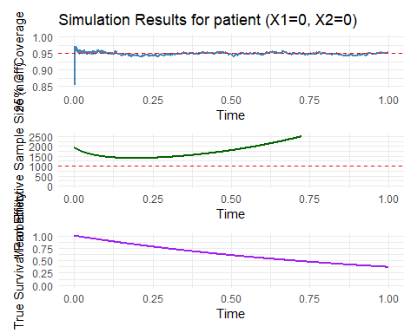
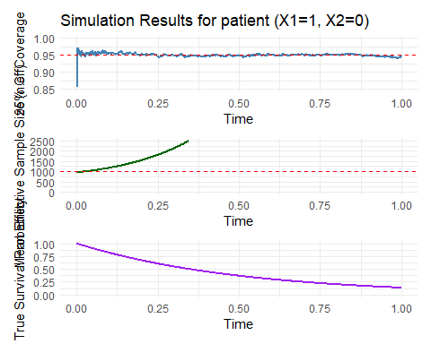
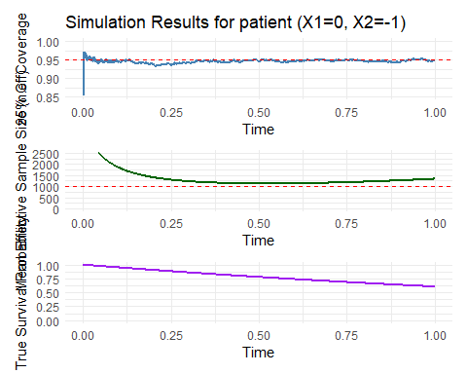

14. Supplement 14: Model-based standard errors are equal to Monte Carlo standard errors
Additionally, we check the model-based standard errors against the empirical standard errors for the same simulation as in the previous section (Supplement 11). We find that they are extremely close, which indicates that the model-based standard errors are accurate and that the effective sample size calculations based on these standard errors are also accurate. There are indications of a slight overestimation of the standard error early on in follow-up, which could be responsible for any slight overcoverage early on in follow-up.
