Week 3 Task: Advanced Data Analysis and Visualization in Logistics
Python-based exploratory analysis of a hypothetical logistics dataset

1. Objective
This project demonstrates how Python can be used to explore logistics operations, compare transport modes, study cost drivers, and communicate findings through visualizations. The dataset is simulated for learning purposes and does not represent a real company or actual shipments.

2. Dataset and Methodology
The dataset contains 120 simulated shipments and nine fields: shipment ID, region, transport mode, distance in kilometres, shipment volume, priority, delivery time in days, transport cost in Indian rupees, and an on-time indicator. Transport modes include Road, Rail, Air, and Sea. The data was generated with a fixed random seed so that the results can be reproduced. The analysis used pandas for data manipulation, NumPy for calculations, and Matplotlib for charts.
The workflow included checking dataset dimensions and variable types, calculating descriptive statistics (mean, median, standard deviation, minimum, and maximum), grouping results by transport mode and region, and calculating Pearson correlations among distance, shipment volume, delivery time, and cost. Five charts were created: a delivery-time histogram, a mode comparison, a distance-cost scatter plot, a regional cost comparison, and a correlation matrix.

3. Exploratory Data Analysis
Metric | Mean | Median | Std. dev. | Minimum | Maximum
Distance (km) | 919.74 | 929.0 | 538.48 | 89.0 | 1796.0
Volume (units) | 130.02 | 132.0 | 73.62 | 6.0 | 248.0
Delivery time (days) | 3.48 | 3.42 | 2.01 | 0.5 | 9.08
Transport cost (INR) | 2441.25 | 2163.32 | 1458.95 | 204.33 | 7879.15
The average delivery time is 3.48 days, while the median is 3.42 days. The average transport cost is ₹2,441.25. Average shipment distance is 920 km. The difference between mean and median can indicate skewness; the histogram helps reveal whether a small number of longer deliveries form a tail.

4. Visualizations and Interpretation

Figure 1. Delivery-time distribution
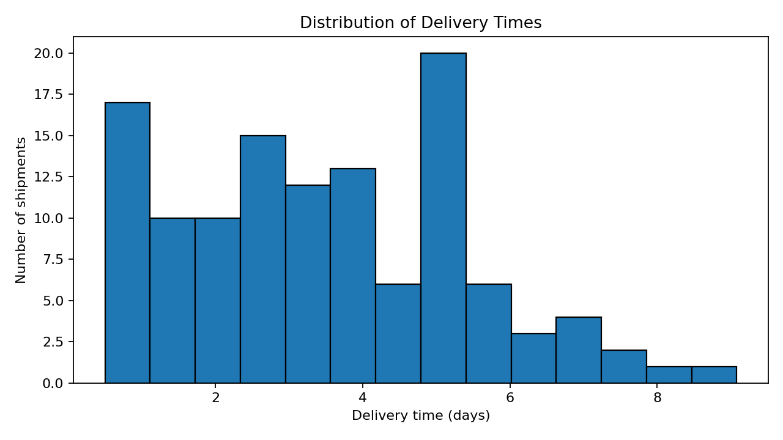
The histogram shows how frequently delivery times fall into different ranges. It helps identify the typical delivery window and whether unusually long deliveries occur.

Figure 2. Average delivery time by transport mode
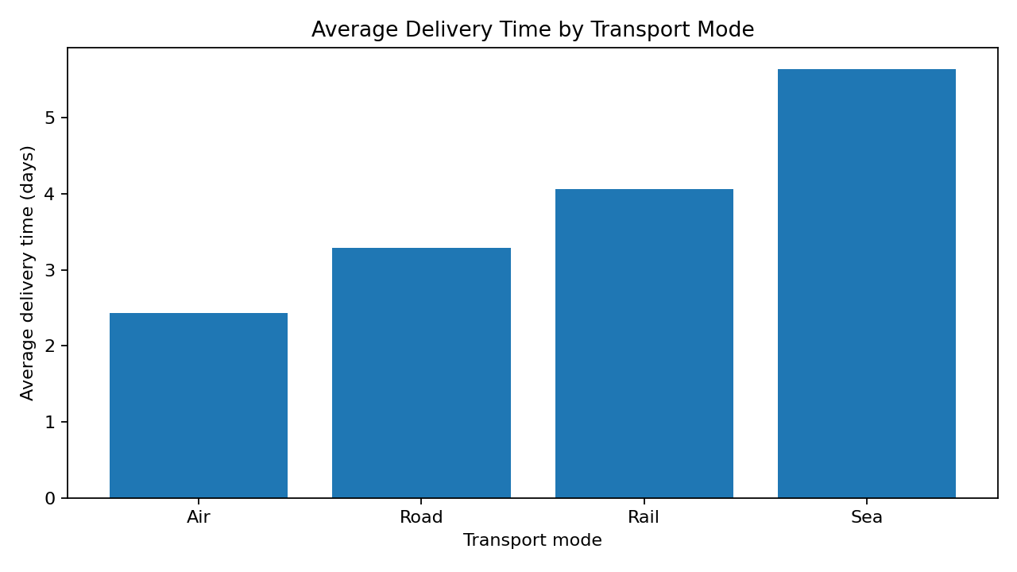
This chart compares mean delivery duration across modes. In this simulated dataset, air transport is generally fastest, while sea transport tends to take longer. Mode comparisons should also consider cost, capacity, and route availability.

Figure 3. Distance versus transport cost
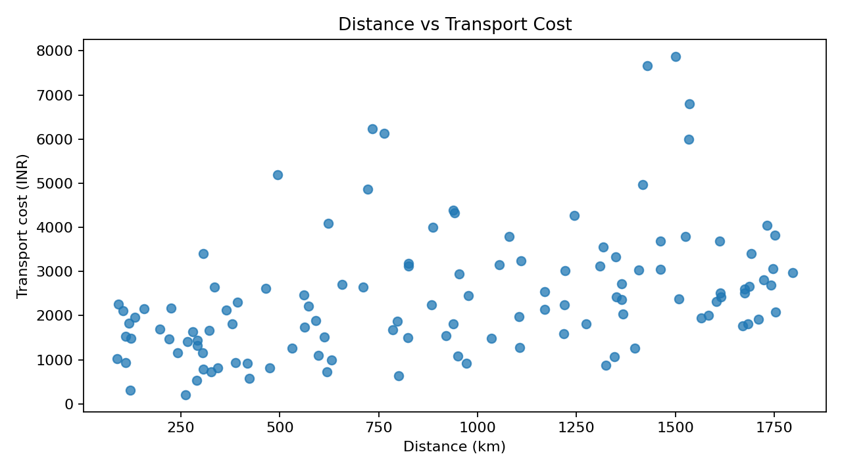
The scatter plot explores whether longer routes are associated with higher costs. An upward pattern is expected because distance contributes to the simulated cost formula. The spread around the pattern reflects mode, volume, priority, and random variation.

Figure 4. Average transport cost by region
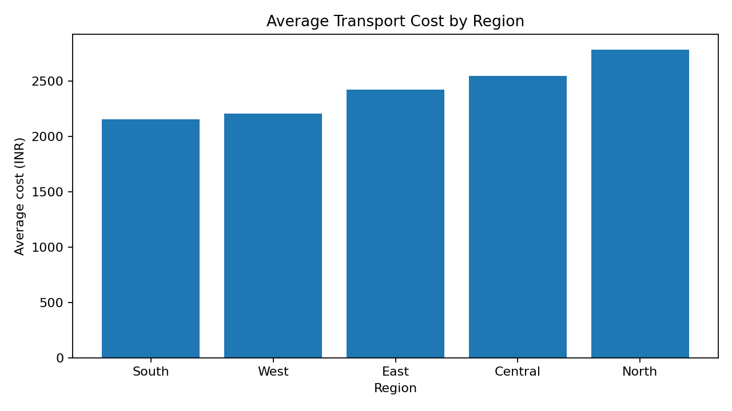
The regional bar chart highlights differences in average shipment spending. Differences should be interpreted cautiously because each region may have a different mix of distances, volumes, priorities, and transport modes.

Figure 5. Correlation matrix
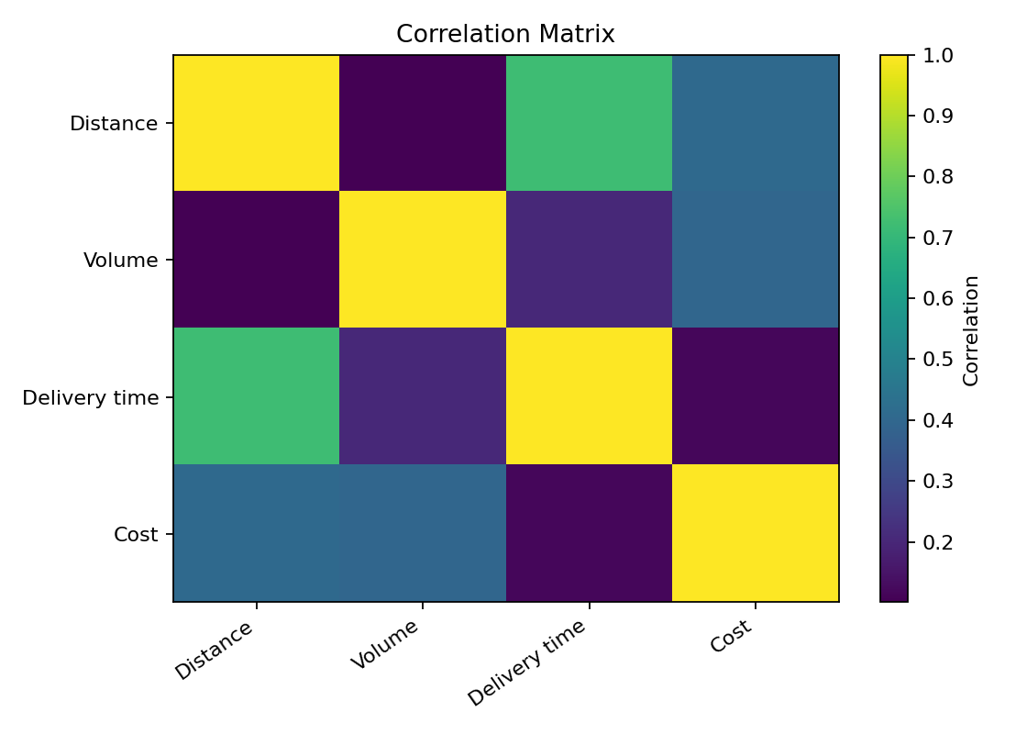
The matrix summarizes linear relationships between numeric variables. A positive distance-cost correlation would support the view that distance is a cost driver; correlation does not prove causation and can be influenced by transport-mode differences.

5. Key Results
By average delivery time, Air is the fastest mode in the simulated data (2.43 days), while Sea is the slowest (5.64 days). Sea has the lowest average cost per shipment (₹1,112.09), and Air has the highest (₹4,491.20). The Pearson correlation between distance and cost is 0.41; between distance and delivery time it is 0.72. These values describe this simulated sample only and should not be generalized to real logistics networks.
The on-time share in the simulated dataset is 86.7%. This metric can be monitored alongside cost and average delivery time because a low-cost option may not meet service expectations.

6. Recommendations
- Use a balanced scorecard for mode selection: compare cost, delivery speed, on-time performance, and shipment volume rather than optimizing one metric alone.
- Investigate shipments with the longest delivery times to check whether distance, mode, region, or priority explains the delay.
- Review high-cost shipments and compare them with shipments of similar distance and volume before concluding that a region or mode is inefficient.
- Track delivery-time percentiles (for example, the 90th percentile) in addition to the mean, since customers are often affected by late outliers.
- Replace simulated data with validated operational records before making business decisions, and document data-quality issues and assumptions.

7. Limitations
All observations are hypothetical and were generated for demonstration. Cost and delivery time were created from simplified assumptions, so the relationships are partly built into the data. The dataset does not include fuel prices, weather, traffic, warehouse handling, customs, carrier contracts, failed deliveries, or actual service-level agreements. The on-time flag is also based on a simplified rule. Therefore, the analysis demonstrates a repeatable workflow rather than evidence about a real logistics company.

8. Conclusion
The project shows how exploratory data analysis and visualization can convert shipment-level records into operational questions. Descriptive statistics summarize typical performance and variability; grouped comparisons reveal differences between modes and regions; and scatter plots and correlations help investigate potential cost drivers. These methods can support better planning when paired with reliable real-world data, clear service targets, and contextual knowledge. The accompanying Python script reproduces the analysis.

Appendix A. How to Run the Code
Keep logistics_analysis.py and logistics_dataset.csv in the same folder. Install the required packages with: pip install pandas numpy matplotlib. Run the script with: python logistics_analysis.py. The script prints summary tables and saves the chart images in the working folder. If using Google Colab, upload both files and run the code in a Python notebook.

Appendix B. Files Included
1. logistics_dataset.csv — simulated shipment data. 2. logistics_analysis.py — reusable analysis and visualization code. 3. This report — findings, figures, interpretation, recommendations, and limitations.

