IOT (Internet Of Things)
name: SUJAL YADAV
ROLL NO : 2524508
-R.k.talreja college
2026
Established – 1961 Subject: ___________
SEVA SADAN’S
















OF
ARTS, SCIENCE & COMMERCE ULHASNAGAR – 421 003


CERTIFICATE

This is to certify that Mr./Ms. ________________________________
of S.Y. Computer Science (SYCS) Roll No. _____________________________ has satisfactorily completed The Internet Of Thing Mini Project entitled_________________ ___________________________________________________________
during the academic year 2025 – 2026, as a part of the practical requirement. The project work is found to be satisfactory and is approved for submission.

PROF. INCHARGE HEAD OF DEPT

________________ _________________

SR.NO | CHAPTER | PG.
1 | INTRODUCTION | 1.
2 | REQUIREMENT SPECIFICATION | 2.
3 | SYSTEM DESIGN | 3-4
4 | IMPLEMENTATION | 5-8
5 | SYSTEM TESTING | 9-10
6 | FUTURE SCOPE & CONCLUSION | 11.
7 | REFRENCES | 11.
8 | GLOSSARY | 12.

1. Introduction
Water quality monitoring is important to ensure safe and clean water for domestic, agricultural, and industrial use. Increasing water pollution has made continuous monitoring necessary to maintain health and environmental standards.
Traditional water testing methods require manual sample collection and laboratory analysis, which are time-consuming and do not provide real-time results. Therefore, an automated monitoring system is needed for efficient and instant analysis.
This project presents an IoT-based water quality monitoring system using the ESP32 microcontroller and a Total Dissolved Solids (TDS) sensor. The TDS sensor measures the concentration of dissolved impurities in water, which indicates its quality level.
The ESP32 processes the sensor data and transmits it to the cloud platform ThingSpeak for real-time visualization and storage. Users can monitor water quality remotely from anywhere using an internet connection.
This system provides a cost-effective, reliable, and real-time solution for monitoring water quality and supports smart environmental management.

1

2. Requirement Specification
1. Hardware Requirements
  - ESP32 Development Board
  - TDS (Total Dissolved Solids) Sensor Module
  - Connecting Wires (Jumper wires)
  - Breadboard (for prototyping{optional})
  - Internet connectivity (Wi-Fi network)

2. Software Requirements
  - Arduino IDE (Version 1.8.19 recommended)
  - ESP32 Board Package installed in Arduino IDE
  - Required Libraries (WiFi, ThingSpeak Library)
  - ThingSpeak Cloud Account – ThingSpeak
  - Operating System: Windows/Linux/macOS

3. Functional Requirements
  - The system must measure TDS values from the water sample.
  - The ESP32 must process analog data from the TDS sensor.
  - The system must connect to a Wi-Fi network.
  - The measured TDS data must be uploaded to the ThingSpeak cloud platform.
  - The system should display real-time data on the cloud dashboard.

4. Non-Functional Requirements
  - The system should provide accurate and stable readings.
  - Data transmission should be reliable and secure.
  - The system should operate continuously with minimal maintenance.
  - The solution should be low-cost and energy-efficient.

3. System Design

3.1 Block Diagram
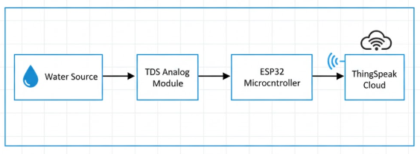

3.2 Circuit Design

1. TDS Sensor Connections
The TDS sensor module generally has three main pins:
VCC – Power supply
GND – Ground
AOUT – Analog output

2. Connections to ESP32:
TDS VCC → 3.3V (or 5V as per module specification) of ESP32
TDS GND → GND of ESP32
TDS AOUT → GPIO 34 (Analog Pin) of ESP32
- 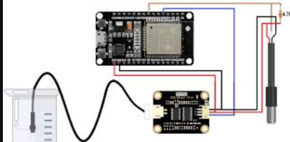

3.3 Working Principle
The working principle of the IoT-based Water Quality Monitoring System is based on measuring the electrical conductivity of water to determine its Total Dissolved Solids (TDS) concentration. Dissolved salts and minerals present in water increase its electrical conductivity. The higher the concentration of dissolved substances, the higher the conductivity and TDS value.
When the TDS sensor probe is immersed in water, it passes a small electrical current through the solution. Based on the conductivity of the water, the sensor produces a corresponding analog voltage signal. This voltage is proportional to the amount of dissolved solids present in the water.
The analog output from the TDS sensor is fed into the ESP32 microcontroller. The built-in Analog-to-Digital Converter (ADC) of the ESP32 converts the analog signal into a digital value. The microcontroller then applies a mathematical formula to convert this value into TDS concentration, usually expressed in parts per million (ppm).
After calculating the TDS value, the ESP32 displays the reading on the Serial Monitor for local observation. It also transmits the processed data to the cloud platform ThingSpeak using Wi-Fi connectivity.
Thus, the system continuously senses, processes, and transmits water quality data, enabling real-time monitoring and remote access through the cloud.

4. Implementation
The ESP32 reads TDS values, compares them with safe limits, and decides whether water is safe or unsafe, then shows the result on serial monitor & Thinkspeak cloud platform

CODE :
#include <WiFi.h>
#include "ThingSpeak.h"

// ---------- TDS SETTINGS ----------
#define TDS_PIN 34
#define VREF 3.3
#define ADC_RESOLUTION 4095.0
#define SAMPLE_COUNT 30

float temperature = 25.0; // assumed room temperature
float calibrationFactor = 1.00; // change after calibration

int analogBuffer[SAMPLE_COUNT];
int indexBuffer = 0;

unsigned long lastUpload = 0;

// ---------- WIFI SETTINGS ----------
const char* ssid = "YOUR_WIFI_NAME";
const char* password = "YOUR_WIFI_PASSWORD";

// ---------- THINGSPEAK SETTINGS ----------
unsigned long channelID = YOUR_CHANNEL_ID;
const char* apiKey = "YOUR_WRITE_API_KEY";

WiFiClient client;

void setup() {
Serial.begin(115200);
delay(2000);
Serial.println("ESP32 Water Quality Monitoring Started");

// Connect WiFi
Serial.print("Connecting to WiFi");
WiFi.begin(ssid, password);

int tries = 0;
while (WiFi.status() != WL_CONNECTED && tries < 20) {
delay(500);
Serial.print(".");
tries++;
}

if (WiFi.status() == WL_CONNECTED) {
Serial.println("\nWiFi Connected!");
Serial.print("IP Address: ");
Serial.println(WiFi.localIP());
} else {
Serial.println("\nWiFi Failed!");
}

ThingSpeak.begin(client);
}

void loop() {

// Continuous sampling
analogBuffer[indexBuffer] = analogRead(TDS_PIN);
indexBuffer++;
if (indexBuffer >= SAMPLE_COUNT) indexBuffer = 0;

// Upload every 15 seconds (ThingSpeak limit)
if (millis() - lastUpload > 15000) {

lastUpload = millis();

// Average ADC
int sum = 0;
for (int i = 0; i < SAMPLE_COUNT; i++) {
sum += analogBuffer[i];
}

float averageADC = sum / (float)SAMPLE_COUNT;

// Convert to voltage
float voltage = averageADC * VREF / ADC_RESOLUTION;

// Temperature compensation
float compensationCoefficient = 1.0 + 0.02 * (temperature - 25.0);
float compensationVoltage = voltage / compensationCoefficient;

// TDS formula
float tdsValue = (133.42 * compensationVoltage * compensationVoltage * compensationVoltage
- 255.86 * compensationVoltage * compensationVoltage
+ 857.39 * compensationVoltage) * 0.5;

// Apply calibration
tdsValue = tdsValue * calibrationFactor;

if (tdsValue < 0) tdsValue = 0;

// Print serial output
Serial.print("Voltage: ");
Serial.print(compensationVoltage, 3);
Serial.print(" V | TDS: ");
Serial.print(tdsValue, 0);
Serial.println(" ppm");

// Send to ThingSpeak
if (WiFi.status() == WL_CONNECTED) {
ThingSpeak.writeField(channelID, 1, tdsValue, apiKey);
Serial.println("Data sent to ThingSpeak ✔");
} else {
Serial.println("WiFi not connected ❌");
}

Serial.println("--------------------------------");
}
}

5. System Testing and Result

5.1 Testing Procedure
- Probe Immersion:
TDS probe dipped into water sample to measure dissolved solids.
- Signal Detection:
Sensor generated analog voltage based on water conductivity.
- Data Processing:
ESP32 read analog signal and converted it into TDS value (ppm).
- Serial Verification:
TDS readings displayed on Serial Monitor for local checking.
- Wi-Fi Connection:
ESP32 connected to Wi-Fi network successfully.
- Cloud Upload:
TDS data sent to ThingSpeak using API key.
- Cloud Monitoring:
Real-time TDS values verified on ThingSpeak dashboard.

5.2 TDS Measurement and Water Quality Table

TDS Range (ppm) | Water Quality Level | Description
0 – 50 ppm | Very Low | Very pure water, minimal dissolved solids
50 – 150 ppm | Excellent | Ideal for drinking, very good quality
150 – 300 ppm | Good | Acceptable for drinking purposes
300 – 500 ppm | Fair | Moderate quality, slightly high dissolved solids
500 – 1000 ppm | Poor | Not recommended for drinking without treatment
Above 1000 ppm | Unacceptable | High contamination, unsafe for drinking

5.3 Testing Image
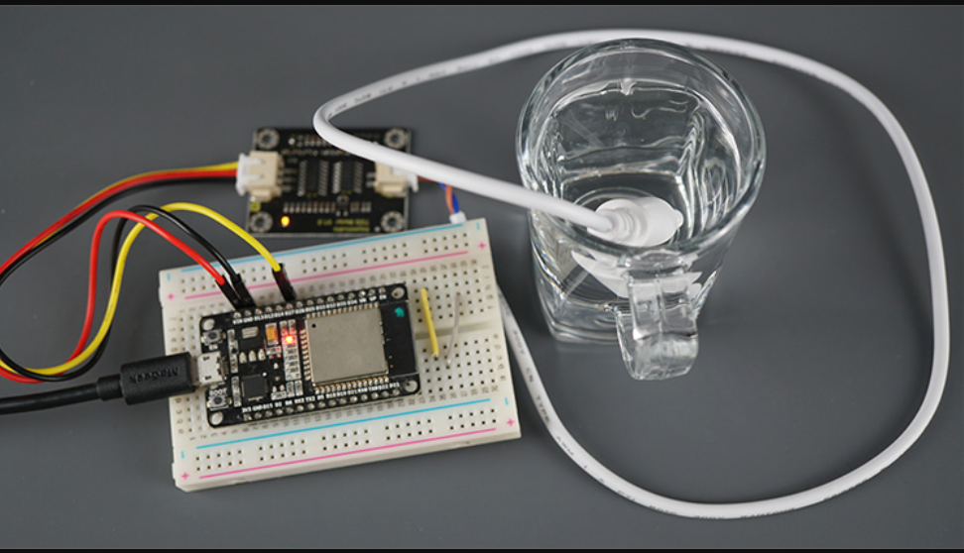

Test Results

Serial Monitor
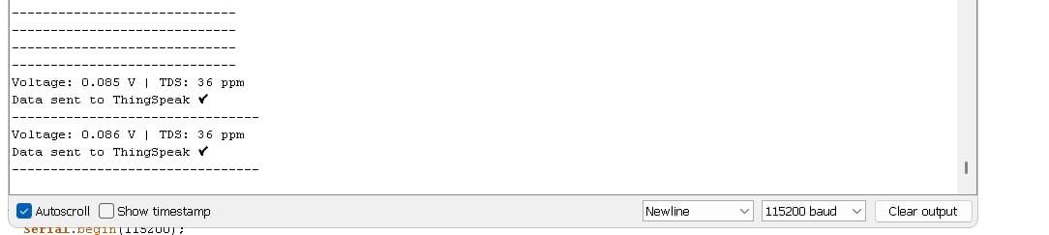

Thinkspeak Dashboard:

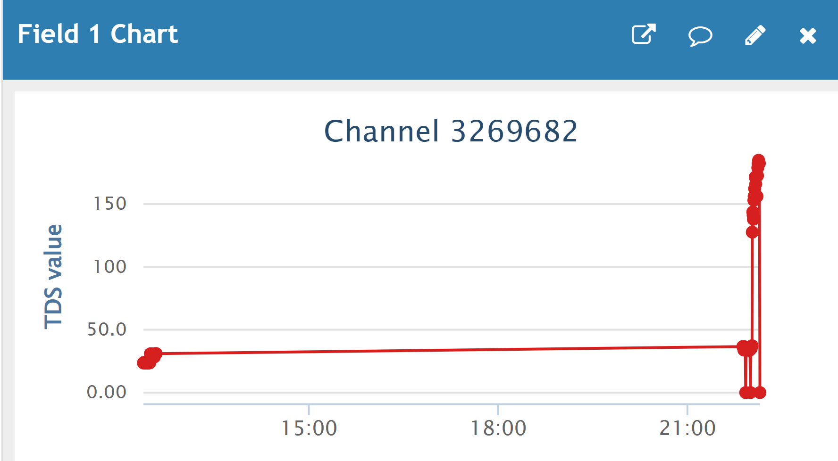

6. Future Scope and Conclusion

6.1 Future Scope
- Integration of additional sensors such as pH, turbidity, temperature, and dissolved oxygen for multi-parameter water quality monitoring.
- Development of a mobile application for real-time monitoring and instant alerts.
- Implementation of SMS or email notification system when TDS exceeds safe limits.
- Use of data analytics and machine learning for trend analysis and prediction.
- Integration with other IoT platforms apart from ThingSpeak for advanced cloud features.
- Solar-powered system design for deployment in remote and rural areas.
- Expansion for large-scale use in industries, water treatment plants, and smart city applications.
- Addition of LCD/OLED display for direct on-site monitoring of water quality.

6.2 Conclusion
The IoT-based Water Quality Monitoring System using ESP32 and a TDS sensor provides an efficient, cost-effective, and reliable solution for real-time water quality monitoring. The system successfully measures the TDS level of water, processes the data through the ESP32 microcontroller, and transmits it to the cloud for remote access and visualization.
The integration of Wi-Fi connectivity and cloud technology enables users to monitor water quality from anywhere, reducing the need for manual testing and laboratory analysis. The real-time data visualization helps in quick decision-making and ensures safer water management practices.
This project demonstrates the practical implementation of IoT in environmental monitoring and highlights how embedded systems and cloud computing can work together to solve real-world problems. Overall, the system contributes to smart environmental management and promotes sustainable water resource monitoring.

7. References
- ThingSpeak – Official Documentation and Cloud Platform Resources.
- Arduino IDE – Software used for programming and uploading code to ESP32.
- ChatGPT – Used for guidance in documentation preparation and project development support.
- YouTube – Online tutorials and implementation guidance for ESP32 and TDS sensor integration.
- ESP32 Datasheet – Technical specifications and pin configuration details provided by Espressif Systems.
- TDS Sensor Module Datasheet – Working principle and calibration details of the sensor.
- Research articles and online resources related to IoT-based water quality monitoring systems.
- Github.com

8. Glossary

- IoT (Internet of Things):
A network of interconnected devices that collect and exchange data over the internet.
- ESP32:
A low-cost, Wi-Fi and Bluetooth-enabled microcontroller used for IoT applications.
- TDS (Total Dissolved Solids):
The total concentration of dissolved substances (salts, minerals, and impurities) present in water, usually measured in ppm.
- ppm (Parts Per Million):
A unit used to measure the concentration of dissolved solids in water.
- ADC (Analog-to-Digital Converter):
A feature in microcontrollers that converts analog signals into digital values for processing.
- Wi-Fi:
A wireless networking technology that allows devices to connect to the internet.
- Cloud Platform:
An online service used for storing, processing, and visualizing data remotely.
- ThingSpeak:
An IoT cloud platform used to collect, store, and analyze sensor data in real time.
- Serial Monitor:
A tool in the Arduino IDE used to display data sent from the microcontroller.
- API Key:
A unique code used to authenticate and allow data transmission to a cloud service.

