1. Customer booking and payment flow
Source-based diagram | Spring Boot controllers, services, repositories, and MySQL
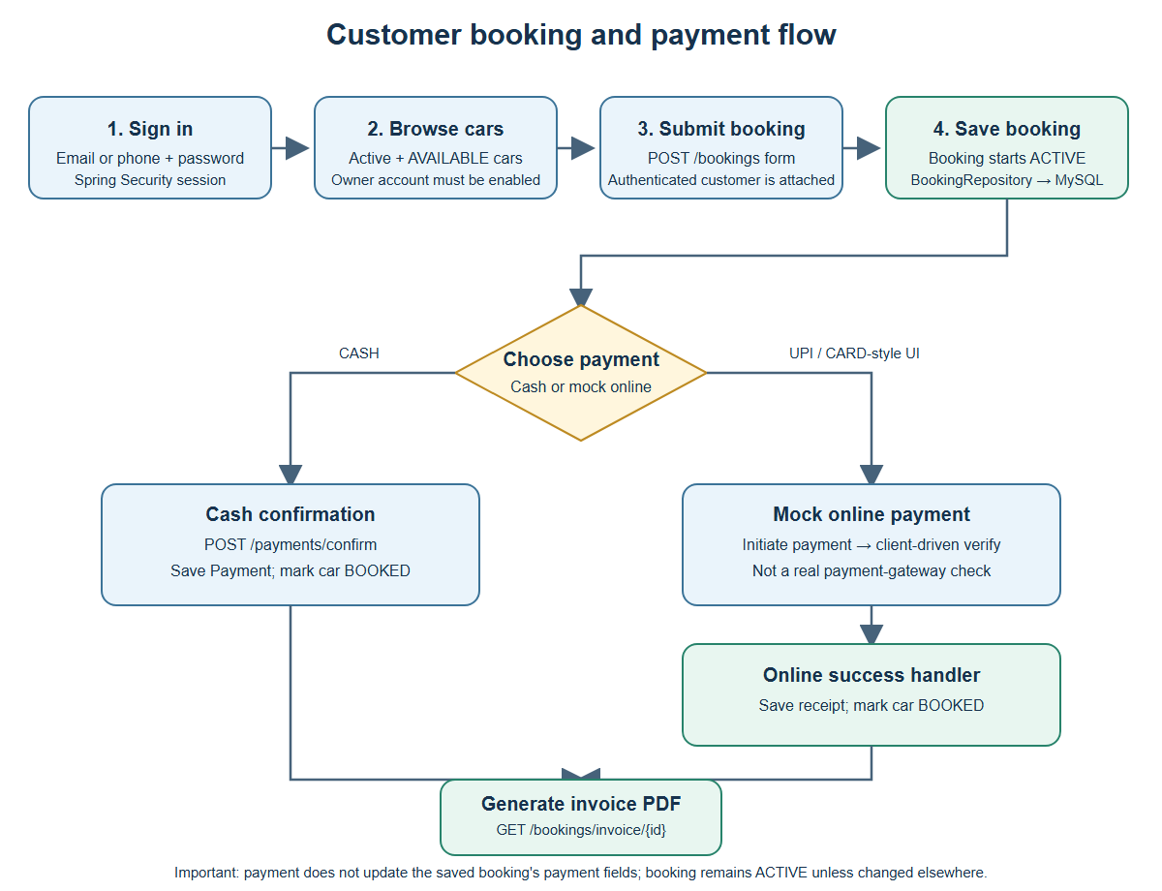
The customer signs in, books an available car, then follows either the cash or mock-online payment path. A booking remains ACTIVE; payment handlers do not update the booking payment fields.

2. Owner onboarding and admin approval
Source-based diagram | Spring Boot controllers, services, repositories, and MySQL
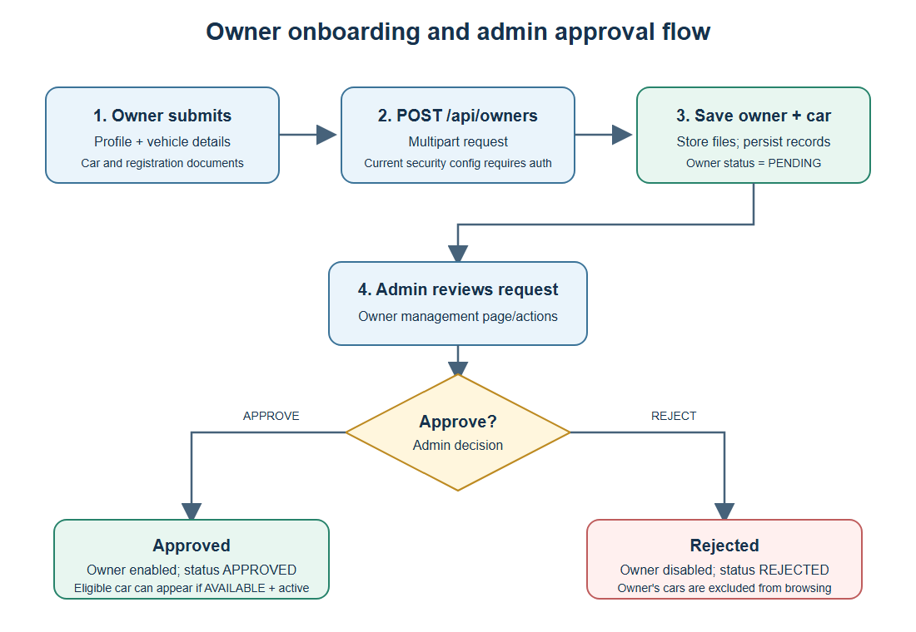
Owner submission creates a PENDING owner and associated car. Administrator approval enables the owner; rejection disables the account. The submission endpoint is not explicitly public under the current security configuration.

3. Authentication and booking sequence
Source-based diagram | Spring Boot controllers, services, repositories, and MySQL
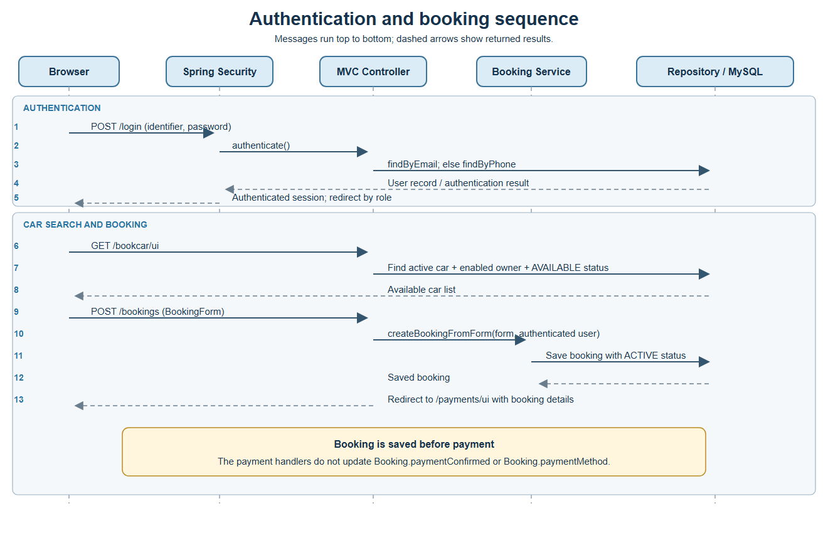
Messages run top to bottom; dashed arrows represent returned results. The booking is persisted before payment.

4. Payment and invoice sequence
Source-based diagram | Spring Boot controllers, services, repositories, and MySQL
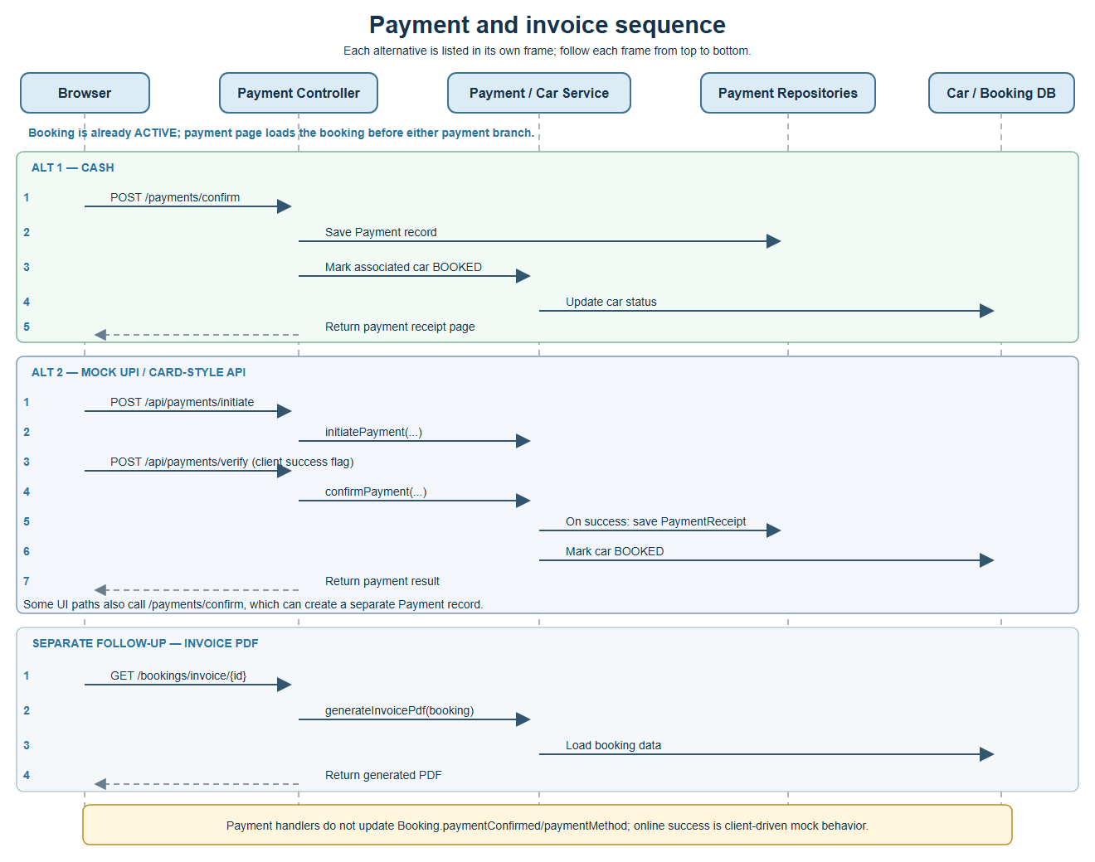
Payment verification is client-driven mock behavior, not a real gateway check. Payment handlers do not update Booking.paymentConfirmed or Booking.paymentMethod; invoice generation is a separate follow-up request.

