**Milestone 1**

**Q1. Using JDBC, Execute a SQL query to fetch the attributes of the mobile with highest camera and lesser price from the mobile table.**

package mindtree_milestone;

import java.sql.DriverManager;

import java.sql.Connection;

import java.sql.SQLException;

import java.sql.Statement;

import java.sql.ResultSet;

public class milestone1

{

    public static void main(String args[])

{

        Try

{

            Class.forName("com.mysql.jdbc.Driver");

Statement st=null;

            Connection conn = null;

            conn = DriverManager.getConnection("jdbc:mysql://localhost/mobiles","root", "");

            System.out.println("Database is connected !");

            st=conn.createStatement();

            String query1 = "Select * from mobile where Camera=(Select max(Camera) from mobile)";

            System.out.println("Camera has highesr pixel = "+query1);

            ResultSet rs = st.executeQuery(query1);

            while(rs.next())

            {

                    System.out.println(rs.getString(1)+" , "+rs.getString(2)+" , "+rs.getString(3)+" , "+rs.getString(4)+" , "+rs.getString(5)+" , "+rs.getString(6));

            }

            String query2 = "Select * from mobile where Price=(Select min(Price) from mobile)";

            System.out.println("lowest price mobile = "+query2);

            rs = st.executeQuery(query2);

            if(rs.next())

            {

                    System.out.println(rs.getString(1)+" , "+rs.getString(2)+" , "+rs.getString(3)+" , "+rs.getString(4)+" , "+rs.getString(5)+" , "+rs.getString(6));

            }

            conn.close();

        }

        catch(Exception e) {

            System.out.print("Do not connect to DB - Error:"+e);

        }

    }

}

Output:

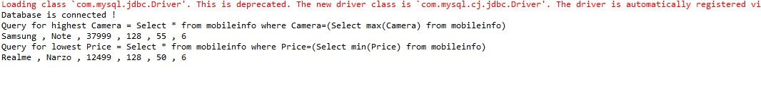

**Using JDBC, Execute a SQL query to fetch the name and brand of the mobile with the biggest screen size from the mobile table.**

**package** mindtree_milestone;

**import** java.sql.DriverManager;

**import** java.sql.Connection;

**import** java.sql.SQLException;

**import** java.sql.Statement;

**import** java.sql.ResultSet;

**public** **class** milestone1 {

**public** **static** **void** main(String args[]) {

**try** {

Class.*forName*("com.mysql.jdbc.Driver");

Connection conn = **null**;

Statement st=**null**;

conn = DriverManager.*getConnection*("jdbc:mysql://localhost/mobiles","root", "");

System.***out***.println("Database is connected !");

st=conn.createStatement();

String query1 = "Select * from mobileinfo where Display=(Select max(Display) from mobileinfo)";

System.***out***.println("Query for highest Display = "+query1);

ResultSet rs = st.executeQuery(query1);

**while**(rs.next())

{

System.***out***.println(rs.getString(1)+" , "+rs.getString(2)+" , "+rs.getString(3)+" , "+rs.getString(4)+" , "+rs.getString(5)+" , "+rs.getString(6));

}

conn.close();

}

**catch**(Exception e) {

System.***out***.print("Do not connect to DB - Error:"+e);

}

}

}

Output:



**Q3. Using JDBC, Execute a SQL query to find the camera and price details of Apple Iphone 13 from the mobile table.**

**package** mindtree_milestone;

**import** java.sql.DriverManager;

**import** java.sql.Connection;

**import** java.sql.SQLException;

**import** java.sql.Statement;

**import** java.sql.ResultSet;

**public** **class** milestone1 {

**public** **static** **void** main(String args[]) {

**try** {

Class.*forName*("com.mysql.jdbc.Driver");

Connection conn = **null**;

Statement st=**null**;

conn = DriverManager.*getConnection*("jdbc:mysql://localhost/mobiles","root", "");

System.***out***.println("Database is connected !");

st=conn.createStatement();

String query1 = "Select * from mobileinfo where Brand='Apple' and NAME='Iphone 13'";

System.***out***.println("Query for highest Display = "+query1);

ResultSet rs = st.executeQuery(query1);

**while**(rs.next())

{

System.***out***.println("Price is "+" "+rs.getString(3)+" Camera is "+" "+rs.getString(5));

}

conn.close();

}

**catch**(Exception e) {

System.***out***.print("Do not connect to DB - Error:"+e);

}

}

}

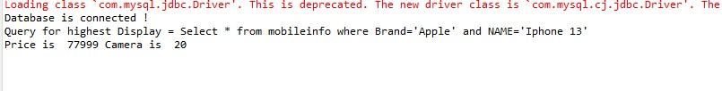

**Q4. Using JDBC, Execute a SQL query to find the names and brands of all the phones with price from 10000 to 20000 and camera from 30-50 MP from the mobile table.**

**package** mindtree_milestone;

**import** java.sql.DriverManager;

**import** java.sql.Connection;

**import** java.sql.SQLException;

**import** java.sql.Statement;

**import** java.sql.ResultSet;

**public** **class** milestone1 {

**public** **static** **void** main(String args[]) {

**try** {

Class.*forName*("com.mysql.jdbc.Driver");

Connection conn = **null**;

Statement st=**null**;

conn = DriverManager.*getConnection*("jdbc:mysql://localhost/mobiles","root", "");

System.***out***.println("Database is connected !");

st=conn.createStatement();

String query1 = "Select * from mobileinfo where PRICE BETWEEN 10000 AND 20000 AND CAMERA BETWEEN 30 AND 50";

System.***out***.println("Query for highest Display = "+query1);

ResultSet rs = st.executeQuery(query1);

**while**(rs.next())

{

System.***out***.println("Price is "+" "+rs.getString(3)+" Camera is "+" "+rs.getString(5));

}

conn.close();

}

**catch**(Exception e) {

System.***out***.print("Do not connect to DB - Error:"+e);

}

}

}

