AURA
Evidence Intake · Validation · Decision Traceability
Requirements & Architecture Series · MRS · PRS · HLD
AURA HIGH-LEVEL DESIGN
Redefined — Architecture, Scenarios, Integrations, Data Flows and Quality Attributes
Document ID | AURA-HLD-2.0
Version | 2.0
Status | REDEFINED BASELINE — FOR REVIEW
Date | 2026-10-13
Classification | TBD
Prepared By | Senior Software Architect (organisation TBD)
Standard | IEEE 1016-2009 · ISO/IEC/IEEE 42010:2022
Supersedes | AURA-HLD-1.0
Companion Docs | AURA-MRS-1.0 · AURA-PRS-2.0
Derived exclusively from Aura_HLD.md, Aura_PRS.md and Aura_MRS.md. Hosting, tenancy, identity provider, storage, eventing, key management, DR and all capacity, availability and performance targets are pending (HLD §7, §9). Classification: TBD.

Document Control
Document ID | AURA-HLD-2.0
Title | High-Level Design (Redefined) — Aura — Software Design Description, Architectural Level
Version | 2.0
Status | Redefined baseline for review
Date | 13 October 2026
Product | Aura — controlled evidence intake, validation and decision traceability workflow
Standard | IEEE Std 1016-2009 (design viewpoints) with ISO/IEC/IEEE 42010:2022 stakeholder / concern framing
Source basis | Aura_HLD.md (authoritative for architecture), Aura_PRS.md, Aura_MRS.md. Reference DOCX files used for formatting only.
Owner | TBD
Series | AURA-MRS · AURA-PRS · AURA-HLD

Revision History
Version | Date | Author | Description
1.0 | 13 October 2026 | Senior Software Architect | Initial IEEE-aligned baseline (AURA-HLD-1.0).
2.0 | 13 October 2026 | Senior Software Architect | Redefined: added mind maps, layered and deployment views, seven high-level user scenarios with sequence diagrams, and dedicated scalability, availability and performance considerations. Source architecture unchanged.

Review and Approval
Role | Name | Signature | Date
Prepared by — Senior Software Architect | TBD
Reviewed by — Product Management | TBD
Reviewed by — Risk / Compliance | TBD
Approved by — Product Owner | TBD

Evidence Conventions
Marker | Meaning
MRS §n | Section n of Aura_MRS.md — Market Requirements Specification (Discovery Baseline).
PRS §n | Section n of Aura_PRS.md — Product Requirements Specification (Initial Baseline).
HLD §n | Section n of Aura_HLD.md — High-Level Design (Initial Baseline).
Stated | Content taken directly from the source Markdown files.
Derived | Architect's structural derivation: component IDs, layer grouping, scenario decomposition, mind maps, allocations and quality-attribute tables. No new technology, target or component is introduced.
TBC | Derived allocation that must be confirmed.
TBD | Not present in the source; no value asserted. Shown in amber in diagrams.

Table of Contents
1 Introduction 8
1.1 Purpose 8
1.2 Scope 8
1.3 Definitions, Acronyms and Abbreviations 8
1.4 References 8
1.5 Stakeholders, Concerns and Viewpoints 9
2 Architecture Overview 10
2.1 Architecture Principles 10
2.2 Architecture Mind Map 10
2.3 Layered Architecture View 11
2.4 Logical Component Architecture 12
3 Context Viewpoint 13
4 Composition Viewpoint — System Components 14
4.1 Component Catalogue 14
4.2 Unassigned Responsibilities 14
5 Information Viewpoint 15
5.1 Conceptual Data Model 15
5.2 Entity Summary 15
5.3 Data Model Gaps 16
5.4 Retention and Storage 16
6 Interaction Viewpoint — Data Flows and User Scenarios 17
6.1 End-to-End Data Flow 17
6.2 High-Level User Scenarios 17
6.2.1 HS-01 Case Creation and Evidence Intake 18
6.2.2 HS-02 Completeness and Validation Checks 19
6.2.3 HS-03 Review and Decision Recording 20
6.2.4 HS-04 Audit Reconstruction and Export 21
6.2.5 HS-05 Exception Handling 22
6.2.6 HS-06 Integration Call 22
6.2.7 HS-07 Unauthorized Access Attempt 23
7 Interface Viewpoint — Integrations 24
7.1 Interface Register 24
7.2 Integration Approach 24
7.3 Candidate Integration Targets 25
8 Security Viewpoint 26
9 Deployment Viewpoint 28
10 Quality Attribute Considerations 30
10.1 Scalability 30
10.2 Availability 31
10.3 Performance 31
10.4 Reliability, Maintainability and Privacy 32
11 Design Rationale and Decisions 33
12 Key Risks 34
13 Requirements Allocation 35
13.1 Product Requirement → Component 35
13.2 Use Case → Scenario 35
13.3 Non-Functional Requirement → Design 36
13.4 Exception Case → Design 36
Appendix A — TBD Register 37
Appendix B — Changes from AURA-HLD-1.0 38

List of Figures
Figure 1 — Architecture mind map 11
Figure 2 — Layered architecture view 12
Figure 3 — Logical component architecture 12
Figure 4 — System context 13
Figure 5 — Conceptual entity–relationship diagram 15
Figure 6 — End-to-end data flow with component allocation 17
Figure 7 — HS-01 — case creation and evidence intake 18
Figure 8 — HS-02 — completeness and validation checks 19
Figure 9 — HS-03 — review and decision recording 20
Figure 10 — HS-04 — audit reconstruction and export 21
Figure 11 — HS-05 — exception handling 22
Figure 12 — HS-06 — integration call with idempotent retry 22
Figure 13 — HS-07 — unauthorized access attempt 23
Figure 14 — Integration adapter pattern 24
Figure 15 — Security and custody control points 26
Figure 16 — Deployment view — pending decisions 28
Figure 17 — Quality attribute mind map 30
List of Tables
Table 1 — Acronyms and abbreviations 8
Table 2 — Referenced documents 8
Table 3 — Stakeholders and concerns 9
Table 4 — Viewpoints used (IEEE 1016 §5) 9
Table 5 — Architecture principles 10
Table 6 — External entities 13
Table 7 — System components 14
Table 8 — Responsibilities without an owning component 14
Table 9 — Entity summary 15
Table 10 — Gaps against product requirements 16
Table 11 — Data flow stages 17
Table 12 — Scenario catalogue 17
Table 13 — HS-02 steps 19
Table 14 — Interface register 24
Table 15 — Adapter contract elements 24
Table 16 — Integration targets 25
Table 17 — Security and custody controls 26
Table 18 — Security-relevant exception cases 26
Table 19 — Reliability and deployment practices 28
Table 20 — Pending architecture decisions 28
Table 21 — Scalability considerations 30
Table 22 — Availability considerations 31
Table 23 — Performance considerations 31
Table 24 — Other quality considerations 32
Table 25 — Architecture decisions — stated 33
Table 26 — Architecture risks 7
Table 27 — PR → component allocation matrix 7
Table 28 — Use case to scenario allocation 7
Table 29 — NFR → design allocation 7
Table 30 — EC → design allocation 7
Table 31 — TBD register 7
Table 32 — Change log 7

1 Introduction

1.1 Purpose
This redefined High-Level Design (HLD) is the architectural Software Design Description of Aura. It presents the architecture through context, composition, information, interaction, interface, security and deployment viewpoints (IEEE 1016), adds mind maps and high-level user scenarios, and records security, scalability, availability and performance considerations. It supersedes AURA-HLD-1.0 without changing the source architecture.

1.2 Scope
Ten logical components, six conceptual entities, the end-to-end data flow, security and custody controls, the integration approach, reliability and deployment practices, key risks and pending decisions (HLD §1 – §9). Technology selections and quantitative targets are pending and marked TBD.

1.3 Definitions, Acronyms and Abbreviations
Table 1 — Acronyms and abbreviations
Term | Definition
C-nn | Logical component (HLD §2 order, Derived ID).
HS-nn | High-level user scenario (Derived).
IF-nn | Interface (Derived).
SC-nn | Security / custody control (HLD §5).
OP-nn | Reliability and deployment practice (HLD §7).
AD-nn / PD-nn | Architecture decision taken / pending (HLD §6, §9).
AR-nn | Architecture risk (HLD §8).
QS / QA / QP | Scalability / availability / performance consideration (Derived).
UCS-nn | Use case (AURA-PRS-2.0).
Correlation ID | Identifier correlating related operations and AuditEvents (HLD §3, §5).
Idempotency key | Key making a retried integration request safe to repeat (HLD §5).
LOS / LMS | Loan Origination / Management System (MRS §9).

1.4 References
Table 2 — Referenced documents
Ref | Document | Relevance
[1] | IEEE Std 1016-2009 — Software Design Descriptions | Design viewpoints.
[2] | ISO/IEC/IEEE 42010:2022 — Architecture description | Stakeholders, concerns, viewpoints.
[3] | ISO/IEC 25010 — Product quality model | Quality attribute framing (§10).
[4] | Aura_HLD.md — High-Level Design (Initial Baseline) | Authoritative architecture.
[5] | Aura_PRS.md / AURA-PRS-2.0 | Requirements and use cases allocated (§13).
[6] | Aura_MRS.md | Market context and open questions.

1.5 Stakeholders, Concerns and Viewpoints
Table 3 — Stakeholders and concerns
Stakeholder | Concern | Viewpoint (section)
Submitter / field operator | Evidence intake with metadata | Interaction (§6)
Reviewer / underwriter; Approver | Validation status; decision recording | Interaction (§6); Information (§5)
Risk or compliance auditor | Lineage; tamper-evident history; reconstruction | Information (§5); Security (§8)
System administrator | Access, health, backups | Security (§8); Deployment (§9)
Integration owners (TBD) | Adapter contracts; failure handling | Interface (§7)
Bank policy / data owners (TBD) | Versioned rules; retention; residency | Information (§5); Quality (§10)

Table 4 — Viewpoints used (IEEE 1016 §5)
Viewpoint | Section | Primary representation
Context | §3 | Context diagram; external entity table
Composition | §2, §4 | Mind map; layered view; component catalogue
Information | §5 | ER diagram; entity tables
Interaction | §6 | Data flow; scenario sequence diagrams
Interface | §7 | Interface register; adapter pattern
Security (concern-specific) | §8 | Control-point diagram; control table
Deployment | §9 | Pending-decision view
Quality attributes | §10 | Quality mind map; consideration tables

2 Architecture Overview

2.1 Architecture Principles
Table 5 — Architecture principles
ID | Principle (HLD §1) | Realisation in source design
AP-01 | Security by default | AuthN and role/tenant AuthZ at API boundaries; secrets outside source control (HLD §5)
AP-02 | Evidence lineage | Decision → rule version; evidence checksum; AuditEvent object reference (HLD §3, §5)
AP-03 | Explicit workflow state | Case.status, EvidenceItem.validation status, Exception.status (HLD §3)
AP-04 | Versioned rules | RuleSetVersion; Decision.rule version (HLD §3)
AP-05 | Idempotent integrations | Idempotency keys and correlation IDs (HLD §5, §6)
AP-06 | Observable failures | Structured logs, health/readiness endpoints, monitoring (HLD §7)
AP-07 | Separation of concerns | Ten logical components (HLD §2)

2.2 Architecture Mind Map
The mind map summarises the full architecture description; amber leaves are pending or TBD items.
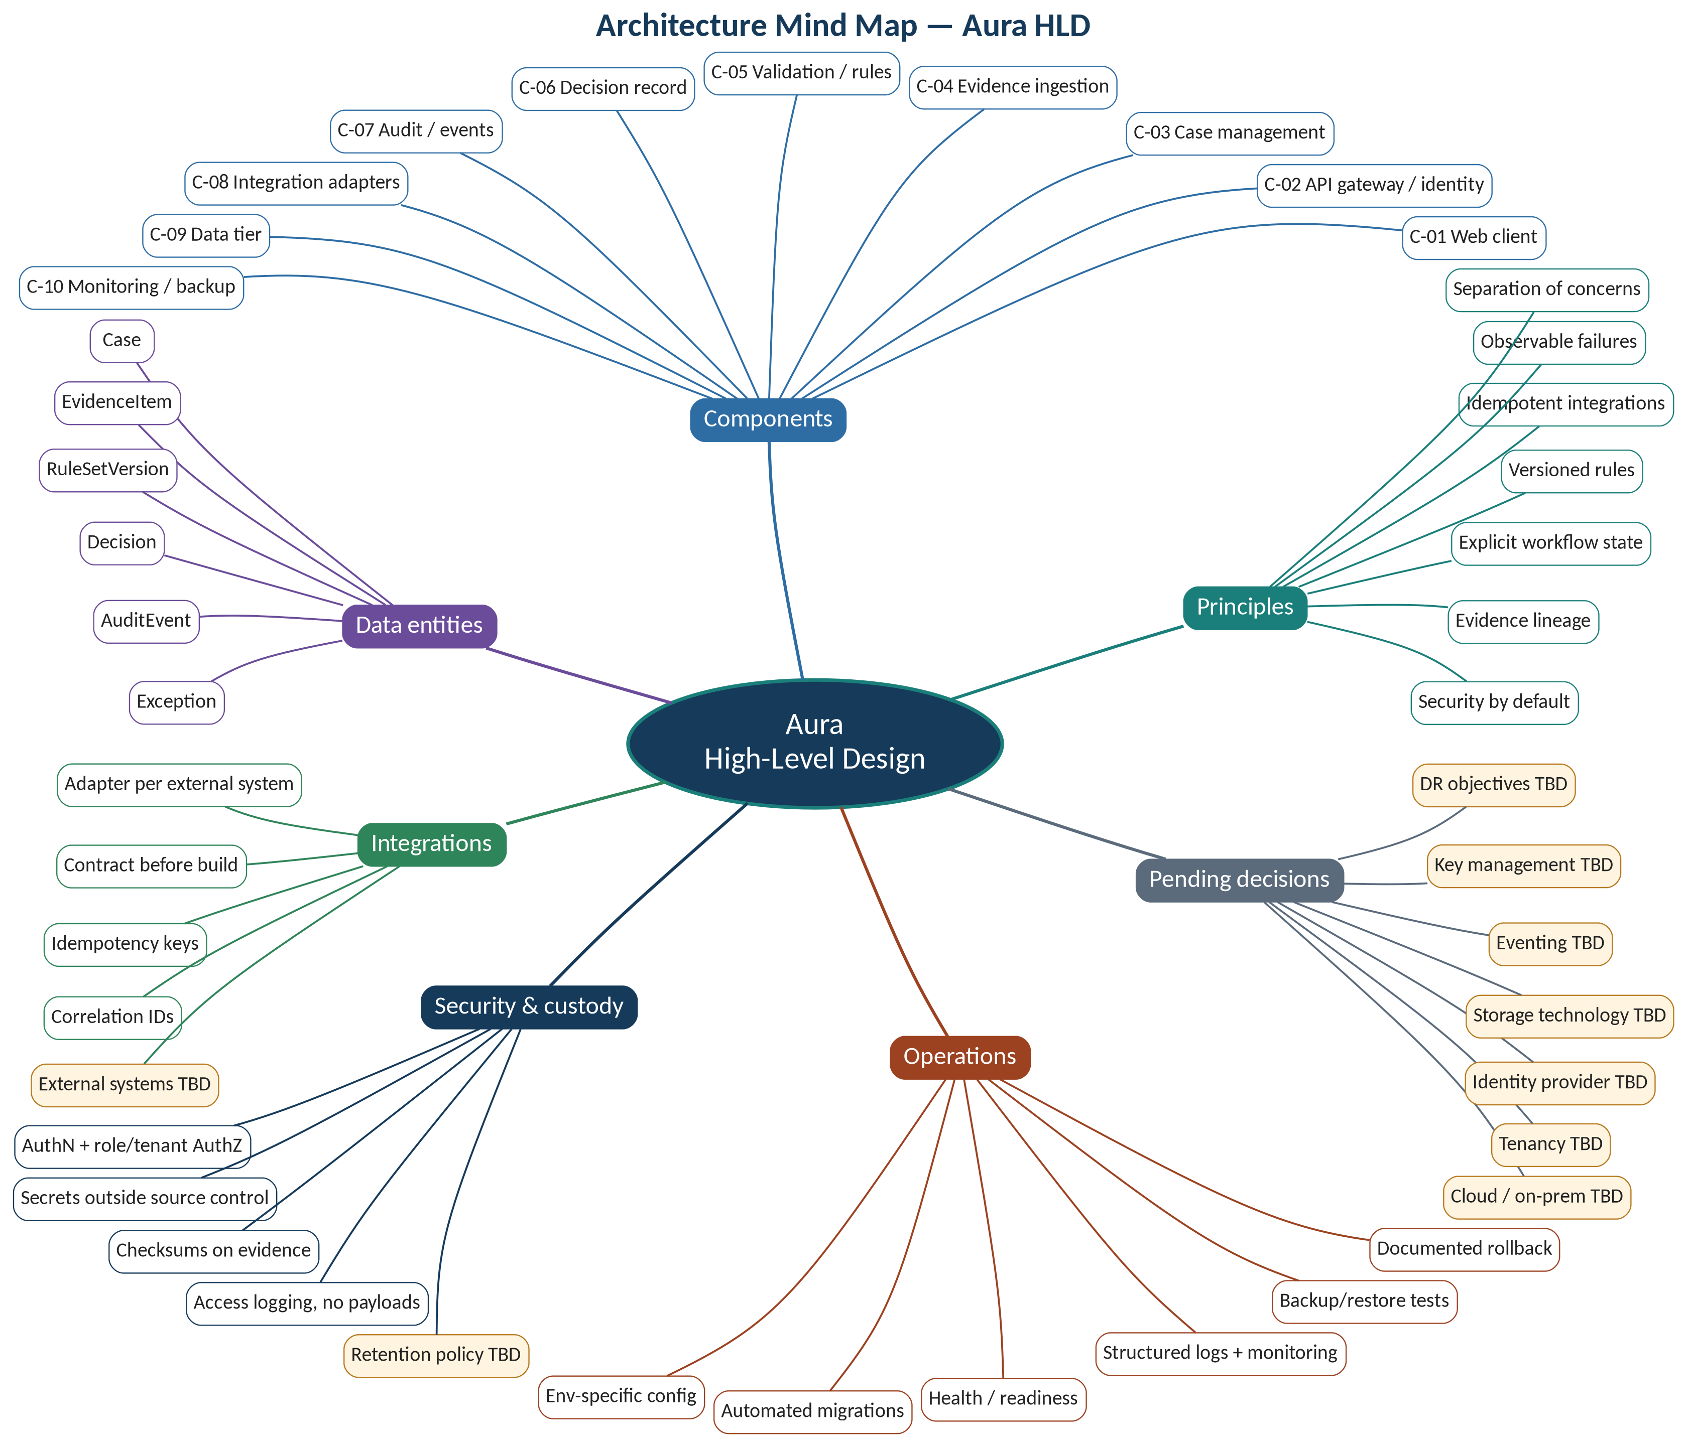
Figure 1 — Architecture mind map

2.3 Layered Architecture View
The ten components are grouped into layers for presentation. The grouping is Derived; HLD §2 lists components without layers.
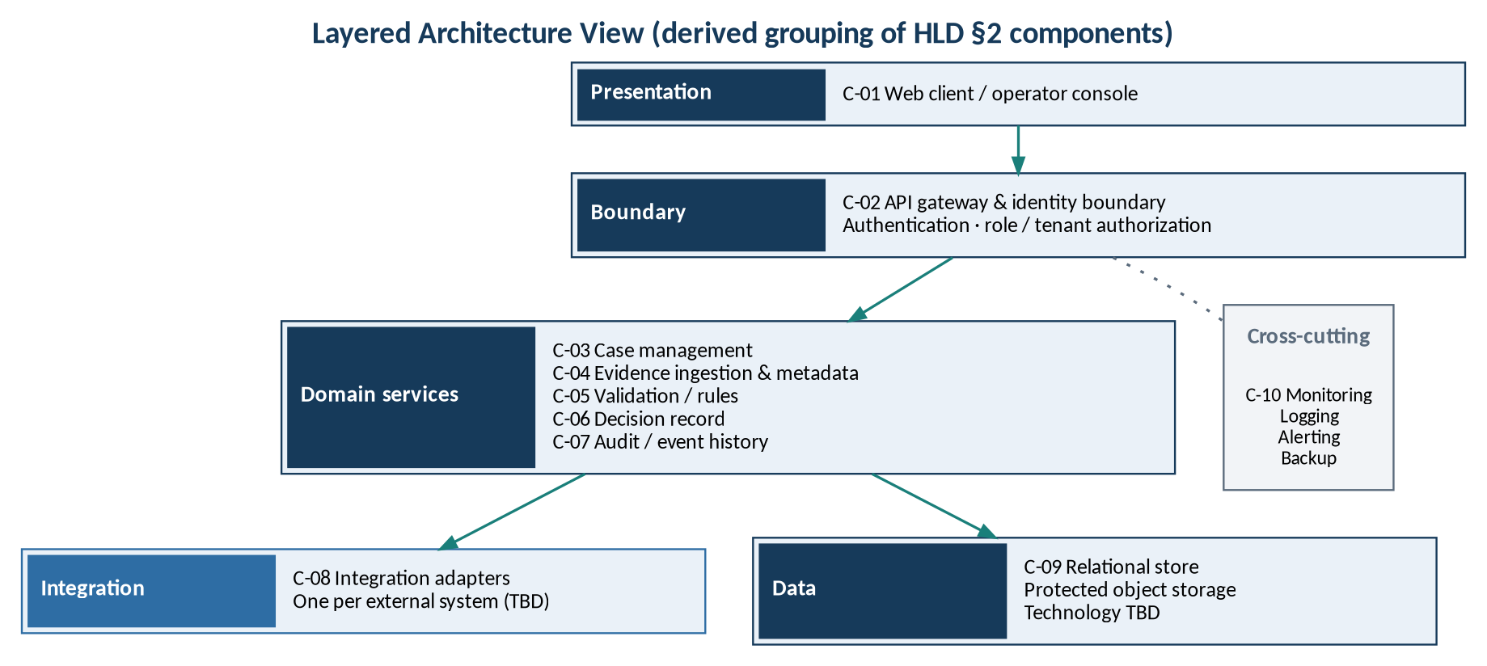
Figure 2 — Layered architecture view

2.4 Logical Component Architecture
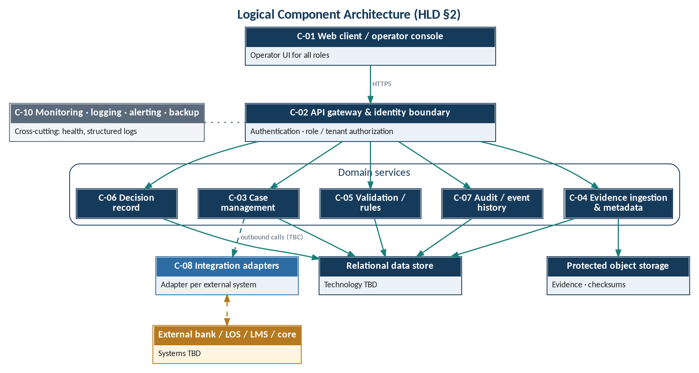
Figure 3 — Logical component architecture
Inter-service call relationships are not specified in HLD §2. The service that invokes integration adapters is TBC.

3 Context Viewpoint
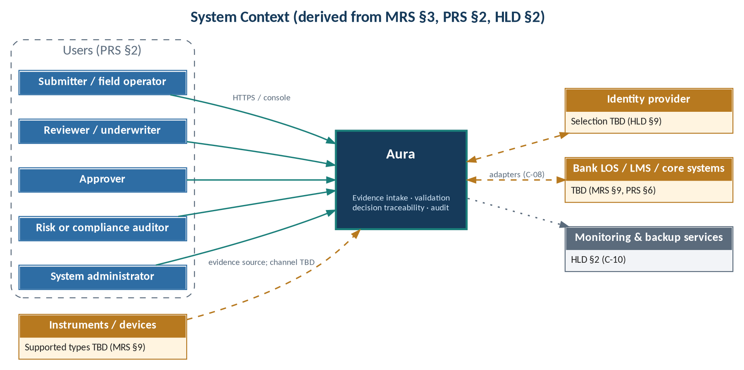
Figure 4 — System context
Table 6 — External entities
Entity | Interaction | Interface | Status
Users (5 roles, PRS §2) | Operate the workflow | C-01 → C-02 (IF-01) | Stated
Bank LOS / LMS / core systems | Case or decision data exchange | C-08 adapters (IF-05) | TBD (MRS §9)
Identity provider | Authentication | C-02 (IF-06) | TBD (HLD §9)
Instruments / devices | Source of instrument-backed evidence | TBD | TBD (MRS §9)
Monitoring / backup services | Telemetry and backups | C-10 (IF-07) | Stated; technology TBD

4 Composition Viewpoint — System Components

4.1 Component Catalogue
Table 7 — System components
ID | Component (HLD §2) | Responsibility (source) | PRs realised | Technology
C-01 | Web client / operator console | Operator UI; keyboard navigable, clear status text (PRS §4) | PR-01, PR-04, PR-08 | TBD
C-02 | API gateway and identity boundary | Authentication and role/tenant authorization (HLD §5) | PR-07 | TBD
C-03 | Case management service | Case lifecycle (HLD §3) | PR-01; PR-08, PR-09 (TBC) | TBD
C-04 | Evidence ingestion and metadata service | Upload, metadata capture, checksums (HLD §4, §5) | PR-01, PR-02, PR-04 | TBD
C-05 | Validation/rules service | Completeness and validation checks; versioned rules | PR-03, PR-04 | TBD
C-06 | Decision record service | Decision records with rule version (HLD §3) | PR-05 | TBD
C-07 | Audit/event history service | Access and material-transition events (HLD §5) | PR-06; PR-10 (TBC) | TBD
C-08 | Integration adapters | One adapter per external system (HLD §6) | PR-11 | TBD
C-09 | Relational data store and protected object storage | Entity persistence; access-controlled evidence | PR-01, PR-06 | TBD (HLD §9)
C-10 | Monitoring, logging, alerting, backup | Logs, health, monitoring, backups (HLD §7) | PR-12 | TBD

4.2 Unassigned Responsibilities
Table 8 — Responsibilities without an owning component
Responsibility | Requirement | Status
Exception handling actions | PR-08 | Exception entity defined (HLD §3); owner TBC (C-03 candidate)
Search and retrieval | PR-09 | Owner TBC (C-03 candidate)
Export of manifest and decision history | PR-10 | Data flow ends in "audit trail and export" (HLD §4); owner TBC (C-07 candidate)
Approval step / decision authority | PRS §6 | TBD

5 Information Viewpoint

5.1 Conceptual Data Model
Six entities are defined in HLD §3. Cardinalities are inferred from foreign-key attributes and are TBC.
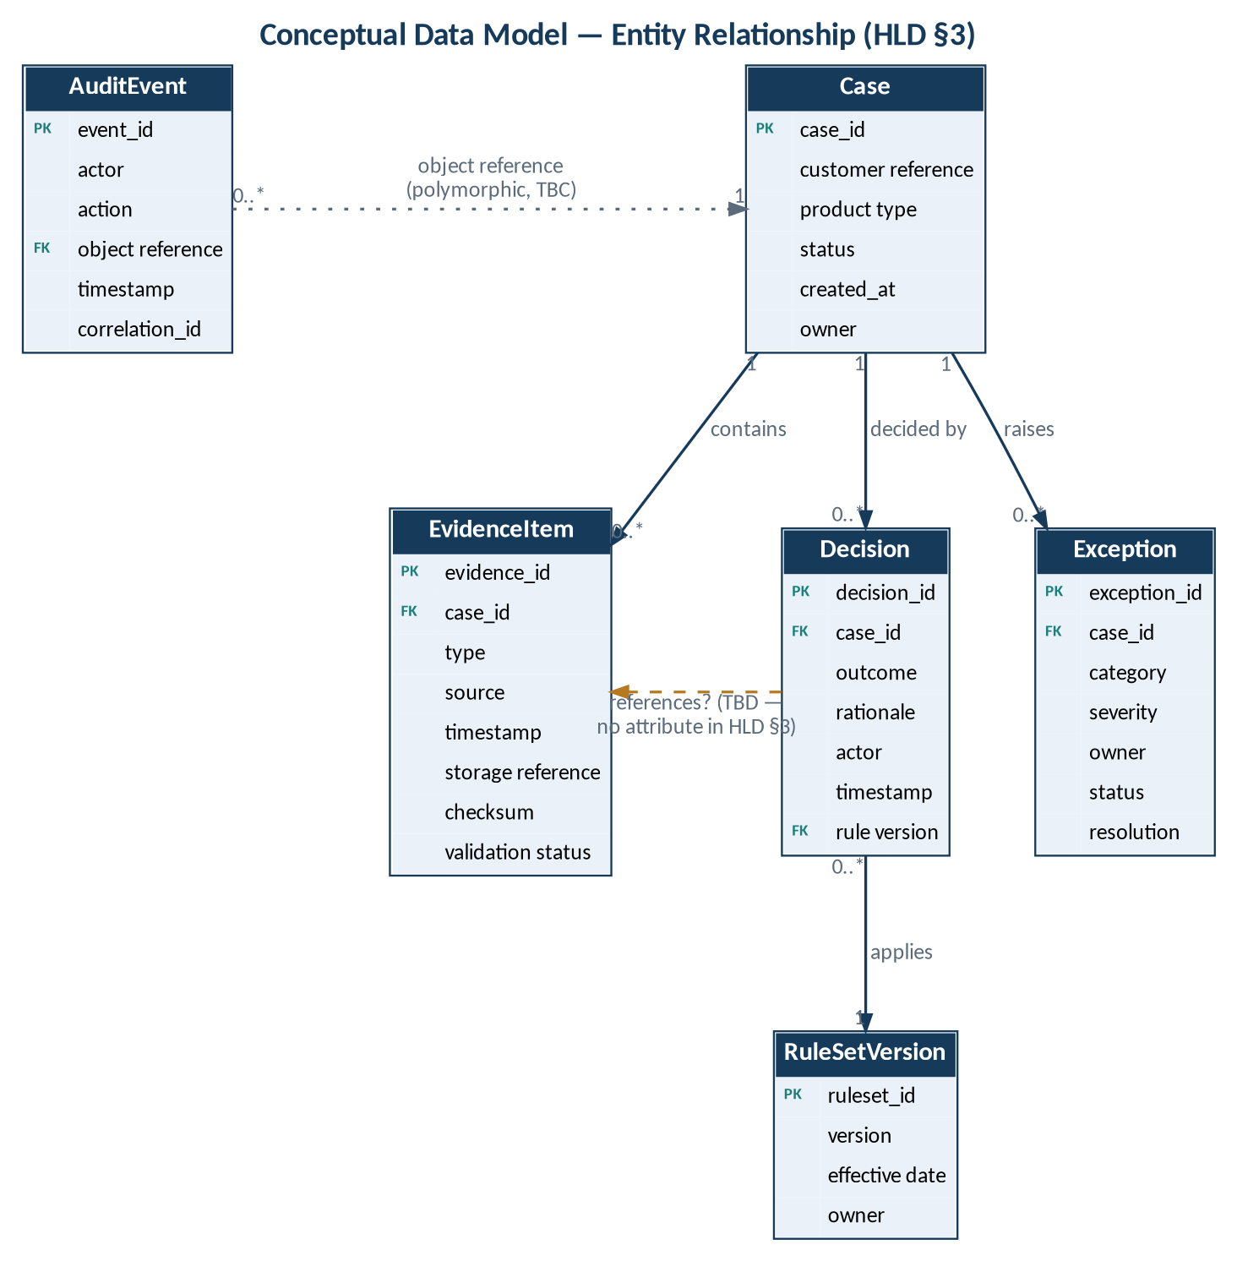
Figure 5 — Conceptual entity–relationship diagram

5.2 Entity Summary
Table 9 — Entity summary
Entity | Attributes (HLD §3) | Owning component | Requirement
Case | case_id, customer reference, product type, status, created_at, owner | C-03 | PR-01
EvidenceItem | evidence_id, case_id, type, source, timestamp, storage reference, checksum, validation status | C-04 | PR-01, PR-02, PR-04
RuleSetVersion | ruleset_id, version, effective date, owner | C-05 | PR-03
Decision | decision_id, case_id, outcome, rationale, actor, timestamp, rule version | C-06 | PR-05
AuditEvent | event_id, actor, action, object reference, timestamp, correlation_id | C-07 | PR-06
Exception | exception_id, case_id, category, severity, owner, status, resolution | TBC | PR-08

5.3 Data Model Gaps
Table 10 — Gaps against product requirements
ID | Finding | Requirement | Resolution
DG-01 | No submitter attribute on EvidenceItem | PR-02 | TBD
DG-02 | No evidence reference on Decision | PR-05 | TBD
DG-03 | No comment / escalation history on Exception | PR-08 | TBD
DG-04 | Form of Decision.rule version reference unspecified | PR-05 | TBD
DG-05 | No evidence-version entity | PR-05 | TBD
DG-06 | Ownership metadata only at Case level | MR-01 | TBD
DG-07 | Approval not modelled | PRS §2 | TBD

5.4 Retention and Storage
Retention, legal hold, deletion and backup policy are to be defined with stakeholders (HLD §5). Evidence is stored with access controls and checksums (HLD §5). Storage technology is pending (HLD §9).

6 Interaction Viewpoint — Data Flows and User Scenarios

6.1 End-to-End Data Flow
Case creation → evidence upload and metadata capture → completeness and validation checks → reviewer workflow → decision record → audit trail and export (HLD §4).
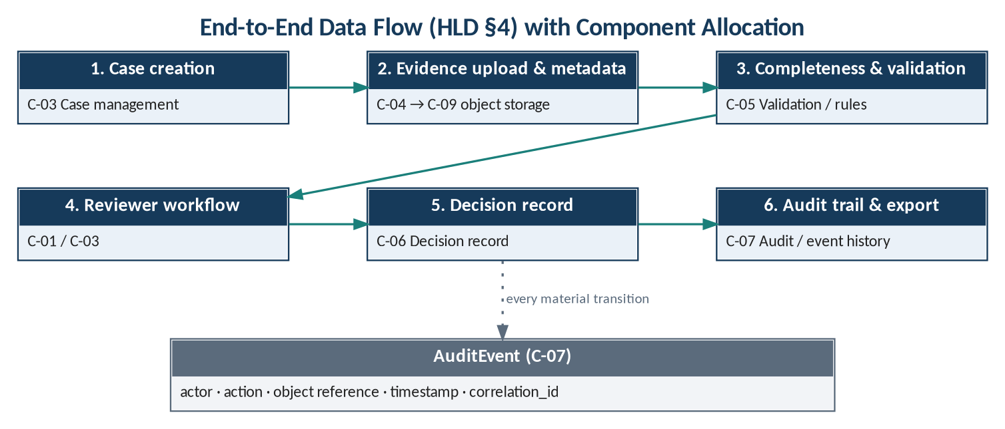
Figure 6 — End-to-end data flow with component allocation
Table 11 — Data flow stages
Stage | Data produced | Component | Store | Audit
1 Case creation | Case | C-03 | Relational | AuditEvent
2 Evidence upload & metadata | EvidenceItem + object | C-04 | Relational + object | AuditEvent
3 Completeness & validation | Validation status | C-05 | Relational | AuditEvent
4 Reviewer workflow | — (review; approval TBD) | C-01 / C-03 | — | Access logged
5 Decision record | Decision | C-06 | Relational | AuditEvent
6 Audit trail & export | Export (format TBD) | C-07 (TBC) | — | Access logged

6.2 High-Level User Scenarios
Table 12 — Scenario catalogue
ID | Scenario | Use cases (PRS 2.0) | Requirements | Components
HS-01 | Case creation and evidence intake | UCS-01, UCS-02 | PR-01, PR-02, PR-06 | C-01 – C-04, C-07, C-09
HS-02 | Completeness and validation checks | UCS-03, UCS-04 | PR-03, PR-04 | C-04, C-05, C-07, C-09
HS-03 | Review and decision recording | UCS-05 | PR-05, PR-07 | C-01 – C-03, C-06, C-07, C-09
HS-04 | Audit reconstruction and export | UCS-06, UCS-08, UCS-09 | PR-06, PR-09, PR-10 | C-01, C-02, C-07, C-09; owners TBC
HS-05 | Exception handling | UCS-07 | PR-08 | C-01, C-02, C-07, C-09; owner TBC
HS-06 | Integration call with idempotent retry | UCS-11 (runtime) | PR-11; EC-04 | C-08, C-07
HS-07 | Unauthorized access attempt | UCS-10; EC-05 | PR-07 | C-02, C-07

UCS-12 (monitor operational health) and UCS-13 (maintain rule set versions) have no dedicated scenario; they are covered by §9 and §5 respectively.

6.2.1 HS-01 Case Creation and Evidence Intake
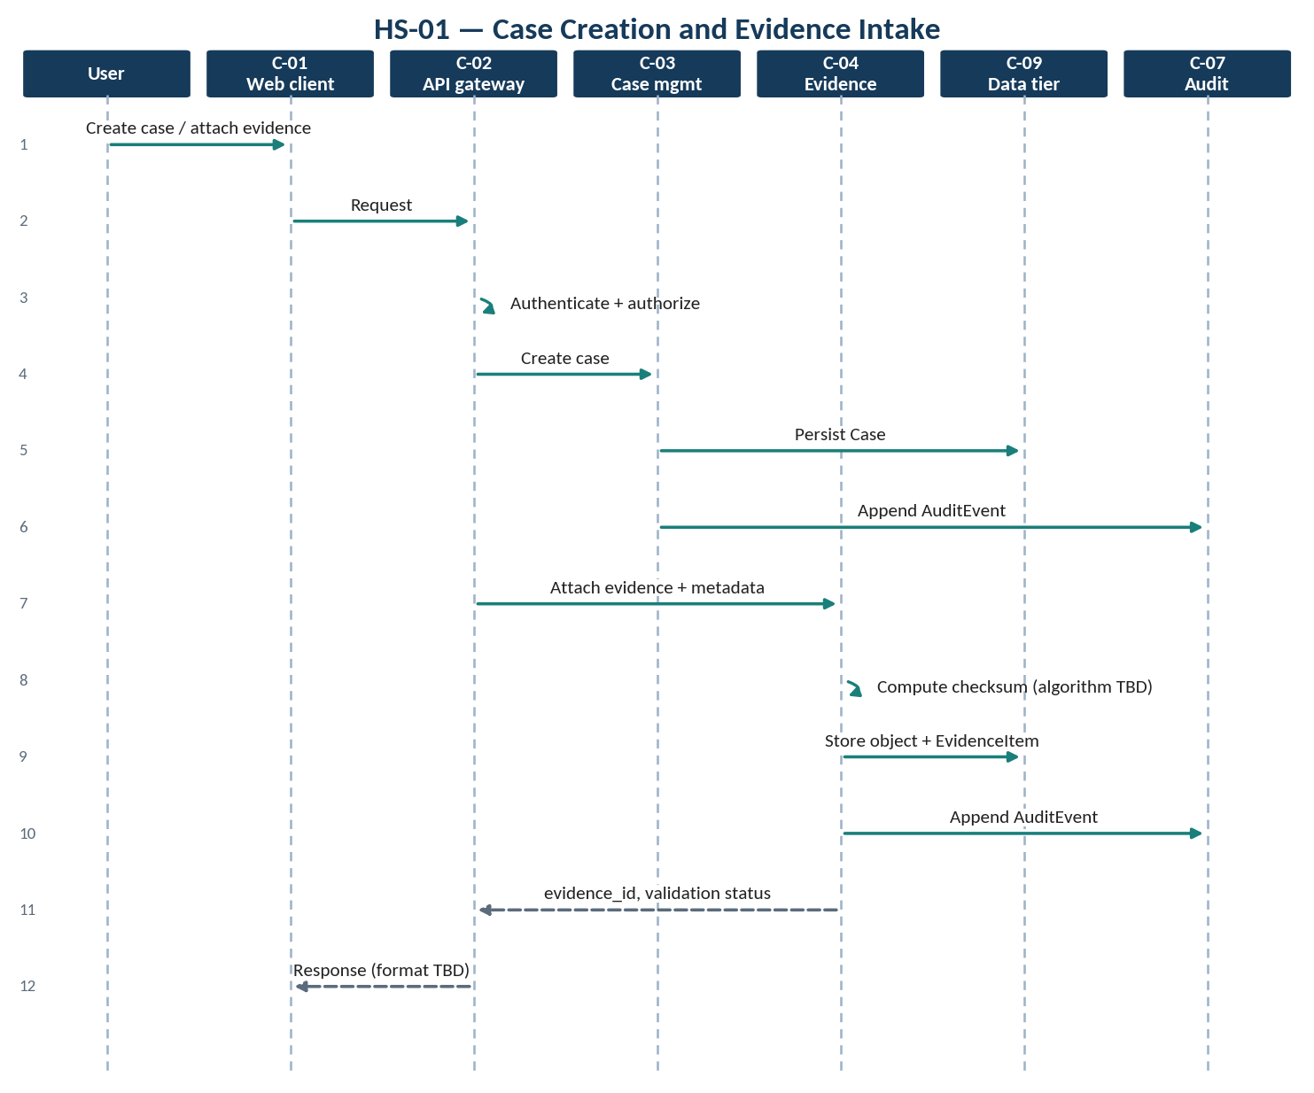
Figure 7 — HS-01 — case creation and evidence intake

6.2.2 HS-02 Completeness and Validation Checks
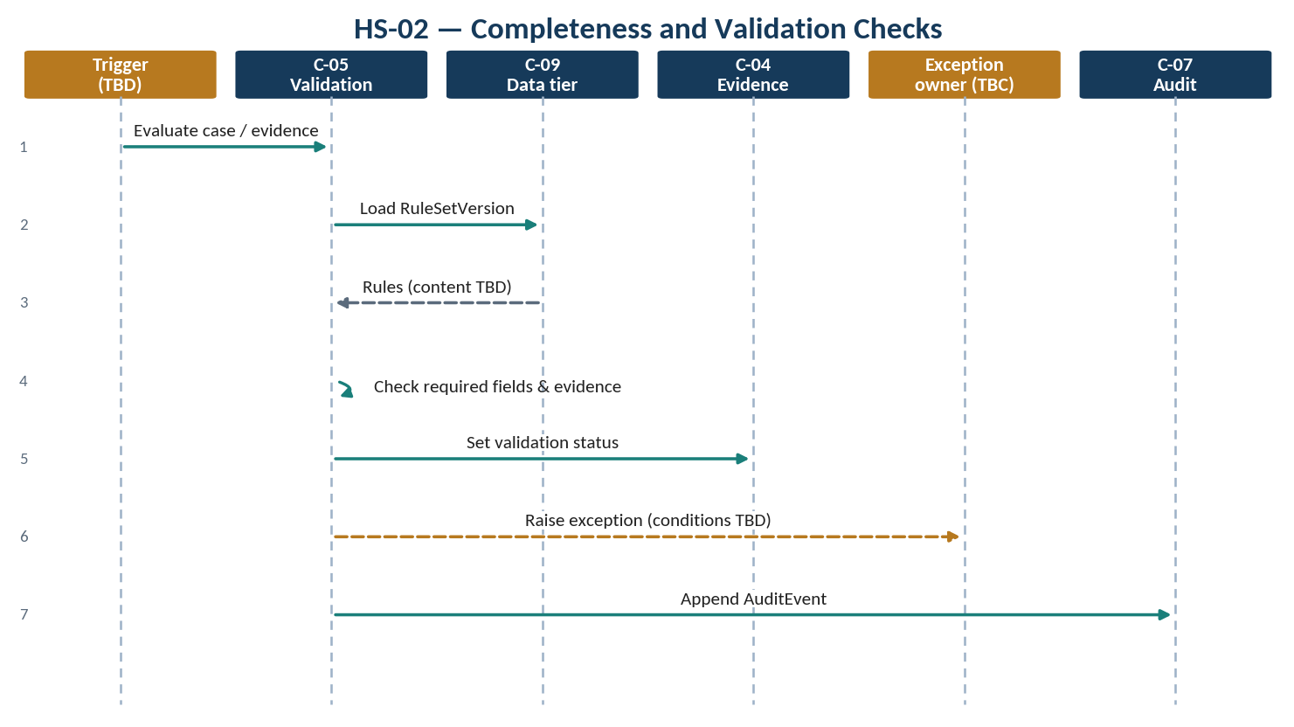
Figure 8 — HS-02 — completeness and validation checks
Table 13 — HS-02 steps
Step | Interaction | Component | Data / control
1 | Trigger evaluation (trigger TBD) | C-05 | case_id
2 | Load applicable rule set version | C-05 → C-09 | RuleSetVersion
3 | Check required fields and evidence (rule content TBD) | C-05 | —
4 | Set validation status | C-05 → C-04 | pending / valid / invalid / exception
5 | Raise exception where applicable (conditions TBD) | TBC | Exception
6 | Append audit event | C-07 | AuditEvent

6.2.3 HS-03 Review and Decision Recording
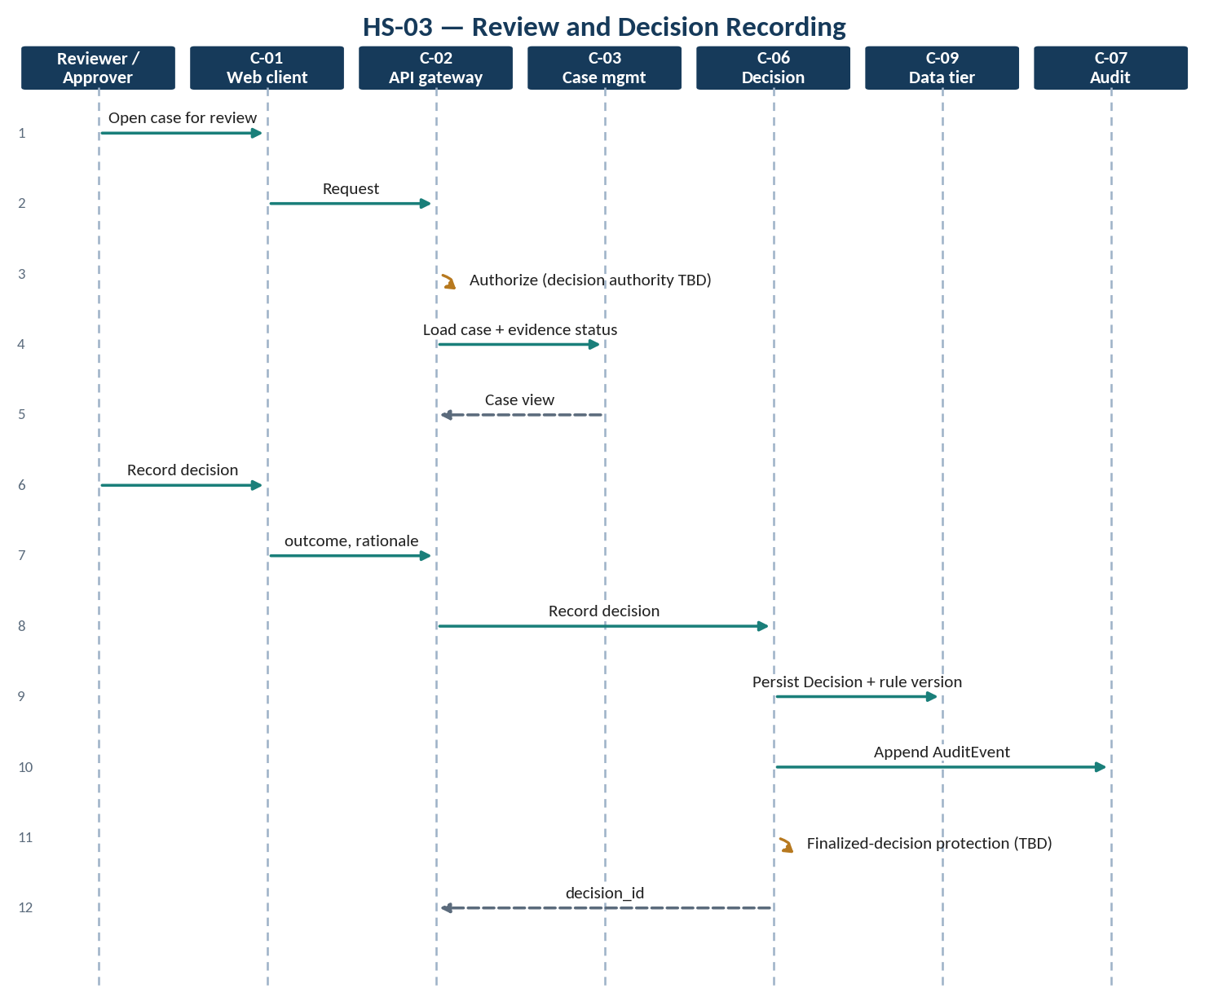
Figure 9 — HS-03 — review and decision recording

6.2.4 HS-04 Audit Reconstruction and Export
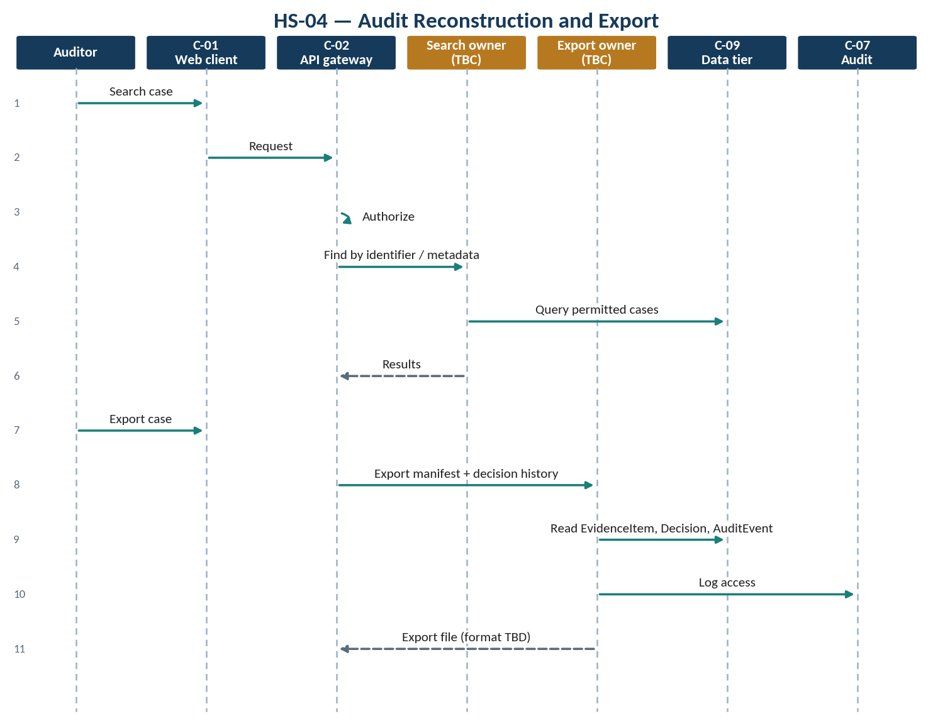
Figure 10 — HS-04 — audit reconstruction and export

6.2.5 HS-05 Exception Handling
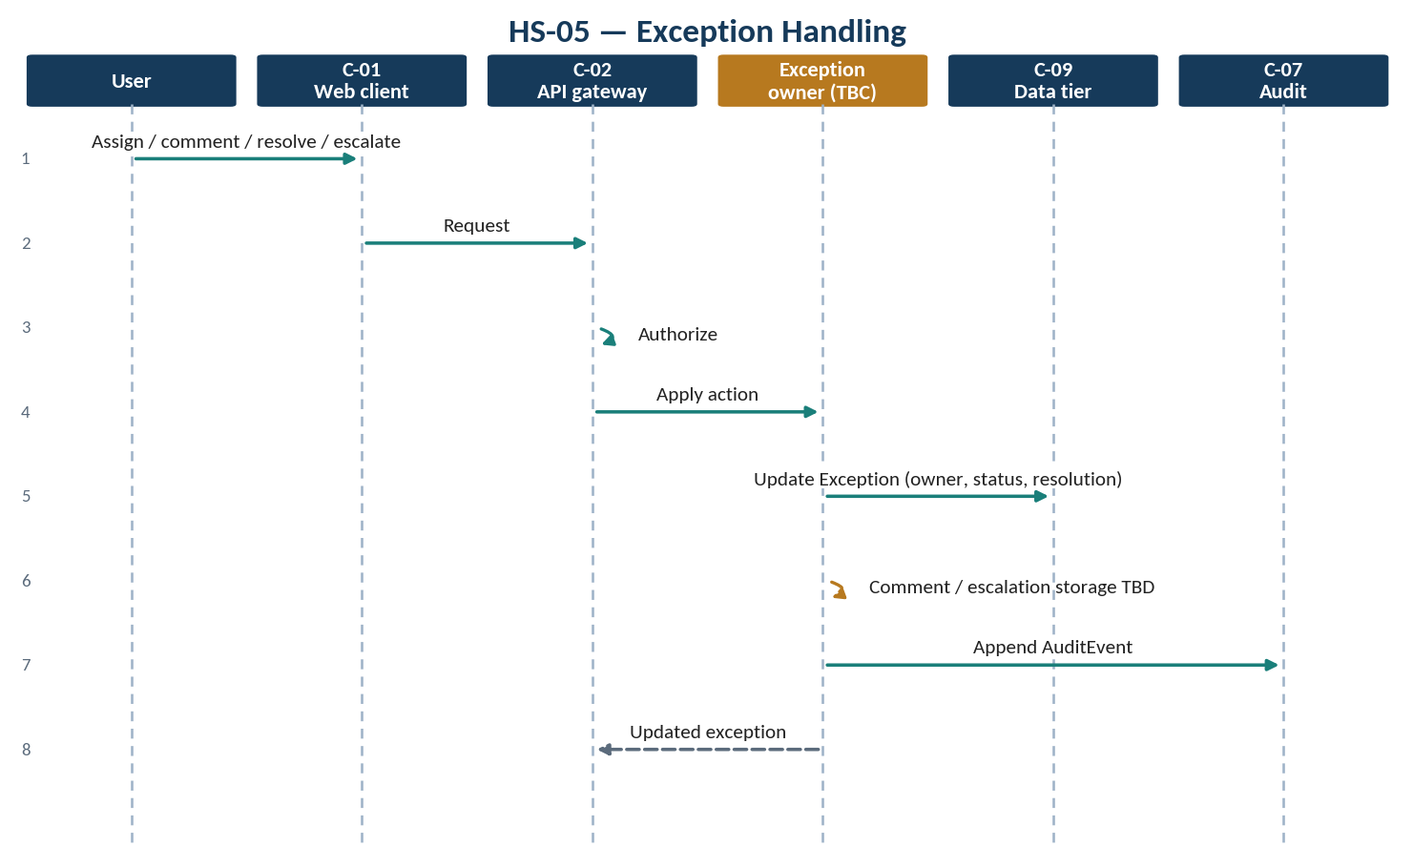
Figure 11 — HS-05 — exception handling

6.2.6 HS-06 Integration Call
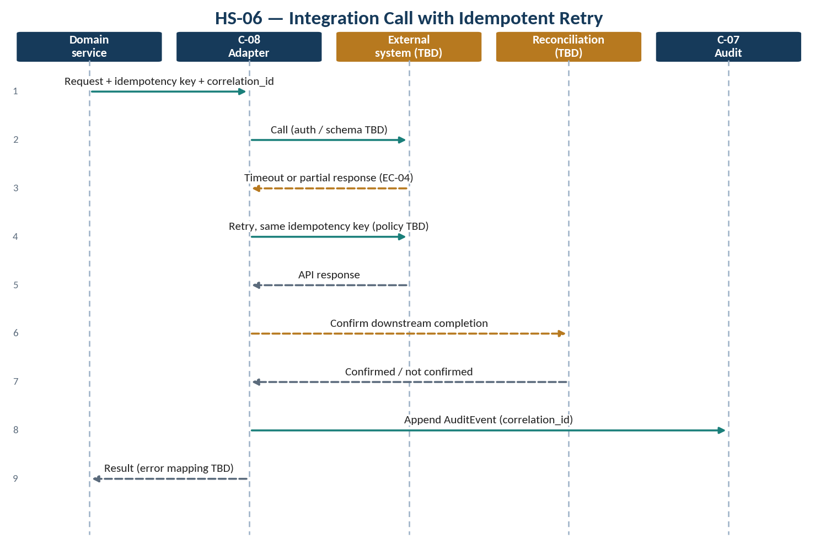
Figure 12 — HS-06 — integration call with idempotent retry

6.2.7 HS-07 Unauthorized Access Attempt
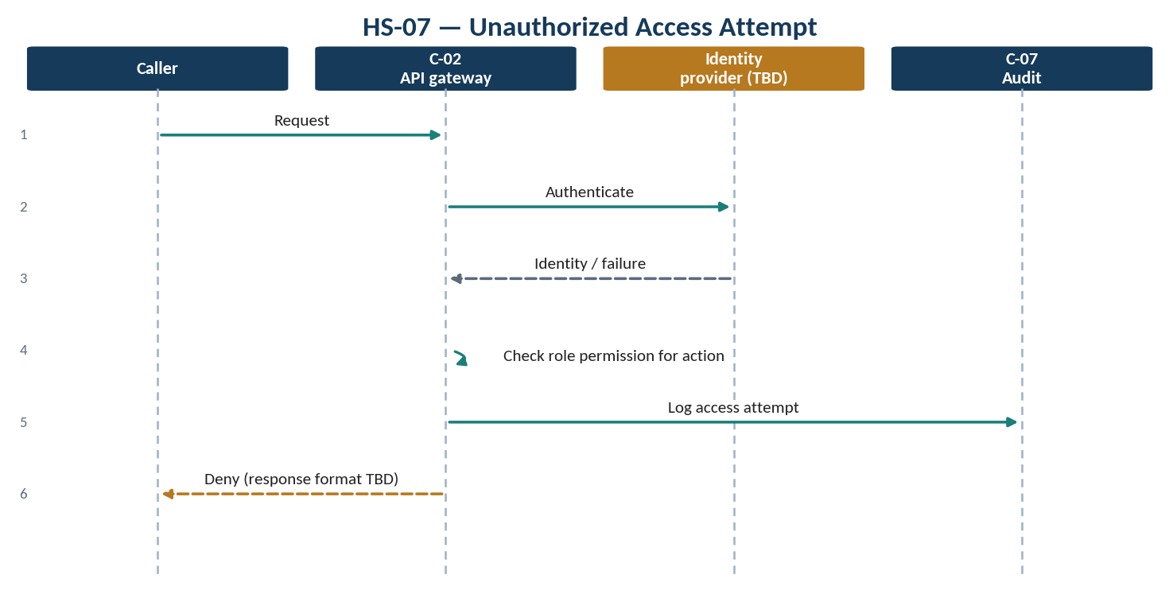
Figure 13 — HS-07 — unauthorized access attempt

7 Interface Viewpoint — Integrations

7.1 Interface Register
Table 14 — Interface register
ID | From → To | Purpose | Protocol / contract
IF-01 | C-01 → C-02 | User requests | TBD; encryption in transit (PRS §4)
IF-02 | C-02 → C-03 … C-07 | Authorized service calls | TBD; versioned APIs (PRS §4)
IF-03 | C-04 → C-09 object storage | Evidence storage with checksum | TBD
IF-04 | C-03 … C-07 → C-09 relational | Entity persistence | TBD; automated migrations
IF-05 | C-08 ↔ external systems | Integration per external system | TBD per adapter
IF-06 | C-02 ↔ identity provider | Authentication | TBD (HLD §9)
IF-07 | All → C-10 | Logs, health, monitoring | TBD; structured logs

7.2 Integration Approach
Adapter interfaces are used per external bank/system. Authentication, payload schema, timeout, retry policy, idempotency, error mapping and reconciliation are specified before implementation. A successful API response is never treated as proof that a downstream business action completed unless confirmed (HLD §6).
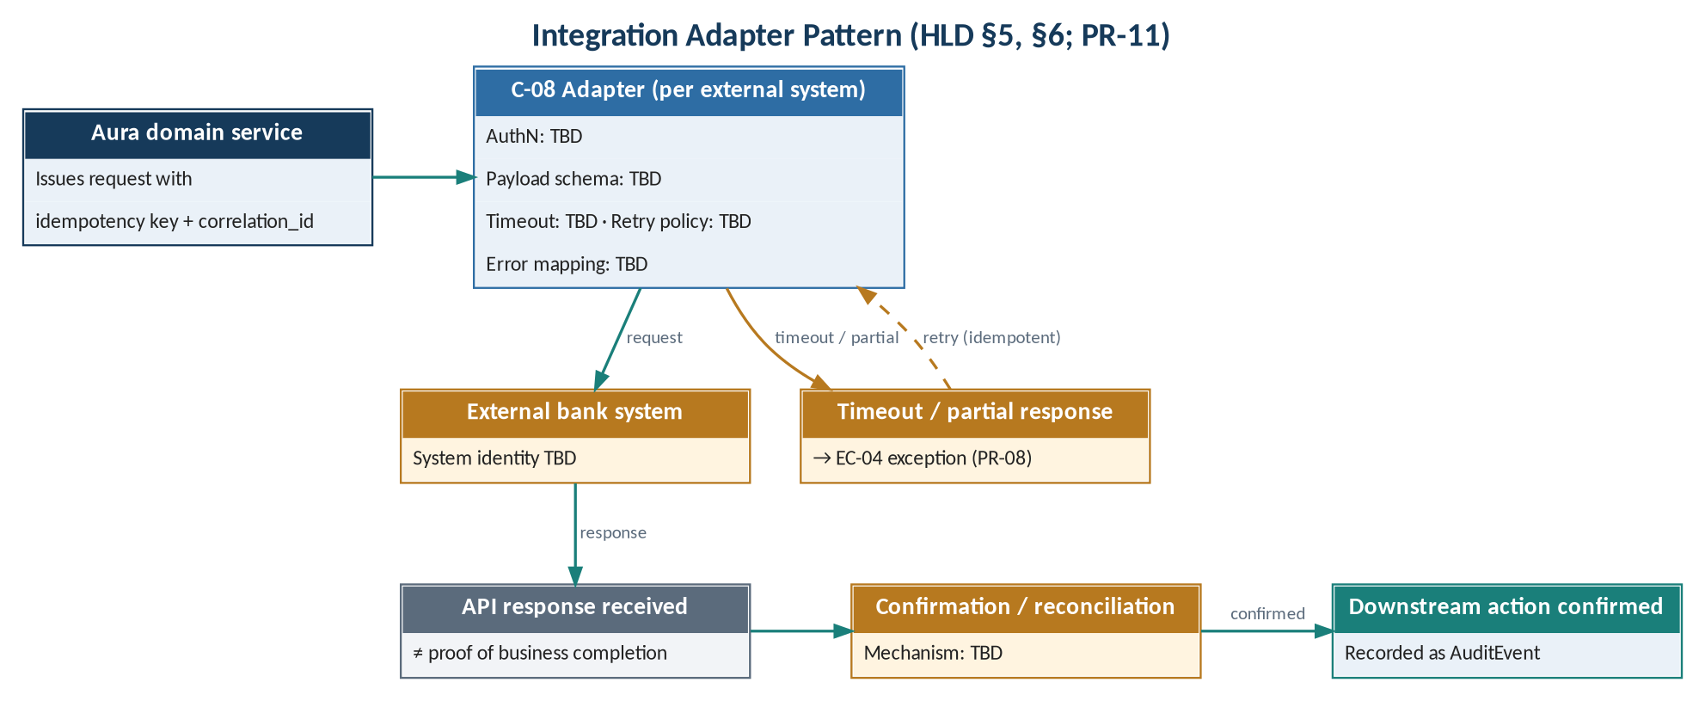
Figure 14 — Integration adapter pattern
Table 15 — Adapter contract elements
Element (HLD §6) | Value | Note
External system | TBD | OD-04; MRS §9
Authentication | TBD
Payload schema | TBD | Versioned
Timeout | TBD | Timeout → EC-04
Retry policy | TBD | Same idempotency key
Idempotency | Idempotency keys | HLD §5
Error mapping | TBD
Reconciliation | TBD | Required before completion is assumed
Correlation | Correlation IDs | HLD §5

7.3 Candidate Integration Targets
Table 16 — Integration targets
Target | Direction | Status
Existing LOS / LMS / core systems | TBD | Open question (MRS §9)
Identity provider | Inbound authentication | Pending (HLD §9)
Instruments / devices | Evidence source | Supported types TBD (MRS §9)

8 Security Viewpoint
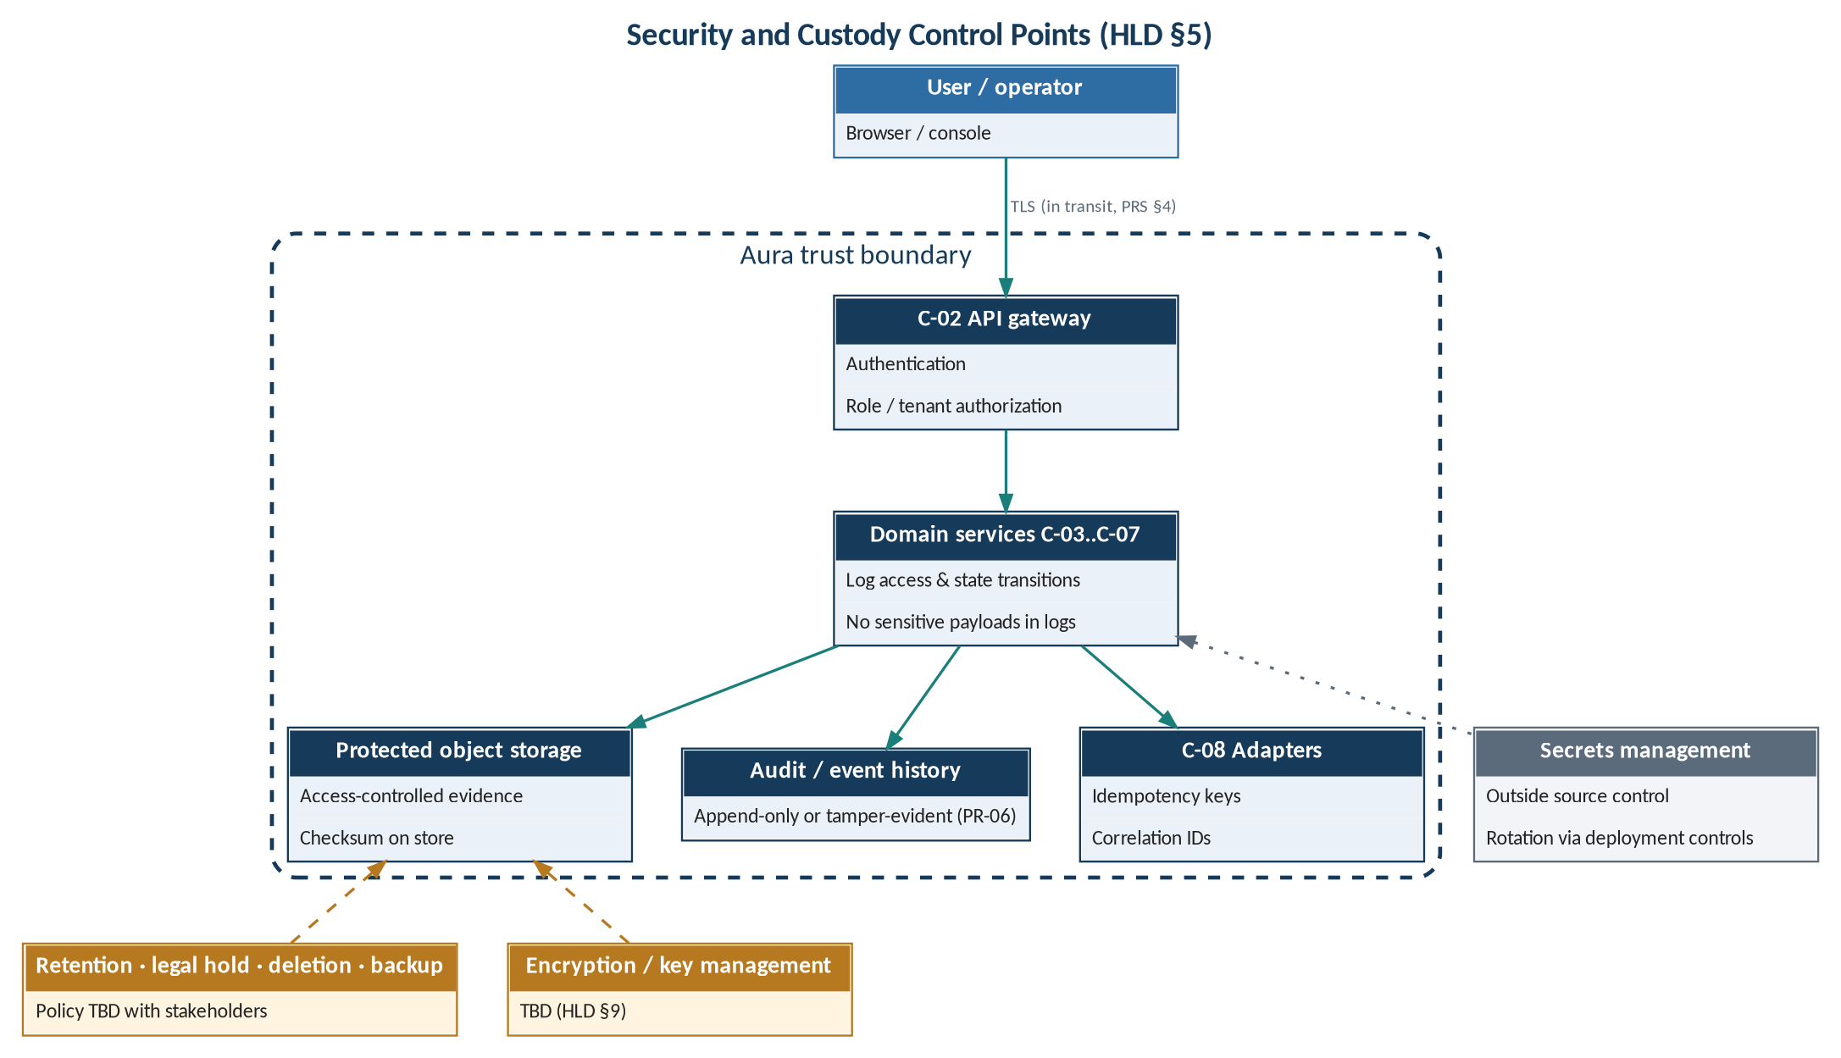
Figure 15 — Security and custody control points
Table 17 — Security and custody controls
ID | Control (HLD §5) | Requirement | Status
SC-01 | Authentication and role/tenant authorization at API boundaries | PR-07; NFR-01 | Stated; IdP TBD
SC-02 | Secrets outside source control; rotated through deployment controls | NFR-01 | Stated
SC-03 | Evidence stored with access controls; checksums detect unintended changes | PR-01, PR-06 | Stated; algorithm TBD
SC-04 | Log access and material state transitions without sensitive payloads | PR-06, PR-12 | Stated
SC-05 | Retention, legal hold, deletion and backup policy with stakeholders | NFR-04 | TBD
SC-06 | Idempotency keys and correlation IDs for retryable integrations | PR-11 | Stated
SC-07 | Encryption in transit and at rest where supported by deployment | NFR-01 (PRS §4) | Key management TBD

Table 18 — Security-relevant exception cases
Case | Threat / condition | Controls | Behaviour
EC-05 | Unauthorized access attempt | SC-01, SC-04 | TBD
EC-07 | Modification of a finalized decision | SC-01; PR-06 tamper-evident history | TBD
EC-02 | Duplicate or stale upload | SC-03 checksum (TBC) | TBD

9 Deployment Viewpoint
Environment-specific configuration, automated migrations, health/readiness endpoints, structured logs, monitoring, backup/restore tests and documented rollback are required (HLD §7). The hosting model, tenancy, storage and DR objectives are pending (HLD §9); no physical topology is asserted.
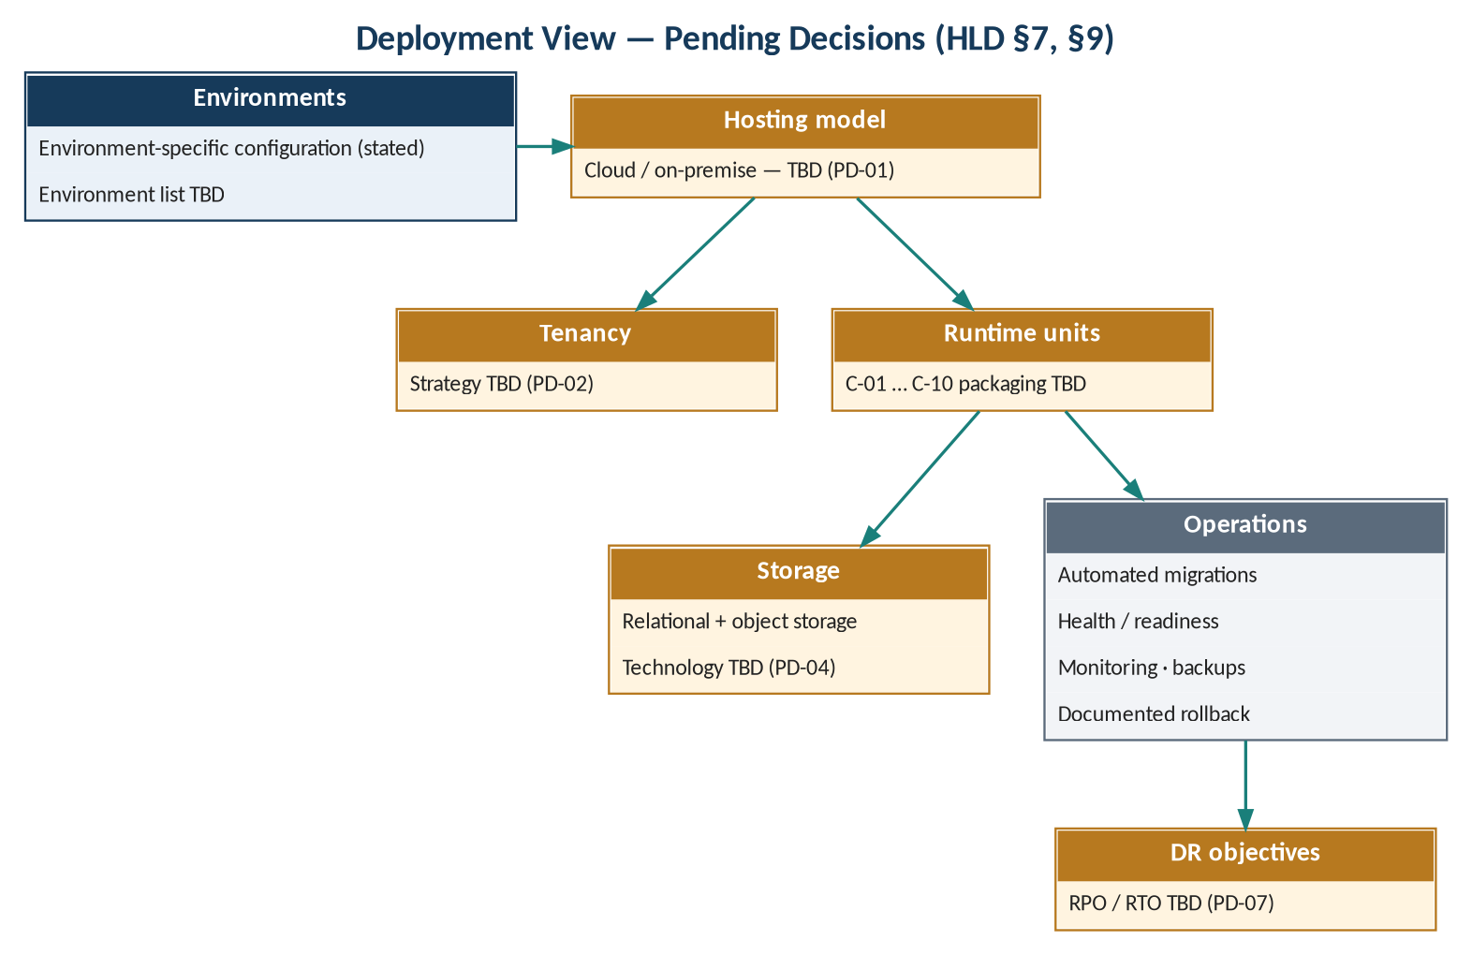
Figure 16 — Deployment view — pending decisions
Table 19 — Reliability and deployment practices
ID | Practice (HLD §7) | Supports
OP-01 | Environment-specific configuration | Maintainability
OP-02 | Automated migrations | NFR-06
OP-03 | Health/readiness endpoints | PR-12; availability
OP-04 | Structured logs | PR-12
OP-05 | Monitoring | PR-12; availability
OP-06 | Backup/restore tests | Availability; NFR-02
OP-07 | Documented rollback | Availability

Table 20 — Pending architecture decisions
ID | Decision area (HLD §9) | Options | Status
PD-01 | Cloud / on-premise model | TBD | Pending
PD-02 | Tenancy strategy | TBD | Pending
PD-03 | Identity provider | TBD | Pending
PD-04 | Storage technology | TBD | Pending
PD-05 | Eventing needs | TBD | Pending
PD-06 | Encryption / key management | TBD | Pending
PD-07 | Disaster recovery objectives | TBD | Pending

10 Quality Attribute Considerations
The source baseline defers all quantitative quality targets: capacity and availability targets remain TBD pending workload discovery (HLD §7); reliability objectives follow agreed workload and hosting assumptions; performance targets follow pilot volume and user expectations (PRS §4). This section records the design mechanisms the source already provides for each attribute and the targets still required.
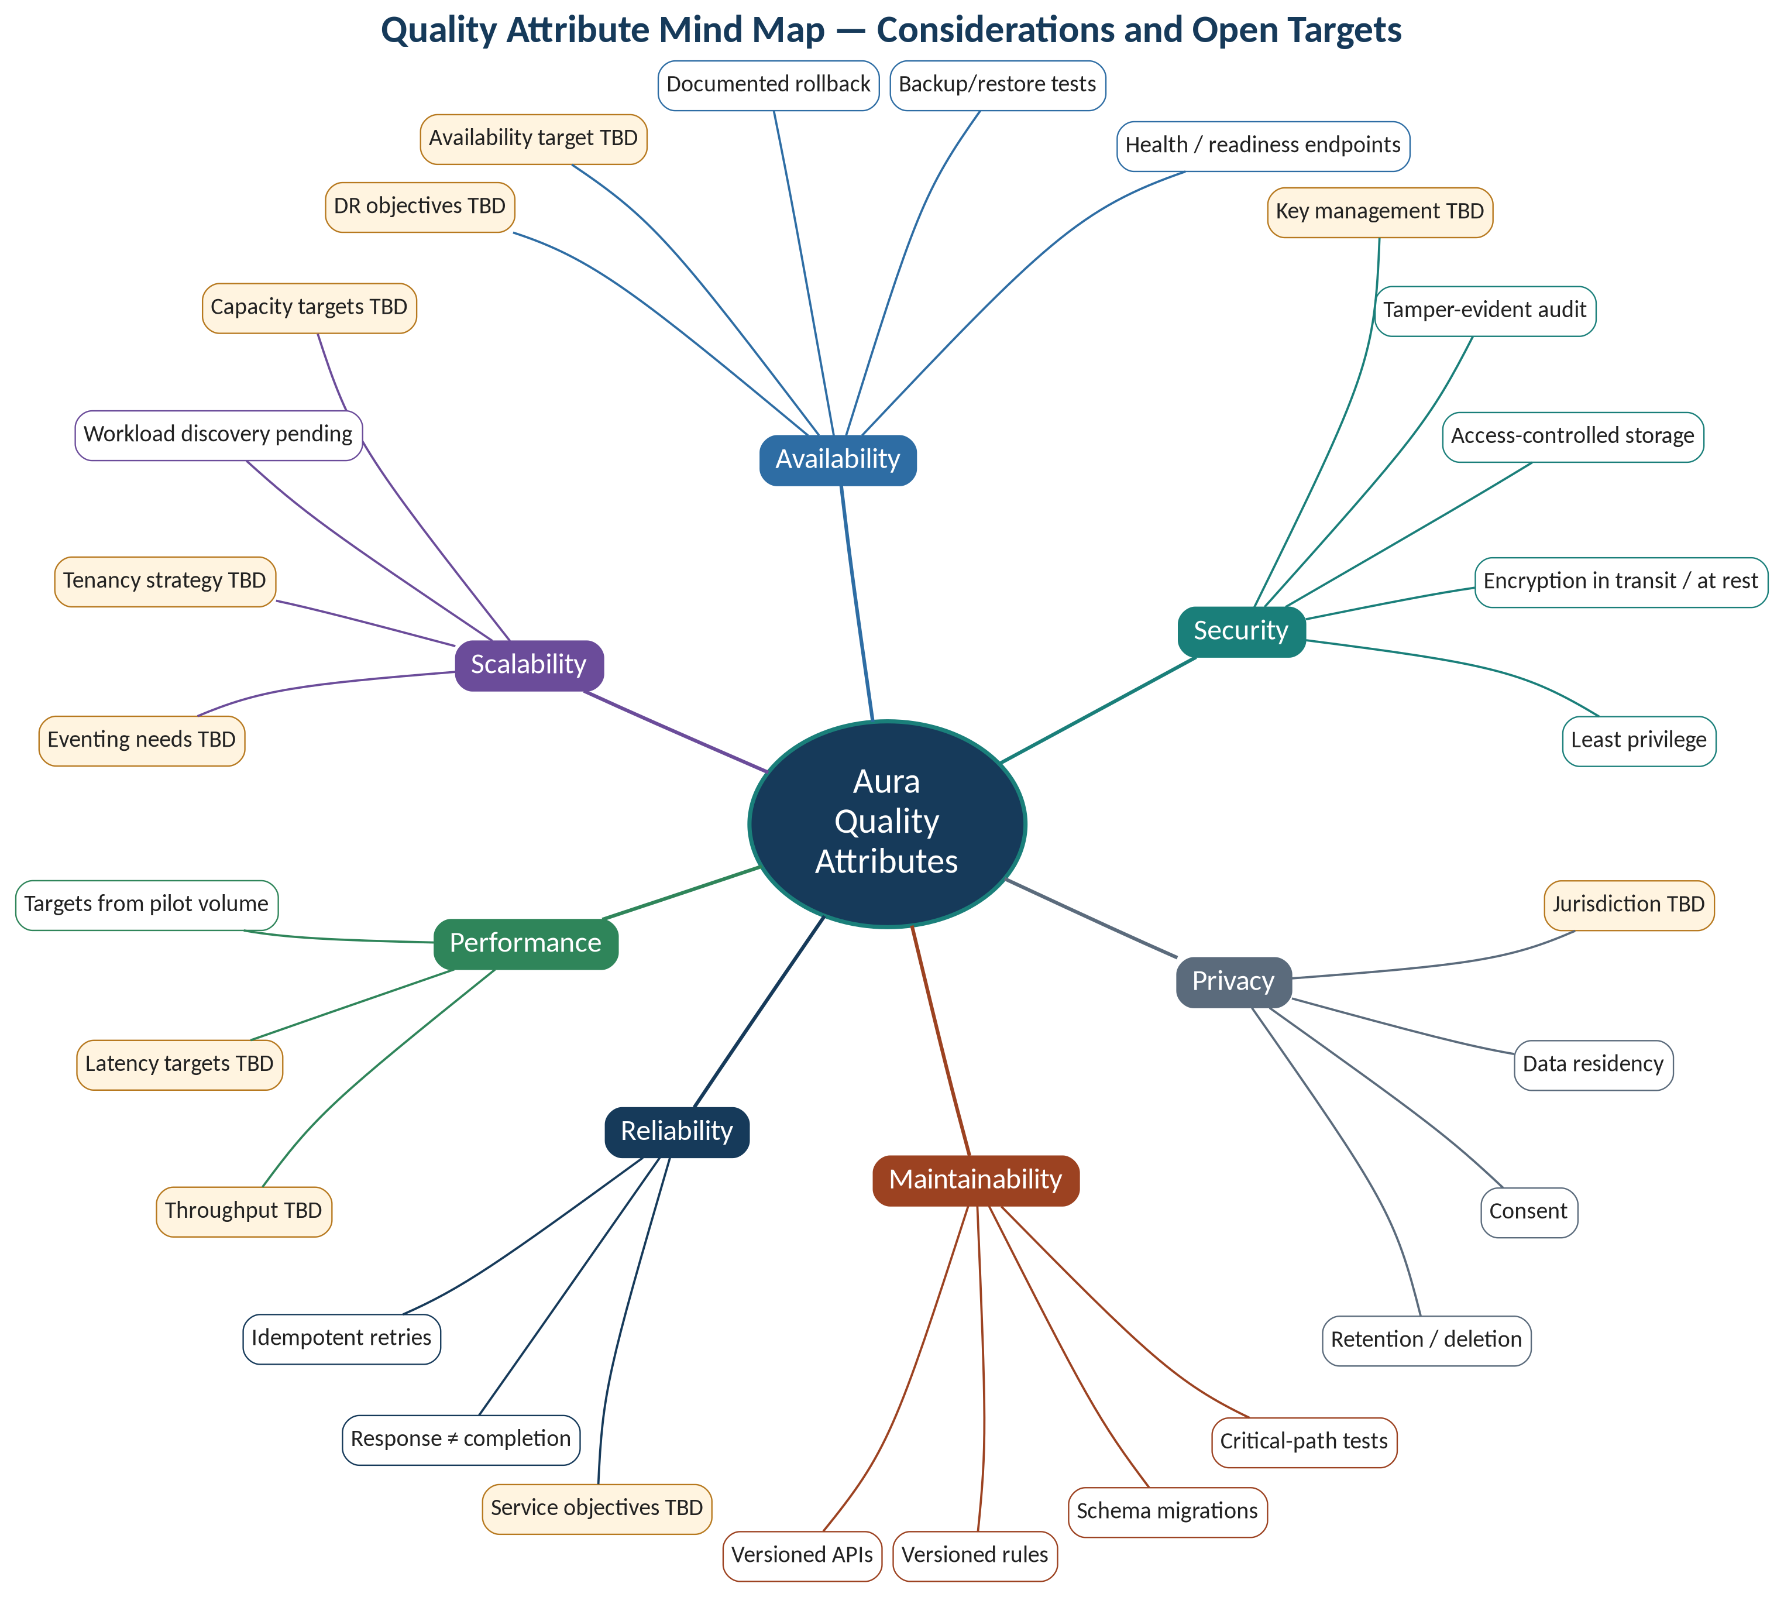
Figure 17 — Quality attribute mind map

10.1 Scalability
Table 21 — Scalability considerations
ID | Consideration | Mechanism in source baseline | Target | Status
QS-01 | Workload capacity | None stated; workload discovery pending (HLD §7) | TBD | Open
QS-02 | Tenant growth | Role/tenant authorization at API boundary (HLD §5) | TBD | PD-02 pending
QS-03 | Evidence volume | Separate protected object storage for evidence (HLD §2) | TBD | PD-04 pending
QS-04 | Asynchronous processing | Eventing needs listed as pending (HLD §9) | TBD | PD-05 pending
QS-05 | Integration volume | Adapter per external system (HLD §6) | TBD | OD-04 pending
QS-06 | Independent component scaling | Separation of concerns (HLD §1); scaling model not stated | TBD | Depends on PD-01

10.2 Availability
Table 22 — Availability considerations
ID | Consideration | Mechanism in source baseline | Target | Status
QA-01 | Availability objective | Defined after workload and hosting agreed (PRS §4) | TBD | Open
QA-02 | Failure detection | Health/readiness endpoints; monitoring; alerting (HLD §2, §7) | TBD | Stated mechanism
QA-03 | Recovery | Backup/restore tests; documented rollback (HLD §7) | RPO/RTO TBD | PD-07 pending
QA-04 | External dependency failure | Timeout, retry, idempotency, reconciliation per adapter (HLD §6) | TBD | Stated mechanism
QA-05 | Data durability | Backup policy with stakeholders (HLD §5) | TBD | Open

10.3 Performance
Table 23 — Performance considerations
ID | Consideration | Mechanism in source baseline | Target | Status
QP-01 | Response time | Targets from pilot volume and user expectations (PRS §4) | TBD | Open
QP-02 | Throughput (intake, validation) | None stated | TBD | Open
QP-03 | Search and export | PR-09, PR-10 functional only | TBD | Open
QP-04 | Integration latency | Timeout specified per adapter (HLD §6) | TBD | Open
QP-05 | Measurement | Structured logs, monitoring, correlation IDs (HLD §5, §7) | — | Stated mechanism

10.4 Reliability, Maintainability and Privacy
Table 24 — Other quality considerations
Attribute | Mechanism in source | Target / status
Reliability | Idempotent integrations; response ≠ completion; explicit workflow state (HLD §1, §6) | Service objectives TBD (PRS §4)
Maintainability | Versioned APIs, rules and schema migrations; critical-path tests (PRS §4) | Coverage criteria TBD
Privacy | Retention, deletion, consent, residency require jurisdictional review (PRS §4) | Jurisdiction TBD (MRS §9)
Observability | Structured logs, health checks, actionable errors (PR-12); payload-free logs (HLD §5) | Alert thresholds TBD

11 Design Rationale and Decisions
Table 25 — Architecture decisions — stated
ID | Decision | Rationale | Source
AD-01 | Adapter interface per external bank/system | Integration variability; separation of concerns | HLD §6, §8
AD-02 | Versioned rule sets referenced by decisions | Versioned rules; evidence lineage | HLD §1, §3
AD-03 | Append-only or tamper-evident history | Audit-ready reconstruction | PRS PR-06
AD-04 | Checksums on stored evidence | Custody; detect unintended changes | HLD §5
AD-05 | Idempotency keys and correlation IDs | Idempotent integrations; observable failures | HLD §5
AD-06 | API response is not proof of business completion | Integration correctness | HLD §6

12 Key Risks
Table 26 — Architecture risks
ID | Risk (HLD §8) | Design response | Likelihood / impact
AR-01 | Unconfirmed bank policies | Configurable, versioned rules | TBD
AR-02 | Unknown evidence formats | TBD (OD-01) | TBD
AR-03 | Unclear data residency | TBD (jurisdictional review) | TBD
AR-04 | Integration variability | Adapter per system; contracts first | TBD
AR-05 | Unvalidated decision rules | Rule versions recorded on decisions | TBD

13 Requirements Allocation

13.1 Product Requirement → Component
Table 27 — PR → component allocation matrix
PR | C-01 | C-02 | C-03 | C-04 | C-05 | C-06 | C-07 | C-08 | C-09 | C-10
PR-01 | ● |  | ● | ● |  |  |  |  | ●
PR-02 |  |  |  | ●
PR-03 |  |  |  |  | ●
PR-04 | ● |  |  | ● | ●
PR-05 |  |  |  |  |  | ●
PR-06 |  |  |  |  |  |  | ● |  | ●
PR-07 |  | ●
PR-08 | ● |  | ?
PR-09 |  |  | ?
PR-10 |  |  |  |  |  |  | ?
PR-11 |  |  |  |  |  |  |  | ●
PR-12 |  |  |  |  |  |  |  |  |  | ●

Legend: ● allocated from source content; ? candidate allocation (TBC).

13.2 Use Case → Scenario
Table 28 — Use case to scenario allocation
Use case (PRS 2.0) | Scenario | Note
UCS-01, UCS-02 | HS-01
UCS-03, UCS-04 | HS-02
UCS-05 | HS-03
UCS-06, UCS-08, UCS-09 | HS-04
UCS-07 | HS-05
UCS-10 | HS-07 | Denial path
UCS-11 | HS-06 | Runtime behaviour of a committed integration
UCS-12 | §9 / §10.2 | Operational monitoring
UCS-13 | §5 (RuleSetVersion) | No dedicated scenario

13.3 Non-Functional Requirement → Design
Table 29 — NFR → design allocation
NFR | Area | Design element(s)
NFR-01 | Security | C-02; SC-01, SC-02, SC-07; PD-06
NFR-02 | Reliability | OP-03, OP-05 – OP-07; QA-01 – QA-05
NFR-03 | Performance | QP-01 – QP-05
NFR-04 | Privacy | SC-05; PD-01; AR-03
NFR-05 | Accessibility | C-01
NFR-06 | Maintainability | Versioned APIs (IF-02); AD-02; OP-02

13.4 Exception Case → Design
Table 30 — EC → design allocation
EC | Exception case | Design element(s) | Scenario
EC-01 | Missing or unreadable evidence | C-04, C-05; Exception | HS-01, HS-02
EC-02 | Duplicate or stale uploads | C-04 (checksum, TBC); C-05 | HS-01
EC-03 | Conflicting evidence values | C-05; Exception | HS-02
EC-04 | Integration timeout or partial response | C-08; retry; reconciliation TBD | HS-06
EC-05 | Unauthorized access attempt | C-02; SC-01; SC-04 | HS-07
EC-06 | Rule version changed after case creation | RuleSetVersion; Decision.rule version | HS-02
EC-07 | Modify a finalized decision | C-06; C-07; behaviour TBD | HS-03

Appendix A — TBD Register
Table 31 — TBD register
ID | Item | Source | Blocks
TBD-01 | PD-01 – PD-07 architecture decisions | HLD §9 | §9; technology
TBD-02 | Capacity, availability, performance, RPO/RTO targets | HLD §7; PRS §4 | §10
TBD-03 | Data-model gaps DG-01 – DG-07 | PRS §3 vs HLD §3 | §5.3
TBD-04 | Owners for exceptions, search, export | Not in source | §4.2
TBD-05 | External systems and adapter contracts | HLD §6; MRS §9 | §7
TBD-06 | Retention, legal hold, deletion, backup policy | HLD §5 | SC-05
TBD-07 | Validation trigger, status transitions, approval step | Not in source | HS-02, HS-03
TBD-08 | Risk ratings | Not in source | §12
TBD-09 | Document owner, classification and approvers | Not in source | Document control

Appendix B — Changes from AURA-HLD-1.0
Table 32 — Change log
Area | Change
Mind maps | Added architecture mind map (§2.2) and quality attribute mind map (§10).
Views | Added layered architecture view (§2.3) and deployment pending-decision view (§9).
Scenarios | Replaced four step tables with seven high-level user scenarios HS-01 – HS-07 and sequence diagrams (§6).
Quality attributes | New §10 with scalability, availability and performance considerations; all targets TBD.
Traceability | Added use case → scenario allocation (§13.2) aligned with AURA-PRS-2.0.
Source architecture | No change to components, entities, controls, practices, decisions or risks.

