AURA
Evidence Intake · Validation · Decision Traceability
Requirements & Architecture Series · MRS · PRS · SyRS · HLD · LLD · PDLC
AURA LOW-LEVEL DESIGN
Detailed Module, Data, Interface and Logic Design — Initial Baseline
Document ID | AURA-LLD-1.0
Version | 1.0
Status | INITIAL BASELINE — FOR REVIEW
Date | 2026-10-13
Classification | TBD
Prepared By | Senior Software Architect (organisation TBD)
Standard | IEEE 1016-2009
Companion Docs | AURA-HLD-1.0 (parent) · AURA-SYRS-1.0 · AURA-PDLC-1.0
Technology, data types, endpoint paths and parameter values are not defined in the baseline (PD-01 – PD-07) and are marked TBD. Classification and distribution: TBD.

Document Control
Document ID | AURA-LLD-1.0
Title | Low-Level Design Description — Aura
Version | 1.0
Status | Initial baseline for review
Date | 13 October 2026
Product | Aura — controlled evidence intake, validation and decision traceability workflow
Standard | IEEE Std 1016-2009 — Software Design Descriptions (detailed design viewpoints)
Source basis | AURA-HLD-1.0 (parent design), AURA-PRS-1.0 and AURA-MRS-1.0; system requirements per AURA-SYRS-1.0. Reference documents supplied for formatting only.
Owner | TBD
Series | AURA-MRS · AURA-PRS · AURA-SYRS · AURA-HLD · AURA-LLD · AURA-PDLC

Revision History
Version | Date | Author | Description
1.0 | 13 October 2026 | Senior Software Architect | Initial baseline refining AURA-HLD-1.0 components C-01 – C-10 into design units. No technology or value introduced beyond the baseline.

Review and Approval
Role | Name | Signature | Date
Prepared by — Senior Software Architect | TBD
Reviewed by — Product Management | TBD
Reviewed by — Risk / Compliance | TBD
Approved by — Product Owner | TBD

Evidence Conventions
Marker | Meaning
MRS §n | Section n of AURA-MRS-1.0 — Market Requirements Specification (finalized baseline).
PRS §n | Section n of AURA-PRS-1.0 — Product Requirements Specification (finalized baseline).
HLD §n | Section n of AURA-HLD-1.0 — High-Level Design (finalized baseline).
ID references | Identifiers defined in the finalized baseline: MR, MP, MS, SM, OQ, CN, GC, RK (MRS); PR, NFR, EC, OD, UC (PRS); C, IF, SC, OP, AP, AD, PD, AR, DG (HLD).
Stated | Content taken directly from the finalized MRS, PRS or HLD; wording preserved where practical.
Derived | Structural derivation by the architect (identifier assignment, decomposition, allocation, trace links, proposed verification method) from stated content. No new requirement, value or technology is introduced; derived items require confirmation.
TBD / TBC | To be determined / to be confirmed. The baseline does not provide this information; no value is asserted.

Table of Contents
1 Introduction 8
1.1 Purpose 8
1.2 Scope 8
1.3 Conventions 8
1.4 References 8
2 Module Detailed Design 10
2.1 C-01 Web Client / Operator Console 11
2.2 C-02 API Gateway and Identity Boundary 11
2.3 C-03 Case Management Service 11
2.4 C-04 Evidence Ingestion and Metadata Service 11
2.5 C-05 Validation / Rules Service 12
2.6 C-06 Decision Record Service 12
2.7 C-07 Audit / Event History Service 12
2.8 C-08 Integration Adapters 12
2.9 C-09 Relational Data Store and Protected Object Storage 13
2.10 C-10 Monitoring, Logging, Alerting and Backup 13
3 Data Design 14
3.1 Conceptual to Logical Data Model 14
3.2 Entity Definitions 15
3.2.1 Case 15
3.2.2 EvidenceItem 15
3.2.3 RuleSetVersion 15
3.2.4 Decision 16
3.2.5 AuditEvent 16
3.2.6 Exception 16
3.3 Data Design Gaps 17
3.4 Data Access Restriction Pattern 17
3.5 Retention and Storage 17
4 Interface Design 18
4.1 Internal and External Interfaces 18
4.2 Logical Operations 18
4.3 Integration Adapter Contract Template 19
5 Processing Logic 20
5.1 Access Evaluation 20
5.2 Case Creation and Evidence Intake 21
5.3 Completeness and Validation Evaluation 22
5.4 Decision Recording 23
5.5 Audit Event Append 24
5.6 Integration Call 24
5.7 Exception Handling 25
5.8 Search and Export 25
6 State-Transition Design 26
7 Error Handling 27
8 Configuration Parameters 28
9 Unit Test Design 29
10 Traceability 30
10.1 System Requirement → Design Unit 30
11 Open Issues 32

List of Figures
Figure 1 — Component to design unit decomposition 10
Figure 2 — Entity–relationship model (from HLD §5.1) 14
Figure 3 — Access evaluation logic 20
Figure 4 — Sequence S1 — case creation and evidence intake 21
Figure 5 — Completeness and validation evaluation 22
Figure 6 — Sequence S3 — review and decision 23
Figure 7 — Sequence S5 — integration call with idempotent retry 24
Figure 8 — Evidence validation status model 26
List of Tables
Table 1 — Design conventions 8
Table 2 — References 8
Table 3 — C-01 design units 11
Table 4 — C-02 design units 11
Table 5 — C-03 design units 11
Table 6 — C-04 design units 11
Table 7 — C-05 design units 12
Table 8 — C-06 design units 12
Table 9 — C-07 design units 12
Table 10 — C-08 design units 12
Table 11 — C-09 design units 13
Table 12 — C-10 design units 13
Table 13 — Case — logical definition 15
Table 14 — EvidenceItem — logical definition 15
Table 15 — RuleSetVersion — logical definition 15
Table 16 — Decision — logical definition 16
Table 17 — AuditEvent — logical definition 16
Table 18 — Exception — logical definition 16
Table 19 — Data design gaps carried from HLD §5.3 17
Table 20 — Interface design 18
Table 21 — Logical operation specifications 18
Table 22 — Adapter contract template 19
Table 23 — Access evaluation steps 20
Table 24 — Evidence intake steps 21
Table 25 — Validation steps 22
Table 26 — Decision recording steps 23
Table 27 — Audit append steps 24
Table 28 — Integration call steps 25
Table 29 — Exception handling steps 25
Table 30 — Search and export steps 25
Table 31 — Validation status transition table 26
Table 32 — Other state-bearing entities 26
Table 33 — Error handling design 27
Table 34 — Configuration parameters 28
Table 35 — Unit test design 7
Table 36 — SYS → design unit traceability 7
Table 37 — Open design issues 7

1 Introduction

1.1 Purpose
This Low-Level Design (LLD) refines AURA-HLD-1.0 to the level of design units, data definitions, logical interfaces, processing logic, state handling, error handling, configuration and unit test design. It realises the system requirements of AURA-SYRS-1.0. Where the baseline does not supply a value or technology, the item is marked TBD rather than assumed.

1.2 Scope
All ten logical components C-01 – C-10 (HLD §4.1), the six conceptual entities (HLD §5), interfaces IF-01 – IF-07 (HLD §6) and scenarios S1 – S4 plus the integration pattern (HLD §6.2, §7).
Implementation language, frameworks, storage technology, identity provider and deployment model are pending decisions PD-01 – PD-07. Consequently this LLD specifies logic and contracts technology-neutrally; code-level signatures, data types and endpoint paths are TBD.

1.3 Conventions
Table 1 — Design conventions
Item | Convention | Status
Design unit ID | U-cc.n — n-th unit of component C-cc (Derived) | Defined here
Logical operation ID | LO-nn (Derived) | Defined here
Unit test ID | UT-nn (Derived) | Defined here
Entity identifiers | case_id, evidence_id, ruleset_id, decision_id, event_id, exception_id (HLD §5.2) | Stated
Identifier format | TBD | TBD
Data types | TBD (storage technology PD-04) | TBD
Time and time zone | TBD | TBD
Implementation language / frameworks | TBD | TBD
Validation status domain | pending, valid, invalid, exception (PR-04) | Stated
API versioning | APIs versioned (NFR-06); scheme TBD | Stated / TBD
Correlation | correlation_id carried on integration calls and AuditEvents (HLD §5.2, SC-06) | Stated

1.4 References
Table 2 — References
ID | Document
R1 | AURA-HLD-1.0 — High-Level Design (parent)
R2 | AURA-SYRS-1.0 — System Requirements Specification
R3 | AURA-PRS-1.0 — Product Requirements Specification
R4 | AURA-MRS-1.0 — Market Requirements Specification
R5 | AURA-PDLC-1.0 — Product Development Life Cycle
R6 | IEEE Std 1016-2009 — Software Design Descriptions

2 Module Detailed Design
Each HLD component is decomposed into design units. Unit responsibilities restate the component responsibilities in HLD §4.1 and the requirements they realise; the decomposition itself is Derived.
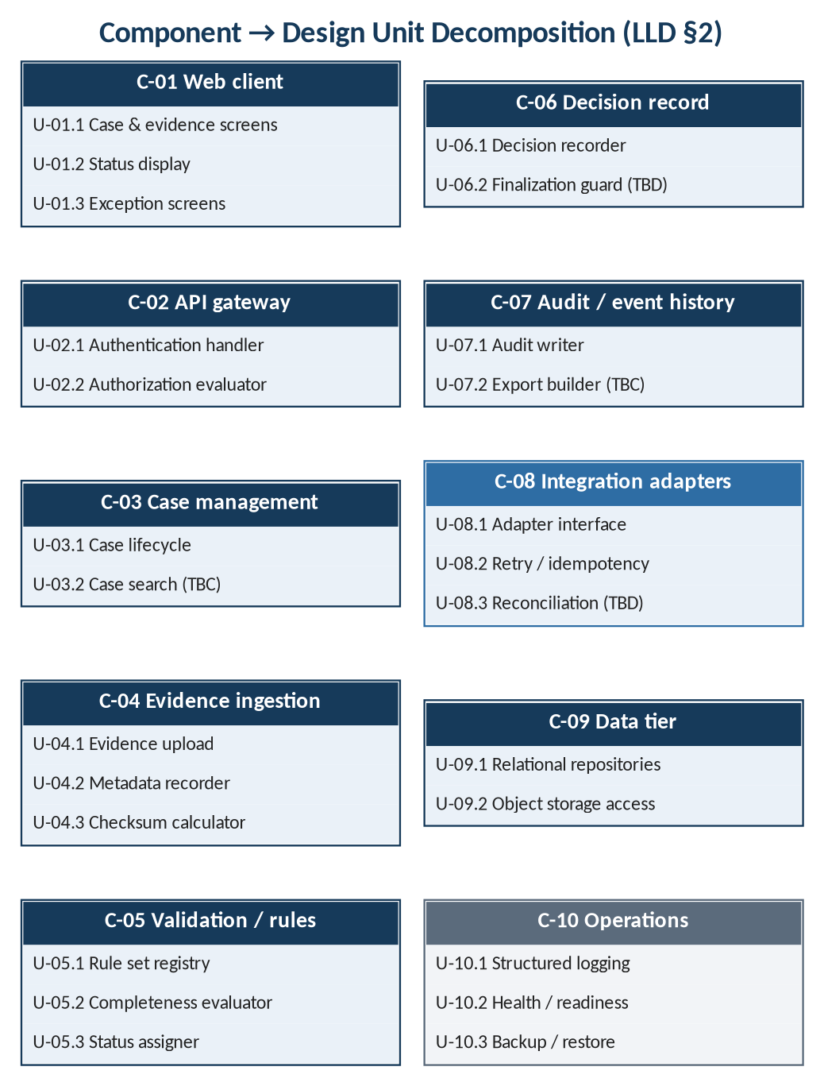
Figure 1 — Component to design unit decomposition

2.1 C-01 Web Client / Operator Console
Table 3 — C-01 design units
Unit | Responsibility (source) | Logical operations | Realises
U-01.1 | User interface for case creation and evidence attachment | LO-01, LO-02 (presentation) | SYS-IN-001, SYS-IN-002, SYS-US-001
U-01.2 | Visible validation status with clear status text | LO-03 (presentation) | SYS-VA-004, SYS-US-002
U-01.3 | Exception assign / comment / resolve / escalate screens | LO-05 – LO-08 (presentation) | SYS-EX-001

2.2 C-02 API Gateway and Identity Boundary
Table 4 — C-02 design units
Unit | Responsibility (source) | Logical operations | Realises
U-02.1 | Authenticate every request at the API boundary | Verify caller identity via IdP (TBD) | SYS-AC-002
U-02.2 | Role/tenant authorization; permission-restricted actions and records; least privilege | Evaluate permission for action; restrict records (§5.1) | SYS-AC-001, SYS-AC-003, SYS-AC-004, SYS-SE-003

2.3 C-03 Case Management Service
Table 5 — C-03 design units
Unit | Responsibility (source) | Logical operations | Realises
U-03.1 | Case lifecycle (Case entity) | LO-01 Create case; read case | SYS-IN-001
U-03.2 | Search and retrieval (owner TBC, HLD §4.2) | LO-09 Search cases | SYS-SR-001

2.4 C-04 Evidence Ingestion and Metadata Service
Table 6 — C-04 design units
Unit | Responsibility (source) | Logical operations | Realises
U-04.1 | Evidence upload and storage in protected object storage | LO-02 Attach evidence | SYS-IN-002, SYS-IN-004
U-04.2 | Metadata capture: timestamp, source, submitter, type, case | Record metadata on EvidenceItem | SYS-IN-003
U-04.3 | Checksum computation to detect unintended changes | Compute checksum on store (algorithm TBD) | SYS-IN-005

2.5 C-05 Validation / Rules Service
Table 7 — C-05 design units
Unit | Responsibility (source) | Logical operations | Realises
U-05.1 | Versioned rule sets (RuleSetVersion) | Register rule set version; select applicable version (rule TBD) | SYS-VA-002, SYS-VA-005
U-05.2 | Completeness checks against configurable rules | Evaluate required fields and evidence | SYS-VA-001
U-05.3 | Validation status assignment | Set status to pending / valid / invalid / exception | SYS-VA-003

2.6 C-06 Decision Record Service
Table 8 — C-06 design units
Unit | Responsibility (source) | Logical operations | Realises
U-06.1 | Decision records referencing rule version | LO-04 Record decision | SYS-DE-001, SYS-DE-002
U-06.2 | Protection of finalized decisions (behaviour TBD) | Reject or handle modification per rule TBD | SYS-DE-003

2.7 C-07 Audit / Event History Service
Table 9 — C-07 design units
Unit | Responsibility (source) | Logical operations | Realises
U-07.1 | Append-only / tamper-evident AuditEvents for access and material transitions | Append audit event (§5.5) | SYS-AU-001 – SYS-AU-003
U-07.2 | Export of evidence manifest and decision history (owner TBC, HLD §4.2) | LO-10 Export case | SYS-SR-002

2.8 C-08 Integration Adapters
Table 10 — C-08 design units
Unit | Responsibility (source) | Logical operations | Realises
U-08.1 | Adapter interface per external bank/system; documented contract | Invoke external system per contract | SYS-IG-001, SYS-IG-002
U-08.2 | Idempotency keys, correlation IDs and retry | Retry with same idempotency key (policy TBD) | SYS-IG-003
U-08.3 | Confirmation / reconciliation of downstream completion | Confirm before treating action as complete (mechanism TBD) | SYS-IG-004

2.9 C-09 Relational Data Store and Protected Object Storage
Table 11 — C-09 design units
Unit | Responsibility (source) | Logical operations | Realises
U-09.1 | Persistence of Case, EvidenceItem, RuleSetVersion, Decision, AuditEvent, Exception; versioned migrations | Create / read / update via repositories (technology TBD) | SYS-IM-001, SYS-IM-003, SYS-OP-003
U-09.2 | Access-controlled evidence object storage | Put / get evidence object by storage reference | SYS-IN-004, SYS-SE-002

2.10 C-10 Monitoring, Logging, Alerting and Backup
Table 12 — C-10 design units
Unit | Responsibility (source) | Logical operations | Realises
U-10.1 | Structured logs without sensitive payloads; monitoring | Emit structured log entry | SYS-OB-001, SYS-AU-003, SYS-OP-004
U-10.2 | Health and readiness endpoints; actionable error reporting | LO-11, LO-12 | SYS-OB-001, SYS-OB-002
U-10.3 | Backups and restore tests | Backup / restore (schedule TBD) | SYS-OP-001, SYS-OP-005

Exception handling (SYS-EX-001, SYS-EX-002) has a presentation unit (U-01.3) but no owning service in HLD §4.2; C-03 is the candidate owner (TBC). No service unit is defined until this is resolved.

3 Data Design

3.1 Conceptual to Logical Data Model
The six entities of HLD §5 are carried into the logical model unchanged. Data types depend on storage technology (PD-04) and are TBD; constraints are those stated or directly implied by the requirements.
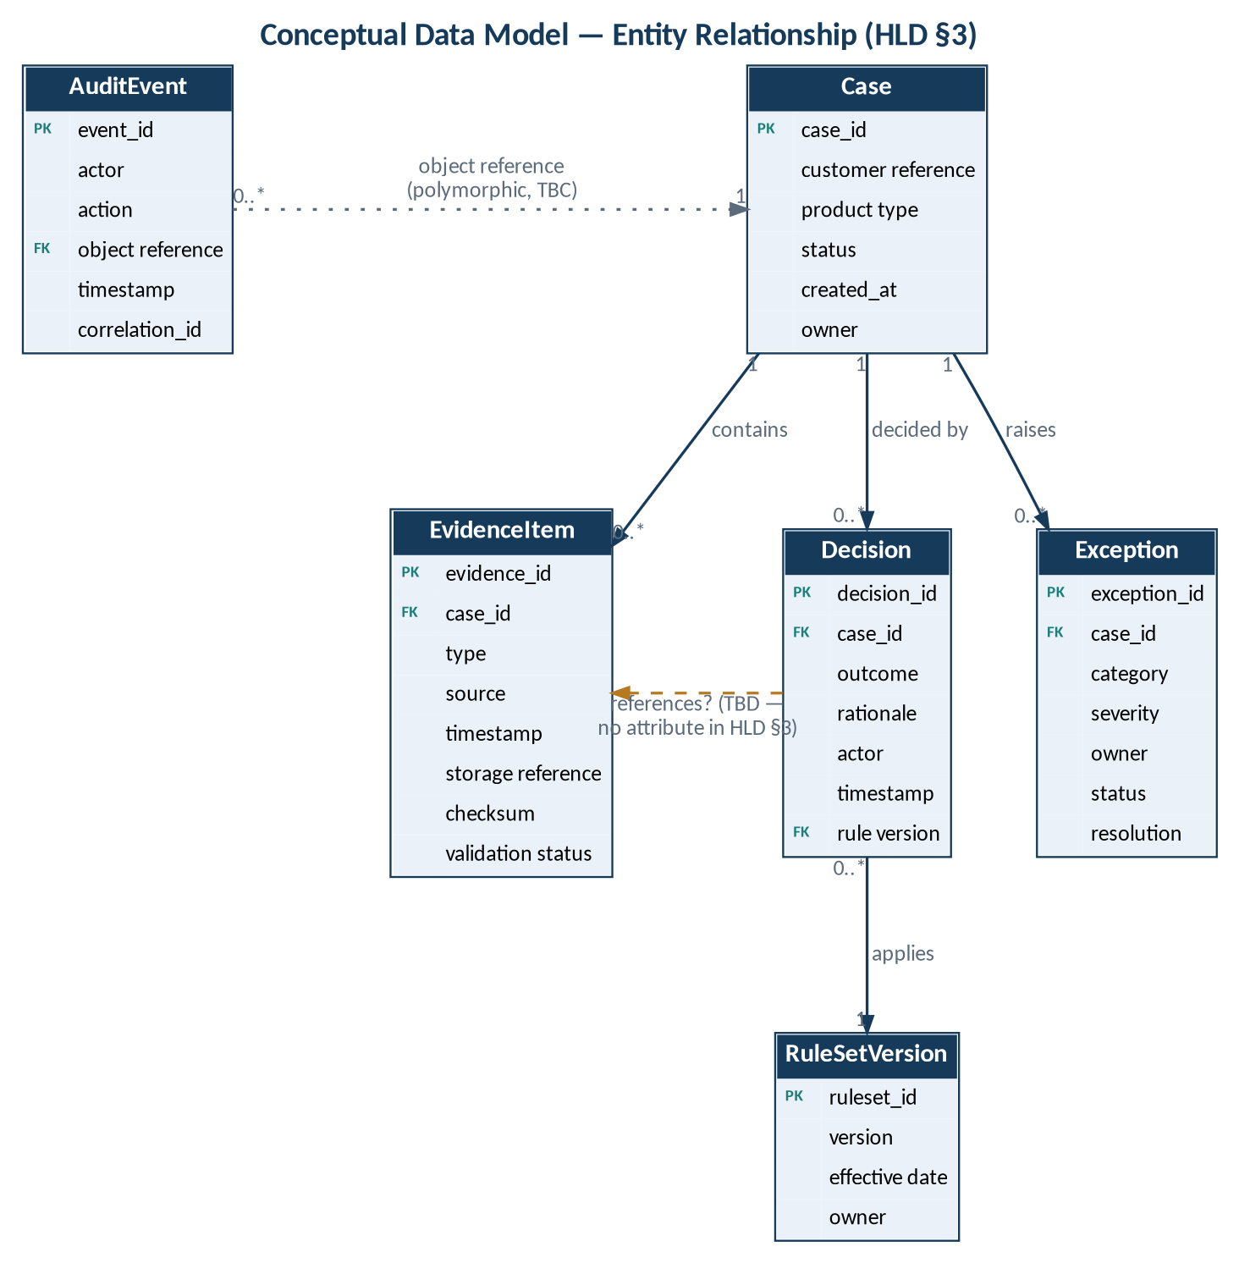
Figure 2 — Entity–relationship model (from HLD §5.1)

3.2 Entity Definitions

3.2.1 Case
Table 13 — Case — logical definition
Attribute | Type | Constraint | Source / note
case_id | TBD | Primary key | HLD §5.2
customer reference | TBD | TBD | HLD §5.2
product type | TBD | Domain TBD (OQ-01) | HLD §5.2
status | TBD | Domain TBD | HLD §5.2
created_at | TBD | Required (TBC) | HLD §5.2
owner | TBD | TBD | HLD §5.2

3.2.2 EvidenceItem
Table 14 — EvidenceItem — logical definition
Attribute | Type | Constraint | Source / note
evidence_id | TBD | Primary key | HLD §5.2
case_id | TBD | Foreign key → Case; required | HLD §5.2; SYS-IN-003
type | TBD | Required; domain TBD (OD-01) | SYS-IN-003
source | TBD | Required | SYS-IN-003
timestamp | TBD | Required | SYS-IN-003
storage reference | TBD | Required once stored | SYS-IN-004
checksum | TBD | Required once stored; algorithm TBD | SYS-IN-005
validation status | TBD | One of pending, valid, invalid, exception | SYS-VA-003
submitter | — | Required by SYS-IN-003; not in HLD entity | Gap DG-01 — TBD

3.2.3 RuleSetVersion
Table 15 — RuleSetVersion — logical definition
Attribute | Type | Constraint | Source / note
ruleset_id | TBD | Key (composite with version TBC) | HLD §5.2
version | TBD | Required | SYS-VA-002
effective date | TBD | Required | SYS-VA-002
owner | TBD | Required | SYS-VA-002

3.2.4 Decision
Table 16 — Decision — logical definition
Attribute | Type | Constraint | Source / note
decision_id | TBD | Primary key | HLD §5.2
case_id | TBD | Foreign key → Case; required | SYS-DE-002
outcome | TBD | Required; domain TBD | SYS-DE-001
rationale | TBD | Required | SYS-DE-001
actor | TBD | Required | SYS-DE-001
timestamp | TBD | Required | SYS-DE-001
rule version | TBD | Reference → RuleSetVersion; form TBD | SYS-DE-002; DG-04
referenced evidence (versions) | — | Required by SYS-DE-001; not in HLD entity | Gaps DG-02, DG-05 — TBD

3.2.5 AuditEvent
Table 17 — AuditEvent — logical definition
Attribute | Type | Constraint | Source / note
event_id | TBD | Primary key | SYS-AU-002
actor | TBD | Required | SYS-AU-002
action | TBD | Required; vocabulary TBD | SYS-AU-002
object reference | TBD | Required; polymorphic (TBC) | SYS-AU-002
timestamp | TBD | Required | SYS-AU-002
correlation_id | TBD | Required where available (TBC) | SYS-AU-002; SC-06
(entity rule) | — | Append-only or equivalent tamper-evident; no sensitive payloads | SYS-AU-001, SYS-AU-003

3.2.6 Exception
Table 18 — Exception — logical definition
Attribute | Type | Constraint | Source / note
exception_id | TBD | Primary key | HLD §5.2
case_id | TBD | Foreign key → Case | SYS-EX-002
category | TBD | Domain TBD (candidate: EC-01 – EC-07, TBC) | SYS-EX-002
severity | TBD | Scale TBD | SYS-EX-002
owner | TBD | Supports assign | SYS-EX-001
status | TBD | Domain TBD | SYS-EX-002
resolution | TBD | Supports resolve | SYS-EX-001
comments / escalation history | — | Required by SYS-EX-001; not in HLD entity | Gap DG-03 — TBD

3.3 Data Design Gaps
Table 19 — Data design gaps carried from HLD §5.3
ID | Gap | Affected design | Resolution
DG-01 | No submitter attribute on EvidenceItem | U-04.2 | TBD
DG-02 | No evidence reference on Decision | U-06.1 | TBD
DG-03 | No comment / escalation history on Exception | U-01.3; exception service TBC | TBD
DG-04 | Form of Decision.rule version reference | U-06.1, U-05.1 | TBD
DG-05 | No evidence-version entity | U-04.1, U-06.1 | TBD
DG-06 | Evidence-level ownership metadata | U-04.2 | TBD
DG-07 | Approval not modelled | U-06.1 | TBD (OD-03)

3.4 Data Access Restriction Pattern
Records are restricted by assigned permissions (SYS-AC-001) and access is evaluated at the API boundary (SC-01). The enforcement mechanism at the data tier (for example, query filtering or storage-level policy) is not specified in the baseline and is TBD, dependent on PD-02 (tenancy) and PD-04 (storage technology).

3.5 Retention and Storage
Retention, legal hold, deletion and backup periods are TBD (SC-05, SYS-IM-002). Evidence objects are stored in protected object storage with a checksum (SYS-IN-004, SYS-IN-005).

4 Interface Design

4.1 Internal and External Interfaces
Table 20 — Interface design
ID | From → To | Content (derived) | Protocol / path | Security
IF-01 | C-01 → C-02 | User requests for LO-01 – LO-10 | TBD | TLS in transit (SYS-SE-002)
IF-02 | C-02 → C-03 … C-07 | Authorized operation + caller identity + correlation_id (TBC) | TBD; versioned | Authenticated, authorized
IF-03 | C-04 → C-09 object storage | Evidence object; returns storage reference | TBD | Access-controlled
IF-04 | C-03 … C-07 → C-09 relational | Entity records | TBD | TBD (PD-06 keys)
IF-05 | C-08 ↔ external system | Per adapter contract (§4.3) | TBD | Authentication TBD
IF-06 | C-02 ↔ identity provider | Authentication exchange | TBD (PD-03) | TBD
IF-07 | All → C-10 | Structured logs; health / readiness status | TBD | No sensitive payloads

4.2 Logical Operations
Logical operations are derived from the acceptance criteria in PRS §4. Endpoint paths, HTTP methods and permission codes are TBD.
Table 21 — Logical operation specifications
ID | Operation | Request essentials | Response essentials | Errors (LLD §7) | Unit
LO-01 | Create case | Case attributes (customer reference, product type — TBC) | case_id | EC-05 | U-03.1
LO-02 | Attach evidence | case_id, file, type, source (submitter from caller, TBC) | evidence_id, validation status | EC-01, EC-02, EC-05 | U-04.1
LO-03 | Get validation status | evidence_id | validation status | EC-05 | U-05.3
LO-04 | Record decision | case_id, outcome, rationale; evidence and rule version references | decision_id | EC-05, EC-06, EC-07 | U-06.1
LO-05 | Assign exception | exception_id, owner | exception | EC-05 | TBC
LO-06 | Comment on exception | exception_id, comment | TBD (DG-03) | EC-05 | TBC
LO-07 | Resolve exception | exception_id, resolution | exception | EC-05 | TBC
LO-08 | Escalate exception | exception_id; target TBD | TBD | EC-05 | TBC
LO-09 | Search cases | identifier or supported metadata (TBD) | matching cases (authorized only) | EC-05 | U-03.2
LO-10 | Export case | case_id | evidence manifest + decision history (format TBD) | EC-05 | U-07.2
LO-11 | Health check | — | health status | — | U-10.2
LO-12 | Readiness check | — | readiness status | — | U-10.2

4.3 Integration Adapter Contract Template
Every adapter (U-08.1) shall complete this contract before the integration is committed (SYS-IG-002). No external system is yet identified (OD-04).
Table 22 — Adapter contract template
Element | Specification | Value
External system | Identity of the bank / LOS / LMS / core system | TBD
Authentication | Credential type and exchange | TBD
Payload schema | Request and response schema; version | TBD
Timeout | Per-call timeout | TBD
Retry policy | Attempts, back-off, retryable conditions | TBD
Idempotency | Idempotency key generation and scope | Key required (SC-06); scheme TBD
Correlation | correlation_id propagation | Required (SC-06)
Error mapping | External error → Aura error category | TBD
Reconciliation | Confirmation of downstream completion | Required (AD-06); mechanism TBD

5 Processing Logic
The following logic specifications define the order of processing for each scenario. Steps are restated from HLD §6 – §8 and PRS §4; elements not defined in the baseline are marked TBD. No algorithm, threshold or formula is introduced.

5.1 Access Evaluation
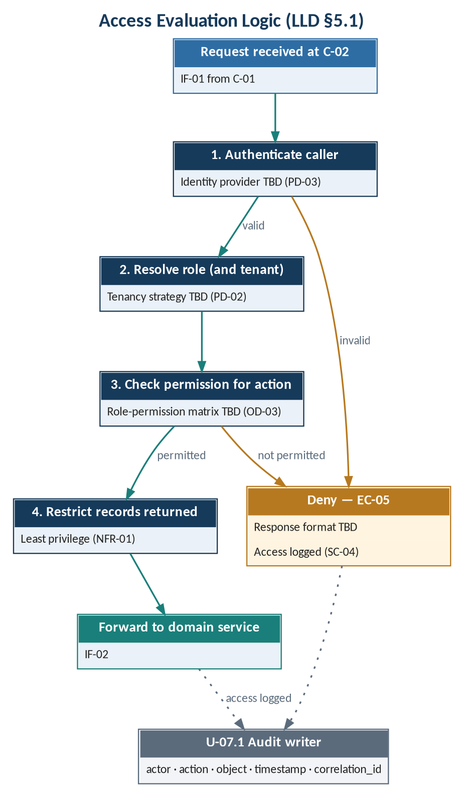
Figure 3 — Access evaluation logic
Table 23 — Access evaluation steps
Step | Logic | Unit | Source
1 | Authenticate the caller; reject if authentication fails | U-02.1 | SC-01; SYS-AC-002
2 | Resolve the caller's role (and tenant, if applicable) | U-02.2 | SC-01; PD-02
3 | Check that the role holds permission for the requested action | U-02.2 | PR-07; OD-03
4 | Restrict returned records to those permitted (least privilege) | U-02.2 | NFR-01
5 | On denial, treat as EC-05 and log the access attempt | U-02.2, U-07.1 | SC-04; SYS-SE-003

5.2 Case Creation and Evidence Intake
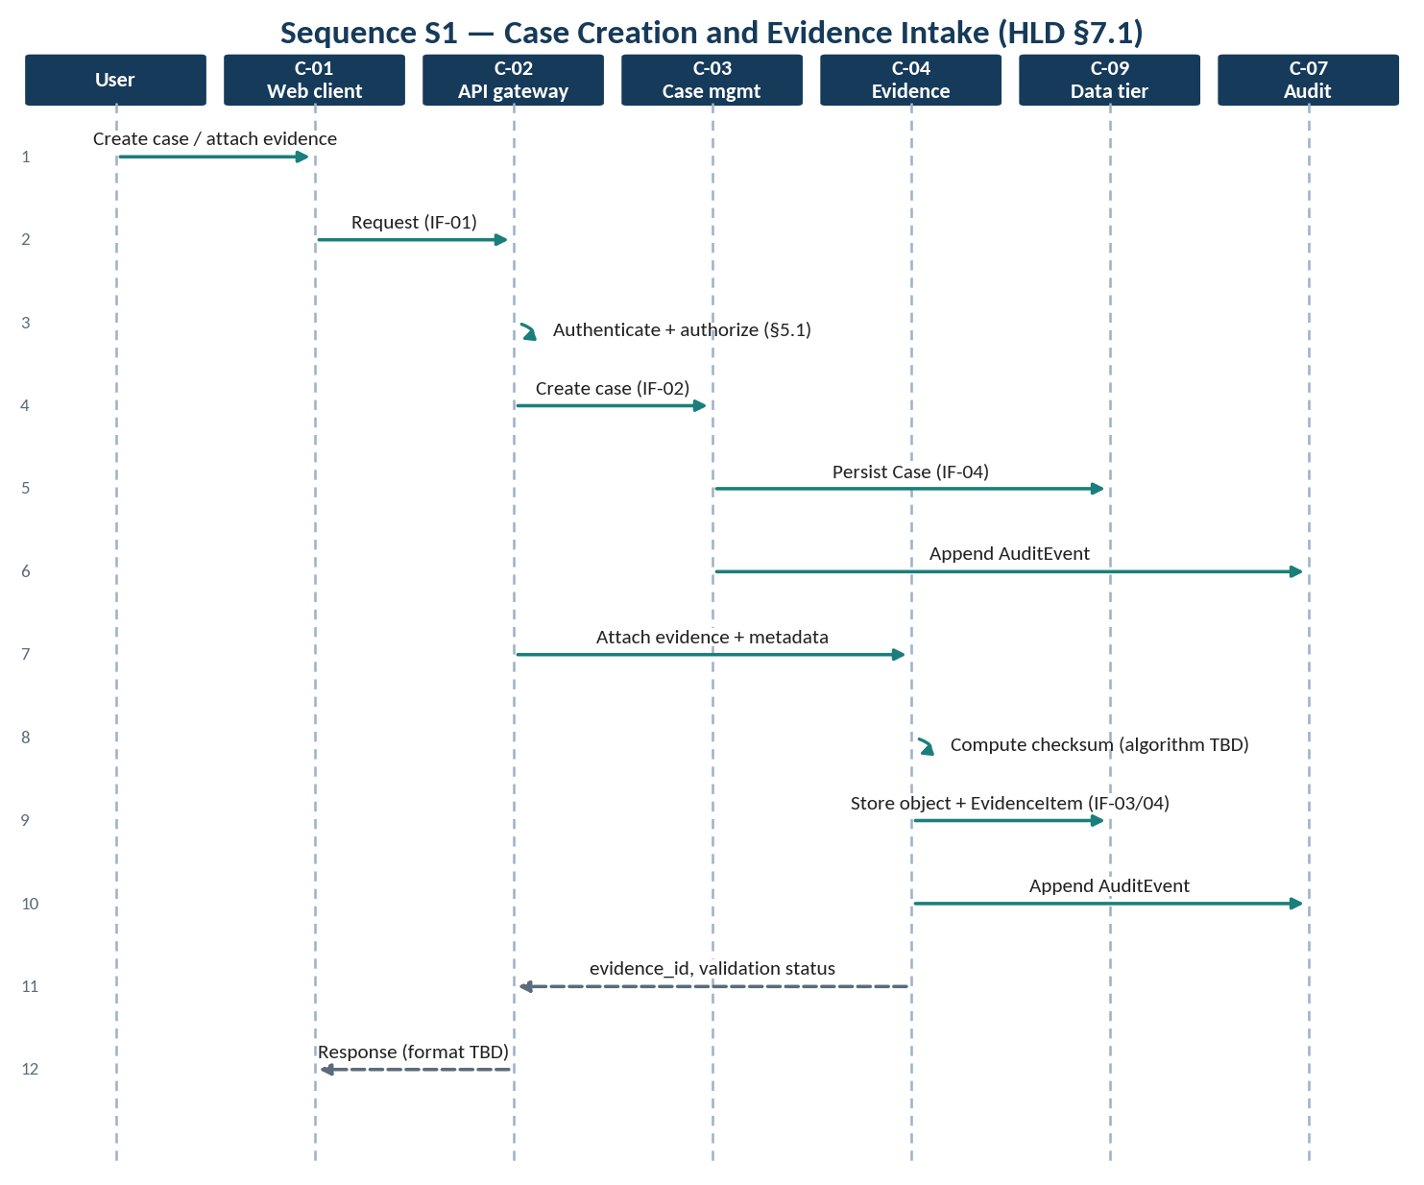
Figure 4 — Sequence S1 — case creation and evidence intake
Table 24 — Evidence intake steps
Step | Logic | Unit | Source
1 | Access evaluation (§5.1) | U-02.1, U-02.2 | SYS-AC-001
2 | Create Case and persist | U-03.1, U-09.1 | SYS-IN-001
3 | Receive evidence; reject unsupported type (types TBD) | U-04.1 | SYS-IN-002; OD-01
4 | Compute checksum (algorithm TBD) | U-04.3 | SYS-IN-005
5 | Store object in protected object storage; record storage reference | U-04.1, U-09.2 | SYS-IN-004
6 | Record metadata: timestamp, source, submitter (DG-01), type, case | U-04.2 | SYS-IN-003
7 | Set initial validation status (initial value TBC) and trigger §5.3 | U-05.3 | SYS-VA-003
8 | Append AuditEvent for each material change | U-07.1 | SYS-AU-001

5.3 Completeness and Validation Evaluation
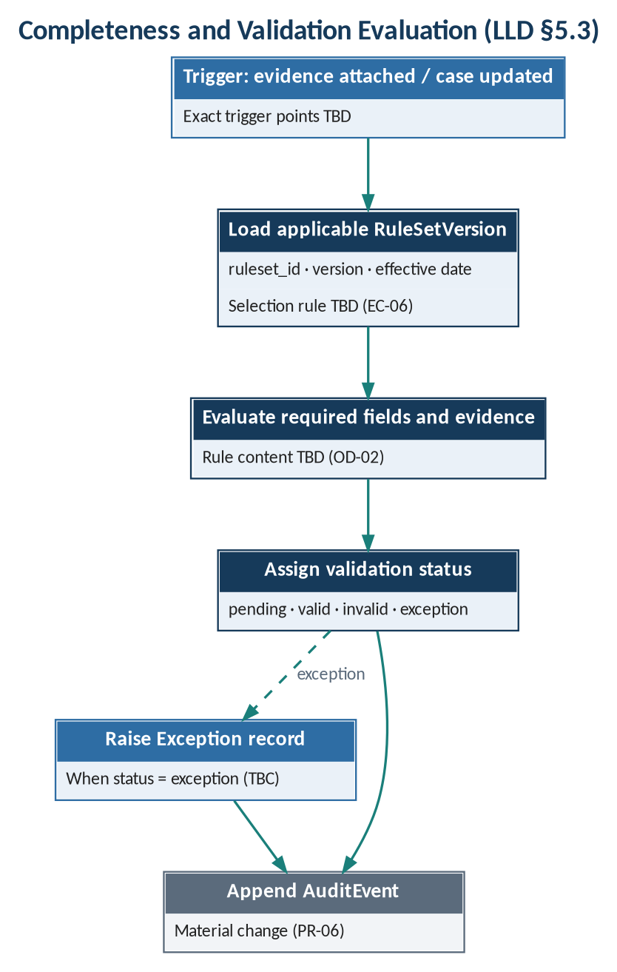
Figure 5 — Completeness and validation evaluation
Table 25 — Validation steps
Step | Logic | Unit | Source
1 | Determine applicable RuleSetVersion (selection rule TBD; EC-06) | U-05.1 | SYS-VA-002, SYS-VA-005
2 | Evaluate required fields and evidence against the rule set (rule content TBD) | U-05.2 | SYS-VA-001; OD-02
3 | Assign validation status: pending, valid, invalid or exception (mapping TBD) | U-05.3 | SYS-VA-003
4 | Where status is exception, create Exception record (TBC) | TBC | SYS-EX-002
5 | Append AuditEvent | U-07.1 | SYS-AU-001

5.4 Decision Recording
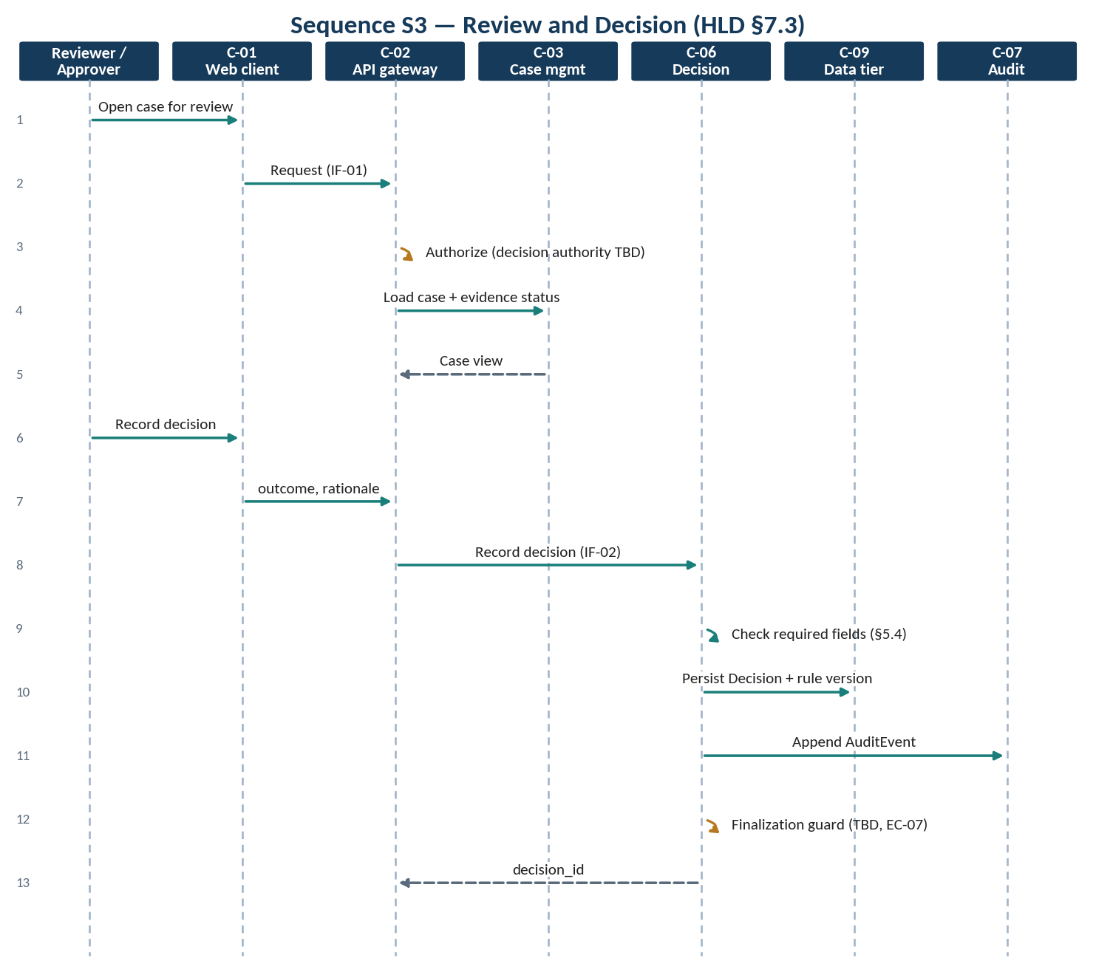
Figure 6 — Sequence S3 — review and decision
Table 26 — Decision recording steps
Step | Logic | Unit | Source
1 | Access evaluation; decision authority TBD | U-02.2 | SYS-AC-001; OD-03
2 | Verify presence of outcome, rationale, actor, timestamp, rule version and evidence references | U-06.1 | SYS-DE-001
3 | Persist Decision associated with the case and rule set version | U-06.1, U-09.1 | SYS-DE-002
4 | Append AuditEvent | U-07.1 | SYS-AU-001
5 | Apply finalization protection to subsequent modification attempts (rule TBD) | U-06.2 | SYS-DE-003; EC-07

5.5 Audit Event Append
Table 27 — Audit append steps
Step | Logic | Unit | Source
1 | Build event with event_id, actor, action, object reference, timestamp, correlation_id | U-07.1 | SYS-AU-002
2 | Exclude sensitive payloads from the event and logs | U-07.1, U-10.1 | SYS-AU-003
3 | Append without update or delete (append-only or tamper-evident mechanism TBD) | U-07.1 | SYS-AU-001; AD-03
4 | Atomicity with the originating change: TBD | U-07.1 | Not in baseline

5.6 Integration Call
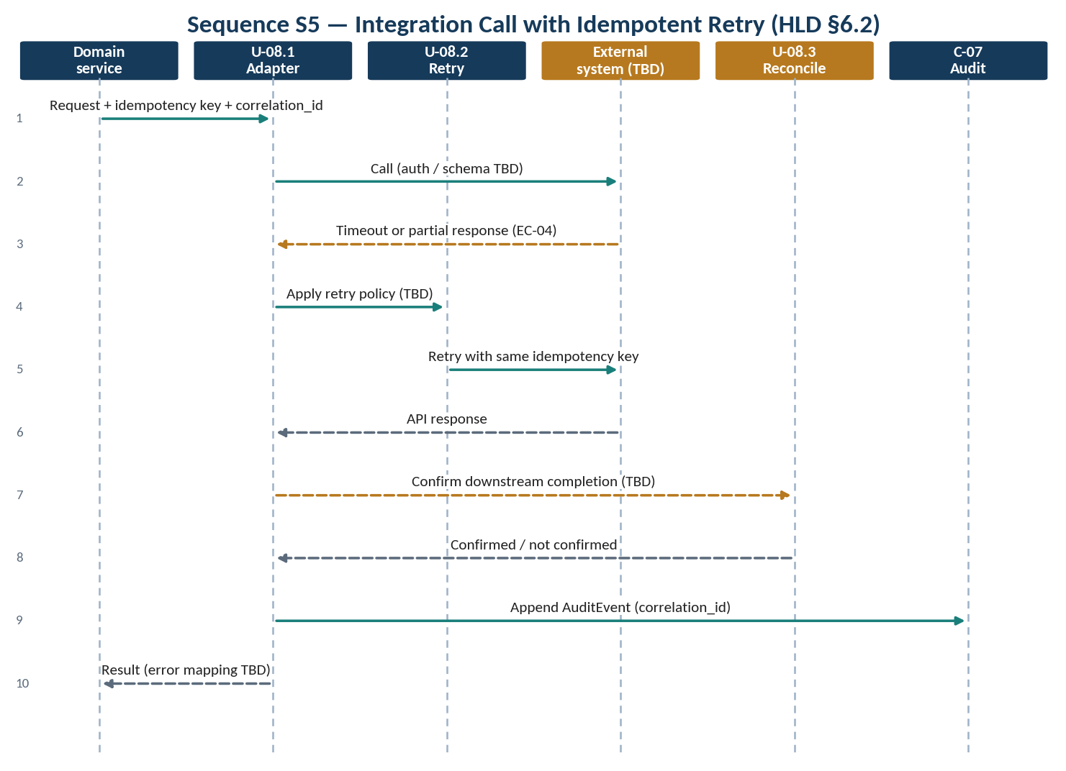
Figure 7 — Sequence S5 — integration call with idempotent retry
Table 28 — Integration call steps
Step | Logic | Unit | Source
1 | Verify adapter contract is documented; otherwise integration is not committed | U-08.1 | SYS-IG-002
2 | Attach idempotency key and correlation_id to the request | U-08.2 | SYS-IG-003
3 | On timeout or partial response (EC-04), retry with the same idempotency key per retry policy (TBD) | U-08.2 | SYS-IG-003
4 | Do not treat the API response as business completion until confirmed (mechanism TBD) | U-08.3 | SYS-IG-004
5 | Map errors per contract (TBD); append AuditEvent with correlation_id | U-08.1, U-07.1 | SYS-AU-002

5.7 Exception Handling
Table 29 — Exception handling steps
Step | Logic | Unit | Source
1 | Assign: set Exception.owner | TBC | SYS-EX-001
2 | Comment: record comment (storage TBD, DG-03) | TBC | SYS-EX-001
3 | Resolve: set resolution and status (status values TBD) | TBC | SYS-EX-001
4 | Escalate: escalation target and path TBD | TBC | SYS-EX-001
5 | Append AuditEvent for each action | U-07.1 | SYS-AU-001

5.8 Search and Export
Table 30 — Search and export steps
Step | Logic | Unit | Source
1 | Access evaluation; return only permitted cases | U-02.2 | SYS-SR-001
2 | Match by identifiers and supported metadata (TBD) | U-03.2 | SYS-SR-001
3 | Export: assemble evidence manifest and decision history (format TBD) | U-07.2 | SYS-SR-002
4 | Log access | U-07.1 | SYS-AU-003

6 State-Transition Design
The validation status values are stated (PR-04); the permitted transitions are not. The transition table below is therefore entirely TBD and must be completed with the policy rules (OD-02) before implementation.
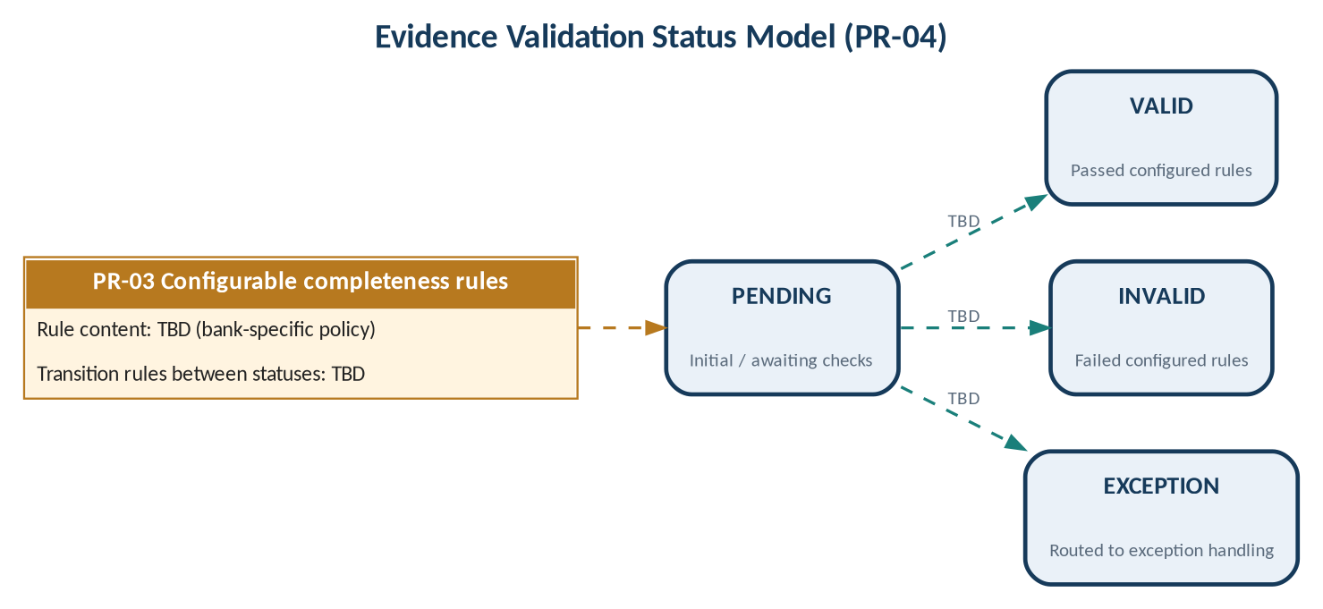
Figure 8 — Evidence validation status model
Table 31 — Validation status transition table
From \ To | pending | valid | invalid | exception
(initial) | TBC | TBD | TBD | TBD
pending | — | TBD | TBD | TBD
valid | TBD | — | TBD | TBD
invalid | TBD | TBD | — | TBD
exception | TBD | TBD | TBD | —

Table 32 — Other state-bearing entities
Entity | State attribute | Values | Transitions
Case | status | TBD | TBD
Exception | status | TBD | TBD
Decision | finalized (implied by EC-07) | TBD | TBD

7 Error Handling
Error categories correspond to the exception cases in PRS §6. Response codes, messages and user-visible behaviour are TBD.
Table 33 — Error handling design
Case | Condition | Detected by | Handling (from baseline) | Response
EC-01 | Missing or unreadable evidence | U-04.1, U-05.2 | Status invalid or exception (TBC) | TBD
EC-02 | Duplicate or stale uploads | U-04.3 (TBC), U-05.2 | TBD | TBD
EC-03 | Conflicting evidence values | U-05.2 | Status exception (TBC) | TBD
EC-04 | Integration timeout or partial response | U-08.2 | Idempotent retry; confirm before completion | TBD
EC-05 | Unauthorized access attempt | U-02.2 | Deny; log access | TBD
EC-06 | Rule version changed after case creation | U-05.1 | TBD | TBD
EC-07 | Attempt to modify a finalized decision | U-06.2 | TBD | TBD
— | Internal failure | All | Actionable error reporting; structured log | TBD

8 Configuration Parameters
Configurable items named in the baseline are listed below. No default values are given in the baseline; all defaults are TBD.
Table 34 — Configuration parameters
Parameter | Default | Used by | Source
Completeness / validation rule sets | TBD | U-05.1, U-05.2 | PR-03; OD-02
Supported evidence types | TBD | U-04.1 | OD-01
Checksum algorithm | TBD | U-04.3 | SC-03
Role–permission assignments | TBD | U-02.2 | PR-07; OD-03
Adapter timeout (per system) | TBD | U-08.1 | HLD §6.2
Adapter retry policy (per system) | TBD | U-08.2 | HLD §6.2
Retention, legal hold, deletion periods | TBD | U-09.1, U-09.2 | SC-05; OD-05
Backup schedule / restore test frequency | TBD | U-10.3 | OP-06
Environment-specific configuration | TBD | All | OP-01
Supported search metadata | TBD | U-03.2 | PR-09
Export format | TBD | U-07.2 | PR-10
Acceptance thresholds | TBD | Test design | OD-07

9 Unit Test Design
Unit test focus areas are derived from the acceptance criteria (PRS §4) and exception cases (PRS §6). Pass thresholds are TBD (OD-07).
Table 35 — Unit test design
ID | Unit | Test focus | Requirement
UT-01 | U-02.1 | Unauthenticated request rejected | SYS-AC-002
UT-02 | U-02.2 | Action without permission denied and logged (EC-05) | SYS-AC-001, SYS-SE-003
UT-03 | U-03.1 | Case created with identifier | SYS-IN-001
UT-04 | U-04.1 | Unsupported evidence type rejected (types TBD) | SYS-IN-002
UT-05 | U-04.2 | All metadata fields recorded | SYS-IN-003
UT-06 | U-04.3 | Checksum computed; change detected | SYS-IN-005
UT-07 | U-05.2 | Rule evaluation against a rule set version | SYS-VA-001
UT-08 | U-05.3 | Only the four status values accepted | SYS-VA-003
UT-09 | U-06.1 | Decision rejected when a required field is missing | SYS-DE-001
UT-10 | U-06.2 | Finalized decision modification handled per rule (TBD) | SYS-DE-003
UT-11 | U-07.1 | Audit history is append-only or tamper-evident (mechanism TBD) | SYS-AU-001
UT-12 | U-07.1, U-10.1 | No sensitive payload in logs | SYS-AU-003
UT-13 | U-08.2 | Retry reuses idempotency key; correlation_id propagated | SYS-IG-003
UT-14 | U-08.3 | Response not marked complete before confirmation | SYS-IG-004
UT-15 | U-03.2 | Search returns only permitted cases | SYS-SR-001
UT-16 | U-07.2 | Export contains manifest and decision history | SYS-SR-002
UT-17 | U-10.2 | Health and readiness endpoints respond | SYS-OB-002
UT-18 | U-10.3 | Restore from backup succeeds | SYS-OP-005

10 Traceability

10.1 System Requirement → Design Unit
Table 36 — SYS → design unit traceability
System requirement | HLD component | LLD unit | Source trace
SYS-IN-001 | C-03 | U-03.1 | PR-01
SYS-IN-002 | C-04 | U-04.1 | PR-01
SYS-IN-003 | C-04 | U-04.2 | PR-02; DG-01
SYS-IN-004 | C-04, C-09 | U-04.1, U-09.2 | SC-03; HLD §5.2
SYS-IN-005 | C-04 | U-04.3 | SC-03; AD-04
SYS-VA-001 | C-05 | U-05.2 | PR-03
SYS-VA-002 | C-05 | U-05.1 | AP-04; NFR-06; HLD §5.2
SYS-VA-003 | C-05, C-04 | U-05.3 | PR-04
SYS-VA-004 | C-01 | U-01.2 | PR-04
SYS-VA-005 | C-05 | U-05.1 | EC-06
SYS-DE-001 | C-06 | U-06.1 | PR-05; DG-02, DG-04, DG-05
SYS-DE-002 | C-06 | U-06.1 | HLD §5.2
SYS-DE-003 | C-06 | U-06.2 | EC-07
SYS-AU-001 | C-07 | U-07.1 | PR-06; AD-03
SYS-AU-002 | C-07 | U-07.1 | HLD §5.2
SYS-AU-003 | C-07, C-10 | U-07.1, U-10.1 | SC-04
SYS-AC-001 | C-02 | U-02.2 | PR-07
SYS-AC-002 | C-02 | U-02.1 | SC-01
SYS-AC-003 | C-02 | U-02.2 | SC-01
SYS-AC-004 | C-02 | U-02.2 | NFR-01
SYS-EX-001 | C-01; owner TBC | U-01.3 | PR-08; DG-03
SYS-EX-002 | TBC (C-03 candidate) | TBD | HLD §5.2
SYS-EX-003 | Per LLD §7 | Per LLD §7 | PRS §6
SYS-SR-001 | TBC (C-03 candidate) | U-03.2 | PR-09
SYS-SR-002 | TBC (C-07 candidate) | U-07.2 | PR-10
SYS-IG-001 | C-08 | U-08.1 | AD-01; HLD §6.2
SYS-IG-002 | C-08 | U-08.1 | PR-11; HLD §6.2
SYS-IG-003 | C-08 | U-08.2 | SC-06
SYS-IG-004 | C-08 | U-08.3 | AD-06
SYS-OB-001 | C-10 | U-10.1, U-10.2 | PR-12
SYS-OB-002 | C-10 | U-10.2 | OP-03
SYS-US-001 | C-01 | U-01.1 … U-01.3 | NFR-05
SYS-US-002 | C-01 | U-01.2 | NFR-05
SYS-PF-001 | All | — | NFR-03
SYS-OP-001 | C-10 | U-10.3 | NFR-02; HLD §9.3
SYS-OP-002 | All | — | OP-01
SYS-OP-003 | C-09 | U-09.1 | OP-02
SYS-OP-004 | C-10 | U-10.1 | OP-05
SYS-OP-005 | C-10 | U-10.3 | OP-06
SYS-OP-006 | C-10 | — | OP-07
SYS-SE-001 | All | — | SC-02
SYS-SE-002 | C-02, C-09 | U-09.1, U-09.2 | NFR-01; SC-07
SYS-SE-003 | C-02, C-07 | U-02.2, U-07.1 | EC-05; SC-04
SYS-IM-001 | C-09 | U-09.1 | HLD §5.2
SYS-IM-002 | C-09, C-10 | TBD | SC-05; NFR-04; OD-05
SYS-IM-003 | C-09 | U-09.1 | NFR-06
SYS-PO-001 | C-09 | TBD | NFR-04; OQ-01; OQ-04
SYS-LS-001 | C-02, C-05 | U-05.1 | NFR-06
SYS-LS-002 | All | LLD §9 | NFR-06

11 Open Issues
Table 37 — Open design issues
ID | Issue | Affects | Source
LI-01 | Technology stack, data types and endpoint paths | All | PD-01 – PD-07
LI-02 | Data-model gaps | §3.2 | DG-01 – DG-07
LI-03 | Owning service for exceptions, search and export | §2 | HLD §4.2
LI-04 | Validation status transitions and other state domains | §6 | Not in baseline
LI-05 | Error response behaviour for EC-01 – EC-07 | §7 | PRS §6
LI-06 | All configuration defaults | §8 | Not in baseline
LI-07 | Atomicity between business change and audit event | §5.5 | Not in baseline
LI-08 | Data-tier access restriction mechanism | §3.4 | PD-02, PD-04

