AURA
Evidence Intake · Validation · Decision Traceability
Requirements & Architecture Series · MRS · PRS · HLD
AURA MARKET REQUIREMENTS SPECIFICATION
Business & Market Requirements — Discovery Baseline
Document ID | AURA-MRS-1.0
Version | 1.0
Status | DISCOVERY BASELINE — FOR REVIEW
Date | 2026-10-13
Classification | TBD
Prepared By | Senior Software Architect (organisation TBD)
Standard | ISO/IEC/IEEE 29148:2018 (BRS)
Companion Docs | AURA-PRS-1.0 (PRS) · AURA-HLD-1.0 (HLD)
Discovery baseline. Contains hypotheses, not validated market claims or compliance claims (MRS §10). Classification and distribution: TBD.

Document Control
Document ID | AURA-MRS-1.0
Title | Market Requirements Specification — Aura
Version | 1.0
Status | Discovery baseline for review
Date | 13 October 2026
Product | Aura — instrument-backed lending evidence workflow
Standard | ISO/IEC/IEEE 29148:2018 — Business Requirements Specification (BRS) content, clause 9.3
Source basis | Aura_MRS.md (Discovery Baseline). Cross-references to Aura_PRS.md and Aura_HLD.md for traceability only.
Owner | TBD
Series | AURA-MRS · AURA-PRS · AURA-HLD

Revision History
Version | Date | Author | Description
1.0 | 13 October 2026 | Senior Software Architect | Initial IEEE-aligned baseline generated from Aura_MRS.md (Discovery Baseline). No content added beyond the source; gaps marked TBD.

Review and Approval
Role | Name | Signature | Date
Prepared by — Senior Software Architect | TBD
Reviewed by — Product Management | TBD
Reviewed by — Risk / Compliance | TBD
Approved by — Product Owner | TBD

Evidence Conventions
Marker | Meaning
MRS §n | Section n of Aura_MRS.md — Aura Market Requirements Specification (Discovery Baseline).
PRS §n | Section n of Aura_PRS.md — Aura Product Requirements Specification (Initial Baseline).
HLD §n | Section n of Aura_HLD.md — Aura High-Level Design (Initial Baseline).
Stated | Content taken directly from the source baseline; wording preserved where practical.
Derived | Structural derivation by the architect (identifier assignment, grouping, trace links) from stated content. No new requirement is introduced; derived links require stakeholder confirmation.
Hypothesis | Statement the source explicitly labels as a hypothesis to be validated; not a commitment or claim.
TBD / TBC | To be determined / to be confirmed. The source baseline does not provide this information; no value is asserted.

Table of Contents
1 Introduction 6
1.1 Purpose 6
1.2 Scope 6
1.3 Definitions, Acronyms and Abbreviations 6
1.4 References 7
1.5 Document Overview 7
2 Business Context 8
2.1 Business Purpose 8
2.2 Problem Statement (Hypothesis) 8
2.3 Market Context 8
3 Market Analysis 10
3.1 Target Segments 10
3.2 Competitive Intelligence 10
3.3 Market Sizing and Pricing 10
4 Stakeholders 11
4.1 Stakeholder Register 11
4.2 Mapping to Product Roles 11
5 Market Requirements 12
5.1 Conventions 12
5.2 Market Requirements 12
5.3 Market Requirement Rationale 12
6 Value Proposition and Differentiation 13
6.1 Value Proposition (Hypothesis) 13
6.2 Proposed Differentiation (Hypothesis) 13
6.3 Hypothesis Chain 13
7 Success Measures 14
8 Constraints, Assumptions and Open Questions 15
8.1 Constraints 15
8.2 Assumptions and Open Questions 15
8.3 Dependencies 15
9 Market and Delivery Risks 16
10 Discovery Gate 17
11 Traceability 18
11.1 Market Requirement to Product Requirement 18
11.2 Product Requirement to Market Requirement (Reverse) 18
11.3 Market Requirement to Success Metric 19
Appendix A — TBD Register 20

List of Figures
Figure 1 — Market context — target segments and open external dependencies 9
Figure 2 — Problem → need → value → metric hypothesis chain 13
Figure 3 — Discovery gate — preconditions for scope freeze and claims 17
List of Tables
Table 1 — Acronyms and abbreviations 6
Table 2 — Referenced documents 7
Table 3 — Market problem hypotheses 8
Table 4 — Target segments 10
Table 5 — Competitor review — comparison dimensions 10
Table 6 — Stakeholder register 11
Table 7 — Market segment to product role mapping (derived) 11
Table 8 — Market requirements 12
Table 9 — Differentiation validation plan 13
Table 10 — Success metrics to baseline 14
Table 11 — Constraints 15
Table 12 — Open questions 15
Table 13 — Risk register 16
Table 14 — Gate criteria 17
Table 15 — MR → PR traceability 18
Table 16 — PR → MR reverse traceability 18
Table 17 — MR → success metric coverage 19
Table 18 — TBD register 20

1 Introduction

1.1 Purpose
This Market Requirements Specification (MRS) records why Aura is proposed, who it is intended to serve and what the market is hypothesised to require of it, independent of how it is built. It is the top of the Aura requirements hierarchy: each product requirement in AURA-PRS-1.0 traces upward to a market requirement in this document, and downward to the components in AURA-HLD-1.0.
Aura is proposed as a workflow for collecting instrument-backed lending evidence and connecting it to reproducible decisions with traceable custody (MRS §1).

1.2 Scope
The scope of this baseline is the discovery-stage market definition of Aura: market problem hypotheses, target segments, user needs, value and differentiation hypotheses, success metrics to be baselined, and the open questions and gate that must be resolved before commercial scope is frozen.
- In scope: evidence capture with source, timestamp and ownership metadata; completeness and quality validation before decisioning; decision-to-evidence and decision-to-rule traceability; decision reconstruction for review or audit; exception and approval management with role-based permissions (MRS §4).
- Not yet determined: lending product, jurisdiction, supported instruments/devices and evidence formats, applicable bank policies and approval rules, data retention/residency/consent rules, integrated LOS/LMS/core systems, and operational support ownership (MRS §9). All are TBD.
- Excluded from this baseline: market sizing, pricing, competitor names and market-share claims, and any compliance claim (MRS §6, §10).

1.3 Definitions, Acronyms and Abbreviations
Table 1 — Acronyms and abbreviations
Term | Definition
BRS | Business Requirements Specification (ISO/IEC/IEEE 29148:2018); the MRS is written to BRS content.
Custody | Traceable record of who held, submitted or changed evidence and when; source term "traceable custody" (MRS §1).
Evidence lineage | The ability to trace a decision back to the evidence and rules used (MRS §4, §8).
HLD | High-Level Design (AURA-HLD-1.0).
Instrument-backed evidence | Lending evidence collected via instruments/devices; supported instruments and formats are TBD (MRS §9).
LOS / LMS | Loan Origination System / Loan Management System (MRS §9).
MR | Market requirement identifier used in this document (derived from MRS §4 user needs).
MRS | Market Requirements Specification (this document).
PR | Product requirement identifier (AURA-PRS-1.0).
PRS | Product Requirements Specification (AURA-PRS-1.0).
RBAC | Role-based access control.
TBD / TBC | To be determined / to be confirmed.

1.4 References
Table 2 — Referenced documents
Ref | Document | Relevance
[1] | ISO/IEC/IEEE 29148:2018 — Systems and software engineering — Life cycle processes — Requirements engineering | BRS/StRS content structure and requirement quality attributes.
[2] | Aura_MRS.md — Aura Market Requirements Specification (Discovery Baseline) | Sole source of market-specific content in this document.
[3] | AURA-PRS-1.0 — Aura Product Requirements Specification (from Aura_PRS.md) | Downward traceability (MR → PR).
[4] | AURA-HLD-1.0 — Aura High-Level Design (from Aura_HLD.md) | Architecture risks and pending decisions referenced in §9.

1.5 Document Overview
Section 2 sets the business context; Section 3 the market analysis; Section 4 the stakeholders; Section 5 the market requirements; Section 6 value and differentiation hypotheses; Section 7 success measures; Section 8 constraints, assumptions and open questions; Section 9 risks; Section 10 the discovery gate; Section 11 traceability. Appendix A lists every TBD item.
Discovery-stage caveat: the source explicitly frames the problem, value proposition and differentiation as hypotheses to validate with target banks and users (MRS §2, §5, §7). This document preserves that status and does not convert hypotheses into claims.

2 Business Context

2.1 Business Purpose
Aura is proposed as a workflow for collecting instrument-backed lending evidence and connecting it to reproducible decisions with traceable custody (MRS §1). The business sponsor, funding model and portfolio position are TBD.

2.2 Problem Statement (Hypothesis)
Lending workflows may involve fragmented documents, inconsistent evidence, manual validation, opaque decision rationale, and difficulty reconstructing what information informed a decision. These are hypotheses to validate with target banks and users (MRS §2).
Table 3 — Market problem hypotheses
ID | Problem hypothesis | Status | Validation method
MP-01 | Fragmented documents in lending workflows | Hypothesis | Customer discovery with target banks and users (MRS §2)
MP-02 | Inconsistent evidence | Hypothesis | Customer discovery with target banks and users (MRS §2)
MP-03 | Manual validation | Hypothesis | Customer discovery with target banks and users (MRS §2)
MP-04 | Opaque decision rationale | Hypothesis | Customer discovery with target banks and users (MRS §2)
MP-05 | Difficulty reconstructing what information informed a decision | Hypothesis | Customer discovery with target banks and users (MRS §2)

2.3 Market Context
The figure below places Aura among its target segments and the external dependencies that the source identifies as open (integration systems; policy, retention, residency and consent rules).
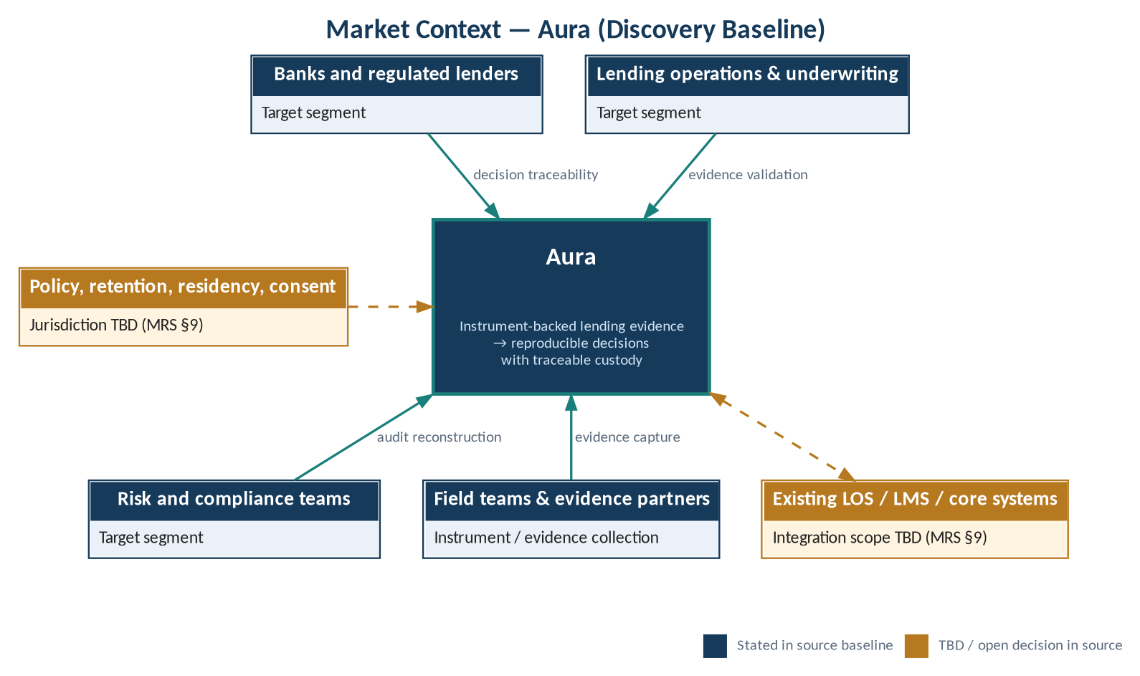
Figure 1 — Market context — target segments and open external dependencies

3 Market Analysis

3.1 Target Segments
Table 4 — Target segments
ID | Segment | Role in market | Segment size / priority
MS-01 | Banks and regulated lenders | Buying organisation (MRS §3) | TBD
MS-02 | Lending operations and underwriting teams | Primary users of intake, validation and decision workflow (MRS §3) | TBD
MS-03 | Risk and compliance teams | Users of traceability, reconstruction and audit (MRS §3) | TBD
MS-04 | Field teams and instrument/evidence collection partners | Evidence capture at source (MRS §3) | TBD

The "Role in market" column is a derived reading of how each segment relates to the user needs in MRS §4; buyer vs. user roles must be confirmed through customer discovery.

3.2 Competitive Intelligence
Competitor names, feature comparisons, pricing and market-share claims have not been independently validated in this baseline. A source-backed competitor review shall be conducted before external circulation (MRS §6). The comparison dimensions mandated by the source are recorded below; every assessment is TBD.
Table 5 — Competitor review — comparison dimensions
ID | Comparison dimension | Aura position | Competitor assessment
CD-01 | Evidence ingestion | TBD | TBD — source-backed review
CD-02 | Workflow configurability | TBD | TBD — source-backed review
CD-03 | Audit history | TBD | TBD — source-backed review
CD-04 | Integration options | TBD | TBD — source-backed review
CD-05 | Explainability | TBD | TBD — source-backed review
CD-06 | Deployment model | TBD | TBD — source-backed review
CD-07 | Security | TBD | TBD — source-backed review
CD-08 | Total cost of ownership | TBD | TBD — source-backed review

3.3 Market Sizing and Pricing
Market sizing, pricing and commercial packaging are not addressed in the source baseline and are TBD. Commercial scope shall not be frozen until the discovery gate in Section 10 is passed (MRS §10).

4 Stakeholders

4.1 Stakeholder Register
Table 6 — Stakeholder register
Stakeholder | Source | Primary interest (from MRS §4) | Named contact
Banks and regulated lenders | MRS §3 | Reproducible, traceable decisions; policy and approval rules (MRS §9) | TBD
Lending operations and underwriting teams | MRS §3 | Complete, validated evidence before decisioning | TBD
Risk and compliance teams | MRS §3 | Decision reconstruction for review or audit | TBD
Field teams and instrument/evidence collection partners | MRS §3 | Capture of evidence with source, timestamp and ownership metadata | TBD
Operational support / exception resolution owner | MRS §9 | Ownership is an open question | TBD

4.2 Mapping to Product Roles
AURA-PRS-1.0 (PRS §2) defines five product roles: submitter / field operator; reviewer / underwriter; approver; risk or compliance auditor; system administrator. The correspondence between market segments and product roles below is derived and requires confirmation.
Table 7 — Market segment to product role mapping (derived)
Market segment | Product role(s) — PRS §2
Field teams and instrument/evidence collection partners | Submitter / field operator
Lending operations and underwriting teams | Reviewer / underwriter; Approver (decision authority TBD, PRS §6)
Risk and compliance teams | Risk or compliance auditor
Banks and regulated lenders | Buying organisation; System administrator assignment TBD

5 Market Requirements

5.1 Conventions
Market requirements MR-nn are stated from the user needs in MRS §4; identifiers are assigned in this document for traceability. Priority is TBD for all requirements because no prioritisation is given in the source. Every MR remains subject to validation in customer discovery (MRS §10).

5.2 Market Requirements
Table 8 — Market requirements
ID | Market requirement (MRS §4) | Addresses problem (derived) | Priority | Validation
MR-01 | Capture evidence with source, timestamp, and ownership metadata. | MP-01 | TBD | Customer discovery; workflow trials
MR-02 | Validate completeness and quality before decisioning. | MP-02, MP-03 | TBD | Customer discovery; workflow trials
MR-03 | Trace each decision to evidence and rules used. | MP-04 | TBD | Customer discovery; workflow trials
MR-04 | Reconstruct a decision for review or audit. | MP-05 | TBD | Customer discovery; workflow trials
MR-05 | Manage exceptions and approvals with role-based permissions. | — (no explicit problem hypothesis) | TBD | Customer discovery; policy review

5.3 Market Requirement Rationale
- MR-01 underpins traceable custody (MRS §1): without source, timestamp and ownership metadata the custody chain cannot be reconstructed.
- MR-02 places validation before decisioning, so decisions rest on complete evidence; quality criteria are TBD pending bank-specific policy (MRS §9).
- MR-03 realises the "reproducible decisions" element of the proposition (MRS §1, §7).
- MR-04 supports risk and compliance review; the related metric is audit reconstruction time (MRS §8).
- MR-05 reflects the need for controlled exceptions and approvals; approval rules and decision authority are TBD (MRS §9; PRS §6).

6 Value Proposition and Differentiation

6.1 Value Proposition (Hypothesis)
Reduce evidence-handling friction and improve traceability. Quantified benefits must be established through pilot baselines and measured outcomes (MRS §5). No quantified benefit is asserted in this baseline; all benefit figures are TBD.

6.2 Proposed Differentiation (Hypothesis)
Instrument-backed evidence linked to reproducible decisions and traceable custody. This is a product hypothesis, not a proven moat; defensibility shall be validated through customer interviews, workflow trials, and partner feedback (MRS §7).
Table 9 — Differentiation validation plan
ID | Hypothesis element | Validation activity (MRS §7) | Outcome
DH-01 | Instrument-backed evidence | Customer interviews; partner feedback | TBD
DH-02 | Reproducible decisions | Workflow trials | TBD
DH-03 | Traceable custody | Customer interviews; workflow trials | TBD

6.3 Hypothesis Chain
The figure below shows the derived chain from problem hypotheses to user needs, to the value hypothesis, and to the success metrics that will test it.
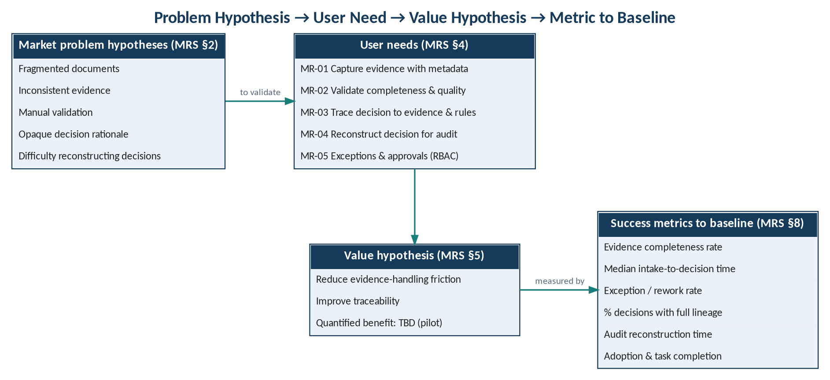
Figure 2 — Problem → need → value → metric hypothesis chain

7 Success Measures
The source requires the following metrics to be baselined (MRS §8). Baseline values, targets, measurement sources and owners are not provided and are TBD; they are to be established through pilot baselines (MRS §5).
Table 10 — Success metrics to baseline
ID | Metric (MRS §8) | Related MR (derived) | Baseline | Target | Data source
SM-01 | Evidence completeness rate | MR-01, MR-02 | TBD | TBD | TBD
SM-02 | Median time from intake to decision | MR-01, MR-02, MR-03 | TBD | TBD | TBD
SM-03 | Exception/rework rate | MR-02, MR-05 | TBD | TBD | TBD
SM-04 | Percentage of decisions with full evidence lineage | MR-03 | TBD | TBD | TBD
SM-05 | Audit reconstruction time | MR-04 | TBD | TBD | TBD
SM-06 | User adoption and task completion rate | MR-01 – MR-05 | TBD | TBD | TBD

8 Constraints, Assumptions and Open Questions

8.1 Constraints
Table 11 — Constraints
ID | Constraint | Source
CN-01 | Do not freeze commercial scope until customer discovery, policy review and technical feasibility checks are complete. | MRS §10
CN-02 | Do not make compliance claims until customer discovery, policy review and technical feasibility checks are complete. | MRS §10
CN-03 | Conduct a source-backed competitor review before external circulation. | MRS §6
CN-04 | Quantified benefits must be established through pilot baselines and measured outcomes. | MRS §5

8.2 Assumptions and Open Questions
The source records the following open questions (MRS §9). Each is unresolved and is carried as a TBD dependency into the PRS and HLD.
Table 12 — Open questions
ID | Open question (MRS §9) | Impacts (derived) | Owner | Resolution
OQ-01 | Which lending product and jurisdiction are in scope? | Scope; privacy NFR; data residency | TBD | TBD
OQ-02 | Which instruments/devices and evidence formats are supported? | MR-01; PR-01 supported evidence types | TBD | TBD
OQ-03 | Which bank policies and approval rules apply? | MR-02, MR-05; PR-03 rules; decision authority | TBD | TBD
OQ-04 | What data retention, residency, and consent rules apply? | Privacy NFR; HLD retention policy | TBD | TBD
OQ-05 | What existing LOS/LMS/core systems must integrate? | PR-11; HLD integration adapters | TBD | TBD
OQ-06 | Who owns operational support and exception resolution? | MR-05; PR-08; PR-12 | TBD | TBD

8.3 Dependencies
- Access to target banks and users for customer discovery and workflow trials (MRS §2, §7).
- Policy review input from bank stakeholders (MRS §10).
- Technical feasibility checks (MRS §10), informed by the pending architecture decisions in AURA-HLD-1.0 (HLD §9).
- Partner feedback from instrument/evidence collection partners (MRS §3, §7).

9 Market and Delivery Risks
The source does not include a dedicated market risk register. The risks below are restated from explicit source statements; likelihood, impact and owner are TBD.
Table 13 — Risk register
ID | Risk (source statement) | Source | Likelihood | Impact | Response
RK-01 | Problem hypotheses are not confirmed by target banks and users. | MRS §2 | TBD | TBD | Customer discovery (MRS §10)
RK-02 | Differentiation is a hypothesis, not a proven moat. | MRS §7 | TBD | TBD | Interviews, workflow trials, partner feedback
RK-03 | Competitive claims are not independently validated. | MRS §6 | TBD | TBD | Source-backed competitor review
RK-04 | Unconfirmed bank policies and unvalidated decision rules. | HLD §8 | TBD | TBD | Policy review (MRS §10)
RK-05 | Unknown evidence formats. | HLD §8 | TBD | TBD | Resolve OQ-02
RK-06 | Unclear data residency. | HLD §8 | TBD | TBD | Resolve OQ-04
RK-07 | Integration variability. | HLD §8 | TBD | TBD | Resolve OQ-05; adapter approach (HLD §6)

10 Discovery Gate
Commercial scope shall not be frozen and compliance claims shall not be made until customer discovery, policy review and technical feasibility checks are complete (MRS §10). The competitor review is a separate precondition for external circulation (MRS §6).
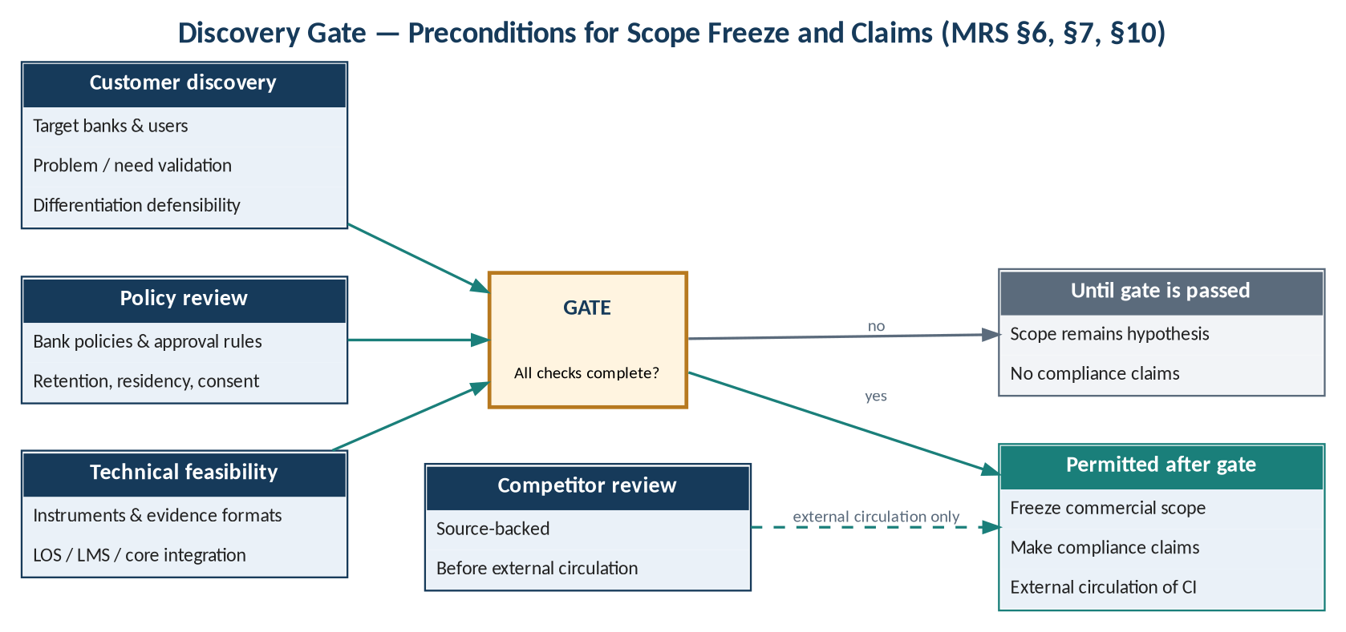
Figure 3 — Discovery gate — preconditions for scope freeze and claims
Table 14 — Gate criteria
ID | Gate criterion | Source | Exit evidence | Status
GC-01 | Customer discovery complete | MRS §10 | TBD | Open
GC-02 | Policy review complete | MRS §10 | TBD | Open
GC-03 | Technical feasibility checks complete | MRS §10 | TBD | Open
GC-04 | Source-backed competitor review complete (before external circulation) | MRS §6 | TBD | Open

11 Traceability

11.1 Market Requirement to Product Requirement
Downward trace links below are derived by the architect from the content of MRS §4 and PRS §3 and are mirrored in AURA-PRS-1.0 Section 9.
Table 15 — MR → PR traceability
MR | Market requirement | Product requirements (PRS §3)
MR-01 | Capture evidence with source, timestamp, and ownership metadata | PR-01 Evidence intake; PR-02 Metadata capture
MR-02 | Validate completeness and quality before decisioning | PR-03 Completeness checks; PR-04 Validation status
MR-03 | Trace each decision to evidence and rules used | PR-05 Decision record
MR-04 | Reconstruct a decision for review or audit | PR-06 Audit history; PR-09 Search and retrieval; PR-10 Export
MR-05 | Manage exceptions and approvals with role-based permissions | PR-07 Role-based access; PR-08 Exception handling

11.2 Product Requirement to Market Requirement (Reverse)
Table 16 — PR → MR reverse traceability
PR | Product requirement | Traces to | Note
PR-01 | Evidence intake | MR-01
PR-02 | Metadata capture | MR-01
PR-03 | Completeness checks | MR-02
PR-04 | Validation status | MR-02
PR-05 | Decision record | MR-03
PR-06 | Audit history | MR-04
PR-07 | Role-based access | MR-05
PR-08 | Exception handling | MR-05
PR-09 | Search and retrieval | MR-04
PR-10 | Export | MR-04
PR-11 | Integration boundary | OQ-05 | No MRS user need; traces to open question on LOS/LMS/core integration (MRS §9).
PR-12 | Operational observability | OQ-06 | No MRS user need; relates to operational support ownership (MRS §9). Upward trace TBC.

11.3 Market Requirement to Success Metric
Table 17 — MR → success metric coverage
MR | SM-01 | SM-02 | SM-03 | SM-04 | SM-05 | SM-06
MR-01 | ● | ● |  |  |  | ●
MR-02 | ● | ● | ● |  |  | ●
MR-03 |  | ● |  | ● |  | ●
MR-04 |  |  |  |  | ● | ●
MR-05 |  |  | ● |  |  | ●

Appendix A — TBD Register
Consolidated list of items the source baseline leaves undetermined. Each must be resolved before the related content can be baselined.
Table 18 — TBD register
ID | Item | Source | Blocks
TBD-01 | Lending product and jurisdiction | MRS §9 | Scope; privacy and residency
TBD-02 | Supported instruments/devices and evidence formats | MRS §9 | MR-01
TBD-03 | Bank policies and approval rules | MRS §9 | MR-02, MR-05
TBD-04 | Retention, residency and consent rules | MRS §9 | Privacy constraints
TBD-05 | LOS/LMS/core systems to integrate | MRS §9 | Integration scope
TBD-06 | Operational support and exception-resolution ownership | MRS §9 | MR-05
TBD-07 | Competitor set and assessments | MRS §6 | External circulation
TBD-08 | Quantified benefits | MRS §5 | Value proposition
TBD-09 | Metric baselines and targets | MRS §8 | Success measures
TBD-10 | Market sizing, pricing and packaging | Not in source | Commercial scope
TBD-11 | Requirement priorities | Not in source | Release planning
TBD-12 | Document owner, classification and approvers | Not in source | Document control

