AURA
Evidence Intake · Validation · Decision Traceability
Requirements & Architecture Series · MRS · PRS · SyRS · HLD · LLD · PDLC
AURA PRODUCT DEVELOPMENT LIFE CYCLE
Life Cycle Model, Stages, Gates, V&V, Release and Governance — Initial Baseline
Document ID | AURA-PDLC-1.0
Version | 1.0
Status | INITIAL BASELINE — FOR REVIEW
Date | 2026-10-13
Classification | TBD
Prepared By | Senior Software Architect (organisation TBD)
Standard | ISO/IEC/IEEE 12207:2017 (tailored)
Companion Docs | AURA-MRS-1.0 · AURA-PRS-1.0 · AURA-SYRS-1.0 · AURA-HLD-1.0 · AURA-LLD-1.0
Schedule, budget, team, named roles, technology and hosting are not defined in the baseline and are marked TBD. Stage structure follows the referenced standards; Aura-specific criteria are derived from MRS, PRS and HLD.

Document Control
Document ID | AURA-PDLC-1.0
Title | Product Development Life Cycle — Aura
Version | 1.0
Status | Initial baseline for review
Date | 13 October 2026
Product | Aura — controlled evidence intake, validation and decision traceability workflow
Standard | ISO/IEC/IEEE 12207:2017 (tailored); ISO/IEC/IEEE 29148:2018; IEEE 1016-2009; IEEE 1012-2016; ISO/IEC/IEEE 29119; IEEE 828-2012; ISO/IEC/IEEE 16085:2021; ISO/IEC/IEEE 16326:2019
Source basis | AURA-MRS-1.0, AURA-PRS-1.0 and AURA-HLD-1.0 (finalized baselines). Reference documents supplied for formatting only.
Owner | TBD
Series | AURA-MRS · AURA-PRS · AURA-SYRS · AURA-HLD · AURA-LLD · AURA-PDLC

Revision History
Version | Date | Author | Description
1.0 | 13 October 2026 | Senior Software Architect | Initial baseline. Stage and gate structure tailored from ISO/IEC/IEEE 12207; Aura-specific gate criteria, risks and V&V content derived from MRS, PRS and HLD.

Review and Approval
Role | Name | Signature | Date
Prepared by — Senior Software Architect | TBD
Reviewed by — Product Management | TBD
Reviewed by — Risk / Compliance | TBD
Approved by — Product Owner | TBD

Evidence Conventions
Marker | Meaning
MRS §n | Section n of AURA-MRS-1.0 — Market Requirements Specification (finalized baseline).
PRS §n | Section n of AURA-PRS-1.0 — Product Requirements Specification (finalized baseline).
HLD §n | Section n of AURA-HLD-1.0 — High-Level Design (finalized baseline).
ID references | Identifiers defined in the finalized baseline: MR, MP, MS, SM, OQ, CN, GC, RK (MRS); PR, NFR, EC, OD, UC (PRS); C, IF, SC, OP, AP, AD, PD, AR, DG (HLD).
Stated | Content taken directly from the finalized MRS, PRS or HLD; wording preserved where practical.
Derived | Structural derivation by the architect (identifier assignment, decomposition, allocation, trace links, proposed verification method) from stated content. No new requirement, value or technology is introduced; derived items require confirmation.
TBD / TBC | To be determined / to be confirmed. The baseline does not provide this information; no value is asserted.

Table of Contents
1 Introduction 6
1.1 Purpose 6
1.2 Scope 6
1.3 Standards Conformance 6
2 Product Concept 7
2.1 Problem Statement (Hypothesis) 7
2.2 Vision 7
2.3 Business Objectives 7
3 Life Cycle Model and Phase Plan 8
3.1 Stages and Gates 8
3.2 Development Increments 8
3.3 First Vertical Slice 10
4 Requirements and Design Baseline 11
4.1 Technology Baseline 12
4.2 Migration 12
5 Verification and Validation 13
5.1 Integrity Levels (IEEE 1012) 13
5.2 Test Levels (ISO/IEC/IEEE 29119) 13
5.3 Mandatory End-to-End Scenarios 13
5.4 Definition of Done 14
6 Transition, Operation and Maintenance 15
6.1 Release Process 15
6.2 Operations 15
6.3 Maintenance 15
7 Project Management 16
7.1 Configuration Management (IEEE 828) 16
7.2 Roles 16
7.3 Risk Register (ISO/IEC/IEEE 16085) 16
7.4 Traceability 17
8 Assumptions, Conflicts and Open Issues 18
8.1 Assumptions 18
8.2 Consistency Findings 18
8.3 Missing Information 18

List of Figures
Figure 1 — Aura life cycle stages and gates 8
Figure 2 — Candidate increment dependencies 9
Figure 3 — Specification-to-verification correspondence 11
Figure 4 — Traceability chain across the specification set 17
List of Tables
Table 1 — Standards applied 6
Table 2 — Business objectives 7
Table 3 — Stages mapped to ISO/IEC/IEEE 12207 8
Table 4 — Candidate increment plan 9
Table 5 — Document set 11
Table 6 — Technology baseline 12
Table 7 — Integrity level assignment 13
Table 8 — Test levels 13
Table 9 — End-to-end scenarios 14
Table 10 — Release steps 15
Table 11 — Operational practices 15
Table 12 — Maintenance types 15
Table 13 — Baselines 16
Table 14 — Responsibilities requiring an owner 16
Table 15 — Consolidated risk register 16
Table 16 — Objective traceability 17
Table 17 — Consistency findings across the baseline 18

1 Introduction

1.1 Purpose
This document defines how Aura moves from discovery to operation: the life cycle stages and gates, candidate development increments, verification and validation, transition and operation, and the management controls (configuration, risk and traceability) that apply to every document in the Aura specification set.

1.2 Scope
In scope: the Aura product as defined in AURA-PRS-1.0 and its architecture in AURA-HLD-1.0 — case and evidence intake, validation against versioned rules, decision records, audit history, role-based access, exception handling, search and export, integration adapters and operational observability.
- Not yet determined: lending product and jurisdiction (OQ-01), integrated systems (OQ-05), deployment model and hosting (PD-01), schedule, budget, team size and named owners. All are TBD.
- Excluded until the discovery gate is passed: freezing commercial scope and making compliance claims (CN-01, CN-02).

1.3 Standards Conformance
Table 1 — Standards applied
Standard | Applied to
ISO/IEC/IEEE 12207:2017 Software life cycle processes | Stage structure and process mapping (§3)
ISO/IEC/IEEE 29148:2018 Requirements engineering | MRS, PRS, SyRS
IEEE 1016-2009 / ISO/IEC/IEEE 42010 | HLD, LLD
IEEE 1012-2016 Verification and validation | Integrity levels and V&V (§5)
ISO/IEC/IEEE 29119 Software testing | Test levels (§5)
IEEE 828-2012 Configuration management | Baselines and change control (§7.1)
ISO/IEC/IEEE 16085:2021 Risk management | Risk register (§7.3)
ISO/IEC/IEEE 16326:2019 Project management | Phase plan and roles (§3, §7.2)

Tailored conformance is intended; no certification is implied. The tailoring itself is subject to approval at Gate G1 (TBC).

2 Product Concept

2.1 Problem Statement (Hypothesis)
Lending workflows may involve fragmented documents, inconsistent evidence, manual validation, opaque decision rationale, and difficulty reconstructing what information informed a decision (MP-01 – MP-05). These remain hypotheses to validate with target banks and users (MRS §2.2).

2.2 Vision
Aura is proposed as a workflow for collecting instrument-backed lending evidence and connecting it to reproducible decisions with traceable custody (MRS §2.1). The product objective is a controlled workflow for evidence intake, validation, decision traceability, and audit-ready reconstruction (PRS §1.2).

2.3 Business Objectives
Objectives restate the value hypothesis (MRS §6) and the success metrics to be baselined (MRS §7). Baselines and targets are TBD and are to be established through pilot measurement.
Table 2 — Business objectives
ID | Objective | Success measure | Baseline / target
BO-01 | Reduce evidence-handling friction | SM-01 evidence completeness rate; SM-02 median intake-to-decision time; SM-03 exception/rework rate | TBD / TBD
BO-02 | Improve traceability | SM-04 % decisions with full evidence lineage | TBD / TBD
BO-03 | Audit-ready reconstruction | SM-05 audit reconstruction time | TBD / TBD
BO-04 | Adoption | SM-06 user adoption and task completion rate | TBD / TBD

3 Life Cycle Model and Phase Plan
The source baseline does not prescribe a life cycle model. This document adopts a stage-gated structure tailored from ISO/IEC/IEEE 12207, in which the already-baselined documents define stages 1 – 3 and incremental delivery follows. The model choice is to be confirmed (TBC); stage content beyond the source-derived criteria is TBD.
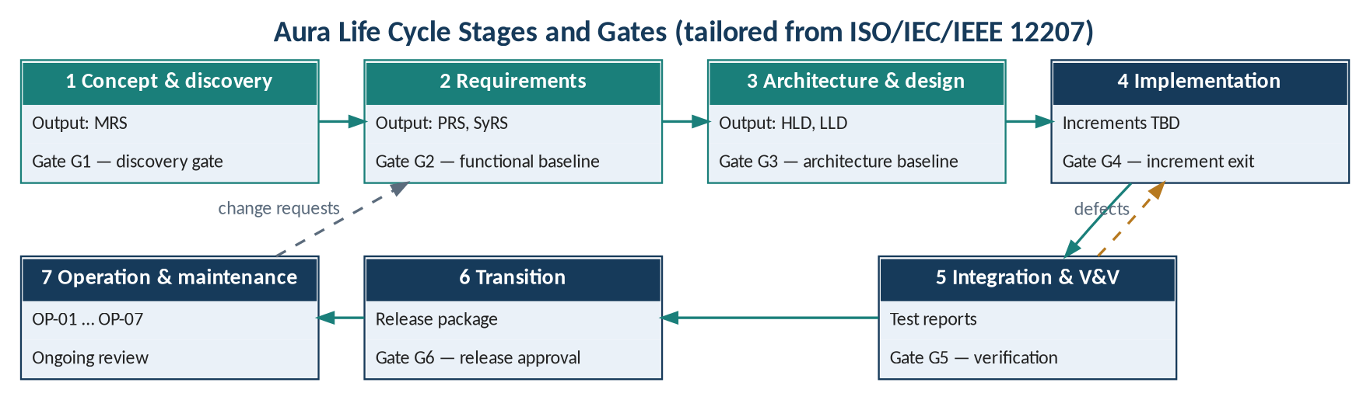
Figure 1 — Aura life cycle stages and gates

3.1 Stages and Gates
Table 3 — Stages mapped to ISO/IEC/IEEE 12207
Stage | 12207 processes | Entry criteria | Exit gate (derived) | Deliverables
1 Concept & discovery | Business / mission analysis | Discovery baseline available | G1: GC-01 – GC-04 met (MRS §10) | MRS
2 Requirements | Stakeholder and system requirements definition | G1 passed | G2: OD-01 – OD-07 resolved; verification methods confirmed; requirements baseline signed | PRS, SyRS
3 Architecture & design | Architecture and design definition | G2 passed | G3: PD-01 – PD-07 decided; DG-01 – DG-07 resolved; architecture baseline frozen | HLD, LLD
4 Implementation | Implementation, integration | G3 passed | G4: increment exit criteria met (§3.2) | Code, migrations (TBD)
5 Integration & V&V | Verification, validation | Increment built | G5: tests in §5 pass at thresholds (OD-07) | Test reports
6 Transition | Transition | All increments verified; DoD met | G6: release approval (approvers TBD) | Release package (TBD)
7 Operation & maintenance | Operation, maintenance | Release deployed | Ongoing review of OP-01 – OP-07 | Monitoring, backups, change records

3.2 Development Increments
Increments, durations and dates are not defined in the baseline. The candidate decomposition below follows the component dependencies and data flow in HLD §2.3 and is Derived; it requires approval at Gate G3.
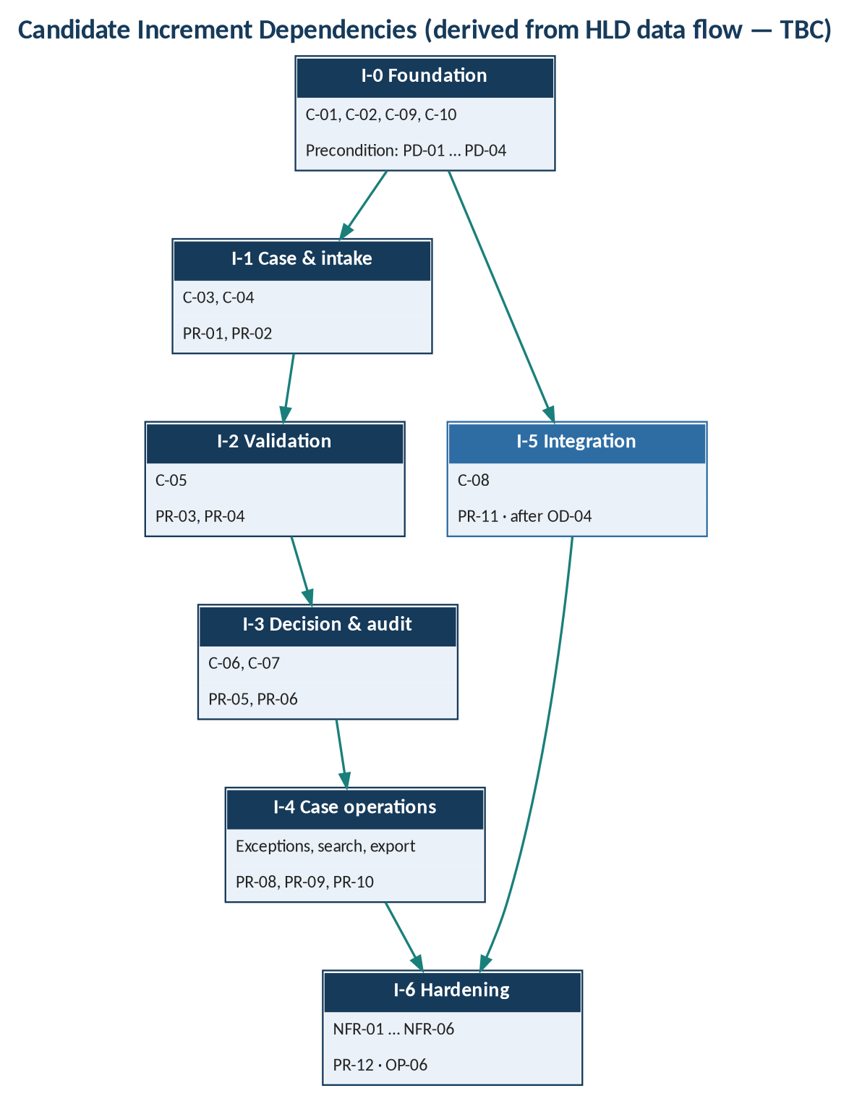
Figure 2 — Candidate increment dependencies
Table 4 — Candidate increment plan
# | Increment | Scope (components / requirements) | Exit criterion (derived) | Duration
I-0 | Foundation | C-01, C-02, C-09, C-10; SYS-AC-002, SYS-OB-002, SYS-OP-002, SYS-OP-003 | Authenticated request reaches a service; health endpoint responds | TBD
I-1 | Case & intake | C-03, C-04; PR-01, PR-02 | Scenario E2E-01 passes | TBD
I-2 | Validation | C-05; PR-03, PR-04 | Scenario E2E-02 passes | TBD
I-3 | Decision & audit | C-06, C-07; PR-05, PR-06 | Scenarios E2E-03, E2E-04 pass | TBD
I-4 | Case operations | Exceptions, search, export; PR-08, PR-09, PR-10 | Scenarios E2E-05, E2E-06 pass | TBD
I-5 | Integration | C-08; PR-11 (after OD-04) | Scenario E2E-07 passes; adapter contract documented | TBD
I-6 | Hardening | NFR-01 – NFR-06; PR-12; OP-06 | Definition of Done met (§5.4) | TBD

3.3 First Vertical Slice
The architecture is proven when the end-to-end data flow of HLD §2.3 operates for one case: case creation → evidence upload and metadata capture → completeness and validation checks → reviewer workflow → decision record → audit trail and export. The slice scope is Derived (TBC).

4 Requirements and Design Baseline
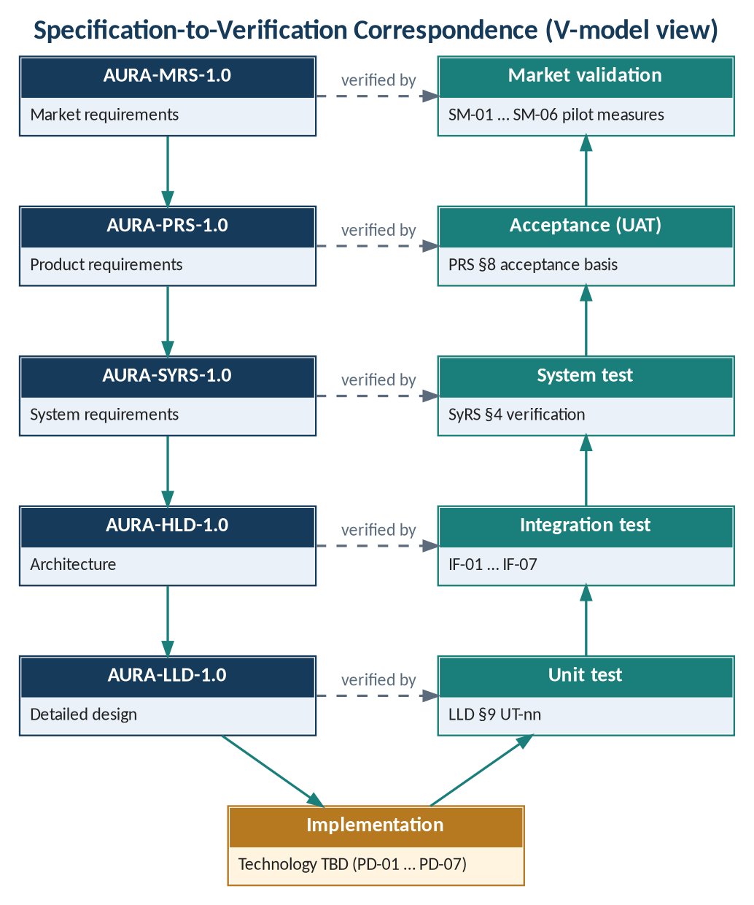
Figure 3 — Specification-to-verification correspondence
Table 5 — Document set
Document | Stage produced | Baseline | Standard
AURA-MRS-1.0 Market Requirements Specification | 1 | Functional | ISO/IEC/IEEE 29148 (BRS)
AURA-PRS-1.0 Product Requirements Specification | 2 | Functional | ISO/IEC/IEEE 29148 (StRS/SRS)
AURA-SYRS-1.0 System Requirements Specification | 2 | Functional | ISO/IEC/IEEE 29148 §9.4
AURA-HLD-1.0 High-Level Design | 3 | Architecture | IEEE 1016 / ISO/IEC/IEEE 42010
AURA-LLD-1.0 Low-Level Design | 3 | Architecture | IEEE 1016
AURA-PDLC-1.0 Product Development Life Cycle | All | Governing | ISO/IEC/IEEE 12207 (tailored)

4.1 Technology Baseline
Table 6 — Technology baseline
Layer | Technology | Decision
Client (C-01) | TBD | —
API gateway / identity (C-02) | TBD | PD-03
Domain services (C-03 – C-07) | TBD | —
Eventing | TBD | PD-05
Relational store / object storage (C-09) | TBD | PD-04
Encryption / key management | TBD | PD-06
Monitoring, logging, backup (C-10) | TBD | —
Hosting (cloud / on-premise) | TBD | PD-01
Tenancy | TBD | PD-02
DR objectives | TBD | PD-07

4.2 Migration
No legacy system or data migration is identified in the baseline. Whether data from existing LOS/LMS/core systems is migrated or integrated is TBD (OQ-05).

5 Verification and Validation

5.1 Integrity Levels (IEEE 1012)
Integrity levels are not assigned in the baseline. The table records the concern that bears on each component's level; the level itself is TBD and is to be set at Gate G3.
Table 7 — Integrity level assignment
Component | Relevant concern (from baseline) | Integrity level
C-02 API gateway & identity | Access control, unauthorized access (PR-07, EC-05) | TBD
C-07 Audit / event history | Tamper-evident history (PR-06) | TBD
C-06 Decision record | Decision traceability; finalized decisions (PR-05, EC-07) | TBD
C-05 Validation / rules | Versioned rules (PR-03, AP-04) | TBD
C-04 Evidence ingestion | Custody; checksums (SC-03) | TBD
C-08 Integration adapters | Integration correctness (AD-06, EC-04) | TBD
C-09 Data tier | Protected storage; retention (SC-03, SC-05) | TBD
C-03, C-01, C-10 | Workflow, usability, observability | TBD

5.2 Test Levels (ISO/IEC/IEEE 29119)
Table 8 — Test levels
Level | Basis | Scope | Tooling | Frequency
Unit | AURA-LLD-1.0 §9 (UT-01 – UT-18) | Design units | TBD | TBD
Integration | IF-01 – IF-07 | Component interfaces | TBD | TBD
System | AURA-SYRS-1.0 §4 | SYS requirements | TBD | TBD
End-to-end | §5.3 scenarios | Critical paths (NFR-06) | TBD | TBD
Security | SC-01 – SC-07; EC-05 | Access, secrets, logging | TBD | TBD
Performance | SYS-PF-001 | Targets TBD (NFR-03) | TBD | TBD
Backup / restore | OP-06; SYS-OP-005 | Restore test | TBD | TBD
Acceptance (UAT) | PRS §8 | PR-01 – PR-12 per role UC-01 – UC-05 | TBD | Pre-release
Market validation | MRS §7 | SM-01 – SM-06 pilot measures | TBD | Pilot

5.3 Mandatory End-to-End Scenarios
Scenarios are derived from HLD §7 and PRS §6. Expected results for exception cases are TBD.
Table 9 — End-to-end scenarios
ID | Scenario | Requirements | Expected result
E2E-01 | Create case and attach evidence with metadata; checksum recorded | PR-01, PR-02 | Per acceptance criteria
E2E-02 | Evidence evaluated against a rule set version; status visible | PR-03, PR-04 | Per acceptance criteria
E2E-03 | Decision recorded with rationale, actor, evidence and rule versions | PR-05 | Per acceptance criteria
E2E-04 | Material changes appear in tamper-evident history | PR-06 | Per acceptance criteria
E2E-05 | Exception assigned, commented, resolved and escalated | PR-08 | Per acceptance criteria
E2E-06 | Authorized user searches and exports a case; unauthorized user denied | PR-07, PR-09, PR-10 | Per acceptance criteria
E2E-07 | Integration timeout retried idempotently; completion confirmed | PR-11, EC-04 | TBD
E2E-08 | Exception cases EC-01 – EC-03, EC-06, EC-07 | PRS §6 | TBD
E2E-09 | Health, readiness and structured logs; backup restored | PR-12, OP-06 | Per acceptance criteria

5.4 Definition of Done
Derived from the acceptance criteria and controls of the baseline; quantitative thresholds are TBD (OD-07).
- PR-01 – PR-12 meet their acceptance criteria at agreed thresholds (PRS §8).
- Every material change is recorded as append-only or tamper-evident history (PR-06).
- Every integration has a documented adapter contract before it is committed (PR-11).
- Security controls SC-01 – SC-07 are verified; secrets are outside source control.
- Structured logs, health checks and actionable error reporting are in place (PR-12).
- Backup/restore has been tested and rollback is documented (OP-06, OP-07).
- Open data-model gaps DG-01 – DG-07 are resolved or formally accepted.
- No compliance claim is made unless the discovery gate is passed (CN-02).

6 Transition, Operation and Maintenance

6.1 Release Process
A release process is not defined in the baseline. The following steps restate the baseline's deployment practices; ordering, environments and approvers are TBD.
Table 10 — Release steps
Step | Activity | Source
1 | Apply environment-specific configuration | OP-01
2 | Run automated migrations | OP-02
3 | Verify health / readiness endpoints | OP-03
4 | Confirm monitoring and structured logs | OP-04, OP-05
5 | Confirm backup/restore test and documented rollback | OP-06, OP-07
6 | Release approval | Approvers TBD

6.2 Operations
Table 11 — Operational practices
Area | Practice | Status
Monitoring and alerting | C-10 monitoring, logging, alerting | Stated; tooling TBD
Backup and recovery | Backup/restore tests; DR objectives | Stated; RPO/RTO TBD (PD-07)
Secrets | Outside source control; rotated via deployment controls | Stated (SC-02)
Retention | Retention, legal hold, deletion, backup policy | TBD (SC-05)
Service objectives | Defined after workload and hosting assumptions agreed | TBD (NFR-02)
Operational support ownership | Exception resolution and support | TBD (OQ-06)

6.3 Maintenance
Table 12 — Maintenance types
Type | Trigger | Path
Corrective | Defect | Change control (§7.1); regression on critical paths (NFR-06)
Adaptive | New evidence type, policy rule or integration | Rule set versioning (AP-04); new adapter (AD-01)
Perfective | Usability or performance | Change request → baseline update
Preventive | Dependency or security updates | TBD

7 Project Management

7.1 Configuration Management (IEEE 828)
Table 13 — Baselines
Baseline | Contents | Established
Functional | MRS, PRS, SyRS | Gate G2
Architecture | HLD, LLD | Gate G3
Product | Code, versioned schema migrations, versioned APIs and rules (NFR-06) | Each increment exit (G4)
Release | Release package (contents TBD) | Gate G6

Changes to baselined items require a change request. The change authority, review board composition and approval thresholds are TBD.

7.2 Roles
Named project roles and owners are not defined in the baseline. The responsibilities below are those the baseline requires to be owned; the role holder is TBD.
Table 14 — Responsibilities requiring an owner
Responsibility | Source | Owner
Discovery gate decision and scope freeze | MRS §10 | TBD
Resolution of open questions OQ-01 – OQ-06 | MRS §8.2 | TBD
Resolution of open decisions OD-01 – OD-07 | PRS §7 | TBD
Architecture decisions PD-01 – PD-07 | HLD §10.2 | TBD
Rule set ownership | RuleSetVersion.owner (HLD §5.2) | TBD
Retention / legal hold / deletion policy | SC-05 | TBD
Operational support and exception resolution | OQ-06 | TBD
Document approvals (all six documents) | Document control | TBD

7.3 Risk Register (ISO/IEC/IEEE 16085)
Risks are consolidated from MRS §9 and HLD §11. Likelihood, impact and owner are not rated in the baseline and are TBD.
Table 15 — Consolidated risk register
ID | Risk | Source | L | I | Treatment (from baseline) | Owner
RK-01 | Problem hypotheses not confirmed | MRS | TBD | TBD | Customer discovery (G1) | TBD
RK-02 | Differentiation not a proven moat | MRS | TBD | TBD | Interviews, workflow trials, partner feedback | TBD
RK-03 | Competitive claims unvalidated | MRS | TBD | TBD | Source-backed competitor review | TBD
AR-01 | Unconfirmed bank policies | HLD | TBD | TBD | Configurable, versioned rules | TBD
AR-02 | Unknown evidence formats | HLD | TBD | TBD | Resolve OD-01 | TBD
AR-03 | Unclear data residency | HLD | TBD | TBD | Jurisdictional review | TBD
AR-04 | Integration variability | HLD | TBD | TBD | Adapter per system; contracts first | TBD
AR-05 | Unvalidated decision rules | HLD | TBD | TBD | Rule versions recorded on decisions | TBD

MRS risks RK-04 – RK-07 restate HLD risks AR-01 – AR-05 and are covered by those entries.

7.4 Traceability
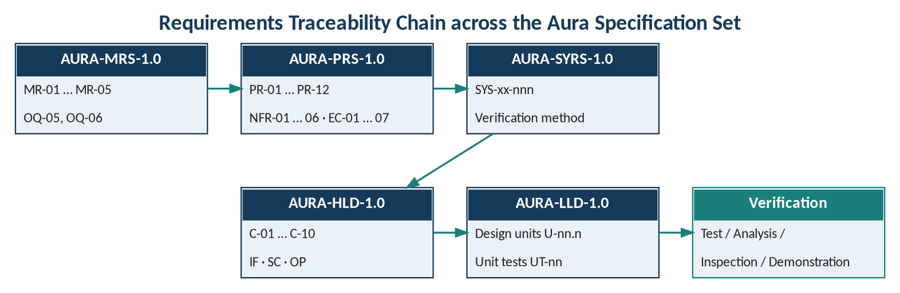
Figure 4 — Traceability chain across the specification set
Table 16 — Objective traceability
Objective | MR | PR | SYS | Increment
BO-01 | MR-01, MR-02, MR-05 | PR-01 – PR-04, PR-08 | SYS-IN, SYS-VA, SYS-EX | I-1, I-2, I-4
BO-02 | MR-03 | PR-05 | SYS-DE | I-3
BO-03 | MR-04 | PR-06, PR-09, PR-10 | SYS-AU, SYS-SR | I-3, I-4
BO-04 | MR-01 – MR-05 | All | SYS-US | All

8 Assumptions, Conflicts and Open Issues

8.1 Assumptions
- The finalized MRS, PRS and HLD are the authoritative source for all product content in this series.
- The stage-gate structure in §3 is a tailoring of ISO/IEC/IEEE 12207 and is subject to confirmation.
- The SyRS was produced after the HLD in this baseline; it refines PRS content and HLD allocations without changing them.

8.2 Consistency Findings
Table 17 — Consistency findings across the baseline
ID | Finding | Documents | To resolve
CF-01 | PRS fields (submitter, evidence references, comments/escalation) absent from HLD entities | PRS §4, HLD §5.3 | DG-01 – DG-07
CF-02 | Owning service for exception handling, search and export not assigned | HLD §4.2 | Gate G3
CF-03 | PR-11 and PR-12 have no MRS user need (trace to OQ-05, OQ-06) | MRS §11.2 | Gate G1/G2

8.3 Missing Information
- Named owners, approvers and project roles.
- Schedule: start date, increment durations, release date; budget and team size.
- Life cycle model confirmation and tailoring approval.
- Hosting, environments and technology stack (PD-01 – PD-07).
- Integrity levels, test tooling and test frequencies.
- Acceptance thresholds and performance, reliability and DR targets (OD-07, NFR-02, NFR-03).
- Release package contents and change-control authority.

