AURA
Evidence Intake · Validation · Decision Traceability
Requirements & Architecture Series · MRS · PRS · HLD
AURA PRODUCT REQUIREMENTS SPECIFICATION
Redefined — Epics, Use Cases, Requirements, Acceptance Criteria and Traceability
Document ID | AURA-PRS-2.0
Version | 2.0
Status | REDEFINED BASELINE — FOR REVIEW
Date | 2026-10-13
Classification | TBD
Prepared By | Senior Software Architect (organisation TBD)
Standard | ISO/IEC/IEEE 29148:2018
Supersedes | AURA-PRS-1.0
Companion Docs | AURA-MRS-1.0 · AURA-HLD-2.0
Derived exclusively from Aura_MRS.md, Aura_PRS.md and Aura_HLD.md. Supported evidence types, policy rules, decision authority, integration systems, retention policy, deployment model and acceptance thresholds remain open (PRS §6). Classification: TBD.

Document Control
Document ID | AURA-PRS-2.0
Title | Product Requirements Specification (Redefined) — Aura
Version | 2.0
Status | Redefined baseline for review
Date | 13 October 2026
Product | Aura — controlled evidence intake, validation and decision traceability workflow
Standard | ISO/IEC/IEEE 29148:2018 — Stakeholder and Software Requirements Specification content (clauses 9.4, 9.6)
Source basis | Aura_PRS.md (authoritative for requirements), Aura_MRS.md (market needs), Aura_HLD.md (architecture allocation). Reference DOCX files used for formatting only.
Owner | TBD
Series | AURA-MRS · AURA-PRS · AURA-HLD

Revision History
Version | Date | Author | Description
1.0 | 13 October 2026 | Senior Software Architect | Initial IEEE-aligned baseline (AURA-PRS-1.0).
2.0 | 13 October 2026 | Senior Software Architect | Redefined: added epics, detailed use cases, decomposed functional requirements, decomposed NFRs, Given/When/Then acceptance criteria and extended traceability. Source requirements PR-01 – PR-12 unchanged.

Review and Approval
Role | Name | Signature | Date
Prepared by — Senior Software Architect | TBD
Reviewed by — Product Management | TBD
Reviewed by — Risk / Compliance | TBD
Approved by — Product Owner | TBD

Evidence Conventions
Marker | Meaning
MRS §n | Section n of Aura_MRS.md — Market Requirements Specification (Discovery Baseline).
PRS §n | Section n of Aura_PRS.md — Product Requirements Specification (Initial Baseline).
HLD §n | Section n of Aura_HLD.md — High-Level Design (Initial Baseline).
Stated | Content taken directly from the source Markdown files; wording preserved where practical.
Derived | Structural derivation by the architect: epics, use cases, decomposed functional requirements (FR), Given/When/Then acceptance criteria (AC), candidate actors and trace links. Derived items introduce no new capability and require stakeholder confirmation.
TBC | Derived item that is plausible from the source but must be confirmed (for example, a candidate actor for a use case).
TBD | Information not present in the source. No value is asserted.

Table of Contents
1 Introduction 8
1.1 Purpose 8
1.2 Scope 8
1.3 Definitions, Acronyms and Abbreviations 8
1.4 References 9
1.5 Requirement Attributes 9
2 Product Overview 10
2.1 Product Perspective 10
2.2 Product Functions 10
2.3 User Classes and Characteristics 11
2.4 Operating Environment 11
2.5 Constraints 11
2.6 Assumptions and Dependencies 11
3 Epics 12
4 Use Cases 14
4.1 Use Case Model 14
4.2 Core Workflow 15
4.3 Use Case Catalogue 15
4.4 Use Case Specifications 16
4.4.1 UCS-01 Create case 16
4.4.2 UCS-02 Attach evidence with metadata 16
4.4.3 UCS-03 Evaluate completeness and validity 17
4.4.4 UCS-04 View validation status 17
4.4.5 UCS-05 Record decision 17
4.4.6 UCS-06 Review audit history 18
4.4.7 UCS-07 Manage exception 18
4.4.8 UCS-08 Search and retrieve case 19
4.4.9 UCS-09 Export case manifest and history 19
4.4.10 UCS-10 Manage access permissions 20
4.4.11 UCS-11 Commit integration contract 20
4.4.12 UCS-12 Monitor operational health 20
4.4.13 UCS-13 Maintain rule set versions 21
5 Functional Requirements 22
5.1 Conventions 22
5.2 EP-01 Evidence Intake 22
5.3 EP-02 Evidence Validation 22
5.4 EP-03 Decision Traceability 23
5.5 EP-04 Audit and Reconstruction 23
5.6 EP-05 Access and Exception Control 24
5.7 EP-06 Integration and Operations 24
6 Non-Functional Requirements 25
7 Exception Cases 26
7.1 Evidence Validation Status 27
8 Acceptance Criteria 28
8.1 Approach 28
8.2 Acceptance Criteria by Requirement 28
8.3 Verification Summary 29
9 Open Decisions 30
10 Requirements Traceability 31
10.1 MR → Epic → PR → Use Case → Acceptance Criteria → HLD 31
10.2 Use Case → Requirement Coverage 31
10.3 Non-Functional Requirement → Design 32
10.4 Coverage Summary 32
Appendix A — TBD Register 34
Appendix B — Changes from AURA-PRS-1.0 35

List of Figures
Figure 1 — Product context — roles, role-based access and functional areas 10
Figure 2 — Epic map — market requirement to epic to product requirement 12
Figure 3 — Use case diagram 14
Figure 4 — Core product workflow with requirement allocation 15
Figure 5 — Exception sources and handling actions 27
Figure 6 — Evidence validation status model (PR-04) 27
Figure 7 — Requirements traceability chain 31
List of Tables
Table 1 — Acronyms and abbreviations 8
Table 2 — Referenced documents 9
Table 3 — Requirement attributes (ISO/IEC/IEEE 29148 §5.2.8) 9
Table 4 — Product function summary 10
Table 5 — User classes 11
Table 6 — Operating environment 11
Table 7 — Epic catalogue 12
Table 8 — Use case catalogue 15
Table 9 — Use case UCS-01 — Create case 16
Table 10 — Use case UCS-02 — Attach evidence with metadata 16
Table 11 — Use case UCS-03 — Evaluate completeness and validity 17
Table 12 — Use case UCS-04 — View validation status 17
Table 13 — Use case UCS-05 — Record decision 17
Table 14 — Use case UCS-06 — Review audit history 18
Table 15 — Use case UCS-07 — Manage exception 18
Table 16 — Use case UCS-08 — Search and retrieve case 19
Table 17 — Use case UCS-09 — Export case manifest and history 19
Table 18 — Use case UCS-10 — Manage access permissions 20
Table 19 — Use case UCS-11 — Commit integration contract 20
Table 20 — Use case UCS-12 — Monitor operational health 20
Table 21 — Use case UCS-13 — Maintain rule set versions 21
Table 22 — Functional requirements — EP-01 Evidence Intake 22
Table 23 — Functional requirements — EP-02 Evidence Validation 22
Table 24 — Functional requirements — EP-03 Decision Traceability 23
Table 25 — Functional requirements — EP-04 Audit and Reconstruction 23
Table 26 — Functional requirements — EP-05 Access and Exception Control 24
Table 27 — Functional requirements — EP-06 Integration and Operations 24
Table 28 — Non-functional requirements 25
Table 29 — Exception cases 26
Table 30 — Acceptance criteria 28
Table 31 — Verification by epic 29
Table 32 — Open decisions 30
Table 33 — Forward traceability matrix 31
Table 34 — Use case coverage matrix 31
Table 35 — NFR → HLD traceability 32
Table 36 — Coverage summary 7
Table 37 — TBD register 7
Table 38 — Change log 7

1 Introduction

1.1 Purpose
This redefined Product Requirements Specification (PRS) defines what the Aura product must do — organised as epics, detailed use cases, functional and non-functional requirements, acceptance criteria and traceability — so that product, engineering, QA and risk/compliance stakeholders share one verifiable definition of the product. It supersedes AURA-PRS-1.0 without changing any source requirement.

1.2 Scope
Product objective: provide a controlled workflow for evidence intake, validation, decision traceability, and audit-ready reconstruction (PRS §1).
- In scope: 6 epics, 13 use cases, 12 product requirements (PR-01 – PR-12) decomposed into 38 functional requirements, 6 non-functional requirement areas decomposed into 16 statements, 7 exception cases and 13 acceptance criteria.
- Open decisions: supported evidence types, bank-specific policy rules, decision authority, integration systems, retention policy, deployment model, and acceptance thresholds (PRS §6).
- Not in source: priorities, release plan, UI design and quantitative targets — all TBD.

1.3 Definitions, Acronyms and Abbreviations
Table 1 — Acronyms and abbreviations
Term | Definition
AC-nn.n | Acceptance criterion in Given/When/Then form (Derived from PRS §3 acceptance criteria).
Case | Container for evidence, decisions and exceptions relating to one lending matter (PR-01; HLD §3).
EC-nn | Exception case (PRS §5).
EP-nn | Epic — a group of product requirements serving one market need (Derived).
FR-nn.n | Functional requirement decomposed from PR-nn (Derived).
MR-nn | Market requirement (MRS §4 user need).
NFR-nn(.n) | Non-functional requirement (PRS §4), with decomposed statements (Derived).
OD-nn | Open decision (PRS §6).
PR-nn | Product requirement (PRS §3).
UC-nn | User class / role (PRS §2).
UCS-nn | Use case specification (Derived).
C-nn | HLD logical component (HLD §2).

1.4 References
Table 2 — Referenced documents
Ref | Document | Relevance
[1] | ISO/IEC/IEEE 29148:2018 — Requirements engineering | Requirement content, characteristics and attributes.
[2] | Aura_PRS.md — Product Requirements Specification (Initial Baseline) | Authoritative product requirements.
[3] | Aura_MRS.md — Market Requirements Specification (Discovery Baseline) | Market needs (upward trace).
[4] | Aura_HLD.md — High-Level Design (Initial Baseline) | Component allocation (downward trace).
[5] | AURA-HLD-2.0 — High-Level Design (Redefined) | Companion architecture document.

1.5 Requirement Attributes
Table 3 — Requirement attributes (ISO/IEC/IEEE 29148 §5.2.8)
Attribute | Value in this document
Identification | PR-nn (source); FR-nn.n, NFR-nn.n, AC-nn.n, UCS-nn, EP-nn (Derived)
Source / rationale | MRS §4 user need (MR-nn) or MRS §9 open question
Priority | TBD — not given in source
Risk | TBD — see MRS §9 / HLD §8
Verification method | Test unless stated; to be confirmed
Acceptance threshold | TBD (OD-07)
Status | Proposed

2 Product Overview

2.1 Product Perspective
Aura is a new product proposed as a workflow for collecting instrument-backed lending evidence and connecting it to reproducible decisions with traceable custody (MRS §1). Its relationship to existing bank LOS/LMS/core systems is open (MRS §9) and governed by PR-11.
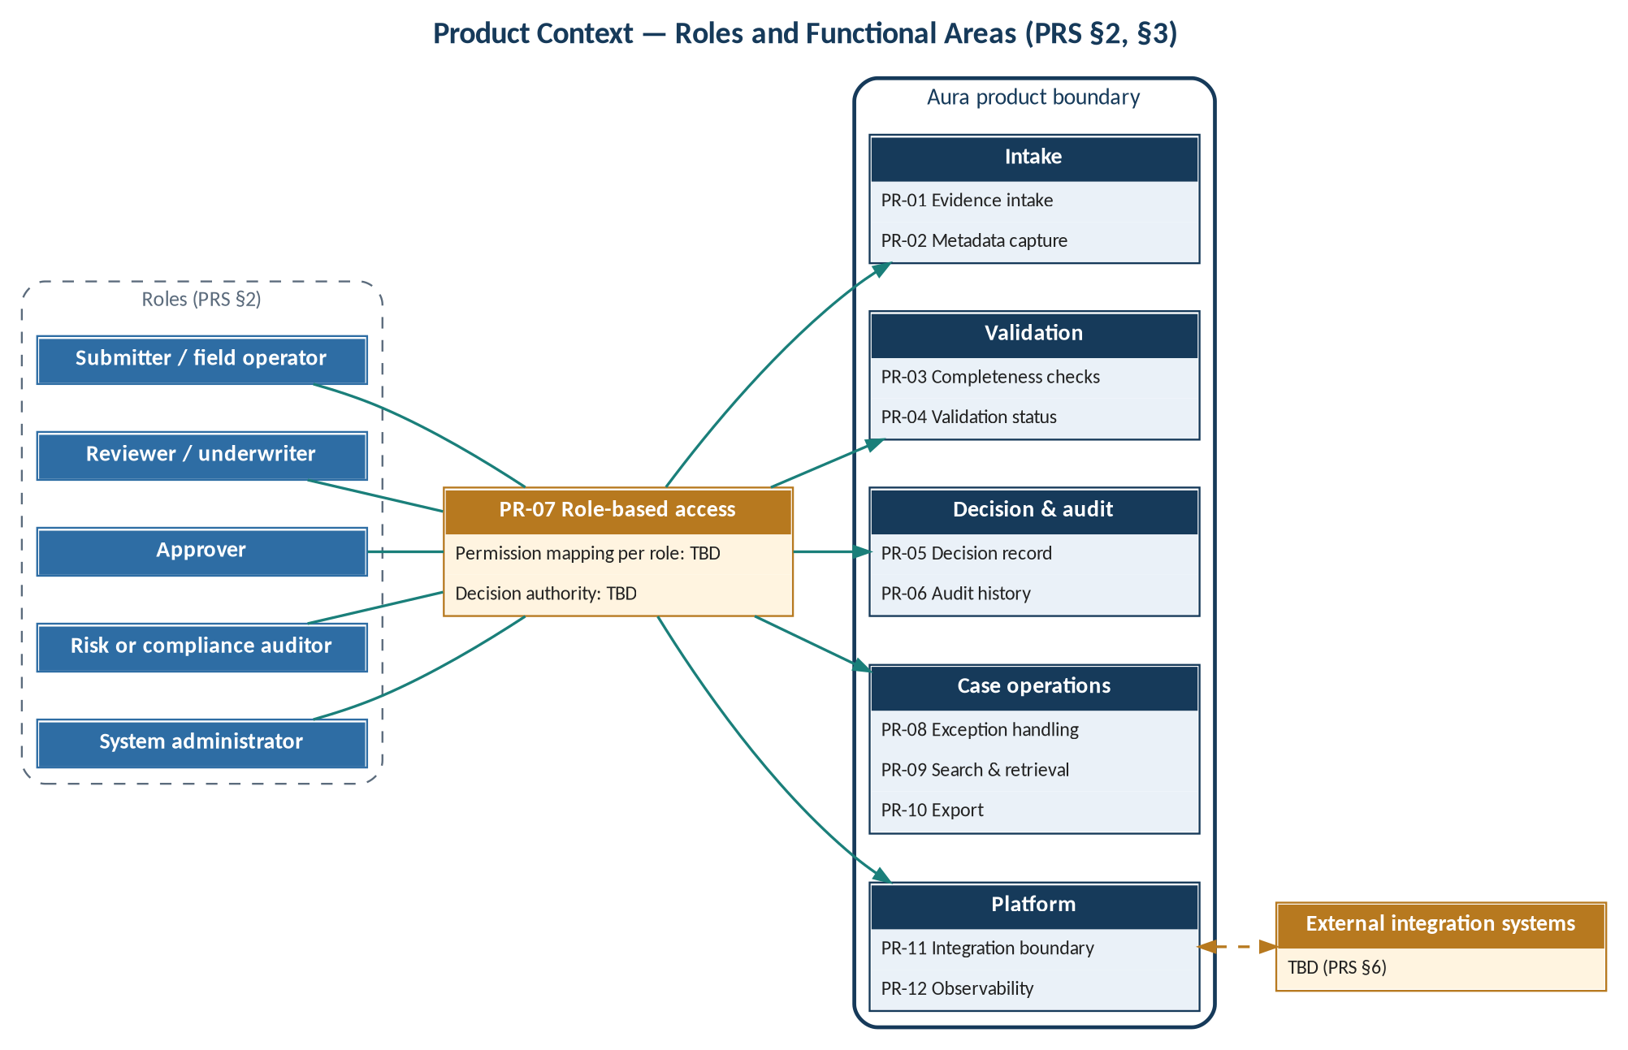
Figure 1 — Product context — roles, role-based access and functional areas

2.2 Product Functions
Table 4 — Product function summary
Epic | Function | Requirements
EP-01 | Evidence intake with metadata | PR-01, PR-02
EP-02 | Completeness checks and visible validation status | PR-03, PR-04
EP-03 | Decision records traceable to evidence and rules | PR-05
EP-04 | Tamper-evident history, retrieval and export | PR-06, PR-09, PR-10
EP-05 | Permission-restricted access and exception handling | PR-07, PR-08
EP-06 | Integration boundary and operational observability | PR-11, PR-12

2.3 User Classes and Characteristics
Table 5 — User classes
ID | Role (PRS §2) | Market segment (MRS §3, derived) | Permissions
UC-01 | Submitter / field operator | Field teams and instrument/evidence collection partners | TBD
UC-02 | Reviewer / underwriter | Lending operations and underwriting teams | TBD
UC-03 | Approver | Lending operations and underwriting teams | TBD (OD-03)
UC-04 | Risk or compliance auditor | Risk and compliance teams | TBD
UC-05 | System administrator | Assignment TBD | TBD

2.4 Operating Environment
Table 6 — Operating environment
Aspect | Status | Source
Client | Web client / operator console | HLD §2
Deployment model | TBD | PRS §6; HLD §9
Tenancy | TBD | HLD §9
Identity provider | TBD | HLD §9
Integrated systems | TBD | PRS §6; MRS §9
Jurisdiction / residency | TBD | PRS §4; MRS §9

2.5 Constraints
- Integrations shall not be committed before API contracts and failure handling are documented (PR-11).
- Commercial scope is not frozen and no compliance claim is made until discovery, policy review and feasibility checks complete (MRS §10).
- Privacy rules require jurisdictional review (PRS §4).

2.6 Assumptions and Dependencies
- Bank-specific policy rules are supplied to configure completeness checks (OD-02).
- Reliability and performance targets depend on agreed workload, hosting and pilot volume (PRS §4).
- Problem and value statements remain hypotheses until validated (MRS §2, §5).

3 Epics
Epics group the product requirements by the market need they serve. The grouping is Derived; it introduces no new requirement.
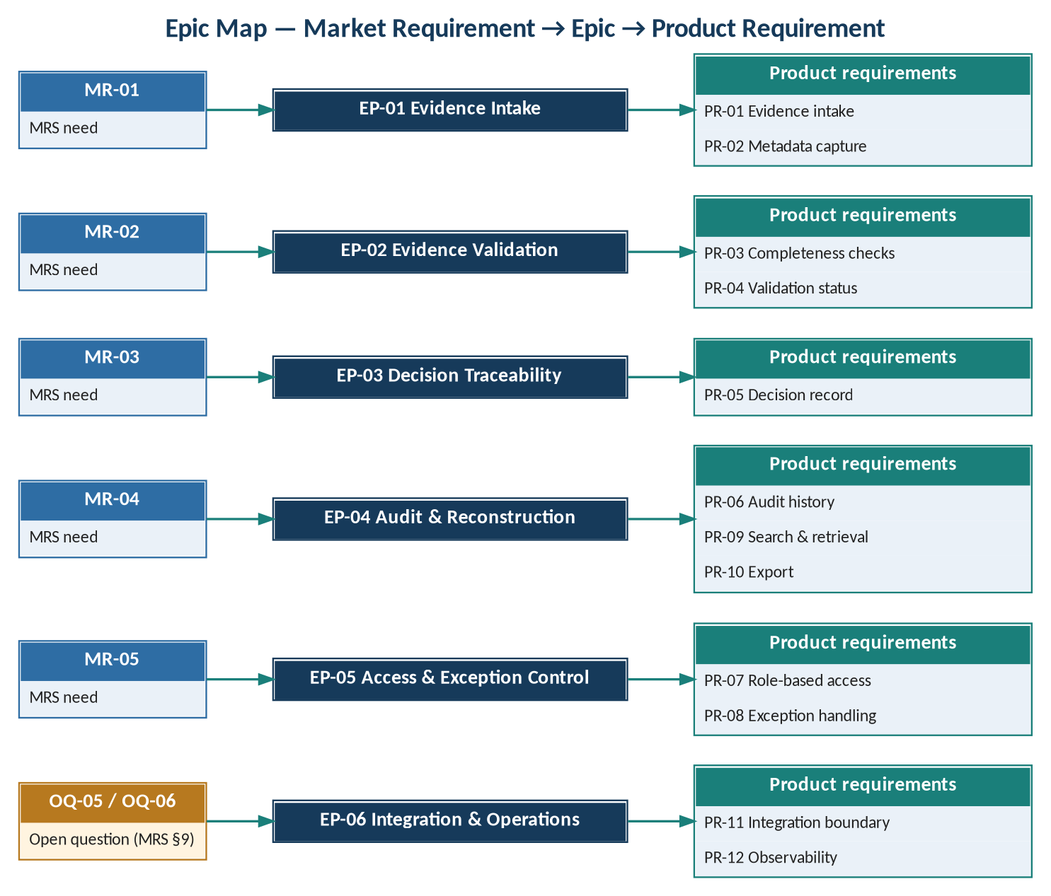
Figure 2 — Epic map — market requirement to epic to product requirement
Table 7 — Epic catalogue
Epic | Goal (from source) | MR | PRs | Use cases | Open items
EP-01 Evidence Intake | Capture evidence with source, timestamp and ownership metadata | MR-01 | PR-01, PR-02 | UCS-01, UCS-02 | OD-01
EP-02 Evidence Validation | Validate completeness and quality before decisioning | MR-02 | PR-03, PR-04 | UCS-03, UCS-04, UCS-13 | OD-02
EP-03 Decision Traceability | Trace each decision to evidence and rules used | MR-03 | PR-05 | UCS-05 | OD-03
EP-04 Audit & Reconstruction | Reconstruct a decision for review or audit | MR-04 | PR-06, PR-09, PR-10 | UCS-06, UCS-08, UCS-09 | OD-05
EP-05 Access & Exception Control | Manage exceptions and approvals with role-based permissions | MR-05 | PR-07, PR-08 | UCS-07, UCS-10 | OD-03
EP-06 Integration & Operations | Documented integration boundary; operational observability | OQ-05, OQ-06 | PR-11, PR-12 | UCS-11, UCS-12 | OD-04, OD-06

4 Use Cases

4.1 Use Case Model
Actor-to-use-case links are candidate assignments: the source defines roles (PRS §2) but not their permissions or decision authority (PRS §6). Every actor assignment is therefore TBC.
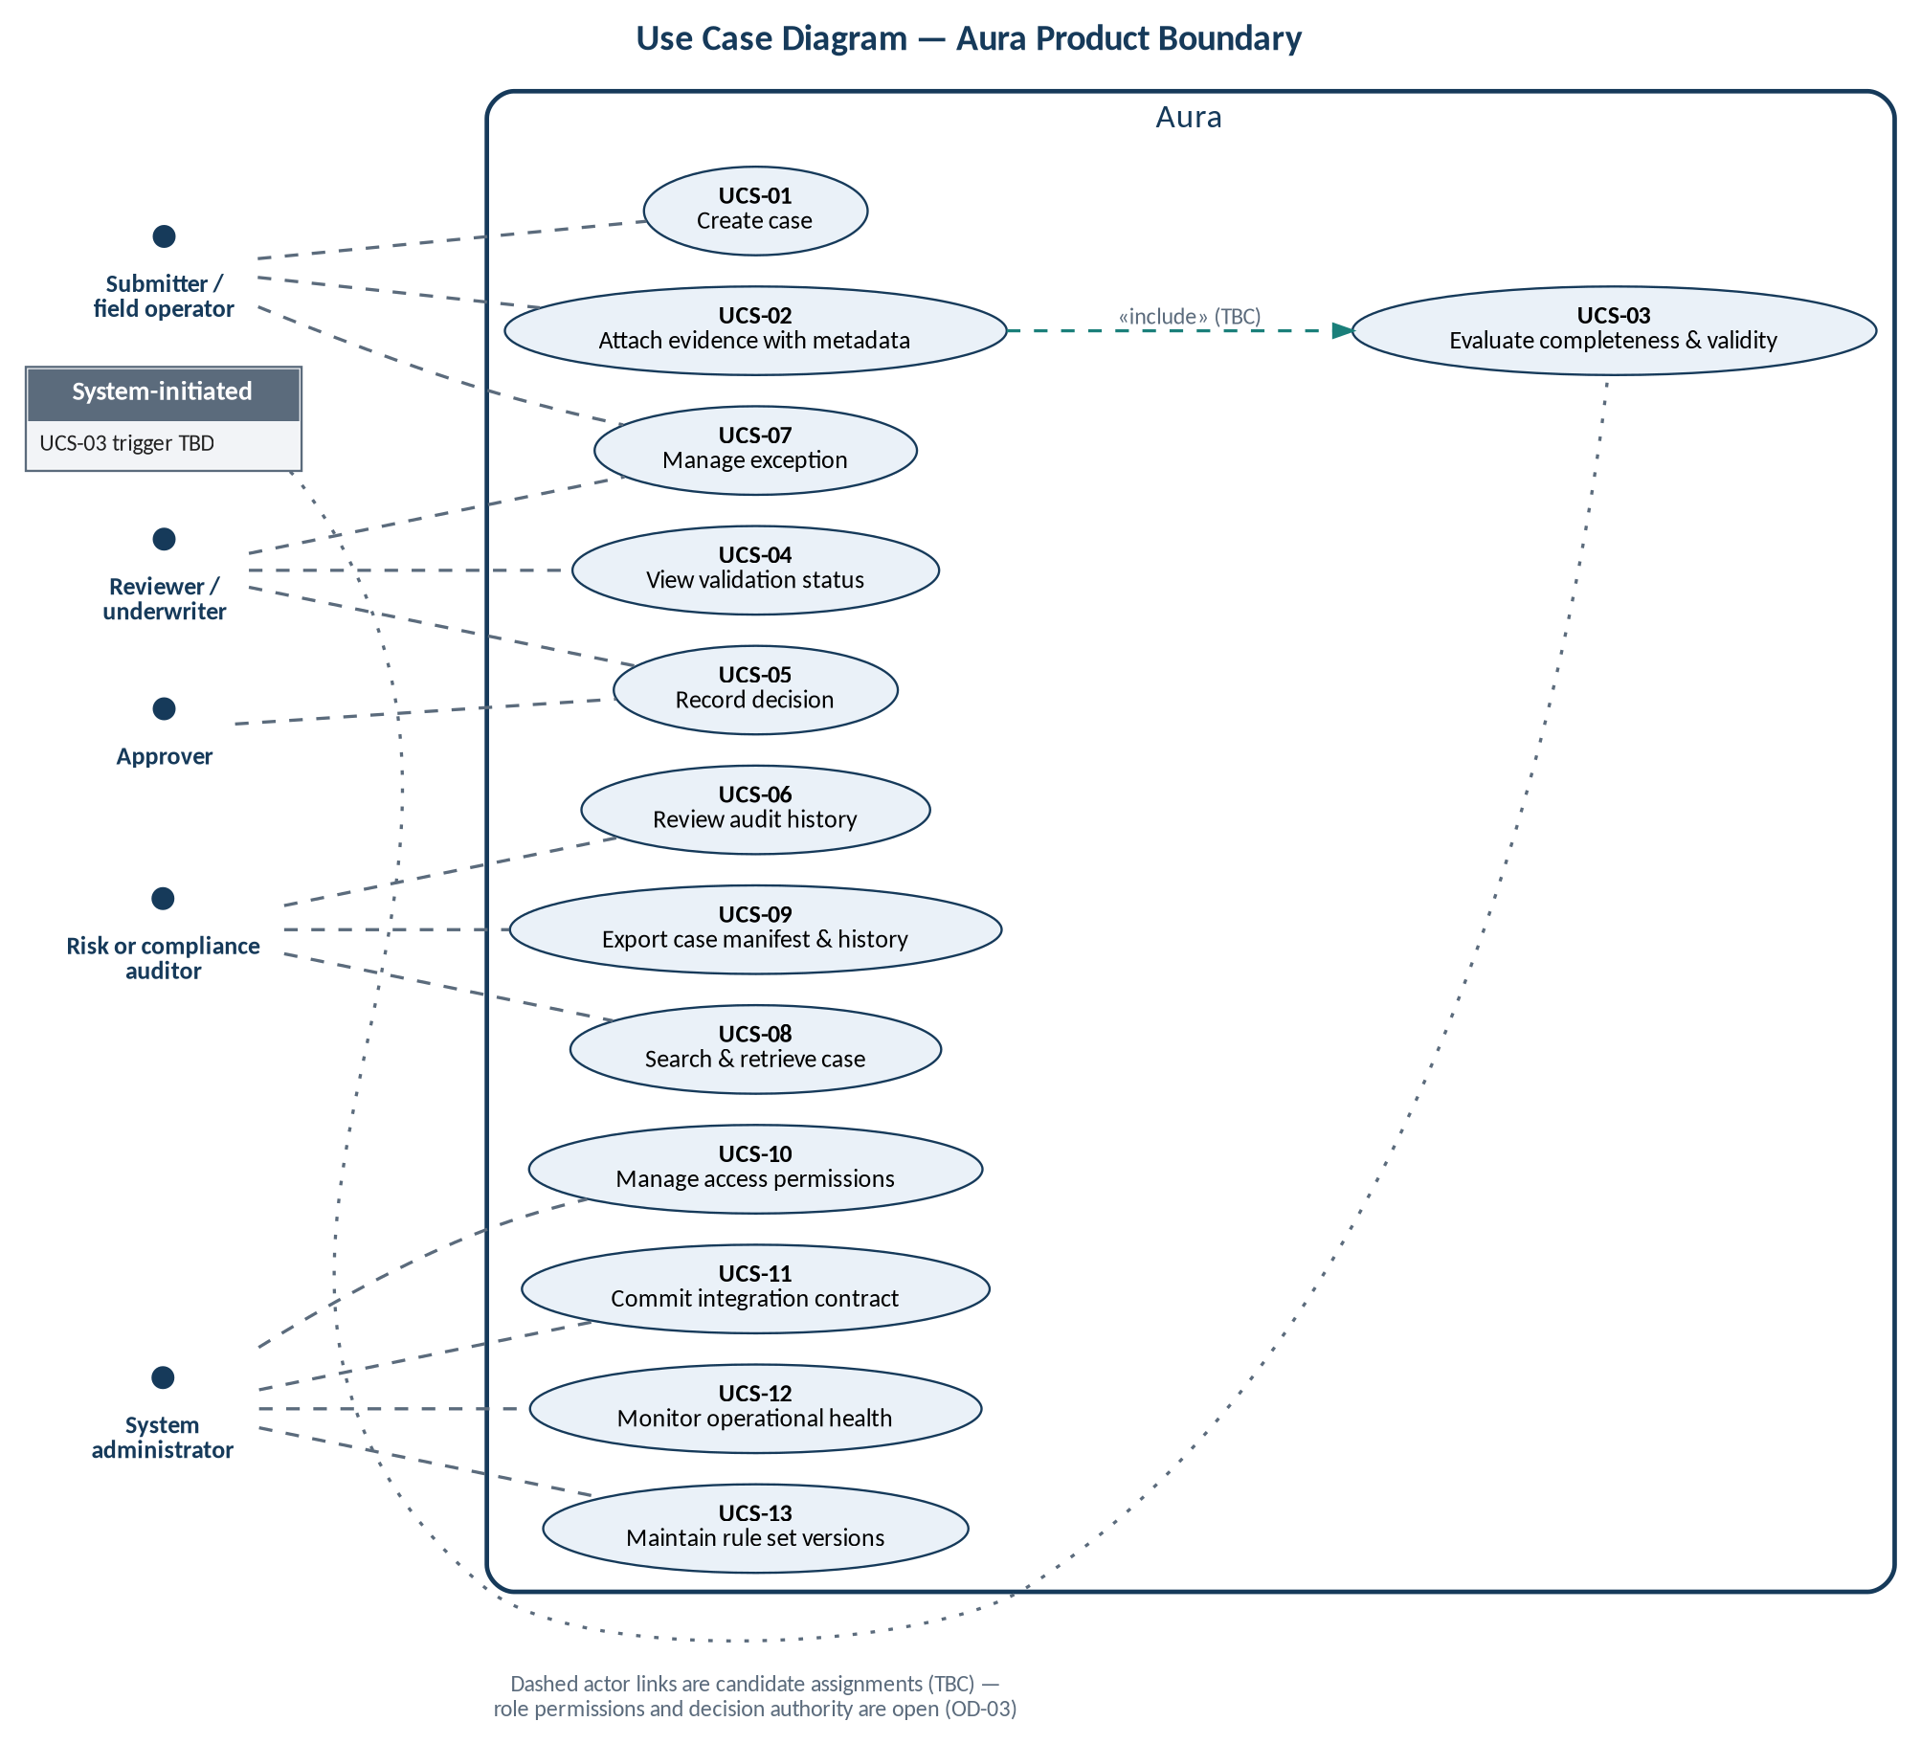
Figure 3 — Use case diagram

4.2 Core Workflow
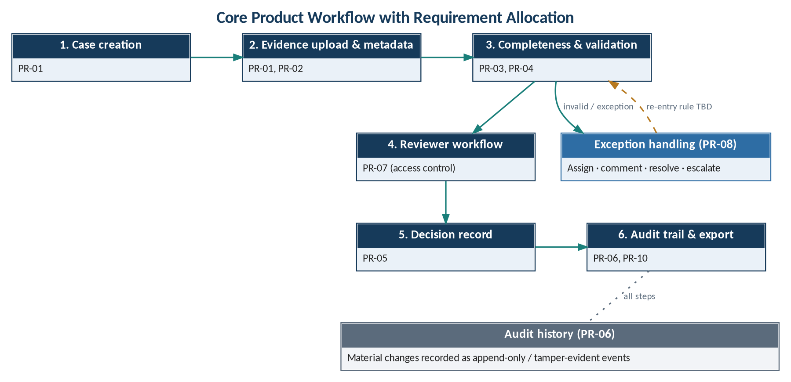
Figure 4 — Core product workflow with requirement allocation

4.3 Use Case Catalogue
Table 8 — Use case catalogue
ID | Use case | Epic | Requirements | Candidate primary actor
UCS-01 | Create case | EP-01 | PR-01, PR-07 | Submitter / field operator (TBC)
UCS-02 | Attach evidence with metadata | EP-01 | PR-01, PR-02, PR-06 | Submitter / field operator (TBC)
UCS-03 | Evaluate completeness and validity | EP-02 | PR-03, PR-04 | System (trigger TBD)
UCS-04 | View validation status | EP-02 | PR-04, PR-07 | Reviewer / underwriter (TBC)
UCS-05 | Record decision | EP-03 | PR-05, PR-06, PR-07 | Reviewer / underwriter or Approver (TBC; decision authority OD-03)
UCS-06 | Review audit history | EP-04 | PR-06, PR-07 | Risk or compliance auditor (TBC)
UCS-07 | Manage exception | EP-05 | PR-08, PR-06 | Users (PR-08); specific roles TBC
UCS-08 | Search and retrieve case | EP-04 | PR-09, PR-07 | Authorized users; Risk or compliance auditor (TBC)
UCS-09 | Export case manifest and history | EP-04 | PR-10, PR-07 | Authorized users; Risk or compliance auditor (TBC)
UCS-10 | Manage access permissions | EP-05 | PR-07 | System administrator (TBC)
UCS-11 | Commit integration contract | EP-06 | PR-11 | TBD (integration owner)
UCS-12 | Monitor operational health | EP-06 | PR-12 | System administrator (TBC); operational support owner TBD (MRS §9)
UCS-13 | Maintain rule set versions | EP-02 | PR-03 | TBD (rule set owner, HLD §3)

4.4 Use Case Specifications

4.4.1 UCS-01 Create case
Table 9 — Use case UCS-01 — Create case
Element | Description
Epic / requirements | EP-01 · PR-01, PR-07
Primary actor | Submitter / field operator (TBC)
Preconditions | User is authenticated and holds permission to create cases (PR-07; permissions TBD).
Trigger | User initiates case creation.
Main success scenario | 1. User requests a new case.  2. System verifies the user's permission.  3. System creates the case.  4. System records the change in audit history (PR-06).  5. System confirms the case to the user.
Alternate / exception flows | 2a. Permission missing → action restricted (PR-07, EC-05); handling TBD.
Postconditions | Case exists and can receive evidence.
Open items | Required case attributes beyond those in HLD §3 (customer reference, product type): TBD.

4.4.2 UCS-02 Attach evidence with metadata
Table 10 — Use case UCS-02 — Attach evidence with metadata
Element | Description
Epic / requirements | EP-01 · PR-01, PR-02, PR-06
Primary actor | Submitter / field operator (TBC)
Preconditions | Case exists; user is authorized for the case.
Trigger | User attaches evidence to the case.
Main success scenario | 1. User selects the case and supplies evidence and source metadata.  2. System verifies the evidence type is supported (types TBD).  3. System records timestamp, source, submitter, type and case association.  4. System stores the evidence (protected storage, checksum — HLD §5).  5. System records the change in audit history.  6. Completeness and validation checks follow (UCS-03; trigger TBD).
Alternate / exception flows | 2a. Missing or unreadable evidence → EC-01.  2b. Duplicate or stale upload → EC-02.  Handling of both: TBD.
Postconditions | Evidence item exists with metadata and a validation status.
Open items | Evidence types (OD-01); capture channel from instruments/devices (MRS §9).

4.4.3 UCS-03 Evaluate completeness and validity
Table 11 — Use case UCS-03 — Evaluate completeness and validity
Element | Description
Epic / requirements | EP-02 · PR-03, PR-04
Primary actor | System (trigger TBD)
Preconditions | A configured, versioned rule set exists (FR-03.3, FR-03.4).
Trigger | TBD (for example, evidence attached — TBC).
Main success scenario | 1. System identifies the applicable rule set version.  2. System checks required fields and evidence against the rules.  3. System sets each evidence item's validation status (pending / valid / invalid / exception).  4. System records the change in audit history.
Alternate / exception flows | 2a. Conflicting evidence values → EC-03.  1a. Rule version changed after case creation → EC-06.  Handling: TBD.
Postconditions | Every evidence item has a validation status.
Open items | Rule content (OD-02); status transition rules; whether an exception record is raised automatically.

4.4.4 UCS-04 View validation status
Table 12 — Use case UCS-04 — View validation status
Element | Description
Epic / requirements | EP-02 · PR-04, PR-07
Primary actor | Reviewer / underwriter (TBC)
Preconditions | User is authorized for the case.
Trigger | User opens a case or evidence item.
Main success scenario | 1. User opens the case.  2. System displays each evidence item with its validation status as clear status text (NFR-05).
Alternate / exception flows | 1a. User lacks permission → restricted (PR-07).
Postconditions | No state change.
Open items | —

4.4.5 UCS-05 Record decision
Table 13 — Use case UCS-05 — Record decision
Element | Description
Epic / requirements | EP-03 · PR-05, PR-06, PR-07
Primary actor | Reviewer / underwriter or Approver (TBC; decision authority OD-03)
Preconditions | Case under review; user holds decision authority (TBD).
Trigger | User records a decision on the case.
Main success scenario | 1. User enters outcome and rationale.  2. System verifies authority.  3. System stores outcome, rationale, actor, timestamp and the referenced evidence and rule versions.  4. System records the change in audit history.
Alternate / exception flows | 3a. Attempt to modify a finalized decision → EC-07; handling TBD.  2a. Not authorized → restricted.
Postconditions | Decision record exists and is traceable to evidence and rules.
Open items | Approval step between review and decision; decision outcomes; finalization rule.

4.4.6 UCS-06 Review audit history
Table 14 — Use case UCS-06 — Review audit history
Element | Description
Epic / requirements | EP-04 · PR-06, PR-07
Primary actor | Risk or compliance auditor (TBC)
Preconditions | User is authorized for the case.
Trigger | User requests the history of a case or object.
Main success scenario | 1. User selects the case or object.  2. System presents the recorded events (actor, action, object, timestamp — HLD §3).
Alternate / exception flows | 1a. Not authorized → restricted.
Postconditions | No state change; access is logged (HLD §5).
Open items | Presentation format: TBD.

4.4.7 UCS-07 Manage exception
Table 15 — Use case UCS-07 — Manage exception
Element | Description
Epic / requirements | EP-05 · PR-08, PR-06
Primary actor | Users (PR-08); specific roles TBC
Preconditions | An exception exists; user is authorized.
Trigger | User acts on an exception.
Main success scenario | 1. User opens the exception.  2. User assigns, comments on, resolves or escalates it.  3. System applies the action.  4. System records the change in audit history.
Alternate / exception flows | 2a. Escalation target undefined → TBD.
Postconditions | Exception reflects the action (owner, status, resolution).
Open items | Severity scale, escalation path, ownership of exception resolution (MRS §9).

4.4.8 UCS-08 Search and retrieve case
Table 16 — Use case UCS-08 — Search and retrieve case
Element | Description
Epic / requirements | EP-04 · PR-09, PR-07
Primary actor | Authorized users; Risk or compliance auditor (TBC)
Preconditions | User is authorized.
Trigger | User searches.
Main success scenario | 1. User enters an identifier or supported metadata.  2. System returns matching cases the user is permitted to see.  3. User opens a case.
Alternate / exception flows | 2a. No match → empty result (presentation TBD).
Postconditions | No state change.
Open items | Supported metadata: TBD.

4.4.9 UCS-09 Export case manifest and history
Table 17 — Use case UCS-09 — Export case manifest and history
Element | Description
Epic / requirements | EP-04 · PR-10, PR-07
Primary actor | Authorized users; Risk or compliance auditor (TBC)
Preconditions | User is authorized for the case.
Trigger | User requests export.
Main success scenario | 1. User selects export for a case.  2. System produces the case evidence manifest and decision history.  3. System records the access.
Alternate / exception flows | 1a. Not authorized → restricted.
Postconditions | Export produced (format TBD).
Open items | Export format; delivery mechanism.

4.4.10 UCS-10 Manage access permissions
Table 18 — Use case UCS-10 — Manage access permissions
Element | Description
Epic / requirements | EP-05 · PR-07
Primary actor | System administrator (TBC)
Preconditions | Administrator is authenticated.
Trigger | A permission assignment changes.
Main success scenario | 1. Administrator assigns or revokes permissions for a user.  2. System applies the assignment to subsequent actions and records.  3. System records the change in audit history.
Alternate / exception flows | —
Postconditions | Permissions updated.
Open items | Role–permission model and decision authority (OD-03); identity provider (HLD §9).

4.4.11 UCS-11 Commit integration contract
Table 19 — Use case UCS-11 — Commit integration contract
Element | Description
Epic / requirements | EP-06 · PR-11
Primary actor | TBD (integration owner)
Preconditions | A target external system is identified (OD-04).
Trigger | An integration is proposed.
Main success scenario | 1. Owner documents authentication, payload schema, timeout, retry policy, idempotency, error mapping and reconciliation (HLD §6).  2. Documentation is reviewed.  3. Integration is committed.
Alternate / exception flows | 1a. Documentation incomplete → integration not committed.
Postconditions | Integration contract documented and committed.
Open items | Integration systems (OD-04); approver: TBD.

4.4.12 UCS-12 Monitor operational health
Table 20 — Use case UCS-12 — Monitor operational health
Element | Description
Epic / requirements | EP-06 · PR-12
Primary actor | System administrator (TBC); operational support owner TBD (MRS §9)
Preconditions | System is running.
Trigger | Routine monitoring or an alert.
Main success scenario | 1. Operator checks health checks.  2. Operator reviews structured logs and error reports.  3. Operator acts on actionable errors (procedure TBD).
Alternate / exception flows | —
Postconditions | Operational state known.
Open items | Alerting thresholds; support ownership.

4.4.13 UCS-13 Maintain rule set versions
Table 21 — Use case UCS-13 — Maintain rule set versions
Element | Description
Epic / requirements | EP-02 · PR-03
Primary actor | TBD (rule set owner, HLD §3)
Preconditions | Bank-specific policy rules are agreed (OD-02).
Trigger | A rule set is created or changed.
Main success scenario | 1. Owner defines or updates the rule set.  2. System stores a new rule set version with effective date and owner.  3. System records the change in audit history.
Alternate / exception flows | —
Postconditions | New rule set version available.
Open items | Effect on in-flight cases (EC-06): TBD.

5 Functional Requirements

5.1 Conventions
Each source requirement PR-nn is reproduced verbatim and decomposed into atomic, verifiable functional requirements FR-nn.n. Decomposition splits the source sentence into its constituent obligations; no obligation is added except where flagged with a source reference.

5.2 EP-01 Evidence Intake
Table 22 — Functional requirements — EP-01 Evidence Intake
ID | Requirement | Parent (verbatim source) | MR
FR-01.1 | The product shall allow a user to create a case. | PR-01 Evidence intake: User can create a case and attach supported evidence with source metadata. | MR-01
FR-01.2 | The product shall allow a user to attach evidence of a supported type to a case. Supported types: TBD (OD-01). | PR-01 (cont.) | MR-01
FR-01.3 | The product shall capture source metadata when evidence is attached. | PR-01 (cont.) | MR-01
FR-02.1 | The product shall record the timestamp of each evidence item. | PR-02 Metadata capture: Each item records timestamp, source, submitter, type, and case association. | MR-01
FR-02.2 | The product shall record the source of each evidence item. | PR-02 (cont.) | MR-01
FR-02.3 | The product shall record the submitter of each evidence item. | PR-02 (cont.) | MR-01
FR-02.4 | The product shall record the type of each evidence item. | PR-02 (cont.) | MR-01
FR-02.5 | The product shall record the case association of each evidence item. | PR-02 (cont.) | MR-01

5.3 EP-02 Evidence Validation
Table 23 — Functional requirements — EP-02 Evidence Validation
ID | Requirement | Parent (verbatim source) | MR
FR-03.1 | The product shall check required fields against configurable rules. | PR-03 Completeness checks: Required fields and evidence are checked against configurable rules. | MR-02
FR-03.2 | The product shall check required evidence against configurable rules. | PR-03 (cont.) | MR-02
FR-03.3 | The rules shall be configurable. Who configures them: TBD. | PR-03 (cont.) | MR-02
FR-03.4 | The rules shall be versioned (HLD §1, §3: RuleSetVersion). | PR-03 (cont.) | MR-02
FR-04.1 | The product shall assign each evidence item a validation status. | PR-04 Validation status: Each evidence item has a visible pending/valid/invalid/exception status. | MR-02
FR-04.2 | The validation status shall take one of the values pending, valid, invalid or exception. | PR-04 (cont.) | MR-02
FR-04.3 | The validation status shall be visible to users. | PR-04 (cont.) | MR-02

5.4 EP-03 Decision Traceability
Table 24 — Functional requirements — EP-03 Decision Traceability
ID | Requirement | Parent (verbatim source) | MR
FR-05.1 | A decision shall store its outcome. | PR-05 Decision record: A decision stores outcome, rationale, actor, timestamp, and referenced evidence/rule versions. | MR-03
FR-05.2 | A decision shall store its rationale. | PR-05 (cont.) | MR-03
FR-05.3 | A decision shall store its actor. | PR-05 (cont.) | MR-03
FR-05.4 | A decision shall store its timestamp. | PR-05 (cont.) | MR-03
FR-05.5 | A decision shall store the referenced evidence versions. | PR-05 (cont.) | MR-03
FR-05.6 | A decision shall store the referenced rule versions. | PR-05 (cont.) | MR-03

5.5 EP-04 Audit and Reconstruction
Table 25 — Functional requirements — EP-04 Audit and Reconstruction
ID | Requirement | Parent (verbatim source) | MR
FR-06.1 | The product shall record material changes. Definition of "material": TBD. | PR-06 Audit history: Material changes are recorded as append-only events or equivalent tamper-evident history. | MR-04
FR-06.2 | Recorded changes shall be append-only events or equivalent tamper-evident history. | PR-06 (cont.) | MR-04
FR-09.1 | Authorized users shall be able to find cases by identifiers. | PR-09 Search and retrieval: Authorized users can find cases by identifiers and supported metadata. | MR-04
FR-09.2 | Authorized users shall be able to find cases by supported metadata. Supported metadata: TBD. | PR-09 (cont.) | MR-04
FR-10.1 | Authorized users shall be able to export a case evidence manifest. Format: TBD. | PR-10 Export: Authorized users can export a case evidence manifest and decision history. | MR-04
FR-10.2 | Authorized users shall be able to export a case decision history. Format: TBD. | PR-10 (cont.) | MR-04

5.6 EP-05 Access and Exception Control
Table 26 — Functional requirements — EP-05 Access and Exception Control
ID | Requirement | Parent (verbatim source) | MR
FR-07.1 | The product shall restrict actions according to assigned permissions. | PR-07 Role-based access: Actions and records are restricted by assigned permissions. | MR-05
FR-07.2 | The product shall restrict records according to assigned permissions. | PR-07 (cont.) | MR-05
FR-08.1 | Users shall be able to assign exceptions. | PR-08 Exception handling: Users can assign, comment on, resolve, and escalate exceptions. | MR-05
FR-08.2 | Users shall be able to comment on exceptions. | PR-08 (cont.) | MR-05
FR-08.3 | Users shall be able to resolve exceptions. | PR-08 (cont.) | MR-05
FR-08.4 | Users shall be able to escalate exceptions. Escalation path: TBD. | PR-08 (cont.) | MR-05

5.7 EP-06 Integration and Operations
Table 27 — Functional requirements — EP-06 Integration and Operations
ID | Requirement | Parent (verbatim source) | MR
FR-11.1 | API contracts shall be documented before an integration is committed. | PR-11 Integration boundary: API contracts and failure handling are documented before integrations are committed. | OQ-05
FR-11.2 | Failure handling shall be documented before an integration is committed. | PR-11 (cont.) | OQ-05
FR-12.1 | The system shall expose structured logs. | PR-12 Operational observability: System exposes structured logs, health checks, and actionable error reporting. | OQ-06 (TBC)
FR-12.2 | The system shall expose health checks. | PR-12 (cont.) | OQ-06 (TBC)
FR-12.3 | The system shall provide actionable error reporting. | PR-12 (cont.) | OQ-06 (TBC)

6 Non-Functional Requirements
Quality requirements restate PRS §4, mapped to ISO/IEC 25010 quality characteristics. Where the source defers a target, the fit criterion is TBD and the deferral condition is recorded.
Table 28 — Non-functional requirements
ID | Quality characteristic | Requirement (PRS §4) | Fit criterion | Dependency
NFR-01.1 | Security | Least privilege | TBD | PR-07
NFR-01.2 | Security | Secure secrets handling | TBD | HLD §5
NFR-01.3 | Security | Encryption in transit | TBD | Deployment (OD-06)
NFR-01.4 | Security | Encryption at rest where supported by deployment | TBD | OD-06; HLD §9 key management
NFR-02.1 | Reliability | Define service objectives after workload and hosting assumptions are agreed | TBD | Workload; hosting
NFR-03.1 | Performance efficiency | Establish measurable targets from pilot volume and user expectations | TBD | Pilot volume
NFR-04.1 | Security (privacy) | Retention rules require jurisdictional review | TBD | OD-05; MRS §9
NFR-04.2 | Security (privacy) | Deletion rules require jurisdictional review | TBD | MRS §9
NFR-04.3 | Security (privacy) | Consent rules require jurisdictional review | TBD | MRS §9
NFR-04.4 | Security (privacy) | Data residency rules require jurisdictional review | TBD | MRS §9
NFR-05.1 | Usability (accessibility) | Core workflows should be keyboard navigable | TBD (conformance level) | —
NFR-05.2 | Usability | Core workflows should use clear status text | TBD | PR-04
NFR-06.1 | Maintainability | Version APIs | TBD | PR-11
NFR-06.2 | Maintainability | Version rules | TBD | PR-03
NFR-06.3 | Maintainability | Version schema migrations | TBD | HLD §7
NFR-06.4 | Maintainability | Test critical paths | TBD (coverage) | —

NFR-05 uses "should" in the source; it is retained as a recommendation-level requirement pending confirmation.

7 Exception Cases
Exception cases are stated in PRS §5. Expected behaviour is not specified and is TBD; related requirements and use cases are Derived.
Table 29 — Exception cases
ID | Exception case (PRS §5) | Related PR | Use case / step | Expected behaviour
EC-01 | Missing or unreadable evidence | PR-03, PR-04, PR-08 | UCS-02 alt 2a | TBD
EC-02 | Duplicate or stale uploads | PR-01, PR-03 | UCS-02 alt 2b | TBD
EC-03 | Conflicting evidence values | PR-04, PR-08 | UCS-03 alt 2a | TBD
EC-04 | Integration timeout or partial response | PR-11, PR-12 | UCS-11 (runtime) | TBD (retry / reconciliation, HLD §6)
EC-05 | Unauthorized access attempt | PR-07, PR-06 | All — alt flows | TBD
EC-06 | Rule version changed after case creation | PR-03, PR-05 | UCS-03 alt 1a; UCS-13 | TBD
EC-07 | User attempts to modify a finalized decision | PR-05, PR-06, PR-07 | UCS-05 alt 3a | TBD

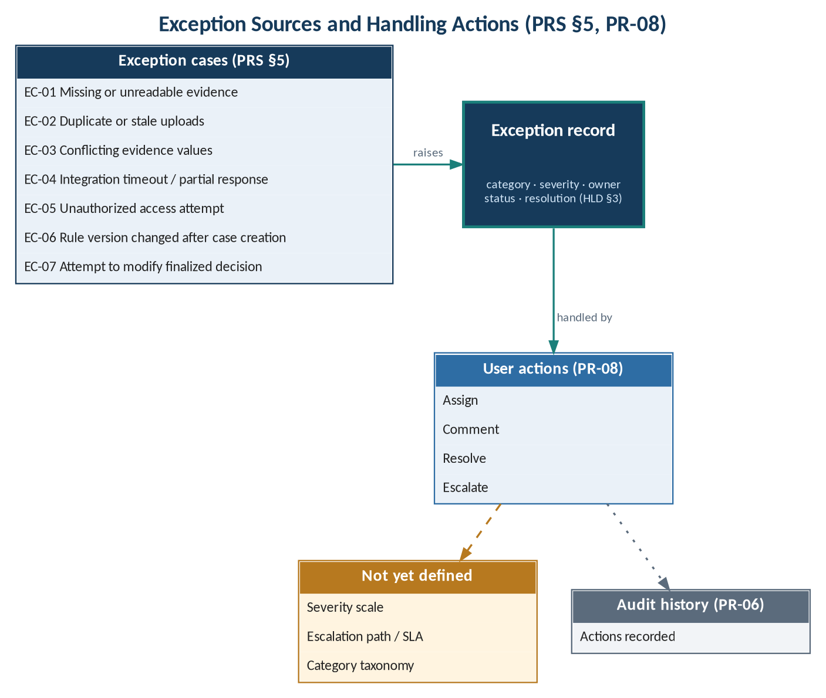
Figure 5 — Exception sources and handling actions

7.1 Evidence Validation Status
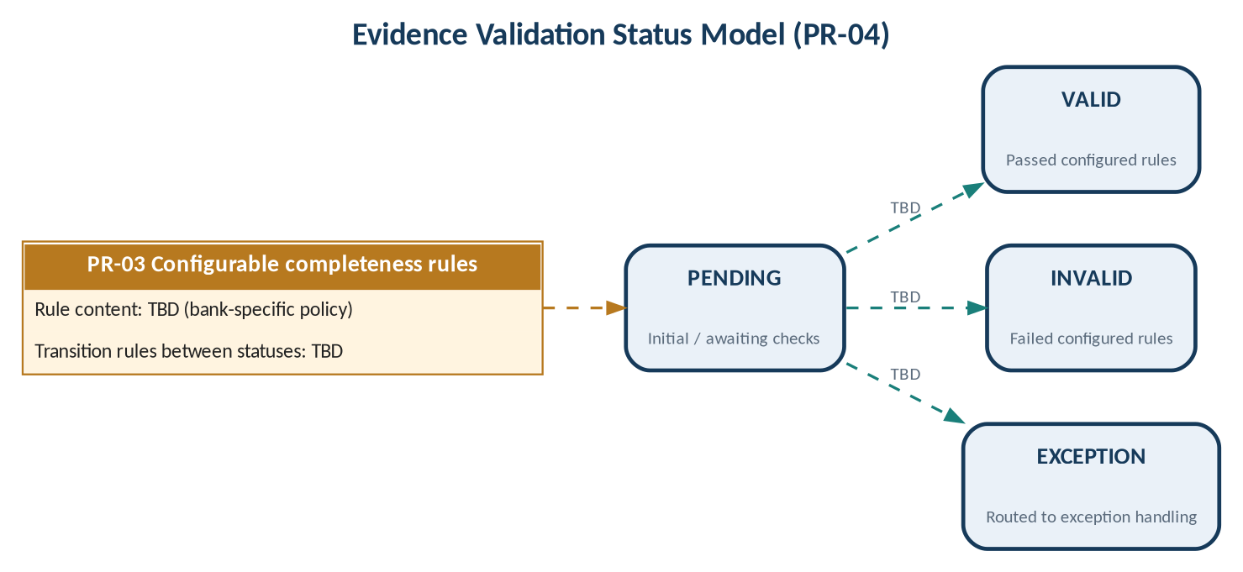
Figure 6 — Evidence validation status model (PR-04)

8 Acceptance Criteria

8.1 Approach
Each source acceptance criterion (PRS §3) is restated as one or more Given/When/Then scenarios. Measurable thresholds (for example response time, error rates) are an open decision (OD-07) and are TBD for every criterion.

8.2 Acceptance Criteria by Requirement
Table 30 — Acceptance criteria
ID | PR | Given | When | Then | Threshold
AC-01.1 | PR-01 | an authorized user | the user creates a case | a case exists and is available for evidence attachment | TBD
AC-01.2 | PR-01 | an existing case and evidence of a supported type (types TBD) | the user attaches the evidence with source metadata | the evidence is associated with the case together with its source metadata | TBD
AC-02.1 | PR-02 | evidence attached to a case | the evidence item is stored | its timestamp, source, submitter, type and case association are recorded | TBD
AC-03.1 | PR-03 | a configured rule set | a case's required fields and evidence are checked | the check is performed against the configured rules (rule content TBD) | TBD
AC-04.1 | PR-04 | an evidence item | a user views it | a status of pending, valid, invalid or exception is visible | TBD
AC-05.1 | PR-05 | a case under review | a decision is recorded | the decision stores outcome, rationale, actor, timestamp, and referenced evidence and rule versions | TBD
AC-06.1 | PR-06 | a material change (definition TBD) | the change occurs | it is recorded as an append-only event or equivalent tamper-evident history | TBD
AC-07.1 | PR-07 | a user without the required permission | the user attempts an action or requests a record | the action or record is restricted | TBD
AC-08.1 | PR-08 | an open exception | a user assigns, comments on, resolves or escalates it | the corresponding action is applied to the exception | TBD
AC-09.1 | PR-09 | an authorized user | the user searches by an identifier or supported metadata | matching cases are found | TBD
AC-10.1 | PR-10 | an authorized user and a case | the user exports the case | a case evidence manifest and decision history are produced (format TBD) | TBD
AC-11.1 | PR-11 | a proposed integration | it is considered for commitment | its API contract and failure handling are already documented | TBD
AC-12.1 | PR-12 | a running system | an operator inspects it | structured logs, health checks and actionable error reports are available | TBD

8.3 Verification Summary
Table 31 — Verification by epic
Epic | Acceptance criteria | Verification method (proposed) | Use cases exercised
EP-01 | AC-01.1, AC-01.2, AC-02.1 | Test | UCS-01, UCS-02
EP-02 | AC-03.1, AC-04.1 | Test, Demonstration | UCS-03, UCS-04, UCS-13
EP-03 | AC-05.1 | Test | UCS-05
EP-04 | AC-06.1, AC-09.1, AC-10.1 | Test, Inspection | UCS-06, UCS-08, UCS-09
EP-05 | AC-07.1, AC-08.1 | Test | UCS-07, UCS-10
EP-06 | AC-11.1, AC-12.1 | Inspection, Demonstration | UCS-11, UCS-12

9 Open Decisions
Table 32 — Open decisions
ID | Open decision (PRS §6) | Affects | Owner | Due
OD-01 | Supported evidence types | FR-01.2; UCS-02; EC-01 | TBD | TBD
OD-02 | Bank-specific policy rules | FR-03.1 – FR-03.3; UCS-03, UCS-13 | TBD | TBD
OD-03 | Decision authority | UCS-05, UCS-10; all actor assignments | TBD | TBD
OD-04 | Integration systems | PR-11; UCS-11; EC-04 | TBD | TBD
OD-05 | Retention policy | NFR-04.1; PR-06 | TBD | TBD
OD-06 | Deployment model | NFR-01.3, NFR-01.4, NFR-02.1 | TBD | TBD
OD-07 | Acceptance thresholds | All AC-nn.n | TBD | TBD

10 Requirements Traceability
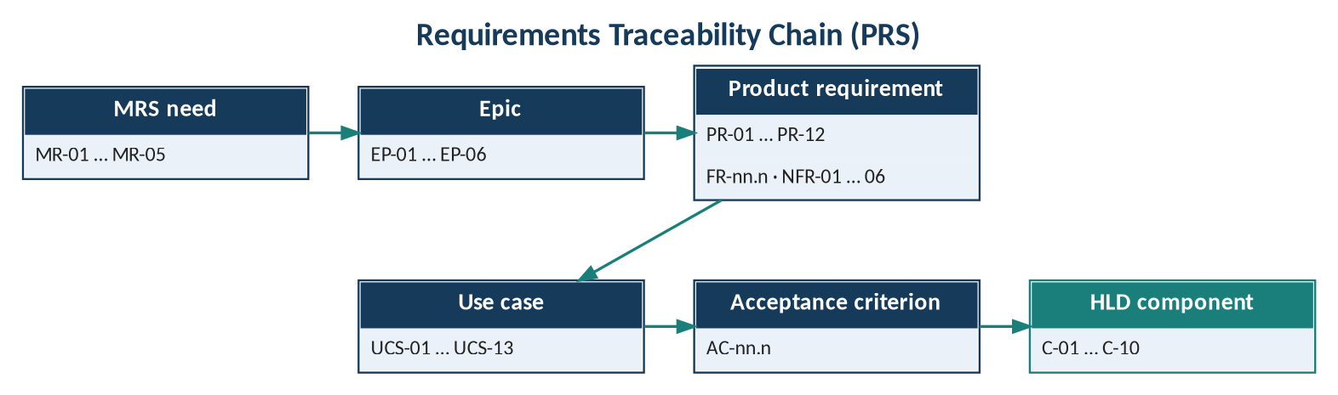
Figure 7 — Requirements traceability chain

10.1 MR → Epic → PR → Use Case → Acceptance Criteria → HLD
Table 33 — Forward traceability matrix
MR | Epic | PR | FR | Use cases | AC | HLD component
MR-01 | EP-01 | PR-01 | FR-01.1 – 01.3 | UCS-01, UCS-02 | AC-01.1, AC-01.2 | C-01, C-03, C-04, C-09
MR-01 | EP-01 | PR-02 | FR-02.1 – 02.5 | UCS-02 | AC-02.1 | C-04
MR-02 | EP-02 | PR-03 | FR-03.1 – 03.4 | UCS-03, UCS-13 | AC-03.1 | C-05
MR-02 | EP-02 | PR-04 | FR-04.1 – 04.3 | UCS-03, UCS-04 | AC-04.1 | C-01, C-04, C-05
MR-03 | EP-03 | PR-05 | FR-05.1 – 05.6 | UCS-05 | AC-05.1 | C-06
MR-04 | EP-04 | PR-06 | FR-06.1 – 06.2 | UCS-06 (all) | AC-06.1 | C-07, C-09
MR-05 | EP-05 | PR-07 | FR-07.1 – 07.2 | UCS-10 (all) | AC-07.1 | C-02
MR-05 | EP-05 | PR-08 | FR-08.1 – 08.4 | UCS-07 | AC-08.1 | C-01; owner TBC
MR-04 | EP-04 | PR-09 | FR-09.1 – 09.2 | UCS-08 | AC-09.1 | TBC (C-03 candidate)
MR-04 | EP-04 | PR-10 | FR-10.1 – 10.2 | UCS-09 | AC-10.1 | TBC (C-07 candidate)
OQ-05 | EP-06 | PR-11 | FR-11.1 – 11.2 | UCS-11 | AC-11.1 | C-08
OQ-06 | EP-06 | PR-12 | FR-12.1 – 12.3 | UCS-12 | AC-12.1 | C-10

10.2 Use Case → Requirement Coverage
Table 34 — Use case coverage matrix
UCS | PR-01 | PR-02 | PR-03 | PR-04 | PR-05 | PR-06 | PR-07 | PR-08 | PR-09 | PR-10 | PR-11 | PR-12
UCS-01 | ● |  |  |  |  |  | ●
UCS-02 | ● | ● |  |  |  | ●
UCS-03 |  |  | ● | ●
UCS-04 |  |  |  | ● |  |  | ●
UCS-05 |  |  |  |  | ● | ● | ●
UCS-06 |  |  |  |  |  | ● | ●
UCS-07 |  |  |  |  |  | ● |  | ●
UCS-08 |  |  |  |  |  |  | ● |  | ●
UCS-09 |  |  |  |  |  |  | ● |  |  | ●
UCS-10 |  |  |  |  |  |  | ●
UCS-11 |  |  |  |  |  |  |  |  |  |  | ●
UCS-12 |  |  |  |  |  |  |  |  |  |  |  | ●
UCS-13 |  |  | ●

10.3 Non-Functional Requirement → Design
Table 35 — NFR → HLD traceability
NFR | HLD design element (Aura_HLD.md)
NFR-01 | C-02 authentication / authorization; secrets outside source control; encryption / key management pending (HLD §5, §9)
NFR-02 | Health/readiness, backup/restore tests, rollback (HLD §7); targets TBD
NFR-03 | Capacity targets TBD pending workload discovery (HLD §7)
NFR-04 | Retention, legal hold, deletion and backup policy with stakeholders (HLD §5)
NFR-05 | C-01 Web client / operator console
NFR-06 | Versioned rules (HLD §1); automated migrations (HLD §7)

10.4 Coverage Summary
Table 36 — Coverage summary
Item | Count | Traced up | Traced down
Product requirements PR | 12 | 12 (10 to MR, 2 to MRS open questions) | 12 to HLD (3 TBC)
Functional requirements FR | 38 | 38 to PR | Via PR
Use cases UCS | 13 | 13 to epic and PR | To HLD scenarios (AURA-HLD-2.0 §6)
Acceptance criteria AC | 13 | 13 to PR | Thresholds TBD
Non-functional statements NFR | 16 | To PRS §4 | 6 areas to HLD
Exception cases EC | 7 | To PR and UCS | To HLD (AURA-HLD-2.0 §13)

Appendix A — TBD Register
Table 37 — TBD register
ID | Item | Source | Blocks
TBD-01 | Supported evidence types | PRS §6 | FR-01.2
TBD-02 | Bank-specific policy rules | PRS §6 | FR-03.x, UCS-13
TBD-03 | Decision authority; role permissions; actor assignments | PRS §6 | UCS-05, UCS-10, all actors
TBD-04 | Integration systems | PRS §6 | PR-11
TBD-05 | Retention policy | PRS §6 | NFR-04.1
TBD-06 | Deployment model | PRS §6 | NFR-01, NFR-02
TBD-07 | Acceptance thresholds | PRS §6 | Section 8
TBD-08 | Expected behaviour for EC-01 – EC-07 | Not in source | Section 7
TBD-09 | Status transition rules; definition of material change | Not in source | FR-04.2, FR-06.1
TBD-10 | Search metadata; export format; escalation path | Not in source | FR-09.2, FR-10.x, FR-08.4
TBD-11 | Priorities, release plan, owner, classification | Not in source | Release planning; document control

Appendix B — Changes from AURA-PRS-1.0
Table 38 — Change log
Area | Change
Epics | New section 3: six epics EP-01 – EP-06 grouping PR-01 – PR-12 by market need.
Use cases | New section 4: use case model and 13 detailed use case specifications.
Functional requirements | PR-01 – PR-12 decomposed into 38 atomic FR-nn.n statements; source wording retained.
Non-functional requirements | NFR-01 – NFR-06 decomposed into 16 statements mapped to ISO/IEC 25010.
Acceptance criteria | Source criteria restated as 13 Given/When/Then criteria.
Traceability | Extended to MR → EP → PR → FR → UCS → AC → HLD.
Source requirements | No change to PR-01 – PR-12, NFR areas, EC-01 – EC-07 or OD-01 – OD-07.

