AURA
Evidence Intake · Validation · Decision Traceability
Requirements & Architecture Series · MRS · PRS · SyRS · HLD · LLD · PDLC
AURA SYSTEM REQUIREMENTS SPECIFICATION
System-Level, Verifiable Requirements — Initial Baseline
Document ID | AURA-SYRS-1.0
Version | 1.0
Status | INITIAL BASELINE — FOR REVIEW
Date | 2026-10-13
Classification | TBD
Prepared By | Senior Software Architect (organisation TBD)
Standard | ISO/IEC/IEEE 29148:2018 §9.4
Companion Docs | AURA-MRS-1.0 · AURA-PRS-1.0 · AURA-HLD-1.0 · AURA-LLD-1.0 · AURA-PDLC-1.0
Initial baseline derived exclusively from AURA-MRS-1.0, AURA-PRS-1.0 and AURA-HLD-1.0. Values not present in those documents are marked TBD. Classification and distribution: TBD.

Document Control
Document ID | AURA-SYRS-1.0
Title | System Requirements Specification — Aura
Version | 1.0
Status | Initial baseline for review
Date | 13 October 2026
Product | Aura — controlled evidence intake, validation and decision traceability workflow
Standard | ISO/IEC/IEEE 29148:2018 — System Requirements Specification information items, clause 9.4
Source basis | AURA-MRS-1.0, AURA-PRS-1.0 and AURA-HLD-1.0 (finalized baselines). Reference documents supplied for formatting only; no content taken from them.
Owner | TBD
Series | AURA-MRS · AURA-PRS · AURA-SYRS · AURA-HLD · AURA-LLD · AURA-PDLC

Revision History
Version | Date | Author | Description
1.0 | 13 October 2026 | Senior Software Architect | Initial baseline. System requirements derived from PR-01 – PR-12, NFR-01 – NFR-06, EC-01 – EC-07 and HLD controls; no new functionality introduced.

Review and Approval
Role | Name | Signature | Date
Prepared by — Senior Software Architect | TBD
Reviewed by — Product Management | TBD
Reviewed by — Risk / Compliance | TBD
Approved by — Product Owner | TBD

Evidence Conventions
Marker | Meaning
MRS §n | Section n of AURA-MRS-1.0 — Market Requirements Specification (finalized baseline).
PRS §n | Section n of AURA-PRS-1.0 — Product Requirements Specification (finalized baseline).
HLD §n | Section n of AURA-HLD-1.0 — High-Level Design (finalized baseline).
ID references | Identifiers defined in the finalized baseline: MR, MP, MS, SM, OQ, CN, GC, RK (MRS); PR, NFR, EC, OD, UC (PRS); C, IF, SC, OP, AP, AD, PD, AR, DG (HLD).
Stated | Content taken directly from the finalized MRS, PRS or HLD; wording preserved where practical.
Derived | Structural derivation by the architect (identifier assignment, decomposition, allocation, trace links, proposed verification method) from stated content. No new requirement, value or technology is introduced; derived items require confirmation.
TBD / TBC | To be determined / to be confirmed. The baseline does not provide this information; no value is asserted.

Table of Contents
1 Introduction 6
1.1 System Purpose 6
1.2 System Scope 6
1.3 System Overview 7
1.3.1 System Context 7
1.3.2 System Functions 7
1.3.3 User Characteristics 8
1.4 Definitions and Conventions 9
2 References 10
3 System Requirements 11
3.1 Functional Requirements 11
3.1.1 Case and evidence intake 11
3.1.2 Validation 11
3.1.3 Decision 11
3.1.4 Audit 12
3.1.5 Access control 12
3.1.6 Exception handling 12
3.1.7 Search and export 13
3.1.8 Integration 13
3.1.9 Observability 13
3.2 Usability Requirements 13
3.3 Performance Requirements 13
3.4 System Interfaces 14
3.5 System Operations 14
3.6 System Modes and States 15
3.7 Physical Characteristics 15
3.8 Environmental Conditions 15
3.9 System Security 16
3.10 Information Management 16
3.11 Policies and Regulations 16
3.12 System Life Cycle Sustainment 16
3.13 Packaging and Delivery 17
4 Verification 18
4.1 Requirement Verification Matrix 18
5 Traceability 21
5.1 Product Requirement → System Requirement 21
5.2 Non-Functional Requirement and Exception Case → System Requirement 21
5.3 HLD Control → System Requirement 22
Appendix A — Assumptions and Dependencies 23
Appendix B — Open Issues 24

List of Figures
Figure 1 — System context and system boundary 7
Figure 2 — System function decomposition and requirement groups 8
Figure 3 — Object states and system modes 15
Figure 4 — Traceability chain across the Aura specification set 21
List of Tables
Table 1 — User classes 8
Table 2 — Definitions and conventions 9
Table 3 — References 10
Table 4 — Case and evidence intake requirements 11
Table 5 — Validation requirements 11
Table 6 — Decision requirements 11
Table 7 — Audit requirements 12
Table 8 — Access control requirements 12
Table 9 — Exception handling requirements 12
Table 10 — Search and export requirements 13
Table 11 — Integration requirements 13
Table 12 — Observability requirements 13
Table 13 — Usability requirements 13
Table 14 — Performance requirements 14
Table 15 — Performance parameters 14
Table 16 — System interfaces 14
Table 17 — Operational requirements 14
Table 18 — Object state summary 15
Table 19 — Security requirements 16
Table 20 — Information management requirements 16
Table 21 — Policy requirements 16
Table 22 — Life cycle sustainment requirements 16
Table 23 — Verification summary by requirement group 18
Table 24 — Requirement verification matrix 18
Table 25 — PR → SYS traceability 21
Table 26 — NFR / EC → SYS traceability 21
Table 27 — HLD control → SYS traceability 22
Table 28 — Open issues 24

1 Introduction

1.1 System Purpose
The Aura system provides a controlled workflow for evidence intake, validation, decision traceability, and audit-ready reconstruction (PRS §1.2). It captures evidence with source, timestamp and ownership metadata, validates it against configurable versioned rules, records decisions with their rationale and the evidence and rule versions used, and keeps a tamper-evident history so that a decision can be reconstructed for review or audit (MR-01 – MR-05).

1.2 System Scope
The system comprises the ten logical components defined in HLD §4.1: web client / operator console (C-01), API gateway and identity boundary (C-02), case management (C-03), evidence ingestion and metadata (C-04), validation/rules (C-05), decision record (C-06), audit/event history (C-07), integration adapters (C-08), relational data store and protected object storage (C-09), and monitoring, logging, alerting and backup services (C-10).
- External to the system: users (UC-01 – UC-05), identity provider (TBD, PD-03), bank LOS/LMS/core systems (TBD, OQ-05), instruments/devices (TBD, OQ-02).
- Not yet determined: deployment model, tenancy, storage technology, eventing, key management and DR objectives (PD-01 – PD-07); supported evidence types, policy rules, decision authority and acceptance thresholds (OD-01 – OD-07).

1.3 System Overview

1.3.1 System Context
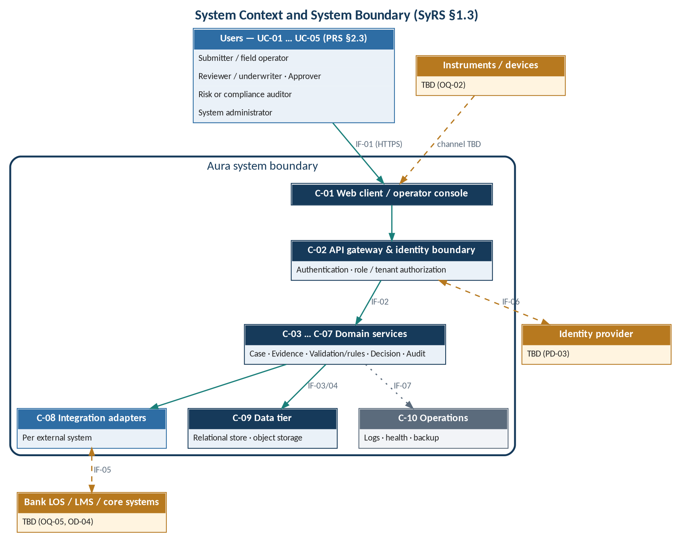
Figure 1 — System context and system boundary

1.3.2 System Functions
The system functions are the nine functional areas of PRS §2.2 and §4, each realised by a group of system requirements in Section 3.1.
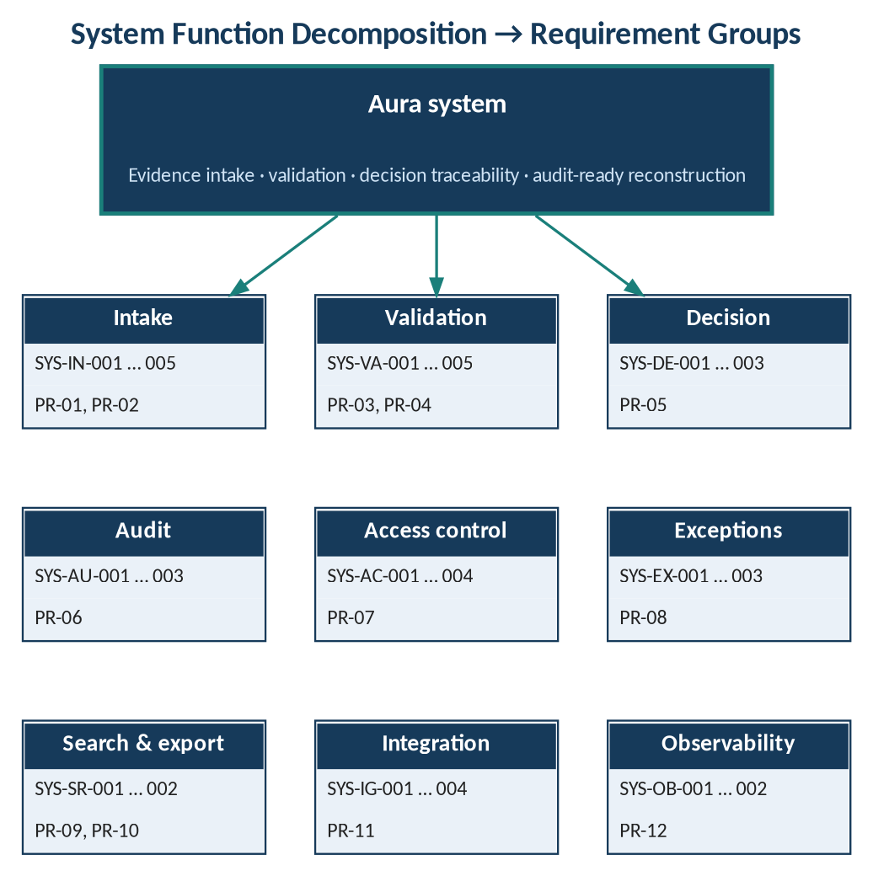
Figure 2 — System function decomposition and requirement groups

1.3.3 User Characteristics
Table 1 — User classes
ID | Role (PRS §2.3) | Permissions | Decision authority
UC-01 | Submitter / field operator | TBD | —
UC-02 | Reviewer / underwriter | TBD | TBD
UC-03 | Approver | TBD | TBD (OD-03)
UC-04 | Risk or compliance auditor | TBD | —
UC-05 | System administrator | TBD | —

1.4 Definitions and Conventions
Table 2 — Definitions and conventions
Term | Definition
SYS-xx-nnn | System requirement identifier assigned in this document (Derived). Group codes: IN intake, VA validation, DE decision, AU audit, AC access control, EX exceptions, SR search/export, IG integration, OB observability, US usability, PF performance, OP operations, SE security, IM information, PO policy, LS life cycle sustainment.
shall | Mandatory system requirement.
V | Proposed verification method: T Test, A Analysis, I Inspection, D Demonstration (Derived; to be confirmed at Gate G2, AURA-PDLC-1.0).
U-nn.n | Design unit in AURA-LLD-1.0 that realises the requirement.

2 References
Table 3 — References
ID | Document
R1 | AURA-MRS-1.0 — Market Requirements Specification
R2 | AURA-PRS-1.0 — Product Requirements Specification
R3 | AURA-HLD-1.0 — High-Level Design
R4 | AURA-LLD-1.0 — Low-Level Design
R5 | AURA-PDLC-1.0 — Product Development Life Cycle
R6 | ISO/IEC/IEEE 29148:2018 — Requirements engineering
R7 | ISO/IEC/IEEE 15288:2023 — System life cycle processes

3 System Requirements

3.1 Functional Requirements

3.1.1 Case and evidence intake
Table 4 — Case and evidence intake requirements
ID | Requirement | V | Trace
SYS-IN-001 | The system shall allow an authorized user to create a case. | T | PR-01
SYS-IN-002 | The system shall allow an authorized user to attach evidence of a supported type to a case, together with source metadata. Supported types: TBD (OD-01). | T | PR-01
SYS-IN-003 | The system shall record for each evidence item its timestamp, source, submitter, type and case association. | T | PR-02; DG-01
SYS-IN-004 | The system shall store evidence in protected object storage with access controls and record a storage reference on the evidence item. | T | SC-03; HLD §5.2
SYS-IN-005 | The system shall compute a checksum for each stored evidence item to detect unintended changes. Algorithm: TBD. | T | SC-03; AD-04

3.1.2 Validation
Table 5 — Validation requirements
ID | Requirement | V | Trace
SYS-VA-001 | The system shall check required fields and evidence against configurable rules. Rule content: TBD (OD-02). | T | PR-03
SYS-VA-002 | The system shall hold rules as versioned rule sets, each recording ruleset_id, version, effective date and owner. | I | AP-04; NFR-06; HLD §5.2
SYS-VA-003 | The system shall hold for each evidence item a validation status with one of the values pending, valid, invalid or exception. | T | PR-04
SYS-VA-004 | The system shall display the validation status of each evidence item to authorized users. | D | PR-04
SYS-VA-005 | The system shall handle a rule-version change after case creation according to a defined rule. Rule: TBD. | TBD | EC-06

3.1.3 Decision
Table 6 — Decision requirements
ID | Requirement | V | Trace
SYS-DE-001 | The system shall store each decision with outcome, rationale, actor, timestamp, and referenced evidence and rule versions. | T | PR-05; DG-02, DG-04, DG-05
SYS-DE-002 | The system shall associate each decision with exactly one case and with the rule set version applied. | I | HLD §5.2
SYS-DE-003 | The system shall handle an attempt to modify a finalized decision according to a defined rule. Rule: TBD. | TBD | EC-07

3.1.4 Audit
Table 7 — Audit requirements
ID | Requirement | V | Trace
SYS-AU-001 | The system shall record material changes as append-only events or equivalent tamper-evident history. Mechanism: TBD. | T | PR-06; AD-03
SYS-AU-002 | The system shall record for each audit event its event_id, actor, action, object reference, timestamp and correlation_id. | I | HLD §5.2
SYS-AU-003 | The system shall log access and material state transitions without exposing sensitive payloads in logs. | I, T | SC-04

3.1.5 Access control
Table 8 — Access control requirements
ID | Requirement | V | Trace
SYS-AC-001 | The system shall restrict actions and records according to assigned permissions. Role–permission matrix: TBD (OD-03). | T | PR-07
SYS-AC-002 | The system shall enforce authentication at API boundaries. Identity provider: TBD (PD-03). | T | SC-01
SYS-AC-003 | The system shall enforce role and tenant authorization at API boundaries. Tenancy strategy: TBD (PD-02). | T | SC-01
SYS-AC-004 | The system shall apply least privilege. | I | NFR-01

3.1.6 Exception handling
Table 9 — Exception handling requirements
ID | Requirement | V | Trace
SYS-EX-001 | The system shall allow users to assign, comment on, resolve and escalate exceptions. | T | PR-08; DG-03
SYS-EX-002 | The system shall record for each exception its case, category, severity, owner, status and resolution. Value domains: TBD. | I | HLD §5.2
SYS-EX-003 | The system shall handle exception cases EC-01 to EC-07 according to defined behaviour. Behaviour: TBD. | TBD | PRS §6

3.1.7 Search and export
Table 10 — Search and export requirements
ID | Requirement | V | Trace
SYS-SR-001 | The system shall allow authorized users to find cases by identifiers and supported metadata. Supported metadata: TBD. | T | PR-09
SYS-SR-002 | The system shall allow authorized users to export a case evidence manifest and decision history. Format: TBD. | T | PR-10

3.1.8 Integration
Table 11 — Integration requirements
ID | Requirement | V | Trace
SYS-IG-001 | The system shall connect to each external bank/system through a dedicated adapter interface. | I | AD-01; HLD §6.2
SYS-IG-002 | The system shall not commit an integration until its authentication, payload schema, timeout, retry policy, idempotency, error mapping and reconciliation are documented. | I | PR-11; HLD §6.2
SYS-IG-003 | The system shall use idempotency keys and correlation IDs for retryable integrations. | T | SC-06
SYS-IG-004 | The system shall not treat a successful API response as proof that a downstream business action completed unless confirmed. | T | AD-06

3.1.9 Observability
Table 12 — Observability requirements
ID | Requirement | V | Trace
SYS-OB-001 | The system shall expose structured logs, health checks and actionable error reporting. | T | PR-12
SYS-OB-002 | The system shall provide health and readiness endpoints. | T | OP-03

3.2 Usability Requirements
Table 13 — Usability requirements
ID | Requirement | V | Trace
SYS-US-001 | Core workflows shall be keyboard navigable. Conformance level: TBD. | D | NFR-05
SYS-US-002 | Core workflows shall use clear status text. | I | NFR-05

3.3 Performance Requirements
No performance values are stated in the baseline. Targets are to be established from pilot volume and user expectations (NFR-03).
Table 14 — Performance requirements
ID | Requirement | V | Trace
SYS-PF-001 | The system shall meet measurable performance targets established from pilot volume and user expectations. Targets: TBD. | T | NFR-03

Table 15 — Performance parameters
Parameter | Value | Basis
API read / write latency | TBD | NFR-03
Concurrent users | TBD | Pilot volume
Evidence upload size and throughput | TBD | OD-01
Search response time | TBD | PR-09
Export generation time | TBD | PR-10

3.4 System Interfaces
Table 16 — System interfaces
ID | Interface | Protocol / format | Requirement
IF-01 | C-01 → C-02 user requests | TBD; TLS in transit (NFR-01) | SYS-AC-002, SYS-SE-002
IF-02 | C-02 → C-03 … C-07 | TBD; versioned APIs | SYS-AC-001, SYS-LS-001
IF-03 | C-04 → C-09 object storage | TBD | SYS-IN-004, SYS-IN-005
IF-04 | C-03 … C-07 → C-09 relational store | TBD; automated migrations | SYS-IM-001, SYS-OP-003
IF-05 | C-08 ↔ external bank systems | TBD per adapter | SYS-IG-001 – SYS-IG-004
IF-06 | C-02 ↔ identity provider | TBD (PD-03) | SYS-AC-002
IF-07 | All components → C-10 | TBD; structured logs | SYS-OB-001, SYS-OB-002

3.5 System Operations
Table 17 — Operational requirements
ID | Requirement | V | Trace
SYS-OP-001 | The system shall meet service objectives defined after workload and hosting assumptions are agreed. Objectives (availability, capacity, RPO/RTO): TBD. | A | NFR-02; HLD §9.3
SYS-OP-002 | The system shall use environment-specific configuration. | I | OP-01
SYS-OP-003 | The system shall apply database schema changes through automated migrations. | I | OP-02
SYS-OP-004 | The system shall be monitored. | I | OP-05
SYS-OP-005 | Backup and restore shall be tested. Frequency: TBD. | D | OP-06
SYS-OP-006 | A documented rollback shall exist for each deployment. | I | OP-07

3.6 System Modes and States
System operating modes (for example maintenance or degraded modes) are not defined in the baseline and are TBD. Object states stated or implied by the baseline are summarised below; transition rules are TBD.
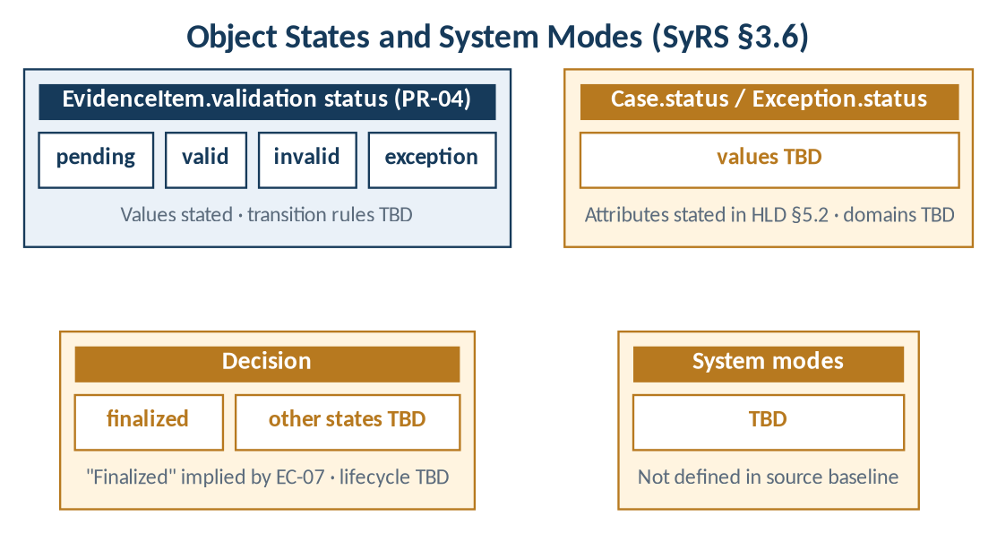
Figure 3 — Object states and system modes
Table 18 — Object state summary
Object | States | Transitions | Source
EvidenceItem | pending, valid, invalid, exception | TBD | PR-04
Decision | finalized (implied); other states TBD | TBD | EC-07
Case | TBD (status attribute exists) | TBD | HLD §5.2
Exception | TBD (status attribute exists) | TBD | HLD §5.2
System | TBD | TBD | Not in baseline

3.7 Physical Characteristics
No physical hardware is specified. The physical form of the deployment (cloud or on-premise) is pending decision PD-01; physical characteristics are TBD.

3.8 Environmental Conditions
The system is accessed through a web client / operator console (C-01). Supported browsers, devices and the server runtime environment are TBD.

3.9 System Security
Table 19 — Security requirements
ID | Requirement | V | Trace
SYS-SE-001 | Secrets shall be kept outside source control and rotated through deployment controls. | I | SC-02
SYS-SE-002 | Data shall be encrypted in transit and at rest where supported by the deployment. Key management: TBD (PD-06). | I | NFR-01; SC-07
SYS-SE-003 | Unauthorized access attempts shall be denied and logged. Response behaviour: TBD. | T | EC-05; SC-04

Related security requirements in Section 3.1: SYS-IN-004, SYS-IN-005, SYS-AU-001 – SYS-AU-003 and SYS-AC-001 – SYS-AC-004.

3.10 Information Management
Table 20 — Information management requirements
ID | Requirement | V | Trace
SYS-IM-001 | The system shall maintain the entities Case, EvidenceItem, RuleSetVersion, Decision, AuditEvent and Exception with the attributes defined in HLD §5.2. | I | HLD §5.2
SYS-IM-002 | Retention, legal hold, deletion and backup policy shall be defined with stakeholders and applied. Values: TBD. | I | SC-05; NFR-04; OD-05
SYS-IM-003 | Schema migrations shall be versioned. | I | NFR-06

Data-model gaps DG-01 – DG-07 (HLD §5.3) affect SYS-IN-003, SYS-DE-001 and SYS-EX-001. They remain TBD and are carried as open issues in Appendix B.

3.11 Policies and Regulations
Table 21 — Policy requirements
ID | Requirement | V | Trace
SYS-PO-001 | The system shall support retention, deletion, consent and data-residency rules resulting from jurisdictional review. Rules: TBD. | I | NFR-04; OQ-01; OQ-04

Applicable jurisdictions are not stated (OQ-01). No compliance claim shall be made until the discovery gate is passed (CN-02, MRS §10).

3.12 System Life Cycle Sustainment
Table 22 — Life cycle sustainment requirements
ID | Requirement | V | Trace
SYS-LS-001 | APIs and rules shall be versioned. | I | NFR-06
SYS-LS-002 | Critical paths shall be covered by tests. | I | NFR-06

Life cycle stages, gates and change control are defined in AURA-PDLC-1.0.

3.13 Packaging and Delivery
Delivery artefacts, packaging format and release contents are not defined in the baseline and are TBD (see AURA-PDLC-1.0 §6).

4 Verification
Verification methods are proposed (Derived) and are to be confirmed at Gate G2. Pass/fail thresholds follow the acceptance thresholds, which are an open decision (OD-07).
Table 23 — Verification summary by requirement group
Group | Primary method | Verification activity (derived) | Threshold
SYS-IN | Test | Case creation, evidence attachment, metadata completeness, checksum on store | TBD
SYS-VA | Test, Inspection | Rule evaluation against rule set versions; status values | TBD
SYS-DE | Test | Decision fields stored; association with case and rule version | TBD
SYS-AU | Test, Inspection | Append-only / tamper-evidence check; no sensitive payload in logs | TBD
SYS-AC, SYS-SE | Test, Inspection | Permission-restricted actions; denied and logged unauthorized attempts | TBD
SYS-EX | Test | Assign, comment, resolve, escalate exceptions | TBD
SYS-SR | Test | Search by identifiers/metadata; export contents | TBD
SYS-IG | Inspection, Test | Adapter contract documented; idempotent retry; confirmation before completion | TBD
SYS-OB, SYS-OP | Test, Demonstration | Health/readiness; backup/restore test; rollback documented | TBD
SYS-US | Demonstration | Keyboard navigation; status text | TBD
SYS-PF | Test | Load tests against targets | TBD

4.1 Requirement Verification Matrix
Table 24 — Requirement verification matrix
ID | Method | HLD component | LLD unit
SYS-IN-001 | Test | C-03 | U-03.1
SYS-IN-002 | Test | C-04 | U-04.1
SYS-IN-003 | Test | C-04 | U-04.2
SYS-IN-004 | Test | C-04, C-09 | U-04.1, U-09.2
SYS-IN-005 | Test | C-04 | U-04.3
SYS-VA-001 | Test | C-05 | U-05.2
SYS-VA-002 | Inspection | C-05 | U-05.1
SYS-VA-003 | Test | C-05, C-04 | U-05.3
SYS-VA-004 | Demonstration | C-01 | U-01.2
SYS-VA-005 | TBD | C-05 | U-05.1
SYS-DE-001 | Test | C-06 | U-06.1
SYS-DE-002 | Inspection | C-06 | U-06.1
SYS-DE-003 | TBD | C-06 | U-06.2
SYS-AU-001 | Test | C-07 | U-07.1
SYS-AU-002 | Inspection | C-07 | U-07.1
SYS-AU-003 | Inspection, Test | C-07, C-10 | U-07.1, U-10.1
SYS-AC-001 | Test | C-02 | U-02.2
SYS-AC-002 | Test | C-02 | U-02.1
SYS-AC-003 | Test | C-02 | U-02.2
SYS-AC-004 | Inspection | C-02 | U-02.2
SYS-EX-001 | Test | C-01; owner TBC | U-01.3
SYS-EX-002 | Inspection | TBC (C-03 candidate) | TBD
SYS-EX-003 | TBD | Per LLD §7 | Per LLD §7
SYS-SR-001 | Test | TBC (C-03 candidate) | U-03.2
SYS-SR-002 | Test | TBC (C-07 candidate) | U-07.2
SYS-IG-001 | Inspection | C-08 | U-08.1
SYS-IG-002 | Inspection | C-08 | U-08.1
SYS-IG-003 | Test | C-08 | U-08.2
SYS-IG-004 | Test | C-08 | U-08.3
SYS-OB-001 | Test | C-10 | U-10.1, U-10.2
SYS-OB-002 | Test | C-10 | U-10.2
SYS-US-001 | Demonstration | C-01 | U-01.1 … U-01.3
SYS-US-002 | Inspection | C-01 | U-01.2
SYS-PF-001 | Test | All | —
SYS-OP-001 | Analysis | C-10 | U-10.3
SYS-OP-002 | Inspection | All | —
SYS-OP-003 | Inspection | C-09 | U-09.1
SYS-OP-004 | Inspection | C-10 | U-10.1
SYS-OP-005 | Demonstration | C-10 | U-10.3
SYS-OP-006 | Inspection | C-10 | —
SYS-SE-001 | Inspection | All | —
SYS-SE-002 | Inspection | C-02, C-09 | U-09.1, U-09.2
SYS-SE-003 | Test | C-02, C-07 | U-02.2, U-07.1
SYS-IM-001 | Inspection | C-09 | U-09.1
SYS-IM-002 | Inspection | C-09, C-10 | TBD
SYS-IM-003 | Inspection | C-09 | U-09.1
SYS-PO-001 | Inspection | C-09 | TBD
SYS-LS-001 | Inspection | C-02, C-05 | U-05.1
SYS-LS-002 | Inspection | All | LLD §9

5 Traceability
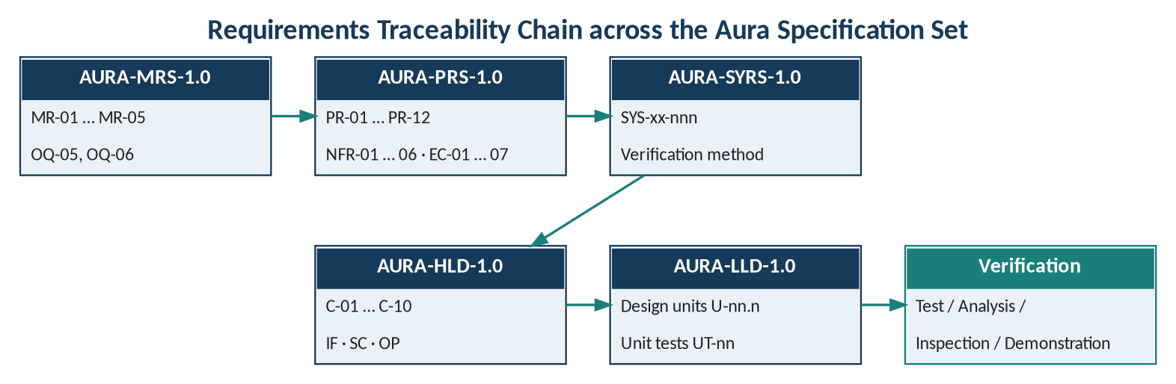
Figure 4 — Traceability chain across the Aura specification set

5.1 Product Requirement → System Requirement
Table 25 — PR → SYS traceability
PR | Product requirement | MR | System requirements
PR-01 | Evidence intake | MR-01 | SYS-IN-001, SYS-IN-002, SYS-IN-004
PR-02 | Metadata capture | MR-01 | SYS-IN-003
PR-03 | Completeness checks | MR-02 | SYS-VA-001, SYS-VA-002
PR-04 | Validation status | MR-02 | SYS-VA-003, SYS-VA-004
PR-05 | Decision record | MR-03 | SYS-DE-001, SYS-DE-002
PR-06 | Audit history | MR-04 | SYS-AU-001, SYS-AU-002
PR-07 | Role-based access | MR-05 | SYS-AC-001 – SYS-AC-003
PR-08 | Exception handling | MR-05 | SYS-EX-001, SYS-EX-002
PR-09 | Search and retrieval | MR-04 | SYS-SR-001
PR-10 | Export | MR-04 | SYS-SR-002
PR-11 | Integration boundary | OQ-05 | SYS-IG-001 – SYS-IG-004
PR-12 | Operational observability | OQ-06 (TBC) | SYS-OB-001, SYS-OB-002

5.2 Non-Functional Requirement and Exception Case → System Requirement
Table 26 — NFR / EC → SYS traceability
Source | Subject | System requirements
NFR-01 | Security | SYS-AC-004, SYS-SE-001, SYS-SE-002
NFR-02 | Reliability | SYS-OP-001
NFR-03 | Performance | SYS-PF-001
NFR-04 | Privacy | SYS-IM-002, SYS-PO-001
NFR-05 | Accessibility | SYS-US-001, SYS-US-002
NFR-06 | Maintainability | SYS-VA-002, SYS-IM-003, SYS-LS-001, SYS-LS-002
EC-01 | Missing or unreadable evidence | SYS-VA-001, SYS-EX-003
EC-02 | Duplicate or stale uploads | SYS-IN-005 (TBC), SYS-EX-003
EC-03 | Conflicting evidence values | SYS-VA-003, SYS-EX-003
EC-04 | Integration timeout or partial response | SYS-IG-003, SYS-IG-004
EC-05 | Unauthorized access attempt | SYS-SE-003, SYS-AU-003
EC-06 | Rule version changed after case creation | SYS-VA-005
EC-07 | Modify a finalized decision | SYS-DE-003

5.3 HLD Control → System Requirement
Table 27 — HLD control → SYS traceability
HLD item | Description | System requirements
SC-01 | Authentication and role/tenant authorization | SYS-AC-002, SYS-AC-003
SC-02 | Secrets outside source control | SYS-SE-001
SC-03 | Access-controlled storage; checksums | SYS-IN-004, SYS-IN-005
SC-04 | Access and transition logging | SYS-AU-003, SYS-SE-003
SC-05 | Retention, legal hold, deletion, backup policy | SYS-IM-002
SC-06 | Idempotency keys and correlation IDs | SYS-IG-003
SC-07 | Encryption in transit and at rest | SYS-SE-002
OP-01 – OP-07 | Reliability and deployment practices | SYS-OP-002 – SYS-OP-006, SYS-OB-002
AD-06 | Response is not business completion | SYS-IG-004

Appendix A — Assumptions and Dependencies
- Commercial scope is not frozen until the discovery gate (GC-01 – GC-04) is passed; system requirements may change as a result (MRS §10).
- Integrations depend on resolution of OQ-05 / OD-04 and documented adapter contracts (SYS-IG-002).
- Physical, environmental and performance requirements depend on the pending architecture decisions PD-01 – PD-07.
- Acceptance thresholds for every requirement depend on OD-07.

Appendix B — Open Issues
Table 28 — Open issues
ID | Issue | Affects | Source
OI-01 | Supported evidence types | SYS-IN-002 | OD-01
OI-02 | Policy rule content and required fields | SYS-VA-001 | OD-02
OI-03 | Decision authority and role–permission matrix | SYS-AC-001, SYS-DE-001 | OD-03
OI-04 | External integration systems | SYS-IG-001 – 004 | OD-04
OI-05 | Retention policy and jurisdiction | SYS-IM-002, SYS-PO-001 | OD-05, OQ-01, OQ-04
OI-06 | Deployment, tenancy, identity, storage, eventing, keys, DR | §3.4 – §3.8 | PD-01 – PD-07
OI-07 | Acceptance thresholds | All | OD-07
OI-08 | Data-model gaps | SYS-IN-003, SYS-DE-001, SYS-EX-001 | DG-01 – DG-07
OI-09 | Expected behaviour for EC-01 – EC-07 | SYS-EX-003, SYS-VA-005, SYS-DE-003 | PRS §6
OI-10 | System modes; state transition rules | §3.6 | Not in baseline
OI-11 | Document owner, classification and approvers | Document control | Not in baseline

