**Project Title: Machine Learning Model Deployment with IBM Cloud Watson Studio**

**Phase 1: Problem Definition and Design Thinking**

**Problem Statement:**

Become a wizard of predictive analytics with IBM Cloud Watson Studio. Train machine learning models to predict outcomes in real-time. Deploy the models as web services and integrate them into your applications. Unlock the magic of data-driven insights and make informed decisions like never before!

**Problem Definition:**

**The challenge at hand is to acquire expertise in predictive analytics through a comprehensive project. This project involves leveraging IBM Cloud Watson Studio to train a machine learning model capable of real-time outcome predictions. The overarching goal is to achieve proficiency in the end-to-end process of predictive analytics, covering the definition of a predictive use case, selection of an appropriate dataset, training the model, deploying it as a web service, and seamlessly integrating it into various applications. The project aims to empower individuals to harness the power of predictive analytics for informed decision-making and enhanced application capabilities**

Real-time Problem :

Predict the total score (runs) a team is likely to achieve in an IPL match based on factors such as venue, pitch conditions, team composition, and historical performance.

**Design Thinking:**

1. Predictive Use Case: IPL Score Prediction

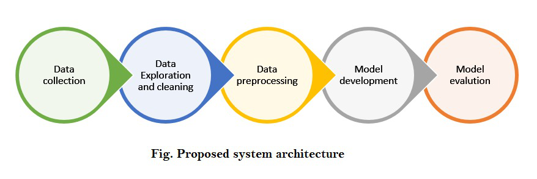

Predicting the total score of an IPL cricket match based on historical match data, team performance, player statistics, pitch conditions, and other relevant factors.

The main objective is to Provide cricket enthusiasts with real-time score predictions during IPL matches to enhance their viewing experience and engagement.

### **Technology used:**

* Machine Learning.
* Deep Learning
* Flask (Front-end integration).
* Well, for the smooth running of the project we’ve used few libraries like NumPy, Pandas, Scikit-learn, TensorFlow, and Matplotlib.

1. Dataset Selection:

Gather historical IPL match data from reliable sources, including details such as team compositions, player statistics, venue information, weather conditions, and final match scores.

1. Model Training:

Choose a suitable machine learning algorithm for regression, such as Random Forest Regression, Gradient Boosting, or even a Neural Network.

Create relevant features like player form, team form, past performance at the venue, and head-to-head statistics. Split the dataset into training and testing sets.

1. Model Deployment:

By Utilizing IBM Cloud Watson Studio for model development and deployment.

Deploy the trained model as a web service on IBM Cloud Watson Studio's deployment capabilities, allowing it to be accessible via RESTful APIs.

1. Integration:

Integrate the deployed model into websites allowing users to access real-time score predictions during live IPL matches. Design a user-friendly interface where users can input match details (teams, players, pitch conditions) to get score predictions.