

**SIES College of Arts, Science and Commerce (Autonomous)**

**Sion (W), Mumbai – 400 022.**

**Department of Computer Science**

**CERTIFICATE**

**This is to certify that ~~Mr~~./Ms.** **JENNIFER GLENN GONSALVES** **of FYBSc[Computer Science], Semester 1 , Seat No FCS2425027 has successfully completed the practicals and submitted it online in Microsoft Teams for the subject of Beginning MySQL as a partial fulfilment of the degree BSc(CS) during the academic year 2024-2025.**

**________________                                                                            _______________**

**Faculty-in-charge                                                                                Internal Examiner**

**Rajesh Yadav                                         Rajesh Yadav**

**Date: 29/09/2024                                 College Seal**

|  |  |  |  |  |
| --- | --- | --- | --- | --- |
| **PRACTICAL**  **NO** | **DESCRIPTION** | **PAGE**  **NO** | **DATE** | **FACULTY**  **SIGN** |
| **1** | WORKING WITH MYSQL | 1-3 | 18-08-2024 |  |
| 2 | WORKING WITH  DDL AND DML STATEMENTS | 5-30 | 25-08-2024 |  |
| 3 | OPERATIONS OF DATE FUNCTIONS. | 31-37 | 31-08-2024 |  |
| 4 | OPERATIONS OF STRING FUNCTIONS. | 38-43 | 31-08-2024 |  |
| 5 | OPERATIONS OF MATH FUNCTIONS | 44-56 | 29-09-2024 |  |
| 6 | USE OF JOINTS AND VIEWS IN MYSQL. | 58-65 | 29-09-2024 |  |

**PRACTICAL NO 1 :**

**AIM :-** For given scenario

Perform the following:

 ● Viewing all databases

● Creating a Database

● Viewing all Tables in a Database

● Creating Tables (With and Without Constraints)

● Inserting/Updating/Deleting Records in a Table

● Saving (Commit) and Undoing (rollback)

***QUESTION NO 1 :-***

*1) Write a mysql command to show all databases .*

**COMMAND:-**

mysql> show databases;

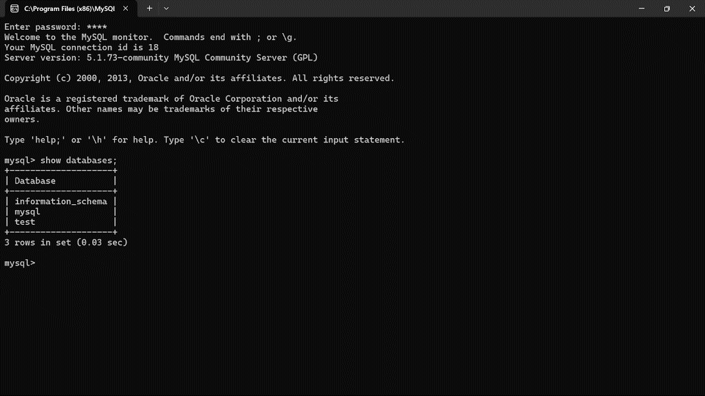

**EXPLANATION:-**

*This command shows all the pre existing databases.*

***QUESTION NO 2:-***

*Write a mysql command to create database fycs2024 and FYCS2023.*

***COMMAND:-***

*mysql> create database FYCS2024;*

*mysql> create database FYCS2023;*

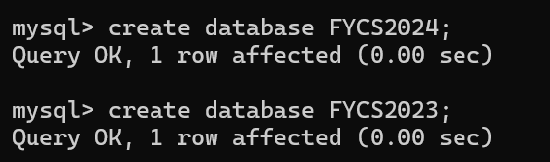

**EXPLANATION:-**

*This command will create the database of the given name if it does not exist.*

***QUESTION NO 3:-***

*Write a mysql command to show created database .*

**COMMAND:-**

*mysql> show databases;*

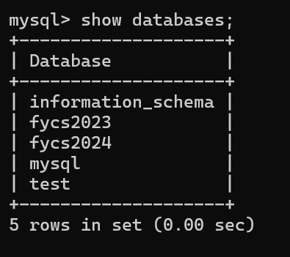

**EXPLANATION:-**

*This command is used to list all the databases on the MySQL server . It shows a list of all databases that the user has access to . As seen above the two new databases which were created are also visible .*

***QUESTION NO 4:-***

*Write a mysql command to make  created database as  working or current database ..select any 1 from created databases.*

**COMMAND:-**

*mysql> use FYCS2024;*

**

**EXPLANATION:-**

*The ‘use database’ is used to select and switch to a specific database within a DBMS, making it the current working database for subsequent SQL commands.*

***QUESTION NO 5:-***

*Write a mysql command to delete FYCS2023 databases .*

**COMMAND:-**

*mysql> DROP DATABASE FYCS2023;*

**

**EXPLANATION:-**

*This command will delete the database that is already in existence.*

**PRACTICAL NO 2**

***Q1:-***

**Create a table member with Primary key constraint to Tno and not null constraint to tname , Salary ,Area , Age , Grade and dept. Deice your own suitable datatypes.**

**COMMAND:-**

*mysql> show databases ;*

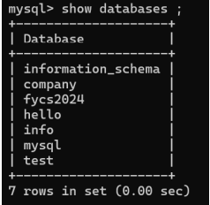

*mysql> use fycs2024 ;*

**

*mysql> create table member (Tno int PRIMARY KEY , Tname varchar(100) NOT NULL , Salary decimal(10.2) NOT NULL , Area varchar(100) NOT*

*NULL , Age int NOT NULL , Grade varchar(20) NOT NULL , Dept varchar(100) NOT NULL ) ;*

*Query OK, 0 rows affected (0.02 sec)*

**

***QUESTION : 2***

***Show the structure of table :***

***COMMAND:-***

*mysql> describe member ;*

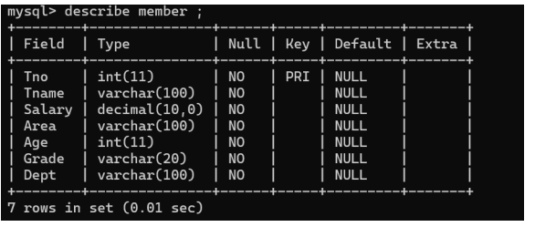

**QUESTION :3**

**Insert into member values**

*mysql> insert into member values(1, 'Shalini', 40000, 'West', 45, 'C', 'Civil') ;*

*Query OK, 1 row affected (0.01 sec)*

*mysql> insert into member values(2, 'Akriti', 35000, 'South', 38, 'A', 'Elec') ;*

*Query OK, 1 row affected (0.01 sec)*

*mysql> insert into member values(3, 'Shyam Prassad', 60000, 'North', 52, 'B', 'Civil') ;*

*Query OK, 1 row affected (0.00 sec)*

*mysql> insert into member values(4, 'Brij Mohan', 38000, 'North', 29, 'B', 'Civil') ;*

*Query OK, 1 row affected (0.01 sec)*

*mysql> insert into member values(5, 'Varun', 42000, 'East', 35, 'A', 'Comp') ;*

*Query OK, 1 row affected (0.01 sec)*

*mysql> insert into member values(6, 'Chanchal', 29000, 'South', 34, 'A', 'Mech') ;*

*Query OK, 1 row affected (0.01 sec)*

**QUESTION : 4**

**Display all records from table member**

*COMMAND:-*

*mysql> select * from member ;*

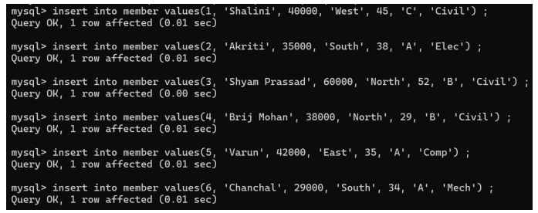

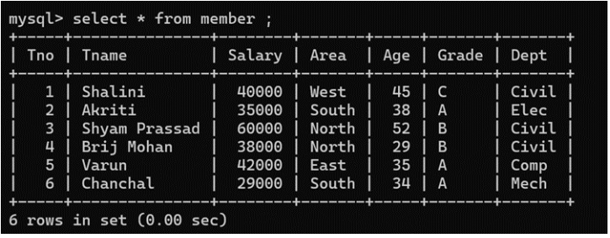

**QUESTION :5**

**Display Tno and tname from member :**

*mysql> select Tno, Tname from member ;*

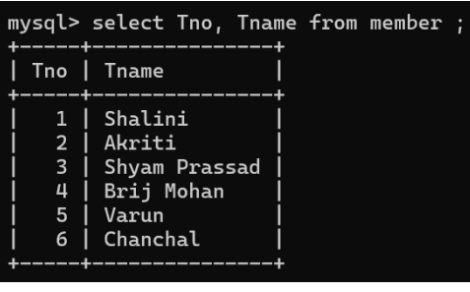

**QUESTION:6**

**Drop the constraint not null of dept**

*mysql> alter table member modify Dept varchar(100);*

*Query OK, 6 rows affected (0.02 sec)*

*Records: 6 Duplicates: 0 Warnings: 0*

***QUESTION :7***

***Add one more column as address with 20 characters after tname***

*mysql> alter table member add column Address varchar(20) after Tname ;*

*Query OK, 6 rows affected (0.02 sec)*

*Records: 6 Duplicates: 0 Warnings: 0*

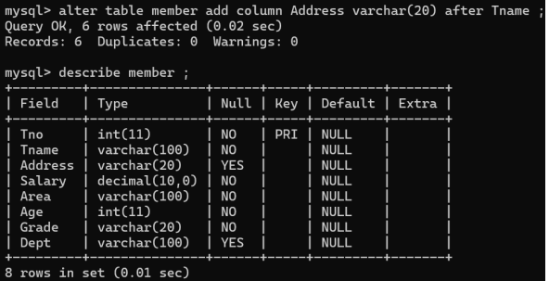

**QUESTION :8**

**Add one more column Sno as integer data type as first field**

*COMMAND:-*

*mysql> alter table member add column Sno int first ;*

*Query OK, 6 rows affected (0.02 sec)*

*Records: 6 Duplicates: 0 Warnings: 0*

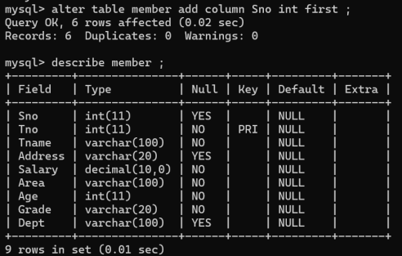

**QUESTION :9**

**Add one more column Bonus as integer datatype at the end**

*mysql> alter table member add column Bonus int ;*

*Query OK, 6 rows affected (0.01 sec)*

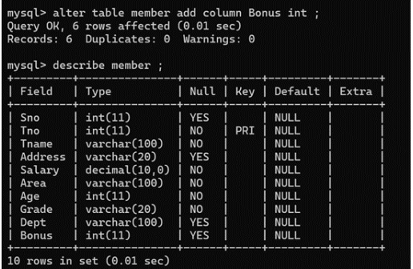

**QUESTION :10**

**Modify the datatype of tname as varchar(30)**

*mysql> alter table member modify column Tname varchar(30); Query OK, 6 rows affected (0.01 sec)*

*Records: 6 Duplicates: 0 Warnings: 0*

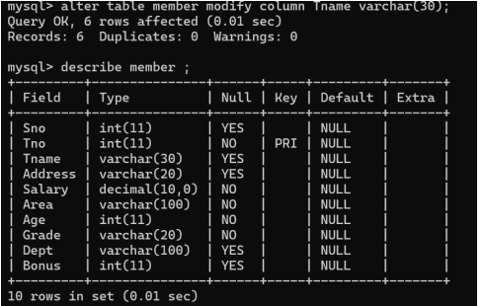

**QUESTION :11**

**Drop the primary key constraint:**

*mysql> alter table member drop PRIMARY KEY ;*

*Query OK, 6 rows affected (0.01 sec)*

*Records: 6 Duplicates: 0 Warnings: 0*

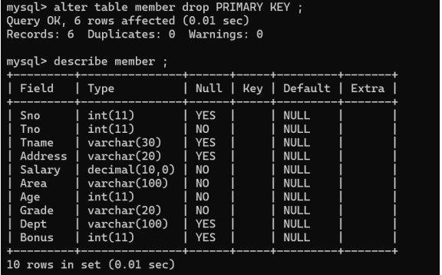

**QUESTION :12**

**Add primary key constraint to Tname :**

*mysql> alter table member add PRIMARY KEY (Tname) ;*

*Query OK, 6 rows affected (0.02 sec)*

*Records: 6 Duplicates: 0 Warnings: 0*

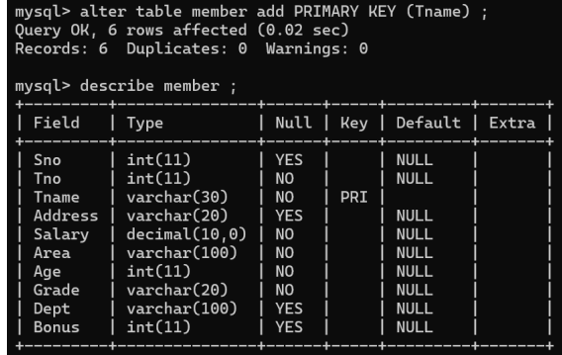

**QUESTION : 13**

**Drop the column area ;**

*mysql> alter table member drop area ;*

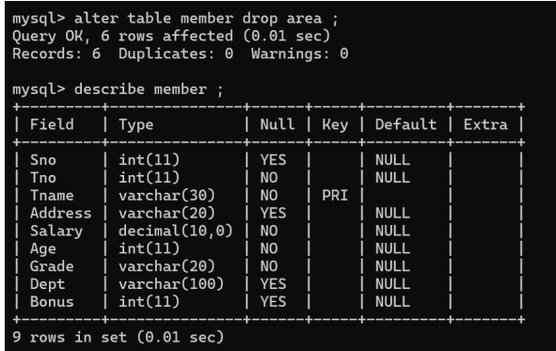

**PRAC 2.2**

**Exercise 2**

QUESTION : 1

Create a table Empl with primary key constraint to empno and null constraint to ename , job , hiredate , sal and deptno :

Command:

mysql> use fycs2024 ;

mysql> create table empl (Empno int PRIMARY KEY , Ename varchar(100) NOT NULL , Job varchar(100) , Hiredate varchar(100) , Sal int , Deptno int ) ;

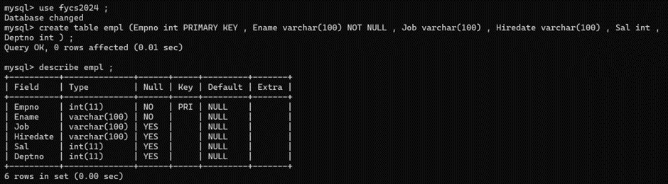

QUESTION : 2

INSERT RECORDS IN THE TABLE EMPL ;

COMMAND :

mysql> insert into empl values(8369, 'SheshNag', 'Clerk', 1990-12-18, 28000, 20) ;

mysql> insert into empl values(8499, 'Anya', 'Salesman', 1991-02-20, 36000, 30) ;

mysql> insert into empl values(8521, 'Shankar', 'Salesman', 1991-02-22, 30000, 30)

 mysql> insert into empl values(8566, 'Mustafa', 'Manager', 1991-04-02, 55000, 10) ;

mysql> insert into empl values(8654, 'Ritu', 'Analyst', 1992-12-09, 70000, 20) ;

mysql> insert into empl values(8698, 'Shefani', 'President', 1991-11-18, 25000, 10) ;

mysql> insert into empl values(8882, 'Radhe Shyam', 'Salesman', 1991-05-01, 32000, 30) ;

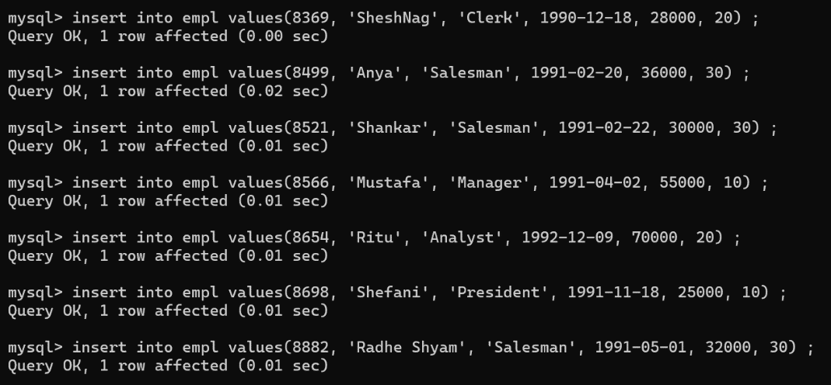

QUESTION : 3

Display all the records from table Empl :

Command :

mysql> select * from empl ;

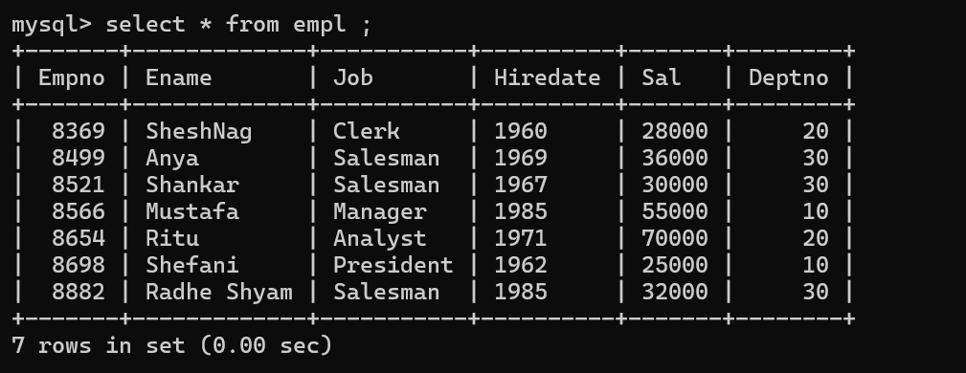

QUESTION : 4

Display empno and ename of all the employees from empl :

Command :

mysql> select Empno , Ename from empl ;

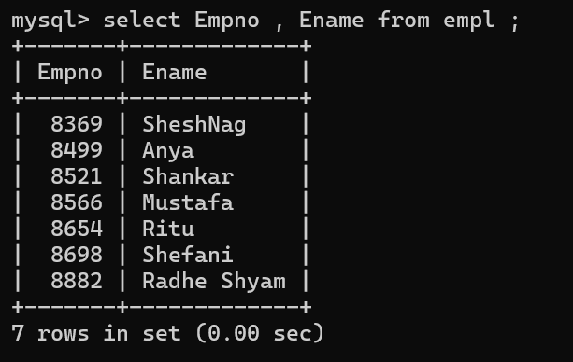

QUESTION: 5

Display the Ename, Sal and sal added with comm from table empl :

Command :

mysql> select Ename, Sal, Comm from empl ;

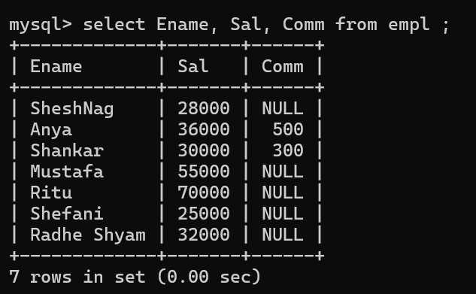

QUESTION :6

Select ename , sal , deptmo from empl where comm is null :

Command :

mysql> select Ename, Sal, Deptno from empl where comm is NULL ;

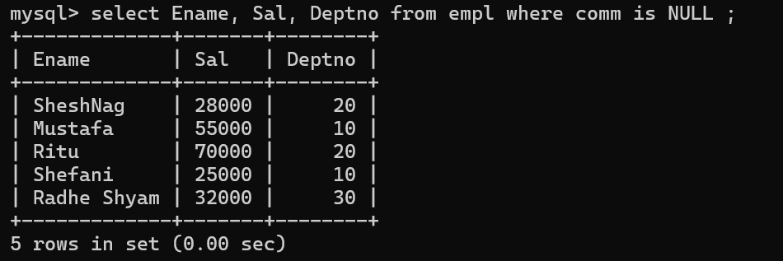

QUESTION :7

Write a query to display employee number , name, sal and salary *12 as annual salary drom table :

mysql> select Empno,Ename,Sal,Sal*12 as annual_Sal from empl ;

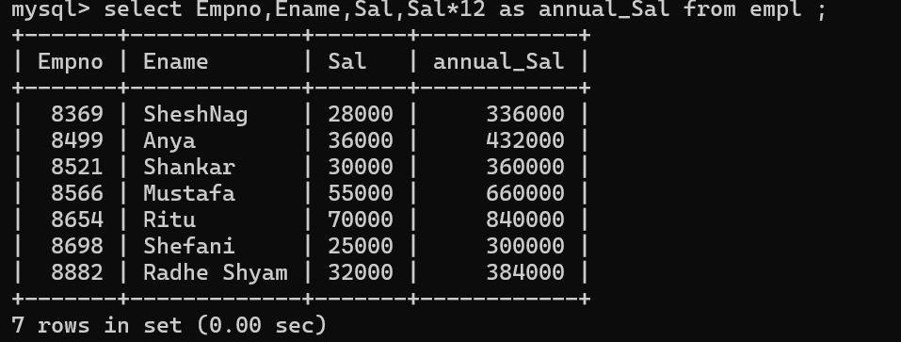

QUESTION :8

List all records whose salary is less than 10000

select Empno,Ename,Job,Hiredate,Sal,comm,Deptno,Sal<10000 from empl;

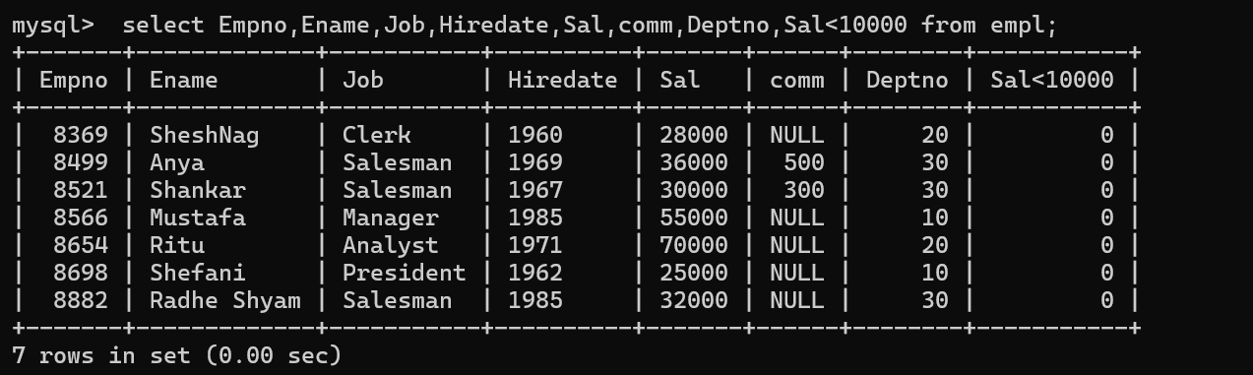

QUESTION : 9

List all records whose salary is between 20000 to 50000 from table

select Empno,Ename,Job,Hiredate,Sal,comm,Deptno from empl where Sal between 20000 and 50000;

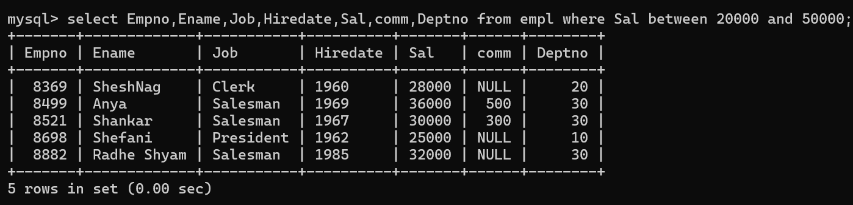

QUESTION :10

List all details of employees who have 4 letter name

mysql>  select Empno,Ename,Job,Hiredate,Sal,comm,Deptno from empl where length(Ename)=4;

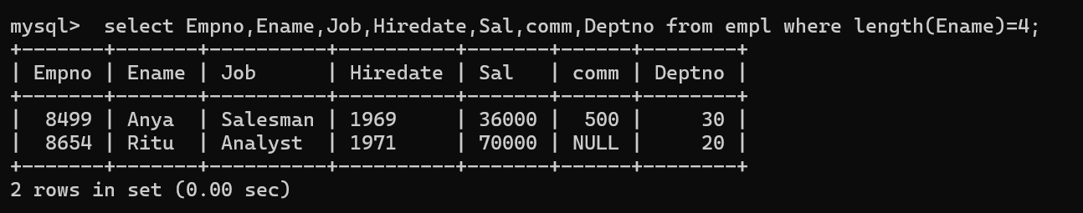

QUESTION :11

List all details of employes whose name starts with M

mysql> select * from empl where Ename like 'M%';

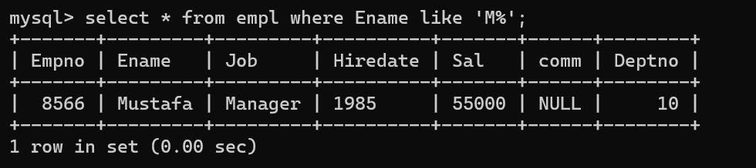

QUESTION :12

List all details of employees whose name ends with a

mysql> select * from empl where Ename like '%a';

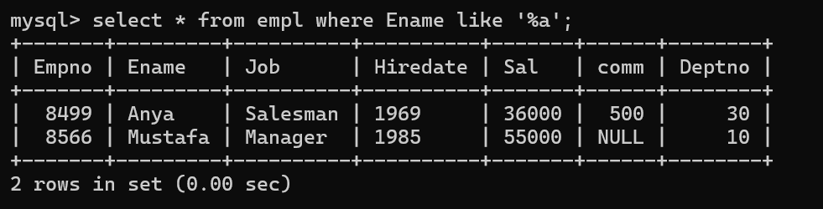

List all names of employes whose commission is not null

mysql> select* from empl where comm like'%0';

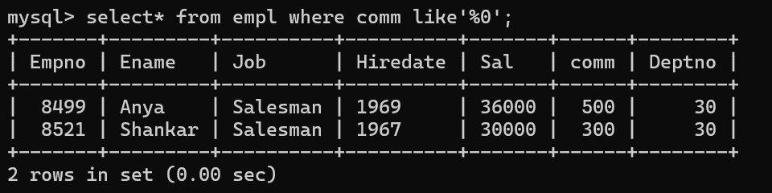

QUESTION : 14

List all details of all employes who are either clerk or salesman

mysql> select * from empl where Job in ('Salesman','Clerk');

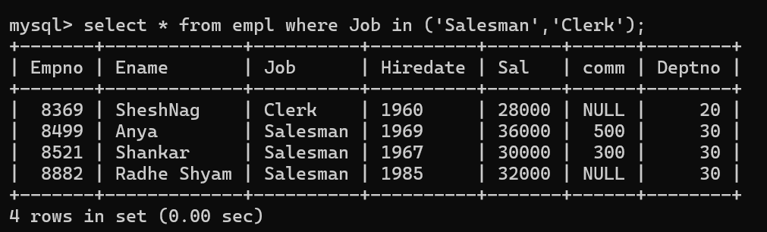

QUESTION :15

List all records in ascending order of deptno

mysql> select * from empl order by Empno Asc ;

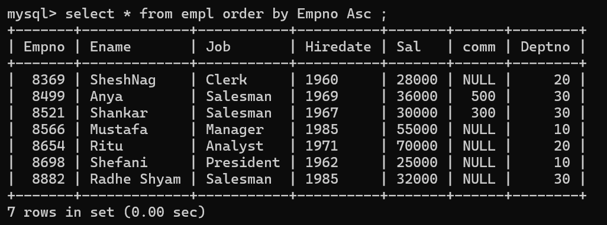

QUESTION :16

List all records in desecending order of salary

mysql> select * from empl order by Sal desc ;

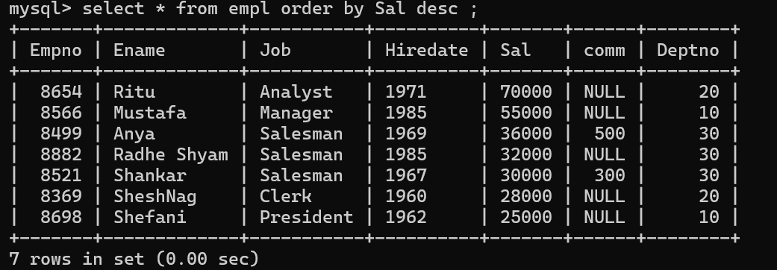

QUESTION : 17

Increase the salary of all employees by 1000

mysql> update empl set Sal=Sal+1000;

mysql> select * from empl ;

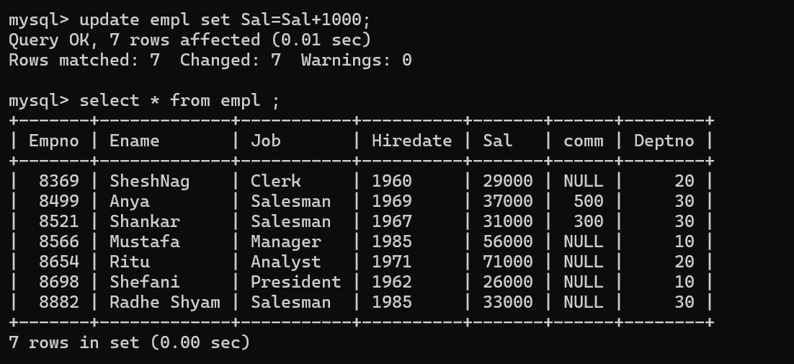

QUESTION :18

Delete all records where comm is null

mysql> select * from empl ;

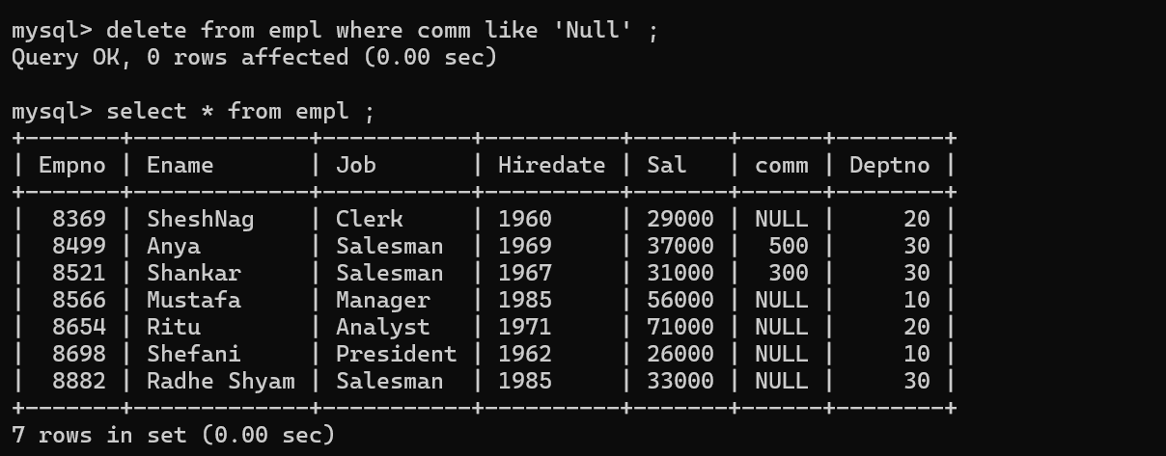

Drop the table

mysql> drop table empl ;

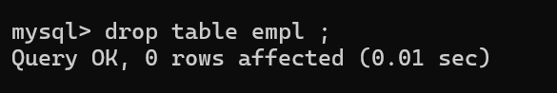

**PRAC2.3**

**Aim:- Working with DDL and DML statements.**

1. **To show all the information about female coaches.**

**Command:-**

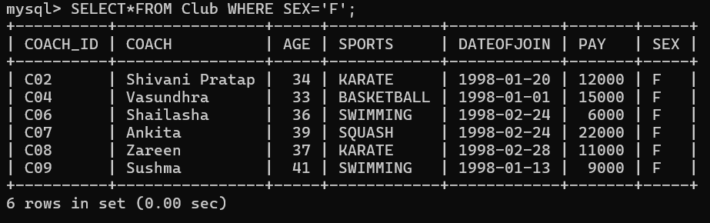

**Explanation:-**

**T**his show all the information of the female coaches from the table.

1. **To display a report, showing coach name, pay, age and bonus (15% of pay) for all the coaches.**

**Command:-**

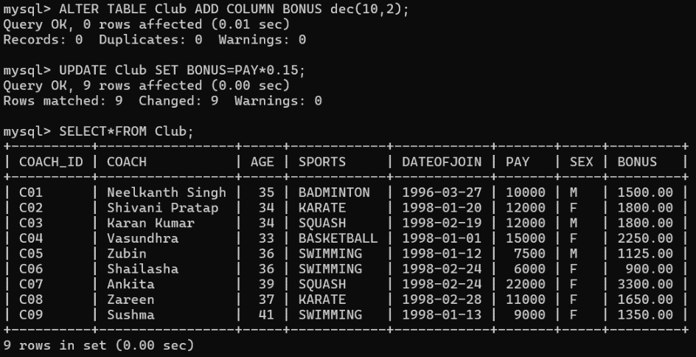

**Explanation:-**

This command will display a new column bonus with records of salary incremented by 15%.

**3. To display all the information of coaches who are getting salary in the range of 10000 to 20000.**

**Command:-**

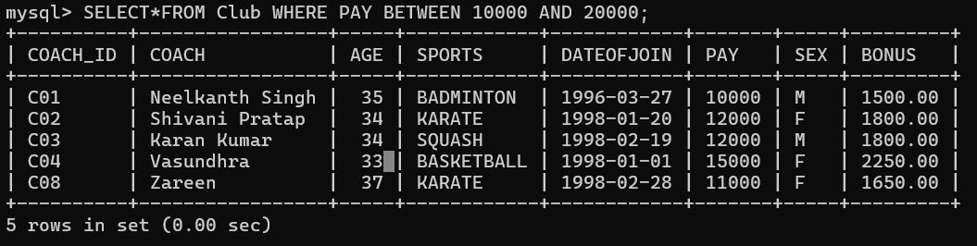

**Explanation:-**

This command will display the coaches getting salary from 10k to 20k**.**

**4.To display all the information of coaches who are less than 35 years of age.**

**Command:-**

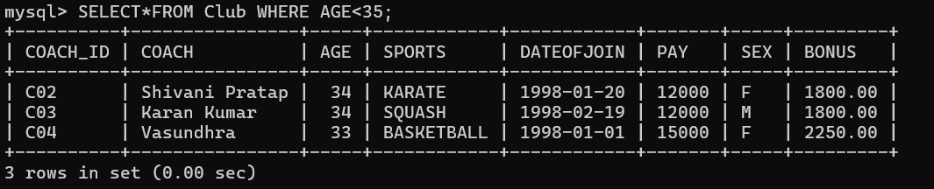

**Explanation:-**

This will display the info of coaches who are below the age of 35yrs.

**5. To display all the information of KARATE and BASKETBALL coaches.**

**Command:-**

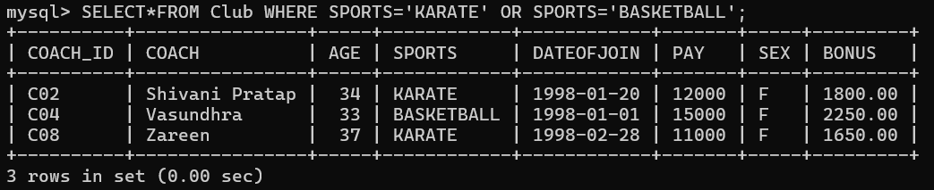

**Explanation:-**

This will display the info related to Karate and Basket ball

1. **To display all the information about male coaches having age above 35.**

**Command:-**

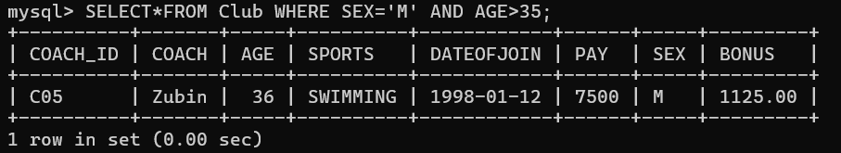

**Explanation:-**

This command will display all male coaches above 35 yrs age.

**7. To display all the information of coaches having C05 or C07 as coach id.**

**Command:-**

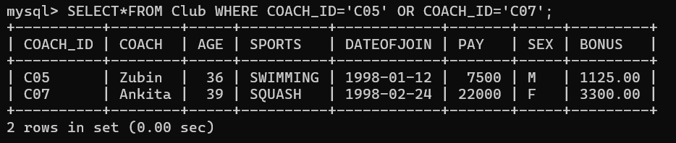

**Explanation:-**

This will display id C05 or C07.

**8. To display all the information of coaches who were hired in year 1998.**

**Command:-**

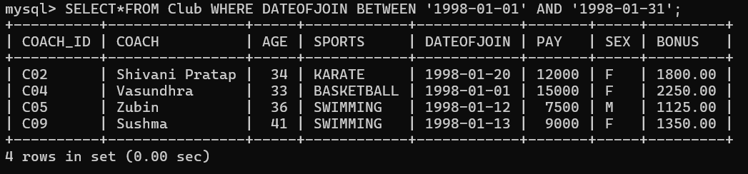

**Explanation:-**

This command will display coaches hired in year 1998.

**9. To display distinct sports.**

**Command:-**

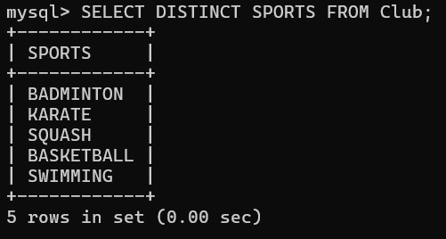

**Explanation:-**

This command will display distinct sport.

1. **To display information of all the coaches whose name starts with S.**

**Command:-**

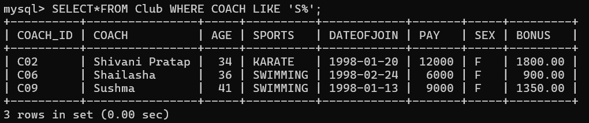

**Explanation:-**

This will display coaches name starting with ‘S’.

**11. To display information of all the coaches whose name ends with A..**

**Command:-**

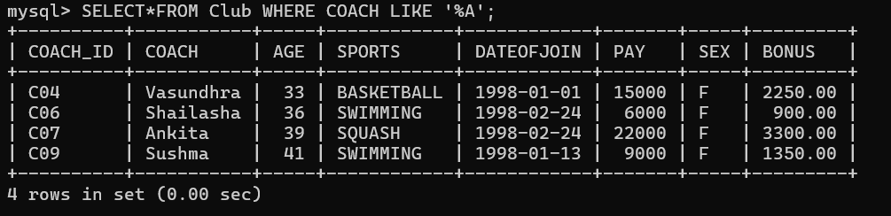

**Explanation:-**

This will display coaches name starting with ‘A.

**12. To display information of all the coaches who have five-letter names**.

**Command:-**

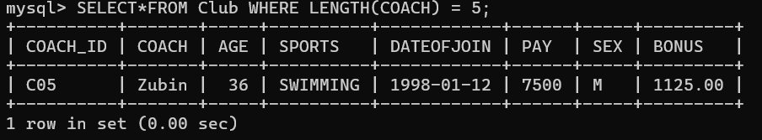

**Explanation:-**

This will display all coaches have five char name.

1. **To list the names of all coaches with their date of joining (DATOFJOIN) in descending order.**

**Command:-**

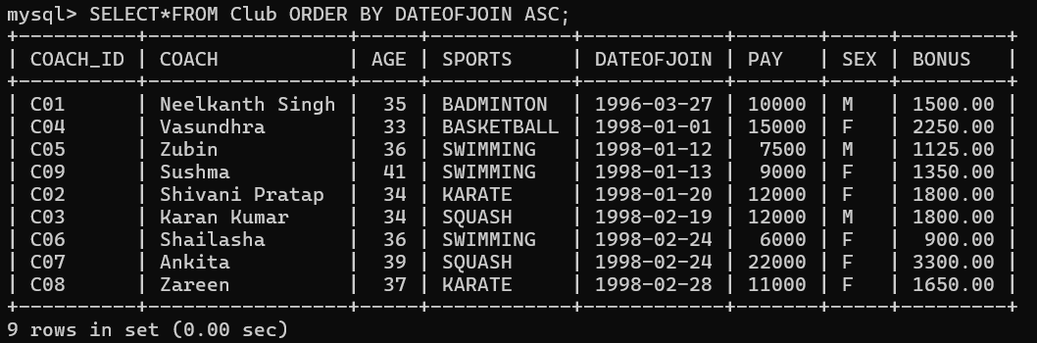

**Explanation:-**

This will display date of joining in descending order.

**14. To list all the information about coaches in ascending order of age.**

**Command:-**

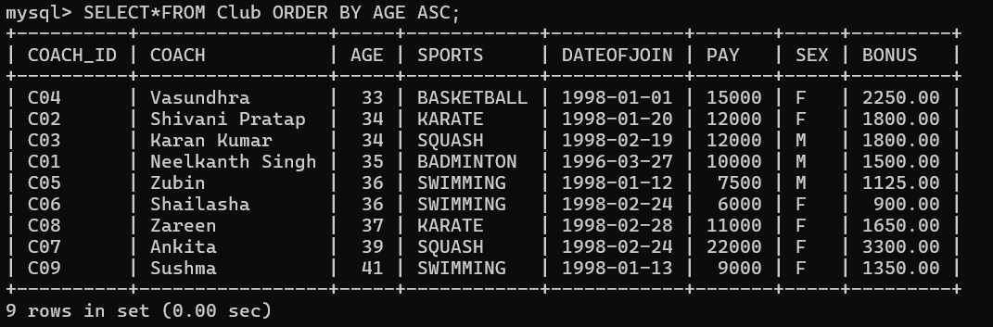

**Explanation:-**

This will display the age in ascending order.

**15.To list all the information about coaches in descending order of age and ascending order of pay.**

**Command:-**

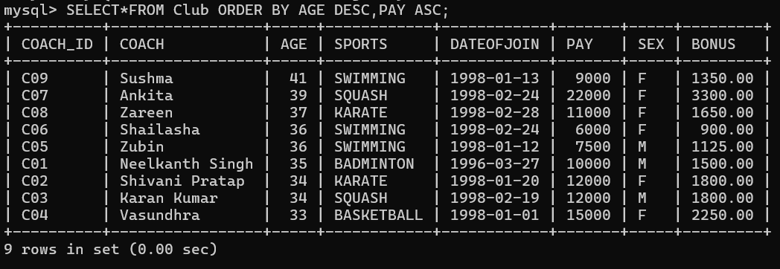

**Explanation:-**

This will display the descending order of age and ascending order of pay.

1. **To list all the information about coaches in ascending order of name**

**Command :-**

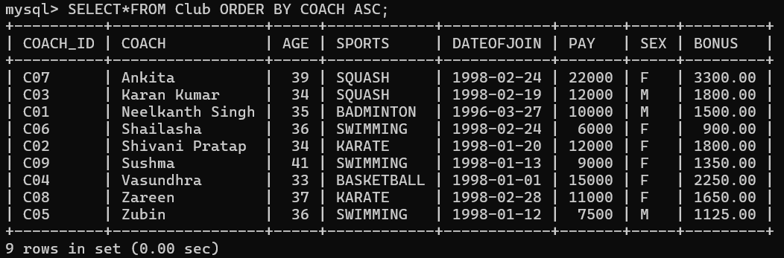

**Explanation:-**

This will display name in ascending order**.**

**17. To increase the pay of all the coaches by 1000.**

**Command:-**

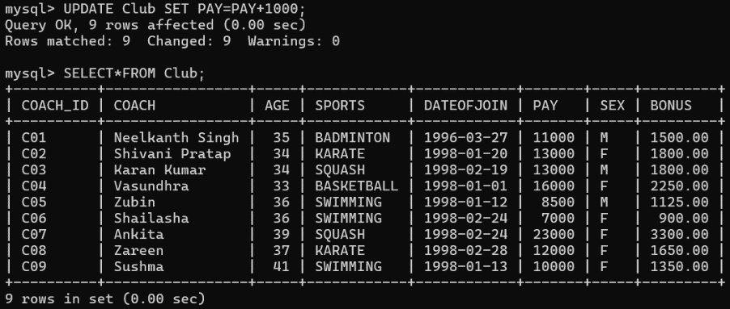

**Explanation:-**

This will display the salary of coaches.

**18. To decrease the pay of all the male coaches by 500.**

**Command:-**

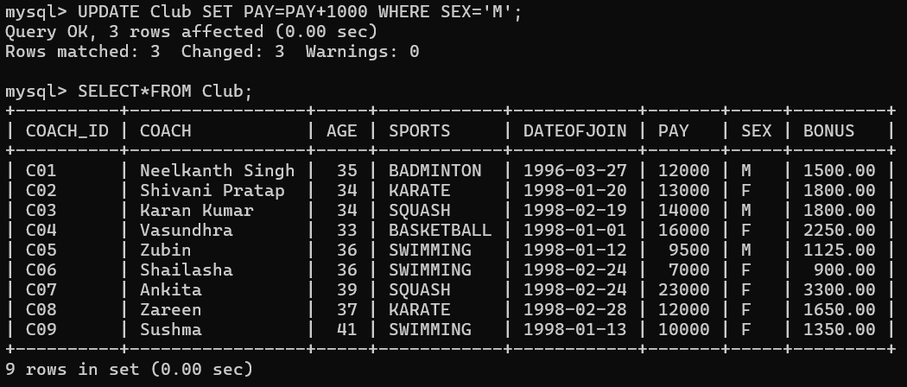

**Explanation:-**

This will display the salary reduced by 500.

1. **To change the age to 40 of coaches whose coach id is C04.**

**Command:-**

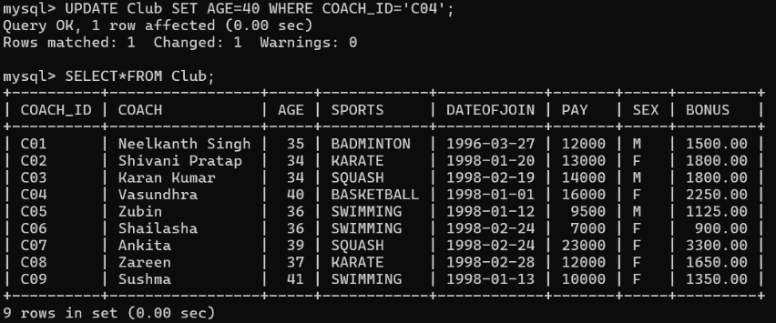

**Explanation:-**

This will display change in age of coaches having id C04.

1. **To change the age to 47 and sports to SWIMMING of coaches whose coach_id is C08.**

**Command:-**

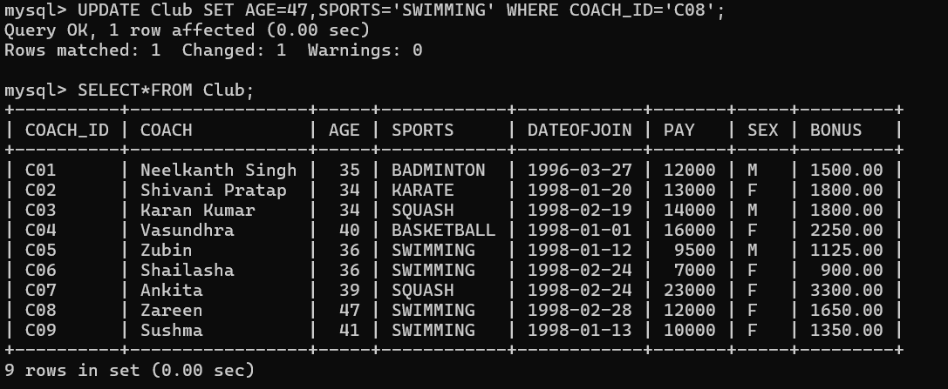

**Explanation:-**

This will display change in age and sports to swim in id C08.

**21. To delete all the records of male coaches who are below 35 years of age.**

**Command:-**

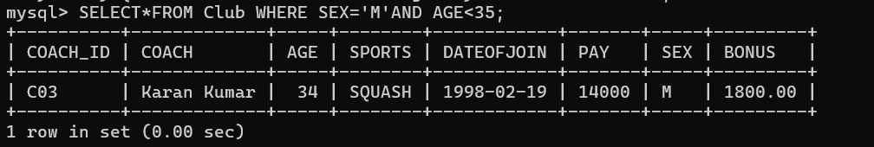

**Explanation:-**

This will delete all records of male coaches below 35yrs.

**22. To delete all the records of female coaches.**

**Command:-**

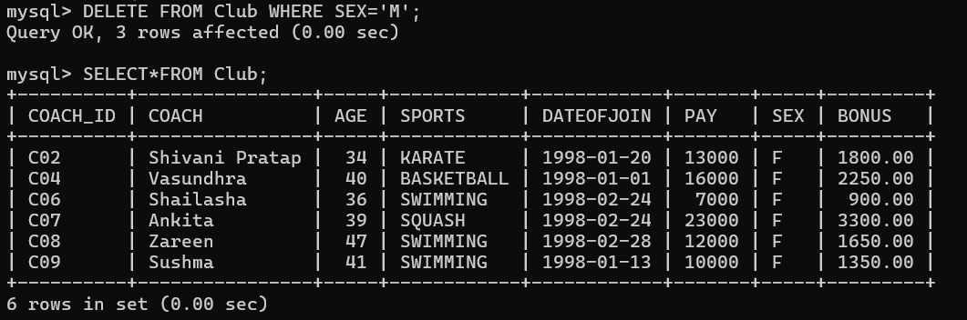

**Explanation:-**

This will delete all records of female coaches.

**23. To delete all records.**

**Command:-**

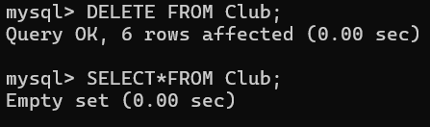

**Explanation:-**

This will delete all records**.**

1. **To delete the table**

**Command:-**

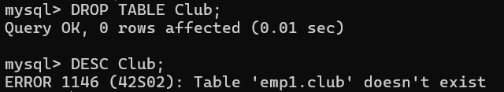

**Explanation:-**

This will delete the whole table.

**PRACTICAL NO 3:-**

**AIM:- For given scenario Queries involving**

**● Date Functions**

**● String Functions**

**I. Practical on Date function**

**COMMAND:-**

1. *mysql> SELECT NOW( );*

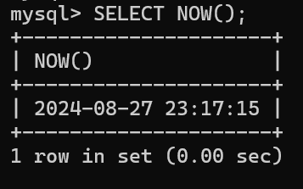

**EXPLANATION:-**

*It is used to retrieve the current date and time from the MySQL server.The query retrieves and displays the current date and time from the MySQL server in the YYYY-MM-DD HH:MM:SS format.*

1. *mysql> SELECT CURDATE();*

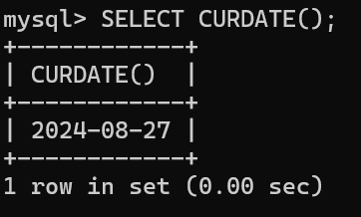

***EXPLANATION:-***

*It is used to retrieve the current date from the MySQL server.The query retrieves and displays the current date from the MySQL server in the YYYY-MM-DD format.*



**i.** *mysql> select date_format('2025-11-16','%a');*

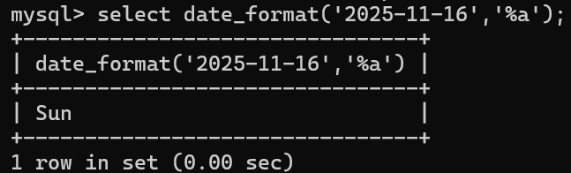

***EXPLANATION:-***

*It is used to format a date according to a specified format string.The query formats the date '2025-11-16' to return the abbreviated weekday name, resulting in 'Sun'.*

**ii.** *mysql> select date_format('2025-11-16','%b');*

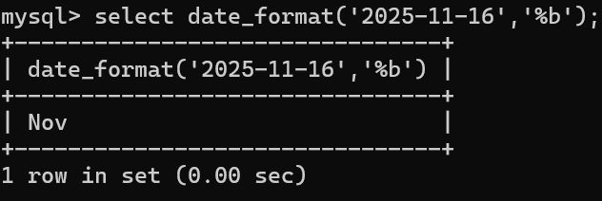

***EXPLANATION:-***

*The query formats the date '2025-11-16' to return the abbreviated month name, resulting in 'Nov'.*

**iii.***mysql> select date_format('2025-11-16','%c');*

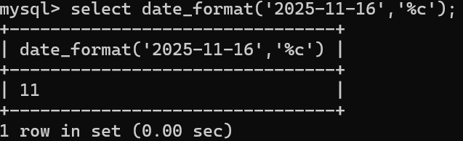

***EXPLANATION:-***

*The query formats the date '2025-11-16' to return the numeric value of the month, which is 11 for November.*

**iv.** *mysql> select date_format('2025-11-16','%D');*

**v.***mysql> select date_format('2025-11-16','%d');*

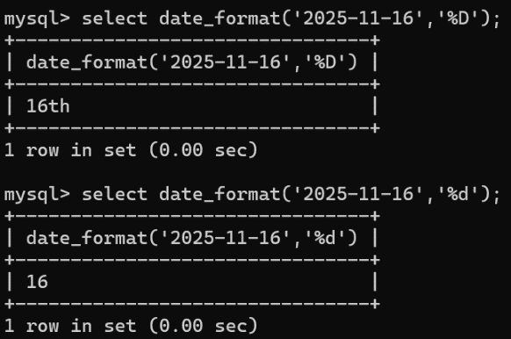

***EXPLANATION:-***

* *The first query (%D) returns the day of the month with an English ordinal suffix, resulting in '16th'.*
* *The second query (%d) returns the day of the month as a numeric value, resulting in '16'.*

**vi.** *mysql> select date_format('2025-11-16','%e');*

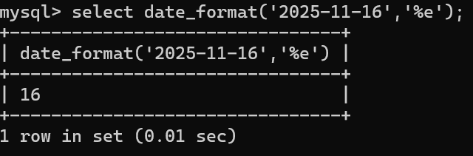

***EXPLANATION:-***

*The query formats the date '2025-11-16' to return the day of the month as a numeric value without leading zeros. The result will be 16.*

**vii.** *mysql> select date_format('2025-11-16','%h');*

*viii. mysql> select date_format('2025-11-16','%I');*

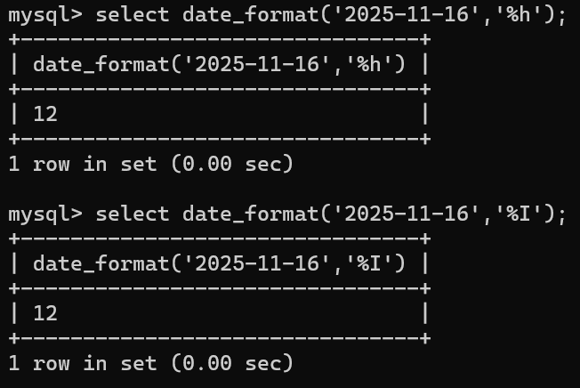

***EXPLANATION:-***

*Both %h and %I format specifiers are used to extract the hour in 12-hour format, with leading zeros if necessary. Since the date '2025-11-16' lacks time information, the output may be 00 or 01, depending on default settings.*

**ix. .** *mysql> select date_format('2025-11-16','%j');*

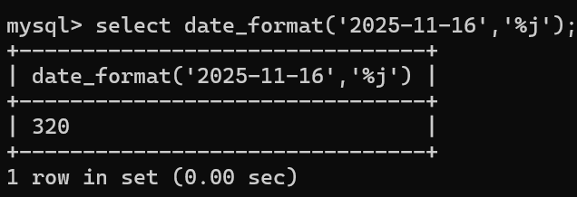

***EXPLANATION:-***

*The query formats the date '2025-11-16' to return the day of the year, resulting in 320.*

**x.** *mysql> select date_format('2025-11-16','%l');*

**xi.** *mysql> select date_format('2025-11-16','%m');*

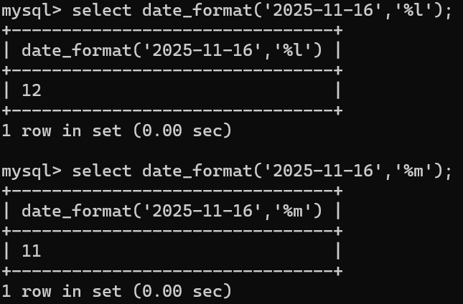

***EXPLANATION:-***

*The first query with %l might return 0 or 12 if the default time is used, but typically %l requires a time part to provide a meaningful result.*

*The second query with %m returns the numeric month value, which is 11 for November.*

**xii.** *mysql> select date_format('2025-11-16','%p');*

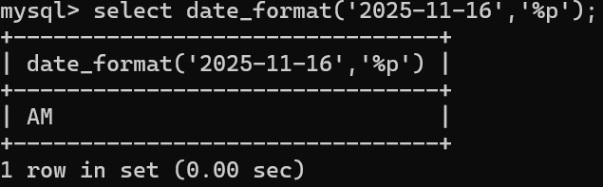

***EXPLANATION:-***

*The query uses %p to display the AM/PM designation, but since '2025-11-16' does not include time, the result may be empty or not applicable.*

**xiii.** *mysql> select date_format('2025-11-16','%r');*

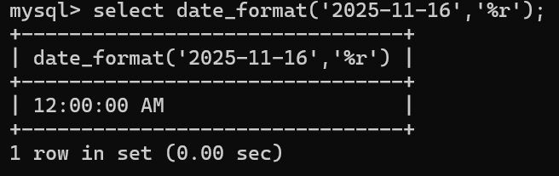

***EXPLANATION:-***

*The query uses %r to format the time in 12-hour format with an AM/PM designation. Since the input '2025-11-16' lacks a time component, the output might be empty or NULL.*

**xiv.** *mysql> select date_format('2025-11-16','%u');*

**xv.** *mysql> select date_format('2025-11-16','%v');*

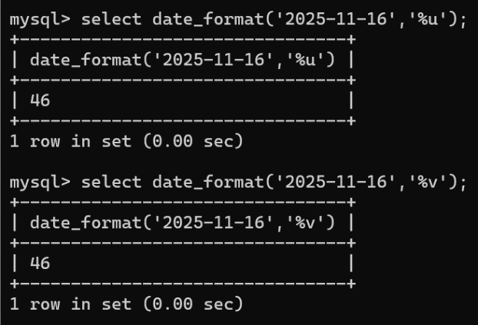

***EXPLANATION:-***

* *The first query with %u returns the ISO week number, which will be 46 for '2025-11-16'.*
* *The second query with %v returns the week number based on different conventions, which is also 46 for '2025-11-16', but this can vary**depending on the specific convention used.*

**xvi.** *mysql> select date_format('2025-11-16','%x');*

**xvii.** *mysql> select date_format('2025-11-16','%y');*

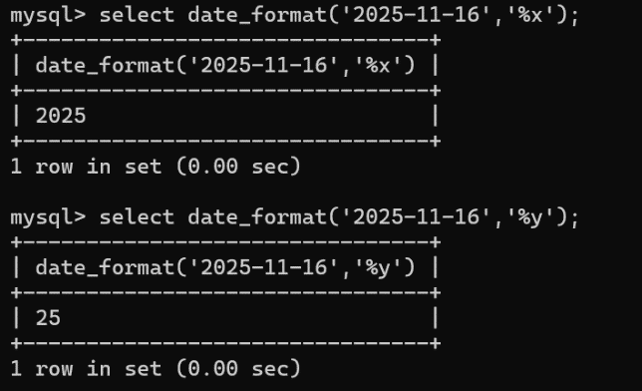

***EXPLANATION:-***

*The query with %x returns the ISO year, which will be 2025 for '2025-11-16'.*

*The query with %y returns the last two digits of the year, which will be 25 for '2025-11-16'.*



**i.** *mysql> select date_add('2025-11-16',interval 10 day);*

**ii.** *mysql> select date_add('2025-11-16',interval 1 month);*

**iii.** *mysql> select date_add('2025-11-16',interval 1 year);*

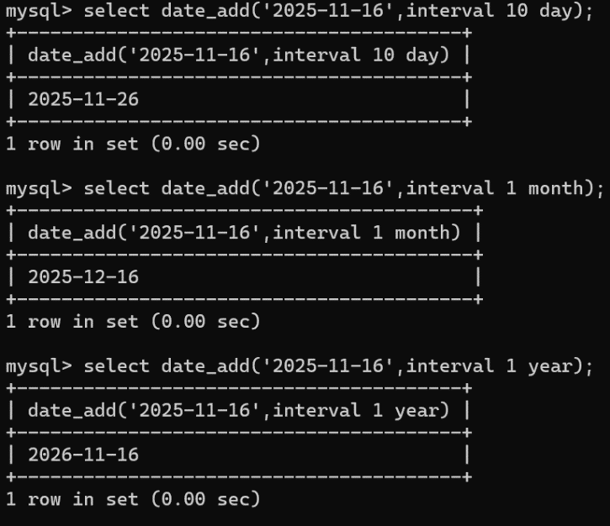

***EXPLANATION:-***

* *Adding 10 Days: Results in '2025-11-26'.*
* *Adding 1 Month: Results in '2025-12-16'.*
* *Adding 1 Year: Results in '2026-11-16'.*

1. **i.** *mysql> SELECT dayofmonth('2025-11-16');*

**ii.** *mysql> SELECT dayofweek('2025-11-16');*

**iii.** *mysql> select dayname('2025-11-16');*

**iv.** *mysql> select dayofyear('2025-11-16');*

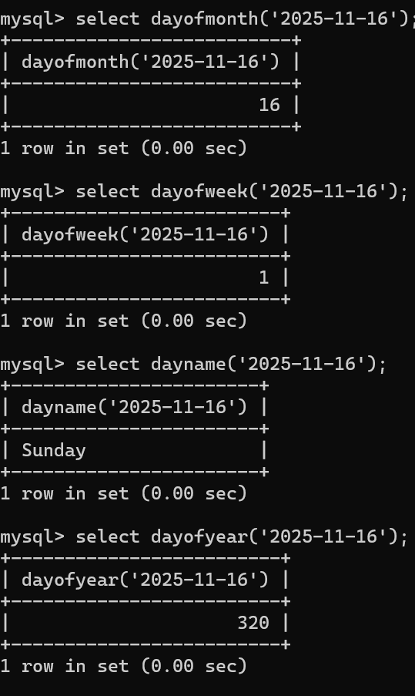

***EXPLANATION:-***

* *DAYOFMONTH('2025-11-16'): Returns 16.*
* *DAYOFWEEK('2025-11-16'): Returns 1 (Sunday).*
* *DAYNAME('2025-11-16'): Returns 'Sunday'.*
* *DAYOFYEAR('2025-11-16'): Returns 320.*

1. *mysql> select utc_date();*

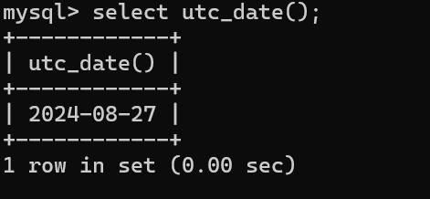

***EXPLANATION:-***

*The query retrieves and displays the current date in UTC format (YYYY-MM-DD).*

1. *mysql> select week('2024-11-16');*

*mysql> select weekday('2024-11-16');*

*mysql> select weekofyear('2024-11-16');*

*mysql> select last_day('2024-11-16');*

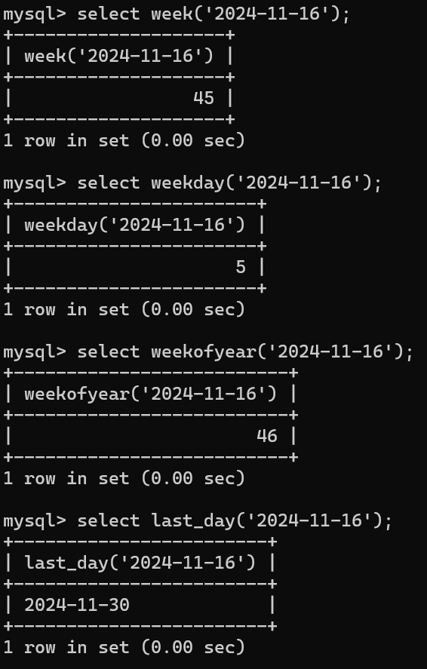

***EXPLANATION:-***

* *WEEK('2024-11-16'): Returns 46 (week of the year).*
* *WEEKDAY('2024-11-16'): Returns 5 (day of the week index, where Saturday is 5).*
* *WEEKOFYEAR('2024-11-16'): Returns 46 (ISO week number).*
* *LAST_DAY('2024-11-16'): Returns 2024-11-30 (last day of the month).*

**PRACTICAL NO 4:-**

**AIM:- For given scenario Queries involving**

**● Date Functions**

**● String Functions**

**II. Practical on String function**

**COMMAND:-**

1. *mysql> select ASCII("SQL stand for structured query language");*

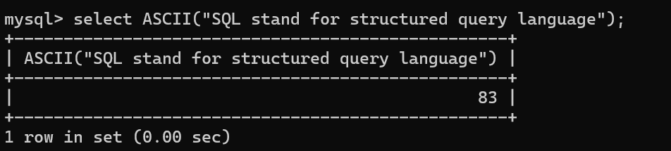

**EXPLANATION:-**

*The query returns the ASCII value of the character 'S', which is the first character of the provided string. The expected output would be ‘83’.*

***2.*** *mysql> select CHAR(75);*

*mysql> select CHAR(100);*

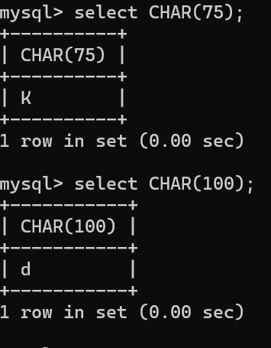

***EXPLANATION :-***

*It is used to return the character associated with the given ASCII values.*

*The first query returns the character 'K' because 75 is the ASCII value for ‘ K’.The second query returns the character 'd' because 100 is the ASCII value for ‘d’.*

**3.** *mysql> SELECT CONCAT('SMART','POINT');*

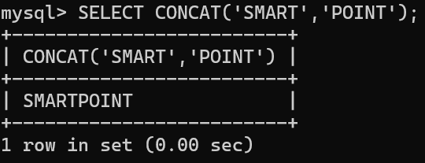

***EXPLANATION:-***

*It is used to concatenate (combine) two or more strings into a single string.*

*The query concatenates the strings 'SMART' and 'POINT' into a single string 'SMARTPOINT' and returns it as the result.*

**4.** *mysql> SELECT CONCAT_WS('_','HELLO','MYSQL','WORLD');*

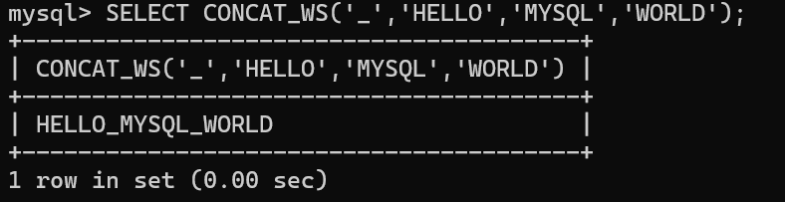

**EXPLANATION:-**

*It is used to concatenate multiple strings into a single string, with a specified separator between each of the strings.*

*The query concatenates the strings 'HELLO', 'MYSQL', and 'WORLD' with an underscore ('_') as the separator, resulting in the output 'HELLO_MYSQL_WORLD'.*

**5.** *mysql> SELECT LEFT('SMARTPHONE',5);*

*mysql> SELECT RIGHT('SMARTPHONE',5);*

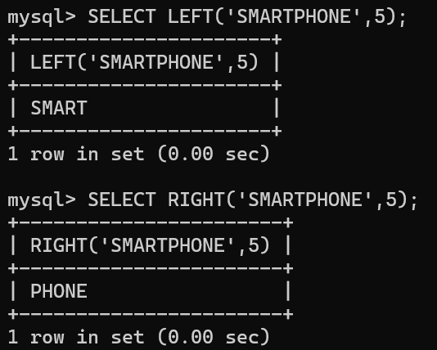

**EXPLANATION:-**

*They are used to extract specific parts of a string from the left and right sides, respectively.*

*The first query returns 'SMART', which are the first 5 characters of the string 'SMARTPHONE'.The second query returns 'PHONE', which are the last 5 characters of the string 'SMARTPHONE'.*

**6.** *mysql> SELECT CHAR_LENGTH('PHILIPPINES')As 'STRING LENGTH OF PHILIPPINES';*

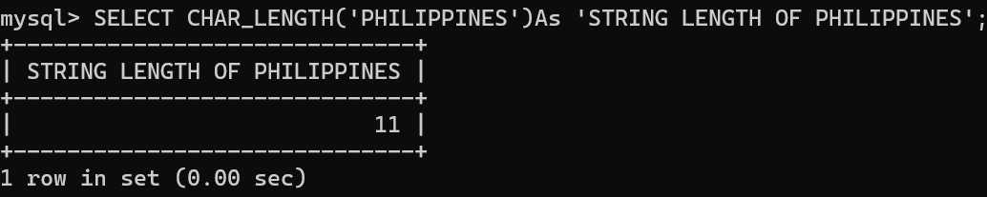

**EXPLANATION:-**

*It is used to calculate the number of characters in the string 'PHILIPPINES' and label the result with a custom column name.The query calculates the number of characters in the string 'PHILIPPINES', which is 11, and returns this value with the label 'STRING LENGTH OF PHILIPPINES'.*

***7.*** *mysql> SELECT LOWER('VARIABLES');*

*mysql> SELECT UPPER('variables');*

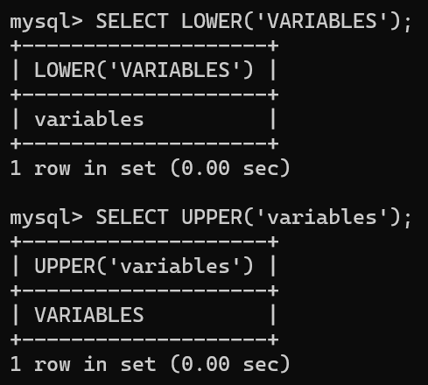

***EXPLANATION:-***

*They are used to convert the case of the characters in the provided strings.The first query converts the string 'VARIABLES' to lowercase, resulting in 'variables'.The second query converts the string 'variables' to uppercase, resulting in 'VARIABLES'.*

***8.*** *mysql> select replace ('INDIA IS A COUNTRY IN NORTH ASIA','NORTH ASIA','SOUTH ASIA');*

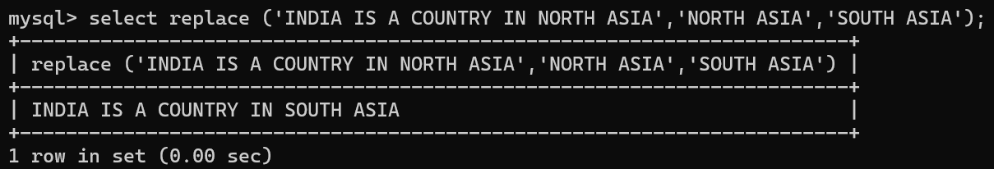

**EXPLANATION:-**

*It is used to replace a specific substring within a string with another substring.The query replaces the substring 'NORTH ASIA' with 'SOUTH ASIA' in the original string, resulting in the output 'INDIA IS A COUNTRY IN SOUTH ASIA'.*

***9.*** *mysql> SELECT SUBSTRING('INDIAN COUNTRY', 1,5);*

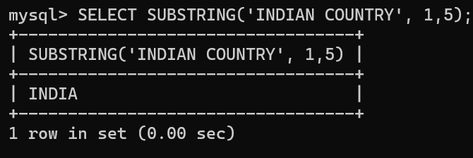

**EXPLANATION:-**

*It is used to extract a portion of a string based on specified start position and length.The query extracts the substring 'INDIA' from the original string 'INDIAN COUNTRY', starting from the first character and including the next 5 characters.*

**PRACTICAL- 5**

AIM: To understand and implement ‘Maths Functions’ using MySQL

1.ABS():

Description : Return the absolute value CODE AND OUTPUT:

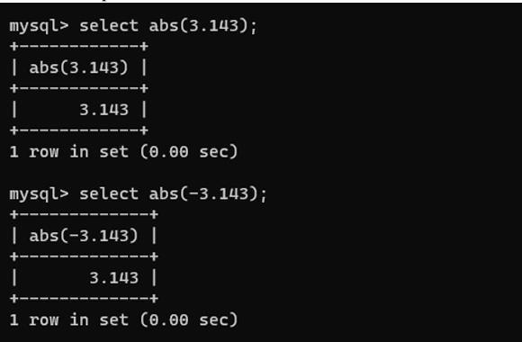

2. ACOS() :

Description : Return the arc cosine CODE AND OUTPUT:

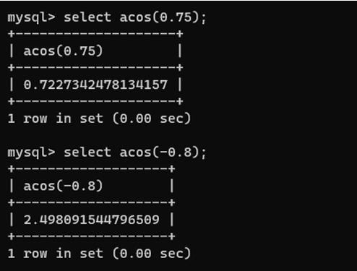

3. ASIN() :

Description : Return the arc sine CODE AND OUTPUT:

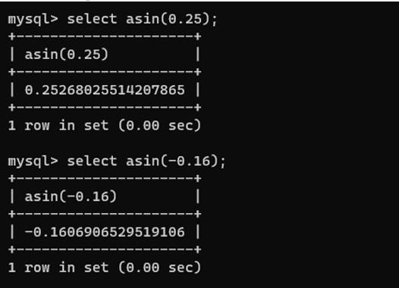

4. ATAN() :

Description: Return the arc tangent CODE AND OUTPUT:

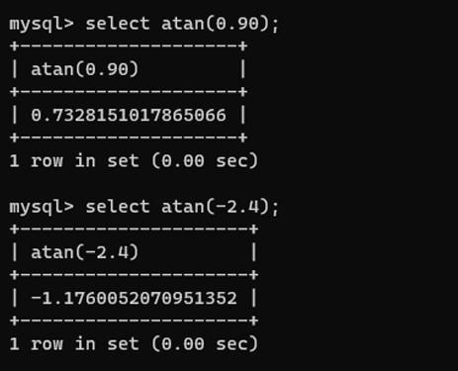

5.ATAN2() :

Description : Return the arc tangent of two arguments

     CODE AND OUTPUT:

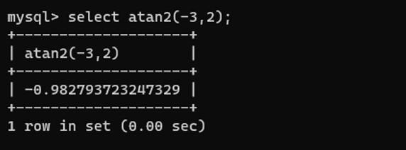

CEIL() :

Description : Return the smallest integer value not less than the argument CODE AND OUTPUT:

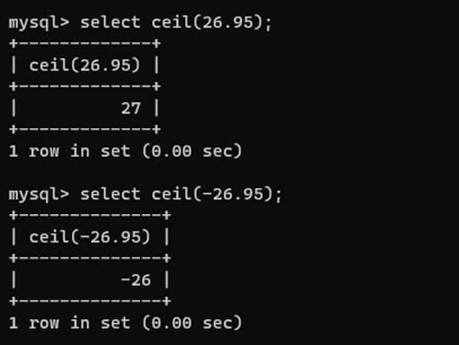

CEILING:

Description : Return the smallest integer value not less than the argument CODE AND OUTPUT:

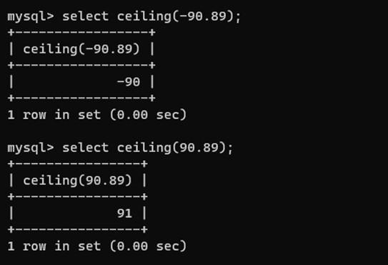

CONV:

Description : Convert numbers between different number bases CODE AND OUTPUT:

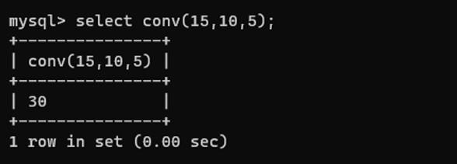

COS() :

Description : Return the cosine CODE AND OUTPUT:

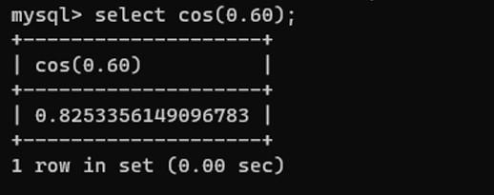

COT() :

Description : Return the cotangent CODE AND OUTPUT:

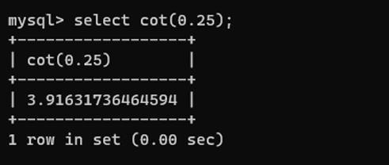

CRC32() :

Description : Compute a cyclic redundancy check value CODE AND OUTPUT:

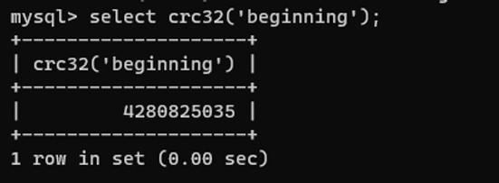

DEGREES() :

Description : Convert radians to degrees CODE AND OUTPUT:

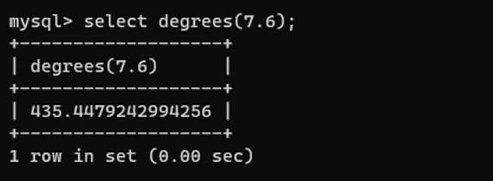

EXP() :

Description : Raise to the power of CODE AND OUTPUT:

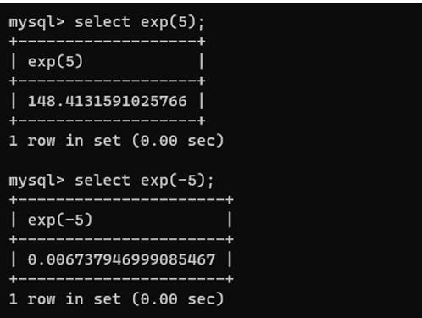

14. FLOOR :

Description : Return the largest integer value not greater than the argument CODE AND OUTPUT:

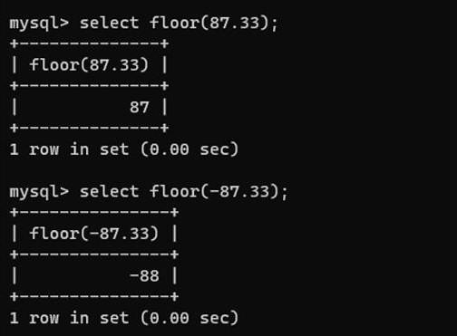

15. LN() :

Description : Return the natural logarithm of the argument CODE AND OUTPUT:

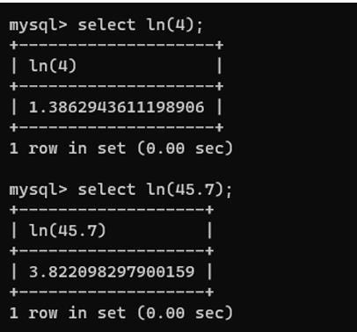

16. LOG() :

Description : Return the natural logarithm of the first argument CODE AND OUTPUT:

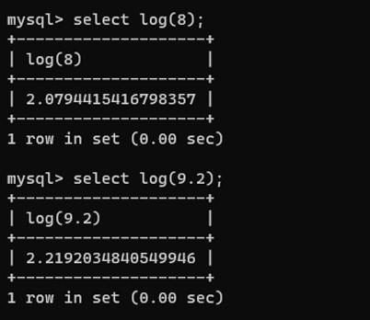

17. LOG10():

Description : Return the base-10 logarithm of the argument. CODE AND OUTPUT:

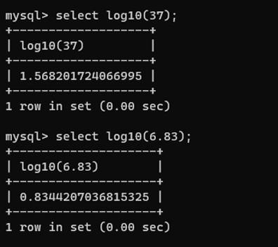

18. LOG2() :

Description : Return the base-2 logarithm of the argument CODE AND OUTPUT:

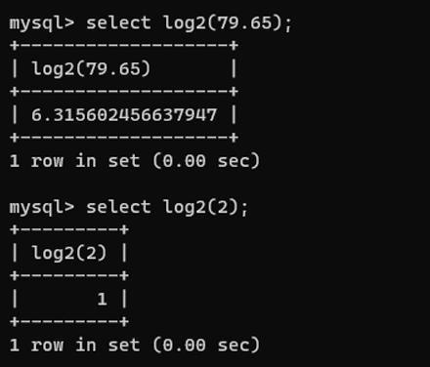

19. MOD() :

Description : Return the remainder CODE AND OUTPUT:

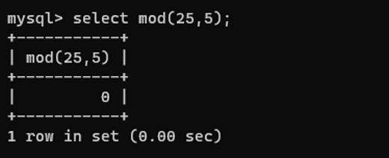

20. PI() :

Description : Return the pi CODE AND OUTPUT:

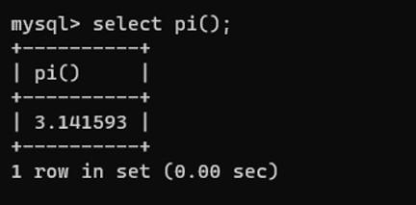

21. POW() :

Description : Return the argument raised to the specified power

CODE AND OUTPUT:

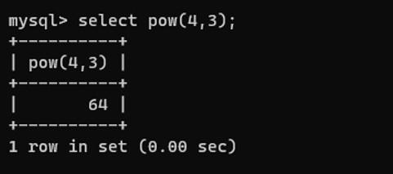

22. POWER() :

Description : Return the argument raised to the specified power CODE AND OUTPUT:

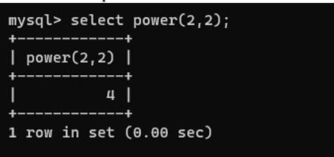

23. RADIANS() :

Description : Return the argument converted to radians CODE AND OUTPUT:

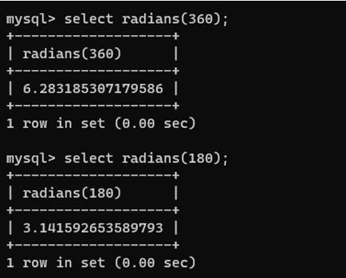

24. RAND() :

Description : Return a random floating-point value CODE AND OUTPUT:

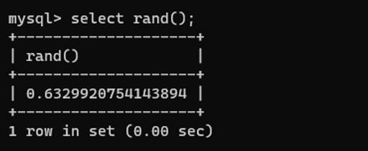

25. ROUND() :

Description : Round the argument CODE AND OUTPUT:

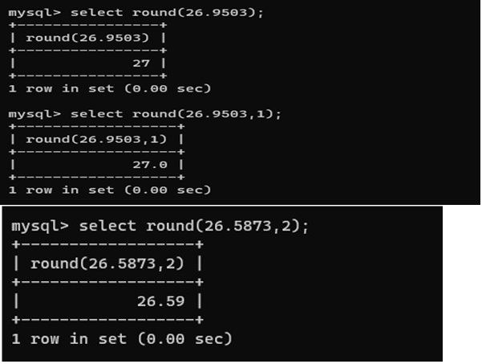

26. SIGN() :

Description : Return the sign of the argument CODE AND OUTPUT:

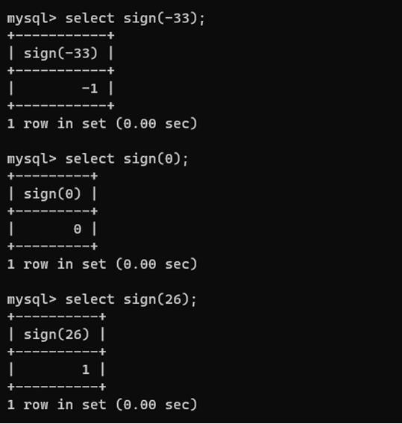

27. SIN() :

Description : Return the sine of the argument CODE AND OUTPUT:

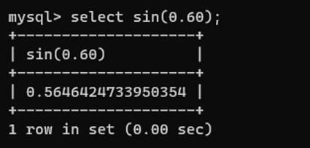

28. SQRT() :

Description : Return the square root of the argument CODE AND OUTPUT:

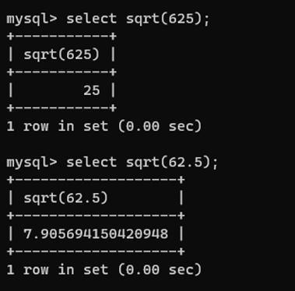

29. TAN() :

Description : Return the tangent of the argument CODE AND OUTPUT:

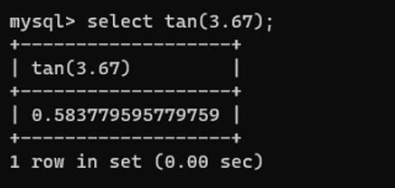

30. TRUNCATE() :

Description : Truncate to specified number of decimal places CODE AND OUTPUT:

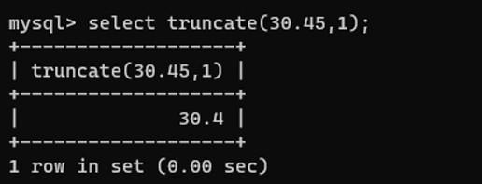

**PRACTICAL NO 6**

**AIM:-***For given scenario Join Queries*

*● Inner Join*

*● Outer Join*

**COMMAND:-**

***mysql> show databases;***

***mysql> create database emp2;***

***Query OK, 1 row affected (0.12 sec)***

***mysql> show databases;***

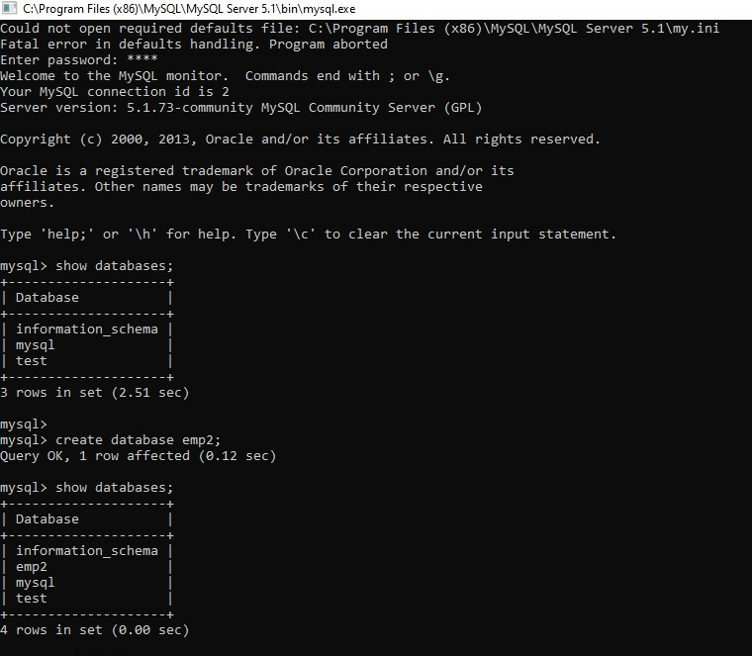

**EXPLANATION:-**

*SHOW DATABASES;  This command lists all the databases present in the MySQL server.*

*CREATE DATABASE emp2;  This query creates a new database named emp2.*

*SHOW DATABASES;  The user runs this command again to verify that the emp2 database was successfully created.*

**COMMAND:-**

***mysql> use emp2;***

***Database changed***

***mysql> create table employee(***

***-> Id int(10) not null PRIMARY KEY,***

***-> NAME varchar(20) not null,***

***-> Department char(15) not null,***

***-> Salary int(10) null,***

***-> Gender char(10) not null,***

***-> Age int(3) not null,***

***-> City char(15) null);***

***Query OK, 0 rows affected (0.36 sec)***

***mysql> desc employee***

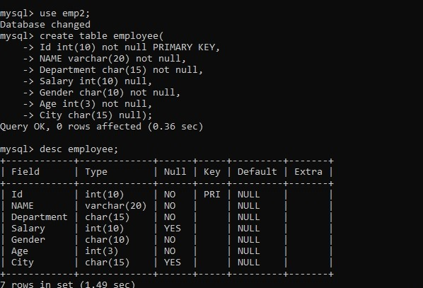

**EXPLANATION:-**

*The user switched to the emp2 database and created an employee table with columns for Id, NAME, Department, Salary, Gender, Age, and City. The table was successfully created, and its structure was confirmed using the DESC employee; command.*

**COMMAND:-**

***mysql> insert into employee values***

***-> (1001,'John Doe','IT',35000,'Male',25,'London'),***

***-> (1002,'Linda Jones','HR',75000,'Female',26,'London'),***

***-> (1003,'James Brown','FINANCE',50000,'Male',28,'London'),***

***-> (1004,'Mike Walker','FINANCE',50000,'Male',28,'London'),***

***-> (1005,'Linda Jones','HR',75000,'Female',26,'London'),***

***-> (1006,'Anurag Mohanty','IT',35000,'Male',25,'Mumbai'),***

***-> (1007,'Priyanka Dewangan','HR',45000,'Female',27,'Mumbai'),***

***-> (1008,'Sambit Mohanty','IT',50000,'Male',28,'Mumbai'),***

***-> (1009,'Pranaya Kumar','IT',50000,'Male',28,'Mumbai'),***

***-> (1010,'Hina Sharma','HR',75000,'Female',26,'Mumbai');***

***Query OK, 10 rows affected (0.16 sec)***

***Records: 10  Duplicates: 0  Warnings: 0***

***mysql> select * from employee;***

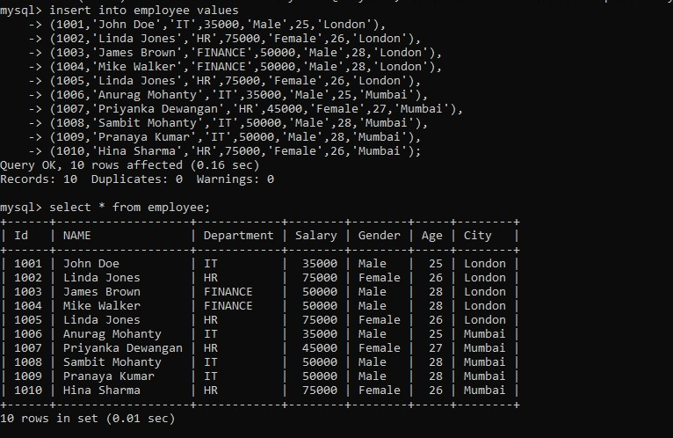

**EXPLANATION:-**

*Inserting Data into employee Table: The user inserted 10 records into the employee table with details .*

*Selecting All Data from the employee Table (SELECT * FROM employee; This command retrieves and displays all the records from the employee table, showing the full data for each employee that was inserted.*

**COMMAND:-**

***mysql> create table projects(ProjectId int(10) null,Title char(100) null, ClientId int(5) null, EmployeeId int(10) null, StartDate varchar(20),EndDate varchar(20) null);***

***Query OK, 0 rows affected (0.14 sec)***

***mysql> desc projects;***

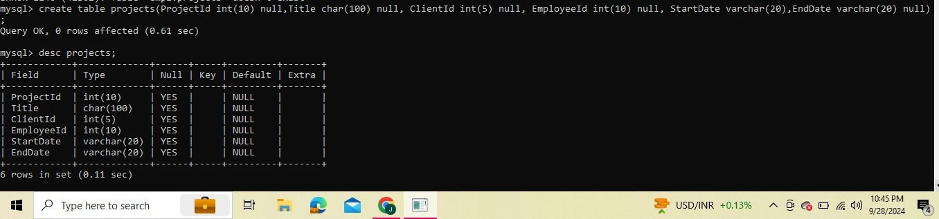

**EXPLANATION:-**

*Creating the projects Table (CREATE TABLE projects): A new table named projects was created*

*Describing the projects Table (DESC projects;):*

*This command retrieves the structure of the projects table, showing details about each column, its data type, whether it can be null, and any key constraints.*

**COMMAND:-**

***mysql> select * from projects;***

***11 rows in set (0.00 sec)***

***mysql> select Id,NAME,Department,city,Title,ClientId***

***-> from employee***

***-> inner join projects***

***-> on employee.Id=projects.EmployeeId***

***-> order by employee.Id;***

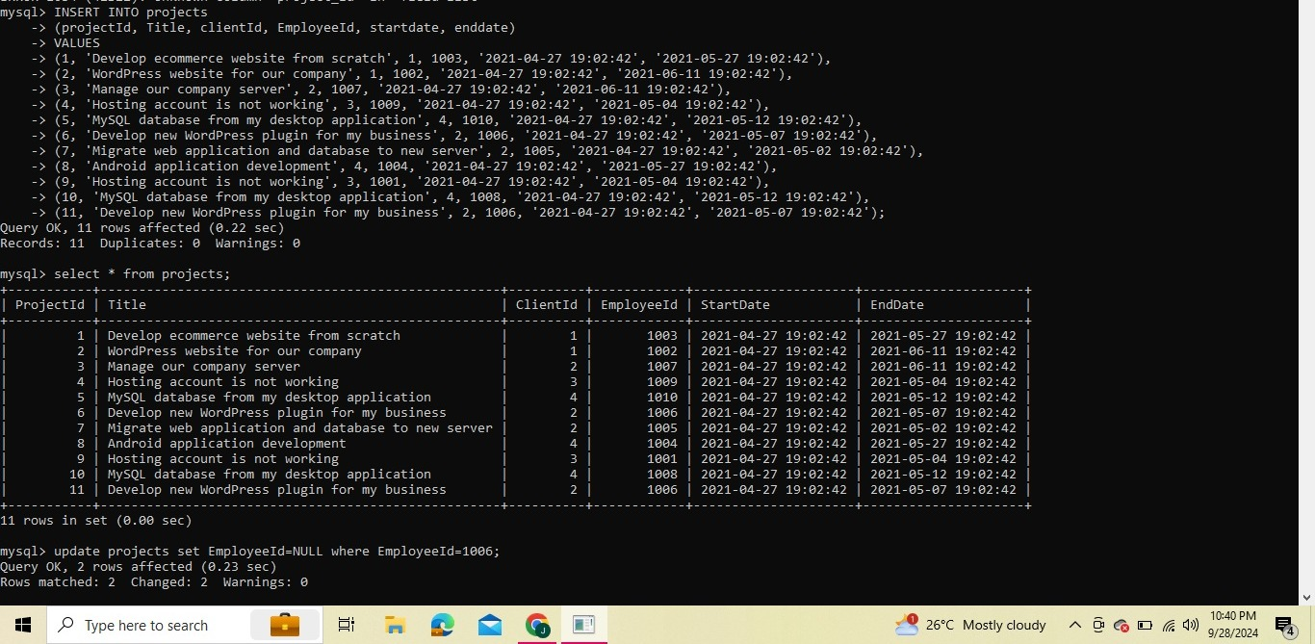

**EXPLANATION:-**

*SELECT * FROM projects;*

*Purpose: This query retrieves all the records from the projects table, displaying every column for each project.*

*SELECT Id, NAME, Department, city, Title, ClientId ... INNER JOIN ...Purpose: This query retrieves specific columns from the employee and projects tables, combining the data from both using an INNER JOIN.*

*Join Condition (ON employee.Id=projects.EmployeeId): This is where the INNER JOIN matches records from the employee and projects tables based on the Id column from the employee table and the EmployeeId column from the projects table. Only rows where these values match will be included in the result.*

*Ordering (ORDER BY employee.Id): The results will be ordered by employee.Id in ascending order.*

**COMMAND:-**

***Cross Join :***

***Description : If two or more tables are combined with each other without any condition then we call it cross join in MySQL. In cross join, each record of a table is joins with each record of another table***

***COMMAND:***

***SELECT column names FROM table 1***

***CROSS JOIN join table 2***

***ON table1.column_name=table2.column_name;***

***OUTPUT:***

