NOISE POLLUTION MONITORING

**Introduction:**

A noise pollution monitor is a device that measures and tracks noise levels in a given area.

It helps identify noisy areas, assess compliance with noise regulations, and gather data to reduce noise pollution.

These monitors are essential for understanding and addressing noise-related problems in our communities.

**Problem:**

1.Data Accuracy and Reliability: Noise monitoring devices might provide inaccurate or unreliable data.

2. Data Interpretation: Interpreting raw noise data to understand its impact on human health and the environment can be complex.

**Solution:**

1.Regular calibration and maintenance of monitoring equipment are essential. Implementing redundancy by using multiple sensors can also enhance accuracy.

2.Collaborate with experts in public health and environmental science to analyze and interpret the data.

**Sensor using noise pollution:**

1.Ultrasound Sensors

2.Radiation Sensors

3. Sound Level Sensors

4.Acoustic Sensors

5. Radiation Sensors

6. Noise Sensors

**COMPONENTS USED FOR NOISE POLLUTION:**

Sound Level Meters (SLMs):

SLMs are handheld devices equipped with a microphone to measure sound levels in decibels (dB).

Microphones:

High-quality microphones are used as sensors in sound level meters to capture and convert sound waves into electrical signals.

Data Loggers:

Data loggers are used to record and store noise level data over a period of time. They can be integrated with SLMs and microphones for continuous monitoring.

Calibrators:

Calibrators are used to calibrate sound level meters and microphones to ensure accurate and consistent measurements.

Noise Dosimeters:

Dosimeters are portable devices worn by individuals to measure their personal exposure to noise over a specific period. They are commonly used in occupational noise monitoring.

Internet of Things Devices:

Internet Of Things (IoT) devices can be used for real-time noise monitoring and data transmission. They can be connected to the internet to provide continuous monitoring and analysis.

**Connectivity:**

1. Sigfox
2. Zigbee
3. NB-IoT (Narrowband Internet of Things)
4. Wi-Fi (Wireless Fidelity)

**Protocol:**

* MQTT
* HTTP
* AMQP

**Cloud:**

* Beeceptor

**Arduino uno:**

It comes with an ATMEGA microcontroller that processes the data and facilitates the proper working of the IoT system. And the beauty is that the Arduino can be programmed 'n' number of times making it possible for you to build various types of IoT projects just by changing a simple code.

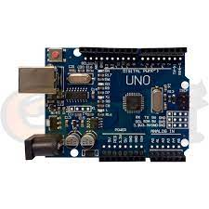

**ESP32:**

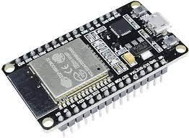The ESP32 provides many GPIO pins that facilitate connection with and control of external devices and sensors. These pins support a variety of interfaces, including SPI, I2C, UART, and PWM. The ESP32 is designed to be power efficient, thus enabling the development of energy-efficient IoT applications.