**README_Git**

# Git Commands and Descriptions

# git –version

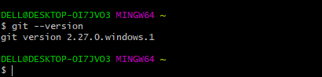

# Creating a git repository

To create a directory

mkdir readme_git

To Change the directory

cd readme_git

## Git Commands

Converts a directory into a local git repository.

git init

To add a single or muiltiple files to staging area

vi firstfile

git add firstfile

To commit the changes in the local repository

git commit -m "initial commit"

To list the status of the files in staging area

git status

To configure the global username and email id

git config --global user.name = "surya1150"

git config --global user.email - [kotha.surya1150@gmail.com](mailto:kotha.surya1150@gmail.com)

### Connect and add Remote Repository

To connect a local repository to a specific remote repository

git remote add origin <https://github.com/surya1150/devopsbootcamp.git>

Output:

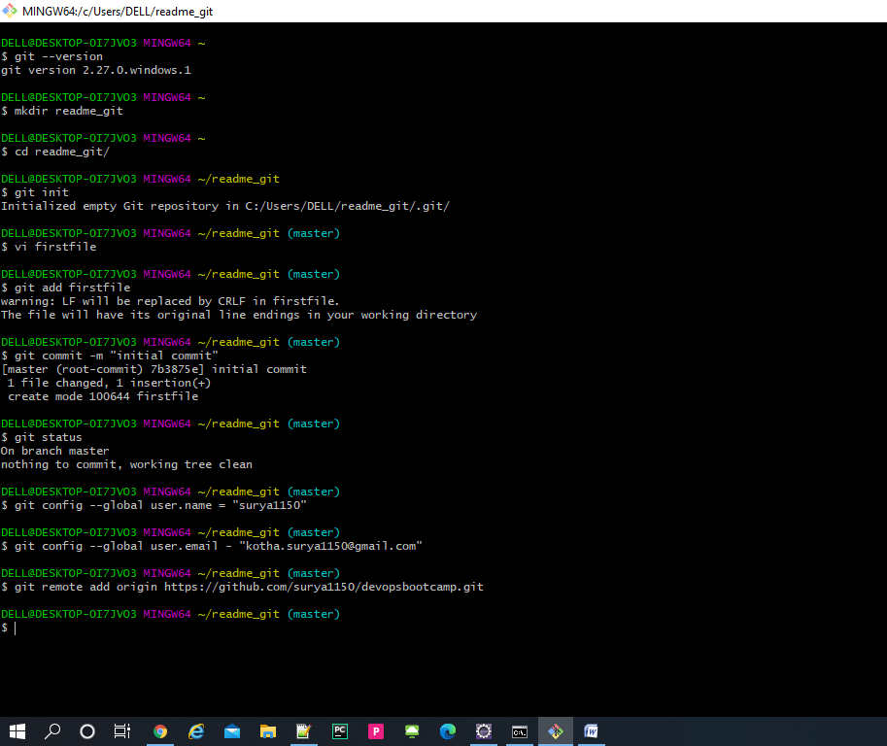

To Clone a remote git repository into a local git repository

git clone <https://github.com/surya1150/devopsbootcamp.git>

To Pull the changes from master branch of the remote git repository

cd devopsbootcamp/

git pull origin master

### Branching

To List all the branches

git branch

To create a new branch

git branch feature/test1

git checkout feature/test1

Output:

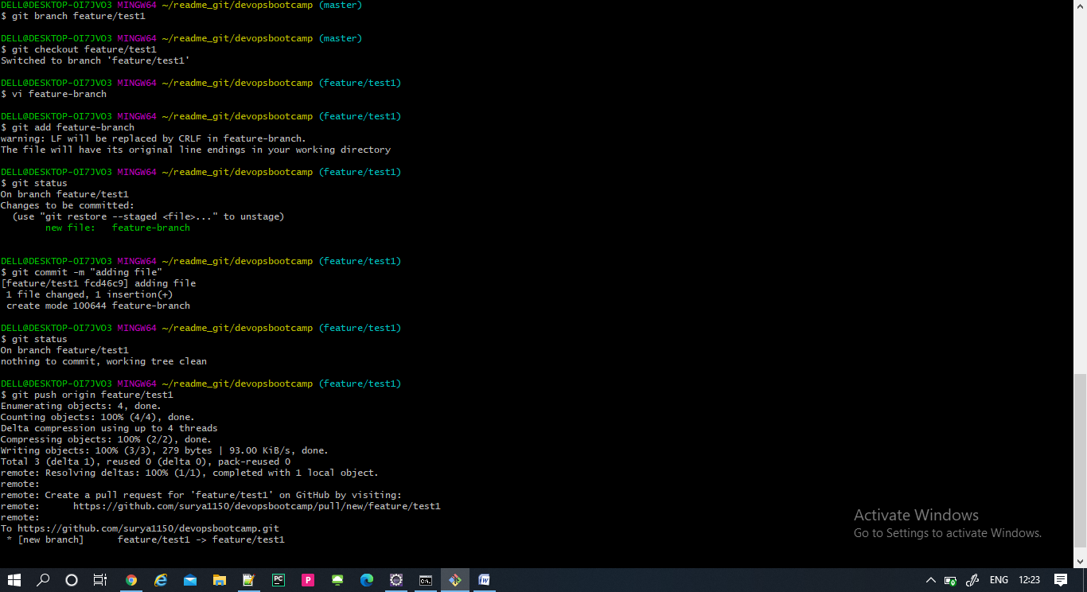

To delete an existing branch

git branch -d feature/test1

Output:

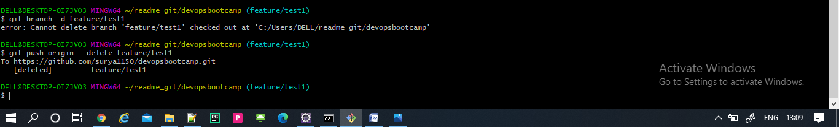

To merge a child branch to master

git checkout master

git merge feature/test1

git push origin master

Output:

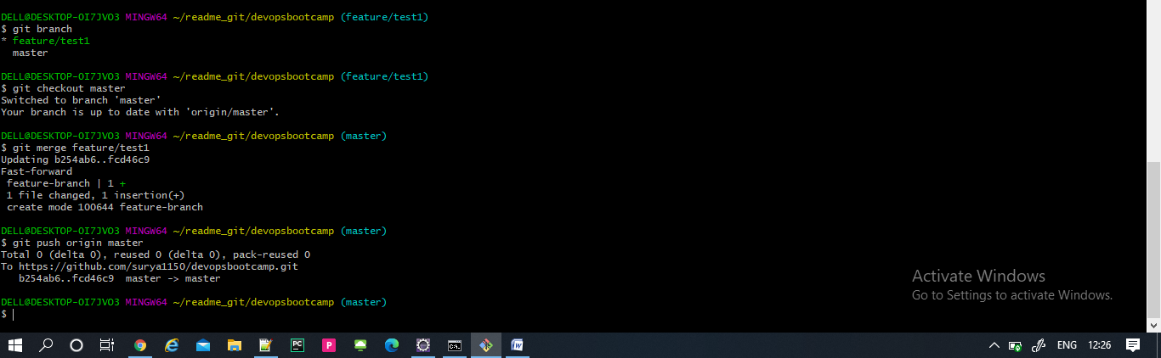

### Advance git commands

To save the changes, when they are not in state of commit

git stash

To List the stashes created

git stash list

To get the stashed work back.

git stash apply

git status

Output:

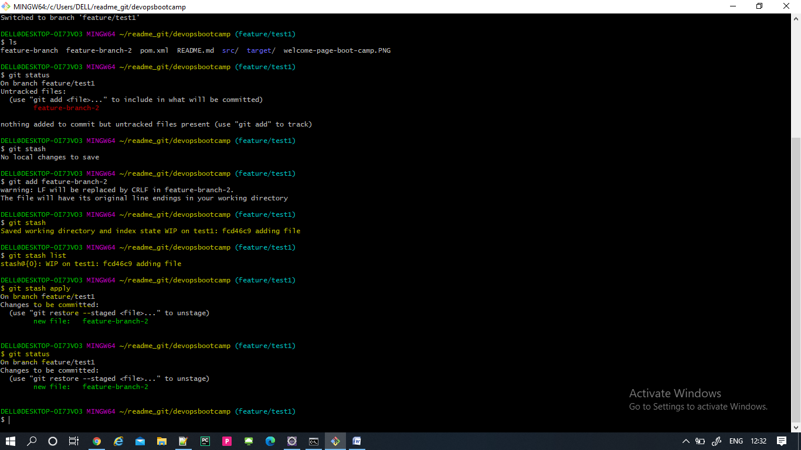

To get the context and history of logs of a repository

git log

To revert back to the previous version of the file.

git revert 90ec9f498137a

output:

