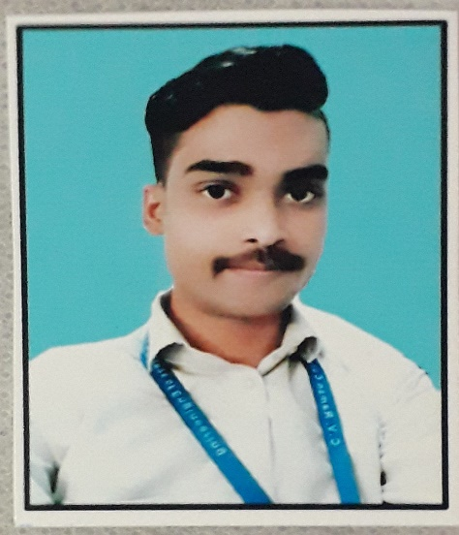

**Aniket Kumar**

**Objective:**

To work in an organization which provides me the opportunity to improve my skills and knowledge to grow along with the organization objectives.

**EDUCATIONAL QUALIFICATIONS**

|  |  |  |  |  |
| --- | --- | --- | --- | --- |
| **Education** | **Institute** | **Board/University** | **Year of passing** | **Aggregate** |
| B. Tech (Chemical Engineering ) | C.V. Raman College of Engineering , BBSR | C.V. Raman Global University ,BBSR | 2020 | 60.04% |
| Intermediate | Pitts Modern School,  Gomia | CBSE | 2016 | 65.08% |
| Matriculation | Pitts Modern School , Gomia | CBSE | 2013 | 64.05% |

**Technical Skills:**

* Operating System: Windows 10, Windows Server 2016, Linux.
* Cloud: Basics of AWS, Azure, DevOps, Tools, Office365.
* Database: SQL, ORACLE DBA
* Scripting Language: Unix Shell, Power shell, Python
* Storage : Storage Basics & Technologies
* Other Modules : Networking basics, JAVA, Middleware.

**Academic Project:** Flue gas desulfurization

**Synopsis:**

Flue gas desulfurization (FGD) is a set of technologies used to remove sulfur dioxide (SO2) from exhaust flue gases of fossil-fuel power plants, as well as from the emissions of other sulfur oxide emitting processes. When using a wet FGD scrubbing process, wastewater is generated, which must be treated before disposal.

**Personal Information:**

* Name : Aniket Kumar
* Gender : Male
* Nationality : Indian
* Date of Birth : 15/01/1996
* Marital Status : Single
* Pan : Yes
* Passport : No
* Languages : English, Hindi & Khortha
* Phone no : 6370977927
* Email id : ashishkr10489@gmail.com
* Address : Hosir choudhary tola, Gomia, Bokaro, Jharkhand, Pin- 829111

**Declaration**

I hereby declare that the above information given by me is to the best of my knowledge and concern. I bear the responsibility for correctness of the above-mentioned particulars.

Place: Gomia .

Date: 25.04.2021