Firewall Configuration on Windows

Tools Used: Windows Defender Firewall with Advanced Security

# Steps Taken:

* Opened Windows Firewall (wf.msc).
* Listed inbound rules.
* Created a rule to block TCP port 23.
* Tested rule using telnet localhost 23.
* Created rule to allow TCP port 22 (SSH).
* Deleted block rule to restore settings.
* Captured screenshot of firewall rule.

# Screenshots:

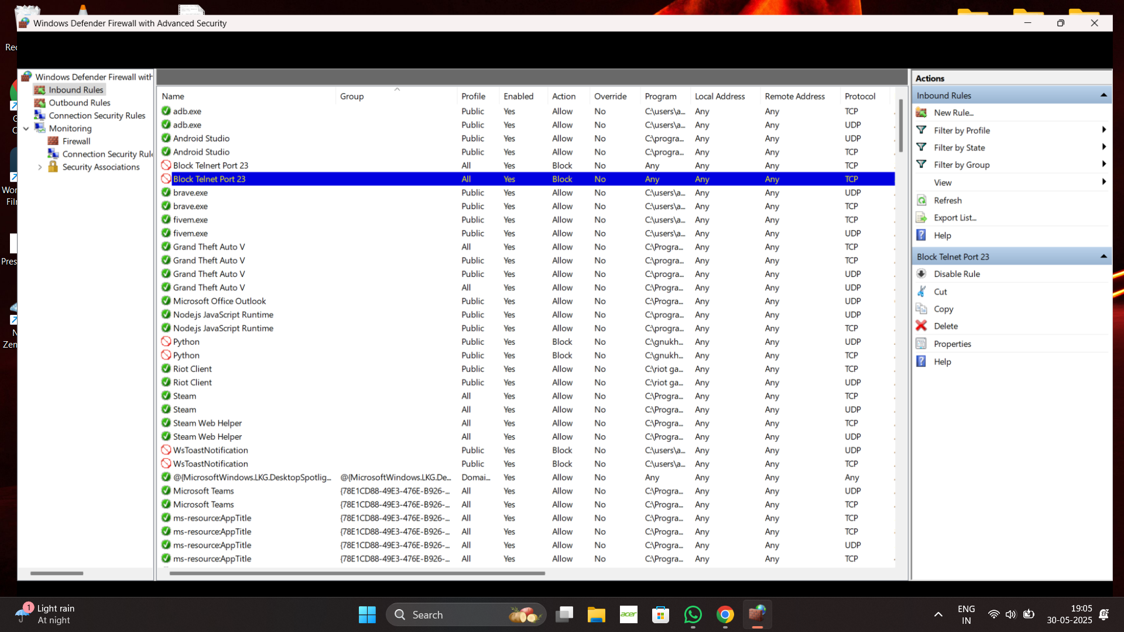

Firewall rule list with Block Telnet Port 23 highlighted.

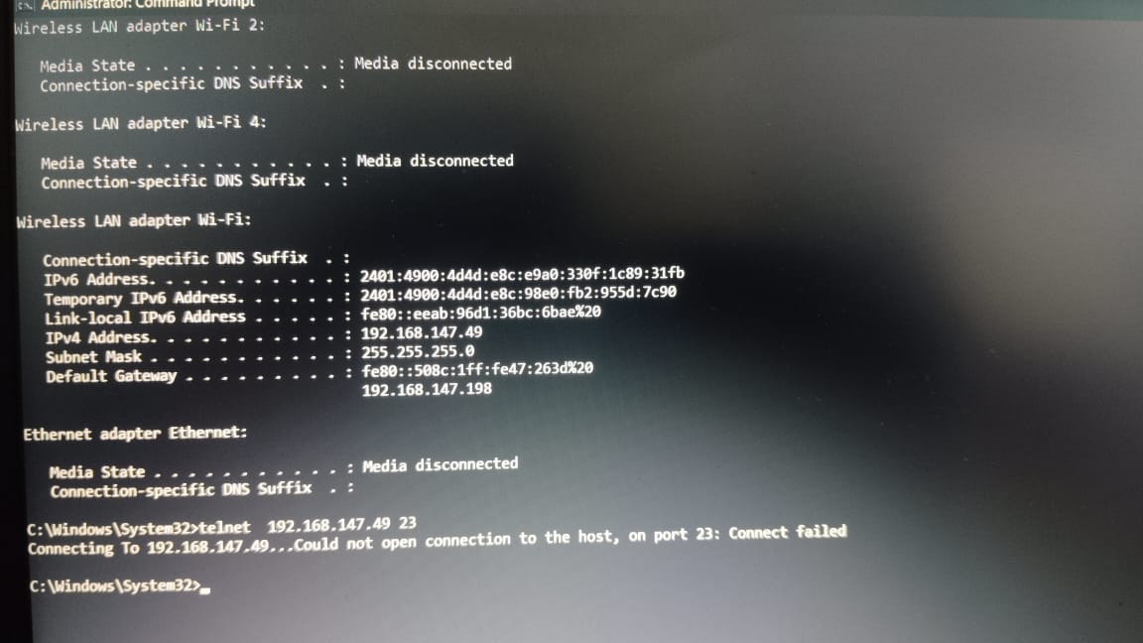

Command Prompt showing Telnet connection failure due to blocked port.

# Summary:

The firewall was configured to block port 23 and allow port 22. Firewalls act as filters between trusted and untrusted networks, applying rules to allow or deny traffic based on security policies.