# Password Strength Checker Report

This report presents the analysis of password strength using the online Password Strength Checker (https://passwordmeter.com). Several sample passwords were tested, and their scores, complexity levels, and contributing factors were recorded. Screenshots of the test results are attached below.

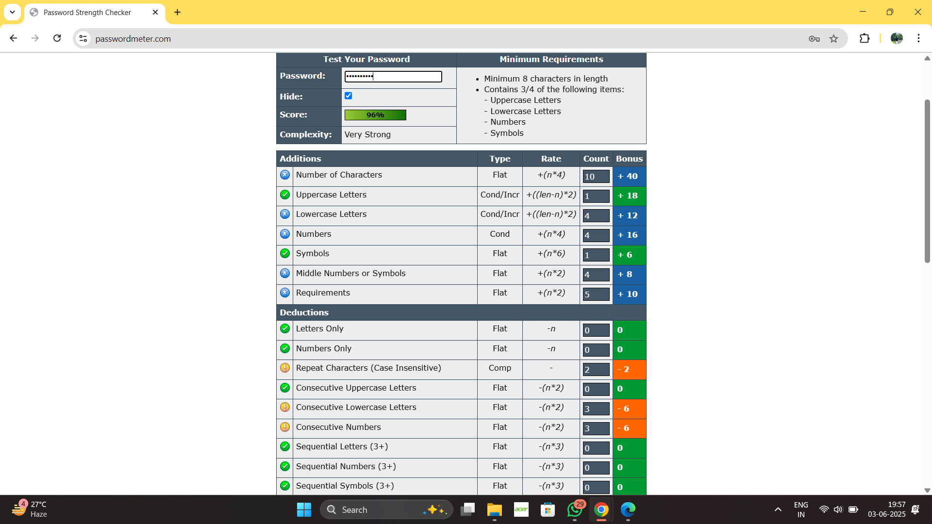

Figure 1: Password scored 96% with 'Very Strong' complexity. It includes uppercase, lowercase, numbers, and symbols.

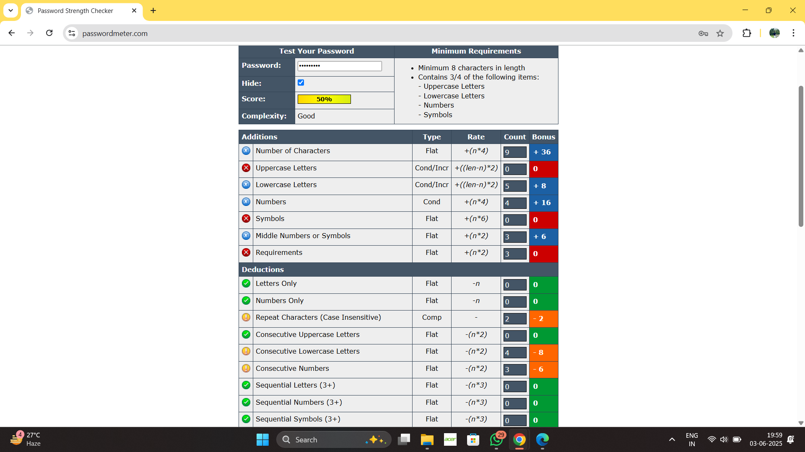

Figure 2: Password scored 50% with 'Good' complexity. It lacks uppercase letters and symbols.

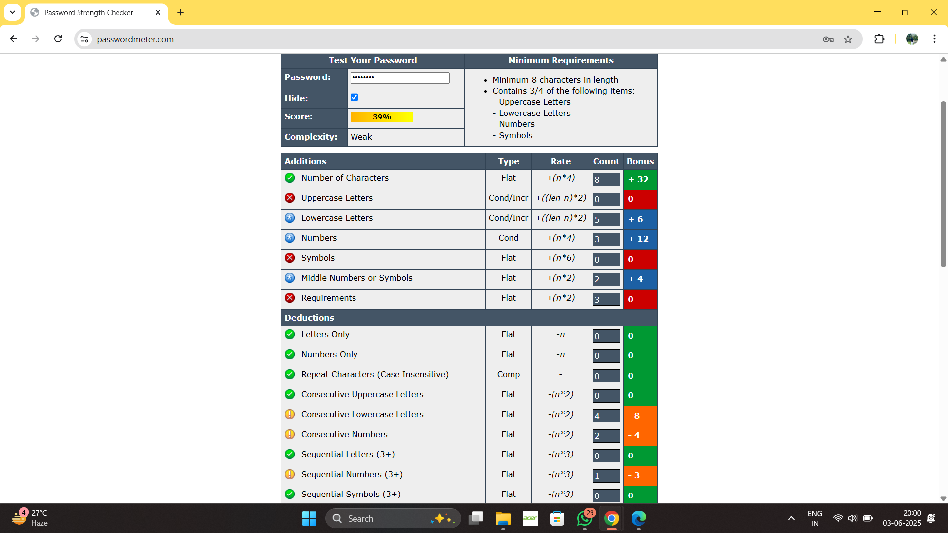

Figure 3: Password scored 39% with 'Weak' complexity. It lacks uppercase letters and symbols, and has minor deductions.

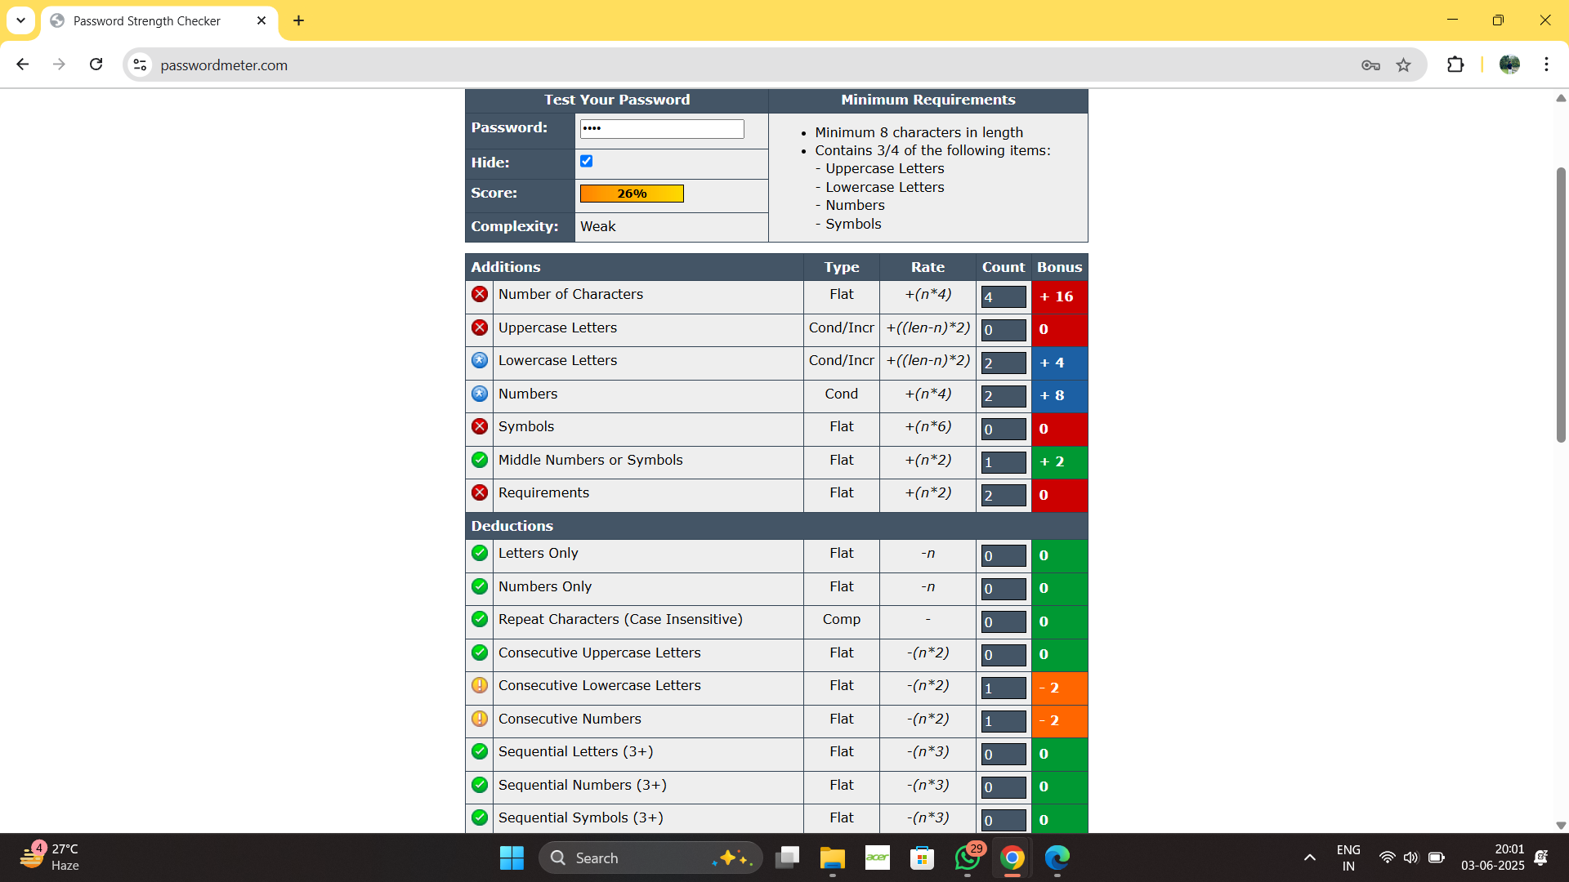

Figure 4: Password scored 26% with 'Weak' complexity. It has very few characters and lacks symbol diversity.

## Summary

The strength of a password heavily depends on its length, variety of characters used (uppercase, lowercase, numbers, symbols), and the avoidance of predictable patterns (like sequences or repeated characters). Strong passwords fulfill most or all of the criteria and avoid common pitfalls.