Wireshark Packet Capture Report

**Filename**: task5.pcapng

**Tool Used**: Wireshark

**Date of Capture**: 02 June 2025

**Capture Duration**: ~1 minute

**Network Interface**: Wi-Fi

**Total Packets Captured**: 27,911

# Protocols Identified

|  |  |  |  |
| --- | --- | --- | --- |
| Protocol | Description | Packet Count (approx.) | Example Info |
| TCP | Transmission Control Protocol | Multiple | Handshake, TLS negotiation |
| DNS | Domain Name System | 80+ | Queries for googleapis.com, msn.com |
| HTTP | HyperText Transfer Protocol | 1 | POST /chat HTTP/1.1 |

# Captured Screenshots

Below are the protocol views captured during the analysis:

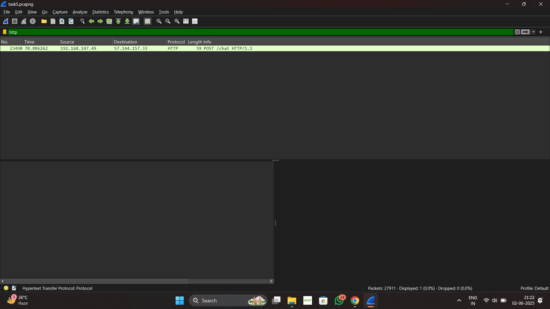

Screenshot 2025-06-02 212305.png

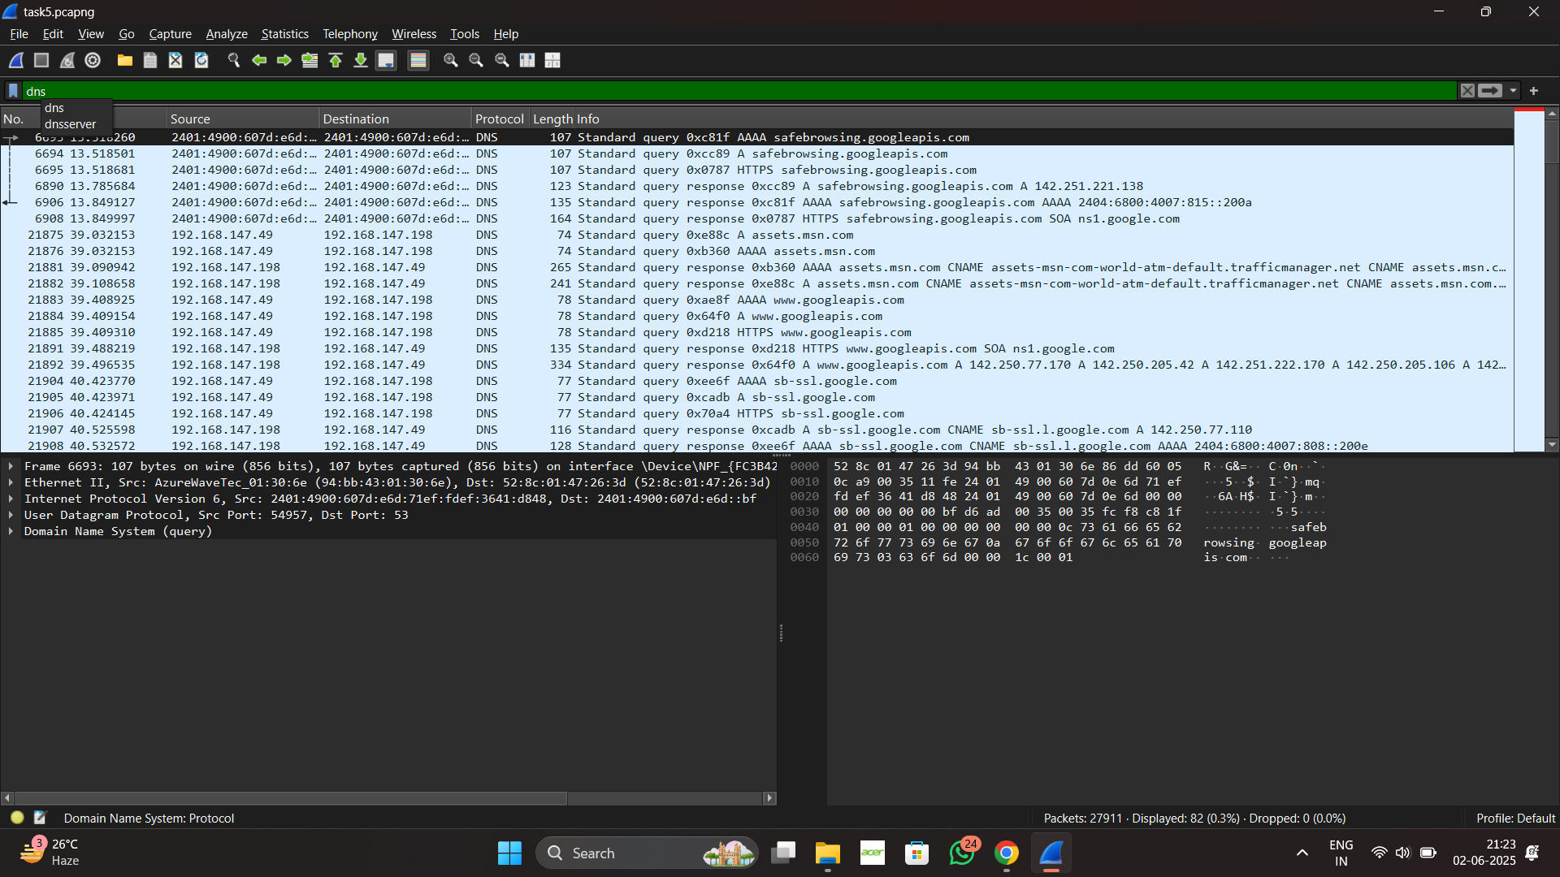

Screenshot 2025-06-02 212329.png

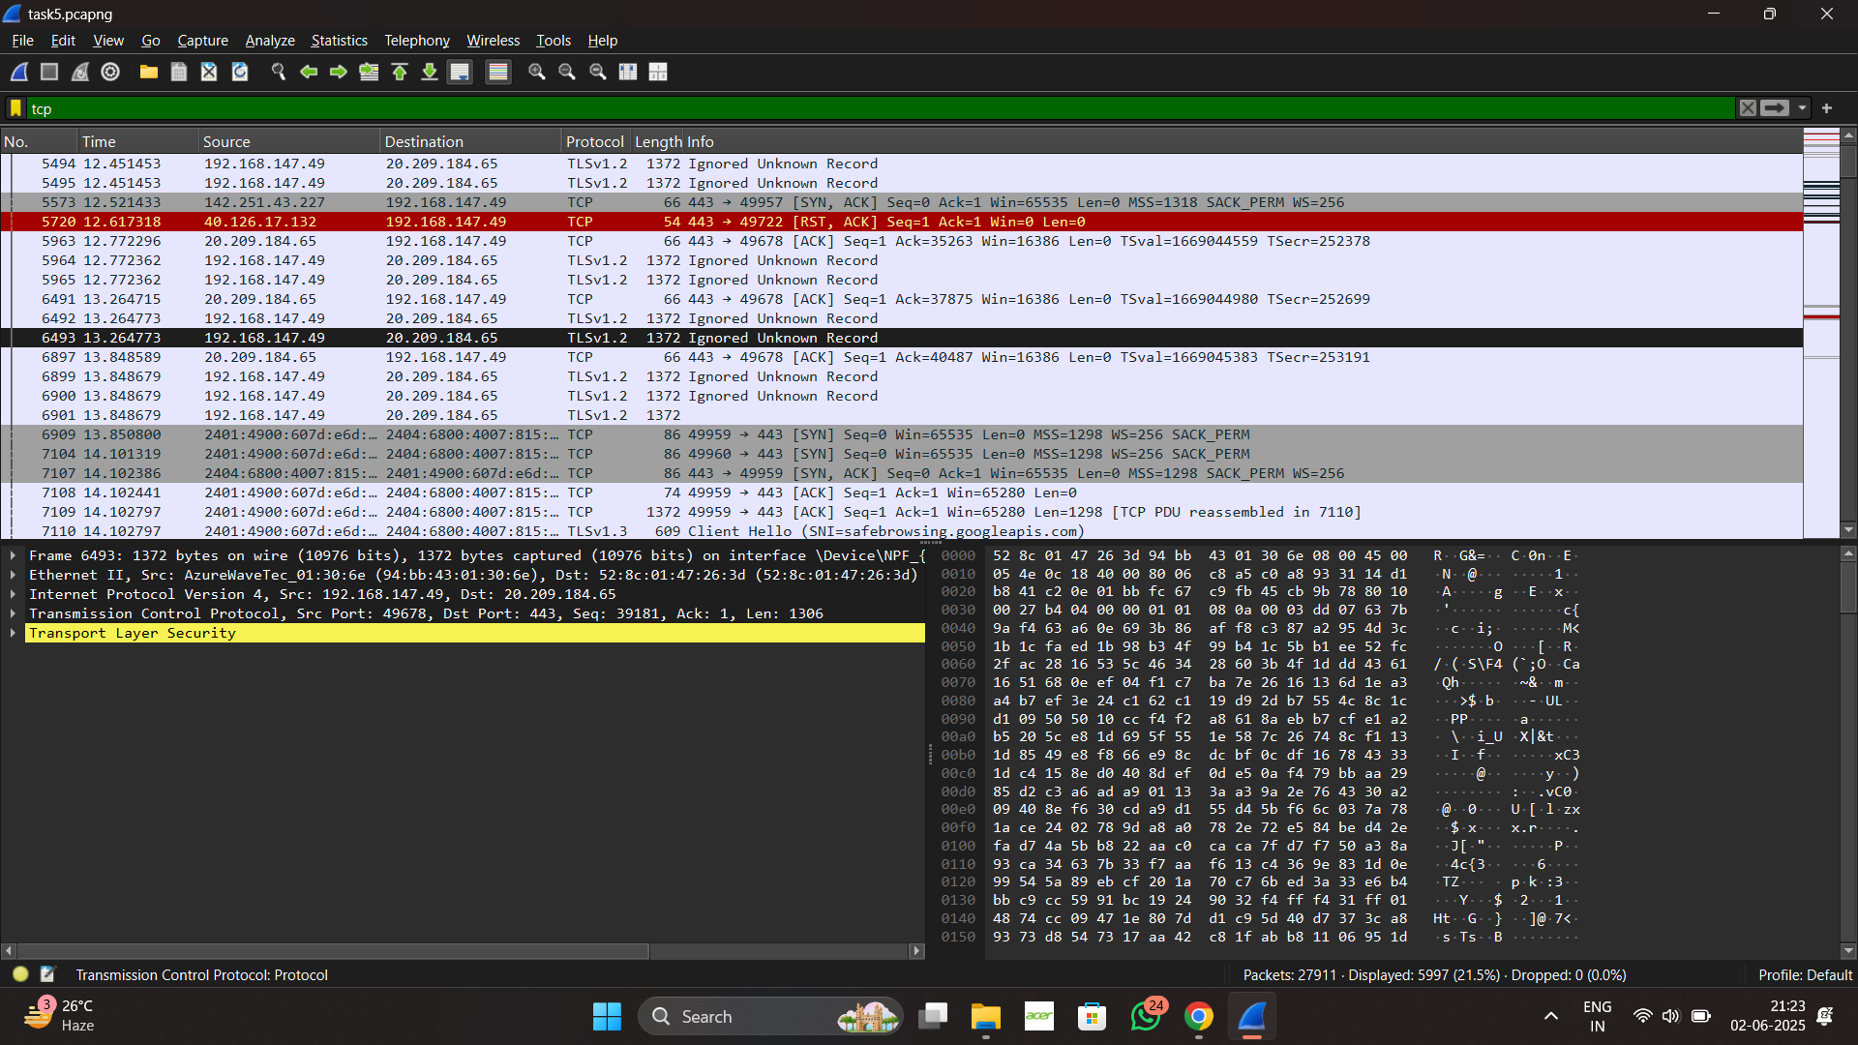

Screenshot 2025-06-02 212342.png

# Summary

The packet capture revealed standard internet browsing behavior. DNS queries resolved various domain names such as googleapis.com and msn.com. A single HTTP POST request was observed, indicating web-based interaction. Multiple TCP packets show the TLS handshake process and secure connections to port 443. This demonstrates basic network protocol awareness and the ability to analyze live traffic using Wireshark.