CSA6303- Threat Intelligence and Network Security
AT1: Application-Based Questions
Topics: Network Security Fundamentals | Security Goals (CIA Triad) | Types of Network Threats |Introduction to Threat Intelligence Types of Threat Intelligence (Strategic, Tactical, perational) — Threat Intelligence Lifecycle — Applications in IT Industry
CO1: Interpret security principles, network threats, and the role of threat intelligence in cybersecurity.

Dr.V.Parthipan Total: 50
Student Name : Surya V
Register number : 192465018
Code of Conduct:

I Surya V / 192465018 (Name / Reg No) certify that this submission is my original work and that I have adhered to the guidelines specified for this assessment. I understand that any violation of academic integrity rules will result in disciplinary action.

Signature of the student
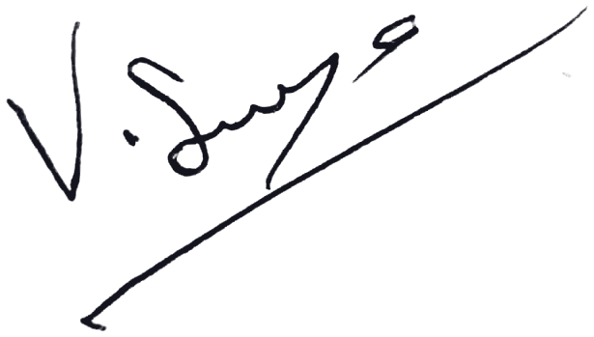

AT1: Application-Based Questions

Q1.CIA Triad — Scenario Identification (5 marks)
An e-commerce site stays fully online during an incident, but customers notice product prices have been silently changed by an attacker who gained database write access. No downtime occurred. Which CIA Triad principle(s) are violated? Justify your answer
Answer: Integrity is the principle violated.
Integrity means data stays accurate and is changed only by authorised parties. Here an attacker with unauthorised database write access silently altered the product prices, so the data can no longer be trusted.
Availability is not affected, because the site stayed fully online with no downtime. Confidentiality is not the main issue, since the scenario describes modification of data, not disclosure (it could be affected only if the attacker also read sensitive data).
Conclusion: Integrity (primary).

Q2. Risk Quantification — Annualized Loss Expectancy (10 marks)
A company's customer database is valued at $50,000. A breach would destroy/corrupt 40% of its value (Exposure Factor). Historical data shows this type of breach occurs about twice a year (Annualized Rate of Occurrence = 2). Calculate the Single Loss Expectancy (SLE) and the Annualized Loss Expectancy (ALE). Show all formulas used.
Answer:
Asset Value (AV) = $50,000; Exposure Factor (EF) = 40% = 0.40; ARO = 2
SLE = AV × EF = 50,000 × 0.40 = $20,000
ALE = SLE × ARO = 20,000 × 2 = $40,000 per year

Q3. Brute-Force Attack Time Estimation (10 marks)
An 8-character password uses a 62-character set (a-z, A-Z, 0-9). An attacker's cracking rig tests 1 billion passwords per second. Calculate the size of the keyspace and the worst-case time required to exhaust it. Express your answer in hours.
Answer:
Keyspace = (character set size)^(length) = 62^8 = 218,340,105,584,896 ≈ 2.18 × 10^14 combinations
Time (worst case, every combination tried) = Keyspace ÷ Rate = 218,340,105,584,896 ÷ 10^9 = 218,340.1 seconds
In hours = 218,340.1 ÷ 3,600 ≈ 60.65 hours (about 2.5 days).
On average the password would be found in about half this time (≈ 30.3 hours).

Q4. Risk Prioritization Matrix (10 marks)
Given five threats rated on Likelihood (1-5) and Impact (1-5), compute the Risk Score (Likelihood x Impact) for each and rank them in order of patching/budget priority:
(a) Ransomware — L4, I5;
(b) Phishing — L5, I3;
(c) Insider data theft — L2, I5;
(d) DDoS — L3, I3;
(e) Unpatched server exploit — L4, I4.
Answer:
Risk Score = Likelihood × Impact
(a) Ransomware = 4 × 5 = 20; (b) Phishing = 5 × 3 = 15; (c) Insider data theft = 2 × 5 = 10; (d) DDoS = 3 × 3 = 9; (e) Unpatched server exploit = 4 × 4 = 16
Priority ranking (highest to lowest): 1. Ransomware (20) > 2. Unpatched server exploit (16) > 3. Phishing (15) > 4. Insider data theft (10) > 5. DDoS (9)
Patching and budget should go first to ransomware and the unpatched server exploit.

Q5. Passive vs. Active Threat Classification (5 marks)
Classify each of the following as a passive or active threat, and state which CIA principle it primarily threatens:
(a) An attacker silently sniffing unencrypted traffic on a public Wi-Fi network.
(b) An attacker performing ARP spoofing to redirect traffic.
(c) A nation-state actor performing long-term network reconnaissance without altering anything.
Answer:
(a) Passive threat. Primarily threatens Confidentiality, because the traffic is only eavesdropped on, not altered.
(b) Active threat. Primarily threatens Integrity, because ARP spoofing falsifies address mappings and redirects or modifies traffic (a man-in-the-middle position can also expose confidentiality).
(c) Passive threat. Primarily threatens Confidentiality, because the actor silently gathers information without changing anything.

Q6. Threat Intelligence Lifecycle sequencing (10 marks)
A SOC analyst receives an executive request: "Are we at risk from the ransomware group currently targeting our industry?" Arrange the following into the correct order of the Threat Intelligence Lifecycle, and name each phase:
- Analysts correlate collected IOCs with internal logs.
- A report is sent to the CISO.
- The request itself is logged as a requirement.
- OSINT and threat feeds are pulled for the group's known TTPs.
- The CISO's follow-up questions shape the next collection cycle.
Answer: Correct order of the Threat Intelligence Lifecycle
1. (iii) Planning & Direction (Requirements): the executive request is logged as an intelligence requirement.
2. (iv) Collection: OSINT and threat feeds are pulled for the group’s known TTPs.
3. (i) Processing & Analysis: collected IOCs are correlated with internal logs to judge whether the organisation is at risk.
4. (ii) Dissemination: the finished report is delivered to the CISO.
5. (v) Feedback: the CISO’s follow-up questions refine requirements and shape the next collection cycle.
Sequence: (iii) → (iv) → (i) → (ii) → (v)

