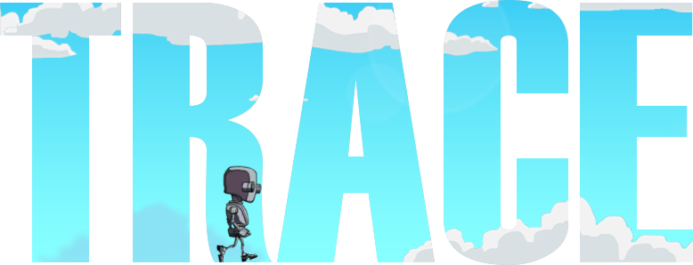

Contents

**OVERVIEW** 3

**UPDATE HISTORY** 4

**SETTING UP THE PROJECT** 5

**IMPORTING INTO UNITY** 5

**SETTING UP THE GAME** 5

**FAQ** 9

**USEFUL INFORMATION** 10

**OVERVIEW**

Thank you for purchasing Trace.

This documentation is constantly updated together with the template. Ensure you have the latest version.

This template has unlimited customization possibilities. Feel free to change the code, the UI…… Pretty much anything you need to make an awesome game. I am always ready to help out where I can.

**NOTE**: ALWAYS BACK-UP YOUR WORK BEFORE UPDATING TO A NEWER VERSION.

I will also be adding new features over time and extend this template’s capabilities. Send me your suggestions via [email](mailto:mintonne@gmail.com?subject=Trace).

**UPDATE HISTORY**

**Version 1.0**

* Initial release.

**SETTING UP THE PROJECT**

# IMPORTING INTO UNITY

This template is designed to be used as a starter kit and I recommending importing it as a new project.

Create a new 2D project and import this template.

You should see all the folders mentioned above in your Unity project.

# SETTING UP THE GAME

1. You need to add the following tags on the Unity Editor exactly as shown. **Case sensitive.**

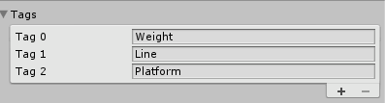

1. You need to assign the appropriate tag to the appropriate gameobjects as follows.

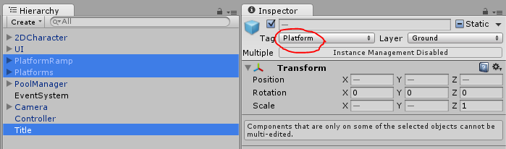

Make sure all child gameobjects under PlatformRamp and Platforms have the same tag (Platform) too.

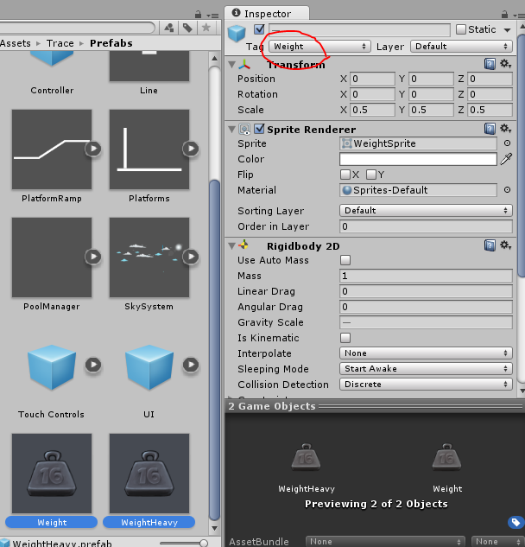

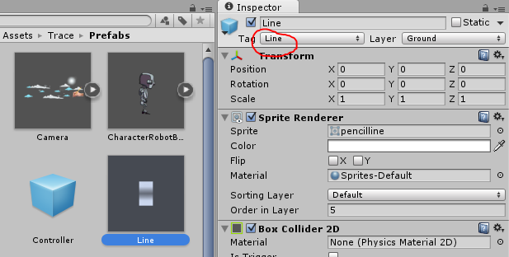

1. Select the pool manager and drag the **line, weight and WeighHeavy** prefabs into it.

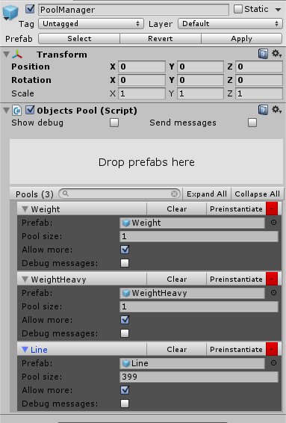

**NOTE**

* Set all the prefabs to allow more in case the pool size is used up.
* ***NOTE***: Whenever you make any change to the prefabs, always **clear** the pooled prefabs and **preinstantiate** again.

1. Set the desired speeds and jump force on the player’s controller.

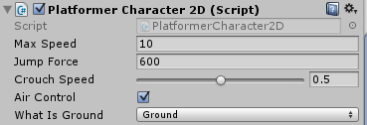

1. Make sure you assign all the appropriate objects on the **Controller.**

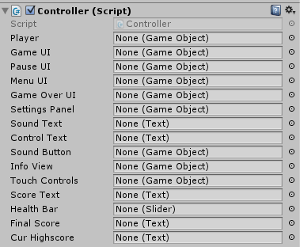

1. Also you can change the camera speed, cloud flow speed etc. under their respective gameobjects. And you are good to go.

**PS: Some earlier Unity 5.x.x versions had issues with colliders and rigidbodies. In case the player is falling off/toppling over, kindly set the player’s rigidbody to fixed angle (or freeze rotation around the Z axis under constraints for later unity versions.)**

**In case the player is falling through the drawn line, increase the size of the collider on the line prefab, clear the pooled objects on the pool manager and preinstiantaite the prefabs again.**

ADMOB INTEGRATION

1. Download the Admob Unity plugin from [here](https://github.com/googleads/googleads-mobile-unity/releases).
2. Import the plugin into the project.
3. Open the ‘Menu’ scene.
4. We will need to configure the project. To do so, go to ***Trace > Configuration > Configure Admob***
5. Allow up to 1 minute for the editor to setup the plugin.
6. Once setup is complete, enter your target platform (Android/iOS) interstitial [Ad ID](https://apps.admob.com/) on the AdManger and set the frequency of ads.

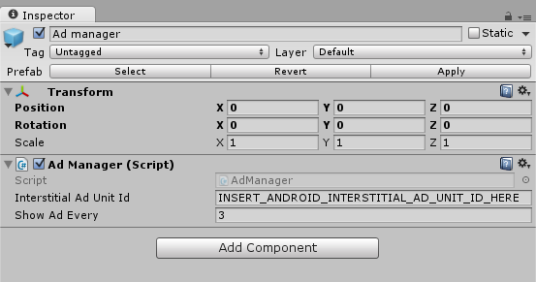

**FAQ**

1. **Does this game template have any ads integrated?**

NO. Different people have their own preferences. I personally use Unity Ads in my games, others prefer other ad networks. Secondly, most people forget to change the AD ids to their own. Due to this reasons, I refrain from adding any ads. If you would like to integrate Unity Ads and don’t know how to, you can [contact me](mailto:mintonne@gmail.com?subject=Trace).

**NB.** Include your order form in the email for verification.

1. **Does this game template have any social features integrated?**

Again NO. Some prefer Facebook, others Google Play, others Game Centre. I personally use Google Play for android. If you would like to integrate Google Play Leaderboards and Achievements and don’t know how to, you can [contact me](mailto:mintonne@gmail.com?subject=Trace).

**NB.** Include your order form in the email for verification.

1. **How do I change the buttons, background etc.?**

Simply swamp the current art with your own. Remember to assign your art to the desired object you want to change.

**NB.** You can use the provided art in the final build of your game.

1. **How can I reach you?**

Please see below.

**CONTACT ME**

A bug? Error? Or you just can’t find something. You can always reach me via email at [mintone@gmail.com](mailto:mintone@gmail.com?subject=QuizApp:%20Ultimate%20Trivia%20Template) and I will get back to you as soon as possible.

## **USEFUL INFORMATION**

Time zone – GMT +3

Twitter - [@MintonneX](http://www.twitter.com/MintonneX)