Effy Prototype

I had designed the prototype of your problem statement with React js and Node js.

**Node Js:**

In node js, I created the api services for adding, updating, deactivating, deleting the user

and for company

add, delete, update, changing user to another company services. I used JSON WEB TOKEN to authenticate every user to do some changes to the model.

Password has been encrypted and stored into database and errors has been handled perfectly.

**React Js:**

I used react js for the UI design. Initially there will be an login/registerpage. After the user gets successful login, he/she can be navigated to dashboard containing the options to view user and company, edit user and company, delete user and company, deactivating user. The google maps are also implemented. The pagination to view the users and company also gets implemented.By giving the correct api_key the maps and address for the company is shown.

The UI screens are:

1. 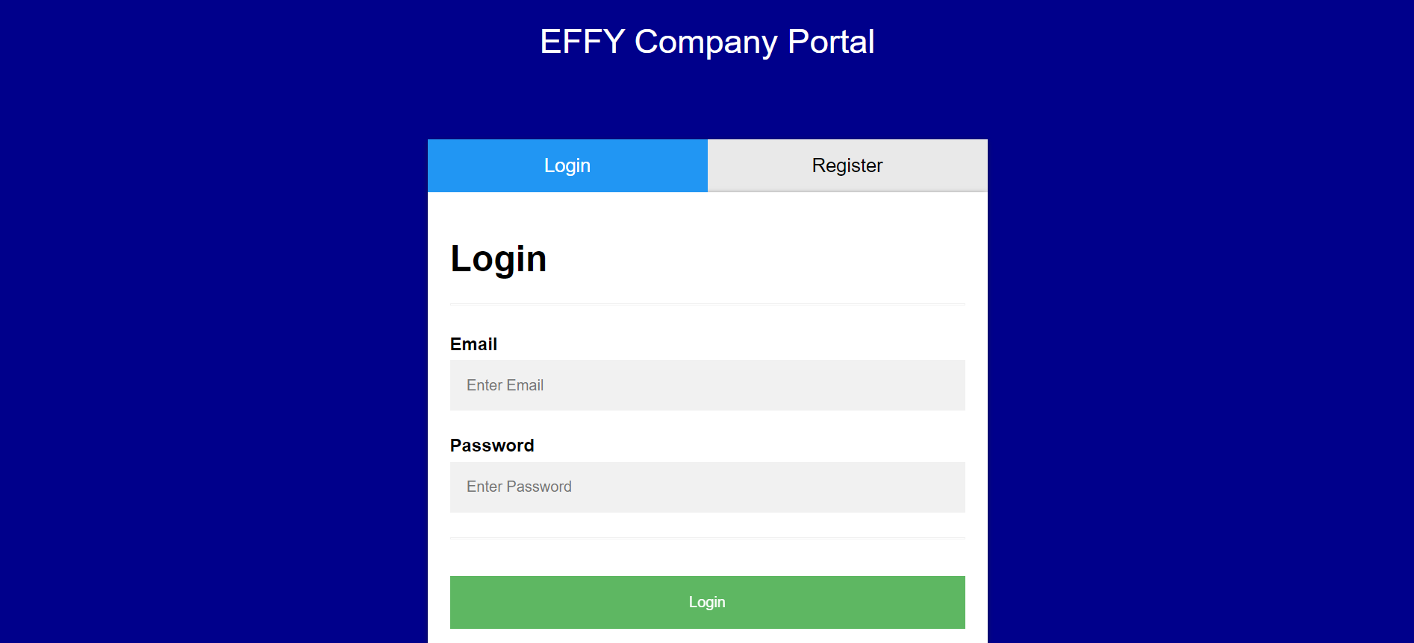
2. 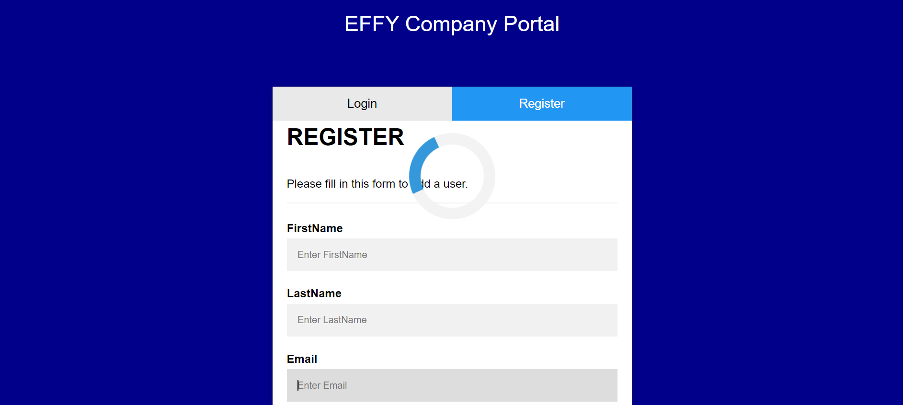
3. 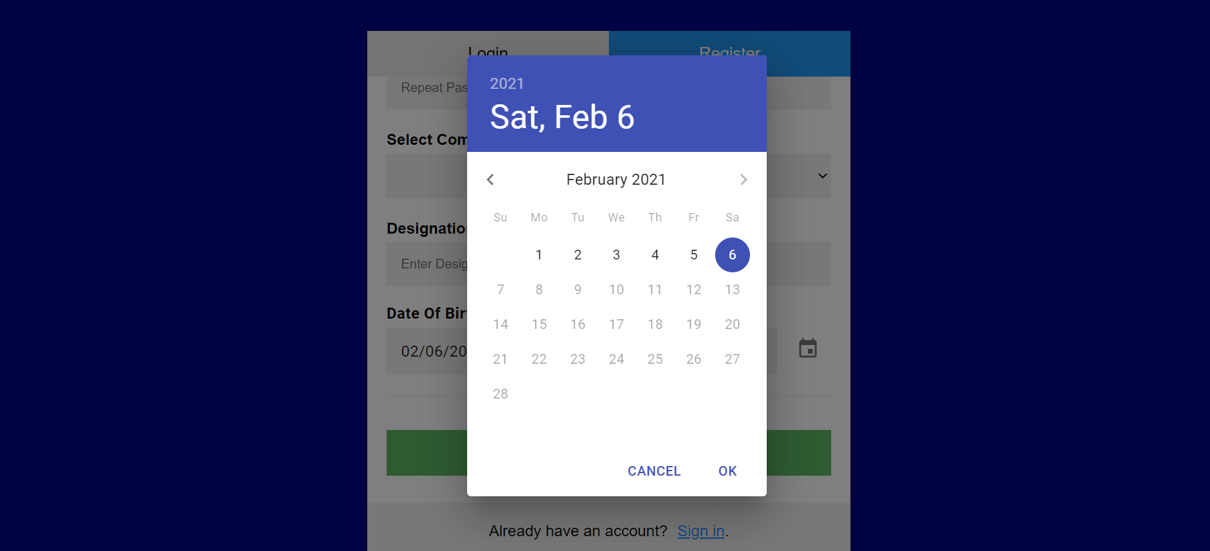
4. 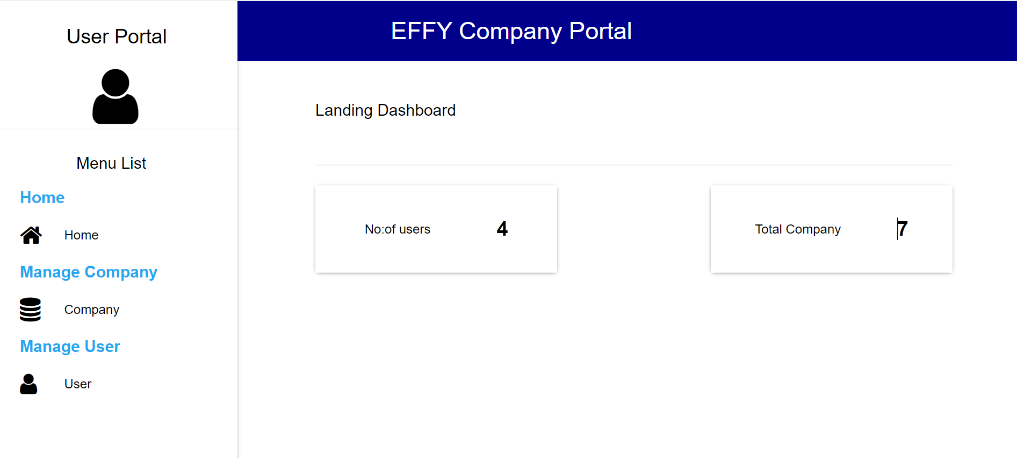
5. 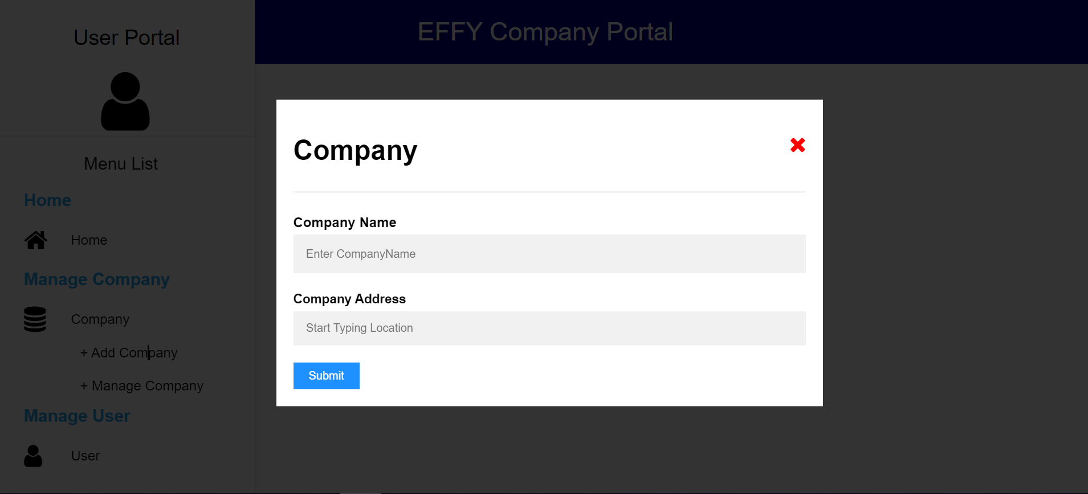
6. 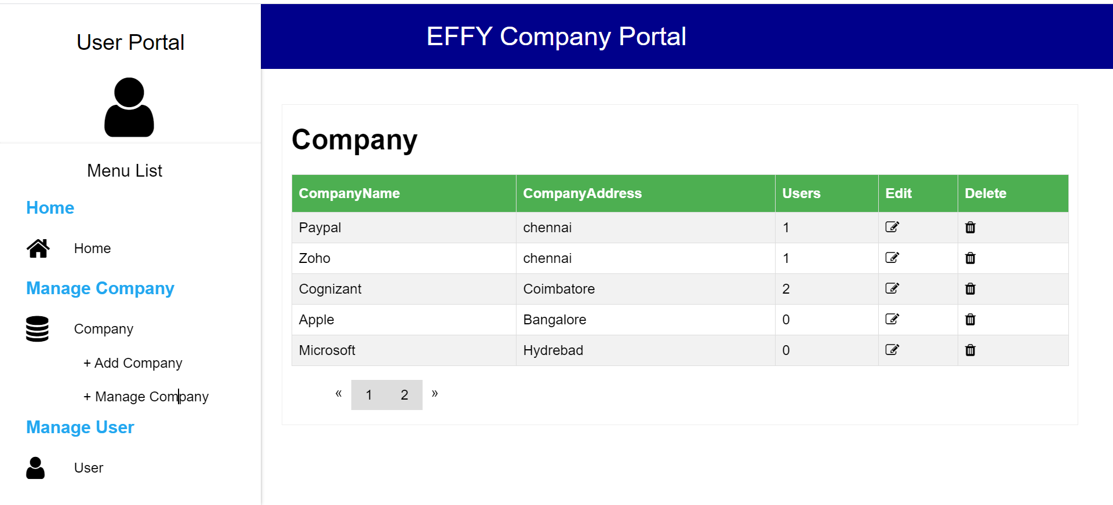
7. 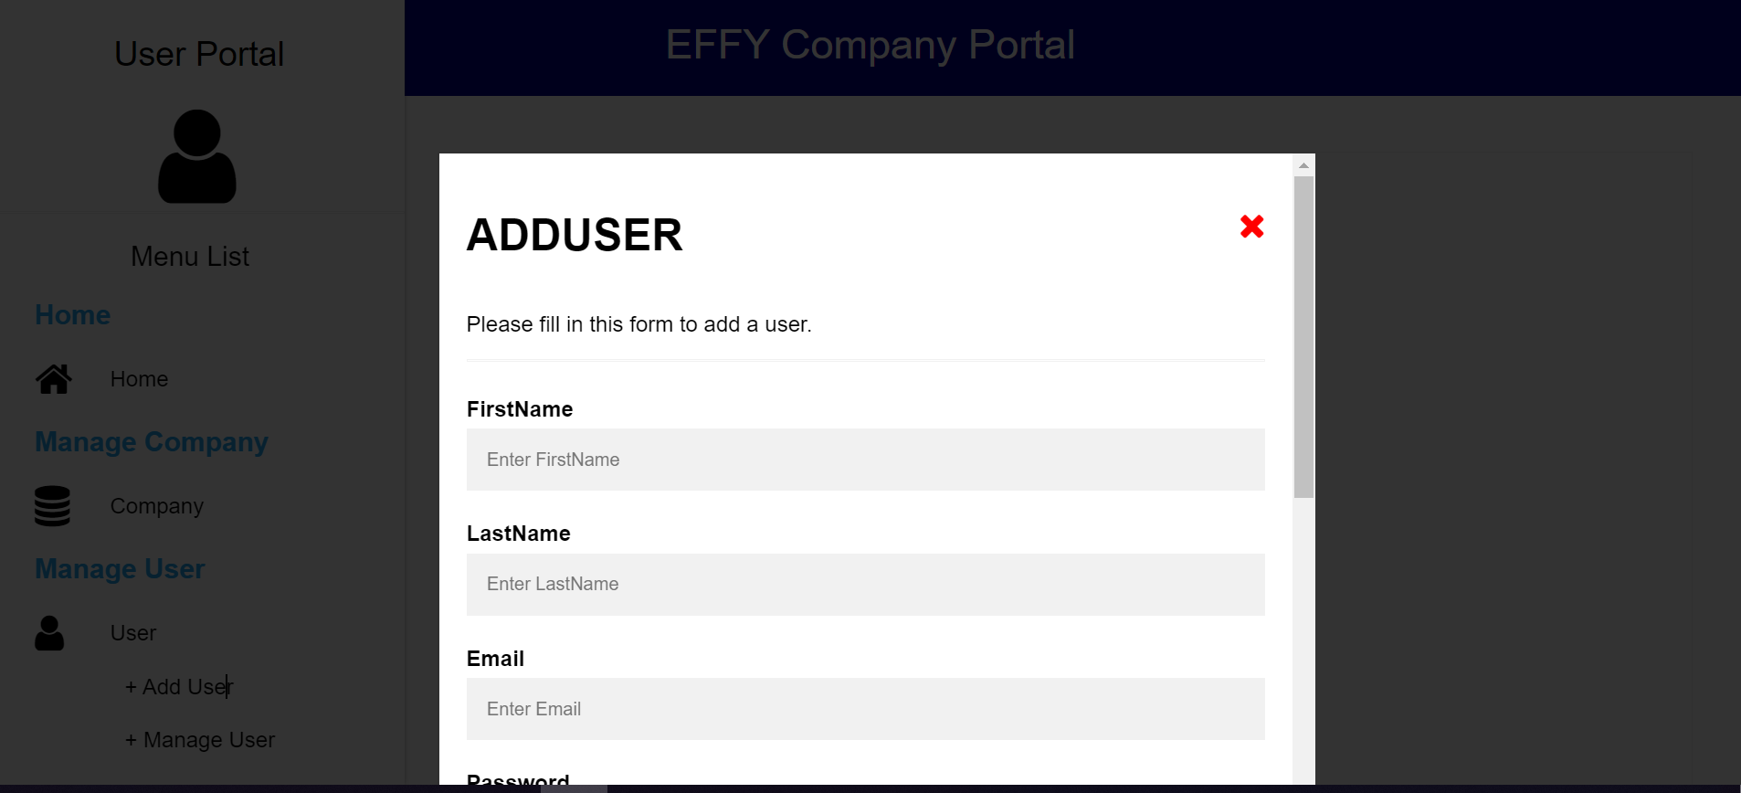
8. 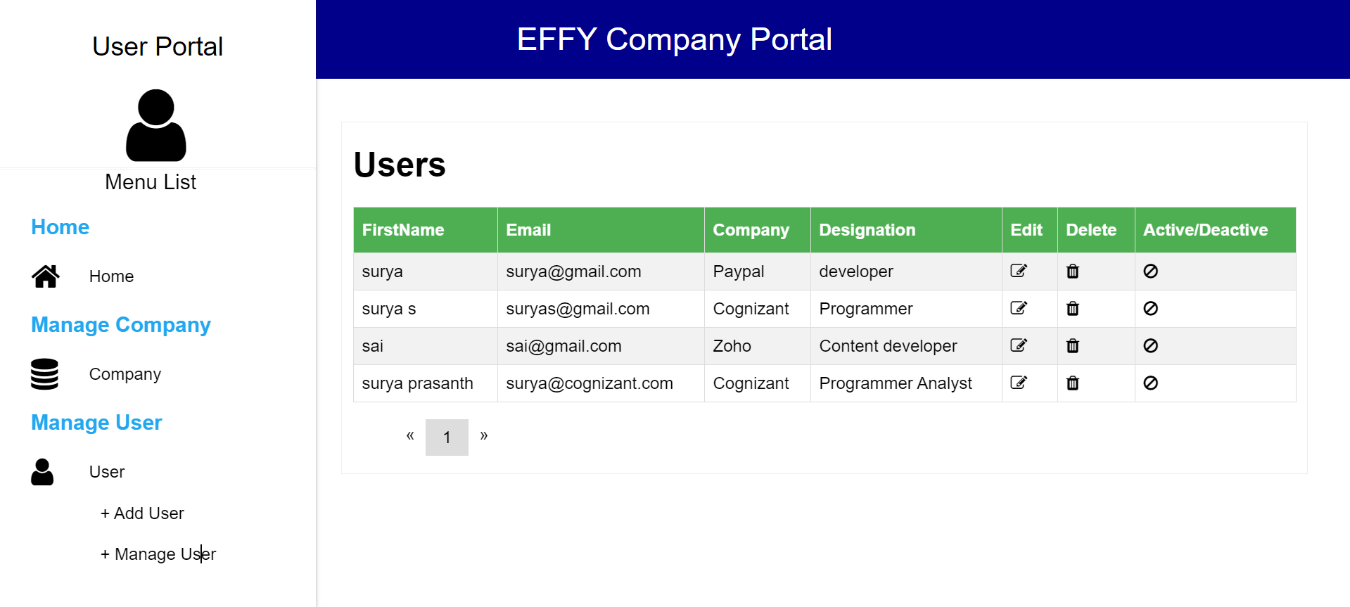
9. 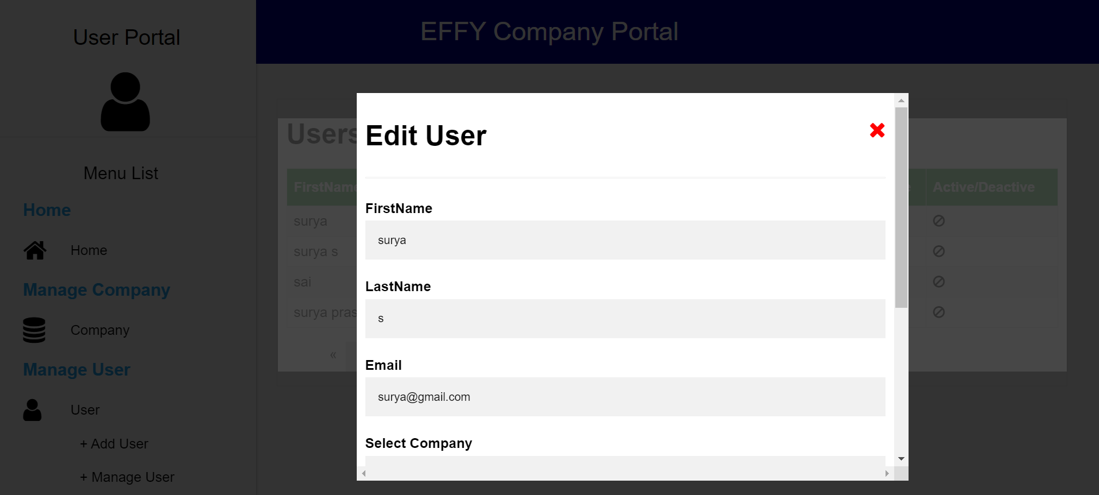
10. 