1. Desktop view for countries list

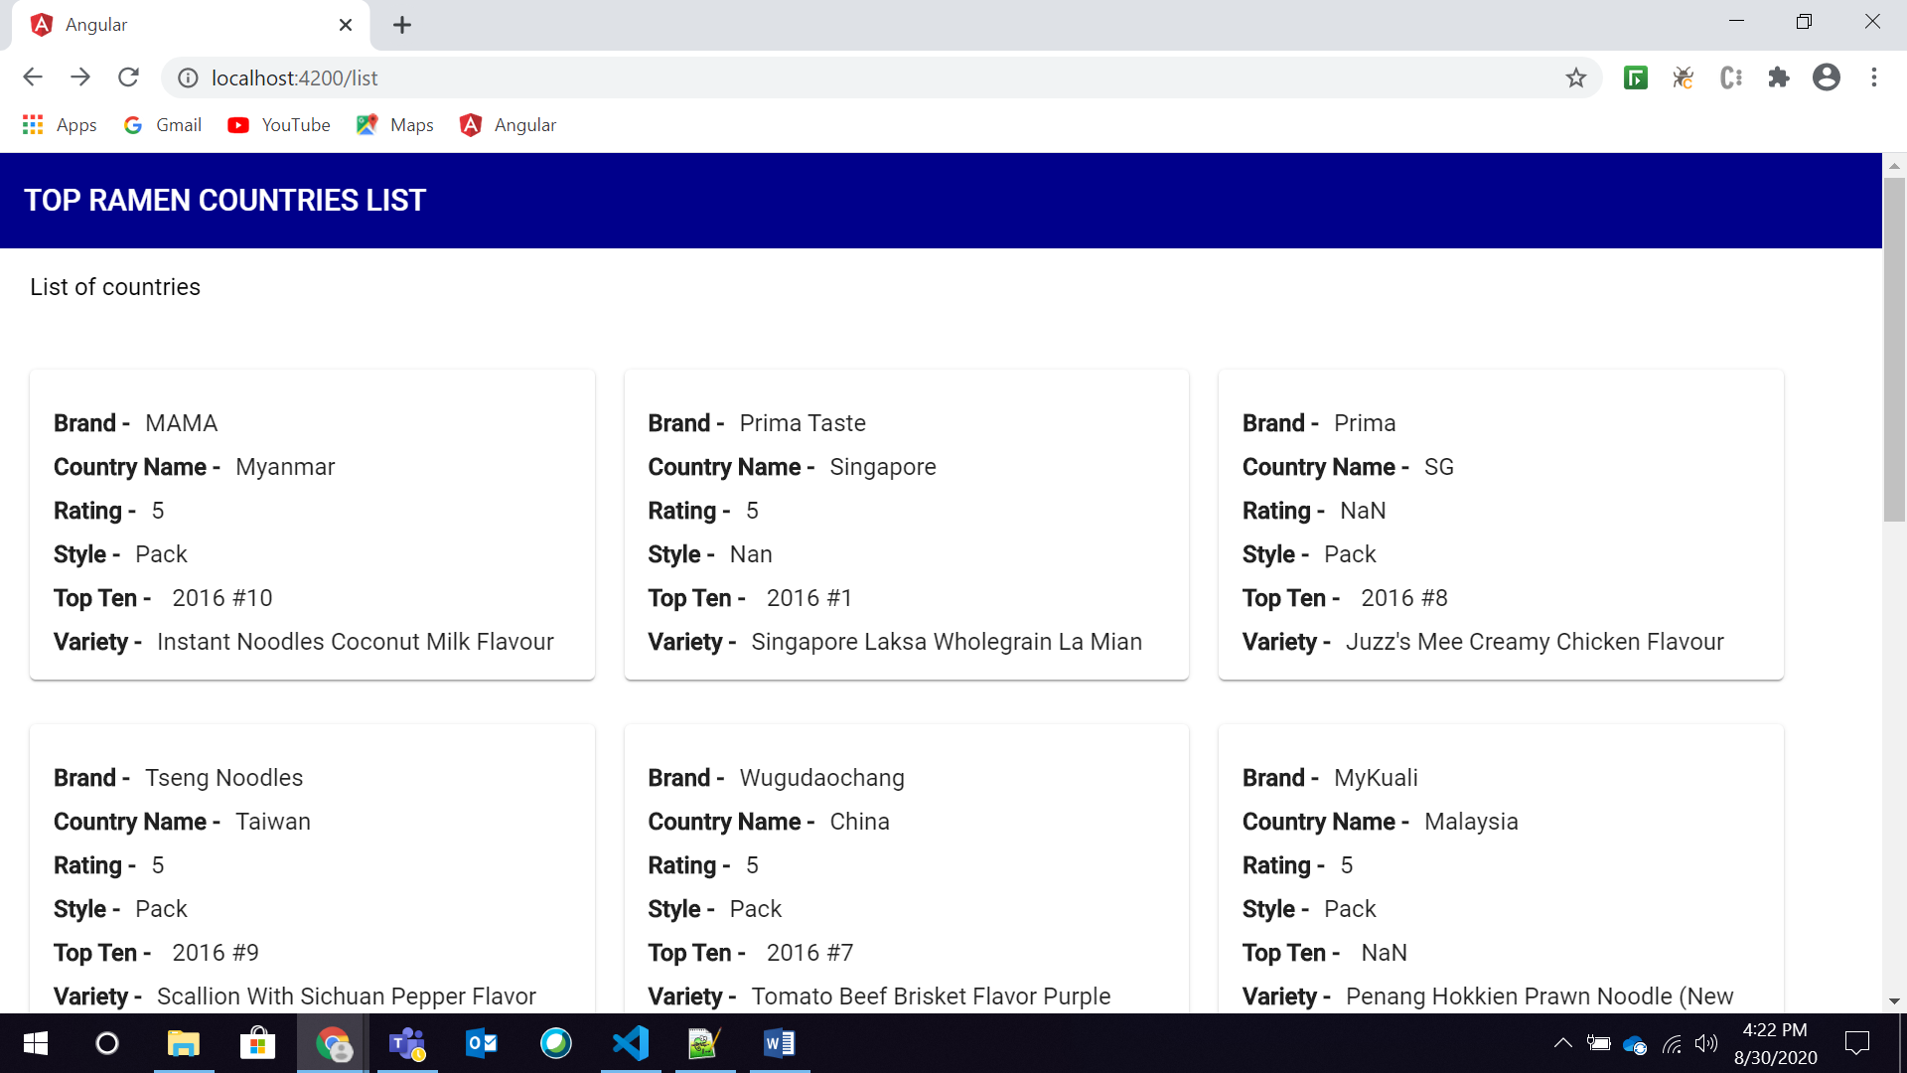

1. Mobile view for countries list

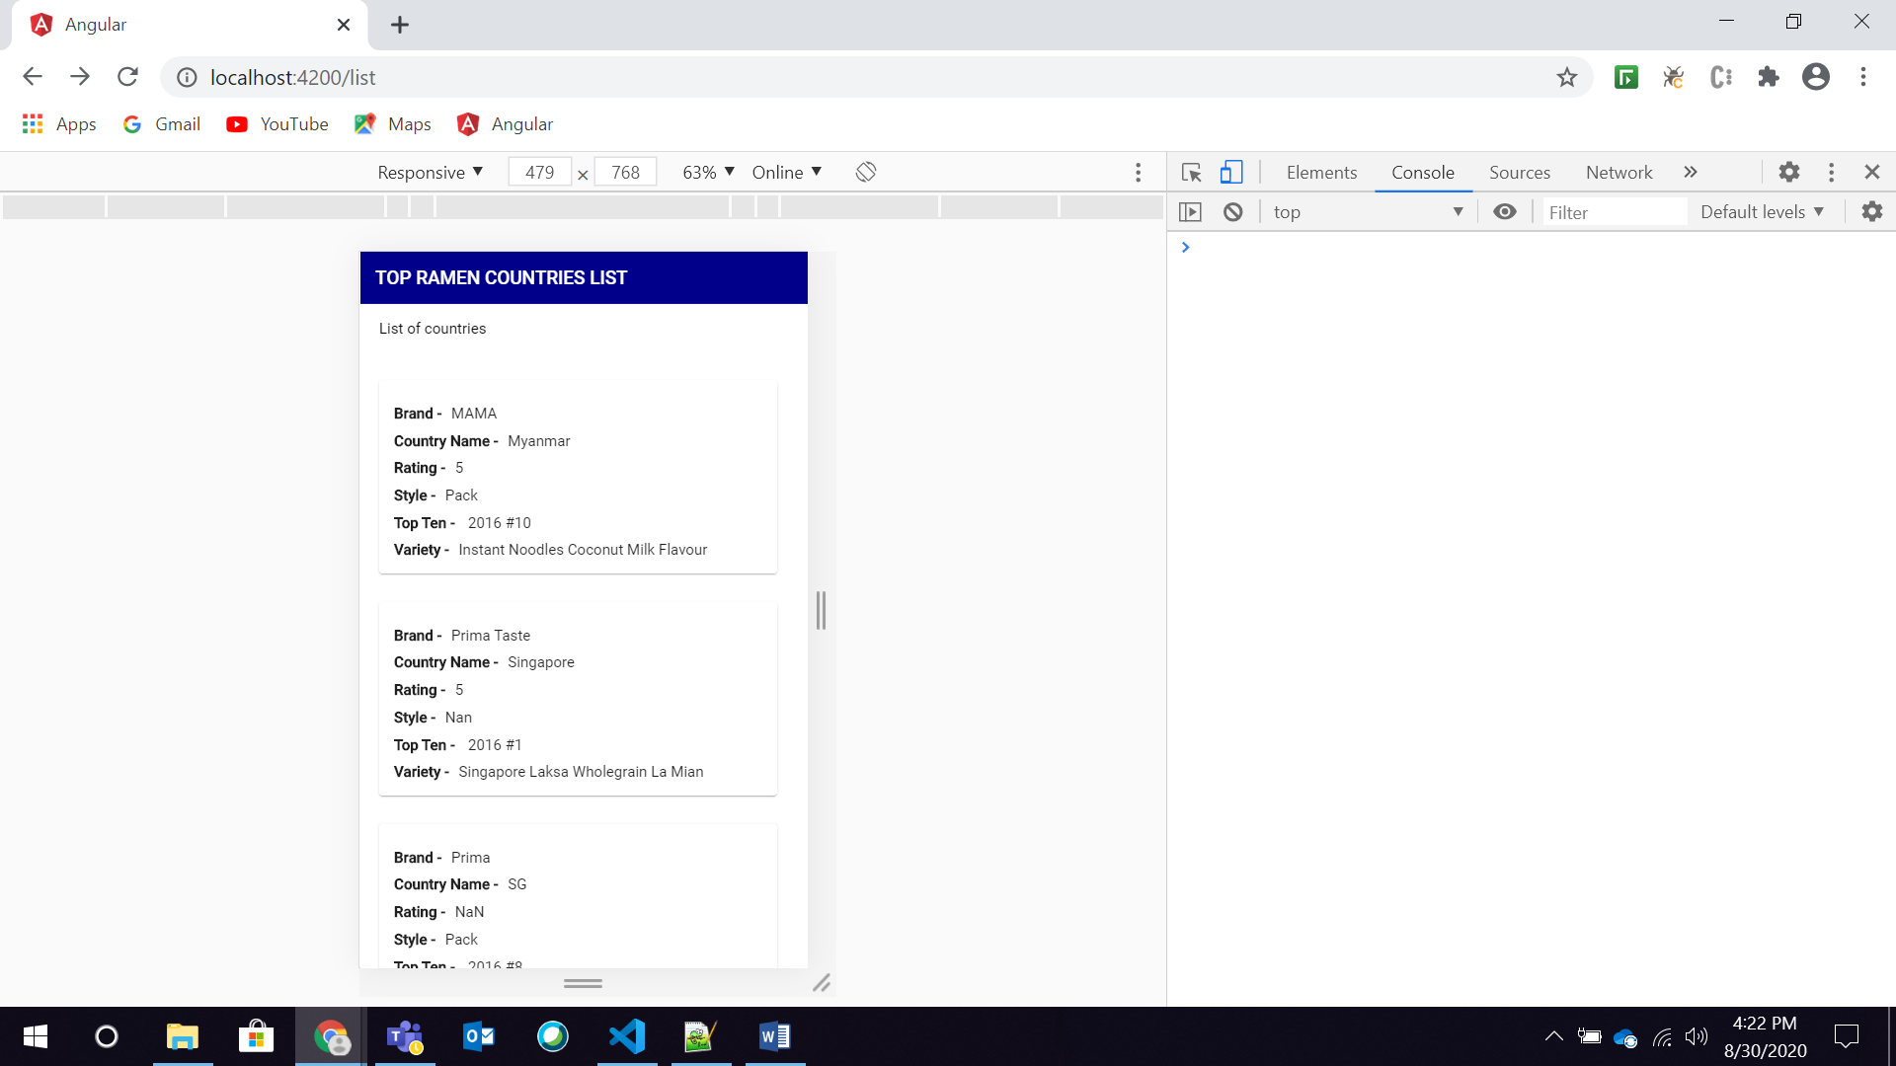

1. After clicking on card the details for that particular country

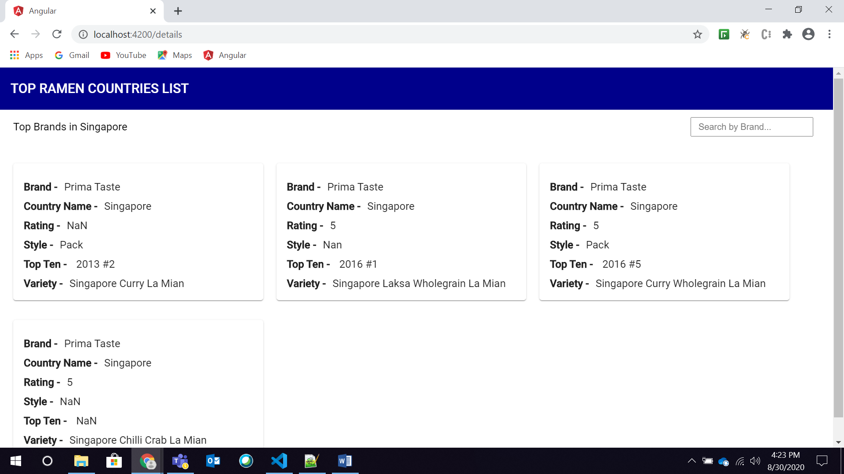

1. By using filter option the list gets filtered based on brand name

