1. **Problem Background:**

Kalyani is a small town in the outskirts of Kolkata. An owner of chain of restaurants wishes to invest in the town. The locality is still under process of development and some places are more developed than others. The owner wants to open up his restaurant at such a place such that it attract most amount of customer to his restaurant.

The places near the densely populated places are not always a great place for a restaurant as many prefer to go to a place which is a reasonable distance away from a crowded place. We would apply the trend of a particular place and its localities’ habit to visit popular places to predict the best place for opening a restaurant.

1. **Problem Description:**

A restaurant is a business which prepares and serves food and drink to customers in return for money, either paid before the meal, after the meal, or with an open account. This place has many restaurants already so a tough competition will emerge. It's food culture includes an array of different cuisines influenced by many people who migrated to this town. We can list down the confusion as follows:

Places near colleges will attract more students as they prefer eating outside.

Location near a housing estates will attracts the middle ages and senior people who are high spender but prefer not to travel very far.

Tastes differs for people of different ages so we must select a locality which has people with similar taste like that of speciality of ABC company.

Places near public places like parks, museum or playground can attract more customers who are there visit casually.

Eventhough well funded ABC Company Ltd. need to choose the correct location to start its first venture.If this is successful they can replicate the same in other locations. First move is very important, thereby choice of location is very important.

1. **Data:**

The data is retrieved from various sources. They are defined below:

* **Neighborhood:** The data is scrapped from Wikipedia using beautiful soup and is written in a csv.

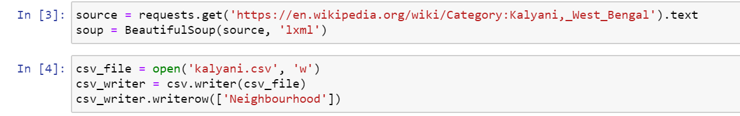

* **Geocoding:** It is done by using the package geopy

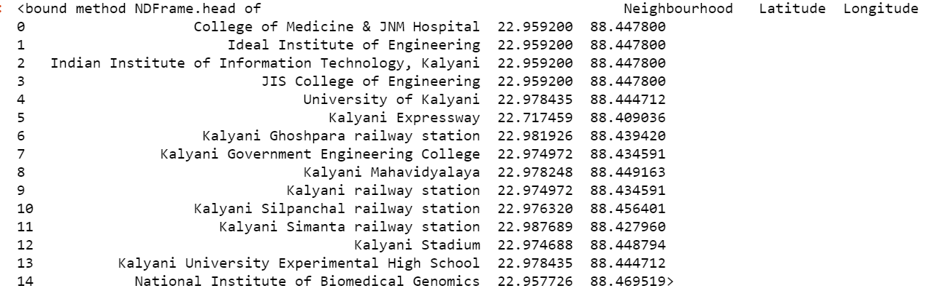

* **Venue Data:** The venue data is scrapped from Foursquare API using the location the data that are fetched from Wikipedia.

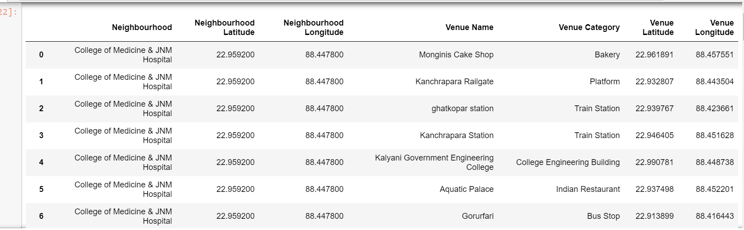

1. **Methodology:** A thorough analysis of the principles of methods, rules, and postulates employed have been made in order to ensure the inferences to be made are as accurate as possible.

* **Geocoding:**

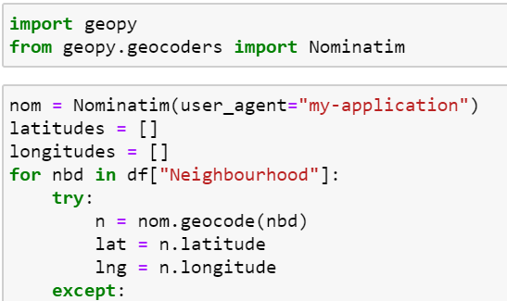

* **Folium:**

Folium builds on the data wrangling strengths of the Python ecosystem and the mapping strengths of the leaflet.js library. All cluster visualization are done with help of Folium which in turn generates a Leaflet map made using OpenStreetMap technology

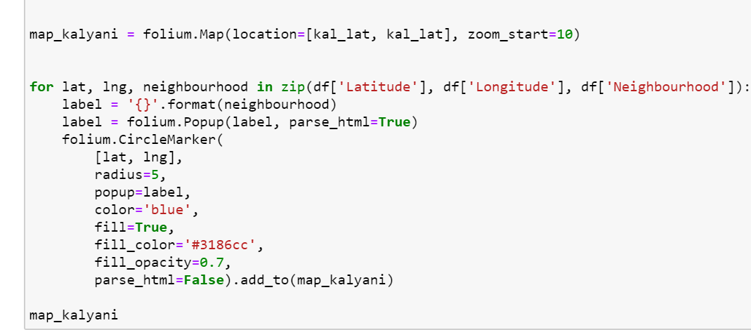

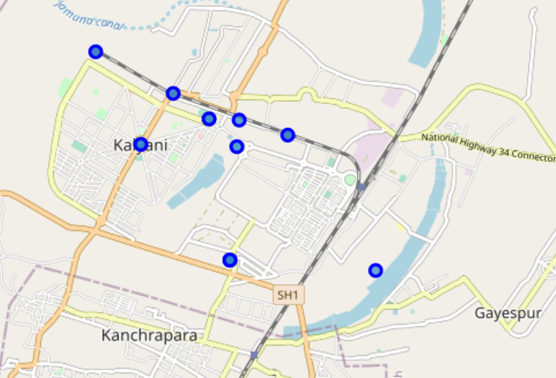

* **Top 5 most common venues:**

The most common places around a neighborhood is picked using the below code

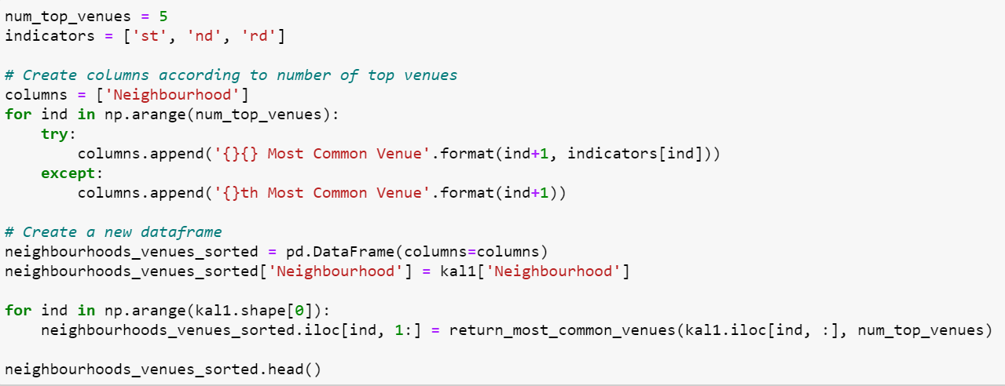

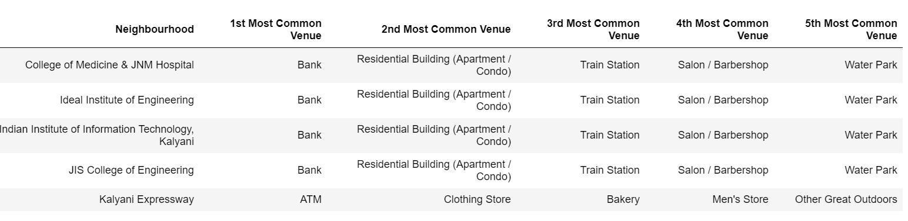

* **Optimal number of clusters:** Silhouette Score is a measure of how similar an object is to its own cluster (cohesion) compared to other clusters (separation). The silhouette ranges from -1 to +1, where a high value indicates that the object is well matched to its own cluster and poorly matched to neighboring clusters. Based on the Silhouette Score of various clusters below 20, the optimal cluster size is determined.

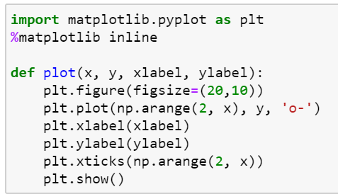

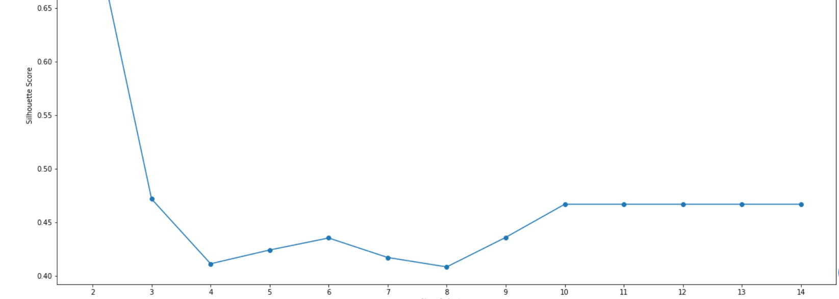

* **K-means clustering:**

The venue data is then trained using K-means Clustering Algorithm to get the desired clusters to base the analysis on. K-means was chosen as the variables (Venue Categories) are huge, and in such situations K-means will be computationally faster than other clustering algorithms.

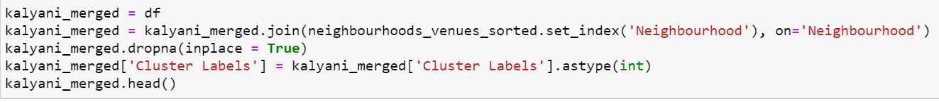

1. **Results:** The neighbourhoods are divided into n clusters where n is the number of clusters found using the optimal approach.

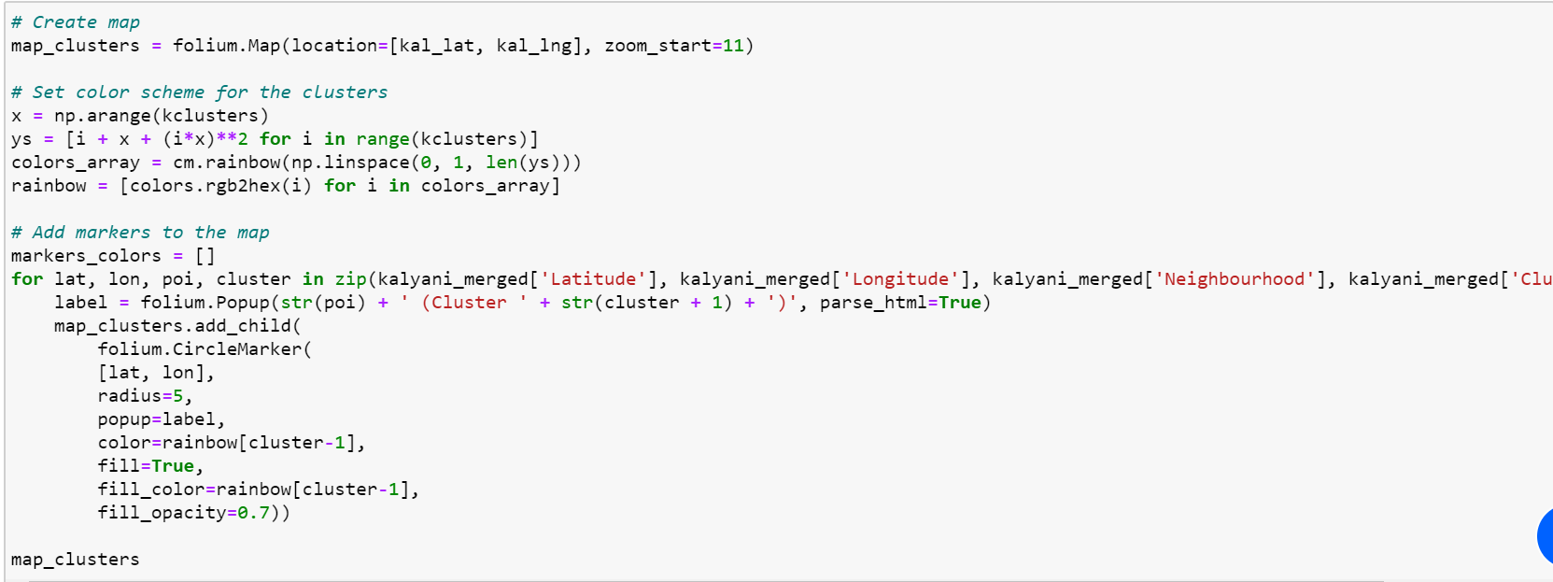

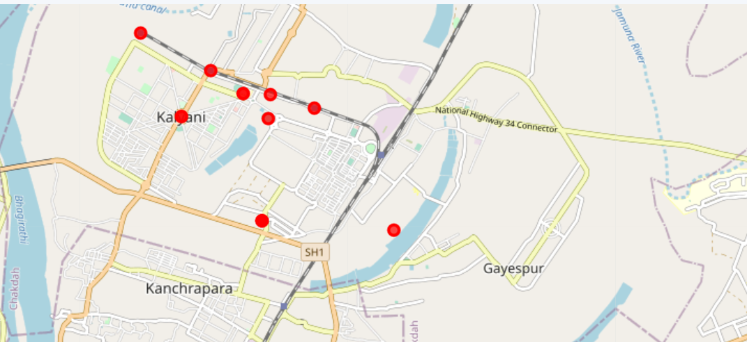

1. **Discussion:**

Analyzing the data we can see that the most visited places near the colleges are bank or residential addresses. So if the new restaurant is made near them we might not get the required footfall. But if the restaurant is created near the Expressway then the people visiting it might increase as the people near them has a greater tendency visiting bakery and food store.

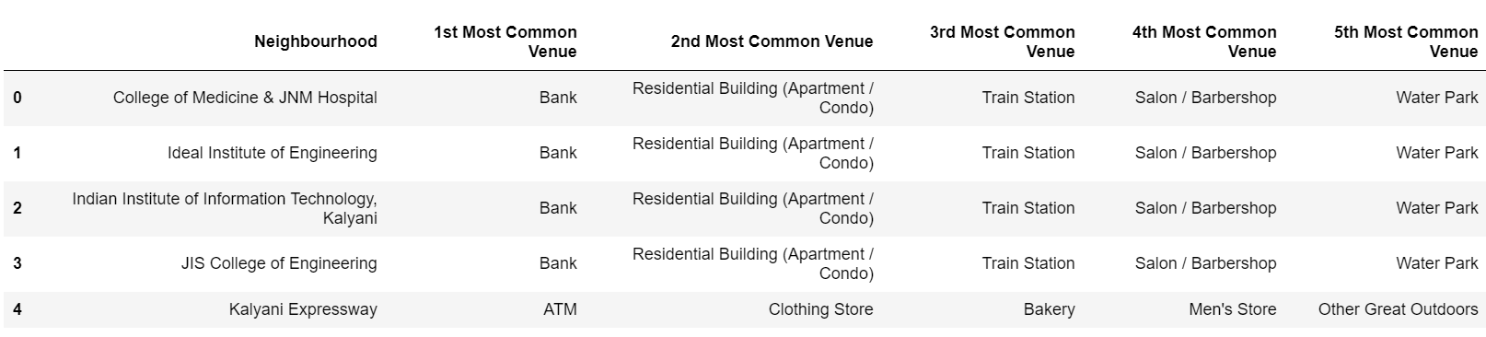

1. **Conclusion:**

Opening food outlets catered for that section of the society will see a massive increase in footfall, which would lead to a further increase in business. Assuming a footfall of 50 people getting in the restaurant and ordering food for 200 INR will generate the turnover a 10000INR daily apart from the increase of demand in the weekends.