Freight Load Rate Prediction
Technical report — validation approach, modeling, and results

1. Objective
Predict posted_rate for freight loads using historical labeled data (data/train_test.csv, Jan–Oct 2025), and apply the trained model to score every load in data/validation.csv (Nov–Dec 2025), plus a fixed 31-day December lane used to sanity-check the model's day-to-day behavior.

2. Data Exploration & Quality Issues
The labeled set contains 48,000 loads across 64 pickup/delivery cities, 3 equipment types (Dry Van, Reefer, Flatbed), and 304 distinct days (Jan 1 – Oct 31, 2025). Two data-quality issues were identified and corrected:
- Negative weight values: 292 of 48,000 rows (~0.6%) had a negative weight, which is physically impossible for a shipment. These read as a sign-flip data entry error rather than genuine outliers — the magnitudes fall inside the normal weight range — so they were corrected by taking the absolute value.
- Missing values: weight was missing in 300 rows (~0.6%) and market_index in 374 rows (~0.8%). Both were imputed using medians learned only on the training split (equipment-specific median for weight, global median for market_index), with binary “was_missing” indicator flags added so the model can learn if missingness itself carries signal.
- Coordinate consistency: pickup_lat/lon and delivery_lat/lon are deterministic per city name (verified: every city maps to exactly one lat/lon pair), so they were kept as continuous geo features and also used to derive a haversine great-circle distance as a cross-check against the provided road distance column.
- Rate outliers: posted_rate ranges from $57 to $25,533 with a long right tail (~24 loads above $15,000). These did not correlate with any single data error — they span multiple lanes, equipment types, and distances — so they were treated as genuine market spikes (e.g. capacity crunches, expedited loads) rather than removed. The model was trained on log1p(posted_rate) to reduce their leverage on the loss function without discarding real signal.
distance is by far the strongest single predictor of posted_rate (Pearson r ≈ 0.91), which matches freight-market intuition — rate scales primarily with haul length, with equipment type, lane-specific effects, weight, and market-condition signals (market_index, quote_signal) adding meaningful secondary lift.

3. Train/Test Split & Validation Approach
The task itself defines the correct validation protocol: the labeled data ends 2025-10-31, and the data requiring final predictions (validation.csv) begins 2025-11-01 and runs through 2025-12-31 — entirely after the labeled window. That makes this a forecasting problem, not an interpolation problem, so a random K-fold split would let the model see both earlier and later dates during training and understate real-world error.
Primary validation — time-based holdout: the labeled data was sorted by date, trained on everything before 2025-09-14, and validated on 2025-09-14 through 2025-10-31 (the most recent ~15% of labeled days, 7,458 loads). The feature-cleaning statistics (weight/market_index medians, category encodings) were fit on the training portion only and applied to the holdout, to avoid any leakage from future data into the imputation logic.
Secondary check — 5-fold random cross-validation: reported alongside as a sanity check on model stability. The two protocols produced closely matching error metrics (below), which is a good sign that there is no severe temporal drift in the underlying rate structure between the training window and the forecast window.
Once the holdout confirmed the model generalizes well to a genuinely unseen future window, the final model used to score validation.csv and the December lane was refit on the full labeled dataset (all 48,000 rows), using the iteration count selected by early stopping on the holdout. This maximizes the data available to the final model without compromising the validation protocol used to judge it.

Validation results
Metric | Time-based holdout (primary) | 5-fold random CV (sanity check)
MAE | $126.15 | $119.22
RMSE | $603.44 | $601.19
MAPE | 5.68% | 5.42%
R² | 0.840 | 0.836

Holdout window: 2025-09-14 to 2025-10-31 (7,458 loads); trained on 40,542 loads before that date. The median absolute error of ~$126 against a median posted_rate of ~$2,031 (~6% typical error) was judged acceptable for a market-rate estimate used in load pricing decisions.

4. Model
Model: LightGBM gradient-boosted trees, trained to predict log1p(posted_rate) (then exponentiated back for reporting/output), with early stopping on the holdout MAE.
Reasoning: gradient-boosted trees were chosen over linear/regularized regression because the strongest relationships in the data are non-linear and interaction-heavy — e.g. rate-per-mile is not constant across distance bands, and lane identity (pickup × delivery combination) interacts with equipment type in ways a linear model can't capture without extensive manual interaction terms. Trees also handle the 64×64 lane cardinality natively as categoricals (no one-hot blow-up) and are robust to the remaining outliers in the target after the log transform.
Features used:
- Route: distance, haversine great-circle distance, distance-vs-haversine gap (circuity), pickup/delivery lat-lon, pickup/delivery/lane identity (native categoricals)
- Load: cleaned weight, weight-was-missing / weight-was-negative flags, weight-per-mile, equipment type
- Market conditions: market_index (cleaned), market_index-was-missing flag, quote_signal
- Calendar: month, day-of-week, day-of-year, week-of-year, weekend flag, and cyclical (sine/cosine) encodings of day-of-year and day-of-week to capture seasonality without a hard year-end discontinuity
Top features by importance (time-based holdout model): distance, quote_signal, delivery, pickup, weight, equipment, lane, market_index, day_of_year, haversine distance — consistent with the correlation analysis in Section 2.

5. December Fixed-Lane Chart
The chart below (produced by the provided score.py against 31 filled-in rows of data/december_chart_inputs.csv) shows the model's predicted rate for the fixed Lexington → Fort Wayne, Dry Van, 360-mile, 32,000 lb lane across every day of December 2025, isolating the calendar effect from all other features. market_index and quote_signal are not part of that file's schema, so they were held at their most recent observed monthly average (October 2025) as the most defensible near-term estimate, since neither signal showed a clear directional trend across the labeled months.
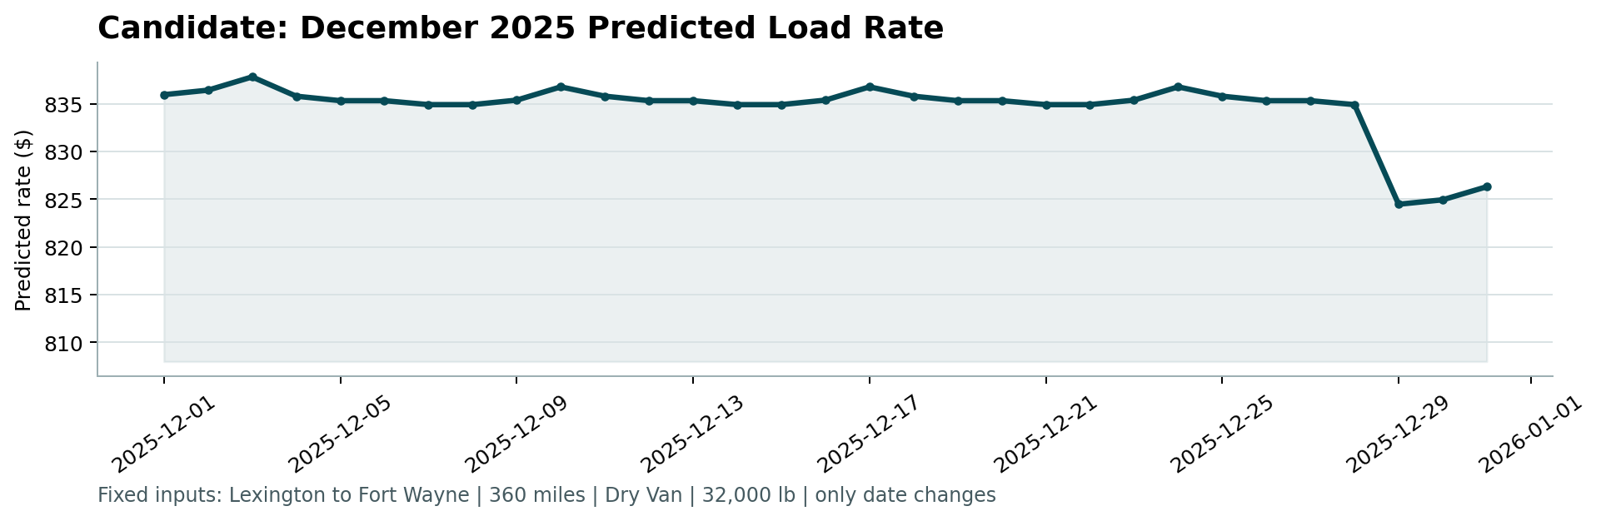
The predicted rate for this fixed lane stays in a tight band (roughly $824–$838) across December, with the model's small day-to-day variation coming entirely from the calendar/day-of-week features and the fixed October-average market signals — which is the expected behavior once route, equipment, and weight are held constant.

6. Code Walkthrough
- src/features.py — FeatureBuilder: fits cleaning/imputation statistics and category encodings on a training split, then applies them consistently to any other split (holdout, validation.csv, the December scenario), avoiding leakage.
- src/train.py — runs the time-based holdout, the 5-fold random CV sanity check, writes reports/validation_metrics.json, then refits the final model on all labeled data and saves reports/final_model.joblib.
- src/predict.py — loads the saved model/feature-builder bundle, scores every row of data/validation.csv into validation_predictions.csv (load_id, predicted_rate, matching the template exactly), and fills predicted_rate into data/december_chart_inputs.csv for the fixed-lane scenario.
- score.py (provided) — re-validates both output files against the assignment's schema/ID/range rules and renders the December chart; both files pass validation as delivered.

