Doubly Linked List
Linear Data Structure
Extra Pointer points to previous node
Operation logic similar to the Linked Linked List.

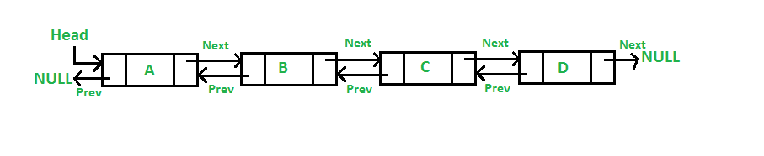
Add a node at the front
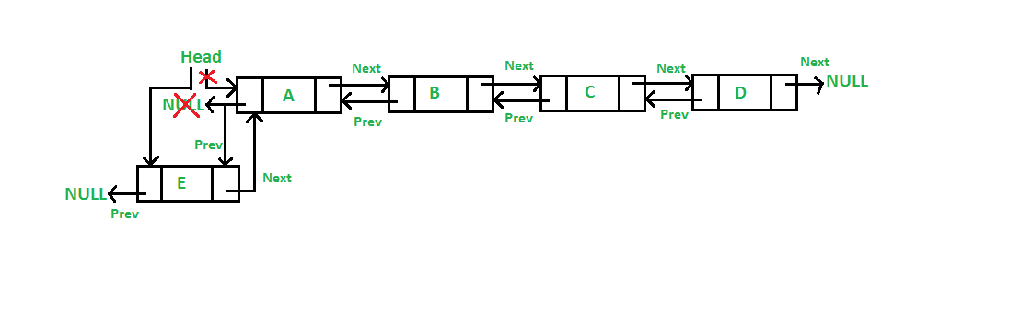
Add a node after a given node

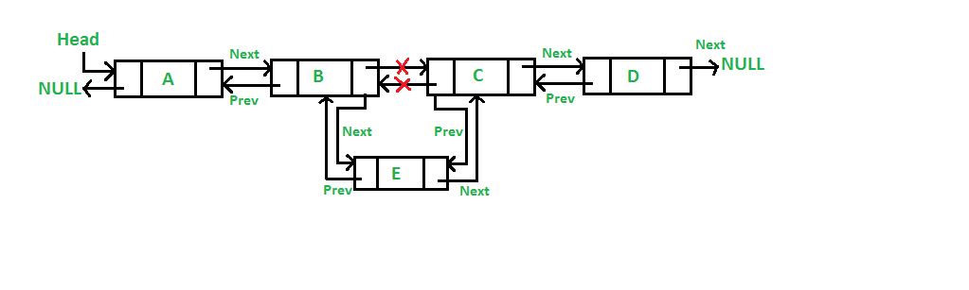

Add a node at the end
