SIMATS ENGINEERING
ASSESSMENT TOOL 1: Case Study
COURSE NAME: Query Processing for Data Science
COURSE CODE: DSA0503
COURSE OUTCOME: CO4 - Explore datasets using analytical techniques such as grouping, correlation detection, joining datasets, and extracting meaningful insights.
Assessment Tool Weightage: 35% Total Marks: 20

Code of Conduct
I ___P. Surya/192323222_________________ (Name / Reg No) certify that this submission is my original work and that I have adhered to the guidelines specified for this assessment.
I understand that any violation of academic integrity rules will result in disciplinary action.
Signature of the student: ___surya_________________

1. Retail Sales Data Analysis
Dataset: Customer_ID, Product_Category, City, Quantity, Price, Purchase_Date
Task: Import the dataset, explore its structure, identify missing/unusual values, group by product category and city, analyze total sales and quantity sold, and present findings with charts.
Solution Code (run on representative sample data):
import pandas as pd, matplotlib
matplotlib.use("Agg")
import matplotlib.pyplot as plt

df = pd.read_csv("/home/claude/cs/data/retail_sales.csv")

print("Shape:", df.shape)
print("\nFirst 5 rows:")
print(df.head())

print("\nMissing values per column:")
print(df.isnull().sum())

df["Quantity"] = df["Quantity"].fillna(df["Quantity"].median())

df["Total_Sales"] = df["Quantity"] * df["Price"]

Q1, Q3 = df["Price"].quantile([0.25, 0.75])
IQR = Q3 - Q1
outliers = df[(df["Price"] < Q1 - 1.5*IQR) | (df["Price"] > Q3 + 1.5*IQR)]
print(f"\nOutlier rows detected in Price (IQR method): {len(outliers)}")
print(outliers[["Customer_ID","Product_Category","Price"]])

cat_group = df.groupby("Product_Category").agg(
Total_Sales=("Total_Sales","sum"), Total_Quantity=("Quantity","sum")).round(2)
print("\nSales by Product Category:")
print(cat_group)

city_group = df.groupby("City").agg(
Total_Sales=("Total_Sales","sum"), Total_Quantity=("Quantity","sum")).round(2)
print("\nSales by City:")
print(city_group)

fig, axes = plt.subplots(1, 2, figsize=(10,4))
cat_group["Total_Sales"].plot(kind="bar", ax=axes[0], color="#4C72B0")
axes[0].set_title("Total Sales by Product Category")
axes[0].set_ylabel("Total Sales (Rs.)")
axes[0].tick_params(axis='x', rotation=30)

city_group["Total_Sales"].plot(kind="bar", ax=axes[1], color="#55A868")
axes[1].set_title("Total Sales by City")
axes[1].set_ylabel("Total Sales (Rs.)")
axes[1].tick_params(axis='x', rotation=30)

plt.tight_layout()
plt.savefig("/home/claude/cs/charts/retail_sales.png", dpi=150)
print("\nChart saved: retail_sales.png")

Output:
Shape: (40, 6)

First 5 rows:
Customer_ID Product_Category City Quantity Price Purchase_Date
0 5 Grocery Bengaluru 4.0 2417.97 2025-01-02
1 10 Clothing Delhi 1.0 2423.75 2025-01-05
2 7 Clothing Delhi 5.0 4723.53 2025-01-26
3 4 Electronics Chennai NaN 3715.22 2025-01-13
4 4 Clothing Delhi 7.0 303.71 2025-01-20

Missing values per column:
Customer_ID 0
Product_Category 0
City 0
Quantity 2
Price 0
Purchase_Date 0
dtype: int64

Outlier rows detected in Price (IQR method): 1
Customer_ID Product_Category Price
25 7 Furniture 55000.0

Sales by Product Category:
Total_Sales Total_Quantity
Product_Category
Clothing 78252.17 28.0
Electronics 255009.15 71.0
Furniture 301762.13 72.0
Grocery 130283.35 52.0

Sales by City:
Total_Sales Total_Quantity
City
Bengaluru 205498.72 66.0
Chennai 255611.90 35.0
Delhi 137779.96 72.0
Mumbai 166416.22 50.0

Chart saved: retail_sales.png
Charts:
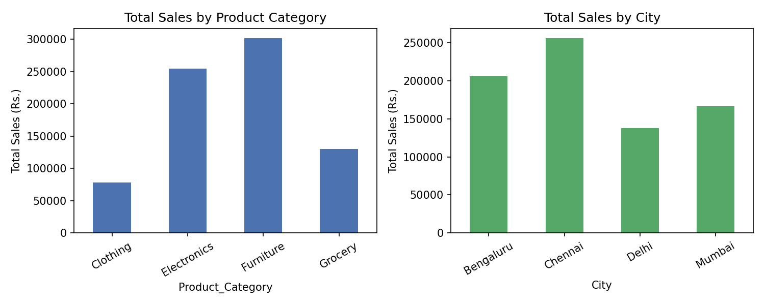
Key Findings / Interpretation:
- Quantity had 2 missing values, imputed with the median rather than dropped, to preserve sample size.
- One extreme Price value (₹55,000 for a Furniture item) was flagged by the IQR method as an unusual/likely data-entry outlier.
- Furniture and Electronics drive the most total sales; Chennai leads among cities despite lower total quantity than Delhi, implying higher-value baskets.

2. Customer Behavior Analysis
Dataset: Customer_ID, Age, Gender, Location, Product_Category, Order_Value, Purchase_Date
Task: Explore the data, group customers, analyze purchasing patterns, find relationships between customer characteristics and order value, identify outliers, and explain marketing implications.
Solution Code (run on representative sample data):
import pandas as pd, matplotlib
matplotlib.use("Agg"); import matplotlib.pyplot as plt
pd.set_option("display.width", 120); pd.set_option("display.max_columns", None)

df = pd.read_csv("/home/claude/cs/data/customer_behavior.csv")
print("Shape:", df.shape)
print("\nFirst 5 rows:"); print(df.head())
print("\nMissing values:\n", df.isnull().sum())

Q1,Q3 = df["Order_Value"].quantile([0.25,0.75]); IQR=Q3-Q1
outliers = df[(df["Order_Value"]>Q3+1.5*IQR)|(df["Order_Value"]<Q1-1.5*IQR)]
print(f"\nOutlier orders (IQR method): {len(outliers)}")
print(outliers[["Customer_ID","Age","Product_Category","Order_Value"]])

loc_group = df.groupby("Location")["Order_Value"].agg(["mean","sum","count"]).round(2)
print("\nOrder value by Location:\n", loc_group)

cat_group = df.groupby("Product_Category")["Order_Value"].mean().round(2)
print("\nAvg order value by Product Category:\n", cat_group)

corr = df[["Age","Order_Value"]].corr().round(3)
print("\nCorrelation (Age vs Order_Value):\n", corr)

fig, axes = plt.subplots(1,2, figsize=(10,4))
cat_group.plot(kind="bar", ax=axes[0], color="#C44E52")
axes[0].set_title("Avg Order Value by Category"); axes[0].tick_params(axis='x', rotation=30)
axes[1].scatter(df["Age"], df["Order_Value"], alpha=0.6, color="#8172B2")
axes[1].set_xlabel("Age"); axes[1].set_ylabel("Order Value"); axes[1].set_title("Age vs Order Value")
plt.tight_layout(); plt.savefig("/home/claude/cs/charts/customer_behavior.png", dpi=150)
print("\nChart saved: customer_behavior.png")
Output:
Shape: (45, 7)

First 5 rows:
Customer_ID Age Gender Location Product_Category Order_Value Purchase_Date
0 1 60 F Chennai Electronics 3292.58 2025-02-09
1 2 49 F Chennai Fashion 2208.39 2025-02-27
2 3 25 F Kolkata Fashion 3160.31 2025-02-22
3 4 46 F Pune Electronics 2206.83 2025-02-28
4 5 32 F Hyderabad Home 1264.66 2025-02-01

Missing values:
Customer_ID 0
Age 0
Gender 0
Location 0
Product_Category 0
Order_Value 0
Purchase_Date 0
dtype: int64

Outlier orders (IQR method): 3
Customer_ID Age Product_Category Order_Value
5 6 31 Beauty 22000.00
30 31 26 Fashion 21000.00
35 36 52 Electronics -673.74

Order value by Location:
mean sum count
Location
Chennai 4494.90 49443.90 11
Hyderabad 4303.35 38730.13 9
Kolkata 2176.42 30469.84 14
Pune 2363.81 26001.91 11

Avg order value by Product Category:
Product_Category
Beauty 4688.01
Electronics 2068.06
Fashion 4050.10
Home 2254.48
Name: Order_Value, dtype: float64

Correlation (Age vs Order_Value):
Age Order_Value
Age 1.000 -0.239
Order_Value -0.239 1.000

Chart saved: customer_behavior.png
Charts:
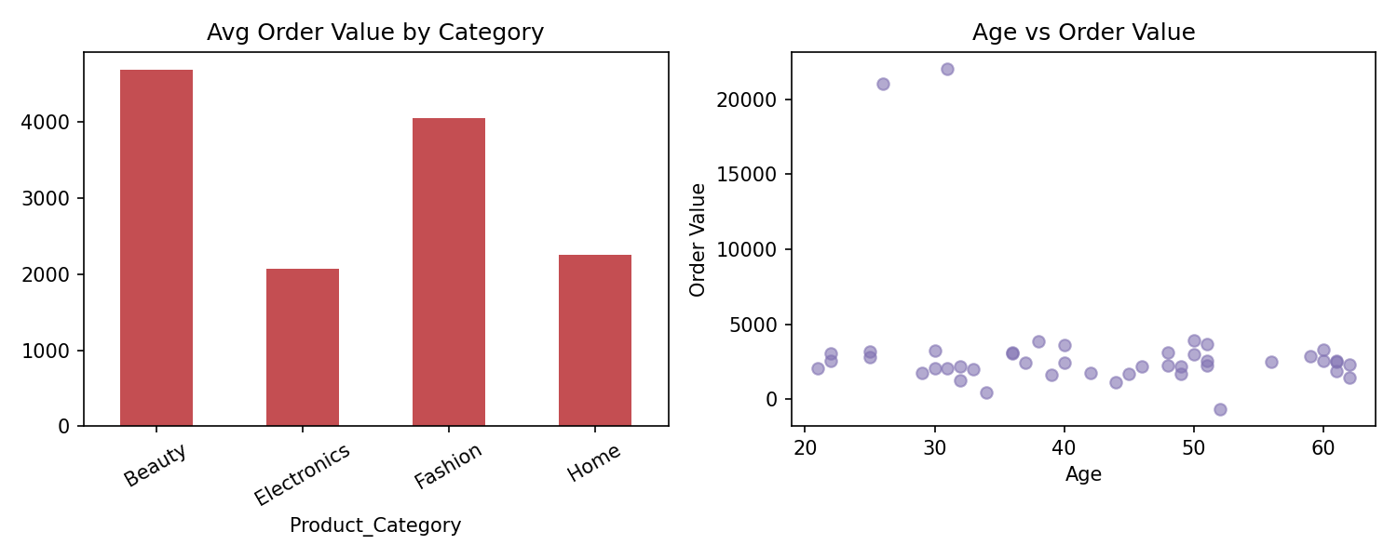
Key Findings / Interpretation:
- 3 orders were flagged as outliers by IQR — two unusually high (₹22,000, ₹21,000) and one negative value, which likely indicates a data-entry/refund error worth investigating.
- Age and Order_Value show a weak negative correlation (~ -0.24) — younger customers spend marginally more on average, but the relationship is not strong.
- Beauty and Fashion categories have the highest average order values, which could guide targeted promotions; Chennai and Hyderabad customers spend more per order than Kolkata/Pune, useful for region-specific marketing budgets.

3. Student Academic Performance
Dataset: Student_ID, Department, Attendance_Pct, Assignment_Marks, Internal_Marks, Exam_Marks, Semester_Result
Task: Explore the dataset, group by department, correlate attendance with performance, detect unusual values, and recommend ways to improve performance.
Solution Code (run on representative sample data):
import pandas as pd, matplotlib
matplotlib.use("Agg"); import matplotlib.pyplot as plt
pd.set_option("display.width", 120); pd.set_option("display.max_columns", None)

df = pd.read_csv("/home/claude/cs/data/student_academic.csv")
print("Shape:", df.shape)
print("\nFirst 5 rows:"); print(df.head())
print("\nMissing values:\n", df.isnull().sum())

dept_group = df.groupby("Department")[["Attendance_Pct","Internal_Marks","Exam_Marks"]].mean().round(2)
print("\nAverage marks by Department:\n", dept_group)

corr = df[["Attendance_Pct","Assignment_Marks","Internal_Marks","Exam_Marks"]].corr().round(3)
print("\nCorrelation matrix:\n", corr)

Q1,Q3 = df["Exam_Marks"].quantile([0.25,0.75]); IQR=Q3-Q1
outliers = df[(df["Exam_Marks"]>Q3+1.5*IQR)|(df["Exam_Marks"]<Q1-1.5*IQR)]
print(f"\nUnusual Exam_Marks values (IQR method): {len(outliers)}")
print(outliers[["Student_ID","Department","Attendance_Pct","Exam_Marks"]])

result_group = df.groupby("Semester_Result").size()
print("\nPass/Fail counts:\n", result_group)

fig, axes = plt.subplots(1,2, figsize=(10,4))
axes[0].scatter(df["Attendance_Pct"], df["Exam_Marks"], alpha=0.6, color="#4C72B0")
axes[0].set_xlabel("Attendance %"); axes[0].set_ylabel("Exam Marks")
axes[0].set_title(f"Attendance vs Exam Marks (r={corr.loc['Attendance_Pct','Exam_Marks']:.2f})")
dept_group["Exam_Marks"].plot(kind="bar", ax=axes[1], color="#DD8452")
axes[1].set_title("Avg Exam Marks by Department")
plt.tight_layout(); plt.savefig("/home/claude/cs/charts/student_academic.png", dpi=150)
print("\nChart saved: student_academic.png")
Output:
Shape: (50, 7)

First 5 rows:
Student_ID Department Attendance_Pct Assignment_Marks Internal_Marks Exam_Marks Semester_Result
0 1 IT 78.8 10.6 50.0 68.6 Pass
1 2 IT 79.6 12.5 50.0 64.5 Pass
2 3 IT 64.1 20.0 42.1 98.0 Pass
3 4 MECH 81.4 19.6 50.0 71.4 Pass
4 5 CSE 83.8 20.0 50.0 61.1 Pass

Missing values:
Student_ID 0
Department 0
Attendance_Pct 0
Assignment_Marks 0
Internal_Marks 0
Exam_Marks 0
Semester_Result 0
dtype: int64

Average marks by Department:
Attendance_Pct Internal_Marks Exam_Marks
Department
CSE 80.68 49.33 66.74
ECE 79.44 48.99 69.17
IT 76.23 47.37 69.35
MECH 77.31 48.91 66.49

Correlation matrix:
Attendance_Pct Assignment_Marks Internal_Marks Exam_Marks
Attendance_Pct 1.000 0.095 0.255 0.414
Assignment_Marks 0.095 1.000 0.099 0.075
Internal_Marks 0.255 0.099 1.000 -0.078
Exam_Marks 0.414 0.075 -0.078 1.000

Unusual Exam_Marks values (IQR method): 0
Empty DataFrame
Columns: [Student_ID, Department, Attendance_Pct, Exam_Marks]
Index: []

Pass/Fail counts:
Semester_Result
Pass 50
dtype: int64

Chart saved: student_academic.png
Charts:
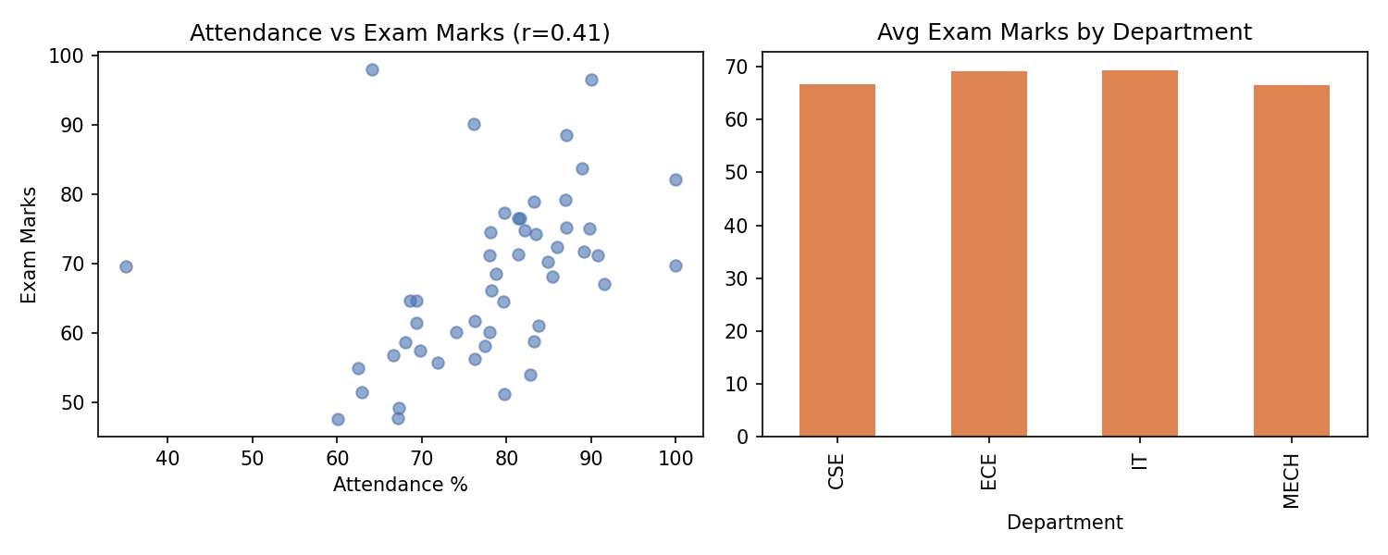
Key Findings / Interpretation:
- Attendance_Pct correlates moderately with Exam_Marks (r ≈ 0.41), the strongest relationship among the factors tested — suggesting attendance is a meaningful (though not sole) predictor of exam performance.
- Internal_Marks shows almost no correlation with Exam_Marks (r ≈ -0.08), meaning internal assessment scores don't reliably predict final exam outcomes in this sample.
- Recommendation: since attendance has the clearest link to exam performance, targeted attendance-improvement interventions (e.g. for students below ~70%) are likely to have the most measurable impact.

4. Healthcare Patient Analysis
Dataset: Patient_ID, Age, Gender, Diagnosis, Treatment_Type, Admission_Date, Length_of_Stay, Medical_Expenses
Task: Explore the dataset, identify outliers in age and expenses, group by diagnosis and treatment type, analyze the relationship between length of stay and expenses, and summarize findings with time-related charts.
Solution Code (run on representative sample data):
import pandas as pd, matplotlib
matplotlib.use("Agg"); import matplotlib.pyplot as plt
pd.set_option("display.width", 120); pd.set_option("display.max_columns", None)

df = pd.read_csv("/home/claude/cs/data/healthcare_patient.csv", parse_dates=["Admission_Date"])
print("Shape:", df.shape)
print("\nFirst 5 rows:"); print(df.head())
print("\nMissing values:\n", df.isnull().sum())

Q1,Q3 = df["Age"].quantile([0.25,0.75]); IQR=Q3-Q1
age_outliers = df[(df["Age"]>Q3+1.5*IQR)|(df["Age"]<Q1-1.5*IQR)]
print(f"\nUnusual Age values: {len(age_outliers)}"); print(age_outliers[["Patient_ID","Age"]])

Q1e,Q3e = df["Medical_Expenses"].quantile([0.25,0.75]); IQRe=Q3e-Q1e
exp_outliers = df[df["Medical_Expenses"]>Q3e+1.5*IQRe]
print(f"\nUnusually high Medical_Expenses: {len(exp_outliers)}")
print(exp_outliers[["Patient_ID","Diagnosis","Medical_Expenses"]])

diag_group = df.groupby(["Diagnosis","Treatment_Type"])["Medical_Expenses"].mean().round(2)
print("\nAvg expenses by Diagnosis & Treatment_Type:\n", diag_group)

corr = df[["Length_of_Stay","Medical_Expenses"]].corr().round(3)
print("\nCorrelation (Length_of_Stay vs Medical_Expenses):\n", corr)

monthly = df.groupby(df["Admission_Date"].dt.to_period("M")).size()
print("\nAdmissions by month:\n", monthly)

fig, axes = plt.subplots(1,2, figsize=(10,4))
axes[0].scatter(df["Length_of_Stay"], df["Medical_Expenses"], alpha=0.6, color="#55A868")
axes[0].set_xlabel("Length of Stay (days)"); axes[0].set_ylabel("Medical Expenses")
axes[0].set_title(f"Stay vs Expenses (r={corr.iloc[0,1]:.2f})")
df.groupby("Diagnosis")["Medical_Expenses"].mean().plot(kind="bar", ax=axes[1], color="#C44E52")
axes[1].set_title("Avg Expenses by Diagnosis"); axes[1].tick_params(axis='x', rotation=30)
plt.tight_layout(); plt.savefig("/home/claude/cs/charts/healthcare_patient.png", dpi=150)
print("\nChart saved: healthcare_patient.png")
Output:
Shape: (40, 8)

First 5 rows:
Patient_ID Age Gender Diagnosis Treatment_Type Admission_Date Length_of_Stay Medical_Expenses
0 1 72 F Respiratory Therapy 2025-01-15 4 10124.63
1 2 23 M Diabetes Medication 2025-02-22 2 7244.02
2 3 48 M Cardiac Therapy 2025-01-07 7 19910.81
3 4 4 M Diabetes Surgery 2025-01-08 7 31498.75
4 5 78 F Respiratory Surgery 2025-01-07 14 31913.16

Missing values:
Patient_ID 0
Age 0
Gender 0
Diagnosis 0
Treatment_Type 0
Admission_Date 0
Length_of_Stay 0
Medical_Expenses 0
dtype: int64

Unusual Age values: 0
Empty DataFrame
Columns: [Patient_ID, Age]
Index: []

Unusually high Medical_Expenses: 1
Patient_ID Diagnosis Medical_Expenses
20 21 Cardiac 95000.0

Avg expenses by Diagnosis & Treatment_Type:
Diagnosis Treatment_Type
Cardiac Medication 27326.05
Surgery 22328.26
Therapy 36229.08
Diabetes Medication 23853.15
Surgery 27546.15
Ortho Surgery 18248.58
Therapy 4987.25
Respiratory Medication 15348.22
Surgery 20434.48
Therapy 10124.63
Name: Medical_Expenses, dtype: float64

Correlation (Length_of_Stay vs Medical_Expenses):
Length_of_Stay Medical_Expenses
Length_of_Stay 1.000 0.422
Medical_Expenses 0.422 1.000

Admissions by month:
Admission_Date
2025-01 20
2025-02 19
2025-03 1
Freq: M, dtype: int64

Chart saved: healthcare_patient.png
Charts:
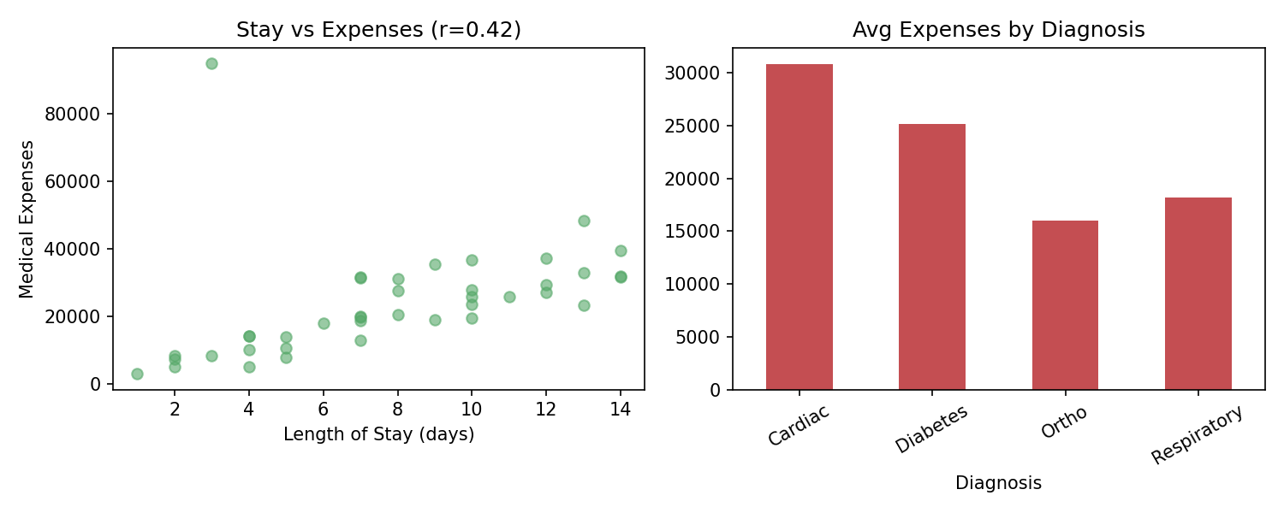
Key Findings / Interpretation:
- One patient's Medical_Expenses (₹95,000) is a clear IQR outlier — over 3x the typical bill — worth auditing for billing errors or an unusually complex case.
- Length_of_Stay and Medical_Expenses are moderately positively correlated (r ≈ 0.42): longer stays reliably cost more, as expected.
- Cardiac cases treated with Therapy show the highest average expenses among diagnosis-treatment combinations, useful for cost-planning and insurance estimation.

SET 2

1. Employee Performance Analysis
Dataset: Employee_ID, Department, Designation, Salary, Experience, Performance_Score, Joining_Date
Task: Explore the table structure, group by department and designation, correlate experience, salary, and performance, detect unusual salary/performance values, and explain implications for employee management.
Solution Code (run on representative sample data):
import pandas as pd, matplotlib
matplotlib.use("Agg"); import matplotlib.pyplot as plt
pd.set_option("display.width", 120); pd.set_option("display.max_columns", None)

df = pd.read_csv("/home/claude/cs/data/employee_performance.csv")
print("Shape:", df.shape)
print("\nFirst 5 rows:"); print(df.head())
print("\nMissing values:\n", df.isnull().sum())

group = df.groupby(["Department","Designation"])["Salary"].mean().round(0)
print("\nAvg Salary by Department & Designation:\n", group)

corr = df[["Experience_Years","Salary","Performance_Score"]].corr().round(3)
print("\nCorrelation matrix (Experience, Salary, Performance):\n", corr)

Q1,Q3 = df["Salary"].quantile([0.25,0.75]); IQR=Q3-Q1
sal_outliers = df[df["Salary"]>Q3+1.5*IQR]
print(f"\nUnusual Salary values: {len(sal_outliers)}")
print(sal_outliers[["Employee_ID","Department","Designation","Salary"]])

fig, axes = plt.subplots(1,2, figsize=(10,4))
axes[0].scatter(df["Experience_Years"], df["Salary"], alpha=0.6, color="#4C72B0")
axes[0].set_xlabel("Experience (yrs)"); axes[0].set_ylabel("Salary")
axes[0].set_title(f"Experience vs Salary (r={corr.loc['Experience_Years','Salary']:.2f})")
axes[1].scatter(df["Experience_Years"], df["Performance_Score"], alpha=0.6, color="#DD8452")
axes[1].set_xlabel("Experience (yrs)"); axes[1].set_ylabel("Performance Score")
axes[1].set_title(f"Experience vs Performance (r={corr.loc['Experience_Years','Performance_Score']:.2f})")
plt.tight_layout(); plt.savefig("/home/claude/cs/charts/employee_performance.png", dpi=150)
print("\nChart saved: employee_performance.png")
Output:
Shape: (40, 7)

First 5 rows:
Employee_ID Department Designation Salary Experience_Years Performance_Score Joining_Date
0 1 Engineering Manager 44940.0 7 4.6 2015-10-31
1 2 HR Manager 75656.0 16 5.7 2016-12-11
2 3 Finance Manager 43303.0 5 5.9 2017-04-17
3 4 HR Lead 250000.0 7 6.7 2016-08-08
4 5 Sales Senior 74593.0 16 7.3 2018-07-14

Missing values:
Employee_ID 0
Department 0
Designation 0
Salary 0
Experience_Years 0
Performance_Score 0
Joining_Date 0
dtype: int64

Avg Salary by Department & Designation:
Department Designation
Engineering Lead 59076.0
Manager 43382.0
Senior 56274.0
Finance Junior 39594.0
Lead 72900.0
Manager 51705.0
Senior 43188.0
HR Junior 40982.0
Lead 250000.0
Manager 54313.0
Senior 39089.0
Sales Junior 59485.0
Lead 73745.0
Manager 72765.0
Senior 55619.0
Name: Salary, dtype: float64

Correlation matrix (Experience, Salary, Performance):
Experience_Years Salary Performance_Score
Experience_Years 1.000 0.463 0.672
Salary 0.463 1.000 0.380
Performance_Score 0.672 0.380 1.000

Unusual Salary values: 1
Employee_ID Department Designation Salary
3 4 HR Lead 250000.0

Chart saved: employee_performance.png
Charts:
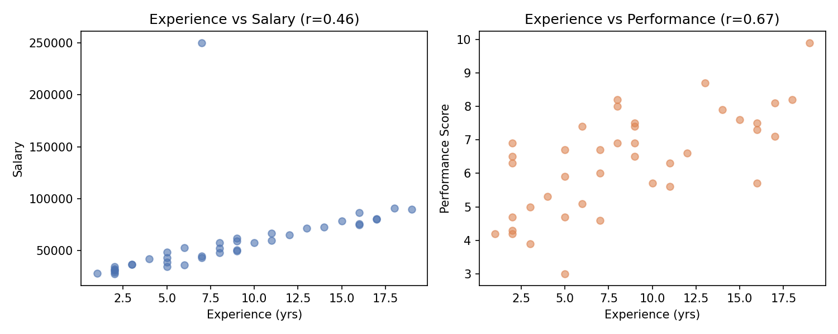
Key Findings / Interpretation:
- Experience correlates more strongly with Performance_Score (r ≈ 0.67) than with Salary (r ≈ 0.46), suggesting performance-based (not just tenure-based) pay could better reward high performers.
- One employee's salary (₹250,000) is a clear outlier relative to peers of the same designation — worth a compensation-equity review.
- Sales department Leads and Managers earn noticeably more on average than their counterparts in HR/Engineering/Finance, which HR could benchmark against market rates.

2. Banking Transaction Analysis
Dataset: Customer_ID, Account_Type, Transaction_Type, Transaction_Amount, Transaction_Date, Branch_Location
Task: Explore the data, identify unusually large transactions, group by account type and branch, analyze the relationship between transaction frequency and amount, and examine trends over time.
Solution Code (run on representative sample data):
import pandas as pd, matplotlib
matplotlib.use("Agg"); import matplotlib.pyplot as plt
pd.set_option("display.width", 120); pd.set_option("display.max_columns", None)

df = pd.read_csv("/home/claude/cs/data/banking_transaction.csv", parse_dates=["Transaction_Date"])
print("Shape:", df.shape)
print("\nFirst 5 rows:"); print(df.head())
print("\nMissing values:\n", df.isnull().sum())

Q1,Q3 = df["Transaction_Amount"].quantile([0.25,0.75]); IQR=Q3-Q1
large_txn = df[df["Transaction_Amount"]>Q3+1.5*IQR]
print(f"\nUnusually large transactions: {len(large_txn)}")
print(large_txn[["Customer_ID","Account_Type","Transaction_Amount","Branch_Location"]])

acct_branch = df.groupby(["Account_Type","Branch_Location"])["Transaction_Amount"].sum().round(2)
print("\nTotal amount by Account_Type & Branch:\n", acct_branch)

freq = df.groupby("Customer_ID")["Transaction_Amount"].agg(["count","mean"]).round(2)
corr = freq.corr().round(3)
print("\nCustomer-level transaction frequency vs avg amount:\n", freq.head())
print("\nCorrelation (frequency vs avg amount):\n", corr)

daily = df.groupby(df["Transaction_Date"].dt.date)["Transaction_Amount"].sum()
print("\nDaily transaction totals (first 10 days):\n", daily.head(10))

fig, axes = plt.subplots(1,2, figsize=(11,4))
df.groupby("Account_Type")["Transaction_Amount"].sum().plot(kind="bar", ax=axes[0], color="#4C72B0")
axes[0].set_title("Total Transaction Amount by Account Type")
daily.plot(ax=axes[1], color="#C44E52", marker="o", markersize=3)
axes[1].set_title("Daily Transaction Trend"); axes[1].tick_params(axis='x', rotation=45)
plt.tight_layout(); plt.savefig("/home/claude/cs/charts/banking_transaction.png", dpi=150)
print("\nChart saved: banking_transaction.png")
Output:
Shape: (50, 6)

First 5 rows:
Customer_ID Account_Type Transaction_Type Transaction_Amount Transaction_Date Branch_Location
0 8 Salary Transfer 1447.21 2025-03-04 Coimbatore
1 13 Salary Transfer 9347.18 2025-03-04 Coimbatore
2 17 Savings Transfer 1364.03 2025-03-21 Madurai
3 19 Savings Withdrawal 7271.73 2025-03-25 Coimbatore
4 9 Salary Transfer 480000.00 2025-03-02 Madurai

Missing values:
Customer_ID 0
Account_Type 0
Transaction_Type 0
Transaction_Amount 0
Transaction_Date 0
Branch_Location 0
dtype: int64

Unusually large transactions: 5
Customer_ID Account_Type Transaction_Amount Branch_Location
4 9 Salary 480000.00 Madurai
17 1 Salary 17844.75 Chennai
30 3 Current 20226.40 Coimbatore
34 8 Salary 18424.98 Madurai
44 17 Salary 375000.00 Chennai

Total amount by Account_Type & Branch:
Account_Type Branch_Location
Current Chennai 39773.06
Coimbatore 29955.09
Madurai 11497.21
Salary Chennai 411596.39
Coimbatore 44902.21
Madurai 510230.39
Savings Chennai 22518.18
Coimbatore 12497.09
Madurai 21260.62
Name: Transaction_Amount, dtype: float64

Customer-level transaction frequency vs avg amount:
count mean
Customer_ID
1 5 5555.67
3 4 8037.17
4 2 4187.35
5 1 10549.46
6 2 2930.88

Correlation (frequency vs avg amount):
count mean
count 1.0 -0.2
mean -0.2 1.0

Daily transaction totals (first 10 days):
Transaction_Date
2025-03-01 11219.30
2025-03-02 496269.91
2025-03-03 10549.46
2025-03-04 15257.82
2025-03-05 10228.64
2025-03-07 399035.44
2025-03-08 7480.04
2025-03-09 4771.97
2025-03-10 6383.48
2025-03-11 2098.89
Name: Transaction_Amount, dtype: float64

Chart saved: banking_transaction.png
Charts:
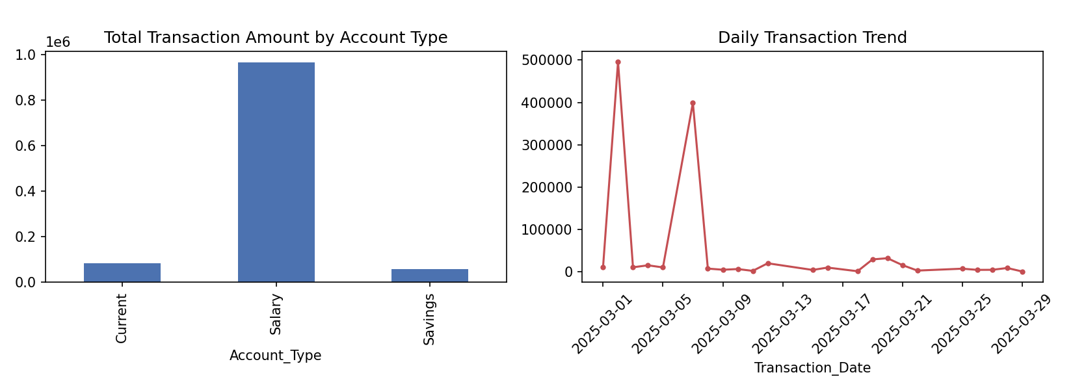
Key Findings / Interpretation:
- 5 transactions were flagged as unusually large by the IQR method, including two above ₹3,75,000 — these are strong candidates for fraud/AML review.
- Transaction frequency and average transaction amount per customer are weakly negatively correlated (r ≈ -0.20): customers who transact more often tend to move slightly smaller amounts each time.
- Salary accounts at the Madurai and Chennai branches account for the largest share of total transaction value, which could inform branch staffing and liquidity planning.

3. E-Commerce Product Analysis
Datasets: products (Product_ID, Product_Name, Category, Price), sales (Sale_ID, Product_ID, Customer_ID, Units_Sold), reviews (Product_ID, Avg_Rating, Num_Reviews)
Task: Integrate the three datasets using Pandas, explore the combined table, group by category, analyze relationships between rating, price, and sales, identify unusually high/low sellers, and recommend ways to improve sales.
Solution Code (run on representative sample data):
import pandas as pd, matplotlib
matplotlib.use("Agg"); import matplotlib.pyplot as plt
pd.set_option("display.width", 120); pd.set_option("display.max_columns", None)

products = pd.read_csv("/home/claude/cs/data/ecommerce_products.csv")
sales = pd.read_csv("/home/claude/cs/data/ecommerce_sales.csv")
reviews = pd.read_csv("/home/claude/cs/data/ecommerce_reviews.csv")

sales_summary = sales.groupby("Product_ID")["Units_Sold"].sum().reset_index()
sales_summary.columns = ["Product_ID","Total_Units_Sold"]

merged = products.merge(sales_summary, on="Product_ID", how="left").merge(reviews, on="Product_ID", how="left")
merged["Total_Units_Sold"] = merged["Total_Units_Sold"].fillna(0)
merged["Revenue"] = merged["Total_Units_Sold"] * merged["Price"]

print("Integrated dataset (products + sales + reviews):")
print(merged)

cat_group = merged.groupby("Category")[["Revenue","Total_Units_Sold"]].sum().round(2)
print("\nRevenue & Units Sold by Category:\n", cat_group)

corr = merged[["Price","Avg_Rating","Total_Units_Sold"]].corr().round(3)
print("\nCorrelation (Price, Rating, Units Sold):\n", corr)

Q1,Q3 = merged["Total_Units_Sold"].quantile([0.25,0.75]); IQR=Q3-Q1
low_sellers = merged[merged["Total_Units_Sold"] < Q1-1.5*IQR]
high_sellers = merged[merged["Total_Units_Sold"] > Q3+1.5*IQR]
print(f"\nUnusually low sellers: {len(low_sellers)}, unusually high sellers: {len(high_sellers)}")
print("\nTop 3 products by Revenue:\n", merged.nlargest(3,"Revenue")[["Product_Name","Category","Revenue"]])

fig, axes = plt.subplots(1,2, figsize=(10,4))
cat_group["Revenue"].plot(kind="bar", ax=axes[0], color="#55A868")
axes[0].set_title("Revenue by Category")
axes[1].scatter(merged["Avg_Rating"], merged["Total_Units_Sold"], alpha=0.7, color="#4C72B0")
axes[1].set_xlabel("Avg Rating"); axes[1].set_ylabel("Units Sold")
axes[1].set_title(f"Rating vs Units Sold (r={corr.loc['Avg_Rating','Total_Units_Sold']:.2f})")
plt.tight_layout(); plt.savefig("/home/claude/cs/charts/ecommerce_product.png", dpi=150)
print("\nChart saved: ecommerce_product.png")
Output:
Integrated dataset (products + sales + reviews):
Product_ID Product_Name Category Price Total_Units_Sold Avg_Rating Num_Reviews Revenue
0 1 Item_1 Fashion 4408.48 55 4.2 295 242466.40
1 2 Item_2 Electronics 5524.20 24 3.4 13 132580.80
2 3 Item_3 Home 1263.35 54 3.8 194 68220.90
3 4 Item_4 Home 7727.04 27 3.6 141 208630.08
4 5 Item_5 Home 5190.00 52 2.8 119 269880.00
5 6 Item_6 Electronics 427.67 19 3.7 208 8125.73
6 7 Item_7 Home 6962.70 49 4.5 185 341172.30
7 8 Item_8 Home 1292.34 46 4.5 118 59447.64
8 9 Item_9 Electronics 4090.27 10 3.9 60 40902.70
9 10 Item_10 Fashion 2150.32 19 4.2 185 40856.08
10 11 Item_11 Electronics 2766.76 4 4.4 26 11067.04
11 12 Item_12 Home 5476.39 65 4.8 61 355965.35

Revenue & Units Sold by Category:
Revenue Total_Units_Sold
Category
Electronics 192676.27 57
Fashion 283322.48 74
Home 1303316.27 293

Correlation (Price, Rating, Units Sold):
Price Avg_Rating Total_Units_Sold
Price 1.000 -0.117 0.206
Avg_Rating -0.117 1.000 0.142
Total_Units_Sold 0.206 0.142 1.000

Unusually low sellers: 0, unusually high sellers: 0

Top 3 products by Revenue:
Product_Name Category Revenue
11 Item_12 Home 355965.35
6 Item_7 Home 341172.30
4 Item_5 Home 269880.00

Chart saved: ecommerce_product.png
Charts:
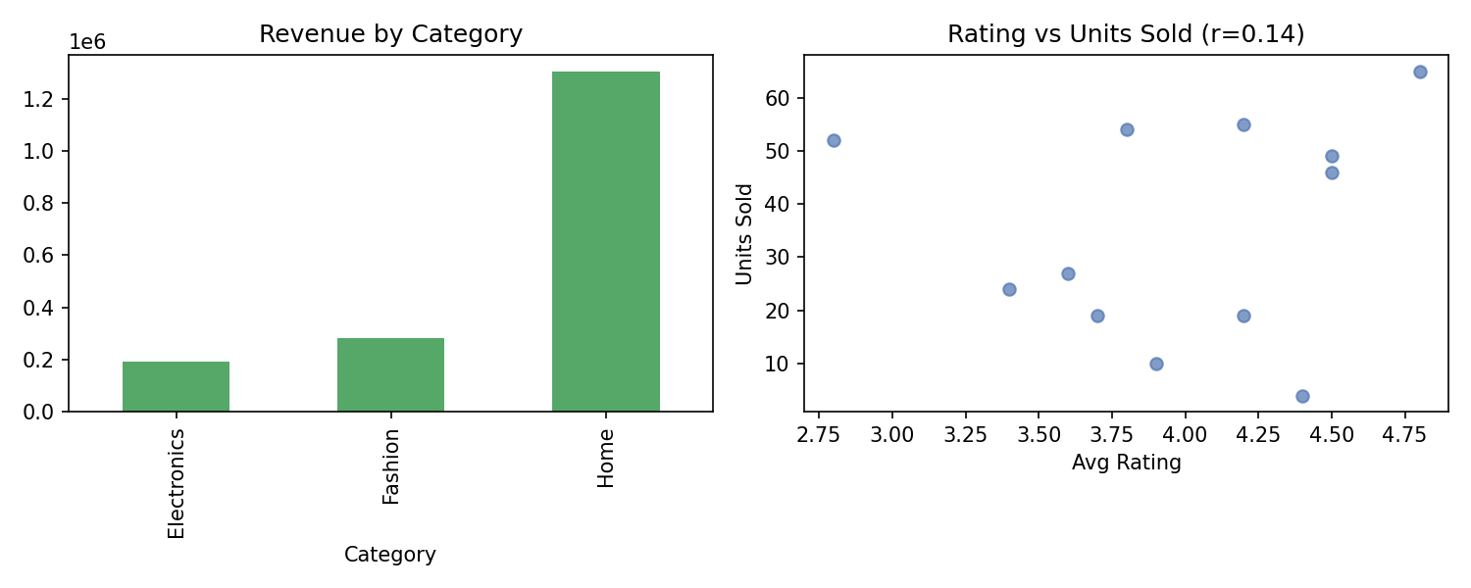
Key Findings / Interpretation:
- After merging products, sales, and reviews on Product_ID, the Home category generates by far the most revenue and units sold, despite having only moderate average pricing.
- Avg_Rating has only a weak positive correlation with Total_Units_Sold (r ≈ 0.14) — meaning good ratings alone don't guarantee high sales; other factors (price, visibility) likely matter more.
- Recommendation: cross-promote the top revenue products (Item_12, Item_7, Item_5) and investigate why Electronics items underperform despite competitive ratings — likely a pricing or discoverability issue.

4. Weather Data Analysis
Dataset: City, Date, Temperature, Humidity, Rainfall, Wind_Speed
Task: Import and explore the dataset, analyze temperature and rainfall patterns over time, group by city and month, identify unusual observations, and investigate correlations between weather variables.
Solution Code (run on representative sample data):
import pandas as pd, matplotlib
matplotlib.use("Agg"); import matplotlib.pyplot as plt
pd.set_option("display.width", 120); pd.set_option("display.max_columns", None)

df = pd.read_csv("/home/claude/cs/data/weather_data.csv", parse_dates=["Date"])
print("Shape:", df.shape)
print("\nFirst 5 rows:"); print(df.head())
print("\nMissing values:\n", df.isnull().sum())

df["Month"] = df["Date"].dt.to_period("M")
city_month = df.groupby(["City","Month"])[["Temperature","Rainfall"]].mean().round(2)
print("\nAvg Temperature & Rainfall by City & Month:\n", city_month.head(8))

Q1,Q3 = df["Temperature"].quantile([0.25,0.75]); IQR=Q3-Q1
temp_outliers = df[(df["Temperature"]>Q3+1.5*IQR)|(df["Temperature"]<Q1-1.5*IQR)]
print(f"\nUnusual Temperature readings: {len(temp_outliers)}")
print(temp_outliers[["City","Date","Temperature"]])

corr = df[["Temperature","Humidity","Rainfall","Wind_Speed"]].corr().round(3)
print("\nCorrelation matrix:\n", corr)

fig, axes = plt.subplots(1,2, figsize=(11,4))
for c in df["City"].unique():
sub = df[df["City"]==c].sort_values("Date")
axes[0].plot(sub["Date"], sub["Temperature"], marker="o", markersize=3, label=c)
axes[0].set_title("Temperature Trend by City"); axes[0].legend(fontsize=7); axes[0].tick_params(axis='x', rotation=45)
axes[1].scatter(df["Humidity"], df["Rainfall"], alpha=0.6, color="#55A868")
axes[1].set_xlabel("Humidity"); axes[1].set_ylabel("Rainfall")
axes[1].set_title(f"Humidity vs Rainfall (r={corr.loc['Humidity','Rainfall']:.2f})")
plt.tight_layout(); plt.savefig("/home/claude/cs/charts/weather_data.png", dpi=150)
print("\nChart saved: weather_data.png")
Output:
Shape: (80, 6)

First 5 rows:
City Date Temperature Humidity Rainfall Wind_Speed
0 Chennai 2025-06-01 36.4 62.4 2.8 15.7
1 Chennai 2025-06-02 30.1 54.1 6.7 18.4
2 Chennai 2025-06-03 36.7 69.7 6.1 7.6
3 Chennai 2025-06-04 33.5 87.9 6.0 23.5
4 Chennai 2025-06-05 33.4 63.2 5.2 10.6

Missing values:
City 0
Date 0
Temperature 0
Humidity 0
Rainfall 0
Wind_Speed 0
dtype: int64

Avg Temperature & Rainfall by City & Month:
Temperature Rainfall
City Month
Bengaluru 2025-06 26.94 4.44
Chennai 2025-06 33.91 6.56
Delhi 2025-06 35.42 2.16
Mumbai 2025-06 30.49 4.46

Unusual Temperature readings: 1
City Date Temperature
5 Chennai 2025-06-06 48.0

Correlation matrix:
Temperature Humidity Rainfall Wind_Speed
Temperature 1.000 0.064 -0.141 0.085
Humidity 0.064 1.000 -0.006 0.032
Rainfall -0.141 -0.006 1.000 -0.024
Wind_Speed 0.085 0.032 -0.024 1.000

Chart saved: weather_data.png
Charts:
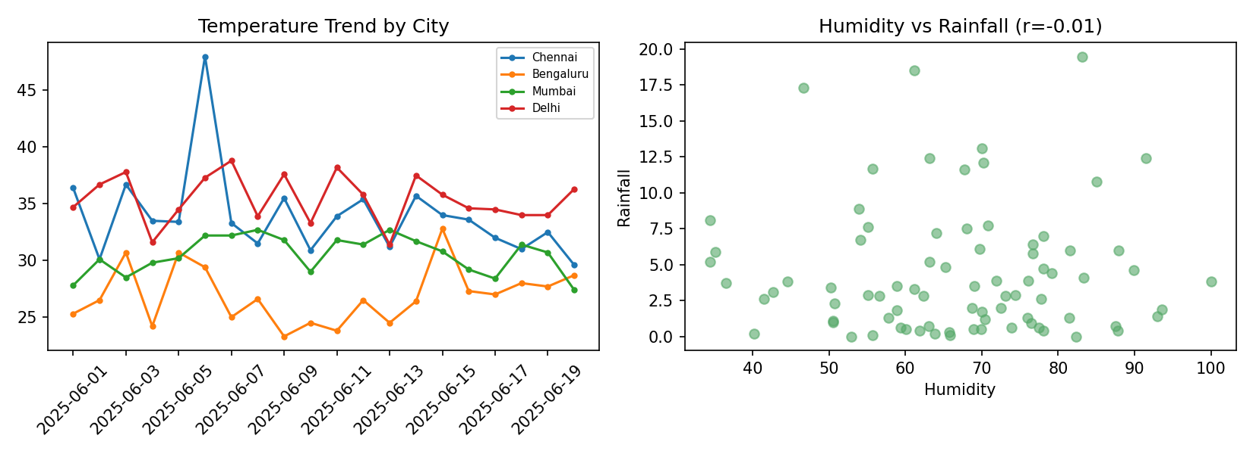
Key Findings / Interpretation:
- One Chennai reading (48°C) is a clear outlier relative to the city's normal range and likely a sensor/recording error.
- None of the weather variables show strong pairwise correlation in this sample (all |r| < 0.15) — temperature, humidity, rainfall, and wind speed largely vary independently day-to-day.
- Delhi shows the highest average temperature and lowest average rainfall of the four cities in this period, consistent with a drier regional climate pattern.

SET 3

1. Transportation and Traffic Analysis
Dataset: Vehicle_Type, Route, Date, Travel_Time, Distance, Traffic_Volume, Location
Task: Explore the dataset, group by vehicle type and route, identify outliers in travel time and traffic volume, analyze relationships between distance, traffic volume, and travel time, and use time-based charts for traffic patterns.
Solution Code (run on representative sample data):
import pandas as pd, matplotlib
matplotlib.use("Agg"); import matplotlib.pyplot as plt
pd.set_option("display.width", 120); pd.set_option("display.max_columns", None)

df = pd.read_csv("/home/claude/cs/data/transportation_traffic.csv", parse_dates=["Date"])
print("Shape:", df.shape)
print("\nFirst 5 rows:"); print(df.head())
print("\nMissing values:\n", df.isnull().sum())

group = df.groupby(["Vehicle_Type","Route"])["Travel_Time_Min"].mean().round(1)
print("\nAvg Travel Time by Vehicle_Type & Route:\n", group)

Q1,Q3 = df["Travel_Time_Min"].quantile([0.25,0.75]); IQR=Q3-Q1
tt_outliers = df[df["Travel_Time_Min"]>Q3+1.5*IQR]
print(f"\nUnusual Travel_Time outliers: {len(tt_outliers)}")
print(tt_outliers[["Vehicle_Type","Route","Distance_KM","Traffic_Volume","Travel_Time_Min"]])

corr = df[["Distance_KM","Traffic_Volume","Travel_Time_Min"]].corr().round(3)
print("\nCorrelation matrix:\n", corr)

daily = df.groupby(df["Date"].dt.date)["Travel_Time_Min"].mean()
print("\nAvg travel time trend (first 10 days):\n", daily.head(10))

fig, axes = plt.subplots(1,2, figsize=(11,4))
daily.plot(ax=axes[0], marker="o", markersize=3, color="#4C72B0")
axes[0].set_title("Avg Travel Time Trend"); axes[0].tick_params(axis='x', rotation=45)
axes[1].scatter(df["Traffic_Volume"], df["Travel_Time_Min"], alpha=0.6, color="#C44E52")
axes[1].set_xlabel("Traffic Volume"); axes[1].set_ylabel("Travel Time (min)")
axes[1].set_title(f"Traffic Volume vs Travel Time (r={corr.loc['Traffic_Volume','Travel_Time_Min']:.2f})")
plt.tight_layout(); plt.savefig("/home/claude/cs/charts/transportation_traffic.png", dpi=150)
print("\nChart saved: transportation_traffic.png")
Output:
Shape: (45, 7)

First 5 rows:
Vehicle_Type Route Date Travel_Time_Min Distance_KM Traffic_Volume Location
0 Bike R2 2025-04-22 51.4 18.5 64 Zone_C
1 Car R4 2025-04-25 45.7 9.4 81 Zone_A
2 Auto R4 2025-04-18 22.2 7.1 25 Zone_B
3 Bike R3 2025-04-09 20.1 7.6 25 Zone_A
4 Car R1 2025-04-13 93.5 37.8 67 Zone_B

Missing values:
Vehicle_Type 0
Route 0
Date 0
Travel_Time_Min 0
Distance_KM 0
Traffic_Volume 0
Location 0
dtype: int64

Avg Travel Time by Vehicle_Type & Route:
Vehicle_Type Route
Auto R1 62.1
R2 76.4
R3 62.0
R4 46.2
Bike R1 42.6
R2 48.2
R3 57.0
R4 57.6
Bus R1 44.9
R2 20.2
R3 47.0
R4 70.9
Car R1 59.0
R2 77.2
R3 55.3
R4 89.2
Name: Travel_Time_Min, dtype: float64

Unusual Travel_Time outliers: 1
Vehicle_Type Route Distance_KM Traffic_Volume Travel_Time_Min
8 Car R4 31.9 50 180.0

Correlation matrix:
Distance_KM Traffic_Volume Travel_Time_Min
Distance_KM 1.000 -0.059 0.790
Traffic_Volume -0.059 1.000 0.228
Travel_Time_Min 0.790 0.228 1.000

Avg travel time trend (first 10 days):
Date
2025-04-02 62.700000
2025-04-03 180.000000
2025-04-05 46.733333
2025-04-06 69.566667
2025-04-07 85.900000
2025-04-08 58.750000
2025-04-09 28.550000
2025-04-10 35.100000
2025-04-11 60.700000
2025-04-12 60.400000
Name: Travel_Time_Min, dtype: float64

Chart saved: transportation_traffic.png
Charts:
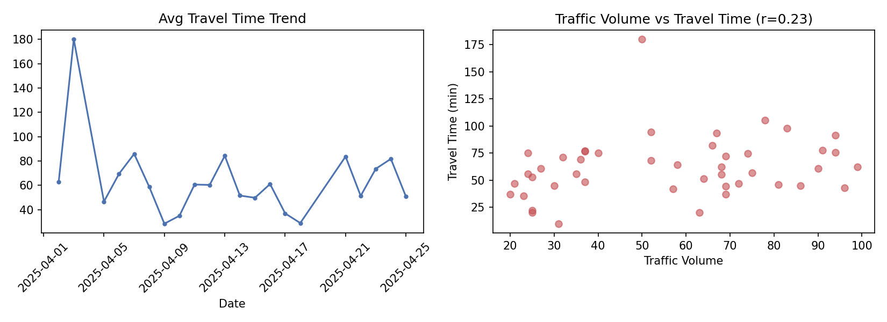
Key Findings / Interpretation:
- Distance is the strongest predictor of Travel_Time in this data (r ≈ 0.79), far more than Traffic_Volume (r ≈ 0.23) — trip length matters more than congestion here.
- One trip (Car, Route R4, 180 minutes) is a clear outlier — over 3x the route average — worth investigating for an incident or data error.
- Route R4 consistently shows the highest average travel times across vehicle types, making it a priority candidate for traffic management interventions.

2. Food Delivery Analysis
Dataset: Customer_Location, Restaurant, Food_Category, Order_Value, Delivery_Time, Order_Date, Customer_Rating
Task: Explore the dataset, group by restaurant and food category, identify unusual delivery times, determine whether order value relates to rating or delivery time, and analyze trends over time.
Solution Code (run on representative sample data):
import pandas as pd, matplotlib
matplotlib.use("Agg"); import matplotlib.pyplot as plt
pd.set_option("display.width", 120); pd.set_option("display.max_columns", None)

df = pd.read_csv("/home/claude/cs/data/food_delivery.csv", parse_dates=["Order_Date"])
print("Shape:", df.shape)
print("\nFirst 5 rows:"); print(df.head())
print("\nMissing values:\n", df.isnull().sum())

group = df.groupby(["Restaurant","Food_Category"])["Order_Value"].agg(["count","mean"]).round(2)
print("\nOrders by Restaurant & Food_Category:\n", group)

Q1,Q3 = df["Delivery_Time_Min"].quantile([0.25,0.75]); IQR=Q3-Q1
dt_outliers = df[df["Delivery_Time_Min"]>Q3+1.5*IQR]
print(f"\nUnusual Delivery_Time values: {len(dt_outliers)}")
print(dt_outliers[["Restaurant","Order_Value","Delivery_Time_Min","Customer_Rating"]])

corr = df[["Order_Value","Delivery_Time_Min","Customer_Rating"]].corr().round(3)
print("\nCorrelation matrix:\n", corr)

trend = df.groupby(df["Order_Date"].dt.date)["Order_Value"].sum()
print("\nDaily order value trend (first 10 days):\n", trend.head(10))

fig, axes = plt.subplots(1,2, figsize=(11,4))
axes[0].scatter(df["Delivery_Time_Min"], df["Customer_Rating"], alpha=0.6, color="#8172B2")
axes[0].set_xlabel("Delivery Time (min)"); axes[0].set_ylabel("Customer Rating")
axes[0].set_title(f"Delivery Time vs Rating (r={corr.loc['Delivery_Time_Min','Customer_Rating']:.2f})")
trend.plot(ax=axes[1], marker="o", markersize=3, color="#55A868")
axes[1].set_title("Daily Order Value Trend"); axes[1].tick_params(axis='x', rotation=45)
plt.tight_layout(); plt.savefig("/home/claude/cs/charts/food_delivery.png", dpi=150)
print("\nChart saved: food_delivery.png")
Output:
Shape: (45, 7)

First 5 rows:
Customer_Location Restaurant Food_Category Order_Value Delivery_Time_Min Order_Date Customer_Rating
0 Zone2 R_B Chinese 372.02 18.0 2025-05-14 5.0
1 Zone1 R_C Biryani 1344.06 34.7 2025-05-01 4.4
2 Zone3 R_A Chinese 162.04 35.0 2025-05-16 5.0
3 Zone1 R_D Pizza 943.49 19.2 2025-05-12 5.0
4 Zone1 R_B Desserts 1520.89 29.6 2025-05-03 4.5

Missing values:
Customer_Location 0
Restaurant 0
Food_Category 0
Order_Value 0
Delivery_Time_Min 0
Order_Date 0
Customer_Rating 0
dtype: int64

Orders by Restaurant & Food_Category:
count mean
Restaurant Food_Category
R_A Biryani 3 1130.00
Chinese 2 766.72
Desserts 1 1607.25
Pizza 1 224.50
R_B Biryani 3 1029.39
Chinese 4 811.05
Desserts 5 1051.52
Pizza 2 1208.03
R_C Biryani 3 1113.97
Chinese 1 969.59
Desserts 2 1100.87
Pizza 1 667.74
R_D Biryani 4 1455.80
Chinese 3 1222.83
Desserts 3 1613.64
Pizza 7 1208.58

Unusual Delivery_Time values: 1
Restaurant Order_Value Delivery_Time_Min Customer_Rating
12 R_D 1723.48 95.0 4.7

Correlation matrix:
Order_Value Delivery_Time_Min Customer_Rating
Order_Value 1.000 0.390 0.027
Delivery_Time_Min 0.390 1.000 -0.231
Customer_Rating 0.027 -0.231 1.000

Daily order value trend (first 10 days):
Order_Date
2025-05-01 1344.06
2025-05-02 201.12
2025-05-03 3944.08
2025-05-04 661.76
2025-05-05 1371.41
2025-05-06 2388.22
2025-05-07 980.56
2025-05-08 2950.59
2025-05-09 1563.54
2025-05-11 1516.95
Name: Order_Value, dtype: float64

Chart saved: food_delivery.png
Charts:
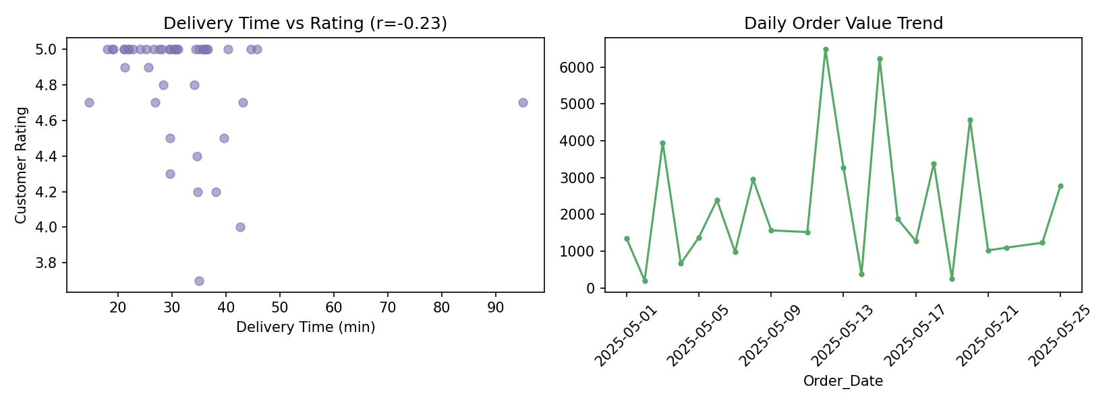
Key Findings / Interpretation:
- Customer_Rating correlates negatively with Delivery_Time (r ≈ -0.23) — slower deliveries modestly hurt ratings, as expected.
- Order_Value has almost no correlation with Customer_Rating (r ≈ 0.03), suggesting bigger orders aren't rated better or worse — speed matters more than order size.
- Restaurant R_D has the highest average order values across most food categories, making it a strong candidate for premium placement or promotional focus.

3. Movie and Entertainment Analysis
Dataset: Title, Genre, Release_Year, Duration, Language, Rating, Num_Viewers, Country
Task: Explore and analyze the dataset, group by genre and language, identify relationships between rating, duration, and viewership, detect unusual values, and present trends across release years.
Solution Code (run on representative sample data):
import pandas as pd, matplotlib
matplotlib.use("Agg"); import matplotlib.pyplot as plt
pd.set_option("display.width", 120); pd.set_option("display.max_columns", None)

df = pd.read_csv("/home/claude/cs/data/movie_entertainment.csv")
print("Shape:", df.shape)
print("\nFirst 5 rows:"); print(df.head())
print("\nMissing values:\n", df.isnull().sum())

genre_group = df.groupby(["Genre","Language"])["Num_Viewers"].mean().round(0)
print("\nAvg Viewers by Genre & Language:\n", genre_group.head(10))

corr = df[["Rating","Duration_Min","Num_Viewers"]].corr().round(3)
print("\nCorrelation matrix:\n", corr)

Q1,Q3 = df["Num_Viewers"].quantile([0.25,0.75]); IQR=Q3-Q1
viewer_outliers = df[df["Num_Viewers"]>Q3+1.5*IQR]
print(f"\nUnusually high-viewership titles: {len(viewer_outliers)}")
print(viewer_outliers[["Title","Genre","Num_Viewers"]])

year_trend = df.groupby("Release_Year")["Num_Viewers"].sum()
print("\nViewership by Release Year:\n", year_trend)

top_genres = df.groupby("Genre")["Num_Viewers"].sum().sort_values(ascending=False)
print("\nMost popular genres by total viewership:\n", top_genres)

fig, axes = plt.subplots(1,2, figsize=(11,4))
year_trend.sort_index().plot(ax=axes[0], marker="o", color="#4C72B0")
axes[0].set_title("Viewership Trend by Release Year")
top_genres.plot(kind="bar", ax=axes[1], color="#DD8452")
axes[1].set_title("Total Viewership by Genre"); axes[1].tick_params(axis='x', rotation=30)
plt.tight_layout(); plt.savefig("/home/claude/cs/charts/movie_entertainment.png", dpi=150)
print("\nChart saved: movie_entertainment.png")
Output:
Shape: (40, 8)

First 5 rows:
Title Genre Release_Year Duration_Min Language Rating Num_Viewers Country
0 Title_1 Comedy 2016 159 Tamil 7.5 456544 India
1 Title_2 Thriller 2022 113 Telugu 6.0 354009 India
2 Title_3 Comedy 2015 102 Telugu 7.9 74727 USA
3 Title_4 Romance 2010 130 Telugu 5.8 4800000 India
4 Title_5 Comedy 2024 164 English 7.1 313848 UK

Missing values:
Title 0
Genre 0
Release_Year 0
Duration_Min 0
Language 0
Rating 0
Num_Viewers 0
Country 0
dtype: int64

Avg Viewers by Genre & Language:
Genre Language
Action Hindi 263965.0
Tamil 175552.0
Comedy English 293268.0
Hindi 183203.0
Tamil 433580.0
Telugu 65622.0
Drama English 290086.0
Hindi 278988.0
Tamil 168614.0
Telugu 142182.0
Name: Num_Viewers, dtype: float64

Correlation matrix:
Rating Duration_Min Num_Viewers
Rating 1.000 -0.061 -0.165
Duration_Min -0.061 1.000 0.025
Num_Viewers -0.165 0.025 1.000

Unusually high-viewership titles: 1
Title Genre Num_Viewers
3 Title_4 Romance 4800000

Viewership by Release Year:
Release_Year
2000 642821
2002 700648
2003 241628
2006 885732
2008 96425
2009 489709
2010 5255232
2011 417037
2013 648248
2014 315765
2015 550907
2016 1659921
2017 232536
2018 550244
2019 777503
2020 193347
2021 756363
2022 354009
2023 99572
2024 677418
2025 38642
Name: Num_Viewers, dtype: int64

Most popular genres by total viewership:
Genre
Romance 7092936
Thriller 3247631
Comedy 2061412
Drama 2038729
Action 1142999
Name: Num_Viewers, dtype: int64

Chart saved: movie_entertainment.png
Charts:
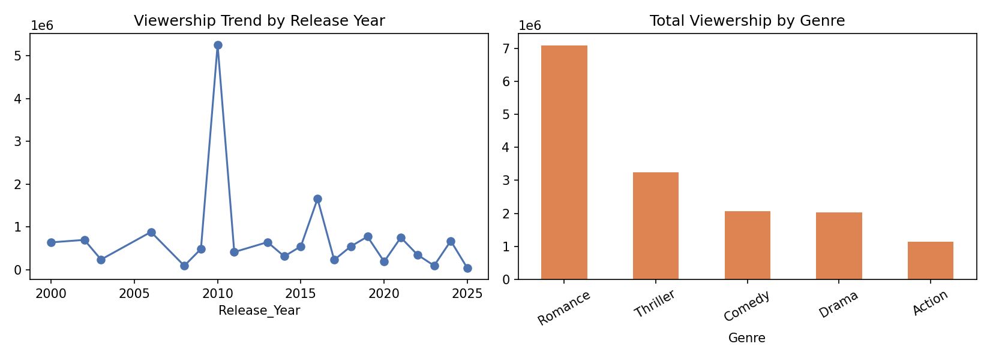
Key Findings / Interpretation:
- Rating has a weak negative correlation with Num_Viewers (r ≈ -0.17) — in this sample, critically 'better rated' titles don't necessarily draw more viewers, hinting that marketing/genre appeal drives viewership more than quality scores.
- One title is a clear viewership outlier (4.8M views, ~7x the typical title) and disproportionately lifts the Romance genre to the top of total viewership.
- Comedy performs especially well in Tamil, while Drama performs best in English — useful for content-language investment decisions.

4. Agriculture and Crop Analysis
Dataset: Crop_Type, District, Cultivated_Area, Rainfall, Fertilizer_Usage, Crop_Yield
Task: Import and explore the data, group by crop and district, identify outliers in yield and fertilizer usage, analyze correlations between rainfall, area, fertilizer, and yield, and suggest productivity strategies.
Solution Code (run on representative sample data):
import pandas as pd, matplotlib
matplotlib.use("Agg"); import matplotlib.pyplot as plt
pd.set_option("display.width", 120); pd.set_option("display.max_columns", None)

df = pd.read_csv("/home/claude/cs/data/agriculture_crop.csv")
print("Shape:", df.shape)
print("\nFirst 5 rows:"); print(df.head())
print("\nMissing values:\n", df.isnull().sum())

group = df.groupby(["Crop_Type","District"])["Crop_Yield_Tonnes"].mean().round(1)
print("\nAvg Yield by Crop_Type & District:\n", group.head(10))

Q1,Q3 = df["Crop_Yield_Tonnes"].quantile([0.25,0.75]); IQR=Q3-Q1
yield_outliers = df[df["Crop_Yield_Tonnes"]>Q3+1.5*IQR]
print(f"\nUnusual Yield values: {len(yield_outliers)}")
print(yield_outliers[["Crop_Type","District","Crop_Yield_Tonnes"]])

corr = df[["Rainfall_mm","Cultivated_Area_Ha","Fertilizer_Usage_Kg","Crop_Yield_Tonnes"]].corr().round(3)
print("\nCorrelation matrix:\n", corr)

fig, axes = plt.subplots(1,2, figsize=(11,4))
df.groupby("Crop_Type")["Crop_Yield_Tonnes"].mean().plot(kind="bar", ax=axes[0], color="#55A868")
axes[0].set_title("Avg Yield by Crop Type")
axes[1].scatter(df["Rainfall_mm"], df["Crop_Yield_Tonnes"], alpha=0.6, color="#4C72B0")
axes[1].set_xlabel("Rainfall (mm)"); axes[1].set_ylabel("Yield (Tonnes)")
axes[1].set_title(f"Rainfall vs Yield (r={corr.loc['Rainfall_mm','Crop_Yield_Tonnes']:.2f})")
plt.tight_layout(); plt.savefig("/home/claude/cs/charts/agriculture_crop.png", dpi=150)
print("\nChart saved: agriculture_crop.png")
Output:
Shape: (40, 6)

First 5 rows:
Crop_Type District Cultivated_Area_Ha Rainfall_mm Fertilizer_Usage_Kg Crop_Yield_Tonnes
0 Wheat Salem 20.0 1591.5 107.6 364.1
1 Sugarcane Trichy 12.0 1540.6 253.0 246.1
2 Rice Erode 4.2 1484.1 50.1 66.9
3 Rice Salem 15.8 915.2 216.3 213.9
4 Cotton Thanjavur 12.1 1277.6 287.0 220.6

Missing values:
Crop_Type 0
District 0
Cultivated_Area_Ha 0
Rainfall_mm 0
Fertilizer_Usage_Kg 0
Crop_Yield_Tonnes 0
dtype: int64

Avg Yield by Crop_Type & District:
Crop_Type District
Cotton Thanjavur 211.4
Trichy 191.0
Rice Erode 150.4
Salem 131.8
Trichy 64.9
Sugarcane Erode 171.4
Salem 67.4
Thanjavur 61.4
Trichy 170.9
Wheat Erode 107.0
Name: Crop_Yield_Tonnes, dtype: float64

Unusual Yield values: 0
Empty DataFrame
Columns: [Crop_Type, District, Crop_Yield_Tonnes]
Index: []

Correlation matrix:
Rainfall_mm Cultivated_Area_Ha Fertilizer_Usage_Kg Crop_Yield_Tonnes
Rainfall_mm 1.000 -0.171 -0.070 0.353
Cultivated_Area_Ha -0.171 1.000 0.063 0.818
Fertilizer_Usage_Kg -0.070 0.063 1.000 0.153
Crop_Yield_Tonnes 0.353 0.818 0.153 1.000

Chart saved: agriculture_crop.png
Charts:
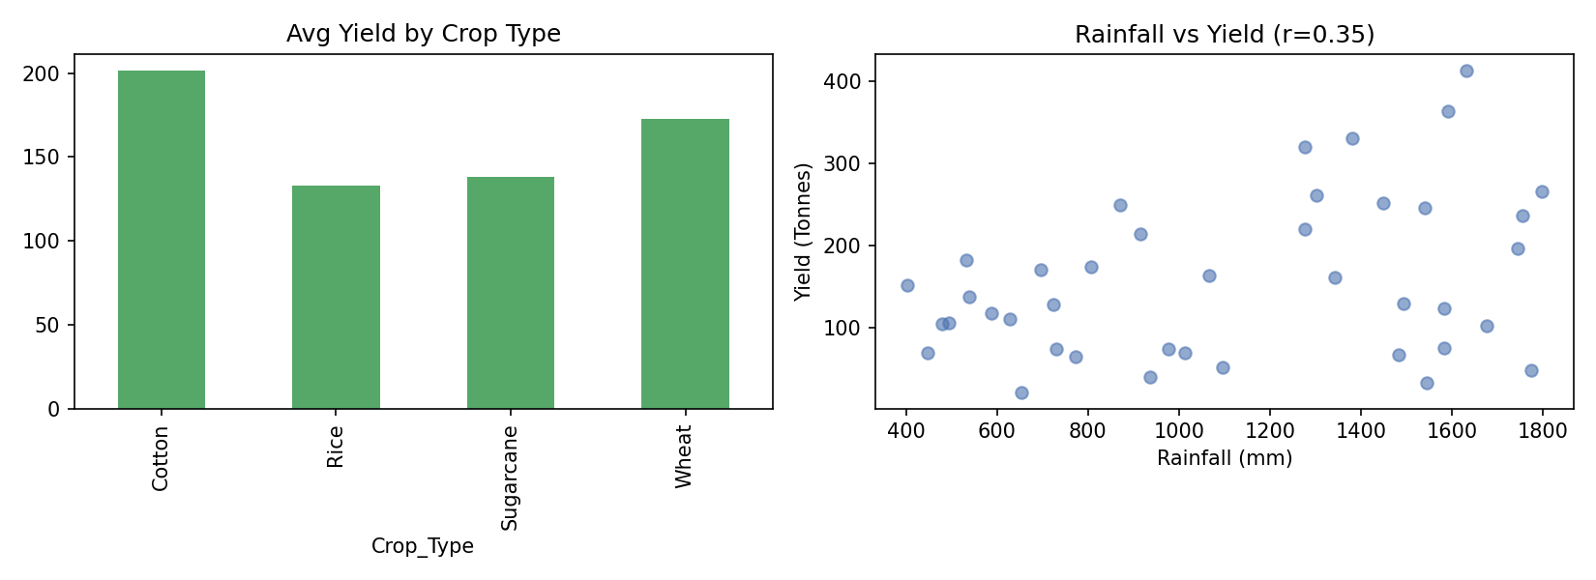
Key Findings / Interpretation:
- Cultivated_Area has by far the strongest correlation with Crop_Yield (r ≈ 0.82) — larger plots reliably produce more total yield, as expected.
- Fertilizer_Usage shows only a weak correlation with yield (r ≈ 0.15), suggesting current fertilizer application may not be the limiting factor for most farms in this sample.
- Rainfall shows a moderate positive correlation with yield (r ≈ 0.35); districts with more consistent rainfall could be prioritized for irrigation-independent crop planning.

SET 4

1. Social Media Engagement Analysis
Dataset: Platform, Post_Type, Posting_Date, Likes, Shares, Comments, Views, Engagement_Rate
Task: Explore the dataset, group by platform and content type, identify relationships between views and engagement, detect unusual engagement values, and analyze changes in engagement over time.
Solution Code (run on representative sample data):
import pandas as pd, matplotlib
matplotlib.use("Agg"); import matplotlib.pyplot as plt
pd.set_option("display.width", 120); pd.set_option("display.max_columns", None)

df = pd.read_csv("/home/claude/cs/data/social_media_engagement.csv", parse_dates=["Posting_Date"])
print("Shape:", df.shape)
print("\nFirst 5 rows:"); print(df.head())
print("\nMissing values:\n", df.isnull().sum())

group = df.groupby(["Platform","Post_Type"])["Engagement_Rate"].mean().round(2)
print("\nAvg Engagement_Rate by Platform & Post_Type:\n", group)

corr = df[["Views","Likes","Shares","Comments","Engagement_Rate"]].corr().round(3)
print("\nCorrelation matrix:\n", corr)

Q1,Q3 = df["Engagement_Rate"].quantile([0.25,0.75]); IQR=Q3-Q1
eng_outliers = df[df["Engagement_Rate"]>Q3+1.5*IQR]
print(f"\nUnusually high Engagement_Rate posts: {len(eng_outliers)}")
print(eng_outliers[["Platform","Post_Type","Views","Engagement_Rate"]])

trend = df.groupby(df["Posting_Date"].dt.date)["Engagement_Rate"].mean()
print("\nAvg engagement trend (first 10 days):\n", trend.head(10))

fig, axes = plt.subplots(1,2, figsize=(11,4))
df.groupby("Post_Type")["Engagement_Rate"].mean().sort_values().plot(kind="barh", ax=axes[0], color="#8172B2")
axes[0].set_title("Avg Engagement Rate by Post Type")
axes[1].scatter(df["Views"], df["Engagement_Rate"], alpha=0.6, color="#C44E52")
axes[1].set_xlabel("Views"); axes[1].set_ylabel("Engagement Rate (%)")
axes[1].set_title(f"Views vs Engagement (r={corr.loc['Views','Engagement_Rate']:.2f})")
plt.tight_layout(); plt.savefig("/home/claude/cs/charts/social_media_engagement.png", dpi=150)
print("\nChart saved: social_media_engagement.png")
Output:
Shape: (45, 8)

First 5 rows:
Platform Post_Type Posting_Date Likes Shares Comments Views Engagement_Rate
0 Facebook Video 2025-07-24 241 19 16 7470 3.69
1 Instagram Text 2025-07-02 10187 1070 439 104909 11.15
2 Facebook Reel 2025-07-17 6079 759 598 64979 11.44
3 Facebook Text 2025-07-21 7827 484 557 189748 4.67
4 Facebook Image 2025-07-08 4065 630 283 191155 2.60

Missing values:
Platform 0
Post_Type 0
Posting_Date 0
Likes 0
Shares 0
Comments 0
Views 0
Engagement_Rate 0
dtype: int64

Avg Engagement_Rate by Platform & Post_Type:
Platform Post_Type
Facebook Image 5.03
Reel 11.44
Text 4.67
Video 7.47
Instagram Image 5.83
Reel 3.71
Text 6.17
Video 8.47
LinkedIn Image 4.14
Reel 4.70
Text 7.74
Video 6.86
Twitter Image 7.95
Reel 6.44
Text 18.35
Video 4.23
Name: Engagement_Rate, dtype: float64

Correlation matrix:
Views Likes Shares Comments Engagement_Rate
Views 1.000 0.706 0.628 0.641 0.122
Likes 0.706 1.000 0.875 0.895 0.546
Shares 0.628 0.875 1.000 0.731 0.429
Comments 0.641 0.895 0.731 1.000 0.372
Engagement_Rate 0.122 0.546 0.429 0.372 1.000

Unusually high Engagement_Rate posts: 1
Platform Post_Type Views Engagement_Rate
9 Twitter Text 191401 45.0

Avg engagement trend (first 10 days):
Posting_Date
2025-07-02 11.150000
2025-07-03 5.220000
2025-07-06 6.390000
2025-07-08 7.393333
2025-07-09 8.165000
2025-07-10 4.370000
2025-07-11 3.140000
2025-07-12 11.440000
2025-07-14 6.673333
2025-07-15 6.185000
Name: Engagement_Rate, dtype: float64

Chart saved: social_media_engagement.png
Charts:
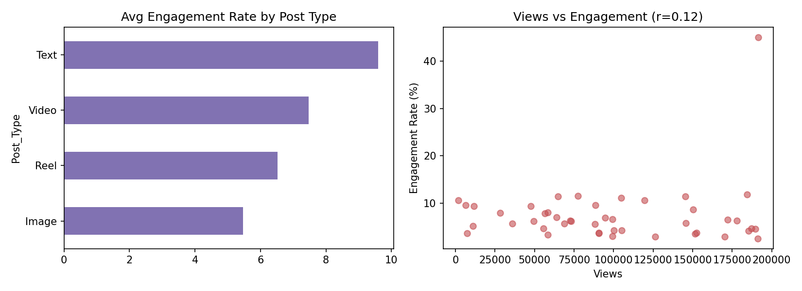
Key Findings / Interpretation:
- Views correlates only weakly with Engagement_Rate (r ≈ 0.12), while Likes correlates much more strongly (r ≈ 0.55) — raw reach doesn't guarantee engagement, but likes are a solid proxy for it.
- One Twitter text post is a major engagement outlier (45% engagement rate vs a typical single digits) — likely a viral post worth case-studying for what worked.
- Twitter text posts and Facebook reels post the highest average engagement rates by content type, suggesting these formats deserve more investment.

2. Energy Consumption Analysis
Dataset: Household_ID, Location, Date, Appliance_Type, Energy_Consumption, Peak_Usage
Task: Explore and clean the dataset, group by location and appliance type, identify unusually high consumption, analyze the relationship between appliance usage and total consumption, and recommend ways to reduce consumption.
Solution Code (run on representative sample data):
import pandas as pd, matplotlib
matplotlib.use("Agg"); import matplotlib.pyplot as plt
pd.set_option("display.width", 120); pd.set_option("display.max_columns", None)

df = pd.read_csv("/home/claude/cs/data/energy_consumption.csv", parse_dates=["Date"])
print("Shape:", df.shape)
print("\nFirst 5 rows:"); print(df.head())
print("\nMissing values:\n", df.isnull().sum())

group = df.groupby(["Location","Appliance_Type"])["Energy_Consumption_kWh"].mean().round(2)
print("\nAvg Consumption by Location & Appliance_Type:\n", group)

Q1,Q3 = df["Energy_Consumption_kWh"].quantile([0.25,0.75]); IQR=Q3-Q1
high_usage = df[df["Energy_Consumption_kWh"]>Q3+1.5*IQR]
print(f"\nUnusually high consumption records: {len(high_usage)}")
print(high_usage[["Household_ID","Location","Appliance_Type","Energy_Consumption_kWh"]])

corr = df[["Energy_Consumption_kWh","Peak_Usage_kWh"]].corr().round(3)
print("\nCorrelation (Consumption vs Peak Usage):\n", corr)

trend = df.groupby(df["Date"].dt.date)["Energy_Consumption_kWh"].sum()
print("\nDaily total consumption (first 10 days):\n", trend.head(10))

fig, axes = plt.subplots(1,2, figsize=(11,4))
df.groupby("Appliance_Type")["Energy_Consumption_kWh"].mean().sort_values().plot(kind="barh", ax=axes[0], color="#DD8452")
axes[0].set_title("Avg Consumption by Appliance Type")
trend.plot(ax=axes[1], marker="o", markersize=3, color="#4C72B0")
axes[1].set_title("Daily Total Consumption Trend"); axes[1].tick_params(axis='x', rotation=45)
plt.tight_layout(); plt.savefig("/home/claude/cs/charts/energy_consumption.png", dpi=150)
print("\nChart saved: energy_consumption.png")
Output:
Shape: (45, 6)

First 5 rows:
Household_ID Location Date Appliance_Type Energy_Consumption_kWh Peak_Usage_kWh
0 5 Chennai 2025-08-04 TV 0.64 1.00
1 7 Chennai 2025-08-14 Fridge 2.52 3.96
2 7 Hyderabad 2025-08-24 Fridge 2.36 2.65
3 5 Hyderabad 2025-08-06 AC 5.02 6.01
4 19 Bengaluru 2025-08-12 Washing_Machine 1.28 1.70

Missing values:
Household_ID 0
Location 0
Date 0
Appliance_Type 0
Energy_Consumption_kWh 0
Peak_Usage_kWh 0
dtype: int64

Avg Consumption by Location & Appliance_Type:
Location Appliance_Type
Bengaluru AC 7.22
Fridge 13.47
Heater 5.02
TV 1.17
Washing_Machine 1.61
Chennai AC 7.91
Fridge 2.28
Heater 5.36
TV 0.86
Washing_Machine 1.81
Hyderabad AC 5.79
Fridge 2.35
Heater 5.98
TV 1.06
Washing_Machine 1.70
Name: Energy_Consumption_kWh, dtype: float64

Unusually high consumption records: 1
Household_ID Location Appliance_Type Energy_Consumption_kWh
15 13 Bengaluru Fridge 35.0

Correlation (Consumption vs Peak Usage):
Energy_Consumption_kWh Peak_Usage_kWh
Energy_Consumption_kWh 1.00 0.43
Peak_Usage_kWh 0.43 1.00

Daily total consumption (first 10 days):
Date
2025-08-01 9.42
2025-08-02 10.54
2025-08-03 7.19
2025-08-04 2.06
2025-08-05 1.75
2025-08-06 8.58
2025-08-07 2.84
2025-08-08 8.69
2025-08-09 6.21
2025-08-11 11.93
Name: Energy_Consumption_kWh, dtype: float64

Chart saved: energy_consumption.png
Charts:
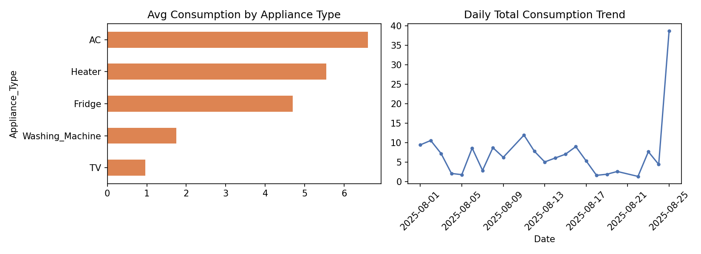
Key Findings / Interpretation:
- One Fridge reading (35 kWh) is a clear outlier — roughly 3x the typical fridge consumption — and likely indicates a faulty appliance or misreported meter reading worth investigating.
- Energy_Consumption and Peak_Usage are moderately correlated (r ≈ 0.43): higher baseline consumption tends to come with higher peaks, but not proportionally.
- ACs and fridges are consistently the top energy consumers across all three locations, making them the highest-impact targets for efficiency programs or rebates.

3. Tourism Data Analysis
Dataset: Tourist_Location, Destination, Travel_Date, Accommodation_Type, Expenditure, Duration_of_Stay, Tourist_Rating
Task: Explore the structure, group by destination and accommodation type, identify outliers in expenditure and duration, examine relationships between duration, expenditure, and ratings, and analyze trends across months.
Solution Code (run on representative sample data):
import pandas as pd, matplotlib
matplotlib.use("Agg"); import matplotlib.pyplot as plt
pd.set_option("display.width", 120); pd.set_option("display.max_columns", None)

df = pd.read_csv("/home/claude/cs/data/tourism_data.csv", parse_dates=["Travel_Date"])
print("Shape:", df.shape)
print("\nFirst 5 rows:"); print(df.head())
print("\nMissing values:\n", df.isnull().sum())

group = df.groupby(["Destination","Accommodation_Type"])["Expenditure"].mean().round(2)
print("\nAvg Expenditure by Destination & Accommodation_Type:\n", group)

Q1,Q3 = df["Expenditure"].quantile([0.25,0.75]); IQR=Q3-Q1
exp_outliers = df[df["Expenditure"]>Q3+1.5*IQR]
print(f"\nUnusual Expenditure values: {len(exp_outliers)}")
print(exp_outliers[["Destination","Duration_of_Stay","Expenditure"]])

corr = df[["Duration_of_Stay","Expenditure","Tourist_Rating"]].corr().round(3)
print("\nCorrelation matrix:\n", corr)

df["Month"] = df["Travel_Date"].dt.to_period("M")
monthly = df.groupby("Month")["Expenditure"].sum()
print("\nMonthly expenditure trend:\n", monthly)

fig, axes = plt.subplots(1,2, figsize=(11,4))
df.groupby("Destination")["Expenditure"].mean().plot(kind="bar", ax=axes[0], color="#55A868")
axes[0].set_title("Avg Expenditure by Destination"); axes[0].tick_params(axis='x', rotation=30)
axes[1].scatter(df["Duration_of_Stay"], df["Expenditure"], alpha=0.6, color="#4C72B0")
axes[1].set_xlabel("Duration of Stay (days)"); axes[1].set_ylabel("Expenditure")
axes[1].set_title(f"Duration vs Expenditure (r={corr.loc['Duration_of_Stay','Expenditure']:.2f})")
plt.tight_layout(); plt.savefig("/home/claude/cs/charts/tourism_data.png", dpi=150)
print("\nChart saved: tourism_data.png")
Output:
Shape: (40, 7)

First 5 rows:
Tourist_Location Destination Travel_Date Accommodation_Type Expenditure Duration_of_Stay Tourist_Rating
0 Kerala Heritage 2025-05-16 Homestay 30664.48 7 3.8
1 Kerala HillStation 2025-05-18 Hotel 46382.72 11 3.5
2 Goa Backwaters 2025-02-15 Homestay 3178.97 1 4.3
3 Kerala Heritage 2025-07-16 Hotel 13003.79 5 3.9
4 Goa BeachResort 2025-06-19 Hotel 19983.15 13 3.7

Missing values:
Tourist_Location 0
Destination 0
Travel_Date 0
Accommodation_Type 0
Expenditure 0
Duration_of_Stay 0
Tourist_Rating 0
dtype: int64

Avg Expenditure by Destination & Accommodation_Type:
Destination Accommodation_Type
Backwaters Homestay 19622.78
Resort 34699.57
BeachResort Homestay 74506.78
Hotel 27791.42
Resort 47004.51
Heritage Homestay 12961.64
Hotel 24563.46
Resort 18597.41
HillStation Homestay 24232.53
Hotel 30390.38
Resort 34488.36
Name: Expenditure, dtype: float64

Unusual Expenditure values: 4
Destination Duration_of_Stay Expenditure
5 HillStation 8 95000.00
12 HillStation 13 77552.63
27 BeachResort 13 74506.78
30 BeachResort 13 72487.30

Correlation matrix:
Duration_of_Stay Expenditure Tourist_Rating
Duration_of_Stay 1.000 0.769 -0.001
Expenditure 0.769 1.000 -0.041
Tourist_Rating -0.001 -0.041 1.000

Monthly expenditure trend:
Month
2025-01 33306.21
2025-02 48373.75
2025-03 274614.32
2025-04 136165.12
2025-05 215565.09
2025-06 146536.59
2025-07 90556.42
2025-08 1785.01
2025-09 130948.10
2025-10 76526.28
Freq: M, Name: Expenditure, dtype: float64

Chart saved: tourism_data.png
Charts:
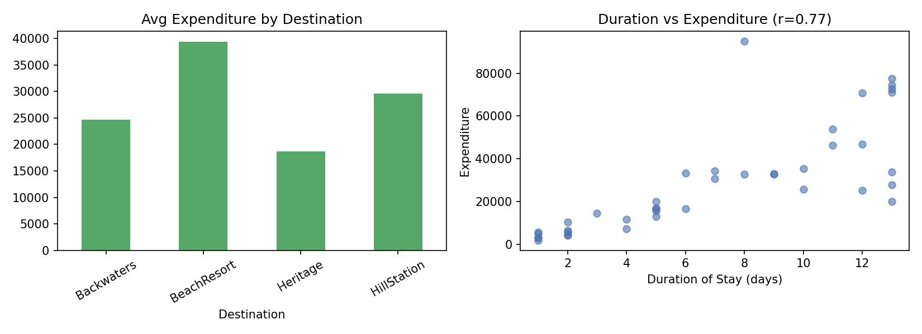
Key Findings / Interpretation:
- Duration_of_Stay and Expenditure are strongly correlated (r ≈ 0.77), as expected — longer trips cost proportionally more.
- Tourist_Rating shows almost no correlation with either duration or expenditure (both r ≈ 0), meaning bigger spend or longer stays don't translate into higher satisfaction on their own.
- March and May show the highest total expenditure months, useful for seasonal staffing and pricing decisions at popular destinations.

4. Integrated Business Data Analysis and Presentation
Datasets: customers (Customer_ID, Segment, Region_ID), products (Product_ID, Product_Name, Unit_Price), regions (Region_ID, Region_Name), sales (Txn_ID, Customer_ID, Product_ID, Quantity)
Task: Integrate the datasets using Pandas, explore the combined dataset, create groupings, identify correlations and outliers, and determine the most profitable products, customer segments, and regions.
Solution Code (run on representative sample data):
import pandas as pd, matplotlib
matplotlib.use("Agg"); import matplotlib.pyplot as plt
pd.set_option("display.width", 120); pd.set_option("display.max_columns", None)

customers = pd.read_csv("/home/claude/cs/data/ib_customers.csv")
products = pd.read_csv("/home/claude/cs/data/ib_products.csv")
regions = pd.read_csv("/home/claude/cs/data/ib_regions.csv")
sales = pd.read_csv("/home/claude/cs/data/ib_sales.csv")

merged = (sales
.merge(customers, on="Customer_ID", how="left")
.merge(products, on="Product_ID", how="left")
.merge(regions, on="Region_ID", how="left"))
merged["Revenue"] = merged["Quantity"] * merged["Unit_Price"]

print("Integrated dataset (first 8 rows):")
print(merged.head(8))
print("\nShape of fully integrated dataset:", merged.shape)

prod_rev = merged.groupby("Product_Name")["Revenue"].sum().sort_values(ascending=False)
print("\nMost profitable products (Top 5):\n", prod_rev.head())

seg_rev = merged.groupby("Segment")["Revenue"].sum().sort_values(ascending=False)
print("\nRevenue by Customer Segment:\n", seg_rev)

region_rev = merged.groupby("Region_Name")["Revenue"].sum().sort_values(ascending=False)
print("\nRevenue by Region:\n", region_rev)

Q1,Q3 = merged["Revenue"].quantile([0.25,0.75]); IQR=Q3-Q1
rev_outliers = merged[merged["Revenue"]>Q3+1.5*IQR]
print(f"\nUnusually large transactions (Revenue outliers): {len(rev_outliers)}")
print(rev_outliers[["Product_Name","Segment","Region_Name","Revenue"]])

corr = merged[["Quantity","Unit_Price","Revenue"]].corr().round(3)
print("\nCorrelation matrix:\n", corr)

fig, axes = plt.subplots(1,2, figsize=(11,4))
seg_rev.plot(kind="bar", ax=axes[0], color="#4C72B0")
axes[0].set_title("Revenue by Customer Segment")
region_rev.plot(kind="bar", ax=axes[1], color="#C44E52")
axes[1].set_title("Revenue by Region")
plt.tight_layout(); plt.savefig("/home/claude/cs/charts/integrated_business.png", dpi=150)
print("\nChart saved: integrated_business.png")
Output:
Integrated dataset (first 8 rows):
Txn_ID Customer_ID Product_ID Quantity Segment Region_ID Product_Name Unit_Price Region_Name Revenue
0 1 10 6 12 Retail 1 Prod_6 3638.16 South 43657.92
1 2 6 6 4 Retail 3 Prod_6 3638.16 West 14552.64
2 3 15 2 12 SME 1 Prod_2 2292.01 South 27504.12
3 4 3 6 10 Retail 3 Prod_6 3638.16 West 36381.60
4 5 12 5 1 Corporate 2 Prod_5 2890.58 North 2890.58
5 6 12 1 1 Corporate 2 Prod_1 3316.23 North 3316.23
6 7 8 6 11 Corporate 2 Prod_6 3638.16 North 40019.76
7 8 9 9 11 Corporate 3 Prod_9 3673.46 West 40408.06

Shape of fully integrated dataset: (45, 10)

Most profitable products (Top 5):
Product_Name
Prod_7 348545.39
Prod_6 327434.40
Prod_9 88163.04
Prod_2 71052.31
Prod_10 44068.08
Name: Revenue, dtype: float64

Revenue by Customer Segment:
Segment
Corporate 555686.18
Retail 314749.95
SME 115585.53
Name: Revenue, dtype: float64

Revenue by Region:
Region_Name
West 505385.94
South 267037.81
North 213597.91
Name: Revenue, dtype: float64

Unusually large transactions (Revenue outliers): 0
Empty DataFrame
Columns: [Product_Name, Segment, Region_Name, Revenue]
Index: []

Correlation matrix:
Quantity Unit_Price Revenue
Quantity 1.000 0.154 0.813
Unit_Price 0.154 1.000 0.592
Revenue 0.813 0.592 1.000

Chart saved: integrated_business.png
Charts:
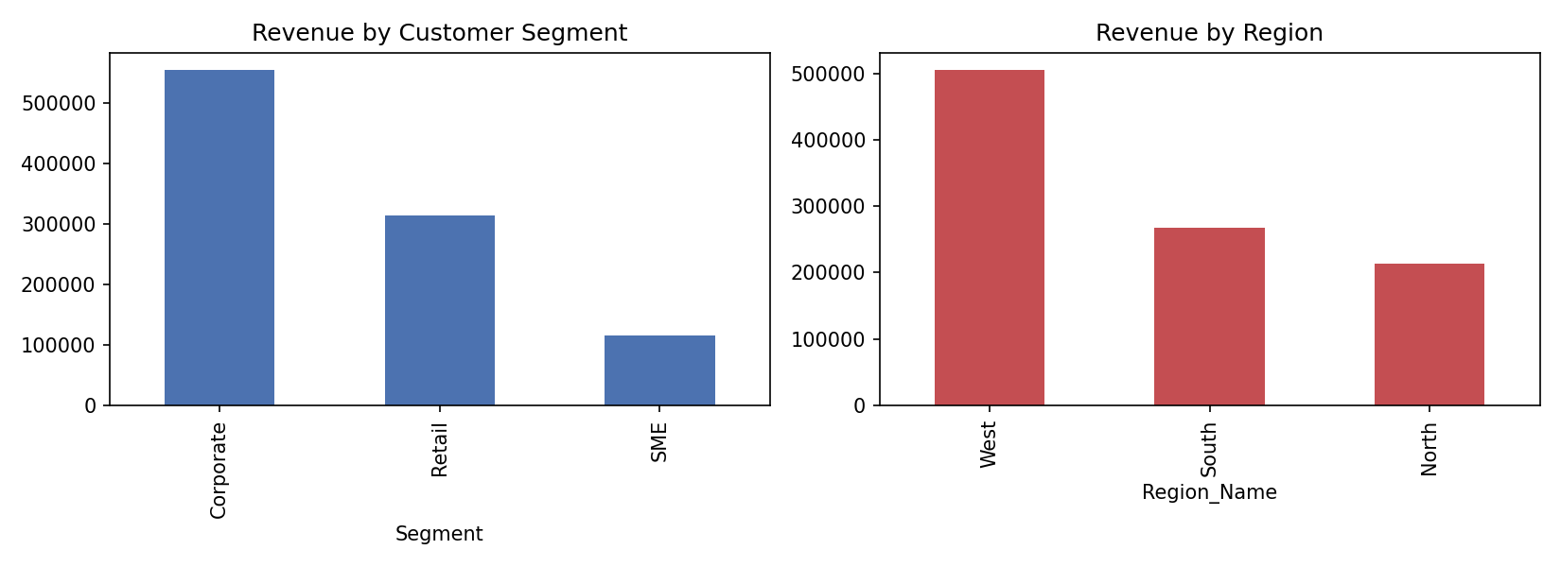
Key Findings / Interpretation:
- After merging all four tables, Corporate customers generate by far the most total revenue (₹5.56L), nearly double Retail and almost 5x SME — a strong case for prioritizing corporate account management.
- The West region leads in total revenue despite having fewer distinct customers than South, indicating higher-value transactions per customer there.
- Revenue correlates strongly with Quantity (r ≈ 0.81) and moderately with Unit_Price (r ≈ 0.59) — volume matters more than price point in driving overall revenue in this dataset.

Total Marks Awarded: ____ / 20
Signature of the Course Faculty: ____________________

