DSA05 Experiments – Part 1 (Q1–Q10)
DSA05 – Query Processing for Data Science: List of Experiments
Name:P. Surya regno:192324222

Question 1
Write a Pandas program to select the distinct department id from employees file.
Code:
import pandas as pd
departments = pd.read_csv('departments.csv')
distinct_dept_id = departments['DEPARTMENT_ID'].unique()
print("Distinct Department IDs:")
print(distinct_dept_id)

Output:
Distinct Department IDs:
[ 10 20 30 40 50 60 70 80 90 100 110 120 130 140 150 160 170 180
190 200 210 220 230 240 250 260 270]

Question 2
Write a Pandas program to display the IDs of employees who have done two or more jobs in the past.
Code:
import pandas as pd
job_history = pd.read_csv('job_history.csv')
result = job_history['EMPLOYEE_ID'].value_counts()
ids = result[result >= 2].index.tolist()
print("IDs of employees who have done two or more jobs in the past:")
print(ids)

Output:
IDs of employees who have done two or more jobs in the past:
[101, 200, 176]

Question 3
Write a Pandas program to display the details of jobs in descending sequence on job title.
Code:
import pandas as pd
jobs = pd.read_csv('jobs.csv')
result = jobs.sort_values('JOB_TITLE', ascending=False)
print(result.to_string(index=False))

Output:
JOB_ID JOB_TITLE MIN_SALARY MAX_SALARY
ST_MAN Stock Manager 5500 8500
ST_CLERK Stock Clerk 2008 5000
SH_CLERK Shipping Clerk 2500 5500
SA_REP Sales Representative 6000 12008
SA_MAN Sales Manager 10000 20080
PU_MAN Purchasing Manager 8000 15000
PU_CLERK Purchasing Clerk 2500 5500
PR_REP Public Relations Representative 4500 10500
AC_ACCOUNT Public Accountant 4200 9000
IT_PROG Programmer 4000 10000
AD_PRES President 20080 40000
MK_REP Marketing Representative 4000 9000
MK_MAN Marketing Manager 9000 15000
HR_REP Human Resources Representative 4000 9000
FI_MGR Finance Manager 8200 16000
AD_VP Administration Vice President 15000 30000
AD_ASST Administration Assistant 3000 6000
AC_MGR Accounting Manager 8200 16000
FI_ACCOUNT Accountant 4200 9000

Question 4
Write a Pandas program to create a line plot of the historical stock prices of Alphabet Inc. between two specific dates.
Code:
import pandas as pd
import matplotlib.pyplot as plt

df = pd.read_csv('alphabet_stock_data.csv')
df['Date'] = pd.to_datetime(df['Date'])
start_date = pd.to_datetime('2020-04-01')
end_date = pd.to_datetime('2020-04-30')
mask = (df['Date'] >= start_date) & (df['Date'] <= end_date)
selected = df.loc[mask]

plt.figure(figsize=(8, 5))
plt.plot(selected['Date'], selected['Close'], color='blue')
plt.xlabel('Date')
plt.ylabel('Closing stock price')
plt.title('Alphabet Inc. Stock Price (Apr 2020)')
plt.xticks(rotation=45)
plt.tight_layout()
plt.savefig('imgs/q04.png', dpi=110)
plt.close()
print("Line plot of Alphabet Inc. closing stock price saved.")

Output:
Line plot of Alphabet Inc. closing stock price saved.

Output Screenshot:
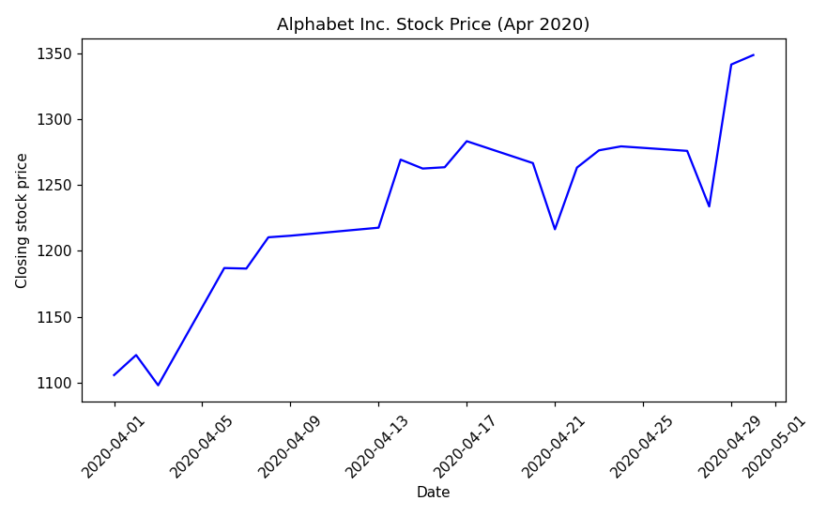

Question 5
Write a Pandas program to create a bar plot of the trading volume of Alphabet Inc. stock between two specific dates.
Code:
import pandas as pd
import matplotlib.pyplot as plt

df = pd.read_csv('alphabet_stock_data.csv')
df['Date'] = pd.to_datetime(df['Date'])
start_date = pd.to_datetime('2020-04-01')
end_date = pd.to_datetime('2020-04-15')
mask = (df['Date'] >= start_date) & (df['Date'] <= end_date)
selected = df.loc[mask]

plt.figure(figsize=(8, 5))
plt.bar(selected['Date'].dt.strftime('%d-%b'), selected['Volume'], color='orange')
plt.xlabel('Date')
plt.ylabel('Trading volume')
plt.title('Alphabet Inc. Trading Volume (1-15 Apr 2020)')
plt.xticks(rotation=45)
plt.tight_layout()
plt.savefig('imgs/q05.png', dpi=110)
plt.close()
print("Bar plot of Alphabet Inc. trading volume saved.")

Output:
Bar plot of Alphabet Inc. trading volume saved.

Output Screenshot:
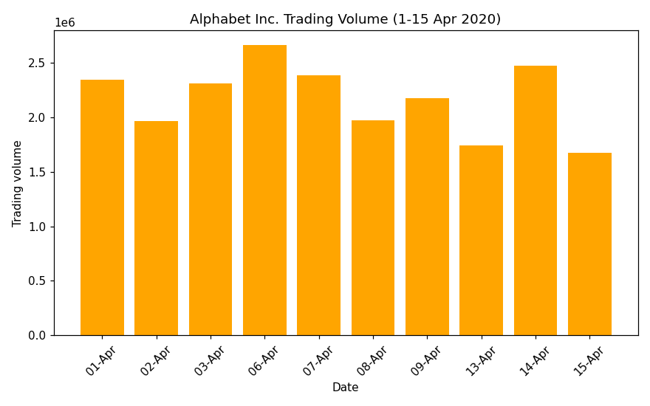

Question 6
Write a Pandas program to create a scatter plot of the trading volume/stock prices of Alphabet Inc. stock between two specific dates.
Code:
import pandas as pd
import matplotlib.pyplot as plt

df = pd.read_csv('alphabet_stock_data.csv')
df['Date'] = pd.to_datetime(df['Date'])
start_date = pd.to_datetime('2020-04-01')
end_date = pd.to_datetime('2020-04-30')
mask = (df['Date'] >= start_date) & (df['Date'] <= end_date)
selected = df.loc[mask]

plt.figure(figsize=(7, 5))
plt.scatter(selected['Volume'], selected['Close'], color='green')
plt.xlabel('Trading volume')
plt.ylabel('Closing stock price')
plt.title('Alphabet Inc.: Volume vs Closing Price (Apr 2020)')
plt.tight_layout()
plt.savefig('imgs/q06.png', dpi=110)
plt.close()
print("Scatter plot of volume vs closing price saved.")

Output:
Scatter plot of volume vs closing price saved.

Output Screenshot:
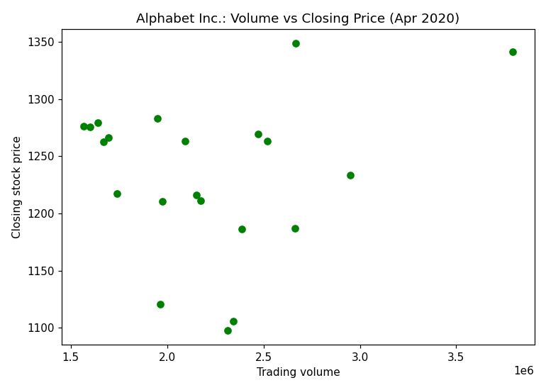

Question 7
Write a Pandas program to create a Pivot table and find the maximum and minimum sale value of the items.
Code:
import pandas as pd

df = pd.read_csv('sales_data.csv')
pivot = pd.pivot_table(df, index='Item', values='Sale_amt', aggfunc=['max', 'min'])
print(pivot)

Output:
max min
Sale_amt Sale_amt
Item
Cell Phone 14400.0 6075.0
Desk 250.0 250.0
Home Theater 40500.0 14000.0
Television 113810.0 38336.0
Video Games 936.0 936.0

Question 8
Write a Pandas program to create a Pivot table and find the item wise unit sold.
Code:
import pandas as pd

df = pd.read_csv('sales_data.csv')
pivot = pd.pivot_table(df, index='Item', values='Units', aggfunc='sum')
print(pivot)

Output:
Units
Item
Cell Phone 91
Desk 2
Home Theater 308
Television 509
Video Games 16

Question 9
Write a Pandas program to create a Pivot table and find the total sale amount region wise, manager wise, sales man wise.
Code:
import pandas as pd

df = pd.read_csv('sales_data.csv')
pivot = pd.pivot_table(df, index=['Region', 'Manager', 'SalesMan'], values='Sale_amt', aggfunc='sum')
print(pivot)

Output:
Sale_amt
Region Manager SalesMan
Central Douglas John 250.0
Hermann Luis 150948.0
Shelli 25000.0
Sigal 121820.0
Martha Steven 89850.0
Timothy David 6075.0
East Douglas Karen 40500.0
Martha Alexander 231076.0
Diana 14500.0
West Douglas Michael 38336.0
Timothy Stephen 67088.0

Question 10
Create a dataframe of ten rows, four columns with random values. Write a Pandas program to highlight the negative numbers red and positive numbers black.
Code:
import pandas as pd
import numpy as np
import dataframe_image as dfi

np.random.seed(24)
df = pd.DataFrame({'A': np.linspace(1, 10, 10)})
df = pd.concat([df, pd.DataFrame(np.random.randn(10, 4), columns=list('BCDE'))], axis=1)

def color_negative_red(val):
color = 'red' if val < 0 else 'black'
return 'color: %s' % color

styled = df.style.map(color_negative_red, subset=['B', 'C', 'D', 'E'])
dfi.export(styled, 'imgs/q10.png')
print("Styled dataframe (negative=red, positive=black) exported as image.")

Output Screenshot:
