DSA05 Experiments – Part 3 (Q21–Q30)
DSA05 – Query Processing for Data Science: List of Experiments
Name: P. Surya reg no:192324222

Question 21
Write a Pandas program to swap the cases of a specified character column in a given DataFrame.
Code:
import pandas as pd

df = pd.DataFrame({
'company_code': ['Abcd', 'EFGF', 'skfow', 'Trgfk'],
'date_of_sale': ['12/05/2002', '16/02/1999', '25/09/1998', '12/02/2022'],
'sale_amount': [12348.5, 233331.2, 22.5, 2566552.0]
})
df['company_code'] = df['company_code'].str.swapcase()
print(df)

Output:
company_code date_of_sale sale_amount
0 aBCD 12/05/2002 12348.5
1 efgf 16/02/1999 233331.2
2 SKFOW 25/09/1998 22.5
3 tRGFK 12/02/2022 2566552.0

Question 22
Write a Python program to draw a line with suitable label in the x axis, y axis and a title.
Code:
import matplotlib.pyplot as plt

x = range(1, 50)
y = [value * 3 for value in x]

plt.plot(x, y)
plt.xlabel('x - axis')
plt.ylabel('y - axis')
plt.title('Draw a line.')
plt.savefig('imgs/q22.png', dpi=110)
plt.close()
print("Line plot with axis labels and title saved.")

Output:
Line plot with axis labels and title saved.

Output Screenshot:
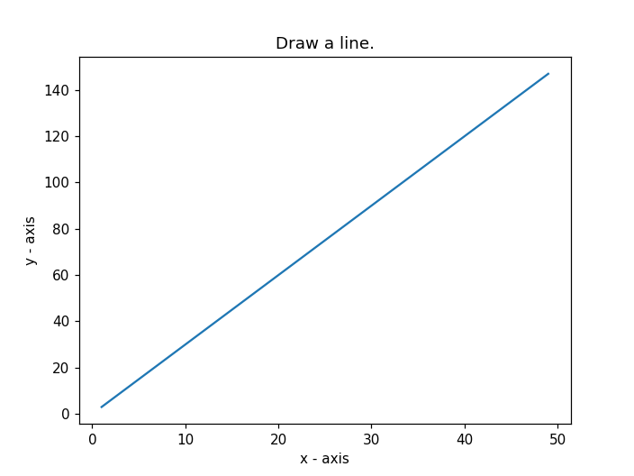

Question 23
Write a Python program to draw a line using given axis values taken from a text file, with suitable label in the x axis, y axis and a title.
Code:
import matplotlib.pyplot as plt

with open('test.txt') as f:
lines = f.readlines()

x = [float(line.split()[0]) for line in lines]
y = [float(line.split()[1]) for line in lines]

plt.plot(x, y, marker='o')
plt.xlabel('x - axis')
plt.ylabel('y - axis')
plt.title('Sample graph!')
plt.savefig('imgs/q23.png', dpi=110)
plt.close()
print("Line plot from text.txt saved.")

Output:
Line plot from text.txt saved.

Output Screenshot:
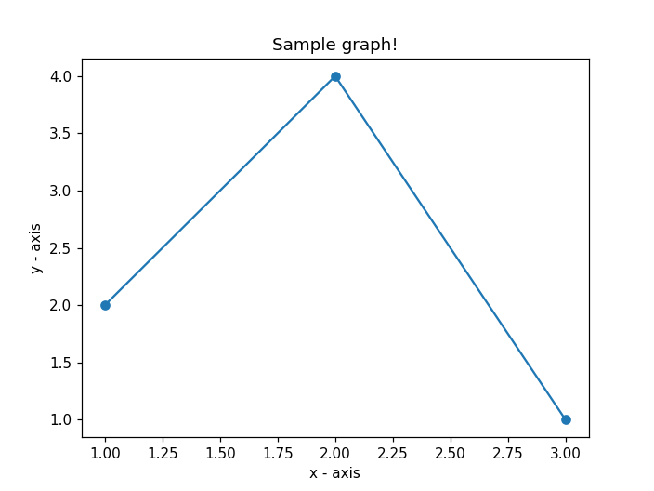

Question 24
Write a Python program to draw line charts of the financial data of Alphabet Inc. between October 3, 2016 to October 7, 2016.
Code:
import pandas as pd
import matplotlib.pyplot as plt

df = pd.read_csv('fdata.csv')
df = df.set_index('Date')
df.plot(figsize=(8, 5))
plt.title('Financial data of Alphabet Inc. (Oct 3-7, 2016)')
plt.savefig('imgs/q24.png', dpi=110)
plt.close()
print("Line chart of Alphabet Inc. financial data saved.")

Output:
Line chart of Alphabet Inc. financial data saved.

Output Screenshot:
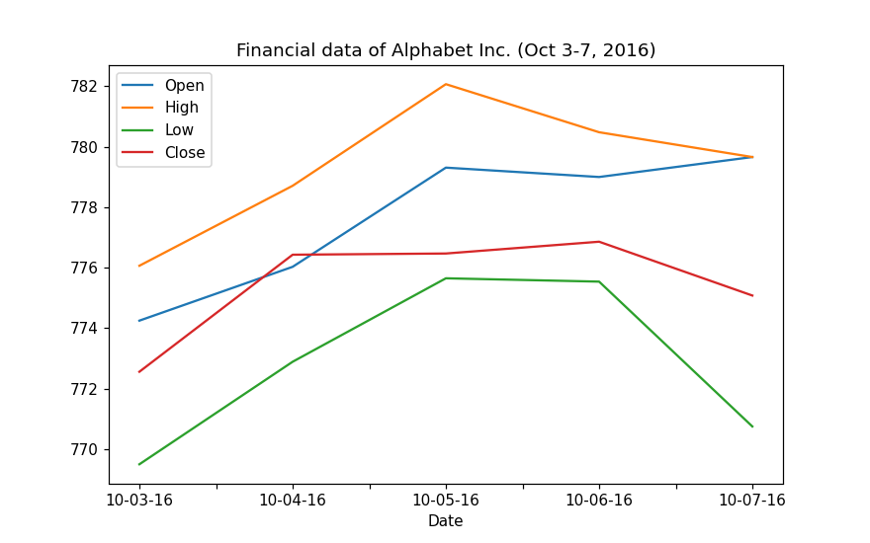

Question 25
Write a Python program to plot two or more lines with legends, different widths and colors.
Code:
import matplotlib.pyplot as plt

x1 = [10, 20, 30]
y1 = [20, 40, 10]
x2 = [10, 20, 30]
y2 = [40, 10, 30]

plt.plot(x1, y1, color='blue', linewidth=3, label='line1-width-3')
plt.plot(x2, y2, color='red', linewidth=5, label='line2-width-5')
plt.xlabel('x - axis')
plt.ylabel('y - axis')
plt.title('Two or more lines with different widths and colors with suitable legends')
plt.legend()
plt.savefig('imgs/q25.png', dpi=110)
plt.close()
print("Multi-line plot with legends saved.")

Output Screenshot:
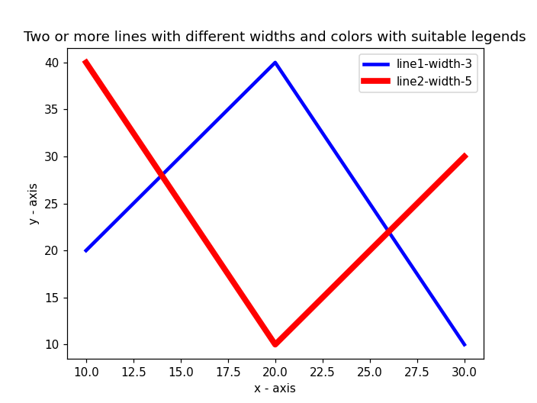

Question 26
Write a Python program to create multiple plots.
Code:
import matplotlib.pyplot as plt

x = [1, 2, 3, 4, 5]
y1 = [10, 20, 25, 30, 40]
y2 = [5, 15, 20, 25, 30]
y3 = [2, 8, 12, 18, 24]

fig = plt.figure(figsize=(8, 8))
ax1 = plt.subplot(2, 1, 1)
ax1.plot(x, y1)

ax2 = plt.subplot(2, 3, 4)
ax2.plot(x, y2)

ax3 = plt.subplot(2, 3, 5)
ax3.plot(x, y3)

ax4 = plt.subplot(2, 3, 6)
ax4.scatter(x, y1)

plt.tight_layout()
plt.savefig('imgs/q26.png', dpi=110)
plt.close()
print("Multiple plots saved.")

Output:
Multiple plots saved.

Output Screenshot:
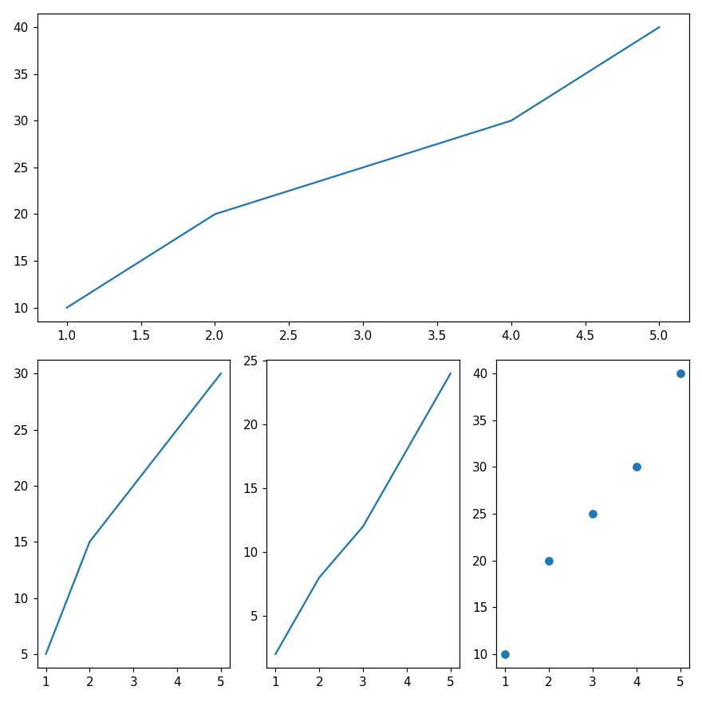

Question 27
Write a Python programming to display a bar chart of the popularity of programming Languages.
Code:
import matplotlib.pyplot as plt

languages = ['Java', 'Python', 'PHP', 'JavaScript', 'C#', 'C++']
popularity = [22.2, 17.6, 8.8, 8, 7.7, 6.7]

plt.bar(languages, popularity, color='blue')
plt.xlabel('Languages')
plt.ylabel('Popularity')
plt.title('PopularitY of Programming Language\nWorldwide, Oct 2017 compared to a year ago')
plt.savefig('imgs/q27.png', dpi=110)
plt.close()
print("Bar chart of programming language popularity saved.")

Output:
Bar chart of programming language popularity saved.

Output Screenshot:
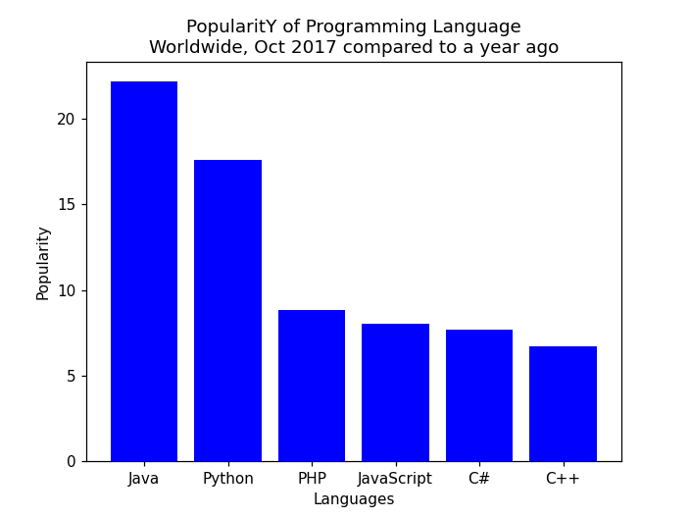

Question 28
Write a Python programming to display a horizontal bar chart of the popularity of programming Languages.
Code:
import matplotlib.pyplot as plt

languages = ['Java', 'Python', 'PHP', 'JS', 'C#', 'C++']
popularity = [22.2, 17.6, 8.8, 8, 7.7, 6.7]

plt.barh(languages, popularity, color='green')
plt.xlabel('Popularity')
plt.ylabel('Languages')
plt.title('PopularitY of Programming Language\nWorldwide, Oct 2017 compared to a year ago')
plt.savefig('imgs/q28.png', dpi=110)
plt.close()
print("Horizontal bar chart of programming language popularity saved.")

Output Screenshot:
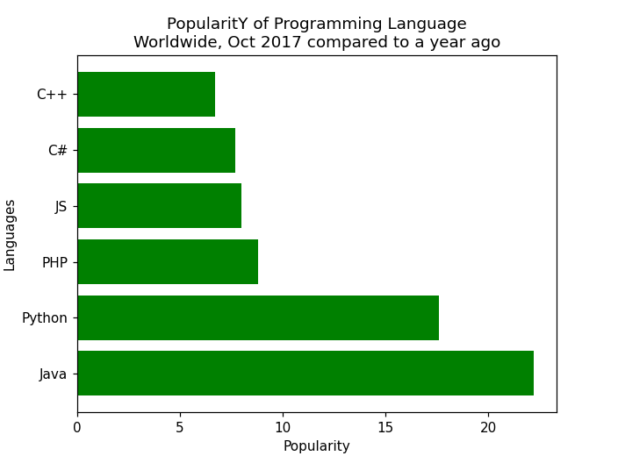

Question 29
Write a Python programming to display a bar chart of the popularity of programming Languages. Use different color for each bar.
Code:
import matplotlib.pyplot as plt

languages = ['Java', 'Python', 'PHP', 'JavaScript', 'C#', 'C++']
popularity = [22.2, 17.6, 8.8, 8, 7.7, 6.7]
colors = ['red', 'black', 'green', 'blue', 'yellow', 'cyan']

plt.bar(languages, popularity, color=colors)
plt.xlabel('Languages')
plt.ylabel('Popularity')
plt.title('PopularitY of Programming Language\nWorldwide, Oct 2017 compared to a year ago')
plt.savefig('imgs/q29.png', dpi=110)
plt.close()
print("Bar chart with different color for each bar saved.")

Output Screenshot:
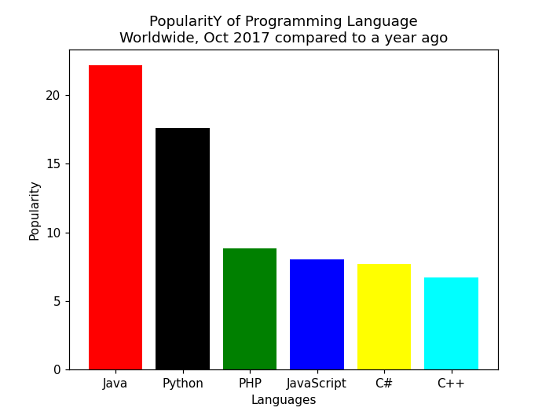

Question 30
Write a Python program to create bar plot of scores by group and gender. Use multiple X values on the same chart for men and women.
Code:
import numpy as np
import matplotlib.pyplot as plt

means_men = (22, 30, 35, 35, 26)
means_women = (25, 32, 30, 35, 29)

n = 5
index = np.arange(n)
width = 0.35

fig, ax = plt.subplots(figsize=(8, 6))
ax.bar(index, means_men, width, color='green', label='Men')
ax.bar(index + width, means_women, width, color='red', label='Women')

ax.set_xlabel('Person')
ax.set_ylabel('Scores')
ax.set_title('Scores by person')
ax.set_xticks(index + width / 2)
ax.set_xticklabels(('G1', 'G2', 'G3', 'G4', 'G5'))
ax.legend()
plt.savefig('imgs/q30.png', dpi=110)
plt.close()
print("Grouped bar plot of scores by group and gender saved.")

Output Screenshot:
