DSA05 Experiments – Part 4 (Q31–Q40)
DSA05 – Query Processing for Data Science: List of Experiments
Name: P.Surya Regno:192324222

Question 31
Write a Python program to create a stacked bar plot with error bars.
Code:
import numpy as np
import matplotlib.pyplot as plt

means_men = (22, 30, 35, 35, 26)
means_women = (25, 32, 30, 35, 29)
men_std = (4, 3, 4, 1, 5)
women_std = (3, 5, 2, 3, 3)

n = 5
index = np.arange(n)
width = 0.35

plt.figure(figsize=(8, 6))
p1 = plt.bar(index, means_men, width, yerr=men_std, color='red', label='Men')
p2 = plt.bar(index, means_women, width, bottom=means_men, yerr=women_std, color='green', label='Women')

plt.ylabel('Scores')
plt.xlabel('Groups')
plt.title('Scores by group\nand gender')
plt.xticks(index, ('Group1', 'Group2', 'Group3', 'Group4', 'Group5'))
plt.legend()
plt.savefig('imgs/q31.png', dpi=110)
plt.close()
print("Stacked bar plot with error bars saved.")

Output Screenshot:
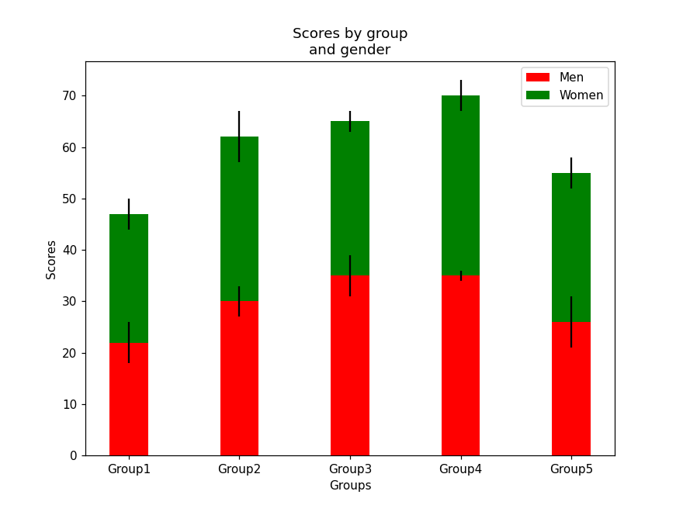

Question 32
Write a Python program to draw a scatter graph taking a random distribution in X and Y and plotted against each other.
Code:
import numpy as np
import matplotlib.pyplot as plt

np.random.seed(1000)
x = np.random.randn(200)
y = np.random.randn(200)

plt.scatter(x, y, color='red')
plt.xlabel('X')
plt.ylabel('Y')
plt.savefig('imgs/q32.png', dpi=110)
plt.close()
print("Scatter plot of random distribution (X, Y) saved.")

Output Screenshot:
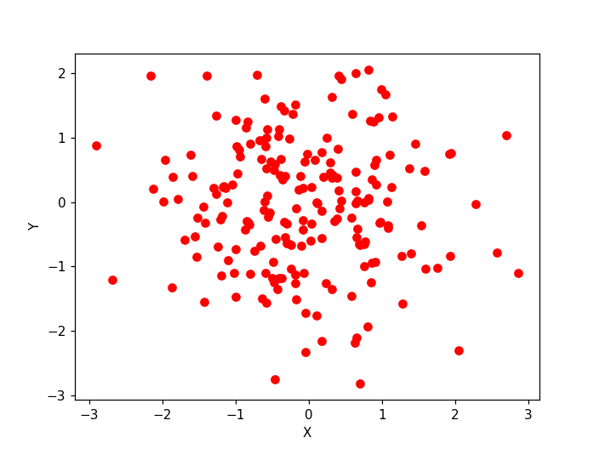

Question 33
Write a Python program to draw a scatter plot with empty circles taking a random distribution in X and Y and plotted against each other.
Code:
import numpy as np
import matplotlib.pyplot as plt

np.random.seed(1000)
x = np.random.randn(60)
y = np.random.randn(60)

plt.scatter(x, y, s=50, facecolors='none', edgecolors='green')
plt.xlabel('X')
plt.ylabel('Y')
plt.savefig('imgs/q33.png', dpi=110)
plt.close()
print("Scatter plot with empty circles saved.")

Output Screenshot:
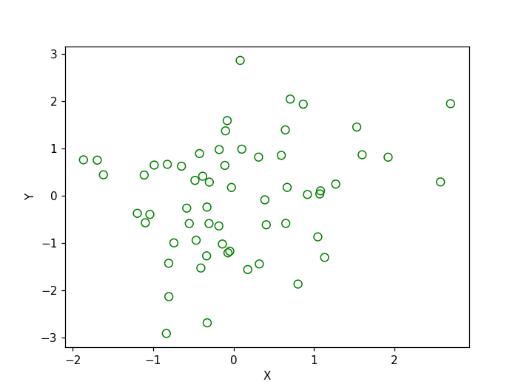

Question 34
Write a Python program to draw a scatter plot using random distributions to generate balls of different sizes.
Code:
import numpy as np
import matplotlib.pyplot as plt

np.random.seed(19680801)
N = 20
x = np.random.rand(N)
y = np.random.rand(N)
colors = np.random.rand(N)
area = (30 * np.random.rand(N)) ** 2

plt.scatter(x, y, s=area, c=colors, alpha=0.7, cmap='jet')
plt.xlabel('X')
plt.ylabel('Y')
plt.savefig('imgs/q34.png', dpi=110)
plt.close()
print("Scatter plot with balls of different sizes saved.")

Output Screenshot:
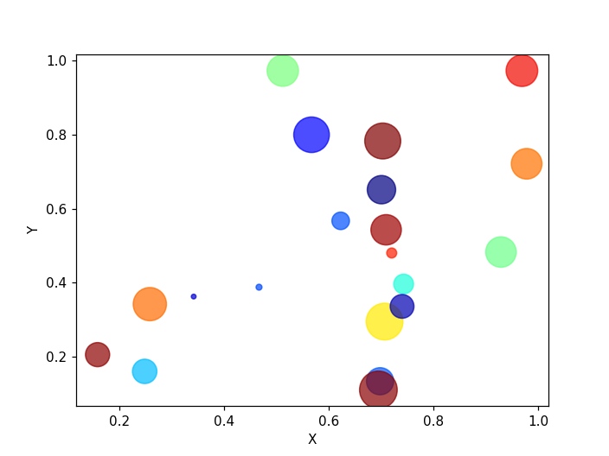

Question 35
Write a Python program to draw a scatter plot comparing two subject marks of Mathematics and Science. Use marks of 10 students.
Code:
import matplotlib.pyplot as plt

math_marks = [88, 92, 80, 89, 100, 80, 60, 100, 80, 34]
science_marks = [35, 79, 79, 48, 100, 88, 32, 45, 20, 30]
marks_range = [10, 20, 30, 40, 50, 60, 70, 80, 90, 100]

plt.scatter(marks_range, math_marks, label='Math marks', color='r')
plt.scatter(marks_range, science_marks, label='Science marks', color='g')
plt.xlabel('Marks Range')
plt.ylabel('Marks Scored')
plt.title('Scatter Plot')
plt.legend()
plt.savefig('imgs/q35.png', dpi=110)
plt.close()
print("Scatter plot comparing Math and Science marks saved.")

Output Screenshot:
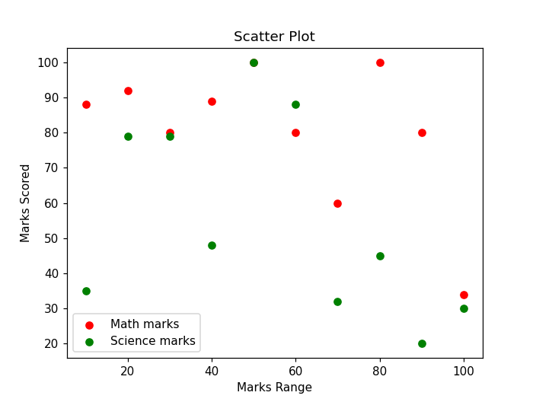

Question 36
Write a Python program to draw a scatter plot for three different groups comparing weights and heights.
Code:
import numpy as np
import matplotlib.pyplot as plt

np.random.seed(3)
weight1 = np.random.normal(60, 3, 8)
height1 = np.random.normal(140, 15, 8)
weight2 = np.random.normal(63, 3, 8)
height2 = np.random.normal(160, 25, 8)
weight3 = np.random.normal(68, 3, 8)
height3 = np.random.normal(170, 30, 8)

weight = np.concatenate((weight1, weight2, weight3))
height = np.concatenate((height1, height2, height3))

plt.scatter(weight, height, marker='*', color='blue')
plt.xlabel('weight')
plt.ylabel('height')
plt.title('Group wise Weight vs Height scatter plot')
plt.savefig('imgs/q36.png', dpi=110)
plt.close()
print("Scatter plot for three groups (weight vs height) saved.")

Output Screenshot:
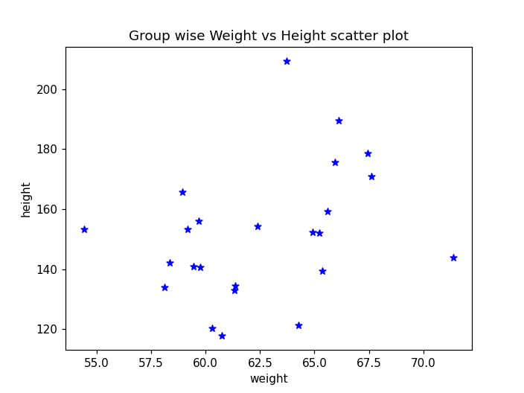

Question 37
Write a Pandas program to create a dataframe from a dictionary and display it.
Code:
import pandas as pd

data = {'X': [78, 85, 96, 80, 86], 'Y': [84, 94, 89, 83, 86], 'Z': [86, 97, 96, 72, 83]}
df = pd.DataFrame(data)
print(df)

Output:
X Y Z
0 78 84 86
1 85 94 97
2 96 89 96
3 80 83 72
4 86 86 83

Question 38
Write a Pandas program to create and display a DataFrame from a specified dictionary data which has the index labels.
Code:
import pandas as pd
import numpy as np

exam_data = {'name': ['Anastasia', 'Dima', 'Katherine', 'James', 'Emily', 'Michael', 'Matthew', 'Laura', 'Kevin', 'Jonas'],
'score': [12.5, 9, 16.5, np.nan, 9, 20, 14.5, np.nan, 8, 19],
'attempts': [1, 3, 2, 3, 2, 3, 1, 1, 2, 1],
'qualify': ['yes', 'no', 'yes', 'no', 'no', 'yes', 'yes', 'no', 'no', 'yes']}
labels = ['a', 'b', 'c', 'd', 'e', 'f', 'g', 'h', 'i', 'j']

df = pd.DataFrame(exam_data, index=labels)
print(df)

Output:
name score attempts qualify
a Anastasia 12.5 1 yes
b Dima 9.0 3 no
c Katherine 16.5 2 yes
d James NaN 3 no
e Emily 9.0 2 no
f Michael 20.0 3 yes
g Matthew 14.5 1 yes
h Laura NaN 1 no
i Kevin 8.0 2 no
j Jonas 19.0 1 yes

Question 39
Write a Pandas program to get the first 3 rows of a given DataFrame.
Code:
import pandas as pd
import numpy as np

exam_data = {'name': ['Anastasia', 'Dima', 'Katherine', 'James', 'Emily', 'Michael', 'Matthew', 'Laura', 'Kevin', 'Jonas'],
'score': [12.5, 9, 16.5, np.nan, 9, 20, 14.5, np.nan, 8, 19],
'attempts': [1, 3, 2, 3, 2, 3, 1, 1, 2, 1],
'qualify': ['yes', 'no', 'yes', 'no', 'no', 'yes', 'yes', 'no', 'no', 'yes']}
labels = ['a', 'b', 'c', 'd', 'e', 'f', 'g', 'h', 'i', 'j']

df = pd.DataFrame(exam_data, index=labels)
print("First three rows of the data frame:")
print(df.iloc[:3])

Output:
First three rows of the data frame:
name score attempts qualify
a Anastasia 12.5 1 yes
b Dima 9.0 3 no
c Katherine 16.5 2 yes

Question 40
Write a Pandas program to select the 'name' and 'score' columns from the following DataFrame.
Code:
import pandas as pd
import numpy as np

exam_data = {'name': ['Anastasia', 'Dima', 'Katherine', 'James', 'Emily', 'Michael', 'Matthew', 'Laura', 'Kevin', 'Jonas'],
'score': [12.5, 9, 16.5, np.nan, 9, 20, 14.5, np.nan, 8, 19],
'attempts': [1, 3, 2, 3, 2, 3, 1, 1, 2, 1],
'qualify': ['yes', 'no', 'yes', 'no', 'no', 'yes', 'yes', 'no', 'no', 'yes']}
labels = ['a', 'b', 'c', 'd', 'e', 'f', 'g', 'h', 'i', 'j']

df = pd.DataFrame(exam_data, index=labels)
print("Select specific columns:")
print(df[['name', 'score']])

Output:
Select specific columns:
name score
a Anastasia 12.5
b Dima 9.0
c Katherine 16.5
d James NaN
e Emily 9.0
f Michael 20.0
g Matthew 14.5
h Laura NaN
i Kevin 8.0
j Jonas 19.0

