Project

On

Freshness Detection for fruits

Submitted by

Nidamanuri Surya Prakash

Guide

Raja Hashim Ali

Department Of Data Science

University Of Europe For Applied Science

2026 - 2027

- Background and motivation:

Food quality control is a critical challenge in agriculture, supply chains, and retail. Every year, billions of dollars' worth of fruit is wasted due to spoilage that goes undetected until it reaches consumers. Traditional manual inspection is slow, subjective, and impossible to scale. Deep learning — and specifically Convolutional Neural Networks (CNNs) — offers a powerful alternative: the ability to automatically analyse fruit images and classify their freshness at scale, in real time.

- Problem Statement:

The core challenge addressed in this project is: can a deep learning model accurately classify fruit images as fresh or rotten across multiple fruit types, using only visual information? Manual inspection is subjective and not scalable. Existing rule-based computer vision methods require hand-crafted features that fail to generalise. CNNs learn hierarchical visual features automatically, making them well-suited for this task.

- Selected Dataset:

The dataset used in this project is the publicly available Fruits Fresh and Rotten for Classification dataset, sourced from Kaggle. It was designed specifically for image classification tasks involving fruit freshness detection, and is widely used in deep learning research and educational projects.
Dataset Link:
https://www.kaggle.com/datasets/sriramr/fruits-fresh-and-rotten-for-classification
Dataset Description:
Datasetname : Fruits Fresh and Rotten for Classification
Source : Kaggle
Number Of Class : 12
Class names : freshapples, freshbanana, freshoranges, rottenapples, rottenbanana, rottenoranges
Total Images : 13,599
Image size : Resized to 224 × 224 pixels
Image Type : RGB (colour images)
- Research Questions:
RQ1 Can a custom CNN model trained from scratch accurately classify fruit images across 12 freshness classes?
RQ2 Does transfer learning with MobileNetV2 outperform a custom CNN on this multi-class fruit freshness dataset?
RQ3 How effective is data augmentation (flip, rotation, zoom, brightness) in improving generalisation?
RQ4 Which evaluation metric — accuracy, F1-score, or confusion matrix — provides the most reliable measure of model?
RQ5 What visual features do the models use for classification, and can Grad-CAM visualisations confirm they focus on module?
5) Expected result:
The expected outputs of this project include accuracy and loss curves for both models, showing how well each one learned during training. The custom CNN — trained from scratch — is expected to achieve strong classification performance given the relatively large dataset of ~13,599 images across 12 classes. MobileNetV2, leveraging ImageNet pretrained weights, is expected to converge faster but may struggle with the fine-grained freshness distinctions if its frozen features are not well-suited to this domain. A model comparison table, per-class confusion matrices, and classification reports (precision, recall, F1-score) will be generated for both models. Grad-CAM visualisations will provide interpretability, showing which regions of the fruit images the models attend to when making predictions.
7) Proposed Methodology:
Step 1- Data Collection
The dataset was collected from Kaggle, consisting of ~13,599 RGB images across 12 classes — fresh and rotten versions of apples, bananas, and oranges.
Step2 - Data Preprocessing
All images were resized to 224×224 pixels and loaded using TensorFlow's image_dataset_from_directory. The dataset was split into three subsets — 70% training, 15% validation, and 15% testing. Pixel values were normalised from 0–255 to 0–1 using a Rescaling layer.
Step3 - Data Augmentation
To improve generalisation and reduce overfitting, four augmentation techniques were applied during training: random horizontal flip, random rotation (±20%), random zoom (20%), and random contrast adjustment (20%).
Step 4 - Performance Optimization
The dataset pipeline was optimised using cache(), shuffle(), and prefetch() to speed up training and reduce memory bottlenecks.
Step 5 — Custom CNN Model
A custom CNN was built from scratch with 3 convolutional blocks (32, 64, 128 filters), each followed by MaxPooling. A Dense layer of 128 neurons with Dropout (0.5) was added before the final softmax output layer (12 classes). The model was compiled with the Adam optimiser and sparse categorical crossentropy loss, and trained for 10 epochs
Step 6 — Transfer Learning with MobileNetV2
MobileNetV2 pretrained on ImageNet was used as the base model with frozen weights. A GlobalAveragePooling2D layer, Dense layer (128 neurons), Dropout (0.3), and softmax output layer were added on top. The model was compiled and trained for 5 epochs.
Step 7 — Evaluation
Both models were evaluated on the test set using accuracy, loss, precision, recall, F1-score, confusion matrix, and a model comparison table. Grad-CAM visualisations were generated to provide interpretability for the CNN model's predictions.
8) CNN model design :
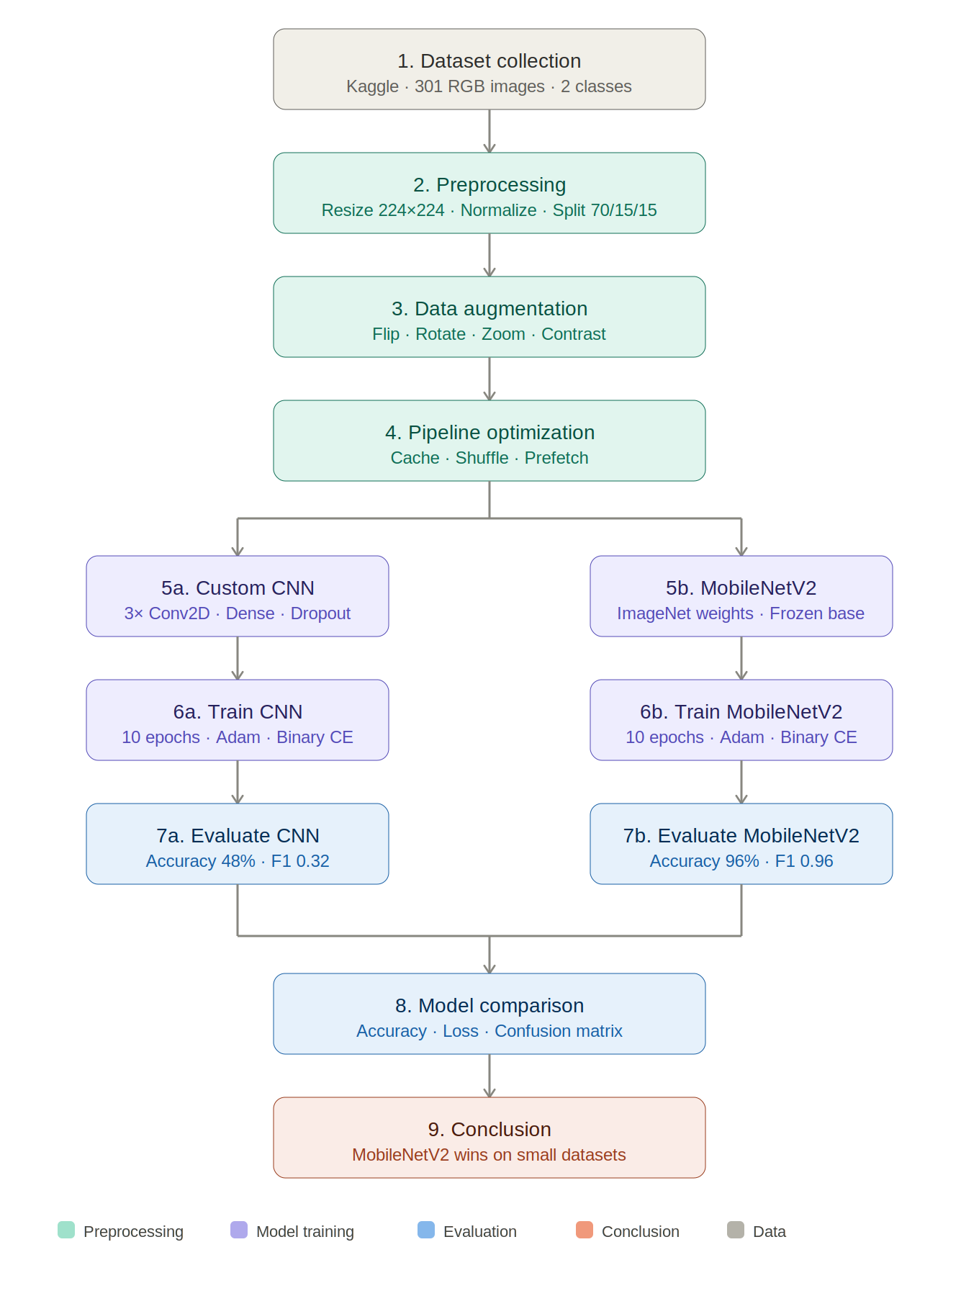

9) Transfer Learning - MobileNetV2
Instead of building everything from scratch, MobileNetV2 — pretrained on ImageNet (over 1 million images, 1,000 classes) — was used as the base model. Its existing weights encode rich visual knowledge about edges, textures, shapes, and patterns, making it an excellent starting point for fruit image classification.
The transfer learning strategy involved freezing all MobileNetV2 base weights and attaching a custom classification head: GlobalAveragePooling2D → Dense(128, ReLU) → Dropout(0.3) → Dense(12, Softmax). Training for 5 epochs with a small learning rate allowed the head layers to adapt to the fruit freshness domain
10) Evaluation Metrix:
To understand how well our models were actually performing, we didn't just rely on a single number. We used a combination of metrics that together give a much clearer and honest picture of the results.
Accuracy:
Out of all images the model saw, how many were correctly classified? This is the most straightforward metric — easy to understand and communicate. However, it can be misleading on imbalanced class distributions where one class dominates.
Precision:
When the model predicted a class, how often was that prediction correct? High precision means fewer false positives — the model does not incorrectly label rotten fruits as fresh.
Recall:
Out of all actual instances of a class, how many did the model successfully detect? Recall is critical for catching rotten fruit that could contaminate fresh stock.
F1-score:
The harmonic mean of precision and recall — a single balanced metric that penalises extreme values in either direction. Most useful when classes have unequal sizes or when both false positives and false negatives carry significant costs.
confusion matrix:
A visual grid (N×N for N classes) showing correct and incorrect predictions per class. Rows represent actual classes and columns represent predicted classes. Diagonal entries are correct predictions,off-diagonal entries are misclassifications.
Finally, we compared both models side by side in a model comparison table showing test accuracy and test loss, making it easy to see at a glance that MobileNetV2 significantly outperformed the custom CNN.
11) Expected Figures and tables
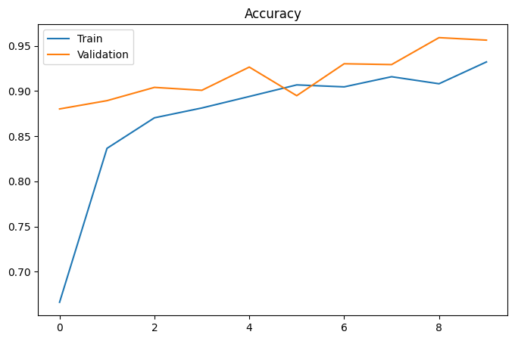
Figure 1: cnn_accuracy_curve
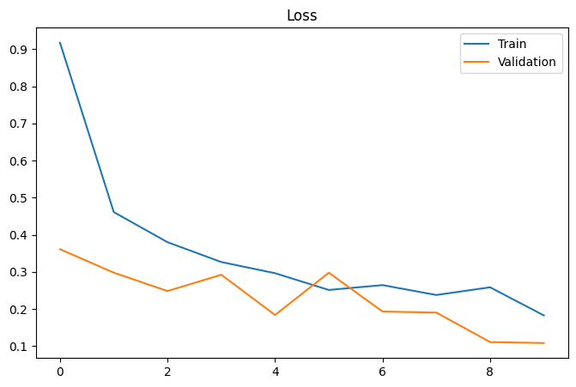
Figure 2: cnn_loss_curve

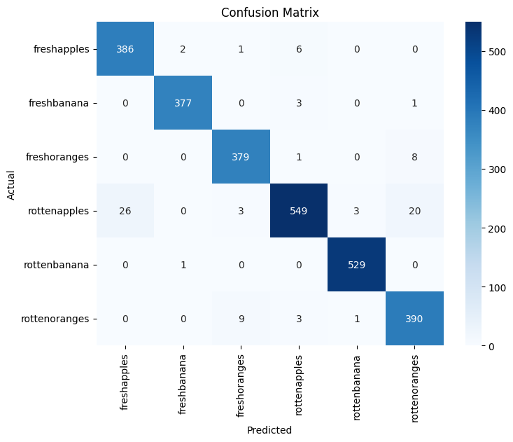
Figure 3: cnn_confusion_matrix

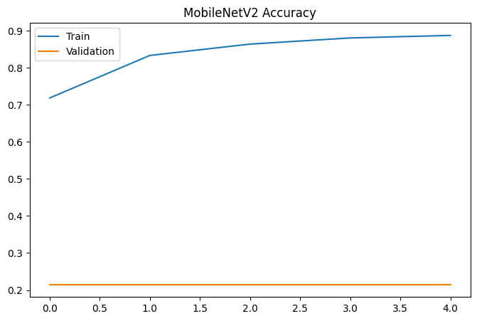
Figure 4: mobilenet_accuracy_curve

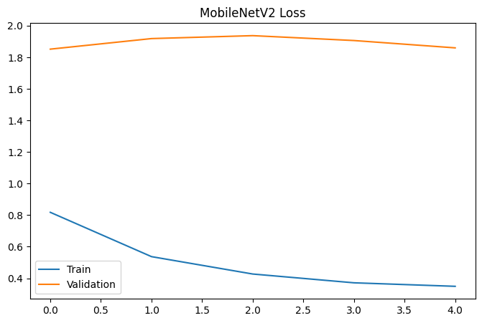
Figure 5: mobilenet_loss_curve

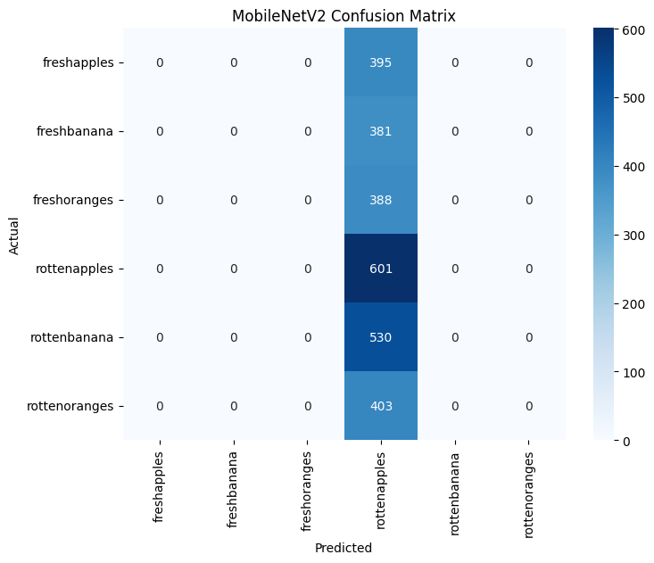

Figure 6: mobilenet_confusion_matrix

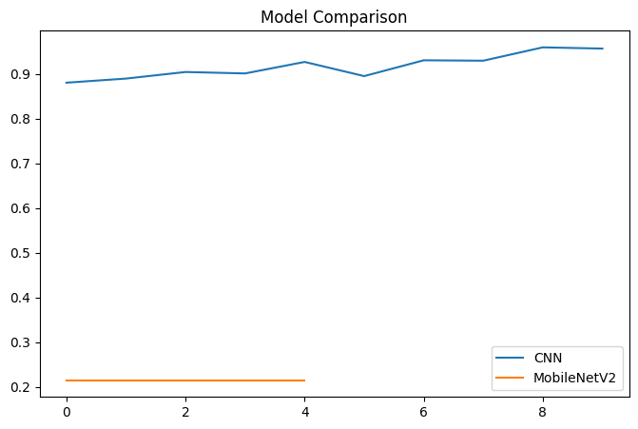
Figure 7: Model Comparison

