**HOTEL RESERVATION SYSTEM**

Group 3

**Team Members**

Shreyas Dharanesh (Y557W378)

Jogesh Venkata Surya Prakash Devathi (N659A624)

Revanth Reddy Kodakandla (?)

Sushma Bojja (?)

**Table of Contents**

|  |  |  |  |
| --- | --- | --- | --- |
| 1. | Introduction ........................................................................................................................................................... | | 4 |
|  | 1.1 | Purpose ..................................................................................................................................................... | 4 |
|  | 1.2 | Scope of the Project .................................................................................................................................. | 5 |
|  | 1.3 | Definition, Acronyms and Abbreviations .................................................................................................... | 5 |
|  | 1.4 | References ................................................................................................................................................. | 4 |
|  | 1.5 | Overview..................................................................................................................................................... | 6 |
| 2 | Overall Description ............................................................................................................................................... | | 7 |
|  | 2.1 | Product Perspective .................................................................................................................................... | 7 |
|  | 2.2 | Product Functions ...................................................................................................................................... | 7 |
|  | 2.3 User Characteristics.................................................................................................................................... | | 9 |
|  | 2.4 | Constraints .................................................................................................................................................. | 9 |
|  | 2.5 | Assumption and Dependencies ................................................................................................................ | 10 |
| 3 | Specific Requirement............................................................................................................................................... | | 11 |
|  | 3.1 | Functional Requirement ........................................................................................................................... | 11 |
|  | 3.2 | Non-Functional Requirements .................................................................................................................. | 11 |
|  | 3.2.1 | Safety Requirements ............................................................................................................................... | 11 |
|  | 3.2.2 | Security Requirements ............................................................................................................................. | 11 |
|  | 3.2.3 | Other Requirements ................................................................................................................................ | 11 |
|  | 3.3 | External Interface .................................................................................................................................... | 12 |
|  | 3.3.1 | User Interface ........................................................................................................................................... | 12 |
|  | 3.3.2 Hardware Interfaces ................................................................................................................................. | | 20 |
|  | 3.3.2 | Software Interfaces ................................................................................................................................... | 20 |
|  | 3.3.3 | Database Interface ................................................................................................................................... | 20 |
|  | 3.3.4 Communications Interfaces ..................................................................................................................... | | 21 |
|  | 3.4 | Performance Requirement ........................................................................................................................ | 21 |
|  | 3.5 | Logical Database Requirements…………………………………………………………………………. | 22 |
|  | 3.6 | Attributes ................................................................................................................................................. | 23 |
|  | 3.6.1 | Reliability................................................................................................................................................. | 23 |
|  | 3.6.2 | Availability ............................................................................................................................................... | 23 |
|  | 3.6.3 | Security ..................................................................................................................................................... | 23 |
|  | 3.6.4 | Maintainability…………………………………………………………………………………………… | 23 |
|  | 3.6.5 | Portability………………………………………………………………………………………………… | 23 |
| 4 | Design | And Analysis ……………………………………………………………………………………………. | 24 |
|  | 4.1 | Use case ………………………………………………………………………………………………… | 24 |
|  | 4.2 | Class Diagram …………………………………………………………………………………………… | 25 |
|  | 4.3 | Sequence Diagram ……………………………………………………………………………………… | 26 |
|  | 4.4 | Dataflow Diagram ………………………………………………………………………………………. | 27 |
| 5 Implementation …………………………………………………………………………………………….……. | | | 28 |
| 6 Testing……………………………………………………………………………………………………………. | | | 30 |
|  |  |  |  |
|  |  |  |  |
|  |  |  |  |
|  |  |  |  |
|  |  |  |  |
|  |  |  |  |
|  |  |  |  |
|  |  |  |  |
|  |  |  |  |
|  |  |  |  |
|  |  |  |  |
|  |  |  |  |
|  |  |  |  |
|  |  |  |  |
|  |  |  |  |
|  |  |  |  |
|  |  |  |  |
|  |  |  |  |
|  |  |  |  |
|  |  |  |  |
|  |  |  |  |
|  |  |  |  |
|  |  |  |  |
|  |  |  |  |

1. **Introduction**

This is the final report document for developed hotel reservation system. It consists of the milestones in development of finalized hotel reservation system. Iterative waterfall method was used as the software development life cycle. Coding was handled through an Object-oriented approach. Above mentioned methodologies made project work load light and provided the ease of developing. The system was evaluated by several people regarding user levels of the developed system. Results of the evaluation helped for further maintenance of the product. Fully functional Hotel Reservation System will fulfil the main objectives and all the events of the hotel.

**1.1** **Purpose**

The Software Requirements Specification (SRS) will provide a detailed description of the requirements for the Hotel Reservation System (HRS). This SRS will allow for a complete understanding of what is to be expected from the newly introduced system which is to be constructed. The clear understanding of the system and its functionality will allow for the correct software to be developed for the end user and will be used for the development of the future stages of the project. This SRS will provide the foundation for the project. From this SRS, the Hotel Reservation System can be designed, constructed, and finally tested.

This SRS will be used by the system development team which is constructing the HRS and the hotel end users. The Project team will use the SRS to fully understand the expectations of this HRS to construct the appropriate software. The hotel end users will be able to use this SRS as a “test” to see if the constructing team will be constructing the system to their expectations. If it is not to their expectations the end users can specify how it is not to their liking and the team will change the SRS to fit the end users’ needs.

**1.2** **Scope of the Project**

The introducing software, Hotel Reservation System which is going to be implemented for Hotel Blue Ribbon will automate the major operations of the hotel. The Reservation System is to keep track in room reservation and check availability. The Room Reservation System is to manage all room types and room services. There are two End Users for HRS. The End Users Are Admin and Customer. Admin can access to all system functionalities without any restrictions. Customer can only access to the Reservation section. To keep restrictions for each End User levels HRS can create different Login functions.

The objectives of the automated Hotel Reservation System is to simplify the day to day processes of the hotel. The system will be able to handle many services to take care of all customers in a quick manner. As a solution to the large amount of file handling happening at the hotel, this software will be used to overcome those drawbacks. Safety, ease of using and most importantly the efficiency of information retrieval is, some benefits the development team going to present with this system. The system should be user appropriate, easy to use, provide easy recovery of errors and have an overall end user high subjective satisfaction.

**1.3 Definition, Acronyms and Abbreviations**

**H.R.S.** – Hotel Reservation System

**SRS** – Software Requirements Specification

**End users** – The people who will be using the system

**1.4 References**

**Internet**

<https://reactjs.org/docs/create-a-new-react-app.html>

<http://react-icons.github.io/react-icons/>

<https://material-ui.com/>

<https://www.mongodb.com/>

<https://dashboard.emailjs.com/>

**1.5 Overview**

* This SRS is organized into two parts the first is the overall description and the second section is the specific requirement.
* The overall description will describe the requirement of Hotel Reservation System.
* The specific requirement section describes the detail of the system.

1. **Overall Description**

**2.1 Product Perspective**

The Hotel Reservation System is a new self-contained software product which will be produced by the project team in order to overcome the problems that have occurred due to the current manual system. The newly introduced system will provide an easy access to the system and it will contain user friendly functions with attractive interfaces. The system will give better options for the problem of handling large scale of physical file system, for the errors occurring in calculations and all the other required tasks that has been specified by the client. The final outcome of this project will increase the efficiency of almost all the tasks done at the Hotel in a much convenient manner.

**2.2 Product Functions**

* Register Customer
* Make Reservations
* Search Rooms
* Add Additional Facilities (Jacuzzi, Swimming pool, Meals, Additional beds)
* Make Payment
* Manage Room Details
* Generate and e-mail Receipt

**Functional Requirements**

|  |  |
| --- | --- |
| Function 1 | **Register Customer** |
| Input | Customer Username, Contact, Company, Name, E-mail, Gender, Address |
| Output | Database Record, Database successfully updated pop-up |
| Workflow | Validate the given details and record the information into the database. |

|  |  |
| --- | --- |
| Function 2 | **Make Reservations** |
| Input | Username, Total child’s, Total Adults, check-in date, check-out date, status, Number of nights. |
| Output | Database Record, Database successfully updated pop-up |
| Workflow | Validate the given details and record the information into the database. |

|  |  |
| --- | --- |
| Function 3 | **Search Rooms** |
| Input | Period, Check-in, Check-out, Guest |
| Output | Display a pop-up with available room details |
| Workflow | Validate the given details and check for the available rooms in a given time and return its availability. |

|  |  |
| --- | --- |
| Function 4 | **Add additional facilities** |
| Input | Period, Check-in, Check-out, Guest |
| Output | Display a pop-up with available facilities details |
| Workflow | Validate the given details and check for the available rooms in a given time and return its availability. |

|  |  |
| --- | --- |
| Function 5 | **Make Payment** |
| Input | Total,1 pay time, Credit card details |
| Output | Database Record, Database successfully updated pop-up |
| Workflow | Validate the given details and record the information into the database. |

|  |  |
| --- | --- |
| Function 6 | **Generate and E-mail Receipt** |
| Input | Billing no, Quantity, Price, Taxes, Date, Services, Unit |
| Output | A printed version of the bill |
| Workflow | Validate the given details and the total cost is calculated according to the Services gain by the customer. |

**2.3 User Characteristics**

**2.3.1 Admin**

Admin can view all the reservations made by the user. They can check the availability of the room.

**2.3.2 Customer**

New Customers can register on the website, if already registered customers can log in to the website and perform the following functionalities. Customers can search for rooms within the selected check-in and check-out dates. The customer pays the total cost at the payment gateway, the total cost is calculated for the selected room type, the number of guests, and extra facilities selected.

**2.4 Constraints**

The software development crew provides their best effort in developing the system. To maintain the reliability and durability of the system, some design and implementation constraints are applied. The availability of an android app for the hotel Reservation system could make the system portable but due to time constraints, it is not possible. The system will need a minimum memory of 512MB. But it is recommended to have a memory of 1GB. Considering the client’s budget, we decided to create those interfaces in a simple realistic manner using affordable technology.

**2.4.1 Hardware**

1. Operating System Supports all known operating systems, such as Windows, Linux.
2. Computer 512MB+ RAM, monitor with a minimum resolution of 1024x768, keyboard, and mouse.
3. Hard Drive should be in NTFS file-system formatted with a minimum of 10 GB of free space.
4. A Laser printer will need to be used to print these reports and notes.

**2.4.2 Software**

1. Software is designed to run on any platform above Microsoft Windows 7 (32bit).
2. Node JS, Express
3. Database: MongoDB
4. SMTP: EmailJS

**2.4.3 High level Language**

1. ReactJS
2. HTML, CSS
3. NoSQL - MongoDB

**2.5 Assumption and Dependencies**

Some software used in implementing the system is at a high cost and the client has agreed to afford the amount of money needed to purchase them. It’s assumed that the client won’t change that decision on the next phases of the software development. Although we assume that the client is using windows 7 or above. Otherwise, if the client uses an open-source operating system, there is a need of changing the SRS accordingly.

**3. Specific Requirement**

**3.1 Functional Requirement**

* Register Customer
* Make Reservations
* Search Rooms
* Add Additional Facilities (Jacuzzi, Swimming pool, Meals, Additional beds)
* Make Payment
* Manage Room Details
* Generate and E-mail Receipt

**3.2 Non-Functional Requirements**

**3.2.1 Safety Requirements**

There are several user levels in the hotel reservation system, Access to the various subsystems will be protected by a user login screen that requires a user name and password. This gives different views and accessible functions of user levels through the system. Maintaining backups ensures system database security. The system can be restored in case of an emergency.

**3.2.2 Security Requirements**

Customers and Admins will be able to log in to the Hotel Reservation System. Customers will have access to the Reservation/Booking and subsystems. Admins have the maximum privilege to all subsystems. Access to the various subsystems will be protected by a user login screen that requires a user name and password.

**3.2.3 Other Requirements**

When the system is completely developed and submitted to the client, a few sessions will be required to make the users of the system understand the functionality of it and some time to adapt to the system. After those sessions, it’s required that a member from the development team should spend some time in the system background for an agreed time. That time will be used in identifying new bugs that could not be reached in the earlier phases of the development process.

The client should have a valid e-mail account to receive reservation e-mail notifications.

**3.3 External Interface**

**3.3.1 User Interface**

Home Page

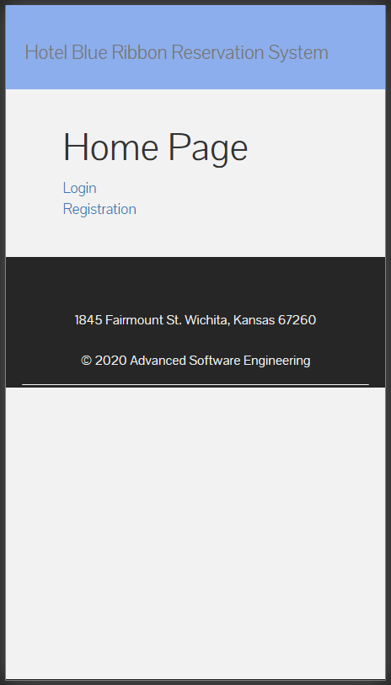

Login Page

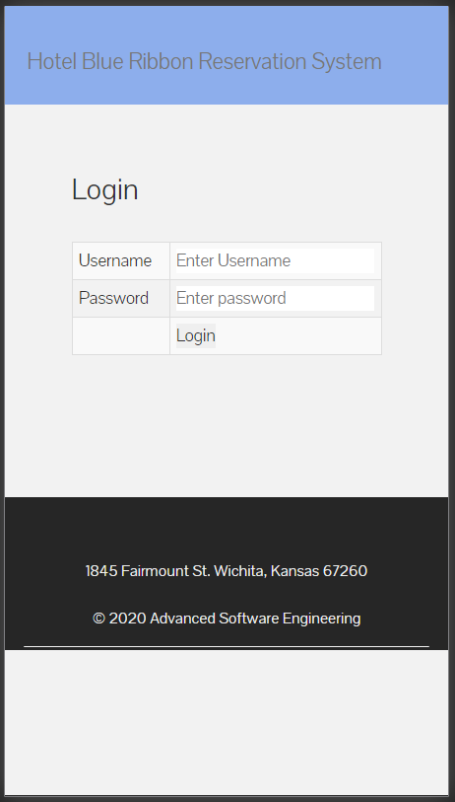

Check-in and Checkout section interface

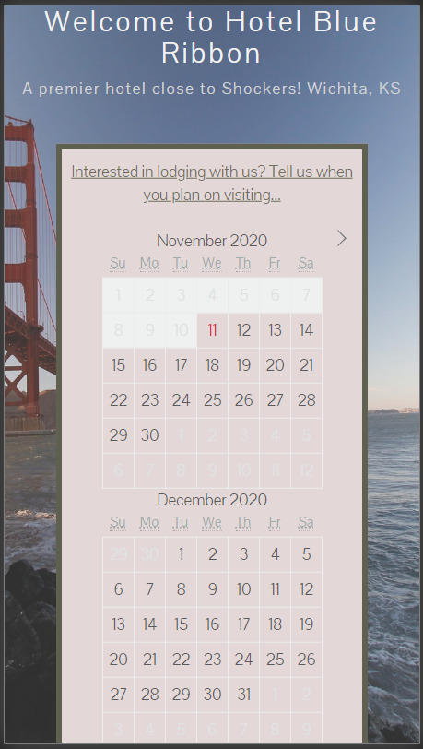 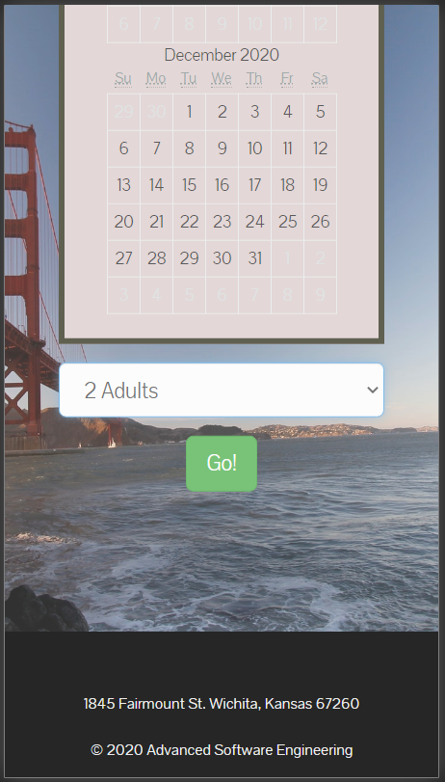

Room selection interface

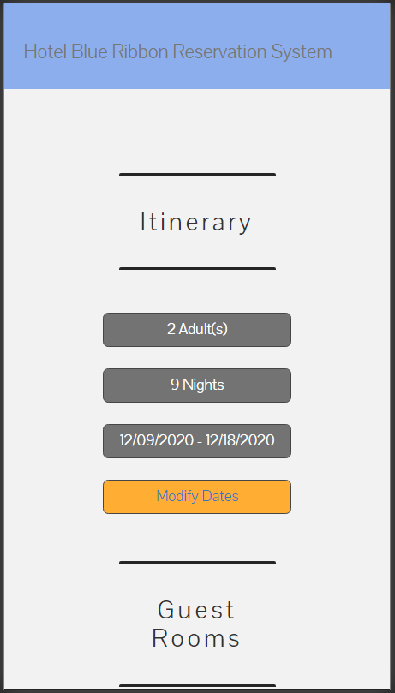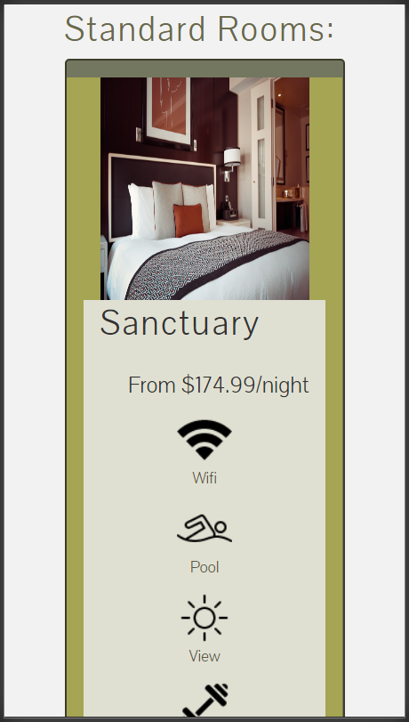

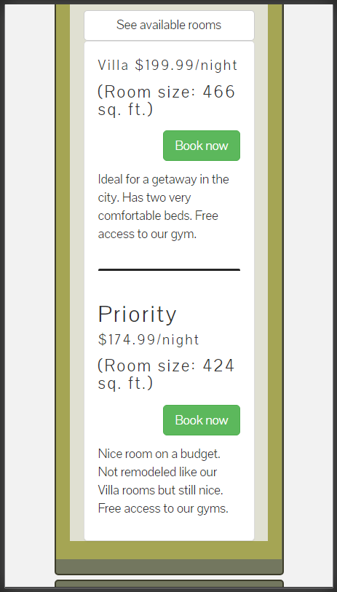

Final Itinerary and Total Payment Cost

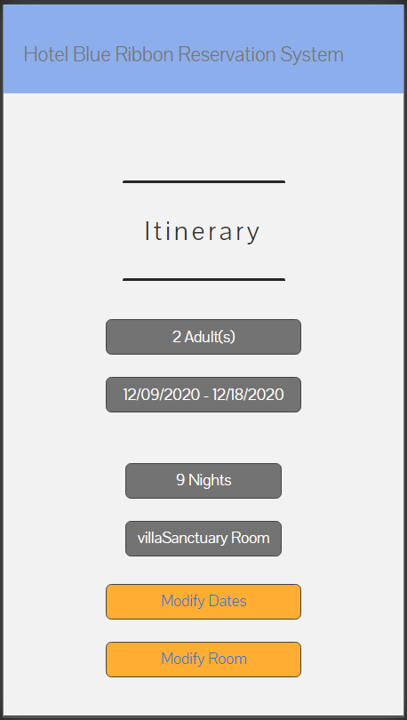 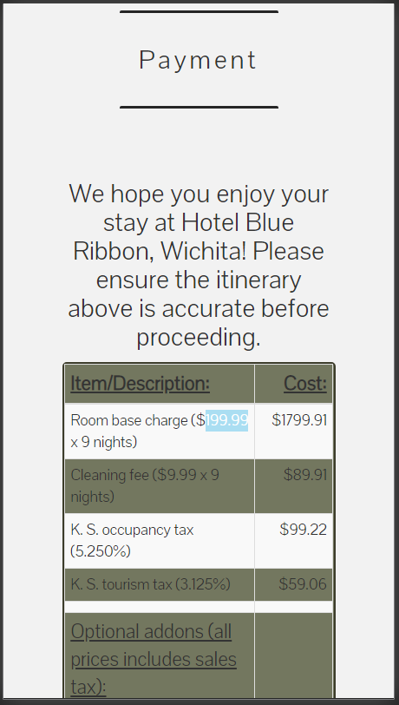

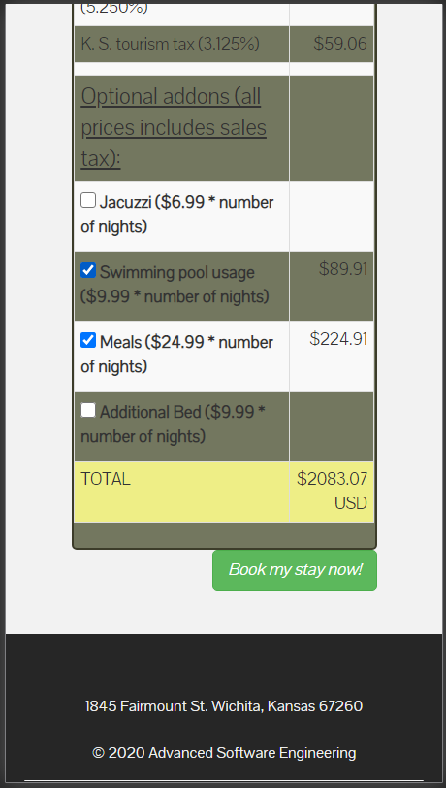

Payment Details

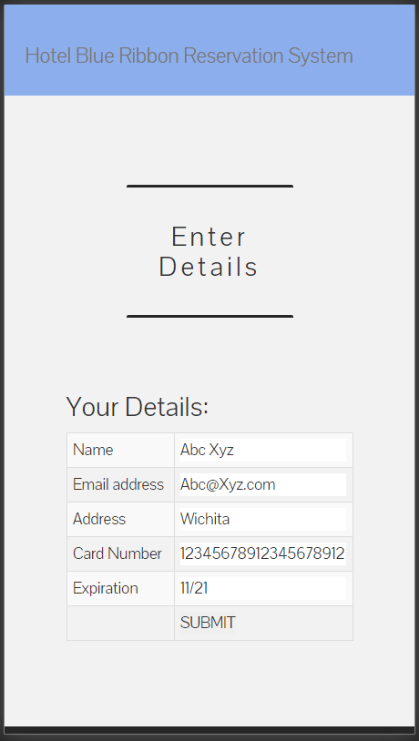

Payment Confirmation Page

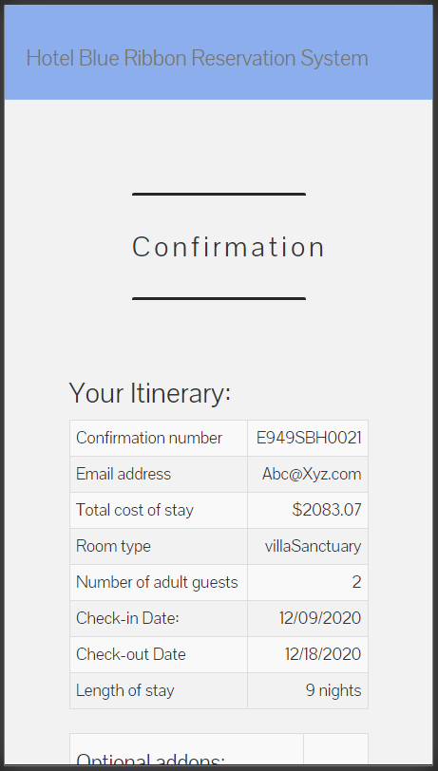 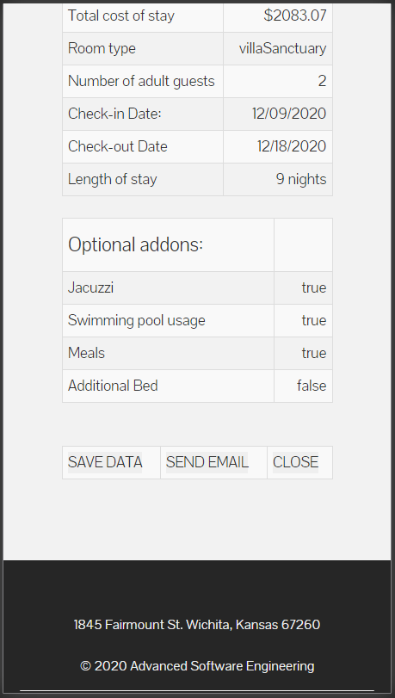

Administrator View

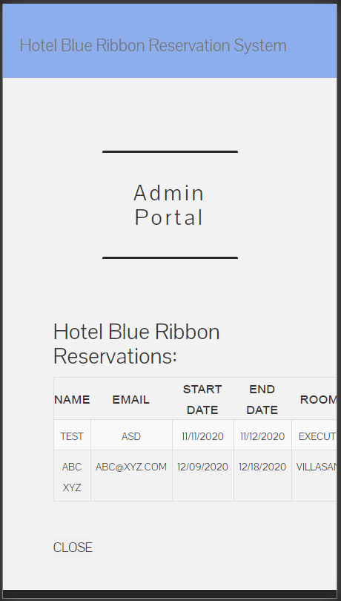

**3.3.2 Hardware Interfaces**

Reservation alerts will be sent to the admin as e-mail notification. So, there is a need for a broadband internet connection. The client should able to keep a stable internet connection.

A laser printer will be needed when printing bills and several reports.

**3.3.2 Software Interfaces**

The computer software going to be installed needs to have a Windows Operating System equal or above, Windows 7. On that Windows platform, any latest web browser will be installed and that will be the platform the particular software will be run. There will be an ADO.NET data transmission with the Microsoft SQL Server Management Studio Express 2010 R2 edition that will be installed on the same computer.

**3.3.3 Database Interface**

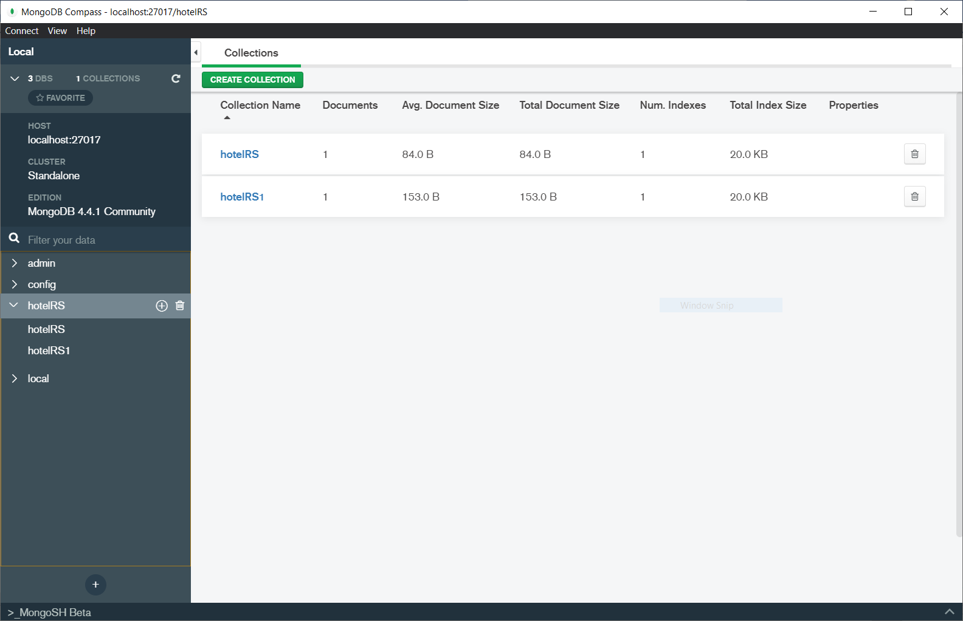

**3.3.4 Communications Interfaces**

When a specific reservation is done at the same time an e-mail notification will be sent to both admin’s e-mail account and the customer’s account. The customer will be notified on the check-out date. To achieve that functionality, it requires having a stable internet connection. Mostly a broadband connection with the client’s computer will provide an efficient service.

**3.4 Performance Requirement**

Performance requirements define acceptable response times for system functionality. Although the system is developed suiting for the least system performances, the performance of the system will highly depend on the performance of the hardware and software components of the installing computer. When considering the timing relationships of the system the load time for user interface screens shall take no longer than two seconds. It makes fast access to system functions. The log-in information shall be verified within five seconds causes’ efficiency of the system. Returning query results within five seconds make the search function more accurate.

**3.5 Logical Database Requirements**

The logical database requirements include the retention of the following data elements.

• Customer first name

• Customer last name

• Customer Code

• Customer address

• Customer phone number

• Number of occupants

• Room no

• Floor no

• Building no

• Room status

• Employee id

• Bill no

• Default room rate

• Rate description

• Guaranteed room (yes/no)

• Expected check-in date

• Actual check-in time

• Expected check-out time

• Actual check-out date

• Customer feedback

• Payment type

• Total Bill

**3.6 Attributes**

**3.6.1 Reliability**

Specify the factors required to establish the required reliability of the software system at the time of delivery. Meantime between failures and mean time to recovery.

**3.6.2 Availability**

The system shall be available during normal hotel operating hours.

**3.6.3 Security**

The extent to which the Hotel Reservation System is safe from outside non-allowed users or attacks.

**3.6.4 Maintainability**

What design, coding standards must adhere to exclusions created

**3.6.5 Portability**

The Hotel Reservation System shall run in any Microsoft Windows environment

1. **Design**
   1. **Use case**

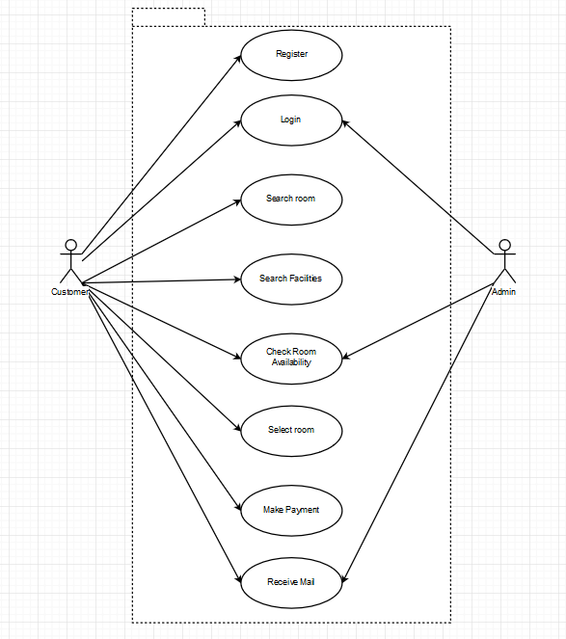

**4.2 Class Diagram**

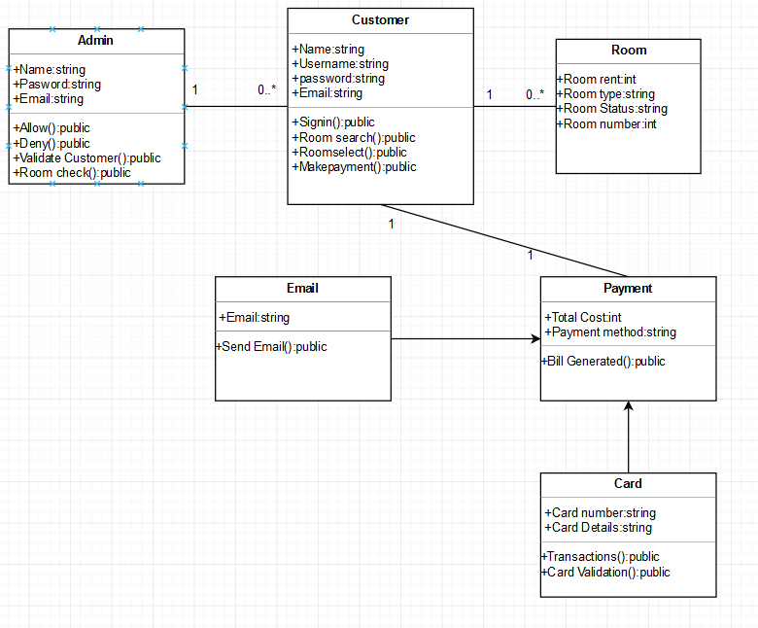

**4.3 Sequence Diagram**

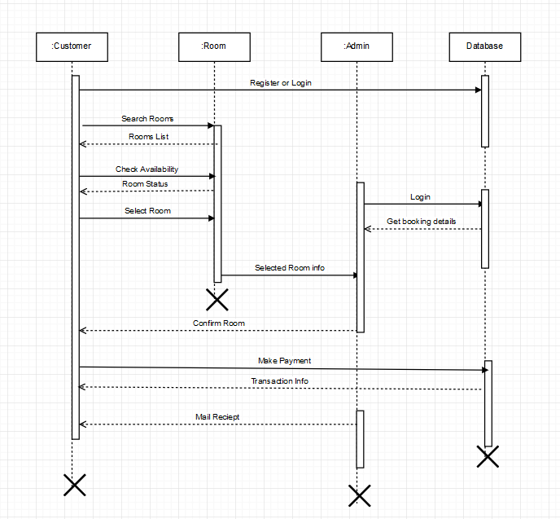

**4.4 Data Flow Diagram**

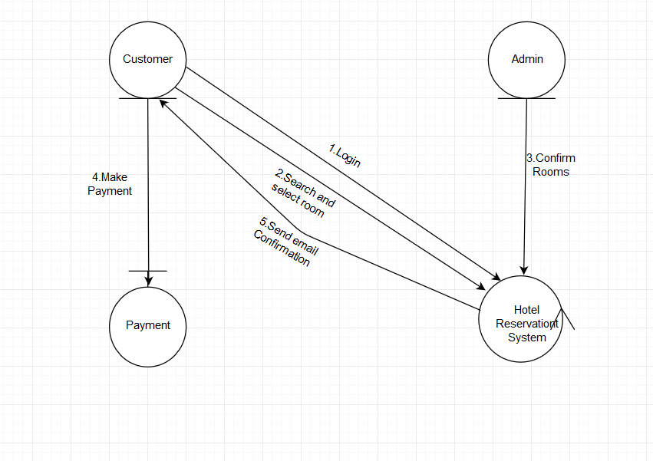

1. **Implementation**

Code Snippets

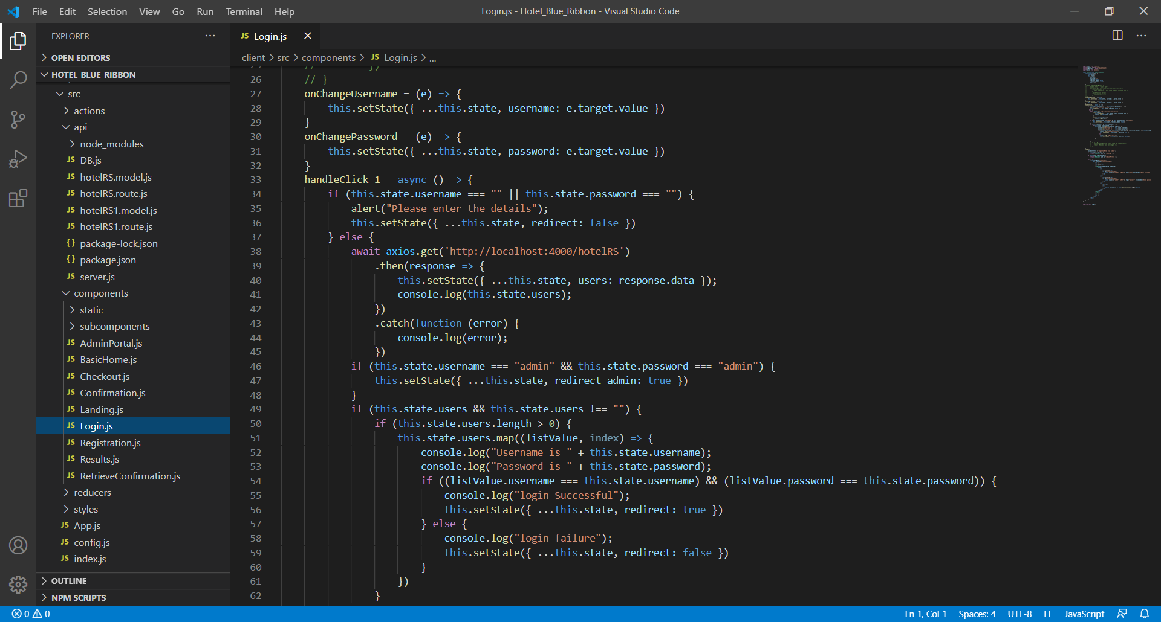

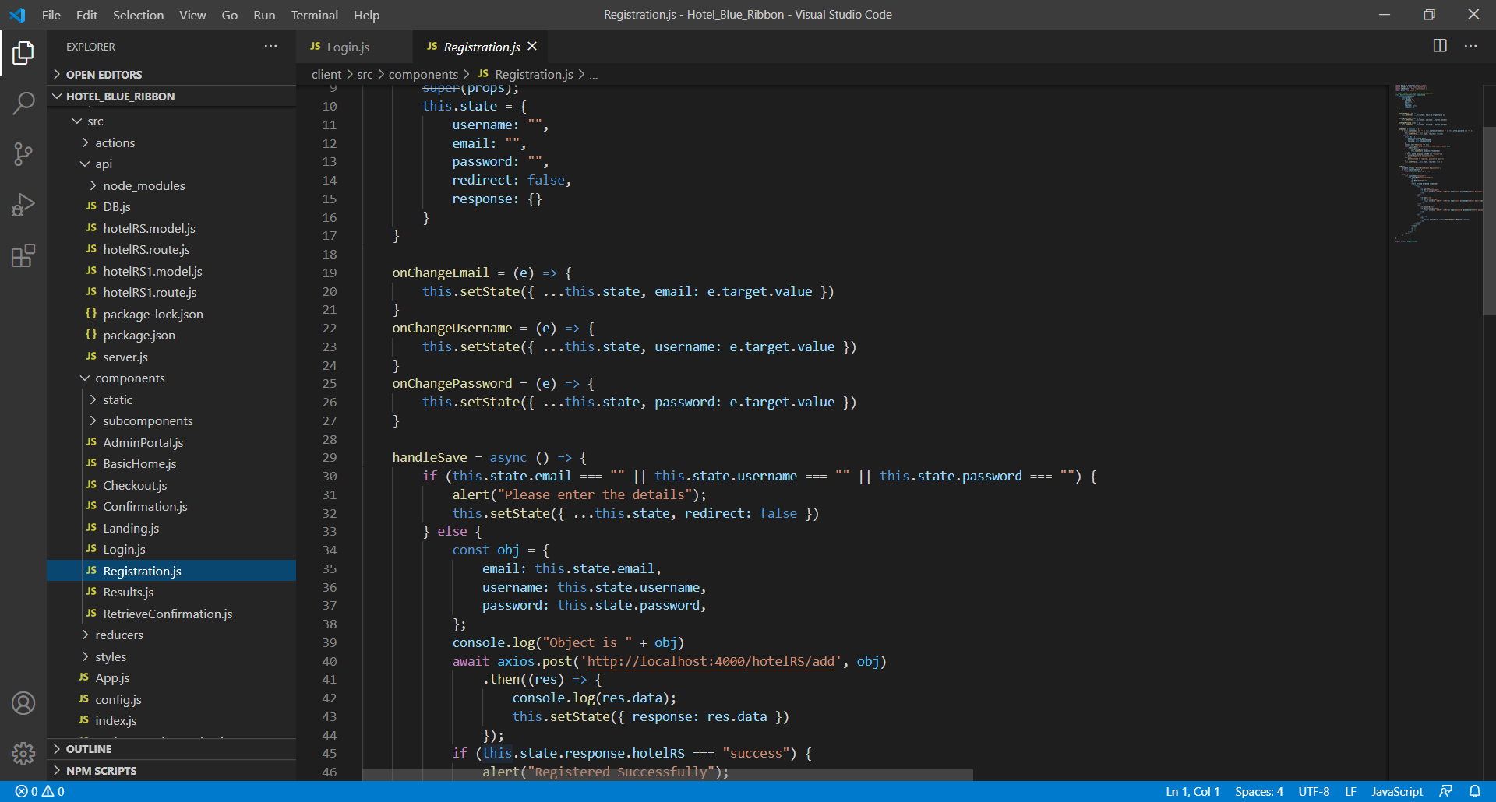

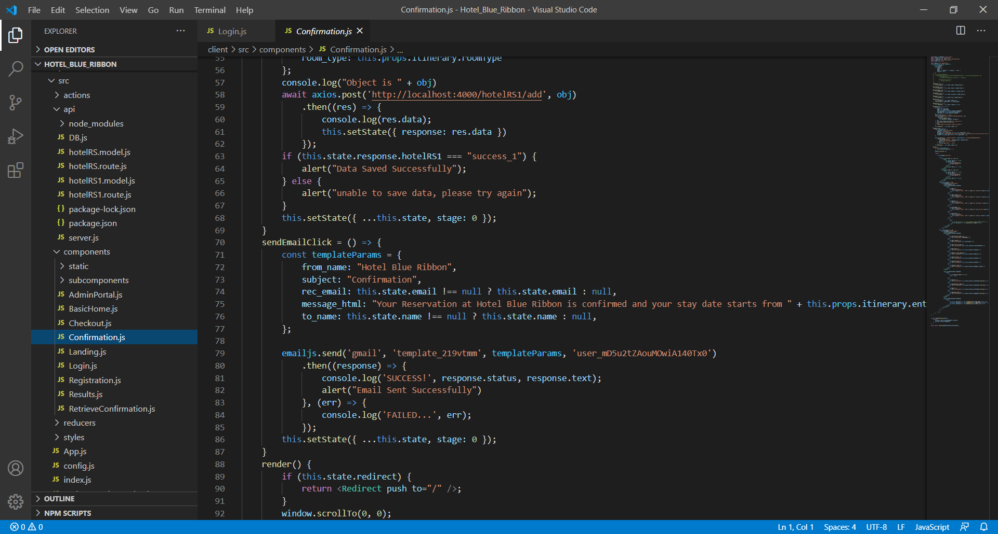

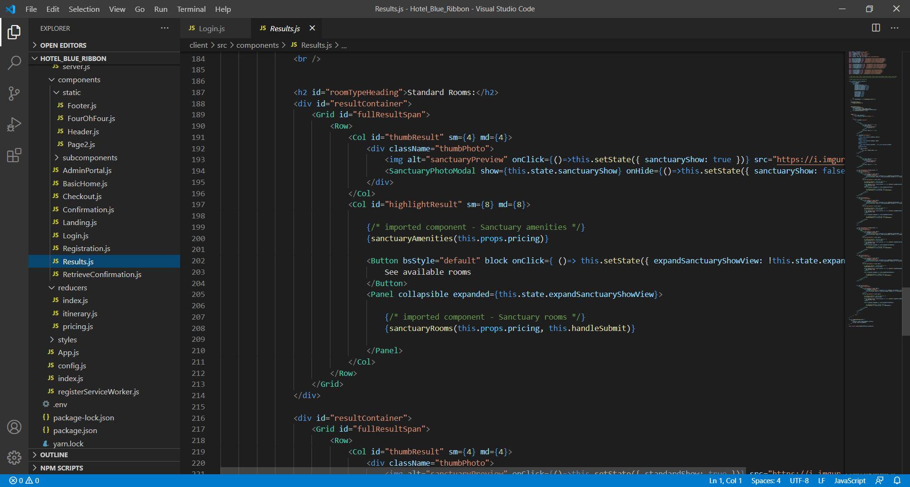

1. **Testing**

**Test case 1:** User tries to register

**Success:** Registered Successfully

**Failure:** Unable to register Please try again

**Test case 2:** User tries to log in

**Success:** Goes to Landing Page

**Failure:** Stays back on the same page

**Test case 3:** User selects specific dates, number of people and particular room of his choice and can add additional facilities and amount reflects respectively

**Test case 4:** When submits payment

**Success:** Data saved Successfully and Email Sent successfully

**Failure:** Unable to save data Please try again