***Wireframe: Spam Ham Detection***

Spam Ham Detection

***Wireframe Documentation***

|  |  |  |  |
| --- | --- | --- | --- |
| **Date Issued** | **Version** | **Description** | **Author** |
| 07-01-2023 | 1 | Wireframe-V1.0 | Surya Pranav |
|  |  |  |  |

**User Interface for Single User Input: Very simple UI for user will be there, Where user only need to**

**feed their text message and they need to click Predict Button.**

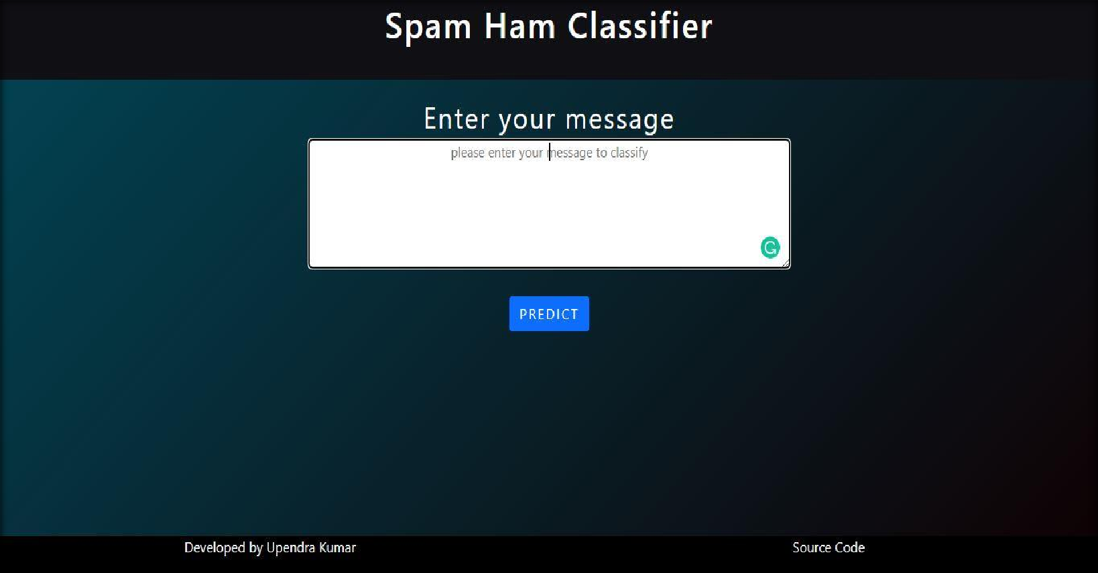

**In provided text area user need to feed their message**.

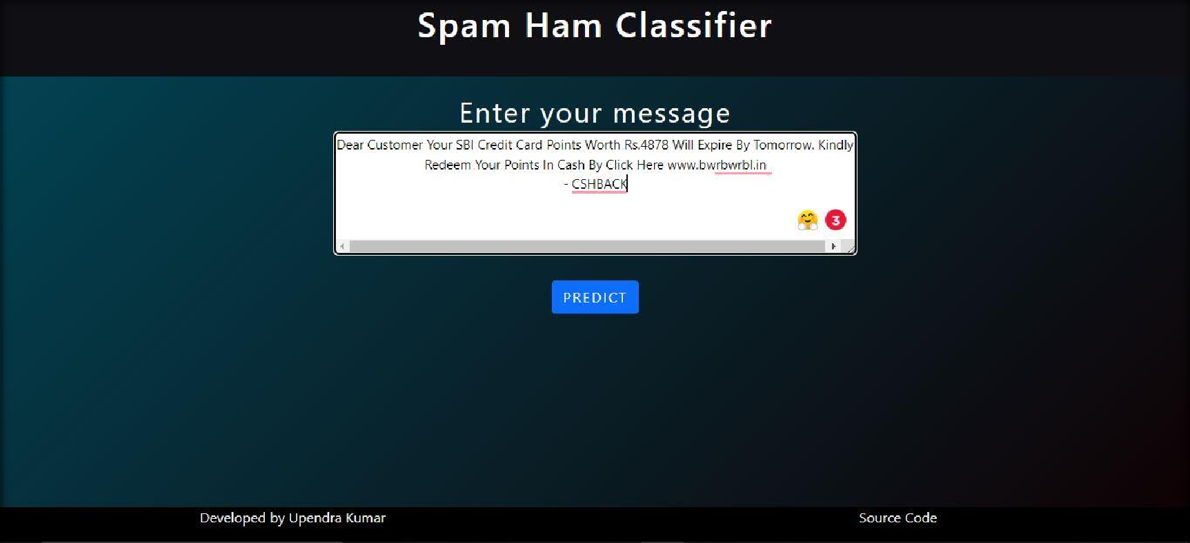

**After feeding text message user need to click Predict Button.**

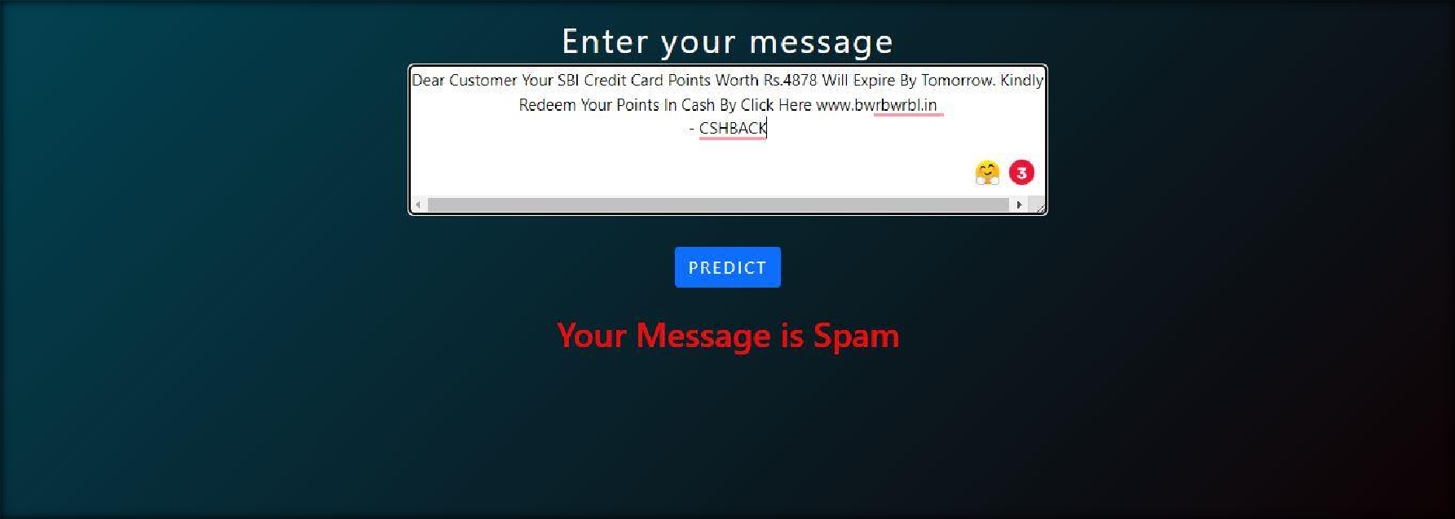

**User Interface for Bulk Prediction**

**Homepage**

We will have a single page UI which will facilitate bulk detection of class of message such as Spam or Ham.

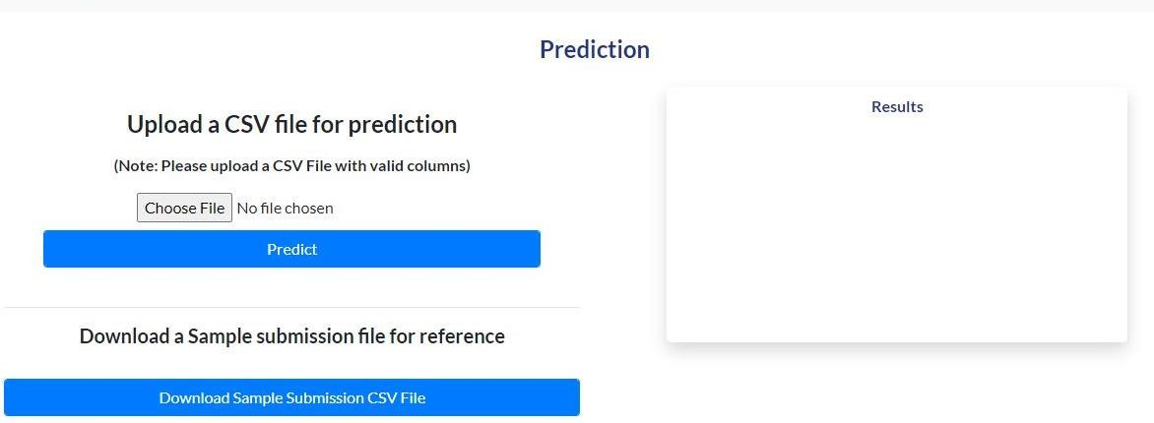

1. First thing anyone will see is a pop-up window on Homepage which will ask for CSV file for prediction.

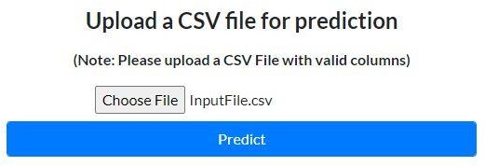

1. After choosing the csv file for prediction, user has to click on predict button for prediction. And then on right side a new pop up window will come which give option to download the prediction in csv file format.

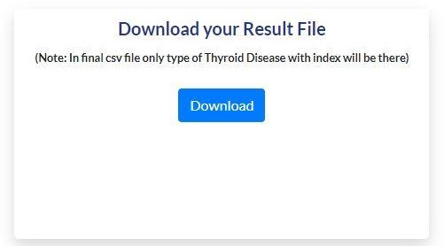

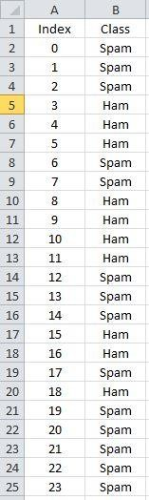Prediction CSV file will contain index with class of message.

At last we will have an option which enable user to download sample submission CSV file for reference.

