DynamoDB - Query Table:

Querying a table primarily requires selecting a table, specifying a partition key, and executing the query. with the options of using secondary indexes and performing deeper filtering through scan operations.

Utilize the GUI Console:

Query Table using the GUI Console

Perform some simple queries using the previously created tables. First, open the console at https://console.aws.amazon.com/dynamodb

Choose Tables from the navigation pane and select Reply from the table list. Then select the Items tab to see the loaded data.

Select the data filtering link (“Scan: [Table] Reply”) beneath the Create Item button.

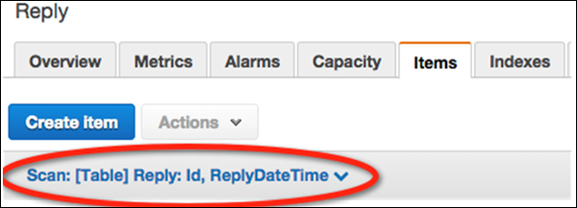

In the filtering screen, select Query for the operation. Enter the appropriate partition key value, and click Start.

The Reply table then returns matching items.

