DynamoDB - Create Table:

Creating a table generally consists of spawning the table, naming it, establishing its primary key attributes, and setting attribute data types.

Create Table using the GUI Console:

Create a table by accessing the console at https://console.aws.amazon.com/dynamodb.

Then choose the “Create Table” option.

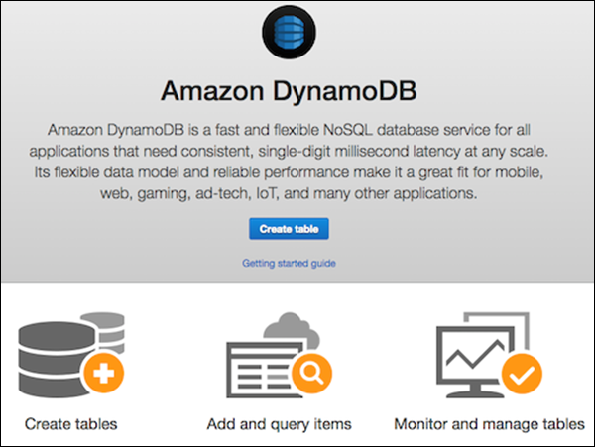

Our example generates a table populated with product information, with products of unique attributes identified by an ID number (numeric attribute). In the **Create Table** screen, enter the table name within the table name field; enter the primary key (ID) within the partition key field; and enter “Number” for the data type.

