

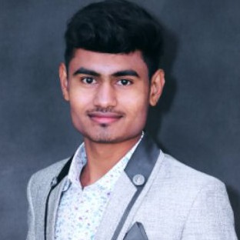Hariom Apartment, Radio Mirchi Road, Satellite, Ahmedabad - 380015 9909412367 | [msureshprajapati@gmail.com](mailto:msureshprajapati@gmail.com)



I aim to leverage my expertise as an Sr Android developer and TL to drive innovation and growth within our organization. My objective is to lead cross-functional teams in delivering cutting-edge Android applications that exceed user expectations and industry standards. I aspire to deepen my knowledge of emerging technologies like AR/VR integration and AI- driven solutions, contributing to our company's competitive edge in the mobile app market.



Jul 2023 - Present

Sr Android Developer (TL)

As a Senior Android developer and TL, I facilitated daily scrum meetings, managed three projects simultaneously, and mentored trainees to enhance their skills. Additionally, I actively pursued learning new technologies such as Jetpack Compose and implementing Clean MVVM

architecture.

Mar 2022 - Jul 2023

Sr Android Developer

I've been employed here for more than 14 months. throughout that time, I've learned new coding techniques, handled client communications, and worked remotely. Learn about Live Data, Data Binding, and MVVM

Dec 2020 - Mar 2022

Android Developer

A key member of the team and worked on more than 8 Projects. Also start kotlin from this company as well as learn Web RTC, Data binding, MVVM structure, Socket.io for chat implementation. also handle client on chat.



Jr Android Developer

I was started my development journey from this company, I have learn all basic things in android from here like Intent, Fragments, Layouts, APIs, Firebase, SQLite database etc. I worked more than 4 projects on this company with java only.



Diploma In Computer Engineering 6.4

April 2019 - Nov 2020

2018



Java & Kotlin Jetpack Compose

Clean MVVM Architecture, MVP & MVC Data Binding & View Binding

Jira, Mentis & Trello

Bit Bucket & Github Room Database Firebase

Socket.Io & Hardware Connectivity Custom & Dynamic Views

Social Media Integration Google Map integration Third Party Integration

Daily Client Communications & Scrum





This project is centered around a POS system designed specifically for efficient billing processes. The system is dedicated solely to managing billing operations through this application, which is hardware-based. We utilized external printers for generating order receipts. The application efficiently handles food billing and all associated calculations such as discounts, taxes, and promotional codes.

This project is a taxi service application similar to Uber or Ola, consisting of two mobile apps: one for customers and another for drivers. The primary goal of the project is to facilitate transportation from one location to another based on user selection. For instance, a customer (User A) can book a ride from their current location (XYZ) to a destination (OPQ) using the customer app. Nearby drivers receive ride requests and can accept them if available. Once accepted, the driver arrives at the customer's location, picks them up, and drops them off at the selected destination.

The project is built using Kotlin and follows the MVVM design pattern.



This is a commercial project enabling users to purchase products through live streaming within the app. Sellers can initiate live streams via the admin panel for mobile users. We utilized the Agora library to facilitate seamless live streaming functionality. Given the presence of multiple seller users, we employed a socket to manage upcoming live streaming sessions. This project was developed using native Android with Java programming language.