NATIONAL INSTITUTE OF TECHNOLOGY,

KARNATAKA, SURATHKAL


SOFTWARE REQUIREMENTS SPECIFICATION

For
LIBRARYMANAGEMENT SYSTEM

Submitted By:

A. SURYA SAI GOPAL | 16IT204
BADUGU SAI MANIKANTA | 16IT209
P UDAY KUMAR | 16IT235

Table of Contents

- Introduction

  - Synopsis

  - Purpose

  - Scope

  - Problem Statement

- Objectives

- Methodology

- System Requirements

- Overall Description

  - User Classes and Characteristics

  - Assumptions and Dependencies

  - Operating Environment

- Conclusion

- References

SYNOPSIS

Library management system is a project which aims in developing a computerized system to maintain all the daily work of library .This project has many features which are generally not availiable in normal library management systems like facility of user login and a facility of teachers login .It also has a facility of admin login through which the admin can monitor the whole system . It has also a facility where student after logging in their accounts can see list of books issued and its issue date and return date and also the students can request the librarian to add new books by filling the book request form.The librarian after logging into his account ie admin account can generate various reports such as student report , issue report, teacher report and book report Overall this project of ours is being developed to help the students as well as staff of library to maintain the library in the best way possible and also reduce the human efforts.
INTRODUCTION

1.1.PURPOSE AND OBJECTIVES:

The project aims and objectives that will be achieved after completion of this project are discussed in this subchapter. The aims and objectives are as follows:

- Request column for librarian for providing new books

- A separate column for digital library

- Student login page where student can find books issued by him/her and date of return.

- A search column to search availability of books

- A teacher login page where teacher can add any events being organized in the college and important suggestions regarding books.

Library Management System is an application which refers to library systems which are generally small or medium in size. It is used by librarian to manage the library using a computerized system where he/she can record various transactions like issue of books, return of books, addition of new books, addition of new students etc. Books and student maintenance modules are also included in this system which would keep track of the students using the library and also a detailed description about the books a library contains. With this computerized system there will be no loss of book record or member record which generally happens when a non computerized system is used. In addition, report module is also included in Library
Management System. If user’s position is admin, the user is able to generate different kinds of reports like lists of students registered, list of books, issue and return reports. All these modules are able to help librarian to manage the library with more convenience and in a more efficient way as compared to library systems which are not computerized.

SCOPE

There is a future scope of this facility that many more features such as online lectures video tutorials can be added by teachers as well as online assignments submission facility , a feature Of group chat where students can discuss various issues of engineering can be added to this project thus making it more interactive more user friendly and project which fulfills each users need in the best way possible
PROBLEM STATEMENT

The problem occurred before having computerized system includes:

- File lost :

When computerized system is not implemented file is always lost because of human environment.Some times due to some human error there may be a loss of records.

- File damaged:

When a computerized system is not there file is always lost due to some accdent like spilling of water by some member on file accidentally.Besides some natural disaster like floods or fires may also damage the files.

- Difficult to search record :

When there is no computerized system there is always a difficulty in searching of records if the records are large in number.

- Space consuming:

After the number of records become large the space for physical storage of file and records also increases if no computerized system is implemented.

- Cost consuming:

As there is no computerized system the to add each record paper will be needed which will increase the cost for the management of library.

OBJECTIVES

- Improvement in control and performance :

The system is developed to cope up with the current issues and problems of library .The system can add user, validate user and is also bug free.

- Save cost:

After computerized system is implemented less human force will be required to maintain the library thus reducing the overall cost.

- Save time:

Librarian is able to search record by using few clicks of mouse and few search keywords thus saving his valuable time.

METHODOLOGY

- NORMAL USER:

- 1 USER LOGIN

Description of feature :

This feature used by the user to login into system. They are required to enter user id and password before they are allowed to enter the system .The user id and password will be verified and if invalid id is there user is allowed to not enter the system.

Functional requirements:

user id is provided when they register

The system must only allow user with valid id and password to enter the system

The system performs authorization process which decides what user level can access to.

The user must be able to logout after they finished using system.

REGISTER NEW USER :

Description of feature:

This feature can be performed by all users to register new

user to create account.

Functional requirements
System must be able to verify information

System must be able to delete information if information is wrong

REGISTER NEW BOOK:

Description of feature:

This feature allows to add new books to the library

Functional requirements:

System must be able to verify information

System must be able to enter number of copies into table.

System must be able to not allow two books having same book id.

SEARCH BOOK :

Description of feature:

This feature is found in book maintenance part . we can search book based on book id , book name , publication or by author name. Functional requirements

System must be able to search the database based on select search type

System must be able to filter book based on keyword entered

System must be able to show the filtered book in table view
ISSUE BOOKS AND RETURN

BOOKS Description of feature :

This feature allows to issue and return books and also view reports of book issued.
Functional requirements:

System must be able to enter issue information in database.

System must be able to update number of books. System must be able to search if book is available or not before issuing books
System should be able to enter issue and return date information

SYSTEM REQUIREMENTS

PROCESSOR | INTEL CORE PROCESSOR OR
PROCESSOR | BETTER PERFORMANCE
OPERATING | BETTER PERFORMANCE
SYSYTEM | WINDOWS 10 OR UBUNTU
APPLICATION | NET BEANS IDE
MEMORY | 1GB OR MORE
 | MINIMUM 3 GB OF DATA SPACE FOR
HARD DISK SPACE | FURURE USE
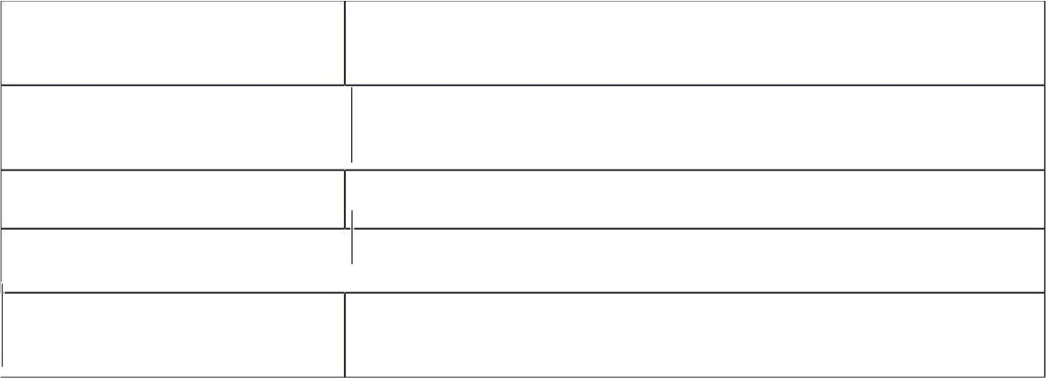

DATA FLOW DIAGRAMS:

A data flow diagram (DFD) is a graphical representation of the "flow" of data through an information system,modelling its process aspects.It’s DFD is often used as a preliminary step to create an

overview of the system without going into great detail,which can later be elobarated.
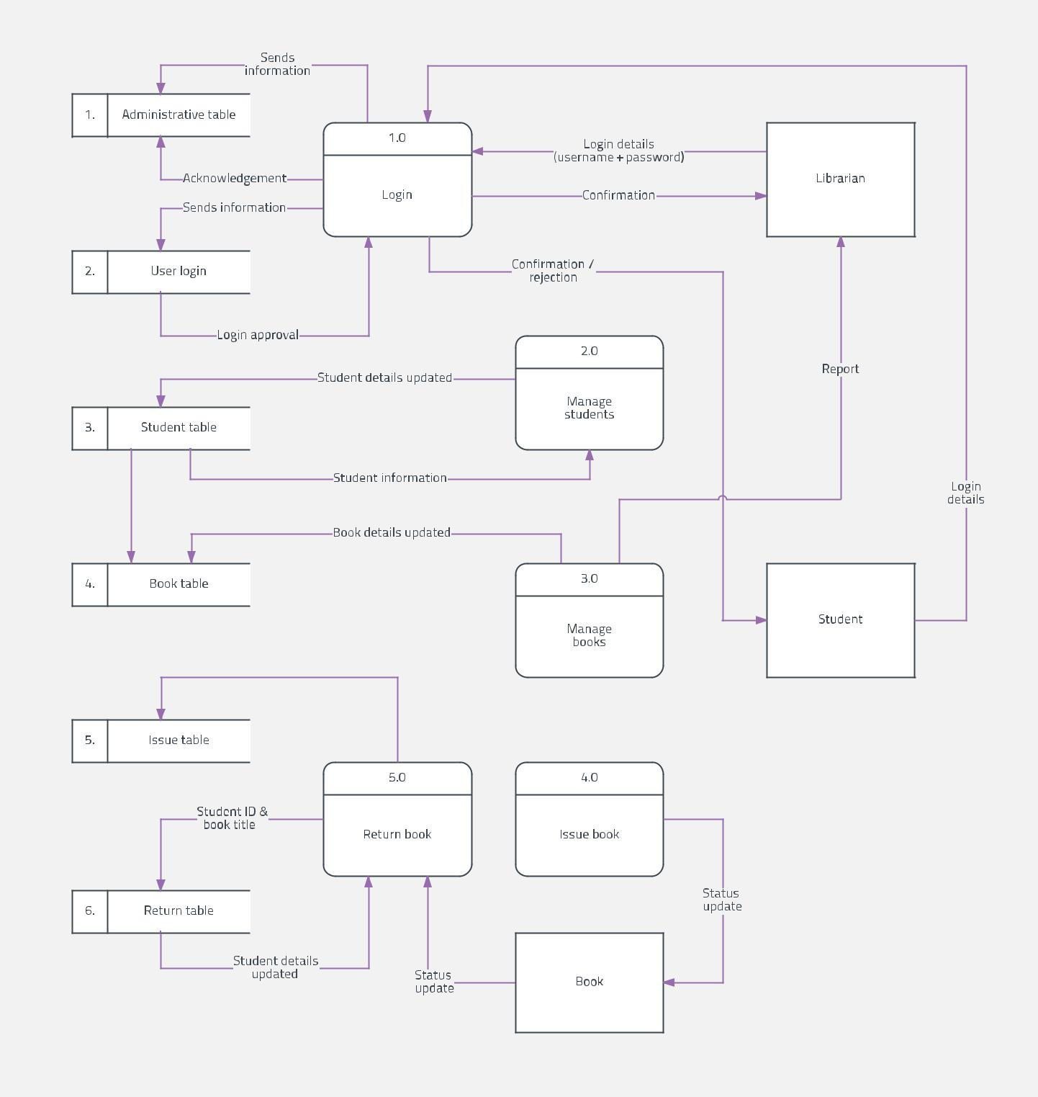

Use case Diagram:
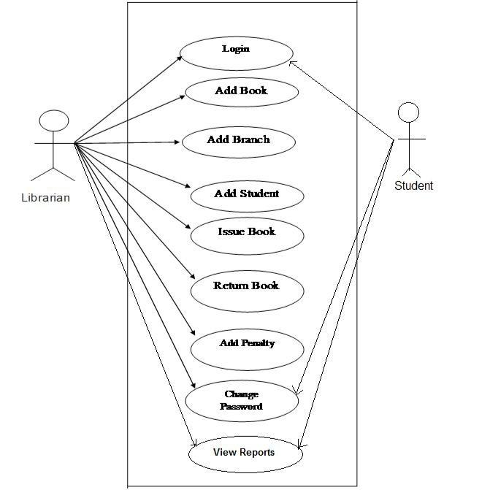
State Diagrams : Issue of book
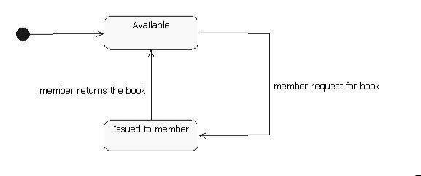

State Diagram : Return of book
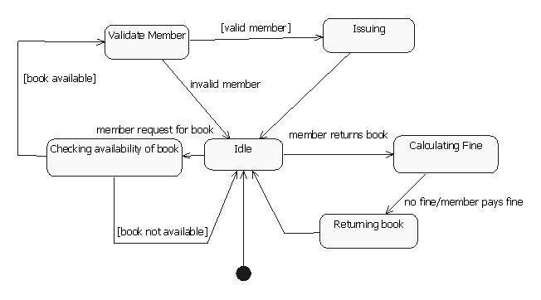
MACRO STATE DIAGRAM(Class Diagram)
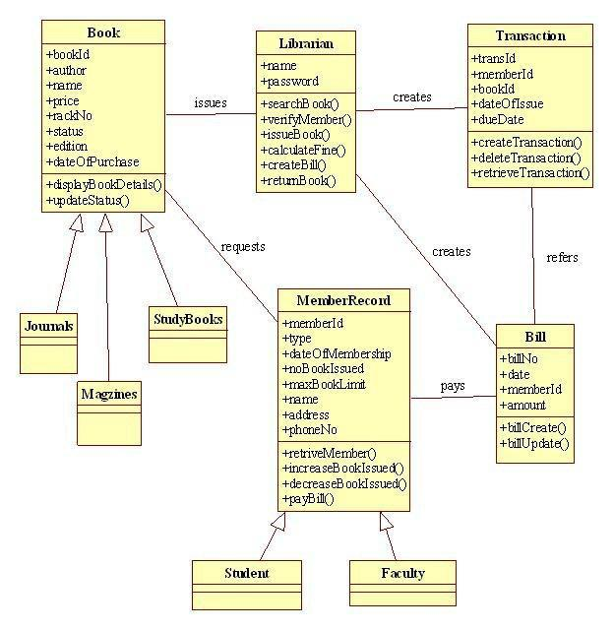

Issue of a book
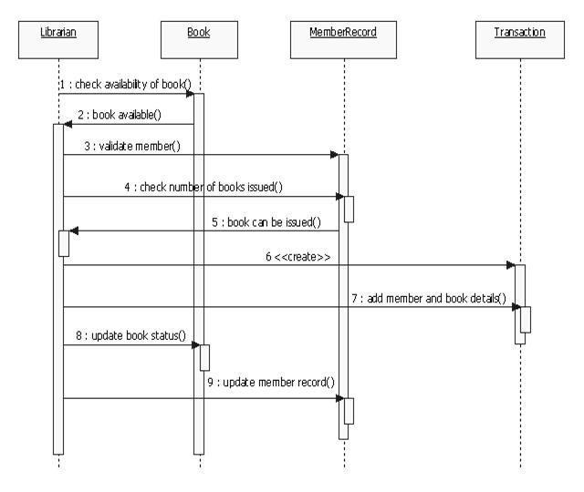
RETURN:
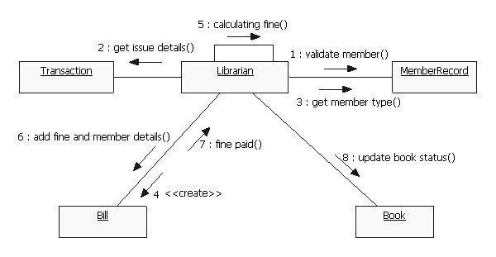
MICROSTATE DIAGRAMS

ISSUE of a book:
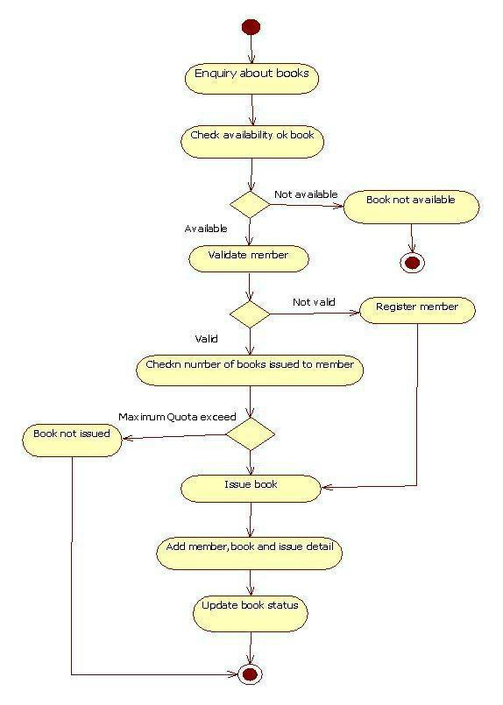

Return of a book:
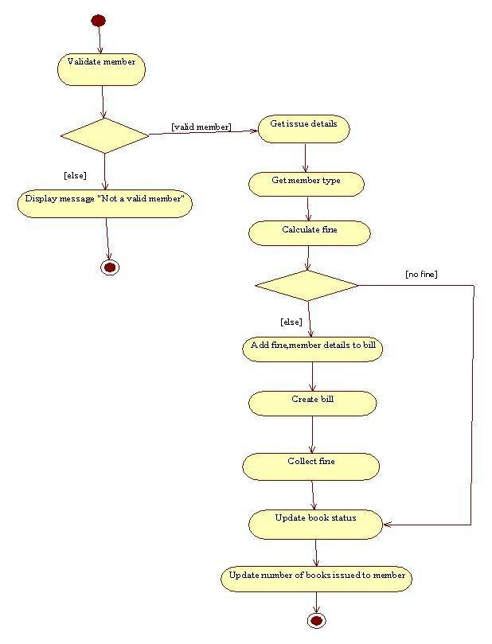

CONCLUSION

This website provides a computerized version of library management system which will benefit the students as well as the staff of the library. It makes entire process online where student can search books, staff can generate reports and do book transactions. It also has a facility for student login where student can login and can see status of books issued as well request for book or give some suggestions. It has a facility of teacher’s login where teachers can add lectures notes and also give necessary suggestion to library and also add info about workshops or events happening in our college or nearby college in the online notice board.

REFERENCE

Complete Java Reference

https://www.javatpoint.com/library management system injava swing
https://www.freelancer.com/jobsearch/java-source codelibrarymanagementsystemproject/

