XALTRAX

6-DOF Robotic Arm - Full Design & Implementation Guide

# Overview

This document provides a complete guide to building a 6 Degrees of Freedom (DOF) robotic arm. It includes mechanical design steps, electronics circuit design, control systems, component list, simulation tools, and use cases.

# 1. Components Required

Mechanical Components:  
- Base platform (cylindrical or square)  
- Link 1 (shoulder)  
- Link 2 (elbow)  
- Link 3 (forearm)  
- Link 4 (wrist pitch)  
- Link 5 (wrist yaw)  
- Link 6 (end-effector/gripper mount)  
  
Electronics:  
- 6x Servo Motors (MG996R, DS3218, or Dynamixel)  
- 1x Arduino Uno or Mega  
- 1x Ultrasonic Sensor (HC-SR04)  
- Breadboard  
- Jumper wires  
- External 5V-7.4V power supply (capable of 2A+ current)  
- USB cable (for Arduino programming)  
- Switches (optional)  
- Voltage regulator (if needed)  
  
Tools & Materials:  
- Autodesk Fusion 360 (for CAD modeling)  
- Soldering iron  
- Screwdriver  
- 3D printer (optional)  
- Screws, bolts, spacers

# 2. Use Cases

- Education: Robotics training, kinematics demonstrations  
- Industrial: Pick and place operations, light assembly tasks  
- Research: Motion planning, AI integration, sensor feedback testing  
- Home Automation: Small object manipulation, telepresence

# 3. Mechanical Design Steps (Fusion 360)

Model Each Component:  
- Use "New Component" for each segment  
- Sketch each part (rectangle or circle)  
- Use Extrude and Fillet for structure  
- Apply As-Built Joints (Revolute) to allow motion  
  
Recommended Dimensions:  
- Base: 10x10x2 cm  
- Link 1: 3x3x15 cm  
- Link 2: 3x3x25 cm  
- Link 3: 3x3x20 cm  
- Wrist: 3x3x5 cm (for each link)  
- End-effector: 4 cm diameter x 5 cm

# 4. Circuit Design (Arduino + Servos + Sensor)

Connections:  
- Servos: Connect signal pins to Arduino D2–D7  
- Ultrasonic Sensor: Trigger to D8, Echo to D9  
- Power: External 5V supply to servo VCC, GND common with Arduino  
- Arduino powered via USB or 5V adapter

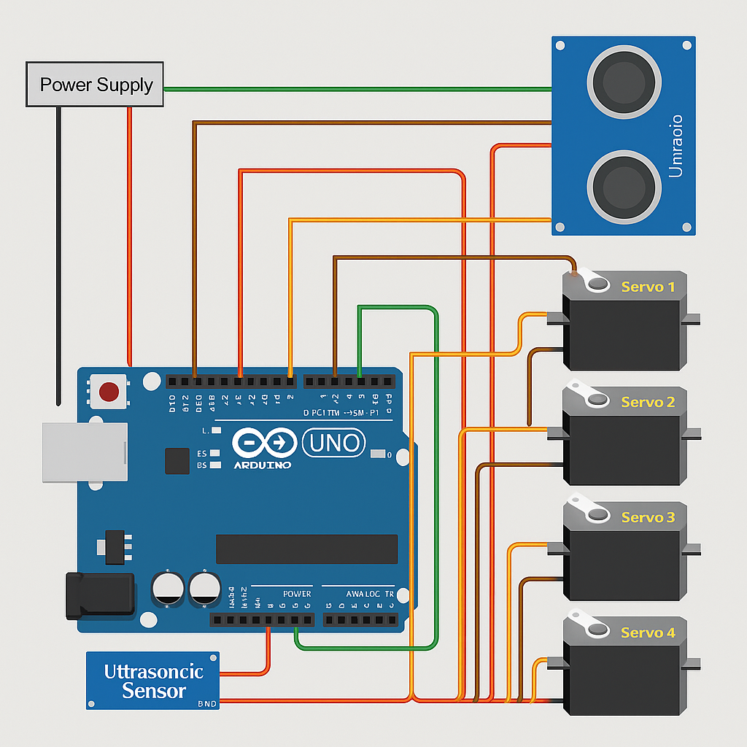

# 5. Software (Arduino Sketch)

Use Servo.h library  
Control each servo by mapping angles (0–180)  
Use ultrasonic sensor for object detection or collision avoidance  
  
Sample Code Outline:  
#include <Servo.h>  
Servo s1, s2, s3, s4, s5, s6;  
void setup() {  
 s1.attach(2); s2.attach(3); s3.attach(4);  
 s4.attach(5); s5.attach(6); s6.attach(7);  
}  
void loop() {  
 s1.write(90); s2.write(45); s3.write(135);  
 s4.write(90); s5.write(90); s6.write(90);  
 delay(1000);  
}

# 6. Kinematics Model (Python - SymPy)

- Use DH parameters  
- Define 6 matrices  
- Multiply to get T0_6 (end-effector transformation)

# 7. Simulation Tools

- Fusion 360 (animation)  
- Python (matplotlib + SymPy)  
- ROS + RViz for full robot simulation

# 8. Output/Applications

- Move object from point A to B  
- Scan surface using sensor  
- Follow programmed path  
- Respond to distance or motion triggers

# 9. Future Improvements

- Add camera module  
- Gripper with force sensors  
- Feedback with encoders  
- AI-based motion control

Additionally, for the simulation in Python, refer to the file on GitHub with the extension.py and pre-download these libraries

import numpy as np

import matplotlib.pyplot as plt

from matplotlib.animation import FuncAnimation

to download libraries

pip install libraryName