Customer Review Analyzer
Project Documentation: Streamlit + Ollama (local LLM)

1. Project Overview
Customer Review Analyzer takes a block of unstructured customer reviews and converts it into a structured business report: overall sentiment, an estimated rating, top positives and negatives, customer pain points, business suggestions, the customer types the product suits, and keywords.
The analysis is done by a large language model that runs locally through Ollama. No API key is needed, there is no per-request cost, and the review text never leaves the user’s machine.

1.1 The core idea
An LLM normally replies in free-form text, which is hard for a program to use. This project forces the model to reply in a fixed JSON schema through prompt design, then parses that JSON, cleans it, and turns it into a report. The whole project is that pipeline:
reviews (text) → prompt → local LLM → JSON text → Python dict → cleaned values → report

1.2 Technology used
Technology | Role in the project
Python 3.9+ | Core language; all logic lives in main.py.
Streamlit | Runs the app in the browser, provides the input widgets and st.session_state to hold results between reruns.
requests | Sends HTTP calls to the Ollama server (health check and chat request).
Ollama | Local server that hosts the model and exposes a REST API at http://localhost:11434.
LLM (default qwen2.5:3b) | Reads the reviews and writes the analysis. Also selectable: llama3.2:1b, llama3.2, mistral.
json, re, html | Standard library: parse model output, rescue JSON from messy text, and escape text before display.

2. Architecture
The project has three runtime pieces that talk to each other over local HTTP:
Piece | Where it runs | Responsibility
Streamlit app (main.py) | Python process, shown in the browser | Collects reviews and settings, builds the prompt, calls Ollama, parses and normalises the answer, displays the report.
Ollama server | Background service on localhost:11434 | Loads the selected model and exposes /api/chat.
Language model | Inside Ollama, on the local CPU/GPU | Generates the JSON analysis text from the prompt.

Inside main.py the code is organised into four logical blocks, which also explains the order in which Streamlit executes it:
- Page setup and styling: st.set_page_config and a CSS string injected once (visual only; not covered in this document).
- Backend logic: check_ollama_running, extract_json, analyse_reviews_ollama.
- Data helpers: esc, as_list, sentiment_class, to_rating, which clean model output before it is displayed.
- Page flow: sidebar settings, health check, input box, the Analyse button, then the results section.

3. Setup and Running
# 1. Install Ollama (ollama.com) and download the default model
ollama pull qwen2.5:3b

# 2. Install the Python dependencies (streamlit, requests)
pip install -r requirements.txt

# 3. Start the app
streamlit run main.py

Ollama must be running before the app starts; otherwise the app shows an error and stops (see Section 5.1).

4. What Happens After the User Enters Reviews
This section follows one real run from start to finish. The sample input is the placeholder text that ships inside the app’s text box:
The product quality is excellent and delivery was fast.
Customer service was helpful.
The packaging was damaged.
The price is slightly expensive.

Step 1: Settings are captured
The sidebar widgets return plain Python values on every run: model_name (default qwen2.5:3b), output_language (English, Telugu or Tenglish) and temperature (0.0 to 1.0, default 0.3). These three values travel with the reviews into the model call.

Step 2: The Ollama health check
Before any input is shown, check_ollama_running() sends GET http://localhost:11434 with a 3-second timeout. If Ollama does not answer with status 200, the app shows an error with the fix (ollama serve) and calls st.stop(), which halts the script so nothing below it runs.

Step 3: Reviews are read and counted
st.text_area returns the whole input as one string. The app counts non-blank lines for the “reviews detected” label:
review_count = len([r for r in reviews_text.splitlines() if r.strip()])

For the sample above this gives 4. The count is informational only. The reviews are not split into a list; the raw text is sent to the model exactly as typed.

Step 4: Button click and validation
Streamlit reruns the whole script when the button is clicked, and analyse_button becomes True. The first check is if not reviews_text.strip(): empty input shows a warning and no model call is made.

Step 5: The prompt is built
Inside analyse_reviews_ollama(), two messages are prepared. The system prompt sets the role and the rules (“Return valid JSON only. No markdown.”). The user prompt embeds the reviews with an f-string, then shows the exact JSON shape that must come back and the chosen output language:
Analyse these customer reviews.

REVIEWS:
<the four reviews pasted by the user>

Return ONLY valid JSON in this exact format:
{ "overall_sentiment": "Positive / Neutral / Negative / Mixed",
"estimated_rating_out_of_5": 4.2,
"one_line_verdict": "short verdict", ... "keywords": [...] }

Output language: English

Step 6: The request goes to Ollama
payload = {
"model": model_name,
"messages": [system_message, user_message],
"stream": False,
"options": {"temperature": temperature},
}
response = requests.post(OLLAMA_CHAT_URL, json=payload, timeout=180)
response.raise_for_status()

- stream: False makes Ollama return the full answer at once instead of token by token, which keeps the code simple.
- timeout=180 allows up to three minutes, because local models can be slow, especially on the first request while the model loads.
- raise_for_status() turns an HTTP error (for example 404 when the model has not been pulled) into a Python exception.

Step 7: The model replies with JSON as text
Ollama’s reply is a JSON envelope. The model’s answer is inside message.content, and it is still just a string:
raw_text = response.json()["message"]["content"]

# raw_text (illustrative):
# {"overall_sentiment": "Mixed", "estimated_rating_out_of_5": 3.5,
# "one_line_verdict": "Great quality and service, but packaging and
# price need attention.", ...}

Small models sometimes wrap this in extra text such as “Here is the analysis:” or markdown fences. Step 8 handles that.

Step 8: The text is parsed into a Python dict
extract_json(raw_text) first tries json.loads on the whole string. If that fails, it searches for the first { and the last } with a regular expression and parses just that part. This rescues the JSON from messy replies (details in Section 5.3). The result is a normal Python dictionary.

Step 9: The result is stored in session state
The dictionary is saved with st.session_state["analysis_result"] = result. This matters because Streamlit reruns the entire script on every interaction (typing, pressing a button, downloading). Without session state the report would vanish on the next rerun. The “Clear Results” button simply removes this key and reruns.

Step 10: Values are cleaned before display
The report section runs only if "analysis_result" in st.session_state. Each field is read with .get() and a default, then passed through the helper functions, because the model’s output cannot be trusted to have the right types:
Model output | Helper | Result
"Mixed" | sentiment_class() | "neutral" (used to pick the card style)
"4.2" (string) or 7 | to_rating() | 4.2 or 5.0 (clamped to 0 to 5)
"N/A" | to_rating() | None, so the raw value is shown instead
"Fast delivery" (string, not a list) | as_list() | ["Fast delivery"]
"<b>great</b>" | esc() | Escaped, so it displays as text and is never run as HTML

Step 11: Export
The download button serialises the dictionary with json.dumps(result, indent=2, ensure_ascii=False). ensure_ascii=False keeps Telugu characters readable in the exported file instead of turning them into \u escape codes.

The final parsed result for the sample input (illustrative)
{
"overall_sentiment": "Mixed",
"estimated_rating_out_of_5": 3.5,
"one_line_verdict": "Great quality and service, but packaging and price need work.",
"top_positives": ["Excellent product quality", "Fast delivery", "Helpful service"],
"top_negatives": ["Damaged packaging", "Slightly expensive price"],
"customer_pain_points": ["Packaging damage in transit"],
"business_suggestions": ["Improve packaging", "Review pricing"],
"best_for": ["Quality-focused buyers"],
"keywords": ["quality", "delivery", "service", "packaging", "price"]
}

(Exact wording varies between runs and models; this shows the shape of the data.)

5. Important Methods

5.1 check_ollama_running()
def check_ollama_running():
try:
response = requests.get("http://localhost:11434", timeout=3)
return response.status_code == 200
except requests.exceptions.RequestException:
return False

- Purpose: detect early whether the Ollama server is reachable, so the user gets a clear message instead of a confusing connection error later.
- How: Ollama answers a plain GET on its root URL with status 200 when it is up. Any RequestException (connection refused, timeout) is caught and turned into False.
- Short timeout (3 s): a health check must fail fast.

5.2 analyse_reviews_ollama(reviews_text, output_language, model_name, temperature)
- Purpose: the heart of the project. It turns raw review text into a Python dictionary.
- Builds the prompt: a system prompt (role and output rules) plus a user prompt containing the reviews, the JSON schema and the language.
- Calls the model: requests.post to /api/chat with stream=False and the chosen temperature.
- Returns: extract_json(raw_text), a dict. It does not catch errors itself; the caller handles them (Section 8).
- Detail worth knowing: inside the f-string prompt, the JSON braces are written as {{ and }}, because a single brace would be read as a Python placeholder.

5.3 extract_json(text)
def extract_json(text):
try:
return json.loads(text) # attempt 1: clean JSON
except Exception:
pass
match = re.search(r"\{[\s\S]*\}", text) # attempt 2: first { to last }
if match:
return json.loads(match.group())
raise ValueError("Could not parse JSON from model response...")

- Purpose: make parsing robust, because LLMs do not always obey “JSON only”.
- Attempt 1 succeeds when the model returns clean JSON.
- Attempt 2 uses the pattern \{[\s\S]*\}: [\s\S]* matches any character including newlines, so the match spans from the first { to the last }, even across many lines.
- Example: for Here is the analysis: {"overall_sentiment": "Positive"} Hope this helps!, attempt 1 fails and attempt 2 extracts {"overall_sentiment": "Positive"}.
- If both fail, a ValueError tells the user to lower the temperature.

5.4 Data-cleaning helpers
Function | What it does and why
as_list(value) | Guarantees a list. None becomes []; a lone string becomes a one-item list; empty or blank items are dropped. Protects the display loop from a model that returns a string instead of a list.
to_rating(value) | Converts to a float and clamps it into 0 to 5 with max(0.0, min(5.0, float(value))). Returns None if conversion fails, so a bad value never crashes the page.
sentiment_class(s) | Lowercases the sentiment text and maps it to "neutral" (Mixed or Neutral), "positive", "negative", with neutral as the default. This is a keyword match, so “Mostly positive” also maps to positive.
esc(value) | Wraps html.escape(str(value)). The app renders with unsafe_allow_html=True, so any model- or user-supplied text must be escaped first. This prevents HTML or script injection through review text.

display_card() and display_list() only format already-cleaned values; they contain no processing logic.

5.5 Streamlit rerun model and session_state
Streamlit executes main.py from top to bottom every time the user interacts with any widget. Two consequences shape the code:
- Variables are lost between runs, so the analysis result is kept in st.session_state.
- The health check and the settings widgets run on every rerun, while the expensive model call runs only inside if analyse_button:.

6. Prompt Design
- Role prompt: “expert customer review analyst” focuses the model on the task.
- Strict output rules: “Return valid JSON only. No markdown. No explanation outside JSON.” reduces extra text that would break parsing.
- Schema by example: the exact key names and value shapes are shown, so the app can rely on result.get("top_positives") and the other keys.
- Delimited input: the reviews sit under a REVIEWS: label, separating the data from the instructions.
- Language switch: one line, Output language: {output_language}, changes the language of every text field without changing the code.
- Low default temperature (0.3): lower randomness gives more consistent, valid JSON. The slider help text and the error message both recommend 0.1 to 0.2 if parsing fails.

7. Output Data Structure
Field | Type | Meaning
overall_sentiment | string | Positive, Neutral, Negative or Mixed.
estimated_rating_out_of_5 | number | Rating estimated by the model; clamped to 0 to 5 on display.
one_line_verdict | string | One-sentence conclusion.
summary | string | Short paragraph summary of all reviews.
top_positives | list | What customers like.
top_negatives | list | What customers dislike.
customer_pain_points | list | Recurring problems customers face.
business_suggestions | list | Recommended actions for the business.
best_for | list | Customer types the product suits.
keywords | list | Important terms from the reviews.

8. Error Handling
Situation | Where it is handled | What the user sees
Ollama not running | check_ollama_running() + st.stop() | Error message and the commands ollama serve / ollama pull <model>.
Empty input | if not reviews_text.strip() | A warning; no model call is made.
Model not downloaded, or other HTTP error | except requests.exceptions.HTTPError | The HTTP error plus a hint to run ollama pull <model>.
Timeout (over 180 s), connection loss, or unparseable JSON | Generic except Exception | The error text plus a tip to use temperature 0.1 or 0.2.
Missing or wrongly typed JSON fields | .get() defaults, as_list, to_rating | A fallback text such as “No summary available.” instead of a crash.

Both exception handlers call st.stop() after showing the message, so a failed run never displays a half-built report.

9. Limitations and Possible Improvements
- JSON reliability: small local models can still return malformed JSON. Ollama’s format: "json" request option could be added to constrain the output.
- Greedy regex fallback: it matches from the first { to the last }, so extra text containing braces after the JSON could still break parsing.
- No input chunking: a very large set of reviews may exceed the model’s context window. Splitting into batches and merging the results would solve this.
- Estimated rating: the rating is the model’s opinion, not a calculated value.
- Reviews inside the prompt: review text is inserted directly into the prompt, so a review containing instructions could influence the model.
- Next steps: schema validation (for example with Pydantic), unit tests for the helper functions, CSV upload, and saving analysis history.

10. End-to-End Code Flow
The diagram below summarises the full journey of a run, from the moment the page loads to the downloaded report. Green boxes are user-facing steps, orange boxes are checks, white boxes are processing, and the red boxes on the right are failure paths.
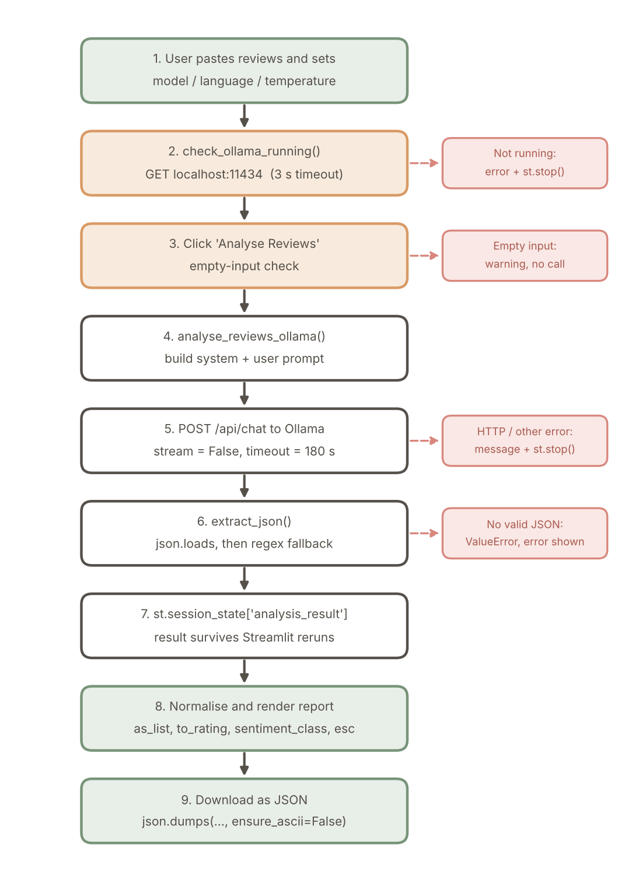

Flow summary
# | Stage | Code | Outcome
1 | Settings and input | st.selectbox, st.slider, st.text_area | model_name, output_language, temperature, reviews_text
2 | Server check | check_ollama_running() | Continue, or error and st.stop()
3 | Trigger and validation | if analyse_button / reviews_text.strip() | Proceed, or empty-input warning
4 | Prompt building | analyse_reviews_ollama() | System and user messages
5 | Model call | requests.post(..., timeout=180) | HTTP response from Ollama
6 | Extract the answer | response.json()["message"]["content"] | raw_text string
7 | Parse | extract_json(raw_text) | Python dict
8 | Persist | st.session_state["analysis_result"] | Result survives reruns
9 | Clean and render | as_list, to_rating, sentiment_class, esc | Report shown on the page
10 | Export | json.dumps(..., ensure_ascii=False) | Downloadable JSON file

In one sentence: the user’s reviews are wrapped in a strict prompt, sent to a local Ollama model over HTTP, the text answer is parsed into a dictionary, stored in session state, cleaned field by field, and then displayed and offered for download.

