📊 Parking Slot Management Dashboard
The Parking Management Slot System is designed to efficiently manage vehicle parking by automating slot allocation, entry/exit tracking, and billing. For example, in places like malls or apartment parking, instead of manually checking for space, the system automatically assigns an available slot and calculates the parking fee when the vehicle exits. This reduces manual effort, avoids confusion, and ensures better space utilization.
📂 Dataset Source
- The dataset was generated from the Parking Slot Management System project (Python + MySQL).
- Additional sample records were created to simulate real-world scenarios (e.g., unpaid bills, frequent customers, slot usage patterns).
- This dataset was then imported into Power BI for dashboard design and measure creation.
Purpose of Creating the Dashboard
- The dashboard was created primarily as a learning project, to practice Power BI and understand how raw data can be transformed into real-time business insights.

- It visualizes the records stored in the Parking Slot Management System (Python + MySQL), showing how backend data translates into actionable information.

- This demonstrates how the project would work in a real-world environment, highlighting slot utilization, revenue trends, customer contribution, and payment status.
- The goal was to bridge system design and analytics, proving that technical development can directly support business decision-making.

Measures:
1. Total Vehicles
Formula: COUNT('Parking_Data'[Record_ID])
Purpose: Shows how many vehicles entered the parking system overall.
2. Total Revenue
Formula: SUM(Parking_Data [parking_fee]) + SUM(Parking_Data late_fee])
Purpose: Captures total earnings from parking fees and late charges.

3. Average Duration
- Formula:FORMAT(AVERAGE('Parking_Data'[Parking_Duration]),"0.0")&"hrs"
- Purpose: Calculates how long vehicles typically stay.

4. 2025 Revenue
- Formula: CALCULATE([Total_Revenue],YEAR(Parking_Data[Entry_Date]) = 2025
- Purpose: Shows only the revenue earned in 2025, excluding other years.

Insights From the Dashboard:
1. Revenue & Payment Tracking
- Measures: Total Revenue, Paid vs Unpaid Vehicles %
- Insight: Nearly 90% vehicles unpaid, highlighting a major operational gap.
2. Customer Contribution
- Measures: Top Customers Revenue
- Insight: A few loyal customers (e.g., Divya Pillai, Prasad Hegde) contribute disproportionately to revenue.
3. Slot Utilization
- Measures: Most Used Slots
- Insight: Slots like S28, S26, S24 are heavily used, while others remain underutilized — showing uneven distribution.
4. Time & Duration Analysis
- Measures: Average Parking Duration
- Insight: Vehicles stay around 2.7 hours, useful for pricing and turnover optimization.
5. Trend & Target Monitoring
- Measures: Revenue CP vs PY, Revenue vs Target
- Insight: Current revenue (₹138.75K) is below target (₹200K), with clear monthly trends showing peak inflows on weekends.

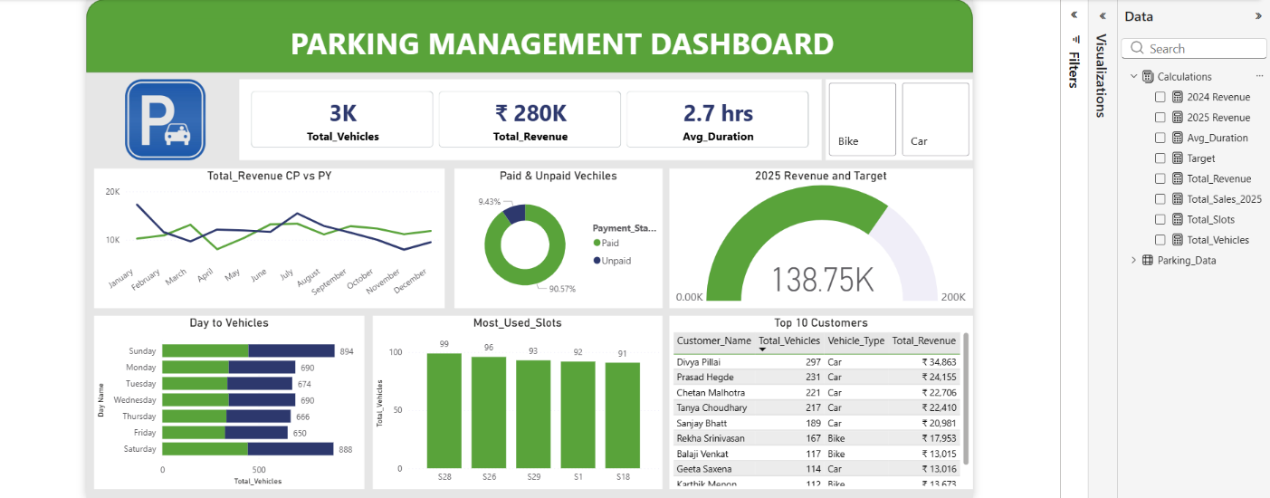
Dashboard:

Conclusion:
The Parking Slot Management Dashboard effectively transforms data from the Python + MySQL Parking System into real-time insights using Power BI. It highlights key metrics like revenue, slot usage, customer contribution, and payment status, proving how backend records can be converted into actionable visuals for learning and real-world decision-making.

