FACE EMOTION
RECOGNITION
A Deep Learning Project Using Convolutional Neural Networks

Project Type | Image Classification / Deep Learning
Framework | TensorFlow / Keras
Model | Convolutional Neural Network (CNN)

Project documentation prepared from the supplied Jupyter Notebook.

1. Abstract
Face Emotion Recognition is an image-classification project that uses a Convolutional Neural Network (CNN) to predict the emotion expressed in a facial image. The notebook loads facial images from training and testing folders, converts them into grayscale pixel arrays, normalizes pixel values, encodes emotion labels, and trains a CNN model.
The model is designed to classify an input image into one of seven categories: angry, disgust, fear, happy, neutral, sad, or surprise. After training, the notebook demonstrates prediction on individual images and displays the corresponding grayscale image.
The supplied notebook contains the data preparation, CNN definition, compilation, training call, and sample prediction code. Its saved training output is incomplete, so a final test accuracy or completed 100-epoch result cannot be confirmed from the notebook output.

2. Introduction
Human facial expressions provide visual information about emotional states. Face emotion recognition is a computer-vision task in which a machine-learning model analyzes facial image patterns and assigns an emotion category.
This project applies deep learning to facial-expression classification. CNNs are suitable for image tasks because convolutional filters learn spatial patterns such as edges, textures, and higher-level facial features from image pixels.

3. Problem Statement
The objective is to build an image-classification model that accepts a facial image and predicts which of seven predefined emotion classes it most closely represents. The project focuses on classifying individual images; the supplied notebook does not implement real-time webcam detection or face tracking.

4. Objectives
- Load facial-expression images from separate training and testing directories.
- Associate each image path with its emotion label.
- Convert images to grayscale and arrange them in a consistent 48 × 48 pixel format.
- Normalize image pixel values to the range 0 to 1.
- Convert categorical emotion labels into numerical and one-hot encoded representations.
- Build and train a CNN model for seven-class classification.
- Use the trained model to predict emotions for individual images.

5. Technologies and Libraries
Technology / Library | Purpose
Python | Main programming language used in the notebook.
TensorFlow / Keras | Defines, compiles, and trains the CNN model.
NumPy | Converts image data into numerical arrays and reshapes the data.
Pandas | Stores image paths and their corresponding labels in DataFrames.
Matplotlib | Displays sample grayscale images.
scikit-learn | Uses LabelEncoder to convert emotion labels into numeric classes.
tqdm | Displays progress while image files are loaded.
OS module | Navigates the dataset directories and retrieves file names.

6. Dataset Description
The notebook expects the dataset to be arranged in class-specific folders under an archive directory. The folder names are used as the emotion labels.
archive/
images/
train/
angry/ disgust/ fear/ happy/
neutral/ sad/ surprise/
test/
angry/ disgust/ fear/ happy/
neutral/ sad/ surprise/
The notebook reports 28,821 training images and 7,066 testing images.
Dataset split | Number of images | Use
Training | 28,821 | Used to fit the CNN model
Testing | 7,066 | Passed as validation_data during model.fit
The notebook output lists seven classes: angry, disgust, fear, happy, neutral, sad, and surprise. The exact per-class image counts are not summarized in the notebook.
The project uses a facial-expression image dataset in the FER-2013 style (Kaggle dataset link). Every image is a 48x48 grayscale face, stored in a folder named after its emotion.

7. Project Workflow
- Set the training and testing directory paths.
- Read image file paths and derive labels from their parent-folder names.
- Create Pandas DataFrames for the training and testing datasets.
- Load each image in grayscale and convert it to a NumPy array.
- Reshape image arrays to (number of images, 48, 48, 1).
- Normalize pixel values by dividing by 255.0.
- Encode emotion labels using LabelEncoder and to_categorical.
- Create the CNN architecture and compile it.
- Train the model using the training data and pass the testing data as validation_data.
- Predict the emotion for selected individual images.

8. Data Preparation and Preprocessing

8.1 Creating image paths and labels
The createdataframe(dir) function loops through each emotion folder. It appends every image path to image_paths and the folder name to labels. These lists are then used to create Pandas DataFrames with two columns: image and label.
def createdataframe(dir):
image_paths = []
labels = []
for label in os.listdir(dir):
for imagename in os.listdir(os.path.join(dir, label)):
image_paths.append(os.path.join(dir, label, imagename))
labels.append(label)
return image_paths, labels

8.2 Loading grayscale images
The extract_features(images) function loads each image using load_img with grayscale mode. Each image is converted into a NumPy array. The resulting collection is reshaped to four dimensions: (number of images, 48, 48, 1).
features = features.reshape(len(features), 48, 48, 1)
The dimensions represent the number of images, image height, image width, and one grayscale channel. The CNN expects this four-dimensional input format.

8.3 Normalization
x_train = train_features / 255.0
x_test = test_features / 255.0
Image pixel values are divided by 255 so that values originally represented on a 0–255 scale are converted to a 0–1 range. This scaling provides a consistent numerical input range for the neural network.

8.4 Label encoding
LabelEncoder converts the text labels into integer class identifiers. The notebook fits the encoder using the training labels and applies the same encoder to the testing labels.
le = LabelEncoder()
le.fit(train['label'])
y_train = le.transform(train['label'])
y_test = le.transform(test['label'])

8.5 One-hot encoding
The integer class identifiers are converted into one-hot encoded vectors with seven positions. Each image has a vector in which the position corresponding to its emotion class is 1 and the other positions are 0.
y_train = to_categorical(y_train, num_classes=7)
y_test = to_categorical(y_test, num_classes=7)
This representation matches the seven output units and the categorical_crossentropy loss used by the model.

9. CNN Model Architecture
The notebook builds a Sequential CNN using four Conv2D blocks, followed by flattening and fully connected Dense layers. Each convolutional block uses ReLU activation, max pooling, and dropout.
Stage | Layer | Configuration | Purpose
Input | Conv2D | 128 filters, 3×3, ReLU; input 48×48×1 | Learns initial image features.
Block 1 | MaxPooling2D + Dropout | 2×2 pool; dropout 0.4 | Reduces spatial dimensions and regularizes.
Block 2 | Conv2D + MaxPooling2D + Dropout | 256 filters, 3×3, ReLU; 2×2; 0.4 | Learns more complex patterns.
Block 3 | Conv2D + MaxPooling2D + Dropout | 512 filters, 3×3, ReLU; 2×2; 0.4 | Learns deeper image features.
Block 4 | Conv2D + MaxPooling2D + Dropout | 512 filters, 3×3, ReLU; 2×2; 0.4 | Further extracts spatial features.
Flatten | Flatten | Converts feature maps to a vector | Prepares features for Dense layers.
Dense 1 | Dense + Dropout | 512 units, ReLU; dropout 0.4 | Learns combinations of extracted features.
Dense 2 | Dense + Dropout | 256 units, ReLU; dropout 0.3 | Further learns class-discriminating patterns.
Output | Dense | 7 units, Softmax | Produces class scores for seven emotions.

9.1 Why multiple convolutional layers are used
The early convolutional layers learn relatively simple visual patterns. Deeper convolutional layers combine these patterns to learn more complex representations. Stacking convolutional layers allows the model to build hierarchical image features rather than relying on a single convolution operation.

9.2 Max pooling
MaxPooling2D with a 2 × 2 pool size downsamples feature maps by retaining the maximum value within each pooling region. This reduces spatial dimensions and computation while retaining strong detected features.

9.3 Dropout
Dropout randomly disables a fraction of units during training. The notebook uses dropout rates of 0.4 in the convolutional blocks and first Dense layer, and 0.3 in the second Dense layer. This is intended to reduce overfitting.

9.4 Softmax output
The final Dense layer has seven units and uses softmax activation. Softmax converts the output values into a normalized set of class scores that sum to approximately 1. The class with the highest score is selected as the predicted emotion.

10. Model Compilation
model.compile(
optimizer='adam',
loss='categorical_crossentropy',
metrics=['accuracy']
)
- Adam optimizer: updates the model weights during training using an adaptive optimization method.
- Categorical cross-entropy: measures the difference between the one-hot true labels and the model's predicted class probabilities for a multi-class classification task.
- Accuracy: tracks the proportion of predictions that match the target class.

11. Model Training
model.fit(
x=x_train,
y=y_train,
batch_size=128,
epochs=100,
validation_data=(x_test, y_test)
)
The training call specifies a batch size of 128 and a maximum of 100 epochs. One epoch is one complete pass through the training dataset. The model processes the data in batches and reports training loss and accuracy, along with validation loss and validation accuracy.
Important implementation detail: the notebook passes x_test and y_test as validation_data during training. Therefore, the reported validation metrics are calculated on the testing split during each epoch. For a more rigorous final evaluation, use three separate splits: training, validation, and an untouched test set.
The saved notebook output shows the first two epochs and part of the third epoch, but does not show a completed training run or final metrics. Consequently, this documentation does not claim a final accuracy value or that all 100 epochs completed.

12. Prediction on an Individual Image
The ef(image) function loads a selected image in grayscale, converts it to a NumPy array, reshapes it to (1, 48, 48, 1), and normalizes its pixel values. The leading dimension of 1 represents one image in the prediction batch.
def ef(image):
img = load_img(image, grayscale=True)
feature = np.array(img)
feature = feature.reshape(1, 48, 48, 1)
return feature / 255.0
The model.predict() method returns seven class scores. argmax() selects the index of the highest score. The notebook maps that index to an emotion name using the label list.
pred = model.predict(img)
pred_label = label[pred.argmax()]
print('model prediction is', pred_label)
The notebook demonstrates this process with sample images from the sad, happy, and surprise folders and displays the input image using Matplotlib.
The prediction examples use images from the training directory. They demonstrate the prediction pipeline, but do not independently establish how well the model generalizes to unseen images.

13. Results and Observations
The notebook successfully constructs the image-path DataFrames, reports 28,821 training images and 7,066 testing images, prepares grayscale image tensors, encodes the seven emotion classes, defines the CNN, and contains a model-training call and sample prediction cells.
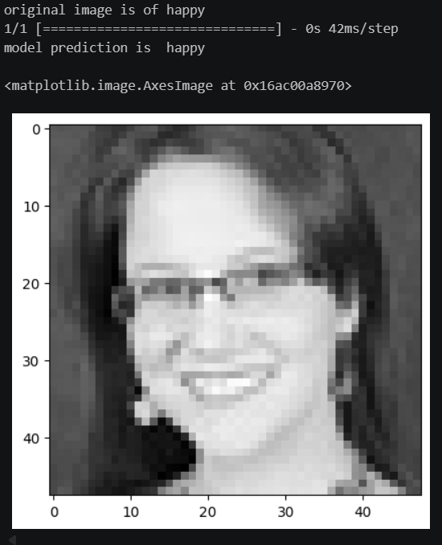
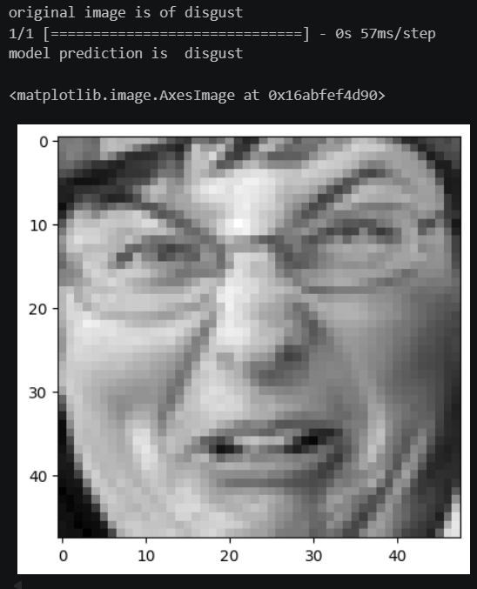
The recorded training output includes early-epoch loss and accuracy values, but the output is truncated during epoch 3. A final performance result cannot be reported from the supplied notebook. To complete this section after a full run, record the final training accuracy, validation accuracy, training loss, validation loss, and preferably a confusion matrix and per-class precision, recall, and F1-score.

14. Limitations and Scope
- The notebook performs classification on individual image files; it does not implement live webcam capture, face detection, or real-time video processing.
- The model is configured for 48 × 48 grayscale images. Inputs must be prepared in the same format.
- The notebook uses the testing split as validation_data during training, so it is not an untouched final test evaluation.
- The saved output does not provide complete training history or final evaluation metrics.
- The notebook does not show a confusion matrix, class-wise metrics, or a systematic error analysis.
- The prediction examples are selected from the training folders rather than a separately collected set of unseen images.

15. Future Enhancements
- Create separate training, validation, and test datasets and reserve the test set for final evaluation.
- Add accuracy and loss plots across epochs.
- Evaluate the model using a confusion matrix, precision, recall, and F1-score for each emotion class.
- Apply data augmentation, such as small rotations, shifts, and horizontal flips, where appropriate.
- Save the trained model and label mapping so they can be loaded for later inference.
- Add face detection and webcam/video input to support real-time emotion classification.
- Test the model on images collected from different sources to assess generalization.

16. Conclusion
This project demonstrates an end-to-end image-classification workflow for facial emotion recognition using a CNN. It covers dataset organization, image loading, grayscale conversion, reshaping, normalization, label encoding, one-hot encoding, CNN architecture design, model compilation, training, and single-image prediction.
The model is configured to recognize seven emotion categories. The notebook provides the implementation pipeline, while a completed training run and independent evaluation are still required before reporting final model performance.

Appendix A. Emotion Classes
- Angry
- Disgust
- Fear
- Happy
- Neutral
- Sad
- Surprise

Appendix B. Implementation Notes to Check Before Submission
- Confirm that the dataset folder exists at the configured TRAIN_DIR and TEST_DIR paths.
- Confirm every image is 48 × 48 pixels, or add a resize step before reshaping.
- Prefer color_mode='grayscale' in load_img; the notebook currently uses grayscale=True in the single-image helper, which may be deprecated in some Keras versions.
- Use the encoder's class order (le.classes_) when mapping prediction indices to labels, rather than maintaining a separate manually typed list. The current list appears to follow the alphabetic order used by LabelEncoder for these seven labels.
- Run training to completion and save the final metrics before adding numerical performance claims to the report.
- For final evaluation, do not repeatedly tune the model against the test set; keep a separate validation set for model selection.

