**Project Car Request Services**

**Group-5**

**Business Requirement**

The main objective of this project is to provide the users with the facility to rent a desired car and rent a car/truck for transportation of vehicles anywhere in Unites States.

There are two perspectives of this portal Admin and Customer.

Customers should be able to create account, view available cars, locations and prices, book cars/trucks by selecting from and to location, view order details.

Admin can use the system to add, view, remove employees and locations which will update the front end accordingly. An admin can also view orders of any user.

Employee can view the orders assigned, update status of the orders to ‘In Progress’ and ‘Completed’ and give feedback.

Once the customer has made the selection the program calculates the total amount and an order is created.

For each order, a reference number is generated.

**Web Pages**

**Common pages for both users:**

* Register
* Login
* Logout

**For Customer:**

* View Location and Pricing
* Booking
* Payment
* View Order History

**For Admin:**

* View/Remove User
* Add/View/Remove Employee
* Update order status
* View all orders

**UML**

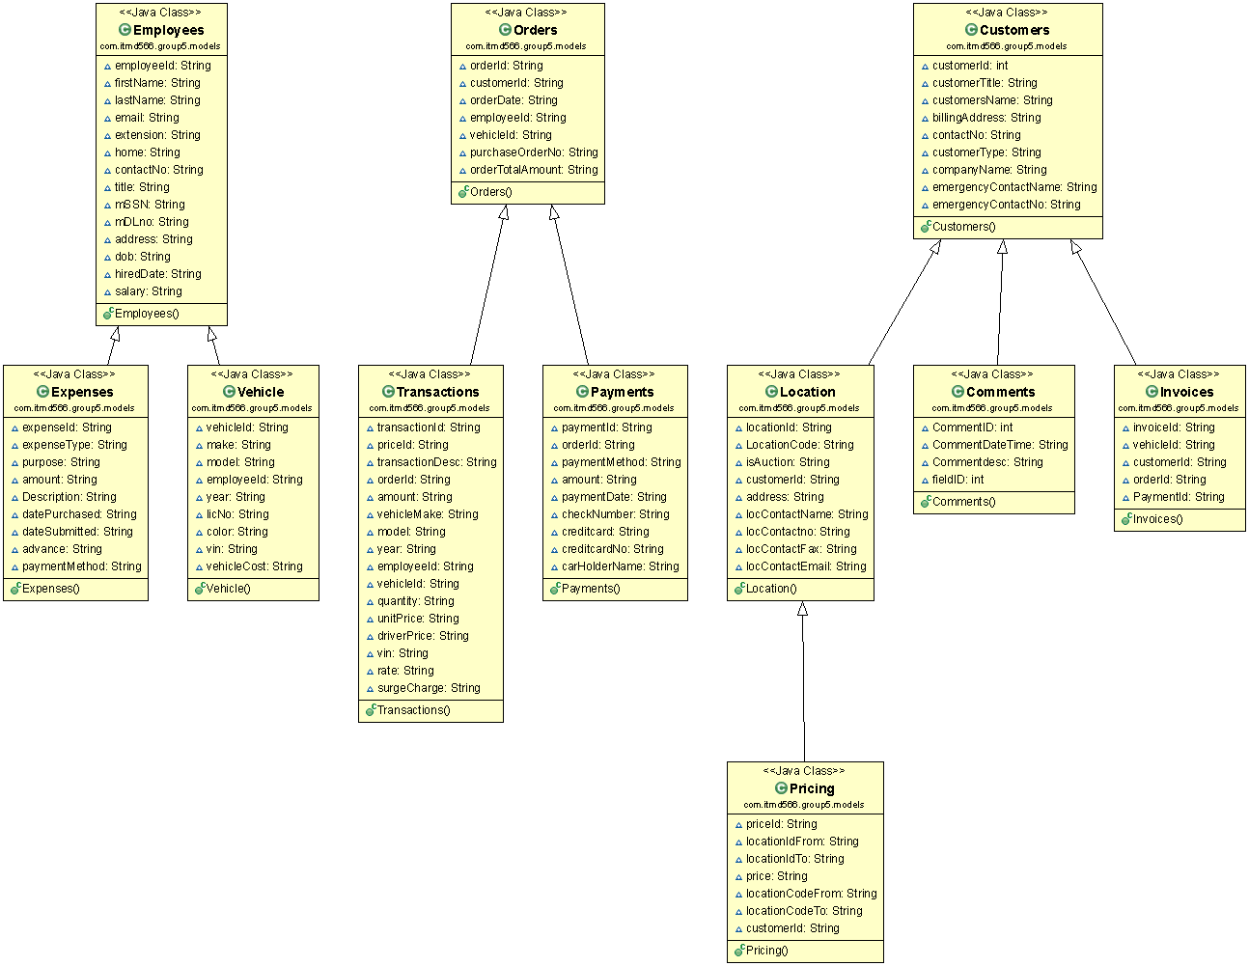

**ERD**

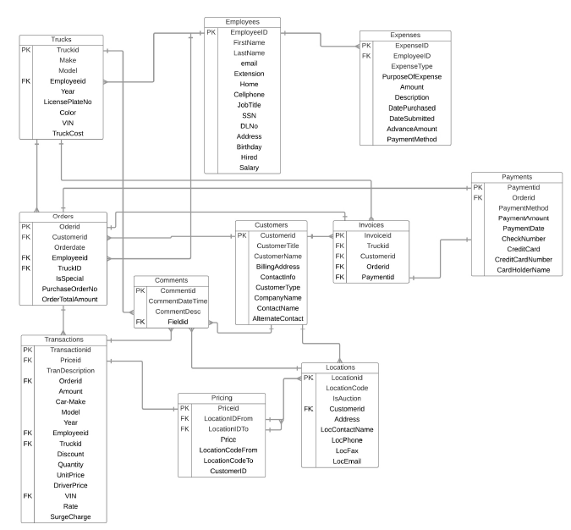

**Webservice API**

* + public ArrayList<Vehicle> getAllVehicles();
  + public ArrayList<Orders> getAllOrders(String customerId);
  + public ArrayList<Location> getLocationByCity(String city);
  + public void registerCustomer(Customers customer);
  + public void registerEmployee(Employees employee);
  + public void updateCustomer(Customers customer);
  + public void updateEmployee(Employees employee);
  + public ArrayList<Pricing> getPricingbyModel(String model);
  + public ArrayList<Transactions> getTransactionbyVehicle(String VehicleId);
  + public ArrayList<Expenses> getExpensesByDate(String date);