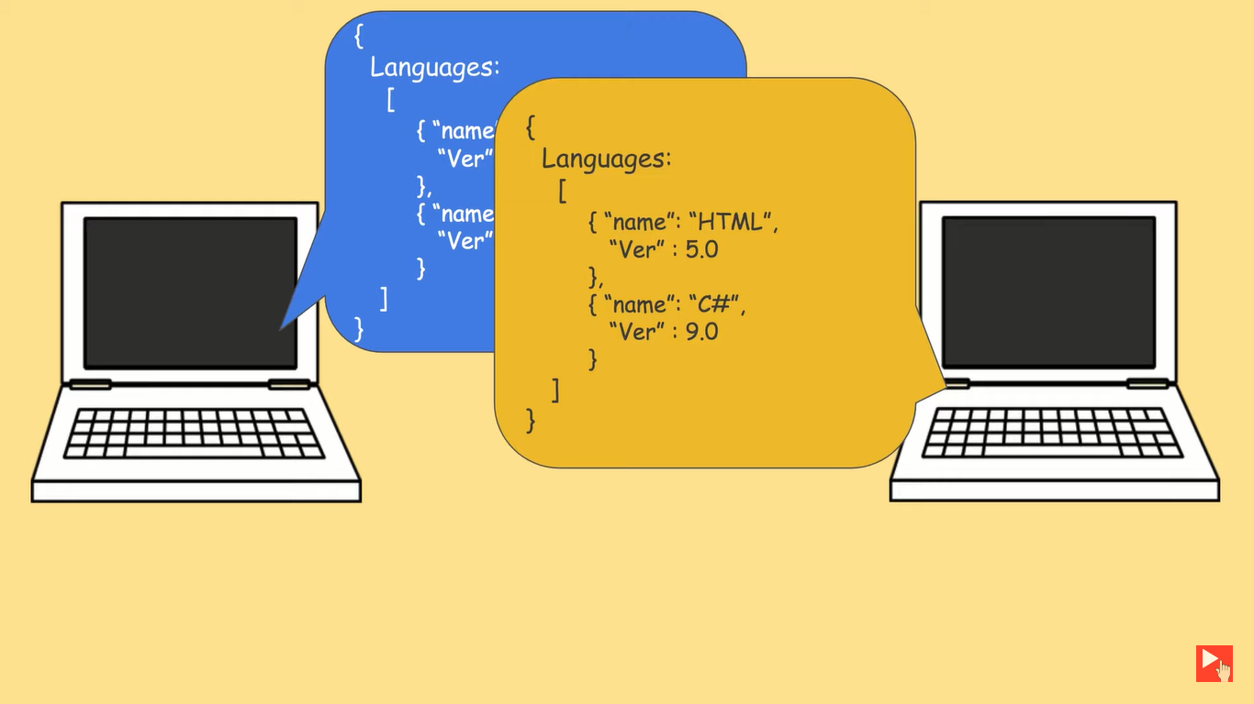

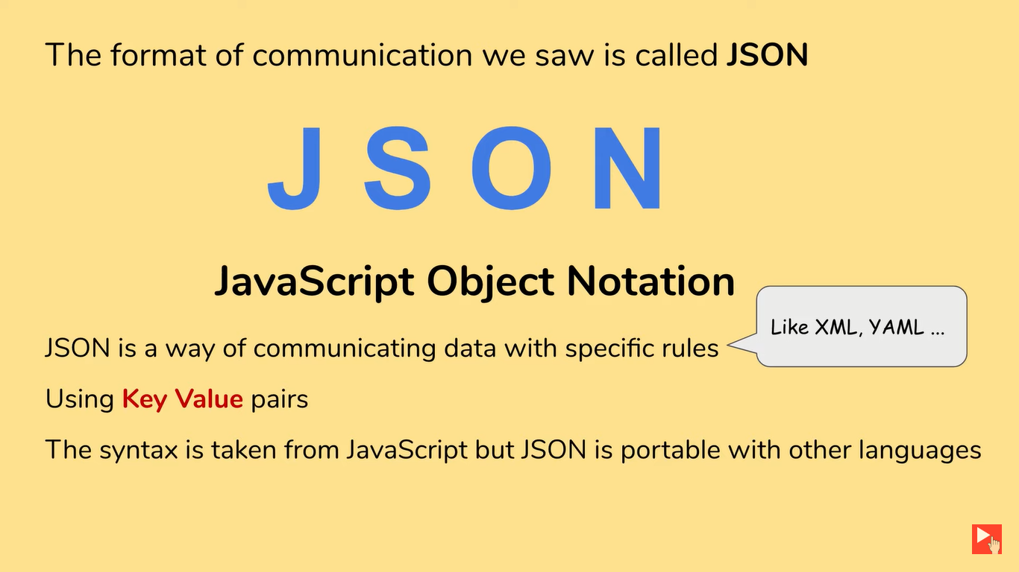

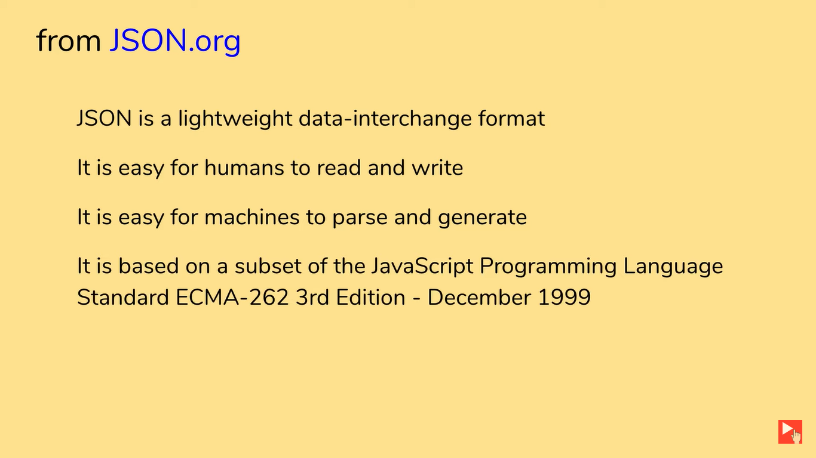

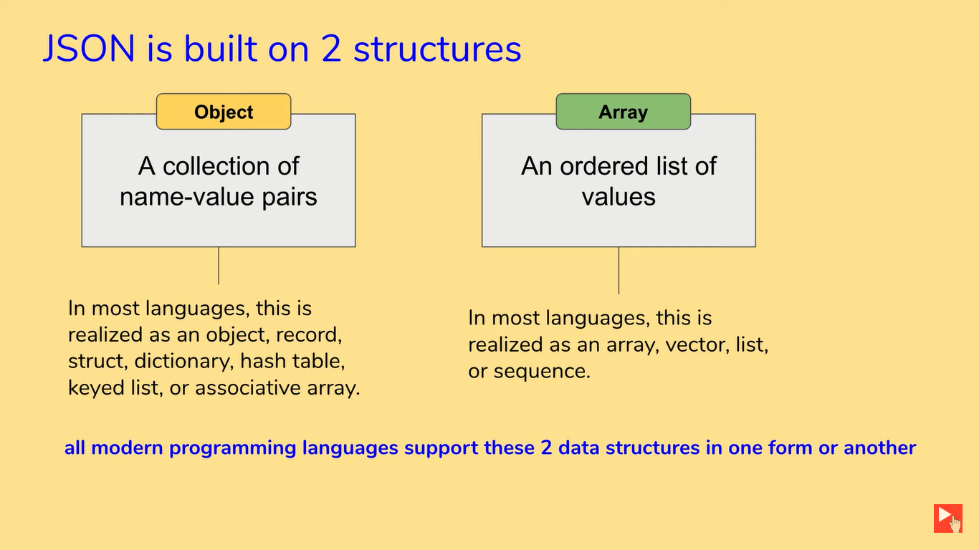

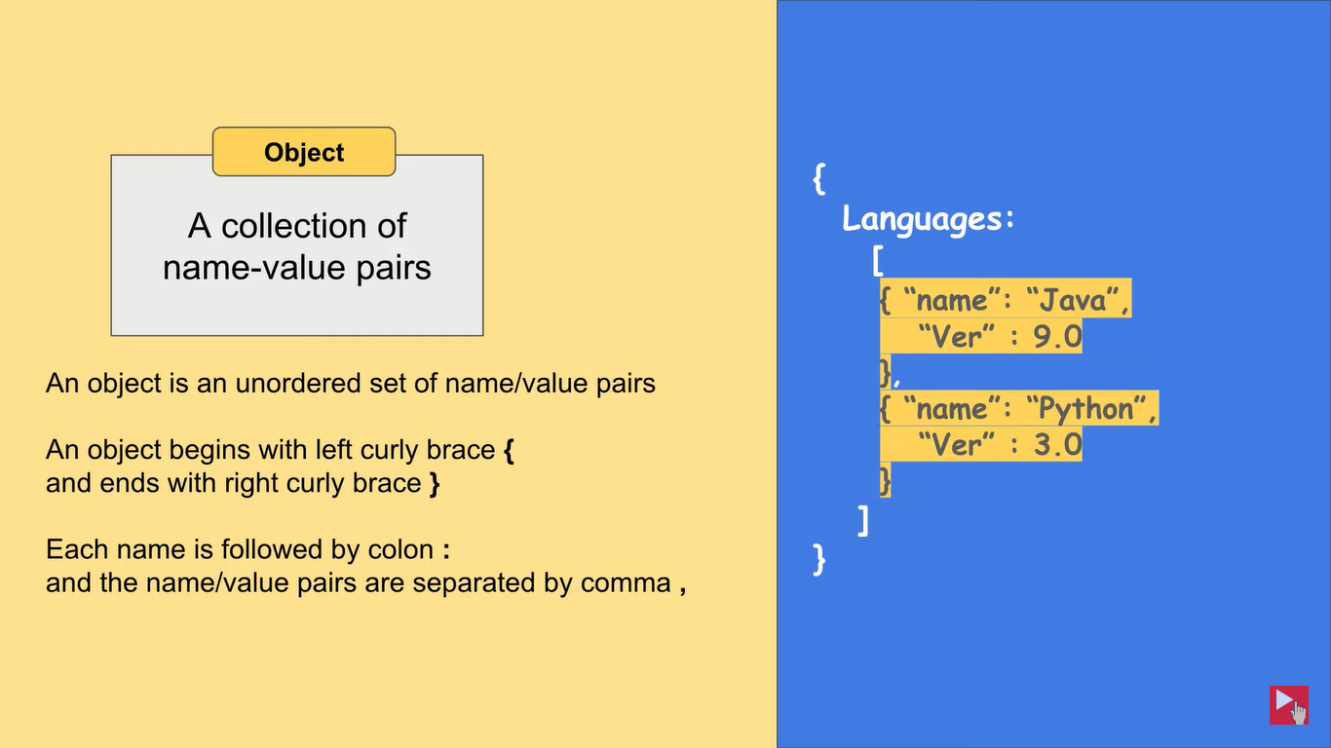

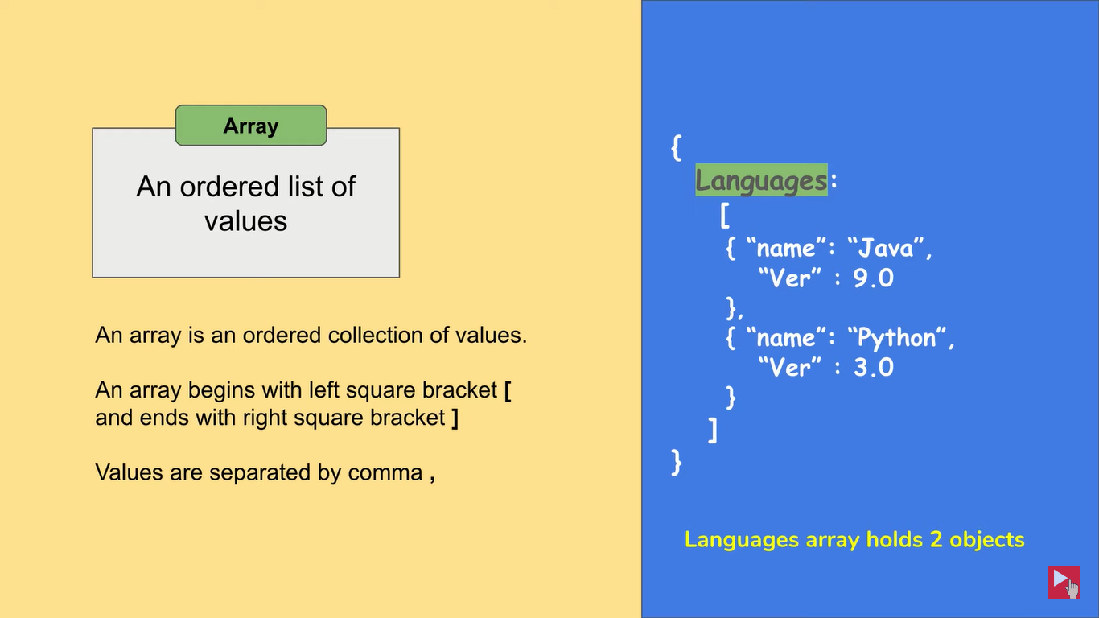

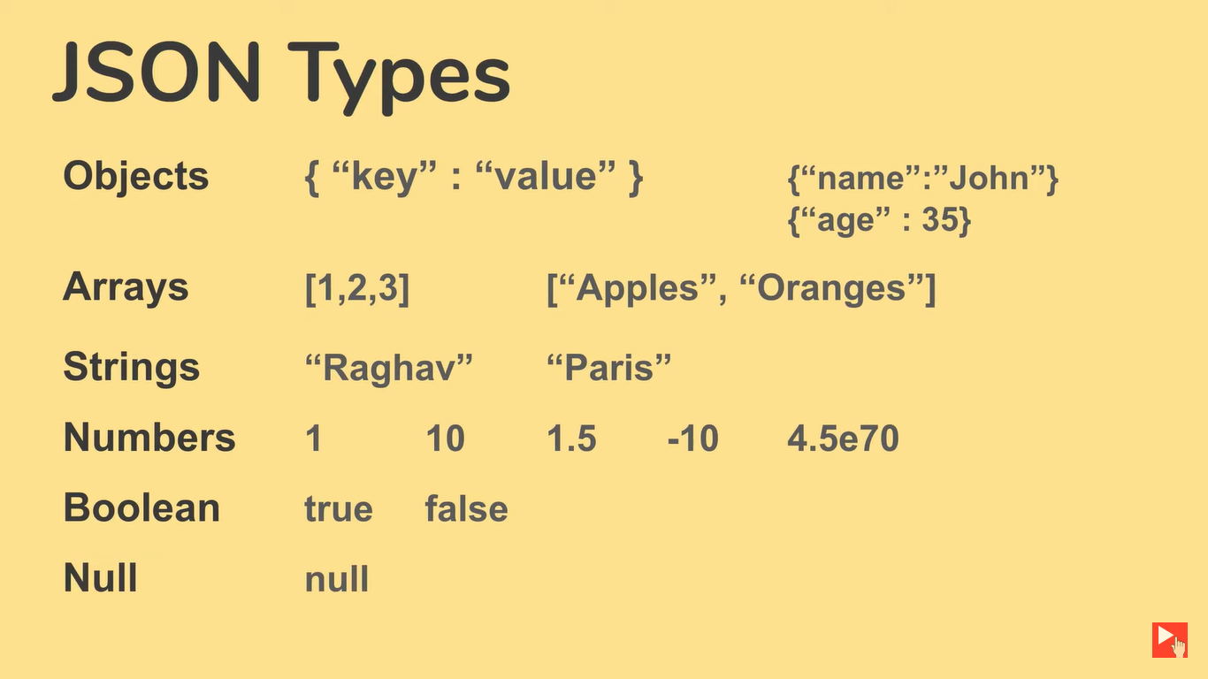

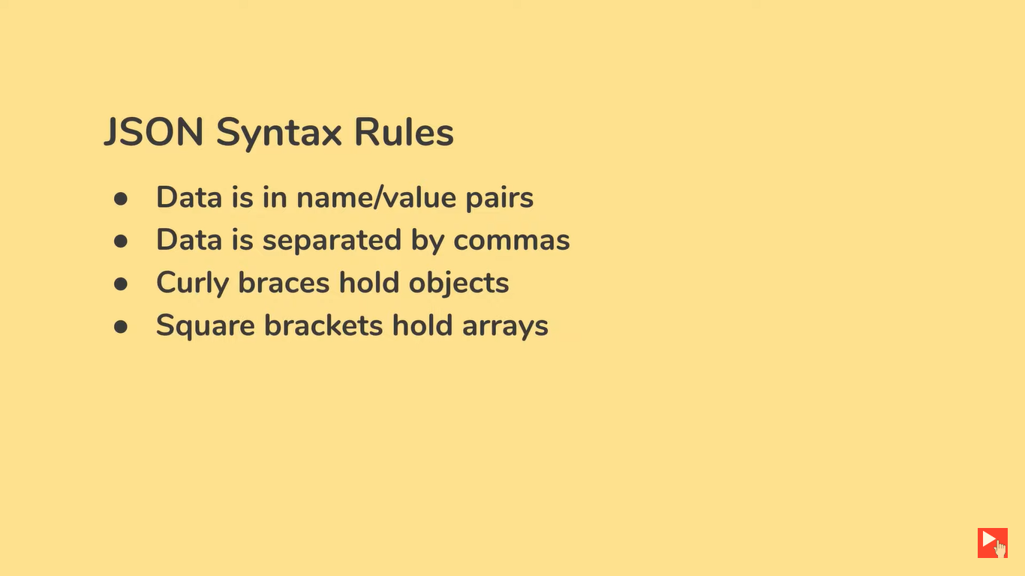

**Example 1**

**{**

**"users":**

**[**

**{**

**"firstName":"Ram",**

**"lastName":"Thapa",**

**"age":20**

**},**

**{**

**"firstName":"Shyam",**

**"lastName":"shrestha",**

**"age":40**

**"hobbies":["reading","writing"],**

**"friends":**

**[**

**{**

**"firstName":"Hari",**

**"lastName":"Maharjan"**

**}**

**]**

**],**

**"subject":**

**[**

**{**

**"name":"Rita",**

**"id":1**

**},**

**{**

**"name":"sita",**

**"id":2**

**}**

**]**

**}**

Both JSON and XML can be used to receive data from a web server.

The following JSON and XML examples both define an employees object, with an array of 3 employees:

JSON Example

{"employees":[  
  { "firstName":"John", "lastName":"Doe" },  
  { "firstName":"Anna", "lastName":"Smith" },  
  { "firstName":"Peter", "lastName":"Jones" }  
]}

XML Example

<employees>  
  <employee>  
    <firstName>John</firstName> <lastName>Doe</lastName>  
  </employee>  
  <employee>  
    <firstName>Anna</firstName> <lastName>Smith</lastName>  
  </employee>  
  <employee>  
    <firstName>Peter</firstName> <lastName>Jones</lastName>  
  </employee>  
</employees>

**JSON DATA**

{

"menu": {

"id": "file",

"value":"File",

"popup": {

"menuitem":[

{"value":"New","onclick":"CreateNewDoc()"},

{"value":"Open","onclick":"openDoc()"},

{"value":"Close","onclick":"CloseDoc()"}

] }

} }

**Its Equivalence XML format**

<?xml version="1.0" encoding="UTF-8" ?>

<menu>

<id>file</id>

<value>File</value>

<popup>

<menuitem>

<value>New</value>

<onclick>CreateNewDoc()</onclick>

</menuitem>

<menuitem>

<value>Open</value>

<onclick>openDoc()</onclick>

</menuitem>

<menuitem>

<value>Close</value>

<onclick>CloseDoc()</onclick>

</menuitem>

</popup>

</menu>

How to validate json

Jsonlint.com

Jsonschemavalidator

Freeformatter.com

Jsoonformatter.curiousconcept.com

Json beautify

Codebeautify.org/jsonviewer

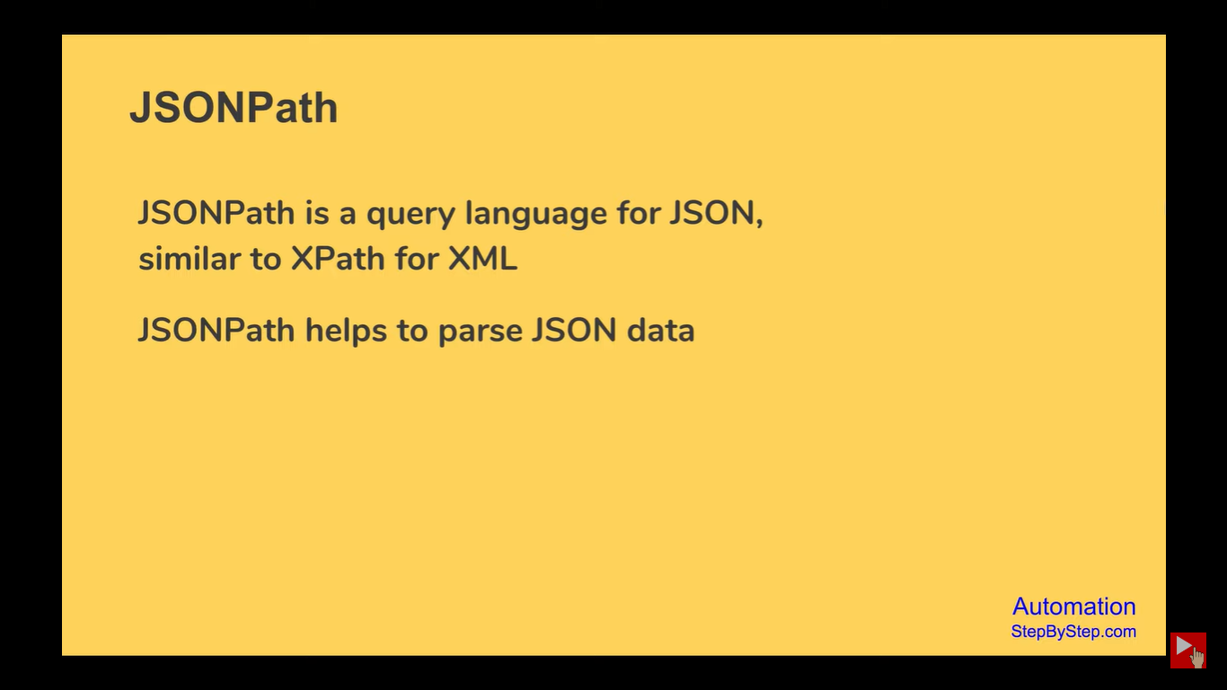

How to Find Json Path

1. Jsonpath.com
2. Jsonpathfinder.com