Software Development Life

Cycle(SDLC )

Software Development Life Cycle(SDLC )

What is SDLC

- SDLC is a framework that describes the activities performed at each stage of software development project. SDLC stands for Software Development Life Cycle. SDLC process is used by the software industry to design, develop and test high quality software. It aims to produce the quality software that meets or exceeds customer expectations, reaches completion within time and budget.
- A Software Development Life Cycle is essentially a series of steps, or phases, that provide a model for the development and lifecycle management of an application or piece of software.

- The Software Development Life Cycle is a process that ensures good software is built. Each phase in the life cycle has its own process and deliverables that feed into the next phase.
Software Development Life Cycle(SDLC )
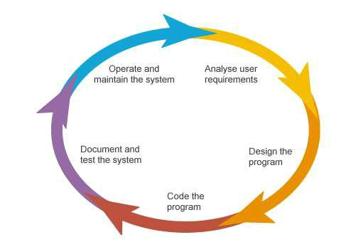

Fig: Software Development Life Cycle(SDLC )

- Requirements Gathering and Analysis

- Design

- Testing

- Implementation

- Operation and Maintenance

Requirements Gathering and Analysis

This step onwards the software development team works to carry on the project.The team holds discussions with various stakeholders from problem domain and tries to bring out as much information as possible on their requirements. The requirements are contemplated and segregated into user requirements, system requirements and functional requirements.

The requirements are collected using a number of practices as given –

- Studying the existing or obsolete system and software,

- Conducting interviews of users and developers,

- Referring to the database or collecting answers from the questionnaires.

- Build multiple use cases to describe each action that a user will take in the new system.

- Prototypes can be built to show the client what the end product will look like. Tools like Omnigraffle, HotGloo and Balsalmiq are great for this part of the process.
Design

Next step is to bring down whole knowledge of requirements and analysis on the desk and design the software product. The inputs from users and information gathered in requirement gathering phase are the inputs of this step.

The output of this step comes in the form of two designs; logical design, and physical design. Engineers produce meta-data and data dictionaries, logical diagrams, data-flow diagrams, and in some cases pseudo codes. Let’s look in more detail at some of the activities involved in this stage:

- Risk analysis

- Functional Specifications

- Non-Functional Specifications
Coding

This step is also known as programming phase. The implementation of software design starts in terms of writing program code in the suitable programming language and developing error-free executable programs efficiently.
Testing

Once the application is migrated to a test environment, different types of testing will be performed including integration and system testing. User acceptance testing is the last part of testing and is performed by the end users to ensure the system meets their expectations. At this point, defects may be found and more work may be required in the analysis, design or coding. Once sign-off is obtained by all relevant parties, implementation and deployment can begin.
Implementation

This means installing the software on user machines. At times, software needs post-installation configurations at user end. Software is tested for portability and adaptability and integration related issues are solved during implementation.
Operation and Maintenance

- This phase confirms the software operation in terms of more efficiency and less errors. If required, the users are trained on, or aided with the documentation on how to operate the software and how to keep the software operational.

- The software is maintained timely by updating the code according to the changes taking place in user end environment or technology. This phase may face challenges from hidden bugs and real-world unidentified problems.
- What is software process & software process model ?Write the activities of software processes .

- A software process is a set of activities that leads to the production of a software Product. These activities may involve the development of software from scratch in a standard programming language like Java or C.

- A software process model is an abstract representation of a process. It presents a description of a process from some particular perspective.

Although there are many software processes, some fundamental activities are
common to all software processes:

- Software specification: The functionality of the software and constraints on its operation must be defined.

- Software design and implementation: The software to meet the specification must be produced.

- Software validation: The software must be validated to ensure that it does what the customer wants.

- Software evolution: The software must evolve to meet changing customer needs.

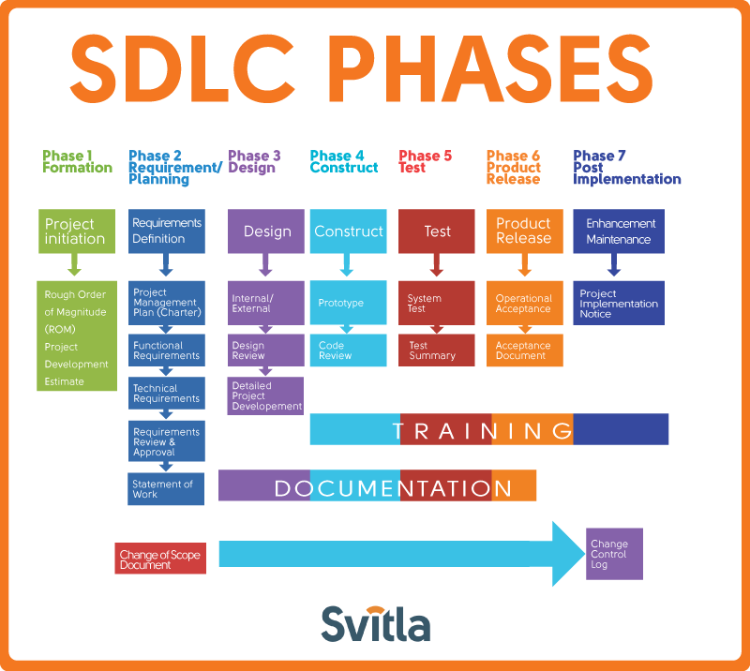
SDLC Models

- Water Fall Model

- Iterative Model

- Spiral Model

- The Incremental model

- Agile Model
- V-model
- Big Bank Model

Some Agile Method:-
-------------------------
- Rapid Application development (RAD)
- Scrum
- Extreme Programming(XP)
- Adaptive Software Development(ASD)
- Feature Driven Development(FDD)
- Crystal Clear
- Dynamic Software Development Method(DSDM)
- Rational Unity Process(RUP)

Why following a model…

- Without using of a particular life cycle model the development of a software product would not be in a systematic and disciplined manner.

- When a software product is being developed by a team there must be a clear understanding among team members about

  - what to do and

  - when to do

- Not following = chaos and project failure.
Waterfall model
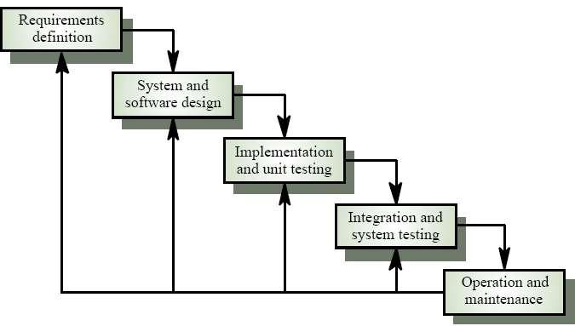

Fig: Waterfall model

Waterfall model phases

- Requirements analysis and definition:

– Develop understanding of problem domain, user needs, function, performance, interfaces.

– Software Design

– Multi-step process to determine architecture, interfaces, data structures, functional detail. Produces (high-level) form that can be checked for quality, conformance before coding.

- System and software design:

-The systems design process partitions the requirements to either hardware or software systems.

-It establishes overall system architecture.

  - Software design involves identifying and describing the fundamental software system abstractions and their relationships.

- Coding :

– Produce machine readable and executable form, match HW, OS and design needs.

- Integration and system testing:

– Confirm that components, subsystems and complete products meet requirements, specifications and quality, find and fix defects.

- Operation and maintenance: Normally (although not necessarily) this is the longest life-cycle phase. The system is installed and put into practical use.

Maintenance: Incrementally, evolve software to fix defects, add features, adapt to new condition. Often 80% of effort spent here!
Advantage & Disadvantage of Waterfall

model

Advantage:

- the waterfall model are that documentation is produced at each phase and that it fits with other engineering process models.

- Disciplined approach

- Careful checking by the Software Quality Assurance Group at the end of each phase.(or Testing in each phase.)

- Documentation available at the end of each phase

- Linear model..

- Easy to understand and implement.

- Identifies deliverables and milestones

Disadvantage:

- the waterfall model is the difficulty of accommodating change after the process is underway. One phase has to be complete before moving onto the next phase.

- Unidirectional

- Unclear requirements lead to confusion.

- Client’s approval is in the final stage.

- Difficult to integrate risk management

- Idealised, doesn’t match reality well.

- Doesn’t reflect iterative nature of exploratory development.
The Prototyping model / Evolutionary

development

Often, a customer defines a set of general objectives for software but does not identify detailed input, processing, or output requirements. In other cases, the developer may be

unsure of The efficiency of an algorithm, The adaptability of an operating system, or

The form that human/machine interaction should take.

- In this case prototyping paradigm may offer the best approach.

- Requirements gathering.

- Developer and customer meet and define the overall objectives for the software, identify whatever requirements are known, and outline areas where further definition is mandatory.

- A "quick design" then occurs. The quick design focuses on a representation of those aspects of the software that will be visible to the customer/user (e.g.,input approaches and output formats).

- Prototype building

- Prototype evaluation by customers

- Prototype may be refined
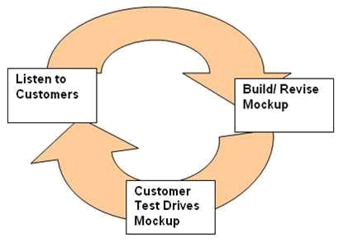

(Figure: The prototyping model.)
# The quick design leads to the construction of a prototype.

There are two fundamental types of evolutionary / Prototyping development model. Such as,

- Exploratory development:

The objective of the process is to work with the customer to explore their requirements and deliver a final system. The development starts with the parts of the system that are understood. The system evolves by adding new features proposed by the customer.
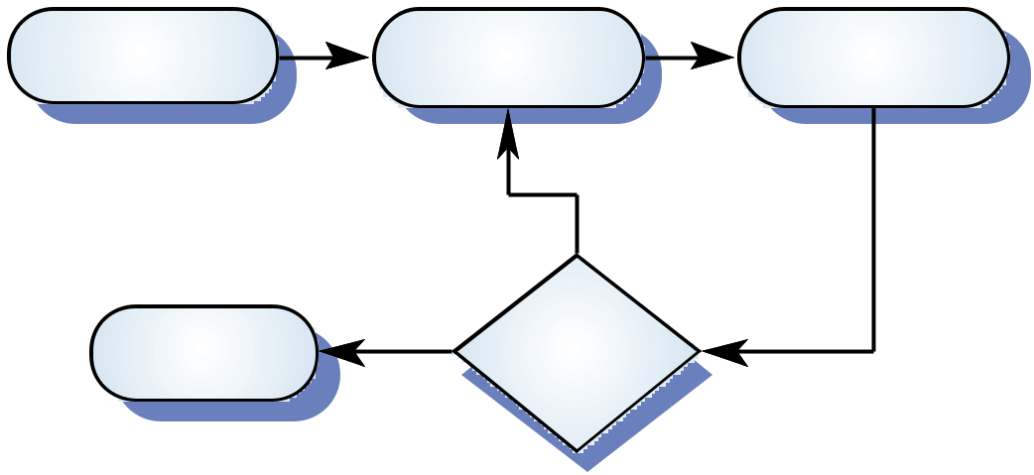

Develop abstract | Build prototype |  | Use prototype
specification |  | system | system
 |  | N
Deliver | YES | System
system |  | adequate?

(Figure: Exploratory development.)

- Throw-away prototyping:

The objective of the evolutionary development process is to understand the customer's requirements and hence develop a better requirements definition for the system. The prototype concentrates on experimenting with the customer requirements that are poorly understood.
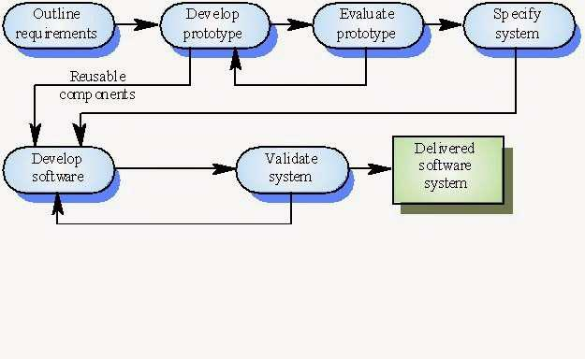

(Figure: Throw-away prototyping.)

Advantage & Disadvantage of prototyping model

Merits:
- Reduces development costs.

- requires user involvement.

- Developers receive quantifiable user feedback.

- Facilitates system implementation since users know what to except.

- Results in higher user satisfaction.

- Exposes developers to potential future system enhancements.

Demerits:
- Can lead to insufficient analysis.

- Users expect the performance of the ultimate system to be the same as the prototype.

- Can cause systems to be left unfinished and/or implemented before they are ready.

- Sometimes leads to incomplete documentation.

- If sophisticated software prototypes (4th GL or CASE Tools) are employed, the time saving benefit of prototyping can be lost.
Spiral Model
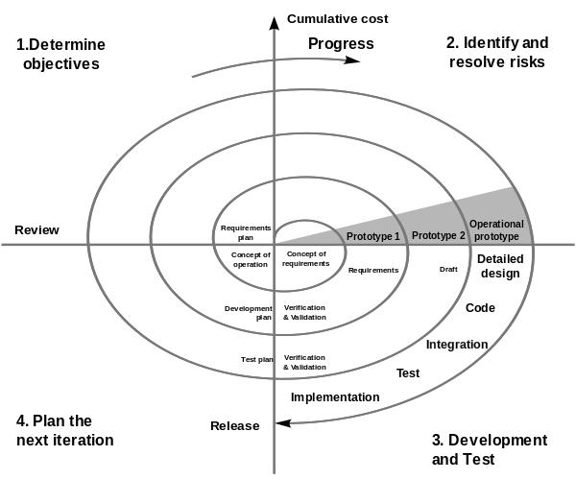
Spiral Model sectors…

- Customer communication

– Tasks required to establish effective communication between developer and customer

- Planning

– The tasks required to define recourses, timelines, and project is reviewed and the next phase of the spiral is planned

- Risk analysis

– Risks are assessed and activities put in place to reduce the key

- Risks engineering

– Tasks required to build one or more representations of the application

- Construction & release

– Tasks required to construct, test, install and provide user support (e.g documentation and training)

- Customer evaluation

– Customer feedback collected every stage
Basic Principles of Spiral Model

- Focus is on risk assessment and on minimizing project risk by breaking a project into smaller segments and providing more ease-of-change during the development process, as well as providing the opportunity to evaluate risks and weigh consideration of project continuation throughout the life cycle.

- "Each cycle involves a progression through the same sequence of steps, for each part of the product and for each of its levels of elaboration, from an overall concept-of-operation document down to the coding of each individual program."

- Each trip around the spiral traverses four basic quadrants/step:

– determine objectives, alternatives, and constraints of the iteration;

– evaluate alternatives; Identify and resolve risks;

– develop and verify deliverables from the iteration; and

– plan the next iteration

- Begin each cycle with an identification of stakeholders and their "win conditions", and end each cycle with review and commitment
Advantage & Disadvantage of Spiral Mode

Merits:
- High amount of risk analysis

- Good for large and mission-critical projects.

- Software is produced early in the software life cycle.

- Users can be closely tied to all lifecycle steps

- Early and frequent feedback from users

- Cumulative costs assessed frequently

- Focuses attention on early error elimination.

Demerits:
- Can be a costly model to use.

- Project’s success is highly dependent on the risk analysis phase.

- Doesn’t work well for smaller projects.

- Time spent for evaluating risks too large for small or low-risk projects

- The model is complex

- The design does not have to be perfect

- Risk assessment expertise is required

- Spiral may continue indefinitely

- Developers must be reassigned during non-development phase activities

The Incremental model
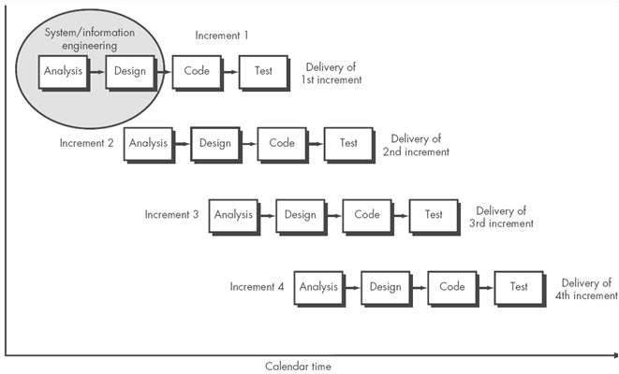
Various methods are acceptable for combining linear and iterative systems development methodologies, with the primary objective of each being to reduce inherent project risk by breaking a project into smaller segments and providing more ease-of-change during the development process.

The basic principles are:

- A series of mini-Waterfalls are performed, where all phases of the Waterfall are completed for a small part of a system, before proceeding to the next increment, or

- Overall requirements are defined before proceeding to evolutionary, mini-Waterfall development of individual increments of a system, or

- The initial software concept, requirements analysis, and design of architecture and system core are defined via Waterfall, followed by iterative Prototyping, which culminates in installing the final prototype, a working system.
Incremental Model…

Problems

– Management problems

  - Progress can be hard to judge and problems hard to find because there is little documentation.

– Contractual problems

  - The normal contract may include a specification; without a specification, different forms of contract have to be used.

– Validation problems

  - Without a specification, what is the system being tested against?

– Maintenance problems

  - Continual change tends to corrupt software structure making it more expensive to change and evolve to meet new requirements.
Advantage & Disadvantage of Incremental

Model
Merits:
- Develop high-risk or major functions first

- Each release delivers an operational product

- Customer can respond to each build

- Lowers initial delivery cost

- Initial product delivery is faster

- Customers get important functionality early

- Risk of changing requirements is reduced

- Easier to test and debug during a smaller iteration.

- Each iteration is an easily managed milestone.

Demerits:
- Requires good planning and design

- Requires early definition of a complete and fully functional system to allow for the definition of increments

- Well-defined module interfaces are required (some will be developed long before others)

- Total cost of the complete system is not lower

- Each phase of an iteration is rigid and do not overlap each other
Why not waterfall?
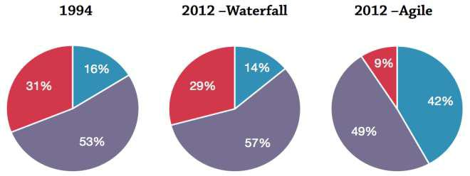

highly risky

often more costly

generally less efficient

Agile

- An alternative way of managing software development

- Different values & principles to traditional development

- Incremental, iterative & collaborative, rather than distinct stages

- It is adaptive, people centric and it always welcome changes
Graphical illustration of the Agile Model
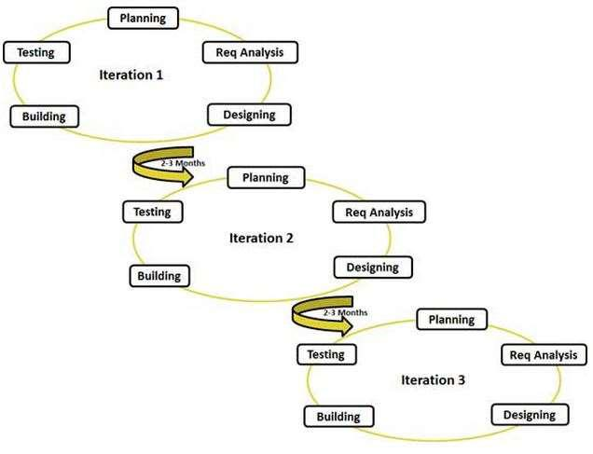
Agile (XP) Manifesto

XP = Extreme Programming

- Individuals and interactions

– Over processes and tools

- Working software

– Over documentation

- Customer collaboration

– Over contract negotiation

- Responding to change

– Over following a plan

Agile Principles (Summary)

- Continuous delivery of software

- Continuous collaboration with customer

- Continuous update according to changes

- Value participants and their interaction

- Simplicity in code, satisfy the space
XP Practices (Summary)

- Programming in pairs

- Test driven development

- Continuous planning, change , delivery

- Shared project metaphors, coding standards and ownership of code

- No overtime! (Yeah right!)
10 Key Principles of Agile

- Active user involvement is imperative

- Agile teams must be empowered

- Time waits for no man

- Agile requirements are barely sufficient

- How do you eat an elephant?

- Fast but not so furious

- Done means DONE!

- Enough’s enough

- Agile testing is not for dummies

- No place for snipers
Agile working flow STORY BOARD
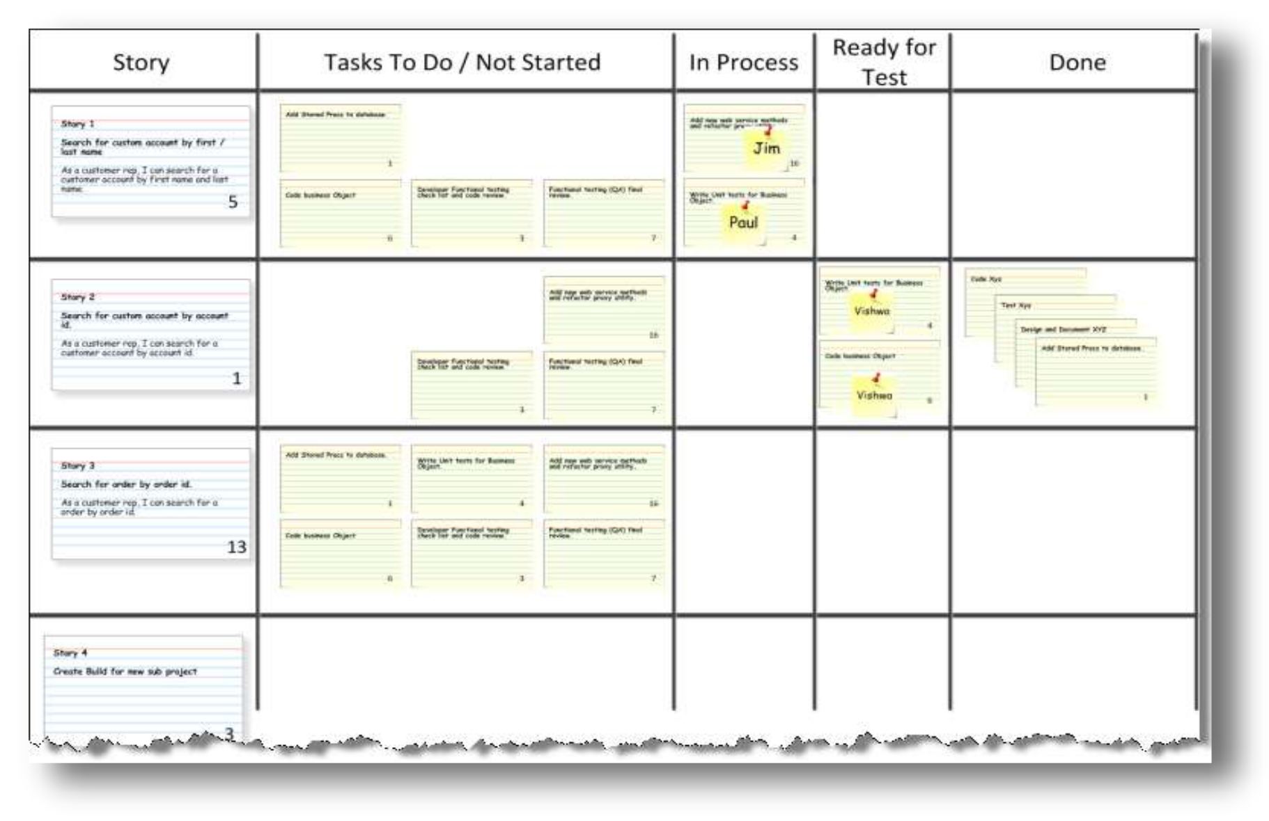
Advantage & Disadvantage of Agile

Advantages
- Customer Satisfaction.

- Saves Time.

- Suitable for fixed or changing requirements.

- Lightweight methods suit small-medium size projects

- Produces good team cohesion

- Emphasises final product

- Iterative

- Test based approach to requirements and quality assurance

Disadvantages

- Difficult to scale up to large projects where documentation is essential

- Needs experience and skill if not to degenerate into code-and-fix

- Programming pairs is costly

- Test case construction is a difficult and specialised skill.

- Not suitable for handling complex dependencies.

- More risk of sustainability, maintainability and extensibility.
Difference between agile and waterfall

Metric | Waterfall | Agile
Planning scale | Long-team | Short-team
Distance between customer | Long | Short
and developer
Time between specification | Long | Short
and implementation
Time to discover problems | Long | Short
Project schedule risk | High | Low
Ability to respond quickly to | low | High
change

Difference between agile and waterfall and

Iterative model
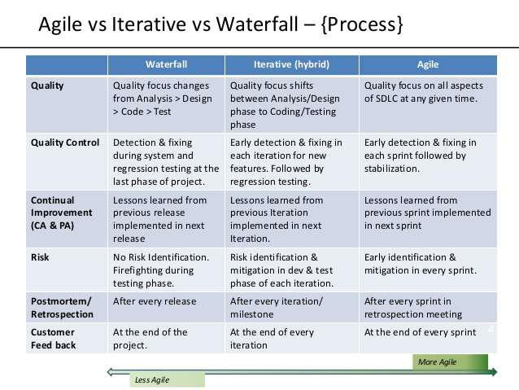

http://www.slideshare.net/MarrajuBollapRagada/agile-vs-iterativevswaterfall

- Rapid Application Model (RAD)

- Difference between agile and Incremental model

Rapid Application Development (RAD):-

The RAD (Rapid Application Development) model is based on prototyping and iterative development with no specific planning involved. The process of writing the software itself involves the planning required for developing the product.
Rapid Application Development focuses on gathering customer requirements through workshops or focus groups, early testing of the prototypes by the customer using iterative concept, reuse of the existing prototypes (components), continuous integration and rapid delivery.

What is RAD?
Rapid application development is a software development methodology that uses minimal planning in favor of rapid prototyping. A prototype is a working model that is functionally equivalent to a component of the product.
In the RAD model, the functional modules are developed in parallel as prototypes and are integrated to make the complete product for faster product delivery. Since there is no detailed preplanning, it makes it easier to incorporate the changes within the development process.
RAD projects follow iterative and incremental model and have small teams comprising of developers, domain experts, customer representatives and other IT resources working progressively on their component or prototype.
The most important aspect for this model to be successful is to make sure that the prototypes developed are reusable.

RAD Model Design
RAD model distributes the analysis, design, build and test phases into a series of short, iterative development cycles.
Following are the various phases of the RAD Model −

Business Modelling
The business model for the product under development is designed in terms of flow of information and the distribution of information between various business channels. A complete business analysis is performed to find the vital information for business, how it can be obtained, how and when is the information processed and what are the factors driving successful flow of information.

Data Modelling
The information gathered in the Business Modelling phase is reviewed and analyzed to form sets of data objects vital for the business. The attributes of all data sets is identified and defined. The relation between these data objects are established and defined in detail in relevance to the business model.

Process Modelling
The data object sets defined in the Data Modelling phase are converted to establish the business information flow needed to achieve specific business objectives as per the business model. The process model for any changes or enhancements to the data object sets is defined in this phase. Process descriptions for adding, deleting, retrieving or modifying a data object are given.

Application Generation
The actual system is built and coding is done by using automation tools to convert process and data models into actual prototypes.

Testing and Turnover
The overall testing time is reduced in the RAD model as the prototypes are independently tested during every iteration. However, the data flow and the interfaces between all the components need to be thoroughly tested with complete test coverage. Since most of the programming components have already been tested, it reduces the risk of any major issues.
The following illustration describes the RAD Model in detail.
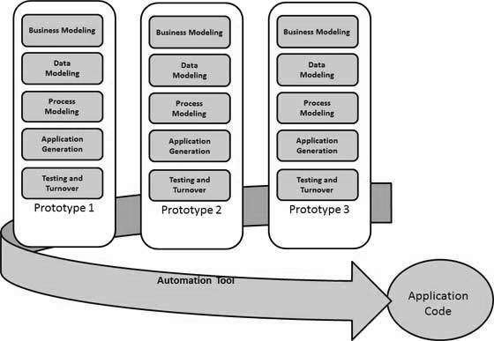

RAD Model Vs Traditional SDLC
The traditional SDLC follows a rigid process models with high emphasis on requirement analysis and gathering before the coding starts. It puts pressure on the customer to sign off the requirements before the project starts and the customer doesn’t get the feel of the product as there is no working build available for a long time.
The customer may need some changes after he gets to see the software. However, the change process is quite rigid and it may not be feasible to incorporate major changes in the product in the traditional SDLC.
The RAD model focuses on iterative and incremental delivery of working models to the customer. This results in rapid delivery to the customer and customer involvement during the complete development cycle of product reducing the risk of non-conformance with the actual user requirements.

RAD Model - Application
RAD model can be applied successfully to the projects in which clear modularization is possible. If the project cannot be broken into modules, RAD may fail.
The following pointers describe the typical scenarios where RAD can be used −
- RAD should be used only when a system can be modularized to be delivered in an incremental manner.
- It should be used if there is a high availability of designers for Modelling.
- It should be used only if the budget permits use of automated code generating tools.
- RAD SDLC model should be chosen only if domain experts are available with relevant business knowledge.
- Should be used where the requirements change during the project and working prototypes are to be presented to customer in small iterations of 2-3 months.

RAD Model - Pros and Cons
RAD model enables rapid delivery as it reduces the overall development time due to the reusability of the components and parallel development. RAD works well only if high skilled engineers are available and the customer is also committed to achieve the targeted prototype in the given time frame. If there is commitment lacking on either side the model may fail.
The advantages of the RAD Model are as follows −
- Changing requirements can be accommodated.
- Progress can be measured.
- Iteration time can be short with use of powerful RAD tools.
- Productivity with fewer people in a short time.
- Reduced development time.
- Increases reusability of components.
- Quick initial reviews occur.
- Encourages customer feedback.
- Integration from very beginning solves a lot of integration issues.
The disadvantages of the RAD Model are as follows −
- Dependency on technically strong team members for identifying business requirements.
- Only system that can be modularized can be built using RAD.
- Requires highly skilled developers/designers.
- High dependency on Modelling skills.
- Inapplicable to cheaper projects as cost of Modelling and automated code generation is very high.
- Management complexity is more.
- Suitable for systems that are component based and scalable.
- Requires user involvement throughout the life cycle.
- Suitable for project requiring shorter development times.

