Question: Need the code defined in a class (based on OOPS principles) not the regular python scripting.

Answer: As per your request we have designed few classes to load models and to retrieve models. See below screen of classes

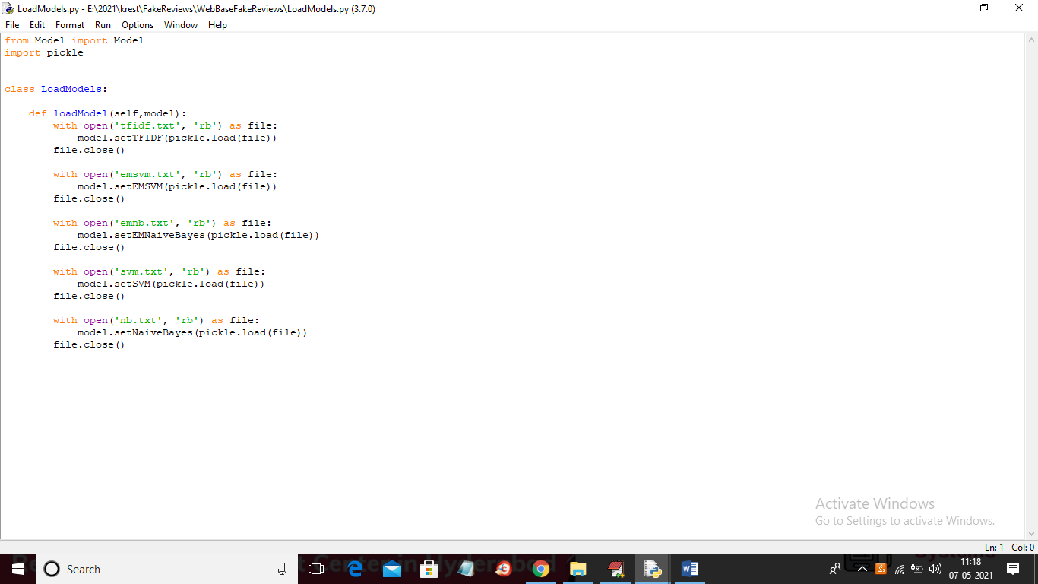

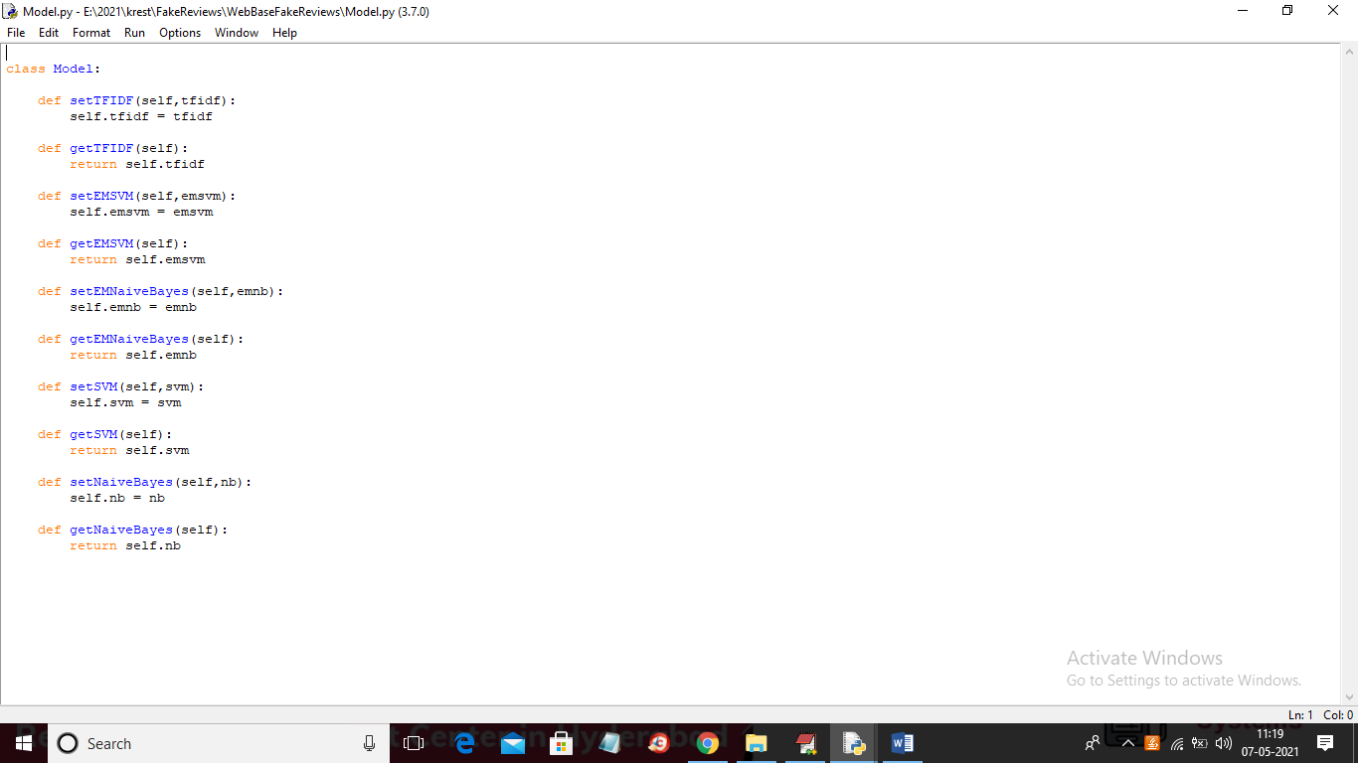

Question: Need basic FRONTEND with HTML, CSS using jQuery for REST calls and simple development server based for BACKEND using flask server.

ANSWER: We have added HTML front with FLASK as backend server and below screen you can see HTML page where user can enter review and select desired algorithm and in below screen you can see Flask server started and you can start this server by double click on ‘run.bat’ file

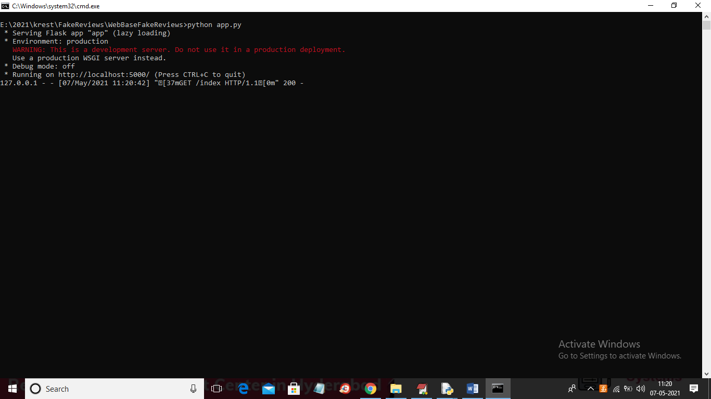

In above screen Flask Server started and now open browser and enter URL as <http://localhost:5000/index> and then press enter key to get below page

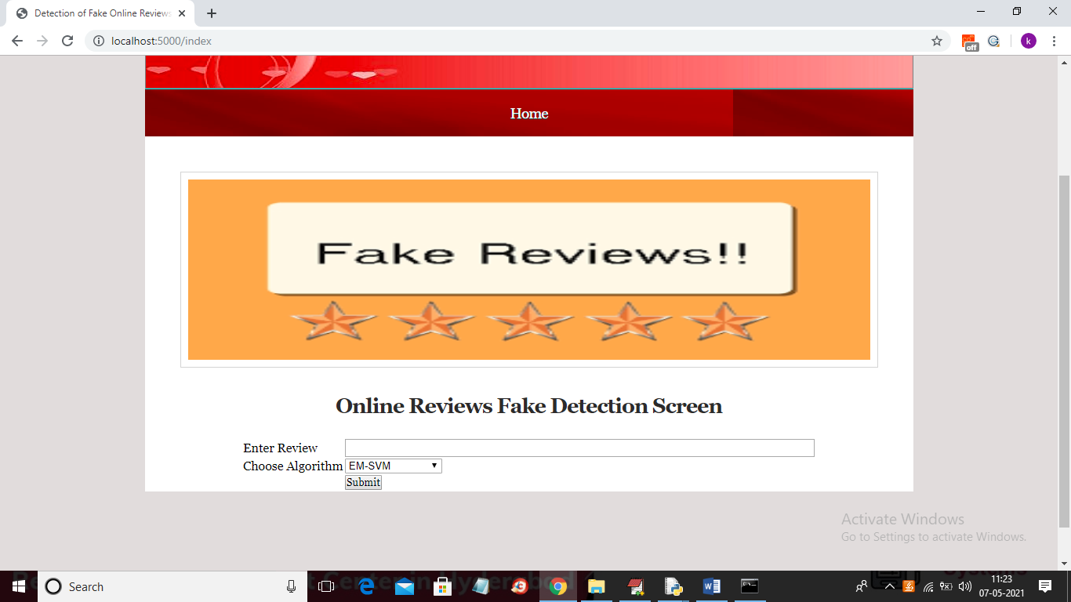

In above screen user can enter review and select one algorithm from give 4 algorithms and in below screen you can see list of algorithms

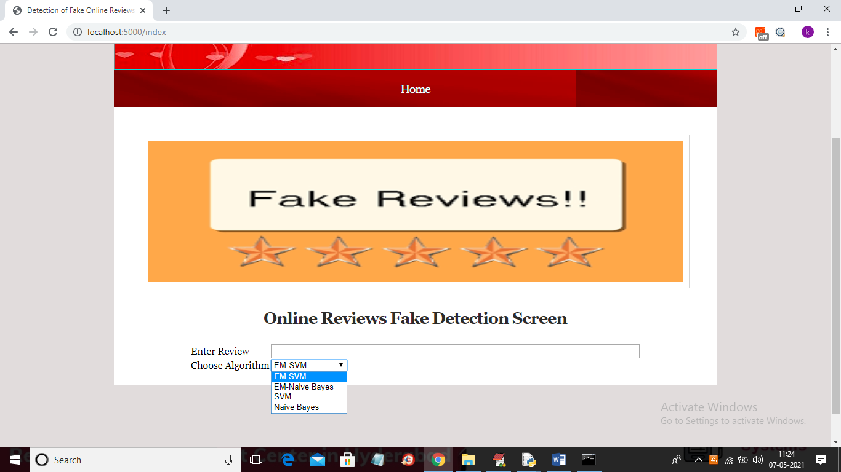

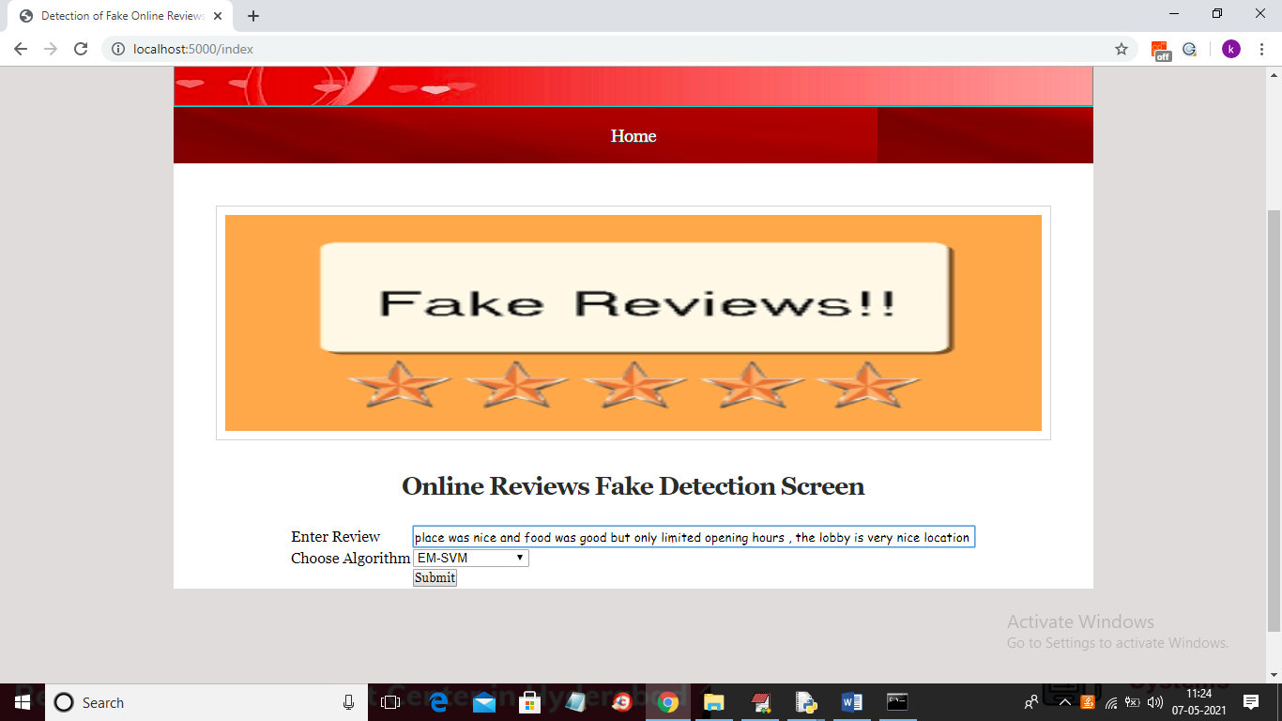

In above screen I entered some review and then select algorithm as ‘EM-SVM’ and now press Submit button to get below result

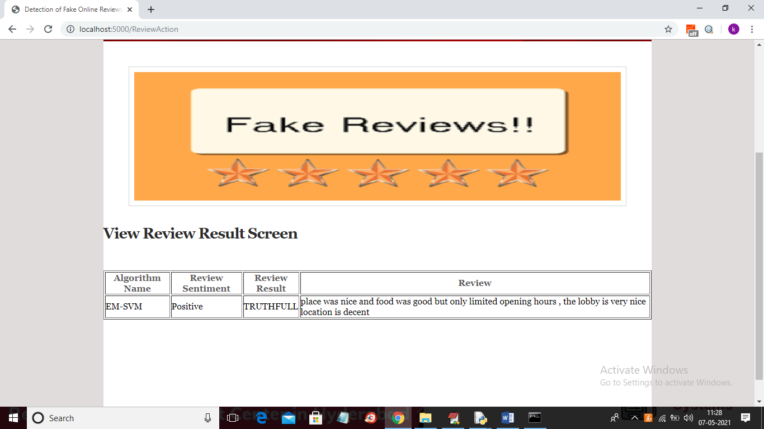

In above screen we can see review result is ‘TruthFull’ and sentiment as ‘Positive’. Now test with other review

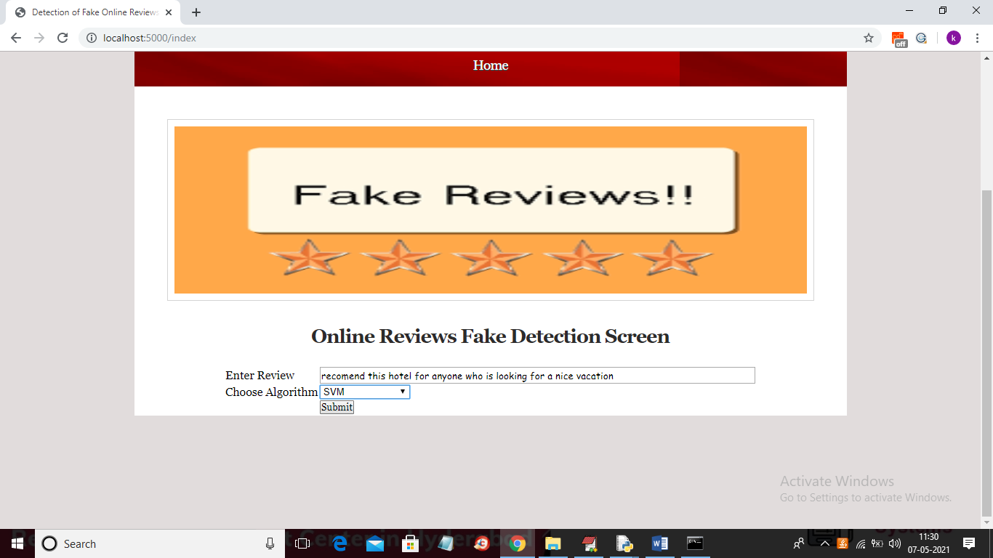

For above review will get below result

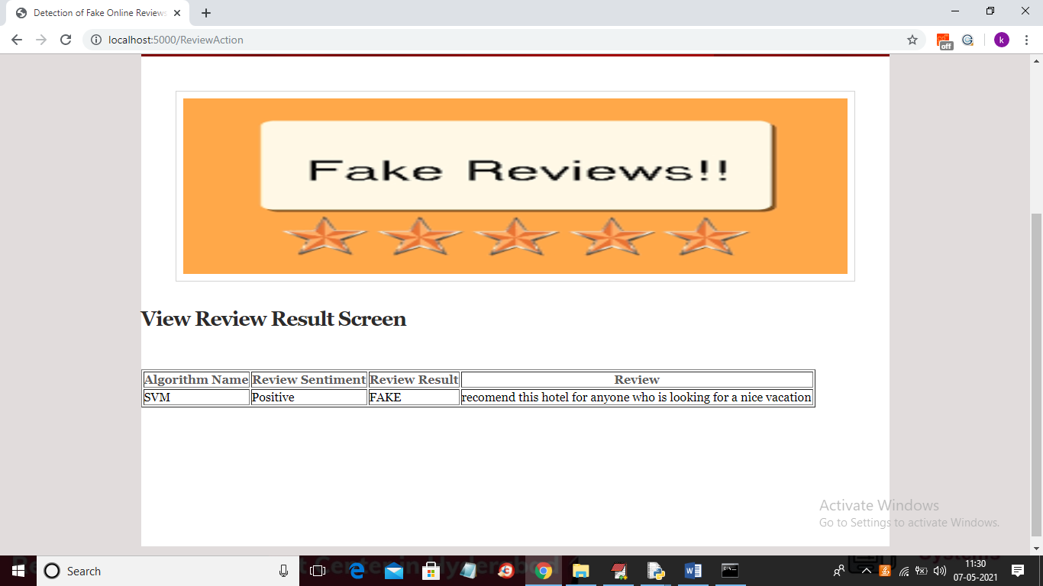

In above screen review is positive but more words are matching with fake reviews so result detected as FAKE.

Question: User gives input from the html page (in a search box and presses button for POST call) and in the backend the process computes and gives the result.

Answer: Yes in above screen you can see user entering review in HTML page and in backend we put all computation process. We saved all models and when we start Flask server then all models will be loaded and do prediction.

Question: Multiple methods defined: One for getting feedback on review, Another for getting review feedback from different models

Answer: Here we added all models in HTML page and user select desire algorithm from multiple algorithms

Question: Model training and loading should be done during application runtime in the backend (Flask server), also it should not be loaded or trained repeatedly with each POST request.

Answer: Yes when firs time when Flask server starts at that time only all models will be loaded and when we send POST request then application will run only prediction code

Question: Please provide some confidence score metric with each review feedback so that the algorithm's performance can be justified. Please note that this metric score should be provided with the response on the FRONTEND.

Answer: Already in old code we have given accuracy calculation for each algorithm and you can see in below screen

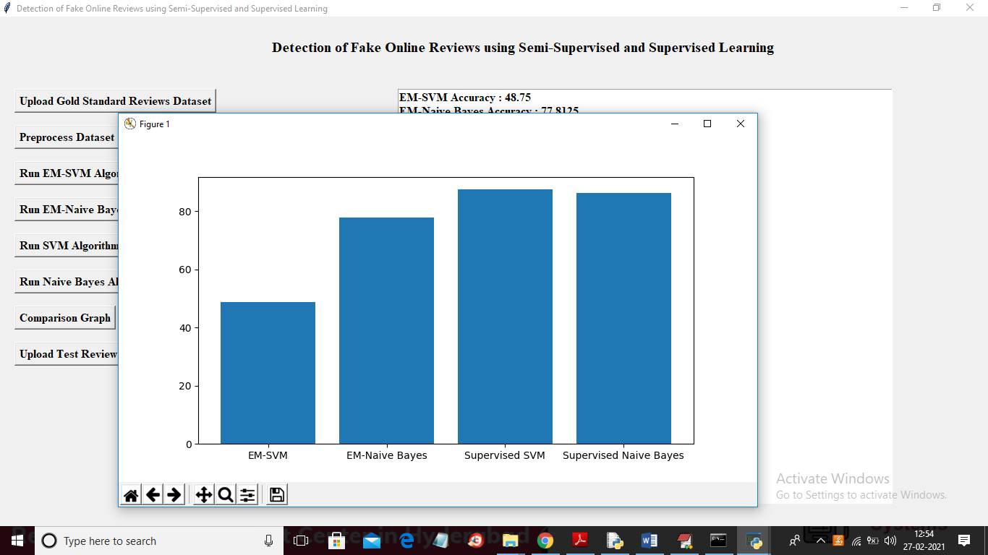

Doubt 1: There is a threshold defined in the code to provide positive or negative review, on what basis did you define that threshold? Please provide some experimental results to justify this threshold.

Answer: when we calculate sentiment then all positive sentiment score will be greater than >= 0.05 and negative sentiment score will be <= - 0.05 and whatever comes between those two values will be consider as NEUTRAL

Question: Training and Testing data was split in 80-20 ratio without any random sampling of dataset, How did you define this ratio? Please provide some evaluation of the dataset used to justify the split

Answer: Normally all ML application will use 80-20 percent for train and test data and we if want we can add “random-state” value to method to perform random sampling