A Short Technical Report towards A5016 – EDT (P) Course

VOICE FOR VOICELESS

Submitted in the Partial Fulfillment of the
Requirements
For the Award of the Degree of

Bachelor of Technology
in
computer science AND ENGINEERING

Submitted
By
Team No.: 09
Praneeth Sunkavalli 19881A05A3
M Nithin 19881A0596
R Suryachand 19881A05A4
S Salman 19881A05A8
P Kartiikeya 19881A05A2
Buchi Reddy 19881A0588

Under the Esteemed Guidance of
Dr. Ms. Koti Tejaswi
Associate Professor



Department of Computer Science and Engineering.

Vardhaman College of Engineering, HYDERABAD
An autonomous institute affiliated to JNTUH
2020- 21
ACKNOWLEDGEMENT
The satisfaction that accompanies the successful completion of the task would be put incomplete without the mention of the people who made it possible, whose constant guidance and encouragement crown all the efforts with success.
We wish to express my deep sense of gratitude to Ms. Koti Tejaswi, Associate Professor for their able guidance and useful suggestions, which helped us in completing the design part of potential project in time.
We particularly thankful to Dr M.A Jabbar, Professor & Head, Department of Computer Science and Engineering for his guidance, intense support and encouragement, which helped us to mould our project into a successful one.
We show gratitude to our honorable Principal Dr J.V.R.Ravindra, for having provided all the facilities and support.
We avail this opportunity to express our deep sense of gratitude and heartful thanks to Dr Teegala Vijender Reddy, Chairman and Sri Teegala Upender Reddy, Secretary of VCE, for providing congenial atmosphere to complete this project successfully.
We also thank all the staff members of Engineering Design Thinking Team for their valuable support and generous advice. Finally, thanks to all our friends and family members for their continuous support and enthusiastic help.
Praneeth Sunkavalli-19881A05A3
M Nithin- 19881A0596
R Suryachand- 19881A05A4
S Salman- 19881A05A8
P Kartiikeya-19881A05A2
Buchi Reddy-19881A0588

Vardhaman College of Engineering, HYDERABAD
An autonomous institute affiliated to JNTUH
Department of Computer Science and Engineering

CERTIFICATE

This is to certify that the short technical report work entitled “VOICE FOR THE VOICELESS” carried out by Mr. Praneeth Sunkavalli, Roll Number 19881A05A3, Mr. M Nithin, Roll Number 19881A0596, Mr. SuryaChand Roll Number 19881A05A4, Mr. S Salman, Roll Number 19881A05A8, Mr. P Kartiikeya, Roll Number 19881A05A2, Mr. Buchi Reddy, Roll Number 19881A0588 towards A5016 – EDT (P) course and submitted to the Department of Electronics and Communication Engineering, in partial fulfillment of the requirements for the award of degree of Bachelor of Technology in Computer Science and Engineering during the year 2021-22.

Name & Signature of the HOD

Dr. M. A Jabbar
HOD, CSE
Name & Signature of the Instructors

Dr. Ms. Koti Tejaswi
Associate Professor

Abstract

Using Convolutional Neural Network for conversion of ASL into English alphabets

Communication is the only medium by which we can share our thoughts or convey the message but for a person with disability (deaf and dumb) faces difficulty in communication with normal person. Because of this, a person who lacks in hearing and speaking ability is not able to stand in race with normal person. Communication for a person who cannot hear is visual, not auditory. Generally dumb people use sign language for communication but they find difficulty in communicating with others who don't understand sign language. So there is a barrier in communication between these two communities. This work aims to lower this barrier in communication The main aim of the proposed project is to develop a cost effective system which can give voice to voiceless person with the help of conversion of ASL sign to English alphabet. It means that using smart gloves communication will not be barrier between two different communities. Using such devices by disabled person also makes nation grow.

LIST OF FIGURES
Fig. No. | Name of the Figure | Page No.
1 | Smart Gloves for gesture identification | 5
2 | Total number of deaf and dumb people across the world | 8
3 | Model Design | 9
4 | Developed Website | 11
4 | Developed Website 2 | 11

LIST OF TABLES
Table. No. | Name of the Table | Page No.
1 | Confusion Matrix | 12
ABBREVATIONS
Abbreviation | Expansion
CNN | Convolutional Neural Network
CV | Computer Vision

OUTLINE
 | Acknowledgements | (ii)
 | Abstract | (iv)
 | List of Figures | (v)
 | List of Tables | (v)
 | Abbreviations | (v)
1 | Introduction | 1
 | 1.1 Motivation | 1
 | 1.2 Scope | 1
 | 1.3 Objectives | 2
 | 1.4 Expected Deliverables | 2
2 | Literature Review | 3
 | 2.1 History | 3
 | 2.2 Definitions (if any) | 4
 | 2.3 Existing System | 5
 | 2.4 Configuring of Peripherals | 6
 | 2.5 Applications | 7
 | 2.6 Advantages & Disadvantages | 7
3 | Methodology | 8
 | 3.1 Comparative Analysis (Decision Matrix) | 8
 | 3.2 Proposed Design | 9
 | 3.3 Challenges towards implementation | 10
4 | Results | 11
5 | Conclusions | 13
 | References  (Include references to books, articles, reports referred to in the report) | 14

CHAPTER 1
INTRODUCTION
  - Motivation
Hand gesture is one of the methods used in sign language for non-verbal communication. It is most commonly used by deaf & dumb people who have hearing or speech problems to communicate among themselves or with normal people. Various sign language systems have been developed by many makers around the world but they are neither flexible nor cost-effective for the end users. Hence in our project we have introduced software which presents a system prototype that is able to automatically recognize sign language to help deaf and dumb people to communicate more effectively with each other or normal people. Being a significant part in nonverbal communication hand gestures are playing key role in our daily life. Hand Gesture recognition system provides us an innovative, natural, user friendly way of communication with the computer which is more familiar to the human beings. By considering in mind the similarities of human hand shape with four fingers and one thumb, the software aims to present a real time system for recognition of hand gesture on basis of detection of some shape-based features like orientation, Centre of mass centroid, fingers status, and thumb in positions of raised or folded fingers of hand.

  - Scope
The proposed hand recognition system is extremely useful as it can be used as human-computer interface as well as can help paralyzed people. In future devices can be easily controlled through the hand gesture movement easily. In previous concepts, the sensor techniques were used but, in this system, no any additional sensor is needed. It can be achieved by deep convolutional neural network algorithm. Deep learning deals with heavy data set, through which the learning process is done for our system

  - Objectives
Our objective is to bring a cost-effective machine into the market which can perform gesture recognition effective and with lesser Hassel since we tend to use cameras to capture the gestures instead of expensive, delicate, and uncomfortable glove based. System. AS deaf and dumb people cannot speak like normal people, they use hand sign language to communicate with other people like themselves. But when it comes to communicating with normal people, it proves to be difficult, as most normal people do not understand the sign language used by them. So, we are developing this program to make it easier for the deaf and dumb to communicate with the people who do not understand their sign language. Our program will detect and translate the hand signs made by the user into text and display it on the screen for the normal people to read. Thus, our project will make it easier for deaf and dumb to communicate with the normal people.

  - Expected Deliverables
We hope to deliver a system developed to recognize various gestures by using cameras, sensors and machine learning algorithms and convey the meaning of these gestures in the form of words through a speaker to all the audience to which the gesture is meant to be delivered, in such a way that the communication gap between the entities involved in the mode of communication is bridged and an effective communicative connection is being established.

CHAPTER 2
LITERATURE REVIEW
2.1 History

Gestures are a form of nonverbal communication in which visible bodily actions are used to communicate important messages, either in place of speech or together and in parallel with spoken words. Gestures include movement of the hands, face, or other parts of the body. Physical non-verbal communication such as purely expressive displays, proxemics, or displays of joint attention differ from gestures, which communicate specific messages. Gestures are culture-specific and may convey very different meanings in different social or cultural settings. Gesture is distinct from sign language. Although some gestures, such as the ubiquitous act of pointing, differ little from one place to another, most gestures do not have invariable or universal meanings, but connote specific meanings in particular cultures. A single emblematic gesture may have very different significance in different cultural contexts, ranging from complimentary to highly offensive.

2.2 Definitions
CNN: A convolutional neural network (CNN) is a type of artificial neural network used in image recognition and processing that is specifically designed to process pixel data. CNNs are powerful image processing, artificial intelligence that use deep learning to perform both generative and descriptive tasks, often using machine vison that includes image and video recognition, along with recommender systems and natural language processing.
OpenCV: OpenCV (Open Source Computer Vision Library) is a library of programming functions mainly aimed at real-time computer vision. OpenCV runs on the following desktop operating systems: Windows, Linux, macOS, FreeBSD, NetBSD, and OpenBSD. OpenCV runs on the following mobile operating systems: Android, iOS, Maemo, BlackBerry. The user can get official releases from Source Forge or take the latest sources from GitHub.

2.3 Existing System

- In currently existent highly accurate image processing system requires certain physical components, which are to be worn by user, which includes sensors and other complex devices which increases level of inconvenience and also result in an increase in expense.
- And later it has been improved to recognize the signs using machine learning, but it’s still doesn’t show higher accuracy and also gestures.
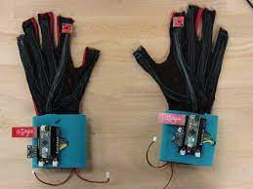

- Show and tell prototype Glove, which demonstrated at a recent Google developer’s event in Tel Aviv.
- Components used in show and tell prototype:
  - Accelerometer
  - tilt sensor
  - Arduino Nano

2.4 Configuring of Peripherals
→Languages:
    - Python 3.9
    - HTML
    - PHP
    - CSS
    - Java Script
→Frameworks and Libraries:
    - Tensorflow 1.11.0
    - OpenCV 3.4.3.18
    - NumPy 1.15.3
    - Matplotlib 3.0.0
    - PIL 5.3.0
    - Keras 2.4.0
    - Flask 2.0.1
→Hardware requirements:
- Computer with good internet connection
- Computer with compactable camera

2.5 Applications

- Removes language barrier
- Expressing feelings
- Helps to understand sign language
- Converts sign language to statements and audio files

2.6 Advantages & Disadvantages

→Advantages:
1. Our project easily converts the hand sign into word s and letters
2. Helps common people to understand the voice of the voiceless
3. Makes Human communication much simpler

→ Disadvantages:
1. Since our project is in starting stage, it can only convert the gestures into letters and words.
2. We used Gray scale which requires empty background to detect the sign accurately
3. Our model can only detect hand sign but not facial expression

CHAPTER 3
METHODOLOGY
3.1 Comparative Analysis (Decision Matrix)

There are several reasons why we choose this particular project, according to statistics around 700,000 to 900, 000," and of these 63 percent, are said to be born deaf, the others losing their hearing by different accidents.

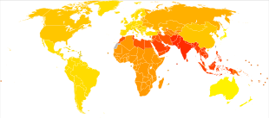
Above graph indicates the number of deaf and dumb people over the world, the briger the color the more the number of people, as we can see, India has been having the more number of deaf and dumb people when compared with many other countries.
That’s the reason we had choosen this project, which can create a communication link between the every person irrespective of any barrier.

3.2 Proposed Design

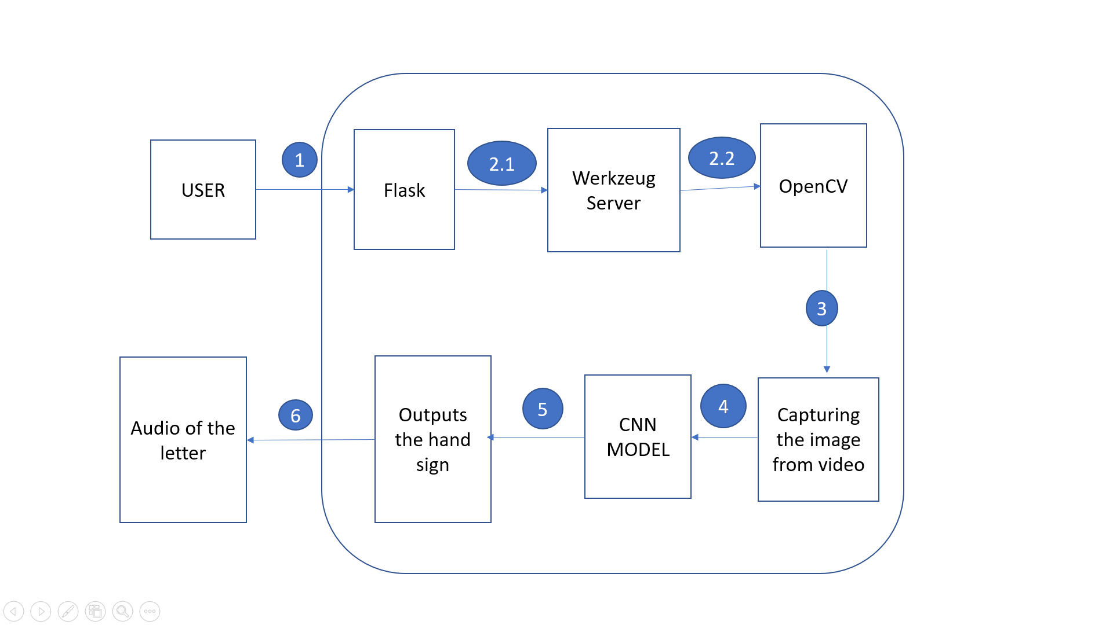

We take the input from the user using camera (OpenCV module), input can be either a video or photo, after taking input the if it is a video, then it will be converted into a set of images, an over iterations of each image the model takes it as input and predicts the hand sign and it’s respective alphabet and returns it.

3.3 Challenges towards implementation

There were many challenges faced by us during the project. The very first issue we faced was of dataset. We wanted to deal with raw images and that too square images as CNN in Keras as it was a lot more convenient working with only square images. We couldn’t find any existing dataset for that hence we decided to make our own dataset. Second issue was to select a filter which we could apply on our images so that proper features of the images could be obtained and hence then we could provide that image as input for CNN model. We tried various filter including binary threshold, canny edge detection, gaussian blur etc. but finally we settled with Gaussian blur filter. More issues were faced relating to the accuracy of the model we trained in earlier phases which we eventually improved by increasing the input image size and also by improving the dataset.

CHAPTER 4
RESULTS
We made a web portal on a personal computer from which we can invoke the generator software which require a camera for recording the gestures, our project converts the input gestures into letters, words and sentences then the sentences are further converted into audio files and spelled out through speakers of the device.

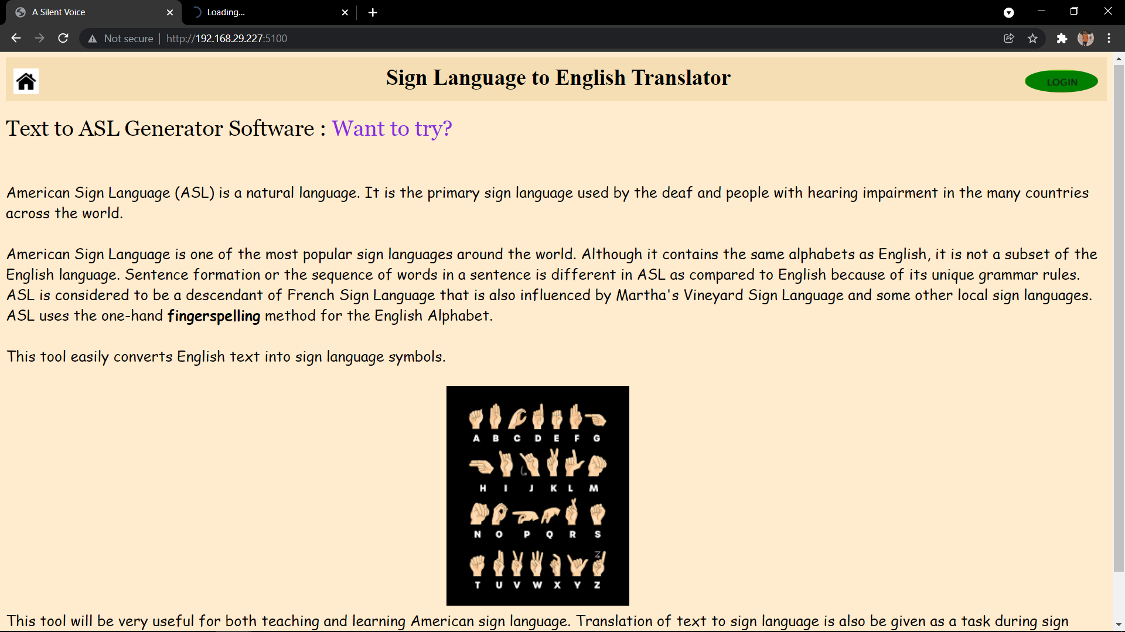

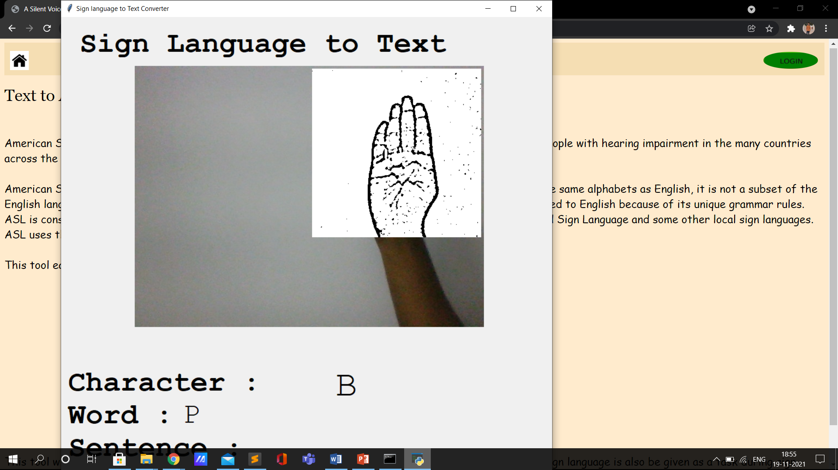

Confusion Matrix of the algorithm:

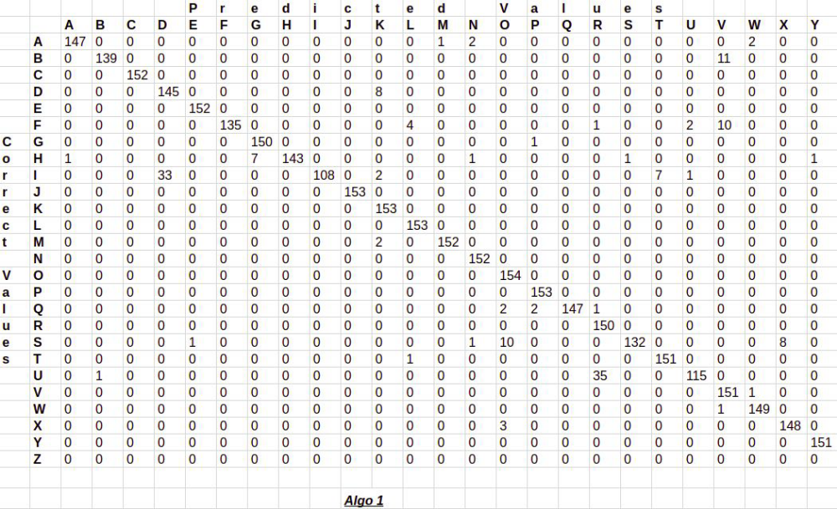

CHAPTER 5
CONCLUSION

Communication is the best approach for conveying the feeling, ideas or thought from one person to another. But several people across the world face difficulty to communicate or express there feeling to other person.
To eradicate this problem we have developed software which makes communication between two or more people much simple than expected. The project we have developed can be upgraded to enhance the body language which can accurately predict the user gesture and transfer it into an audio.
We are planning to achieve higher accuracy even in case of complex back-grounds by trying out various background subtraction algorithms. We are also thinking of improving the pre-processing to predict gestures in low light conditions with a higher accuracy

REFERENCES

- https://books.google.co.in/books?hl=en&lr=&id=DOamDwAAQBAJ&oi=fnd&pg=PP1&dq=cnn+image+classification+tutorial&ots=3rvweGJJBQ&sig=epI5qmT_jTckEvKEZiDoAc-bLuA#v=onepage&q&f=false
- https://link.springer.com/chapter/10.1007/978-3-319-97982-3_16
- https://www.tensorflow.org/tutorials/images/cnn
- https://www.kaggle.com/ash2703/handsignimages

