Lab Cycle 1

- Prepare a short note on the following hardware components.
  - Motherboard
  - Internal storage devices
    - RAM- different types
    - ROM
    - Hard Disk
  - SMPS
  - daughter cards
  - Bus slots
  - Interfacing ports

ANSWER

MOTHERBOARD

A motherboard is the main printed circuit board (PCB) in a computer. The motherboard is a computer's central communications backbone connectivity point, through which all components and external peripherals connect. Motherboards can be found in virtually all computers, especially desktop and laptop PCs.
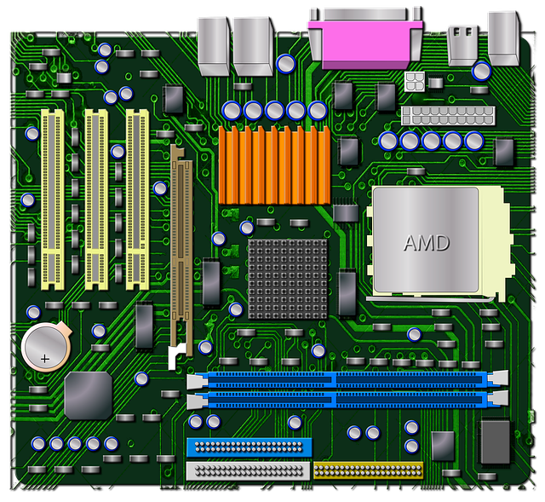
The motherboard is the backbone that ties the computer's components together at one spot and allows them to talk to each other. Without it, none of the computer pieces, such as the CPU, GPU, or hard drive, could interact. Total motherboard functionality is necessary for a computer to work well.

Features of Motherboard
A motherboard comes with following features:
- Motherboard varies greatly in supporting various types of components.
- Motherboard supports a single type of CPU and few types of memories.
- Video cards, Hard drives, Sound cards have to be compatible with the motherboard to function properly.
- Motherboard, Cases, and Power supplies must be compatible to work properly together.

Advantages of Motherboard
- A motherboard is the main component without it a computer cannot function.
- Any peripheral can be connected and data transfer is faster.

\

Internal storage devices

The term 'internal' describes a device installed inside the computer, unlike the external peripheral devices. For example, RAM is an internal device, whereas a keyboard is an external device.
some storage devices are classed as 'internal' which means they are inside the computer case.
Most computers have some form of internal storage. The most common type of internal storage is the hard disk.
At the most basic level, internal storage is needed to hold the operating system so that the computer is able to access the input and output devices.
It will also be used to store the applications software that you use and more than likely, the original copies of your data files.
Internal storage allows the data and applications to be loaded very rapidly into memory, ready for use. The data can be accessed much faster than data which is stored on an external storage device. This is because internal storage devices are connected directly to the motherboard and its data bus whereas external devices are connected through a hardware interface such as USB, which means they are considerably slower to access.


RAM- different types

RAM (Random Access Memory) is the hardware in a computing device where the operating system (OS), application programs and data in current use are kept so they can be quickly reached by the device's processor. RAM is the main memory in a computer. It is much faster to read from and write to than other kinds of storage, such as a hard disk drive (HDD), solid-state drive (SSD) or optical drive.

Random Access Memory is volatile. That means data is retained in RAM as long as the computer is on, but it is lost when the computer is turned off. When the computer is rebooted, the OS and other files are reloaded into RAM, usually from an HDD or SSD.

SRAM VS DRAM

SRAM | DRAM
SRAM has lower access time, so it is faster compared to DRAM. | DRAM has higher access time, so it is slower than SRAM.
SRAM is costlier than DRAM. | DRAM costs less compared to SRAM.
SRAM requires a constant power supply, which means this type of memory which consumes more power. | DRAM offers reduced power consumption because the information is stored in the capacitor.
It is a complex internal circuitry, and it offers less storage capacity is available compared to the same physical size of a DRAM memory chip. | It is the small internal circuitry in the one-bit memory cell of DRAM. The large storage capacity is available.
SRAM has a low packaging density. | DRAM has a high packaging density.
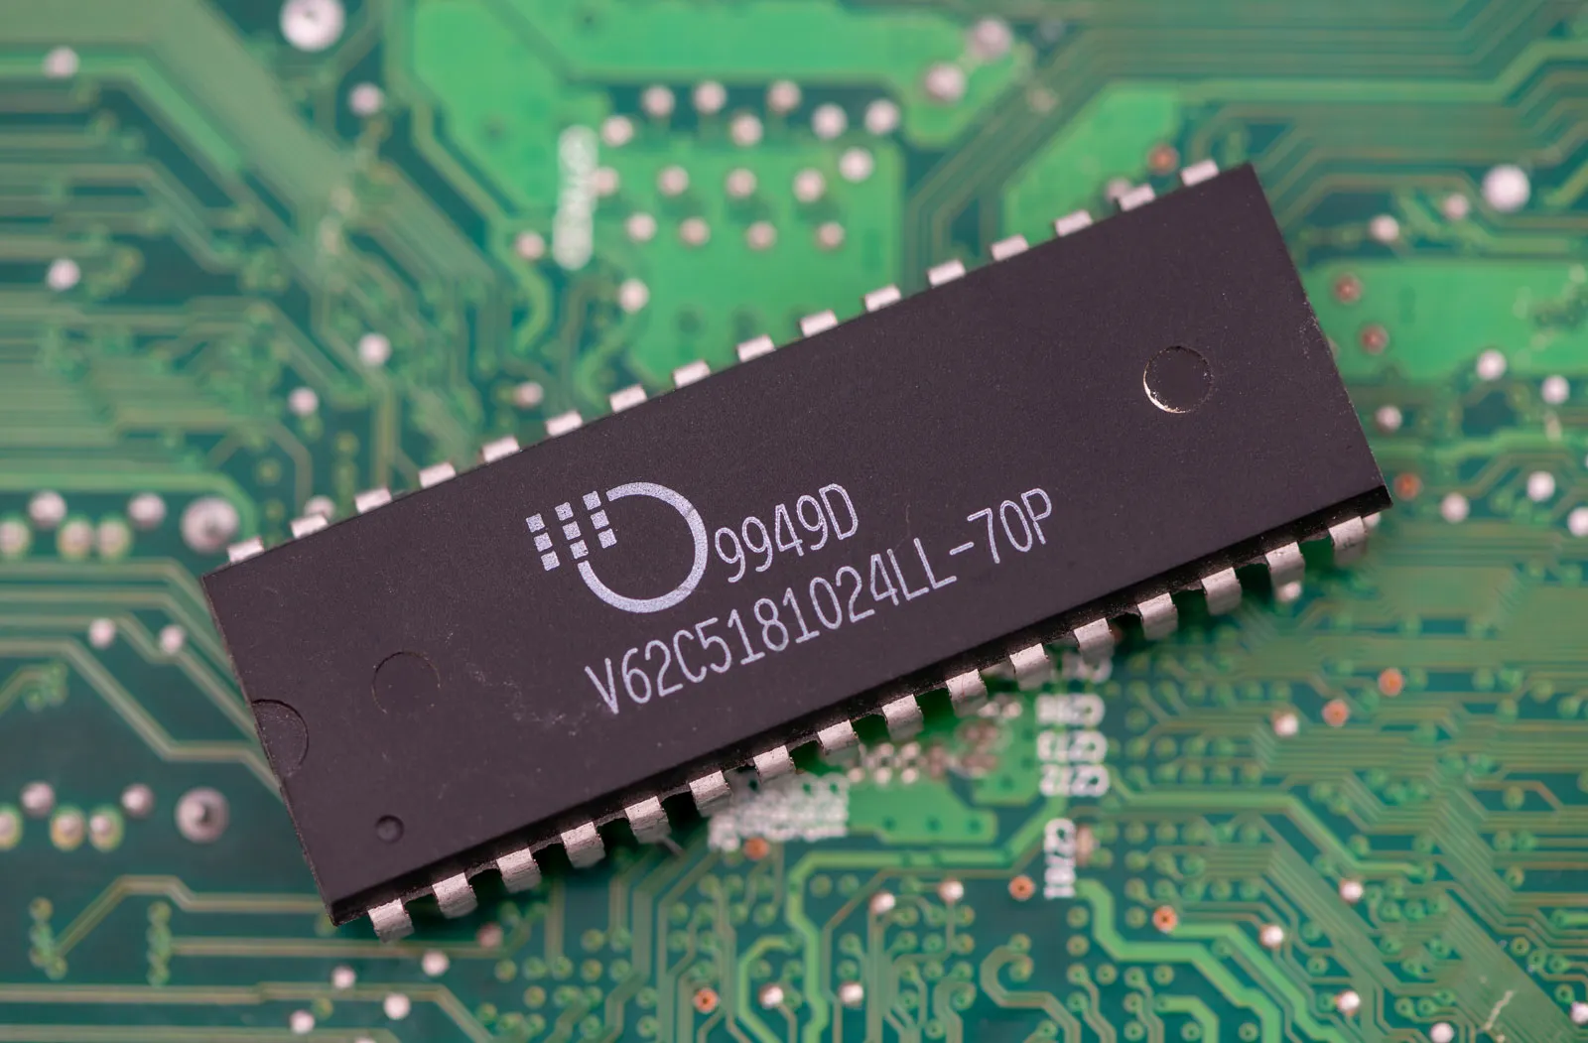
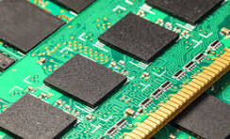

ROM

ROM (read-only memory) is a non-volatile memory type. This means it receives data and permanently writes it on a chip, and it lasts even after you turn off your computer. The data is coded to not be overwritten, so it's used for things like your printer software or your startup programs.

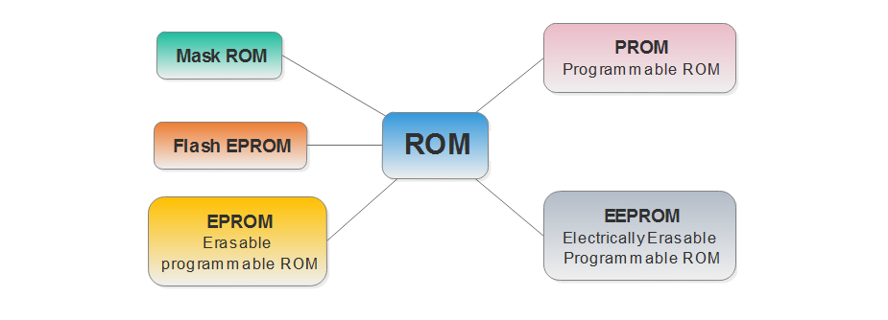

Hard Disk
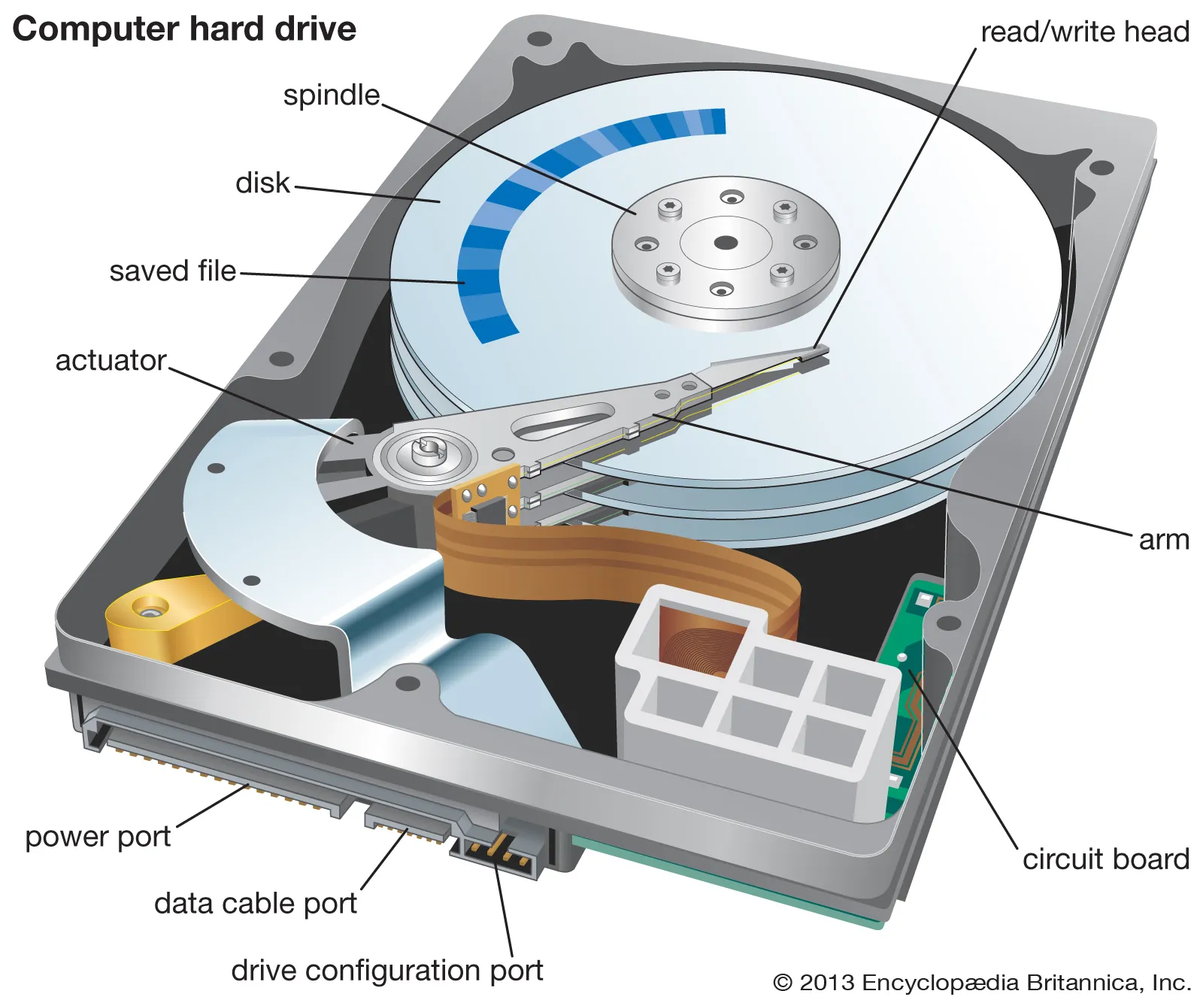

hard disk, magnetic storage medium for a computer. Hard disks are flat circular plates made of aluminum or glass and coated with a magnetic material. Hard disks for personal computers can store terabytes (trillions of bytes) of information. Data are stored on their surfaces in concentric tracks.

SMPS

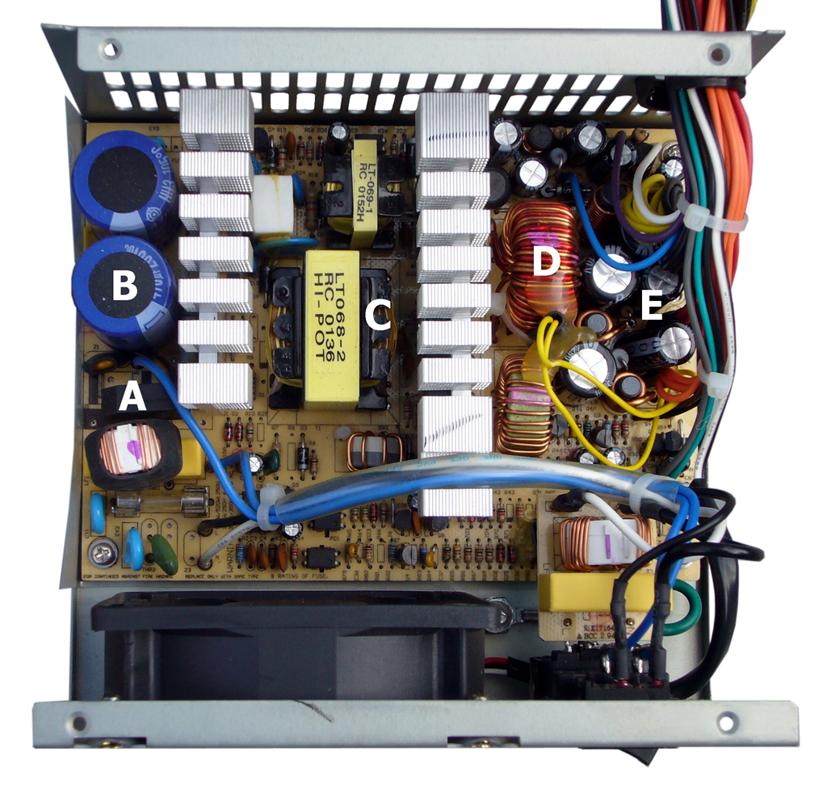
A switched-mode power supply (SMPS), also called switching-mode power supply, switch-mode power supply, switched power supply, or simply switcher, is an electronic power supply that incorporates a switching regulator to convert electrical power efficiently.

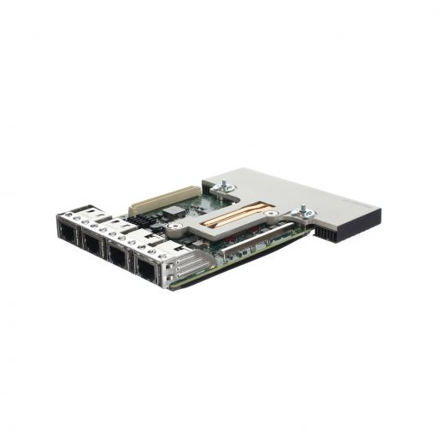
daughter cards

Network Daughter Cards (NDCs) are small circuit boards that can be added to a computer or hardware device to improve network connectivity. They plug into a slot on the motherboard and provide additional network interfaces that can help with various tasks. For example, you can use NDCs to: Balance the network load.

Bus slots
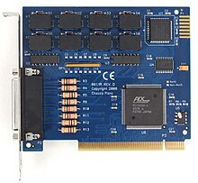
In computing, an expansion card (also called an expansion board, adapter card, peripheral card or accessory card) is a printed circuit board that can be inserted into an electrical connector, or expansion slot (also referred to as a bus slot) on a computer's motherboard (see also backplane) to add functionality to a computer system.

Interfacing ports
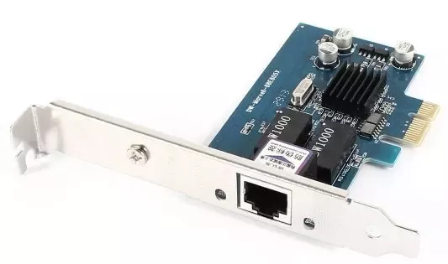
In short, a "port" is a specific point of connection on a device, often physical, through which data can be transferred. An "interface," on the other hand, is a broader term referring to the means or method by which different systems, devices, or components connect and communicate.

- Write the specification for a desktop computer

Minimum specification (LSS Solo)
- Intel i5 or higher (or equivalent)
- 32bit or 64bit Windows 10 or 11
- No minimum memory or graphics capability - whatever Windows will comfortably run on
- 200Mb free hard disk space for the program and supporting files
- 2.5Gb of free disk space for the installation of movie tutorials (optional)
- 1366x768 resolution screen&
- Spare USB2 port for the connection of the LSS dongle
- 2-button mouse with wheel
- Occasional Internet access for program updates
& This is a minimum screen size. Even at 100% desktop scaling, you won’t have a lot of room to work with and may end up turning off some menu icon bars to free up space. See the recommended spec below for a more approriate specification.
Recommended power-user computer (LSS Vista or Elite, but not LSS Point Clouds)
- Intel i5 or higher (or equivalent)
- 64bit Windows 10 or 11
- 8/16Gb RAM
- 4Gb dedicated Graphics card (such as NVIDIA or AMD Radeon – Open GL 4.0 or later)
- HD screen (1920x1080 with 100% desktop scaling) or higher
- 500Gb HDD (the LSS program only takes up about 100Mb, but you'll need space for your data)
- Spare USB2 port for the connection of the LSS dongle
- 2-button mouse with wheel
- Occasional Internet access for program updates

3. Write the specification for a server computer
Server specifications provide detailed information for your server, including dimensions, electrical, power, temperature, environment, and service clearances.
Select the appropriate models to view the specifications for your server.
- Model 8247-21L, 8247-22L, 8247-42L, 8284-21A, 8284-22A, 8286-41A, and 8286-42A server specifications
Server specifications provide detailed information for your server, including dimensions, electrical, power, temperature, environment, and service clearances.

4. Write short note on the following.
a. Operating System
b. Linux
c. Ubuntu
d. Virtual Machine
e. Kernel
f. Shell
g. Terminal
h. Bash
i. Shell scripting
A good starting point when choosing reliable server specifications is a quad-core (8 threads) Intel Xeon processor, 32GB of DDR4 RAM, 8TB storage space, and a 1Gbps internet connection. You should upgrade the storage space to 16TB for IPTV streaming servers and opt for a 10Gbps connection and unmatered bandwidth.
4. Write short note on the following.
a. Operating System
b. Linux
c. Ubuntu
d. Virtual Machine
e. Kernel
f. Shell
g. Terminal
h. Bash
i. Shell scripting
Operating System

An Operating System (OS) is a collection of software that manages computer hardware resources and provides common services for computer programs. The operating system is the most important type of system software in a computer system.

Linux

Linux® is an open source operating system (OS). An operating system is the software that directly manages a system’s hardware and resources, like CPU, memory, and storage. The OS sits between applications and hardware and makes the connections between all of your software and the physical resources that do the work.

Ubuntu

Ubuntu is a Linux distro based on Debian. It is suitable for cloud computing, servers, desktops, and internet of things (IoT) devices. The main difference between Linux and Ubuntu is that the former is an operating system family based on Unix, while Ubuntu is a Linux distribution.

Virtual Machine

A virtual machine is a computer file, typically called an image, that behaves like an actual computer. It can run in a window as a separate computing environment, often to run a different operating system—or even to function as the user's entire computer experience—as is common on many people's work computers.

Kernel
The kernel is a computer program at the core of a computer's operating system and generally has complete control over everything in the system. The kernel is also responsible for preventing and mitigating conflicts between different processes.

Terminal

The place where a train, bus, aircraft, or ship begins or ends a trip, or the building used by passengers who are arriving or leaving: Your flight leaves from Terminal 3.

Bash

A bash script is a file containing a sequence of commands that are executed by the bash program line by line. It allows you to perform a series of actions, such as navigating to a specific directory, creating a folder, and launching a process using the command line.

Shell scripting

Shell scripting is a powerful tool commonly used across industries to automate tasks, test solutions, and increase efficiency. Shell scripting is a text file with a list of commands that instruct an operating system to perform certain tasks.

5 Steps to create a Shell Script in linux
Let us understand the steps in creating a Shell Script:
- 1.Create a file using a vi editor (or any other editor). Name script file with extension . sh.
- 2. Start the script with #! /bin/sh.
- 3 Write some code.
- 4. Save the script file as filename.sh.
- 5.For executing the script type bash filename.sh.

6. What is the extension of shell script.
- Normally, a Bash script file has . sh extension to make it clear that it is a shell script file.
- sh or . zsh since these are used by regular executable scripts.
- Bash (AKA Bourne Again Shell) is a type of interpreter that processes shell commands.
7. What is shebang ?
In computing, a shebang is the character sequence consisting of the characters number sign and exclamation mark ( #!) at the beginning of a script. It is also called sharp-exclamation, sha-bang, hashbang, pound-bang, or hash-pling.
When a text file with a shebang is used as if it is an executable in a Unix-like operating system, the program loader mechanism parses the rest of the file's initial line as an interpreter directive. The loader executes the specified interpreter program, passing to it as an argument the path that was initially used when attempting to run the script, so that the program may use the file as input data.[8] .

8. How to put your comments in your script.
All text on a line that follows to the right of // (two forward slashes) will be considered a comment and will not be executed when the script is run. Alternatively, you can enclose a section of code with /* and */. You can also insert comments to the script using the Rem statement.
Single line comments start with // . Any text between // and the end of the line will be ignored by JavaScript (will not be executed).
Any line starting with a hash (#) becomes comment. Comment means, that line will not take part in script execution. It will not show up in the output.
9. How to execute a shell script.
Step 1 – Open the terminal. To write a shell script, open the terminal app. ...
Step 2 – Write the shell script using an editor. ...
Step 3 – Make the shell script executable. ...
Step 4 – Execute the shell script in Linux.

10. Write a shell script to display your name .
echo “SURYA S NAIR”

